# Create your first quotation

Quotations are documents sent to prospects to offer an estimated price for a particular set of products or services. The prospects can accept the quotation, in which case the seller will have to issue a sales order, or refuse it.

## Business case

For example, *My Company* sells electronic products and a client *Agrolait* showed interest in buying 3 *iPads* to facilitate their operations. I would like to send them a quotation for those *iPads* with a sales price of *320 USD* per *iPad* with a **5% discount**.

## Configuration

Install the **Sales Management** application. In order to be able to issue quotation, you’ll need to install the **Sales Management** application from the **Apps** in the Odoo backend.

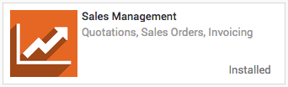

### Discounts on sales order line

Allowing discounts on quotations is a common sales practice to improve the chances to convert the prospect into a customer.

In our example, we want to grant 5% discount to our customer *Agrolait* on the sale price. To enable the feature, go into the **Sales** application, select **Configuration / Settings** and, under **Pricing** section, select it and **APPLY** to allow manual discounts on order lines.

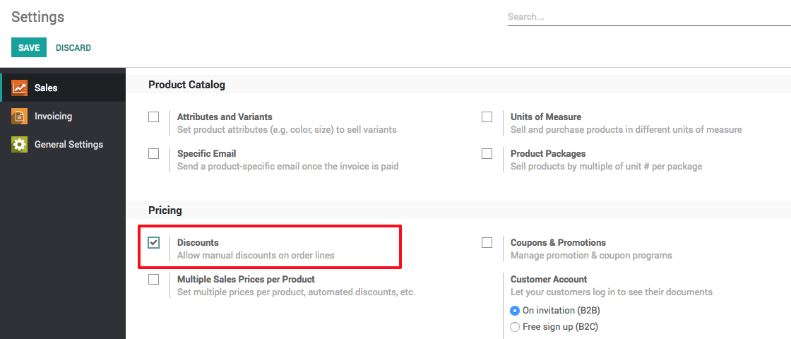

## Create your quotation

To create your first quotation, go to **Sales / Quotations** and click on **CREATE**. Then, complete your quotation as follows:

### Customer and Products

The basic elements to add to any quotation are the prospects or customer (the person you will send your quotation to) and the products you want to sell.

From the quotation view, choose the prospect from the **Customer** drop-down list and under **Order Lines**, click on **Add an item** and select your product. Do not forget to manually add the number of items under **Ordered Quantity** and the **Discount** if applicable.

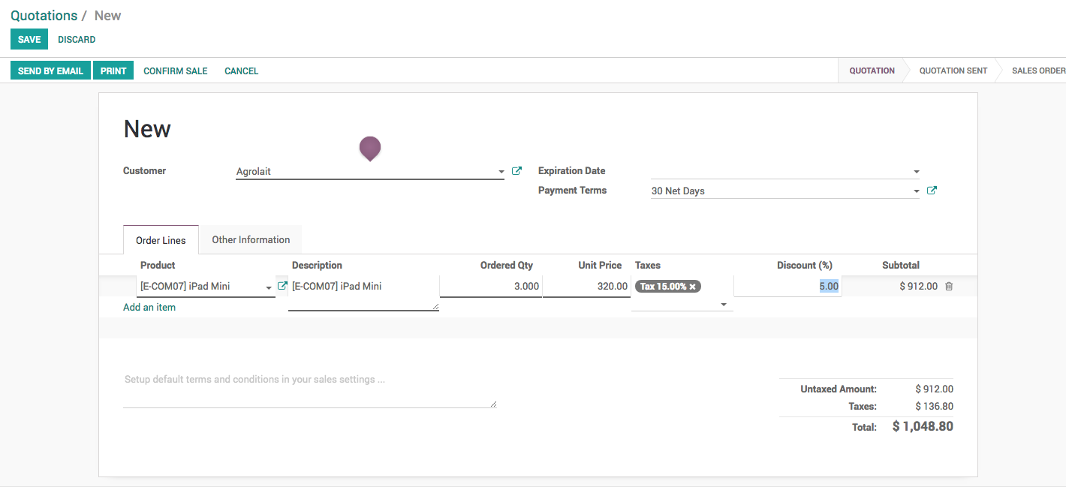

The discount should be entered between 0 to 100, it computes discount in percentage. To apply 5% discount enter 5 in the **Discount (%)**.

If you don’t have any customer or product created before on your Odoo instance yet, you can create them on the fly directly from your quotations :

* To add a new customer, click on the **Customer** drop-down menu and click on **Create and edit**. In this new window, you will be able to record all the customer details, such as the address, website, phone number and person of contact.
* To add a new product, under **Order Line**, click on **Add an item**, click on **Create and Edit** on the drop-down list of **Product** field. You will be able to record your product information (product type, cost, sale price, invoicing policy, etc.) along with a picture.

### Taxes

To parameter taxes, simply go on the **Taxes** field of the order line and click on **Create and Edit**. Fill in the details (for example if you are subject to a 15% taxe on your sales, simply fill in the right amount in percentage) and save.

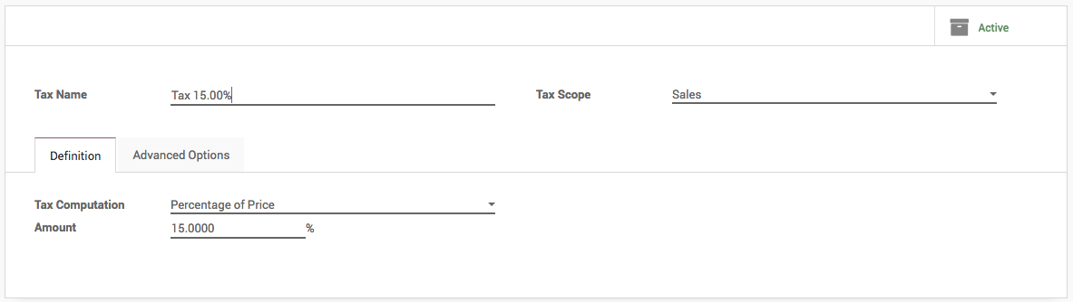

### Terms and conditions

You can select the expiration date of your quotation and add your company’s terms and conditions directly in your quotation (see picture below).

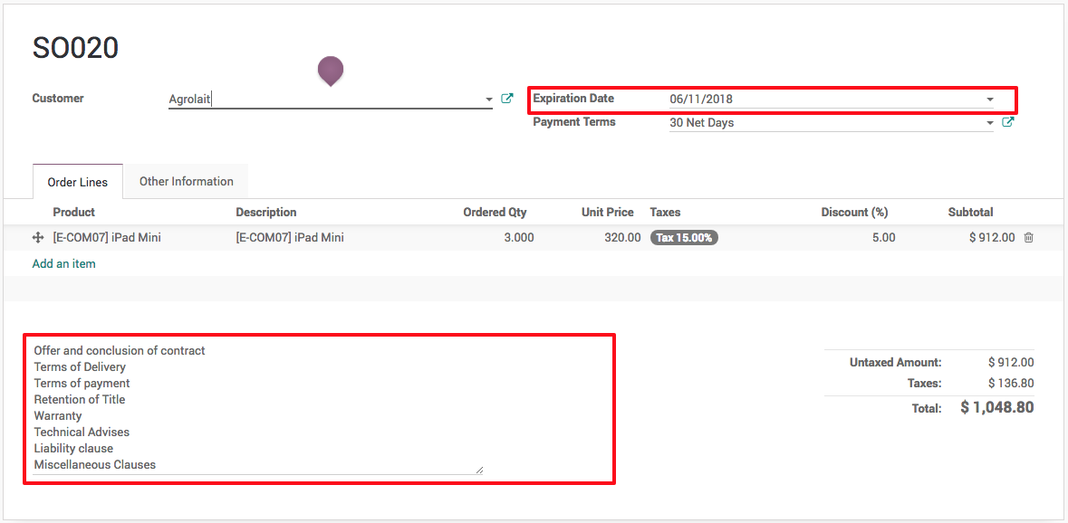

## Preview quotation

If you want to see what your quotation looks like before sending it, click on the Print button (upper left corner). It will give you a printable PDF version with all your quotation details.

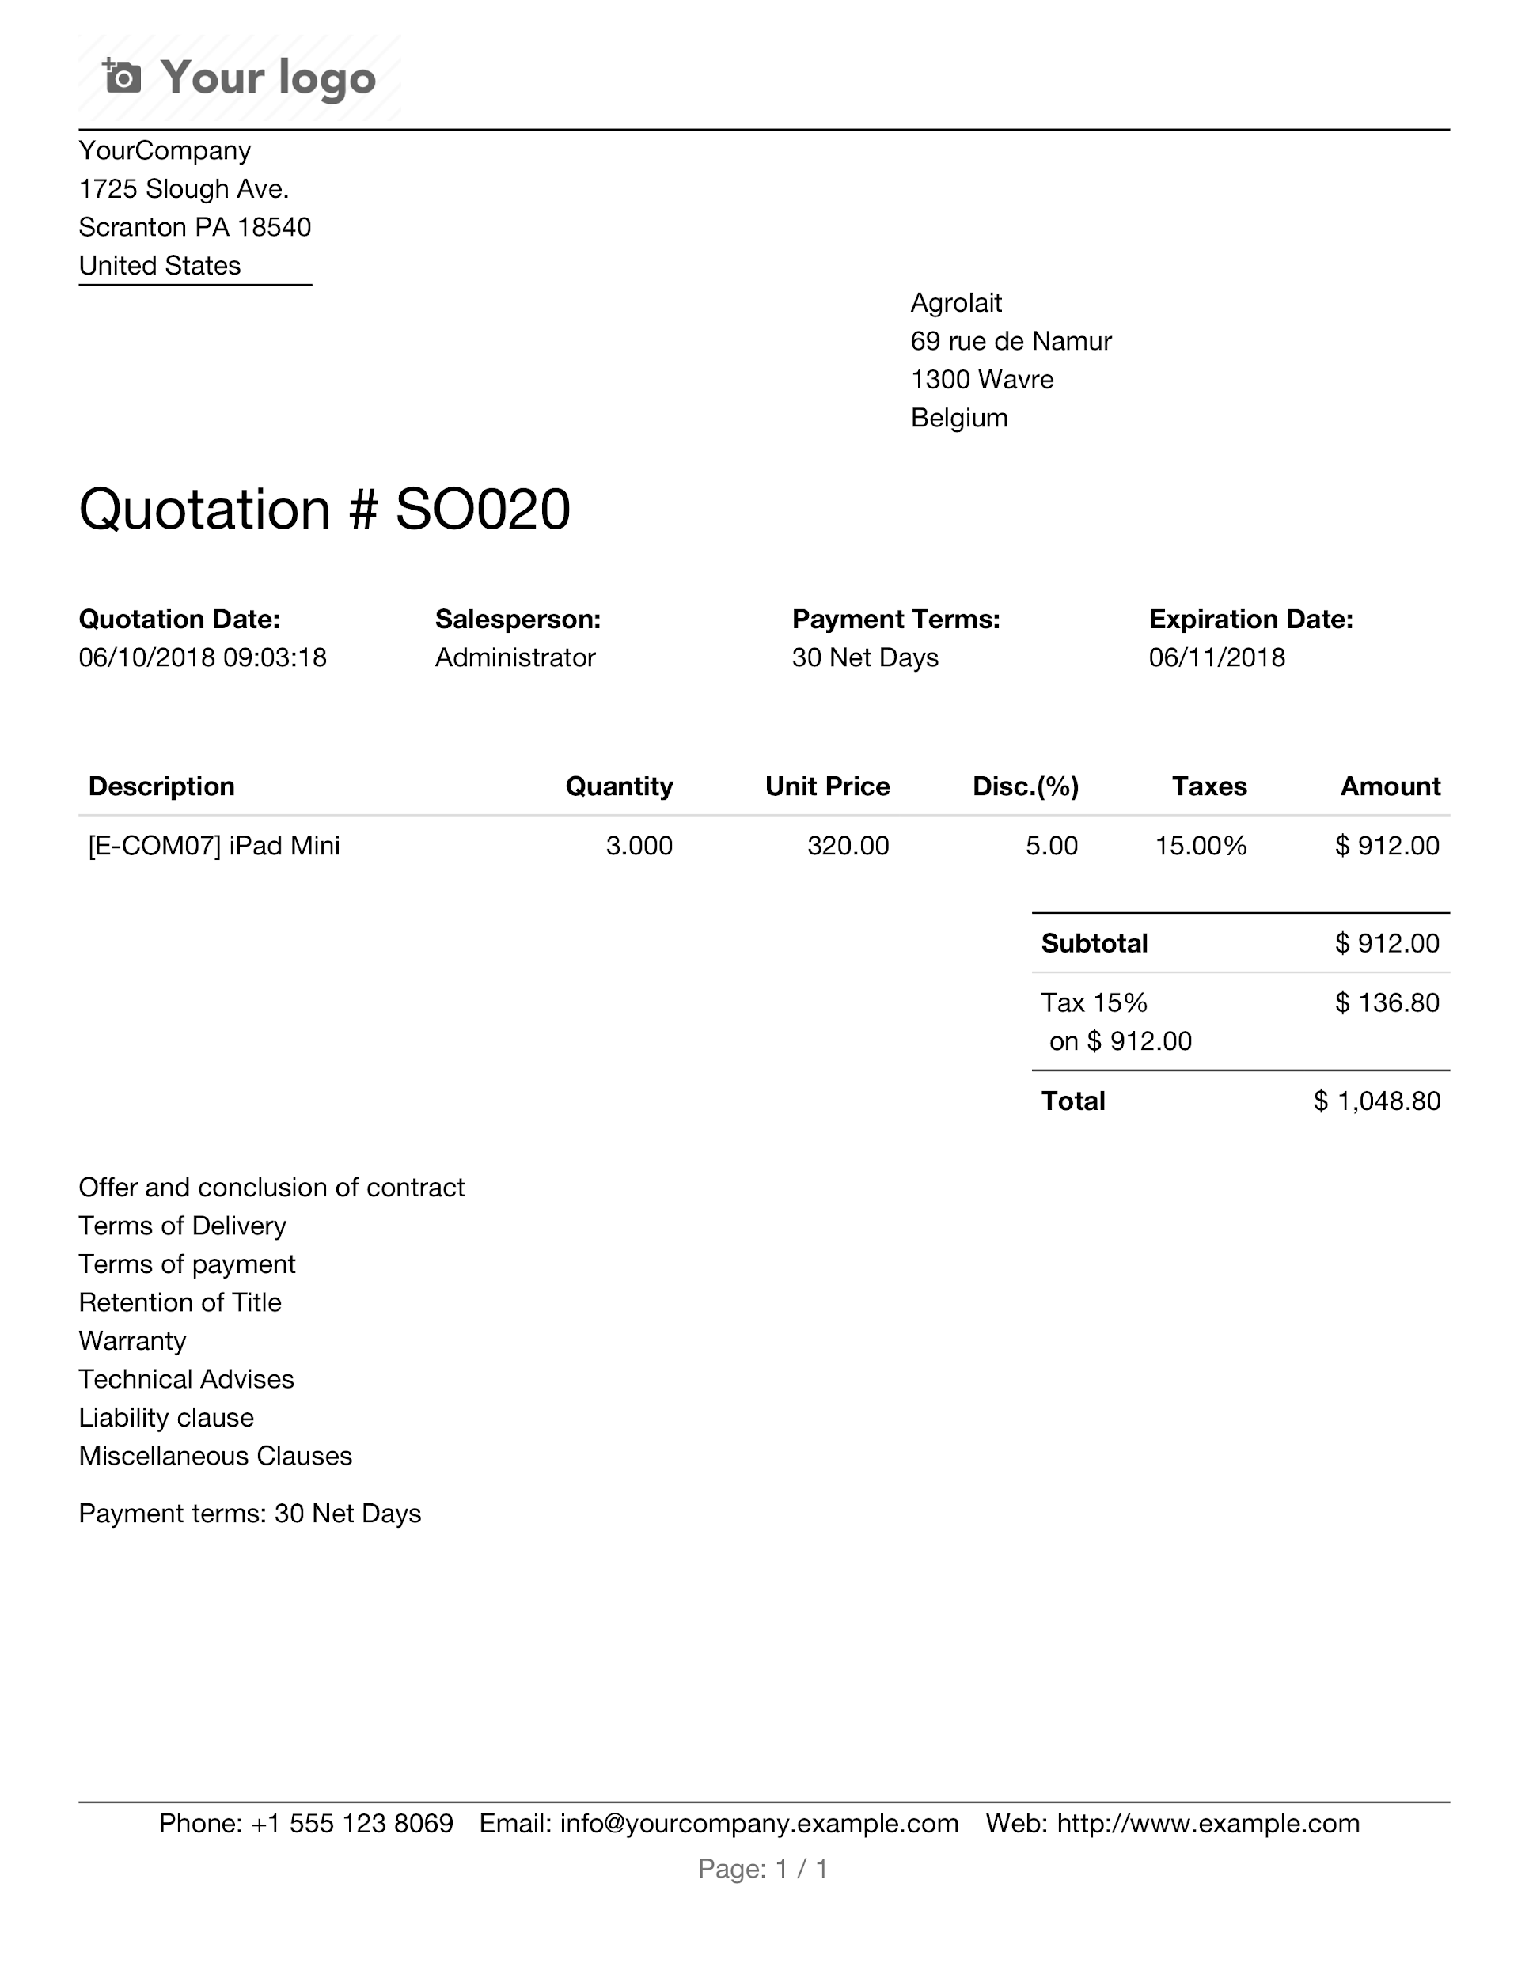

Update your company’s details (address, website, logo, etc) appearing on your quotation from the the Settings menu on the app switcher, and on click on the link Settings → General settings → Configure company data.