# Increase your sales with suggested products

The use of suggested products is an attempt to offer related and useful products to your client. For instance, a client purchasing a cell phone could be shown accessories like a protective case, a screen cover, and a headset.

## Business case

The consulting company want to add the suggested product such as *Software training program* on the quotation when they make a quotation for *Offshore Projects*.

## Configuration

Assumed that the **Sales Management** application is installed and quotation template is configured well for the *Offshore Project*.

### Suggested products

Open the Offshore Project quotation template, add the product(s) under the **Suggested Product** tab on quotation template. In our case let’s add the Software training program as a service product.

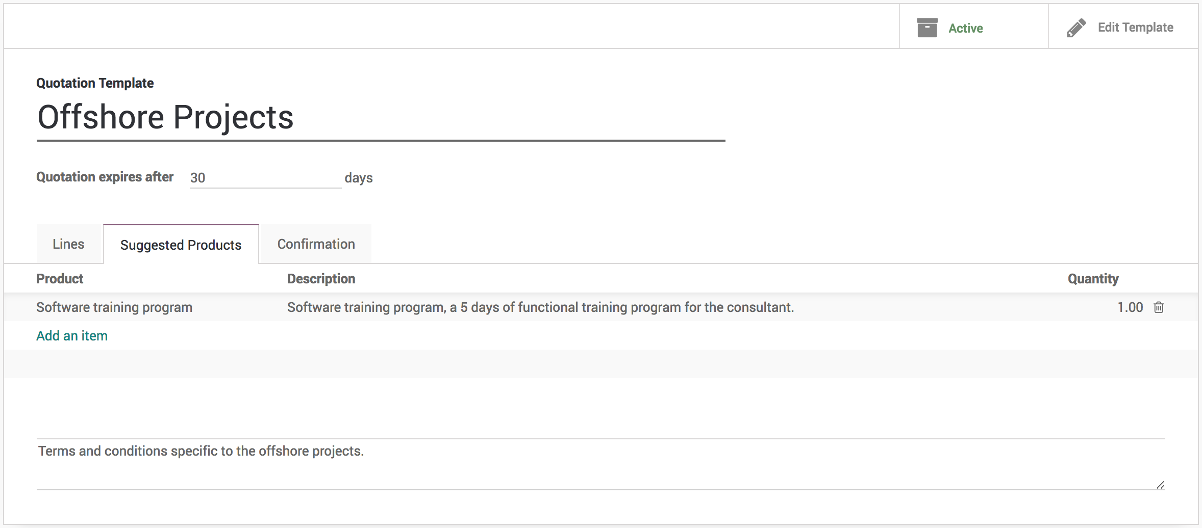

## Send the quotation

Prepare and send the quotation to customer by email. Customer can see the quotation a full product or service detailed specification along with the quoted price, and suggested products at the end. If customer find valuable products or service in suggested products they can directly add them in to quotation by themself before they approve and pay quotation online.

