# Online customer approval and payment on quotation

Sending an online quotation can speed up the negotiation process, customer can negotiate and approve the quotation online, this can boost up your sales process and minimise the sales cycle.

Getting online approval on quotation is good but getting paid online is great, it will be really cool to get online payment from the customer along with the approval of quotation.

## Business case

The service company who is selling the *Support pack* which is service offered at fixed price. As soon as customer make the online payment, they can start getting the support by sending support request. The company wants to get the online payment instead of signature from the customer to start the support service.

## Configuration

Assumed that you have installed **Sales Management** application, configure the quotation template for the support packs.

### Online payment

The **Confirmation Mode** on the quotation template available on the **Configuration** tab is set to *Online Signature* by default, change it to *Online Payment*. The customer have to pay online to confirm the quotation by themselves.

### Accept online payment

Installing the **Sales Management** application also installed the **Invoicing** application, the payment acquire needs to be activated from the list of payment acquires (payment gateways) available in Odoo. All the payment acquires can be found and activated from **Invoicing / Configuration / Payment Acquirers**.Install and configure the payment acquirer, which suits your requirement.

I have installed and configure the *Authorised.net* payment acquirer.

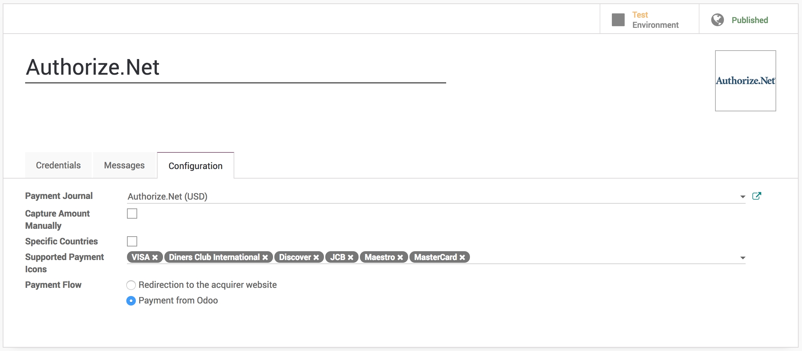

.. tip:: Do not forget to **Publish** configured payment acquire to force customer to pay by that and unpublish other acquire such as **Wire Transfer**.

I have also made change to **Payment Flow** from *Redirect to the acquirer website* to *Payment from Odoo* as i want to process the payment directly from Odoo without redirecting to acquirer website. You can switch to **Production** as soon as everything configured and working properly.

## Create and send quotation by email

Create a quotation select customer, select quotation template. Before you send the quotation to customer make sure that **Confirmation Mode** is set to *Online Payment* on quotation under the **Other Information** tab.

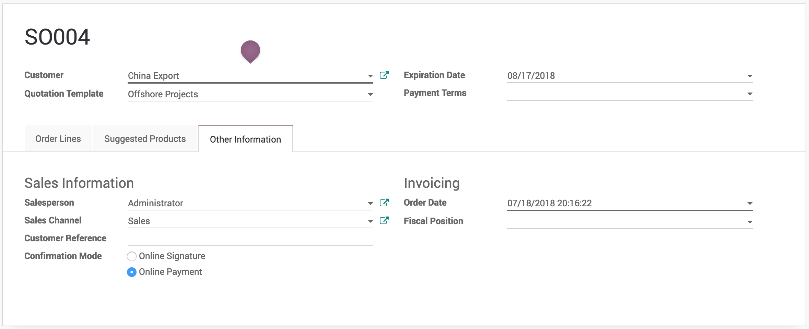

.. tip:: You can change the **Confirmation Mode** for each quotation regardless of the configuration on quotation template.

### Accept and pay online

Customer can review the quotation online, once it suite their need that can accept the quotation by clicking on the **Accept Order** and make the online payment on the quotation.

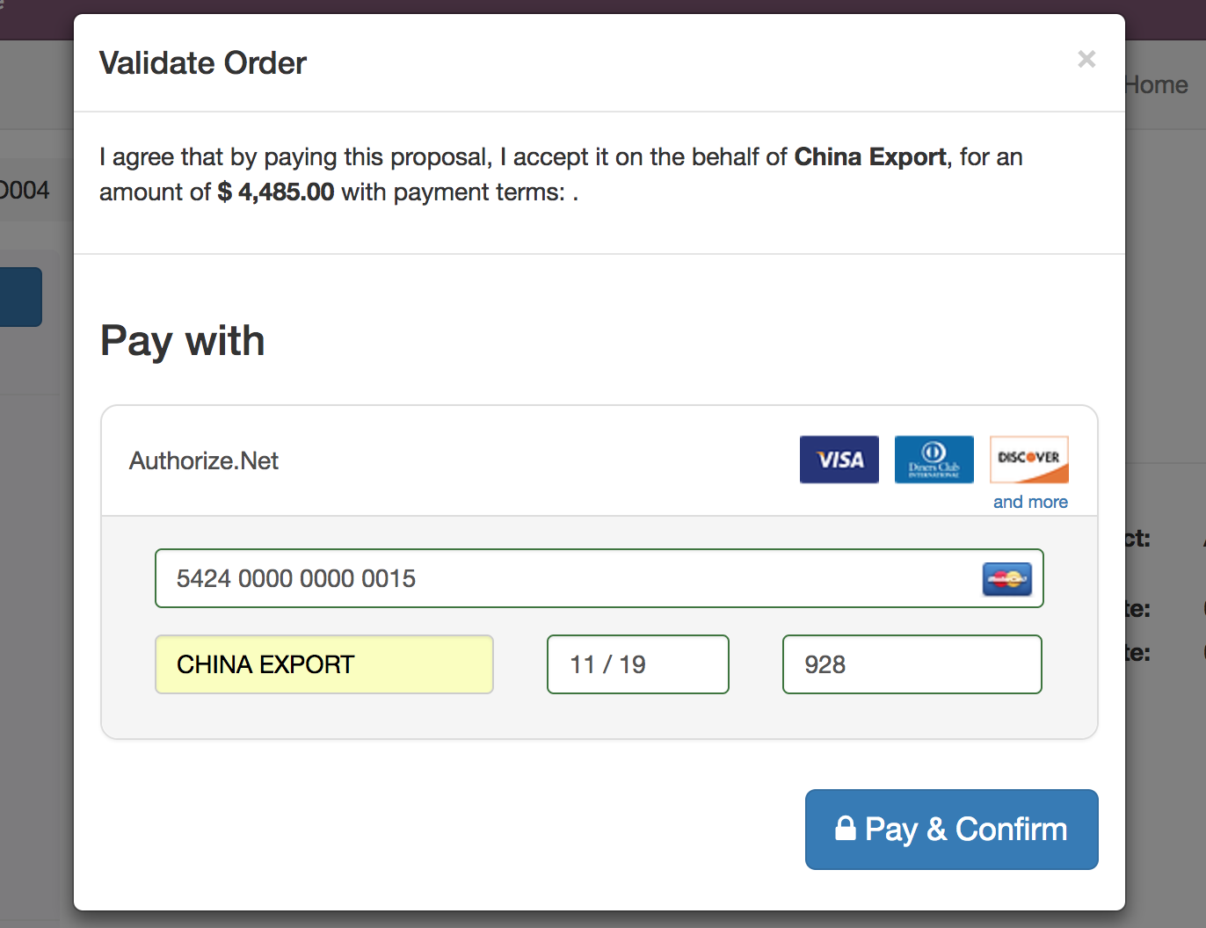

The quotation accepted and paid by the customer online will convert quotation to sales order in backend.

.. warning:: Make sure that customer has correct contract details before they process for the online payment. Some payment acquirer required complete customer details.

.. tip:: Customer can accept and pay online quotation which are not expired yet. The expiration date will be computed on quotation based on the number of days defined on quotation template in **Quotation expires after** field. However the specific **Expiration Date** can be set on the quotation manually before you send the quotation by email.

The quotation converted to sales order and It will automatically triggers the next business process in backend such as creating a delivery order, manufacturing order or create a task or project in the project management depending on your configuration.

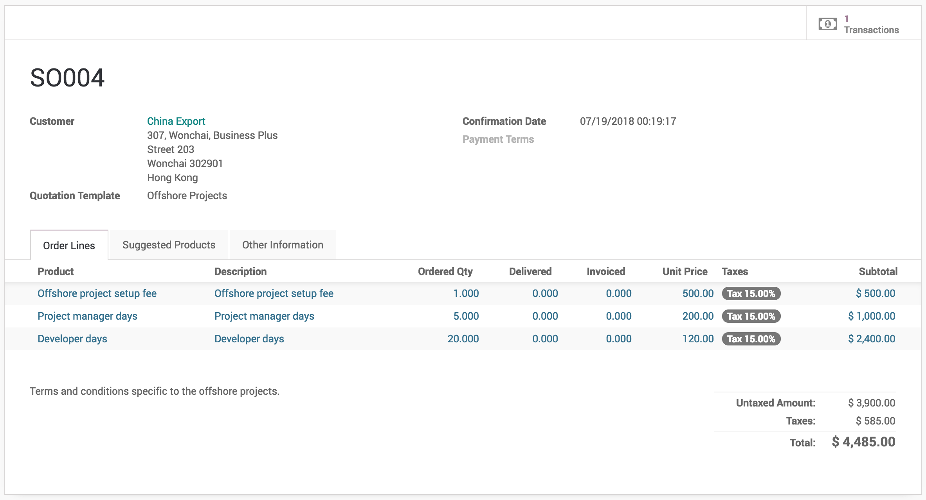

The Transaction is attached to the confirmed sales order, you can click on the transaction and get the status and reference about the online payment made by customer. It is set to **Done** and **Acquirer Reference** number is available on the transaction when payment was successfully processed.

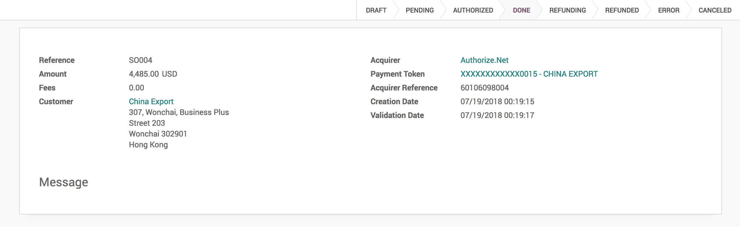

### Reject quotation

The quotation will be set to **Cancelled** state in the backend once it has been rejected by the customer online, however it can be reset to draft modified and send it back to the customer when you are in negotiation process.