# Online customer approval on quotation

Sending an online quotation can speed up the negotiation process, customer can negotiate and approve the quotation online, this can boost up your sales process and minimise the sales cycle.

## Business case

The service company who is selling the *Support pack* which is service offered at fixed price. As soon as customer accept the proposal, customer can start sending the support requests. The company wants to get the online signature from the customer and customer can release the payment based on the payment terms.

## Configuration

Assumed that you have installed **Sales Management** application, configure the quotation template for the support packs.

### Online signature

The **Confirmation Mode** on the quotation template available on the **Confirmation** tab is set to *Online Signature* by default. The customer can confirm the quotation by themselves by signing the quotation. Keep it as it is when you just want the online signature form customer.

## Create and send quotation by email

Create a quotation select customer, select quotation template. Before you send the quotation to customer make sure that **Confirmation Mode** is set to *Online signature* on quotation under the **Other Information** tab.

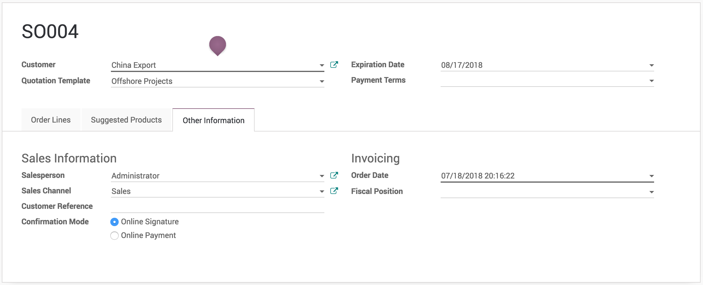

.. tip:: You can change the **Confirmation Mode** for each quotation regardless of the configuration on quotation template.

### Accept quotation

Customer can review the quotation online, once it suits his/her need than he/she can accept the quotation by clicking on the **Accept Order** and signing the quotation online.

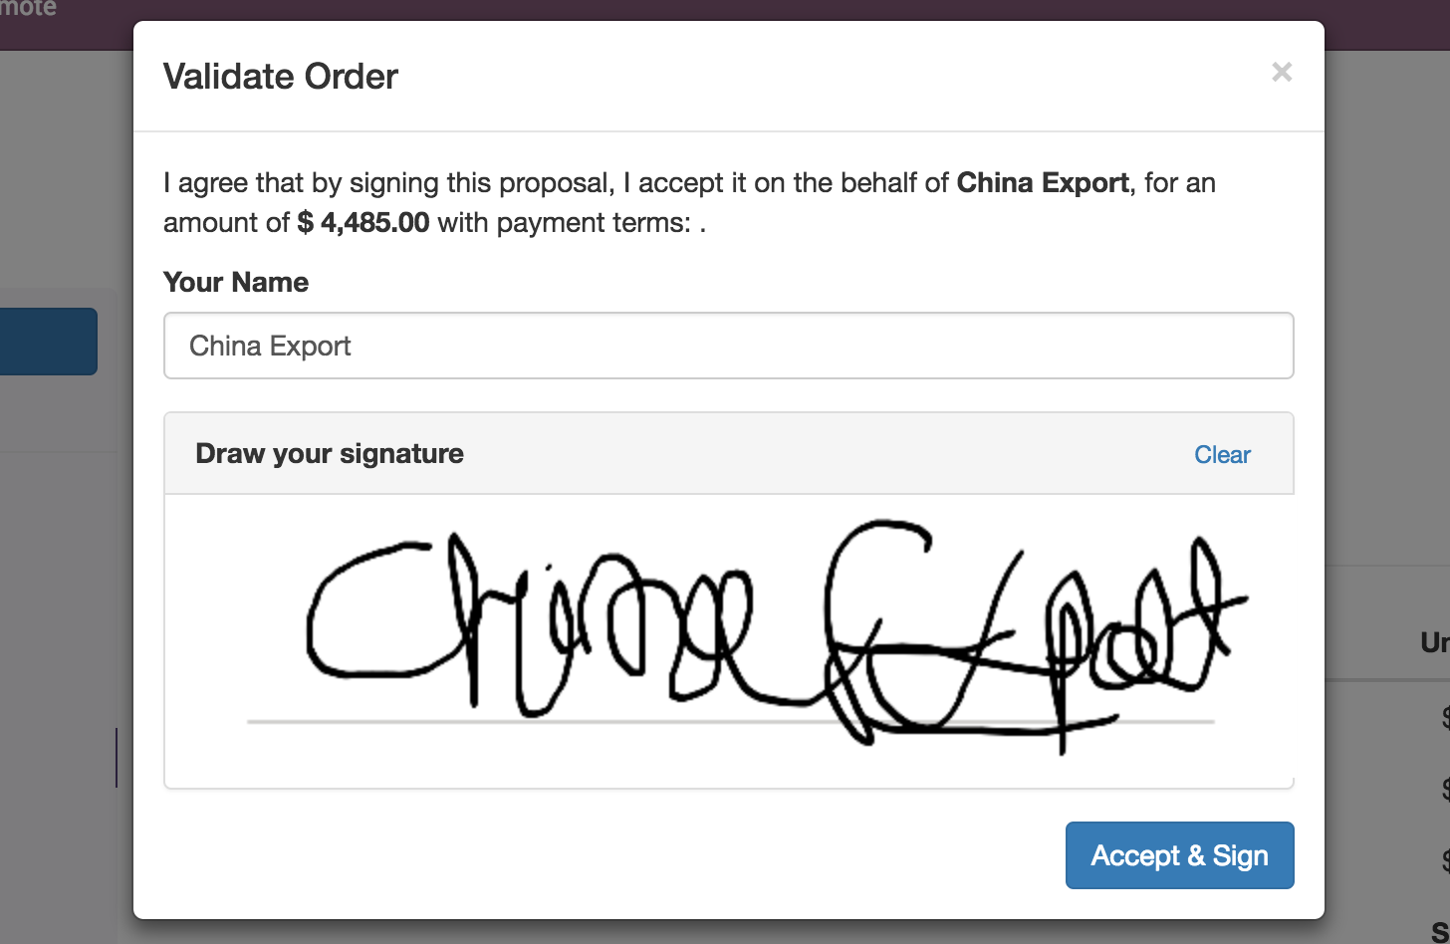

The quotation accepted and signed by the customer will be confirmed and converted to sales order in backend. It will automatically triggers the next business process in backend such as creating a delivery order, manufacturing order or create a task or project in the project management depending on your configuration.

.. tip:: Customer can accept and sign online quotation which are not expired yet. The expiration date will be computed on quotation based on the number of days defined on quotation template in **Quotation expires after** field. However the specific **Expiration Date** can be set on the quotation manually before you send the quotation by email.

### Reject quotation

The quotation will be set to **Cancelled** state in the backend once it has been rejected by the customer online, however it can be reset to draft modified and send it back to the customer when you are in negotiation process.