# Create quick quotation using quotation template

If you often sell the same products or services, you can save a lot of time by creating standard quotation templates. By using a quotation template you can send a complete quotation in no time.

## Business case

The service company who is selling the offshore projects to their customers with standard set of service products such as Project manager days, Developer days, and Project setup fee. The developers days are minimum to 20 days and project manager are one third of the developer days.

## Configuration

Assumed that **Sales Management** application is installed.

### Quotation template

Quotation template is a great feature that allows user to create offers with group of products those are sold together.

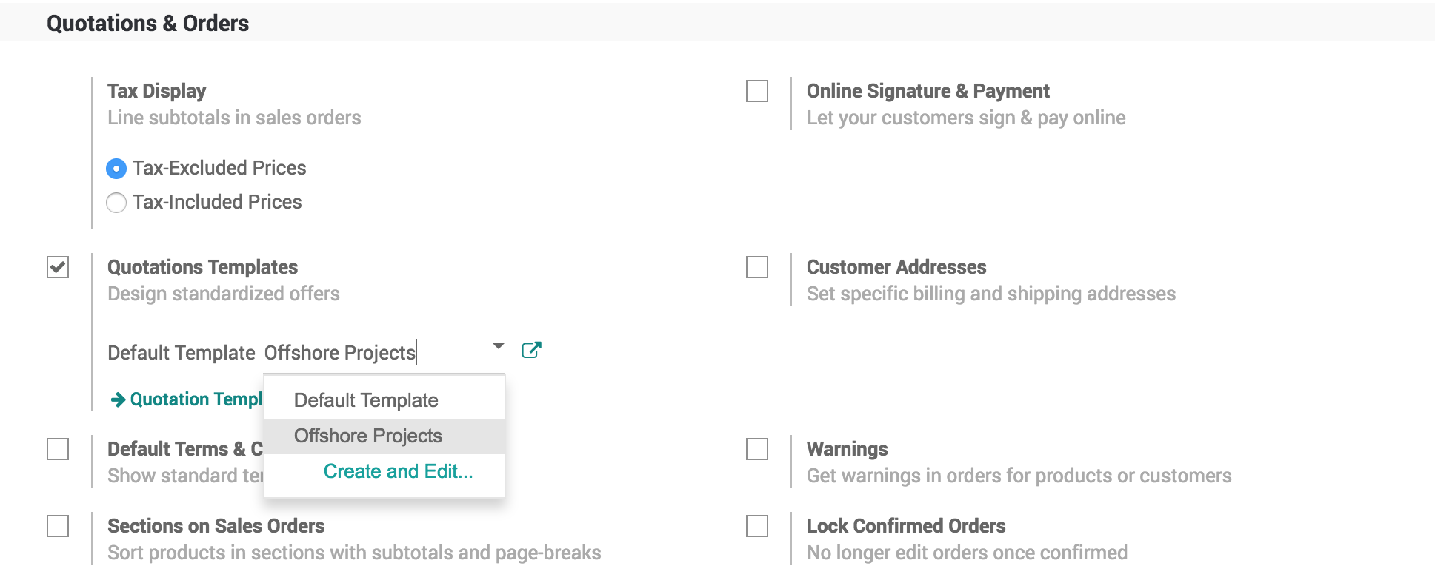

### Create a products

Create the list of products that you are going to sale together, in our business case the list of products of type service are as below:

* Offshore Project Setup Fee
* Project Manager Consulting Days
* Developer Days

### Create your quotation template

The quotation templates can be found under **Sales / Configuration / Quotation Template**, create or edit an existing template. Enter the appropriate name of the template and select the list of product(s) and their quantity as well as the expiration time for the quotation.

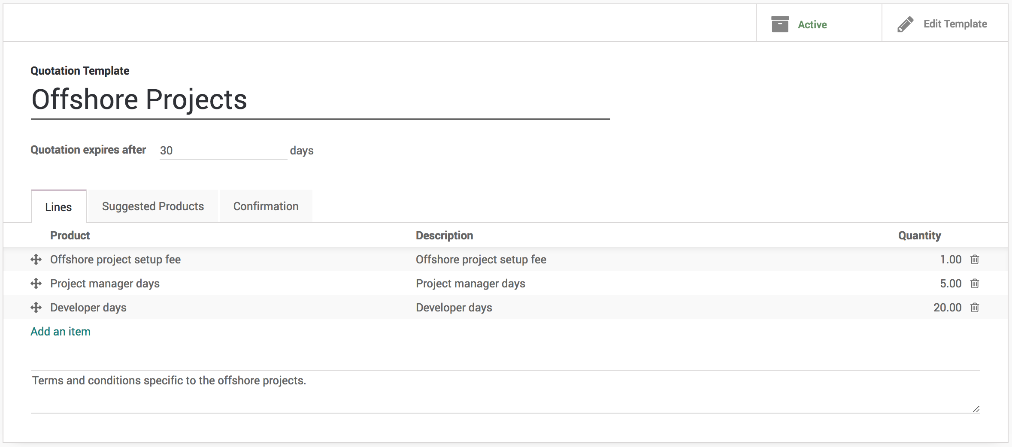

.. tip:: You can also specify discount,if discount option is activated in the Sales settings.

You can edit the customer interface of the template that they see to accept or pay the quotation. This lets you describe your company, services and products. When you click on **Edit Template** you will be brought to the quotation template editor.

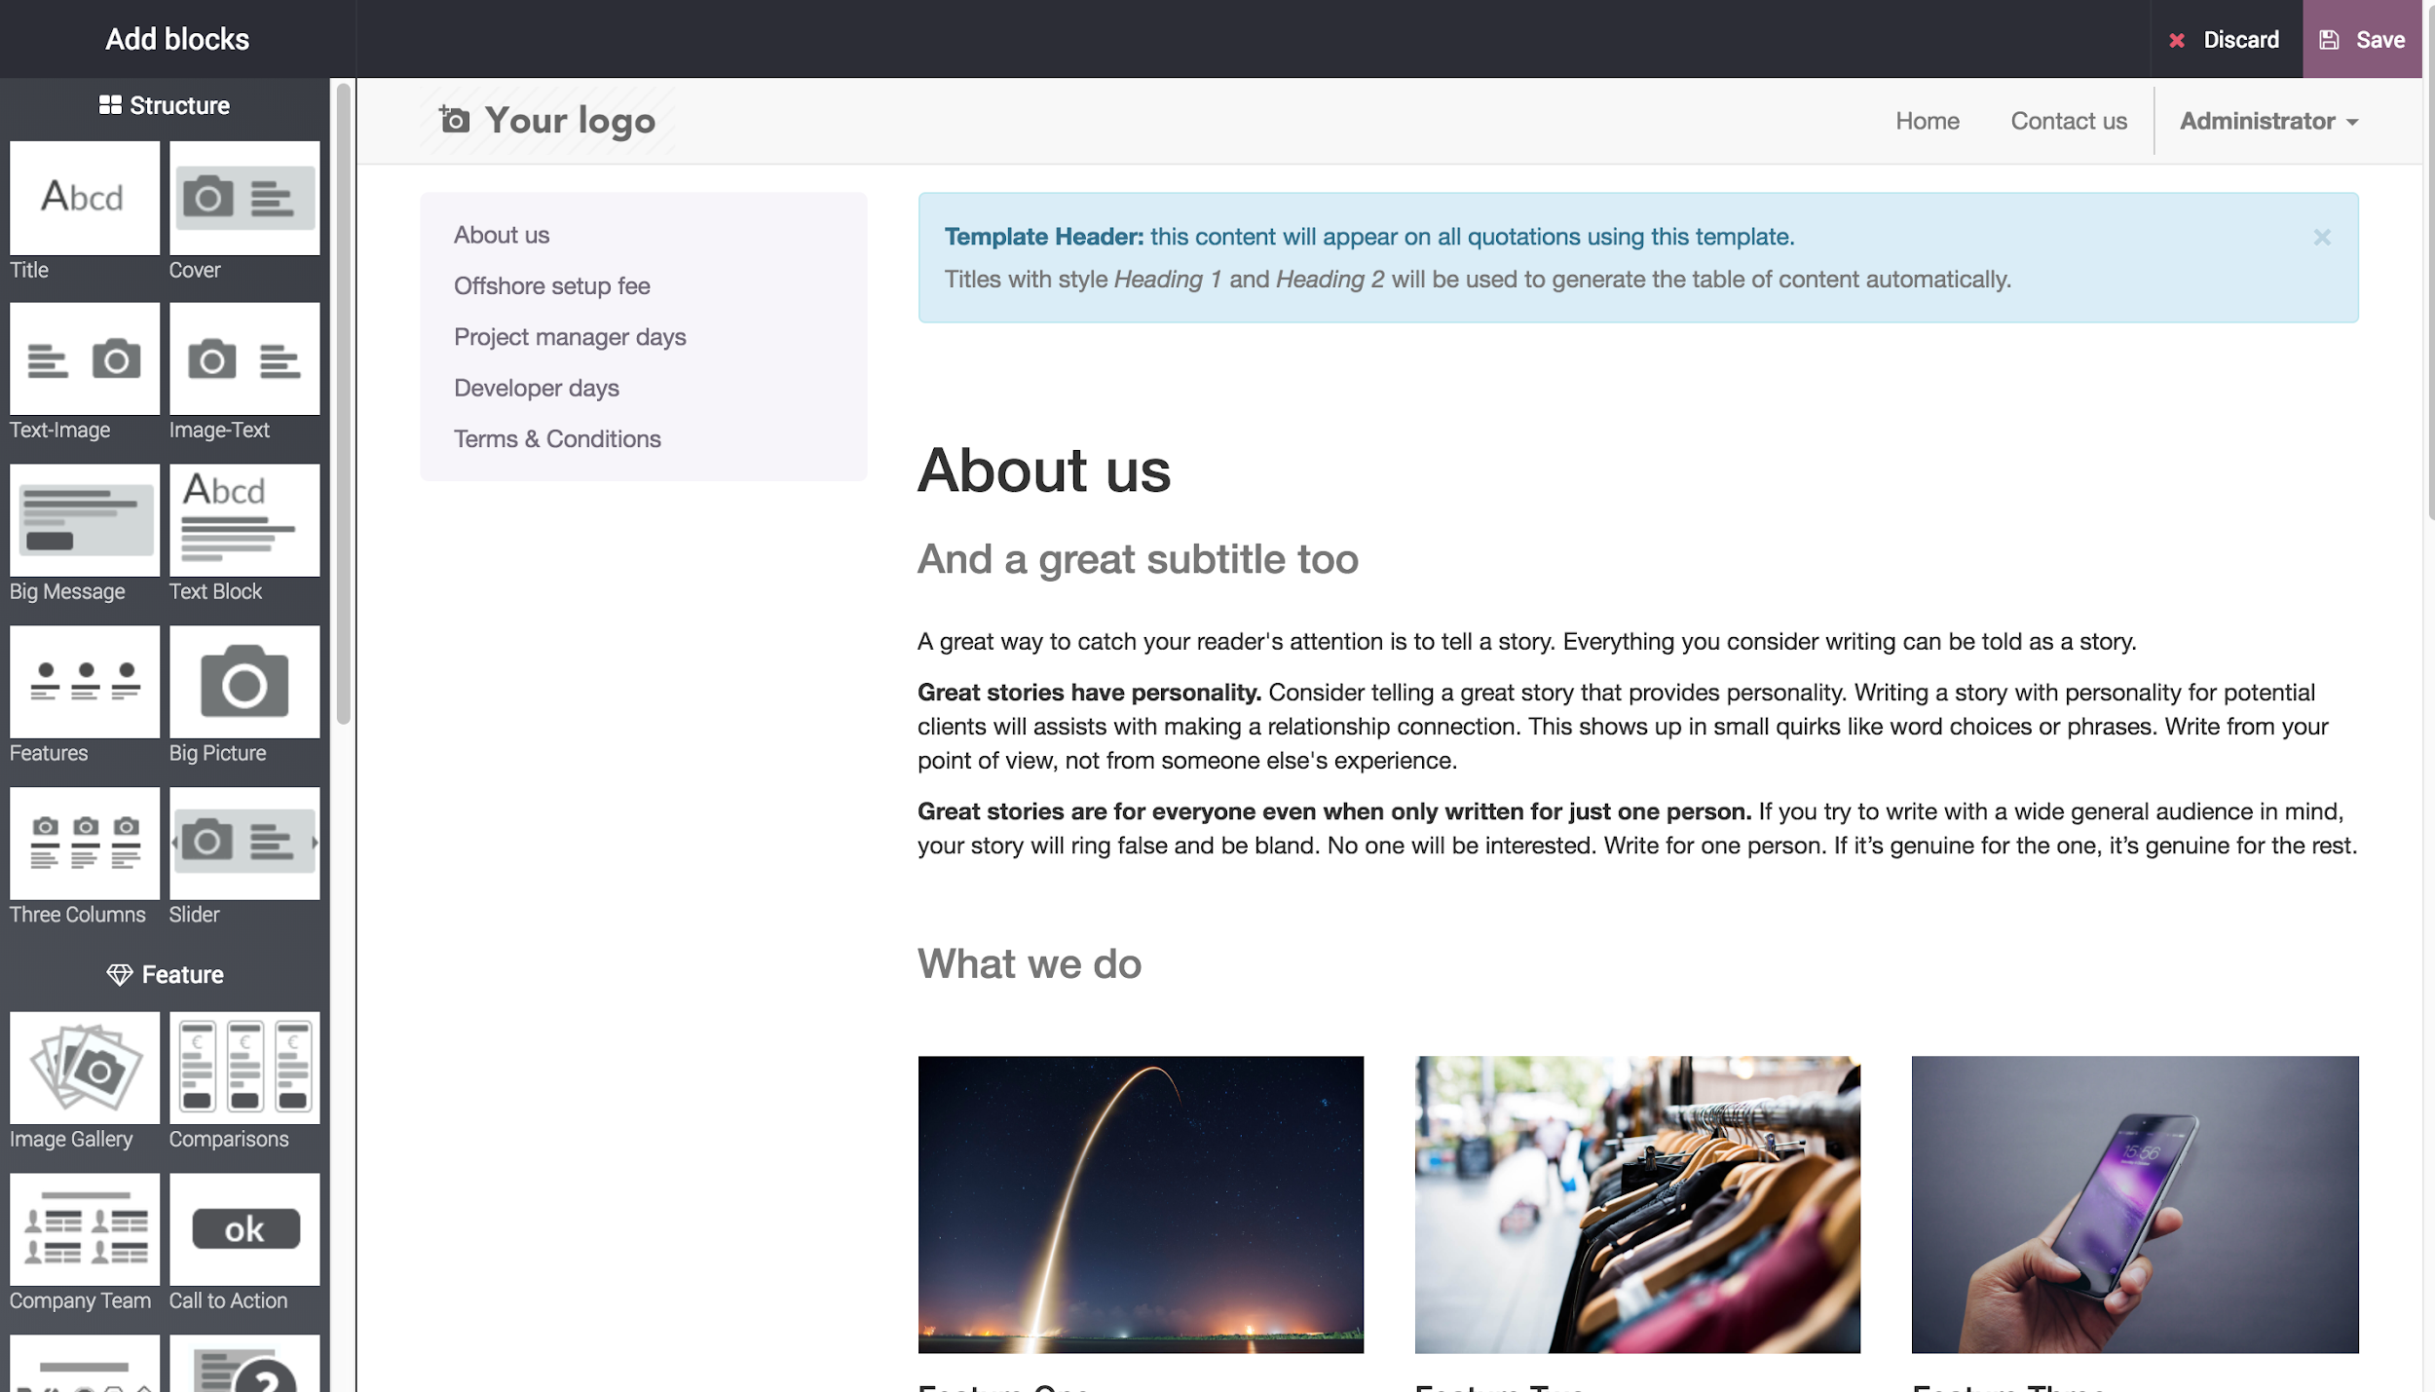

The quotation template editor lets you edit the description content thanks to drag & drop of building blocks. To describe your products add a content block in the zone dedicated to each product.

.. note:: The description set for the products will be used in all quotations templates containing those products.

## Create a quotation

When creating a quotation, you have to select a template, product in that template will be added to your quotation.

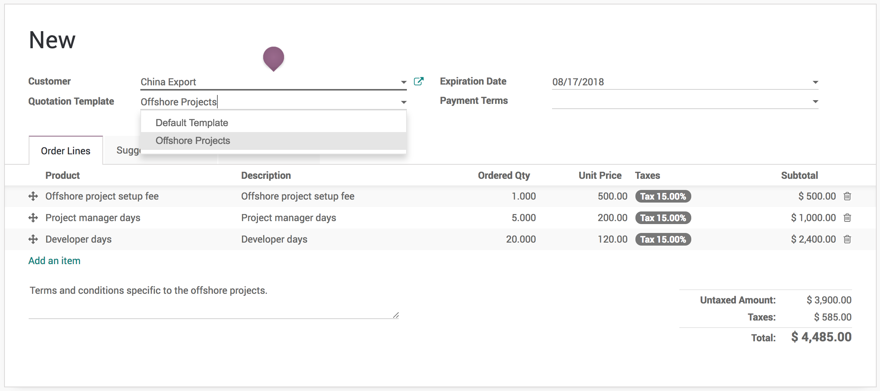

.. tip:: You can select a template to be suggested by default in the Sales settings.

### Send quotation by email

You have to send the quotation by email, so that the quotation can be viewed, accept or reject or paid online by the customer.

### Quotation viewed by customer

As a salesman you can start the follow-up on the quotation as soon as you see that a quotation viewed by customer. Everytime customer open the quotation preview you will have a message in chatter, this features of the quotation template help salesman to understand the customer interest on quotation.

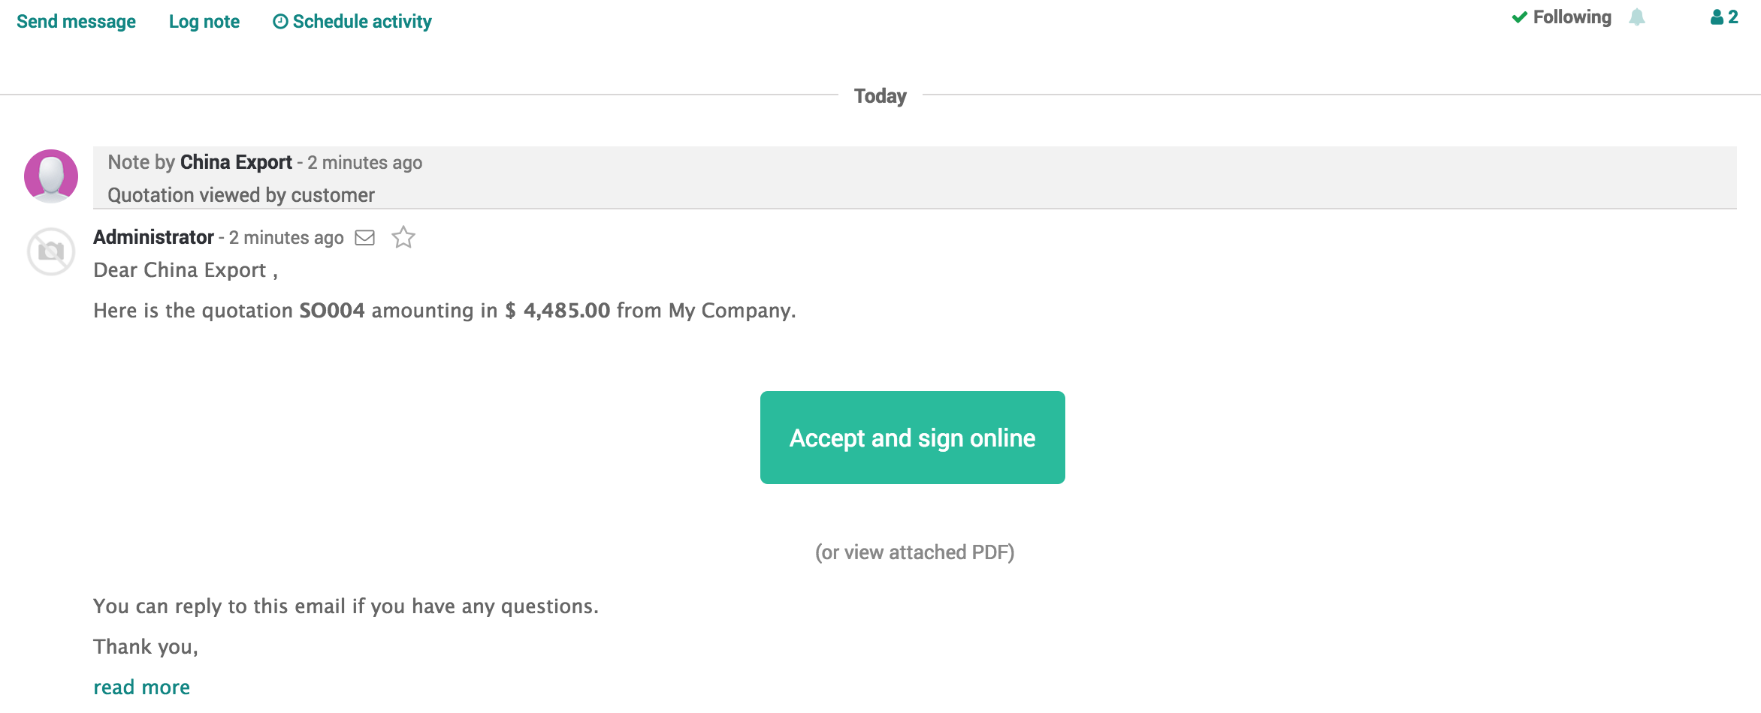

.. tip:: Please remove the attached pdf quotation at the time sending quotation by mail, if you want customer open the quotation preview.

## Seealso:

* [Send quotation by email](https://drive.google.com/open?id=16WVao-q0zonQDDRu3v1_W7qpTvgp8Ka1G0dKDYBjWW8)