# Sections on sales orders, sort products in sections with subtotals and page-breaks

Some business who delivers products and services, they need to prepare a quotation that differentiate the products based on Service and Material part. This section will help customer to understand what the total cost of the Material and Service separately.

## Business case

Let’s take an example of the trading and service company who wants to send the quotation for Air-condition, related material to install it and Installation service.

## Configuration

Assumed **Sales Management** application is installed.

### Sections on sales orders

Goto **Sales / Configuration / Settings** and enable **Sections on Sales Orders** feature that allows to create sections, sort products in sections with subtotals and page-breaks.

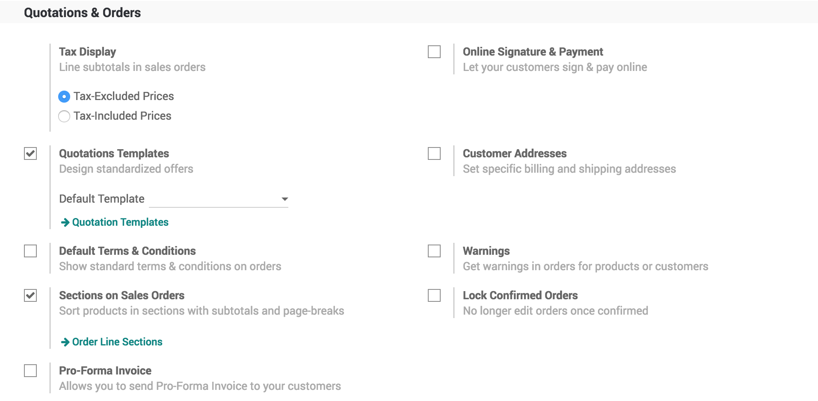

### Configure the sections

The two sections *Service* and *Material* are available by default, you can configure those sections from **Sales / Configuration / Report Layout Categories**.

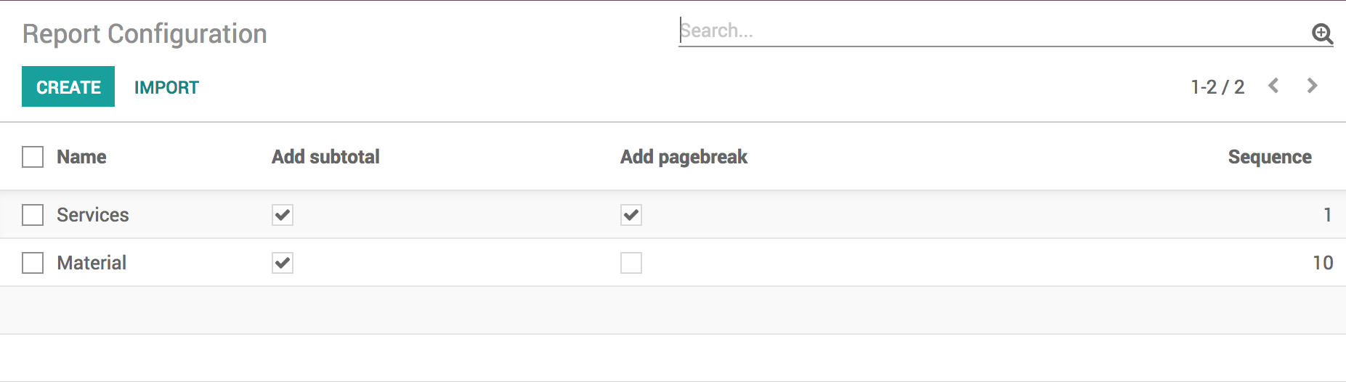

There are 4 parameters available which can configure each section, that decided how section will be printed on reports.

* **Name** - name of the section to be displayed on the report
* **Add subtotal** - if selected, the subtotal will be displayed for section
* **Add pagebreak** - if selected, once this section print on page, the next section will be printed on the next page. Uncheck **Add pagebreak** in *Service* section, if you would like to see all the section on single page.
* **Sequence** - decided the order of the section to be printed on the report

## Create a sales order

Create a sales order, select customer and products such as *Split Air Conditioner - 1.5T*, *Copper pipe* and *Installation Service*, beside each product you have to select this product comes into which section.

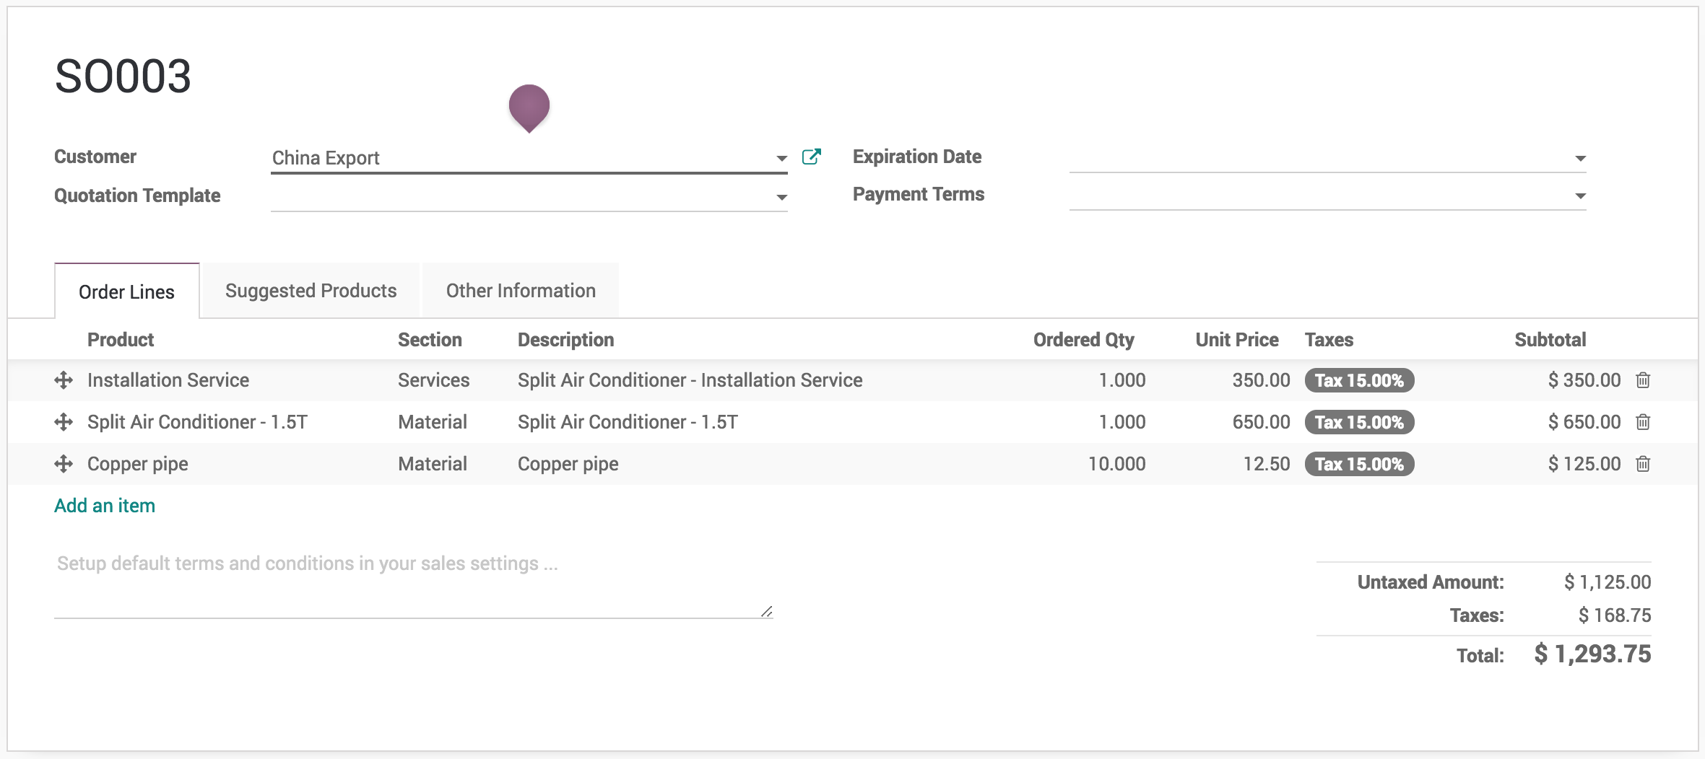

## Print sales order

You are ready to print your sales order by sections with subtotals for each sections.

