# Send quotation by email

Quotations are documents sent to customers to offer an estimated price for a particular set of goods or services. The customer can accept the quotation, in which case the seller will have to issue a sales order, or refuse it.

In traditional business process people use to send the quotation by courier, it is not efficient way as it delays the negotiation and quotation confirmation process, Odoo allows you to send the quotation by email and real-time discuss through email on the quotation.

## Business case

Let’s send your first quotation by email, so that customer can view and start negotiation on the quotation.

## Configuration

You don’t need any configuration when you are using Odoo online. Email feature is already configure and working out-of-the-box on Odoo online platform.

You need to configure the external email server, if you are not using Odoo online platform, to be precise you need to configure an incoming and outgoing mail servers.

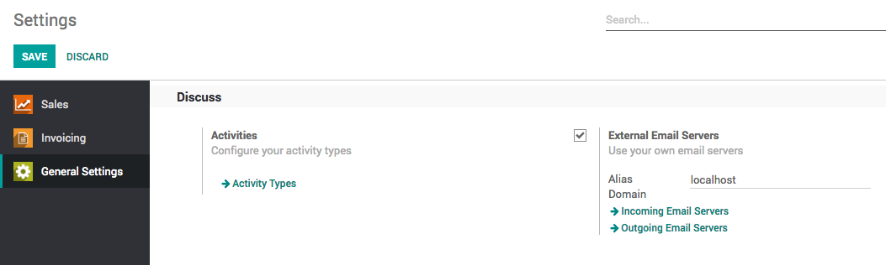

Tip: If you configure only Outgoing Email Servers you will be able to send the quotation but not receive any feedback from prospects through email

### Email address on customer

Make sure you have entered the correct email address in the **Email** field, when you create a new customer.

## Send by mail

Assumed that the quotation is prepared and ready to be shared with prospect, click on the **SEND BY EMAIL** button to send the quotation by email, automatic email will be prepared based on the predefined template which prepare the beautiful email with content and attachment on the email, review the email content, you can also add the content if you wish and send by clicking on the **SEND** button.

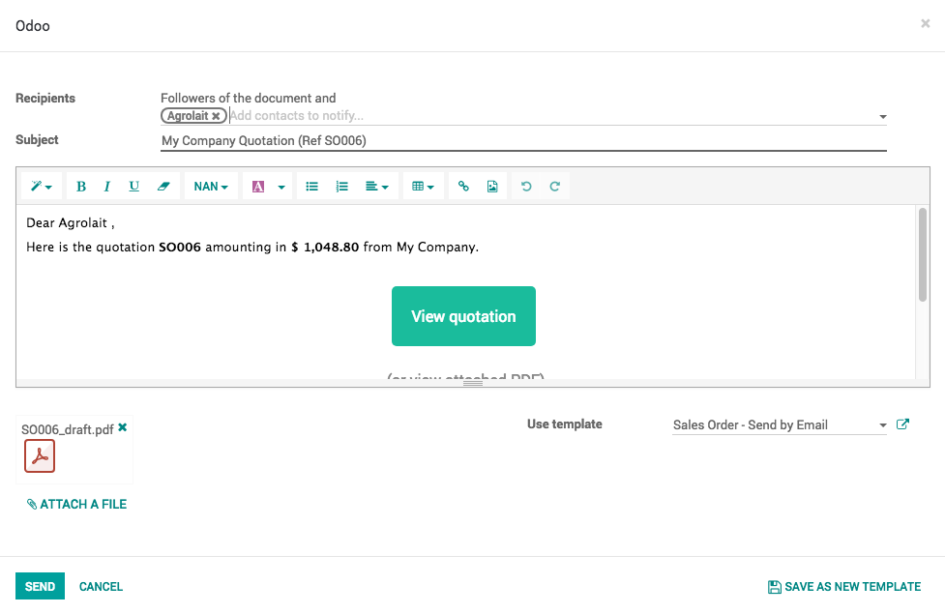

### Enter email address

You may be asked to enter the email address before send an email, if you have not entered the email at the time of creating the customer.

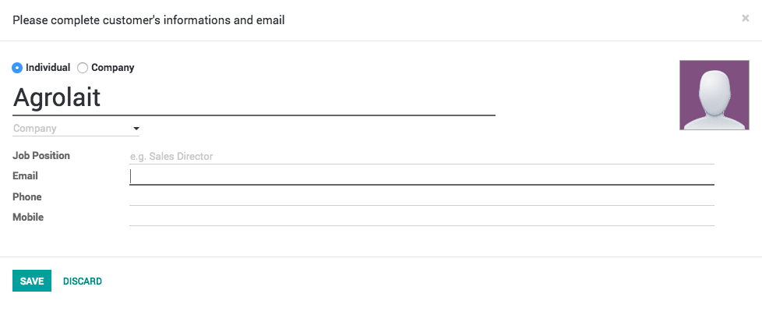

Enter the valid email address and you are ready to send the quotation by email.

### Chatter

All the communication made to this quotation can be tracked in chatter, messages send to customer or received from the customer are available below quotation. All the communication history will be preserved and available when quotation gets converted to sales order.