# Set default terms and condition on quotation

Every quotation issued to the prospect need to have terms and conditions, those terms and conditions are accepted by the customer at the time of accepting the quotation.

The most common terms and conditions includes the payment terms, delivery date, and tax clarification, there are many other points as below can be included in the terms and conditions:

* Acceptance
* Payment Terms
* Taxes
* Warranty
* Claims
* Returns
* Shipment
* Security Interest
* Cancellation
* Indemnification
* Governing Law

## Business case

Let’s take an example of the trading company, they need to define the terms and conditions required by their nature of business, the terms and conditions should be applied to all the quotation created by any salesman. They want to set the below point as a default terms and conditions:

* Delivery of the goods will take 10 working days
* Other taxes such as octroi will be charges extra
* 100% payment should be released at the time of confirmation

## Configuration

Assumed that the **Sales Management** application is already installed.

### Default terms and conditions

Let’s go to Sales / Configuration / Settings, enable the default terms and conditions and enter all the conditions those required to be set by default on all the quotation.

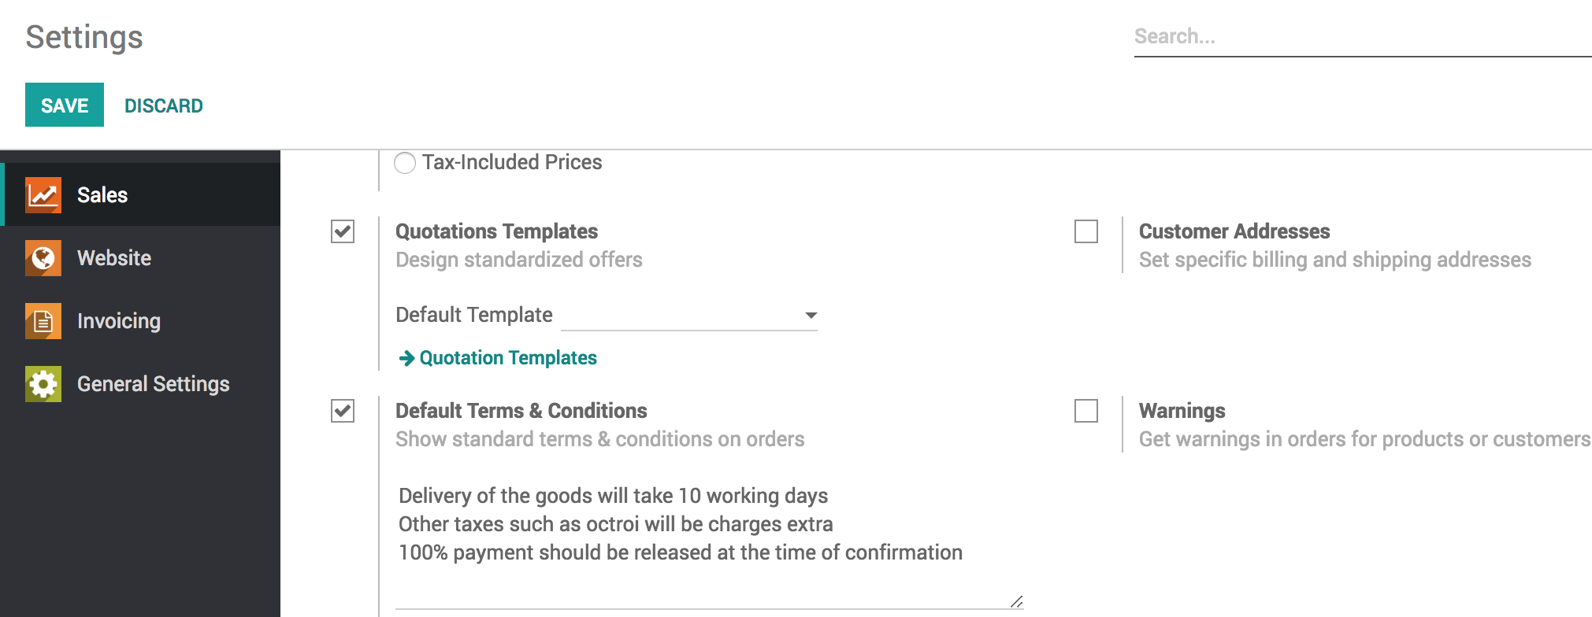

Click on **SAVE** to apply the settings.

## Create a quotation

Goto **Sales / Orders / Quotations** and create a new quotation, you will notice that quotation is empty but the default terms and conditions are set on it.

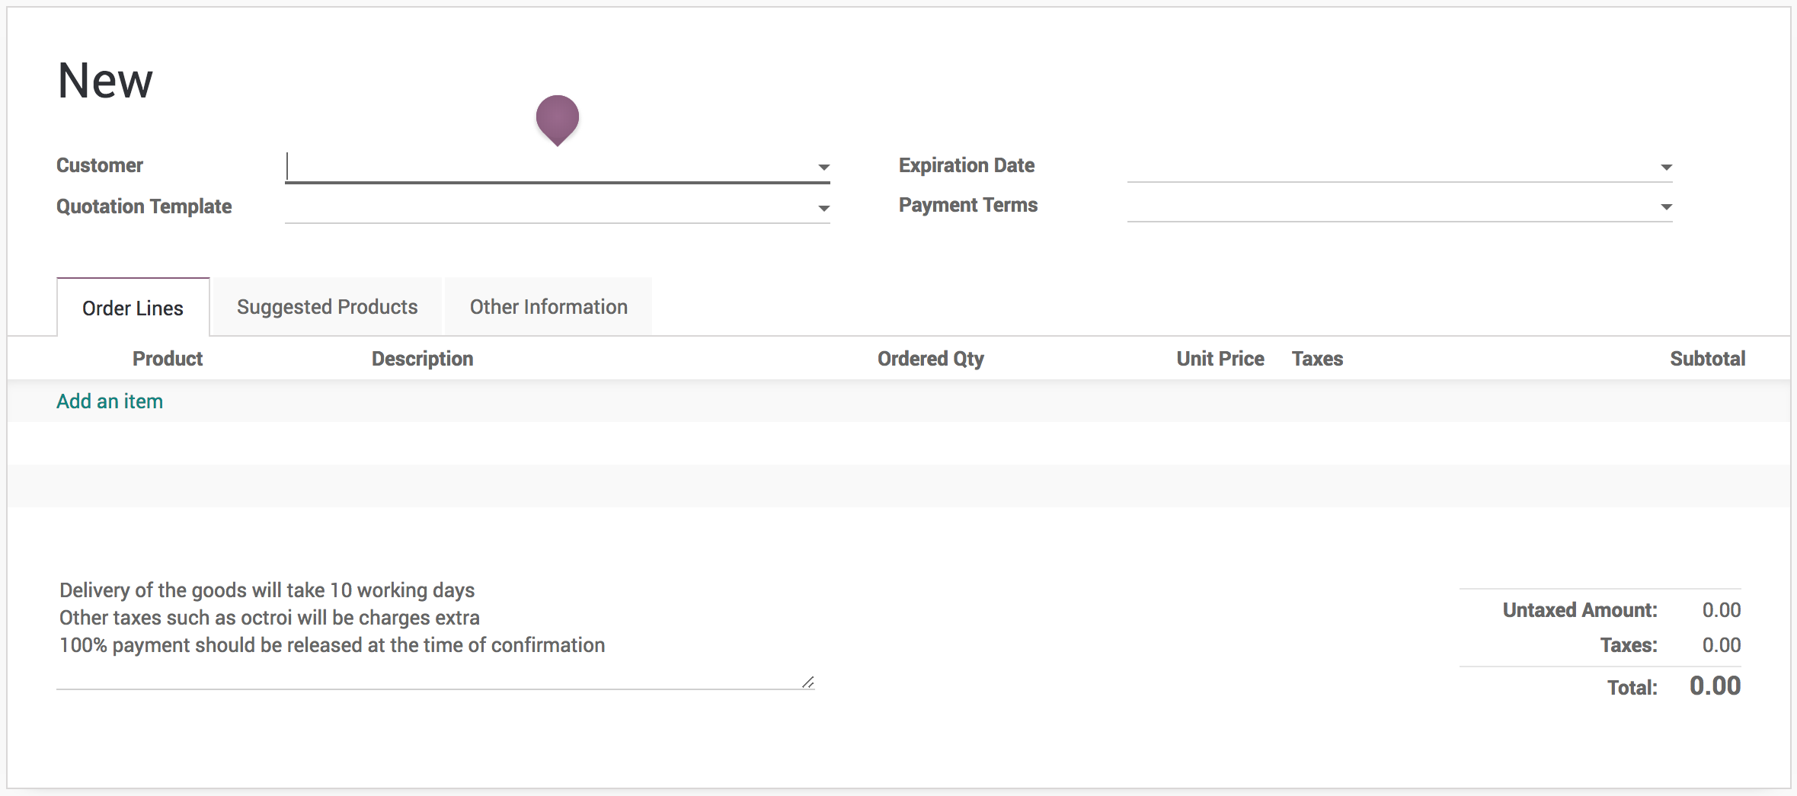

The salesman can make the changes as per the requirement but you can be sure that salesman will never forget to add the default terms and conditions.

.. tip:: The payment terms will be added automatically at the end of every quotation as a part of the terms and conditions in the printed quotation if any.