

| **Political Campaign** |
| --- |
|  |

**Contents**

1 Business Description 3

1.1 Business background 3

1.2 Problems. Current Situation 3

1.3 the Benefits of implementing a database. Project Vision 3

2 Model description 3

2.1 Definitions & Acronyms 3

2.2 Logical Scheme 3

2.3 Objects 4

# 

# Business Description

## Business background

An independent commission gathers comprehensive information about the elections, which encompasses data on voters, campaign donors, and contributions. This includes details about campaign volunteers, such as their roles, contact information, availability, and assigned tasks (e.g., events like rallies, town halls, and social media interactions). Additionally, the commission collects data on opposition research, finances, and survey results.

Moreover, it is essential to analyze information regarding any issues that arose during the preparatory measures and the elections themselves.

## Problems. Current Situation

No problems encountered. Proposed logical data model.

## the Benefits of implementing a database. Project Vision

Implementing a database improves data management by guaranteeing accuracy, cutting down on redundancy, and offering strong security. It enables effective data reporting and retrieval, supporting teamwork and well-informed decision-making. The ability to properly use data for expansion and operational efficiency is ultimately provided by a well-structured database.

# Model description

## Definitions & Acronyms

**ID**: Identifier; a unique number assigned to an entry in a table.

**VARCHAR**: Variable Character; a data type used to store strings of varying lengths.

**TEXT**: A data type used to store long strings of text.

**INT**: Integer; a data type used to store whole numbers.

**NOT NULL**: A constraint that ensures a field must have a value (cannot be empty).

**AUTO INCREMENT**: A feature that automatically generates a unique number for each new entry.

**FK (FOREIGN KEY)**: A field in one table that uniquely identifies a row of another table, establishing a relationship between the two.

**PK (PRIMARY KEY)**: A field in a database table that uniquely identifies each row in that table, ensuring that no two rows can have the same value for this field. It serves as a unique identifier for records and cannot contain NULL values.

## Logical Scheme

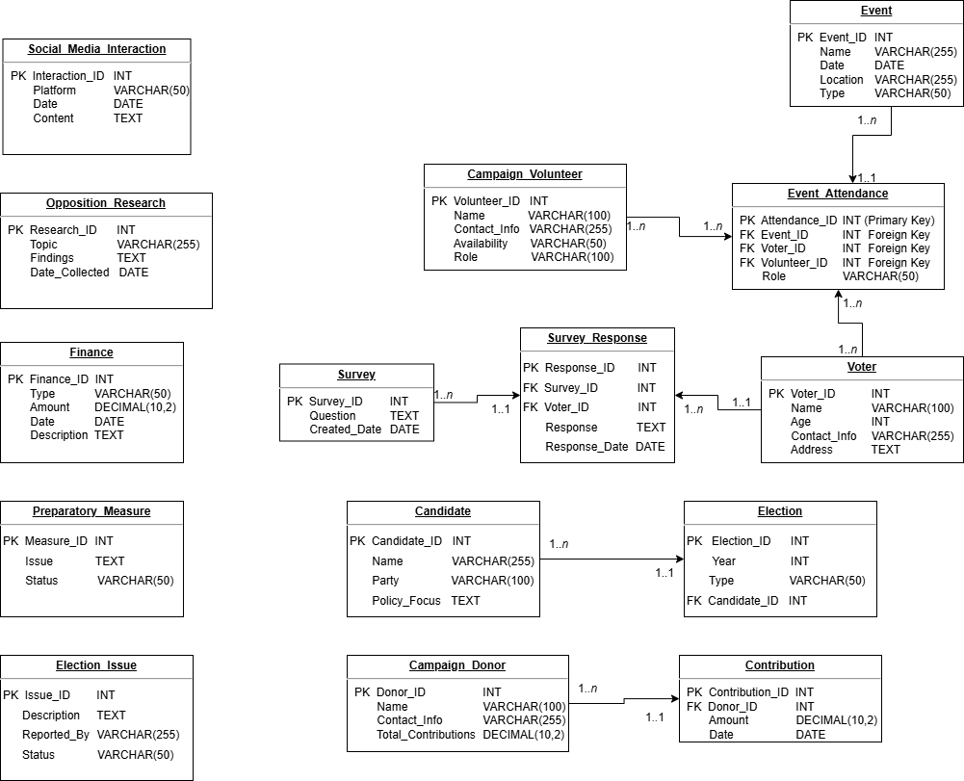

## Objects

Table Description

Stores details of registered voters.

| Table Name | Field name | Field Description | Data Type |
| --- | --- | --- | --- |
| Voter | Voter_ID | Auto Increment, NOT NULL, PK | INT |
| Name | NOT NULL | VARCHAR(100) |
| Age | CHECK(Age >= 18) | INT |
| Contact_Info | UNIQUE, NOT NULL | VARCHAR(255) |
| Address |  | TEXT |

A voter can submit multiple survey responses

Example with data

| Voter_ID | Name | Age | Contact_Info | Address |
| --- | --- | --- | --- | --- |
| 1 | John Doe | 18 | john.doe@example.com | 539 Pennsylvania Road Middleton, WI 53562 |

Table Description

Stores donor information.

| Table Name | Field name | Field Description | Data Type |
| --- | --- | --- | --- |
| Campaigm_Donor | Donor_ID | Auto Increment, NOT NULL, PK | INT |
| Name | NOT NULL | VARCHAR(100) |
| Contact_Info | UNIQUE, NOT NULL | VARCHAR(255) |
| Total_Contributions | DEFAULT 0 | DECIMAL(10,2) |

A campaign donor can make multiple contributions

Example with data

| Donor_ID | Name | Contact_Info | Total_Contributions |
| --- | --- | --- | --- |
| 1 | Jane Smith | jane.smith@example.com | 12345678.90 |

Table Description

Tracks donations made by donors.

| Table Name | Field name | Field Description | Data Type |
| --- | --- | --- | --- |
| Contribution | Contribution_ID | Auto Increment, NOT NULL, PK | INT |
| Donor_ID | FK(Campaign_Donor) | INT |
| Amount | CHECK (Amount > 0) | DECIMAL(10,2) |
| Date | NOT NULL | DATE |

Each contribution belongs to only one donor

Example with data

| Contribution_ID | Donor_ID | Amount | Date |
| --- | --- | --- | --- |
| 1 | 1 | 98765432.12 | 2022-09-30 |

Table Description

Tracks campaign volunteers.

| Table Name | Field name | Field Description | Data Type |
| --- | --- | --- | --- |
| Campaign_Volunteer | Volunteer_ID | Auto Increment, NOT NULL | INT |
| Name | NOT NULL | VARCHAR(100) |
| Contact_Info | UNIQUE, NOT NULL | VARCHAR(255) |
| Availability | NOT NULL (e.g., "Weekends", "Full-time") | VARCHAR(50) |
| Role | NOT NULL | VARCHAR(100) |

A volunteer can attend multiple events.

Example with data

| Voter_ID | Name | Contact_Info | Availability | Role |
| --- | --- | --- | --- | --- |
| 1 | Michael Johnson | michael.j@example.com | Full-time | Content Writer |

Table Description

Tracks campaign events like rallies, town halls.

| Table Name | Field name | Field Description | Data Type |
| --- | --- | --- | --- |
| Event | Event_ID | Auto Increment, NOT NULL, PK | INT |
| Name | NOT NULL | VARCHAR(255) |
| Date | NOT NULL | DATE |
| Location | NOT NULL | VARCHAR(255) |
| Type | CHECK (Type IN ('Rally', 'Town Hall', 'Debate')) | VARCHAR(50) |

An event can have multiple attendees.

Example with data

| Event_ID | Name | Date | Location | Type |
| --- | --- | --- | --- | --- |
| 1 | Spring Rally | 2023-04-15 | Central Park, New York, NY | Rally |

Table Description

The Attendance table tracks participation in events.

| Table Name | Field name | Field Description | Data Type |
| --- | --- | --- | --- |
| Event_Attendance | Attendance_ID | Auto Increment, NOT NULL, PK | INT |
| Event_ID | FK (Event) | INT |
| Voter_ID | FK (Voter) (Nullable) | INT |
| Volunteer_ID | FK (Campaign_Volunteer) (Nullable) | INT |
| Role | (e.g., "Speaker", "Attendee", "Organizer") | VARCHAR(50) |

Event_Attendance is the junction table tracking which volunteers attend which events. A voter can attend multiple events. A volunteer can attend multiple events.

Example with data

| Attendance_ID | Event_ID | Voter_ID | Volunteer_ID | Role |
| --- | --- | --- | --- | --- |
| 1 | 1 | 1 | NULL | Attendee |

Table Description

Tracks campaign-related social media activity.

| Table Name | Field name | Field Description | Data Type |
| --- | --- | --- | --- |
| Social_Media_Interaction | Interaction_ID | Auto Increment, NOT NULL, PK | INT |
| Platform | CHECK (Platform IN ('Twitter', 'Facebook', 'Instagram')) | VARCHAR(50) |
| Date | NOT NULL | DATE |
| Content | NOT NULL | TEXT |

This table has no relationships.

Example with data

| Interaction_ID | Platform | Date | Content |
| --- | --- | --- | --- |
| 1 | Facebook | 2023-03-08 | Happy national women's days, for all the ladies. |

Table Description

Stores research about the opposition.

| Table Name | Field name | Field Description | Data Type |
| --- | --- | --- | --- |
| Opposition_Research | Research_ID | Auto Increment, NOT NULL, PK | INT |
| Topic | NOT NULL | VARCHAR(255) |
| Findings | NOT NULL | TEXT |
| Date_Collected | NOT NULL | DATE |

This table has no relationships.

Example with data

| Research_ID | Topic | Findings | Date_Collected |
| --- | --- | --- | --- |
| 1 | Voter Engagement Strategies | Interactive town halls boost community involvement. | 2023-04-15 |

Table Description

Tracks campaign finances.

| Table Name | Field name | Field Description | Data Type |
| --- | --- | --- | --- |
| Finance | Finance_ID | Auto Increment, NOT NULL, PK | INT |
| Type | CHECK (Type IN ('Income', 'Expense')) | VARCHAR(50) |
| Amount | CHECK (Amount > 0) | DECIMAL(10,2) |
| Date | NOT NULL | DATE |
| Description |  | TEXT |

This table has no relationships.

Example with data

| Finance_ID | Type | Amount | Date | Description |
| --- | --- | --- | --- | --- |
| 1 | Income | 1500.00 | 2023-01-10 | Donation from local business |

Table Description

Stores campaign survey questions.

| Table Name | Field name | Field Description | Data Type |
| --- | --- | --- | --- |
| Survey | Survey_ID | Auto Increment, NOT NULL, PK | INT |
| Question | FK (Event) | TEXT |
| Created_Date | FK (Voter) (Nullable) | DATE |

A survey can have multiple responses**.**

Example with data

| Survey_ID | Question | Created_Date |
| --- | --- | --- |
| 1 | How do you feel about the current policies? | 2023-04-17 |

Table Description

Stores responses to surveys from voters.

| Table Name | Field name | Field Description | Data Type |
| --- | --- | --- | --- |
| Survey_Response | Response_ID | Auto Increment, NOT NULL, PK | INT |
| Survey_ID | FK (Survey) | INT |
| Voter_ID | FK (Voter) | INT |
| Response | NOT NULL | TEXT |
| Response_Date | NOT NULL | DATE |

Each response belongs to only one survey

Example with data

| Response_ID | Survey_ID | Voter_ID | Response | Response_Date |
| --- | --- | --- | --- | --- |
| 1 | 1 | 101 | I believe healthcare is the top issue. | 2023-01-15 |

Table Description

Tracks problems that arose during the election.

| Table Name | Field name | Field Description | Data Type |
| --- | --- | --- | --- |
| Election_Issue | Issue_ID | Auto Increment, NOT NULL, PK | INT |
| Description | NOT NULL | TEXT |
| Reported_By | NOT NULL | VARCHAR(255) |
| Status | CHECK (Status IN ('Open', 'Resolved')) | VARCHAR(50) |

This table has no relationships.

Example with data

| Issue_ID | Description | Reported_By | Status |
| --- | --- | --- | --- |
| 1 | Voter registration issues | Maria Garcia | Open |

Table Description

Tracks problems during campaign preparation.

| Table Name | Field name | Field Description | Data Type |
| --- | --- | --- | --- |
| Preparatory_Measure | Measure_ID | Auto Increment, NOT NULL, PK | INT |
| Issue | NOT NULL | TEXT |
| Status | CHECK (Status IN ('Pending', 'Completed')) | VARCHAR(50) |

This table has no relationships.

Example with data

| Issue_ID | Description | Status |
| --- | --- | --- |
| 1 | Repair malfunctioning voting machines | Completed |

Table Description

Stores candidates running for election.

| Table Name | Field name | Field Description | Data Type |
| --- | --- | --- | --- |
| Candidate | Candidate_ID | Auto Increment, NOT NULL, PK | INT |
| Name | NOT NULL | VARCHAR(255) |
| Party | NOT NULL | VARCHAR(100) |
| Policy_Focus |  | TEXT |

A candidate can participate in only one election

Example with data

| Candidate_ID | Name | Party | Policy_Focus |
| --- | --- | --- | --- |
| 1 | Bob Smith | Republican | Tax cuts, national security |

Table Description

Tracks election details.

| Table Name | Field name | Field Description | Data Type |
| --- | --- | --- | --- |
| Election | Election_ID | Auto Increment, NOT NULL, PK | INT |
| Year | CHECK (Year >= 1900) | INT |
| Type | CHECK (Type IN ('Presidential', 'Congressional', 'Local')) | VARCHAR(50) |
| Candidate_ID | FK (Candidate) | INT |

An election can have multiple candidates

Example with data

| Election_ID | Year | Type | Candidate_ID |
| --- | --- | --- | --- |
| 1 | 2024 | Local | 2 |