

Political Campaign

Contents
1 Business Description 3
1.1 Business background 3
1.2 Problems. Current Situation 3
1.3 the Benefits of implementing a database. Project Vision 3
2 Model description 3
2.1 Definitions & Acronyms 3
2.2 Logical Scheme 3
2.3 Objects 4

Business Description

Business background
An independent commission gathers comprehensive information about the elections, which encompasses data on voters, campaign donors, and contributions. This includes details about campaign volunteers, such as their roles, contact information, availability, and assigned tasks (e.g., events like rallies, town halls, and social media interactions). Additionally, the commission collects data on opposition research, finances, and survey results.
Moreover, it is essential to analyze information regarding any issues that arose during the preparatory measures and the elections themselves.

Problems. Current Situation
No problems encountered. Proposed logical data model.

the Benefits of implementing a database. Project Vision
Implementing a database improves data management by guaranteeing accuracy, cutting down on redundancy, and offering strong security. It enables effective data reporting and retrieval, supporting teamwork and well-informed decision-making. The ability to properly use data for expansion and operational efficiency is ultimately provided by a well-structured database.

Model description

Definitions & Acronyms
ID: Identifier; a unique number assigned to an entry in a table.
VARCHAR: Variable Character; a data type used to store strings of varying lengths.
TEXT: A data type used to store long strings of text.
INT: Integer; a data type used to store whole numbers.
NOT NULL: A constraint that ensures a field must have a value (cannot be empty).
AUTO INCREMENT: A feature that automatically generates a unique number for each new entry.
FK (FOREIGN KEY): A field in one table that uniquely identifies a row of another table, establishing a relationship between the two.
PK (PRIMARY KEY): A field in a database table that uniquely identifies each row in that table, ensuring that no two rows can have the same value for this field. It serves as a unique identifier for records and cannot contain NULL values.

Logical Scheme
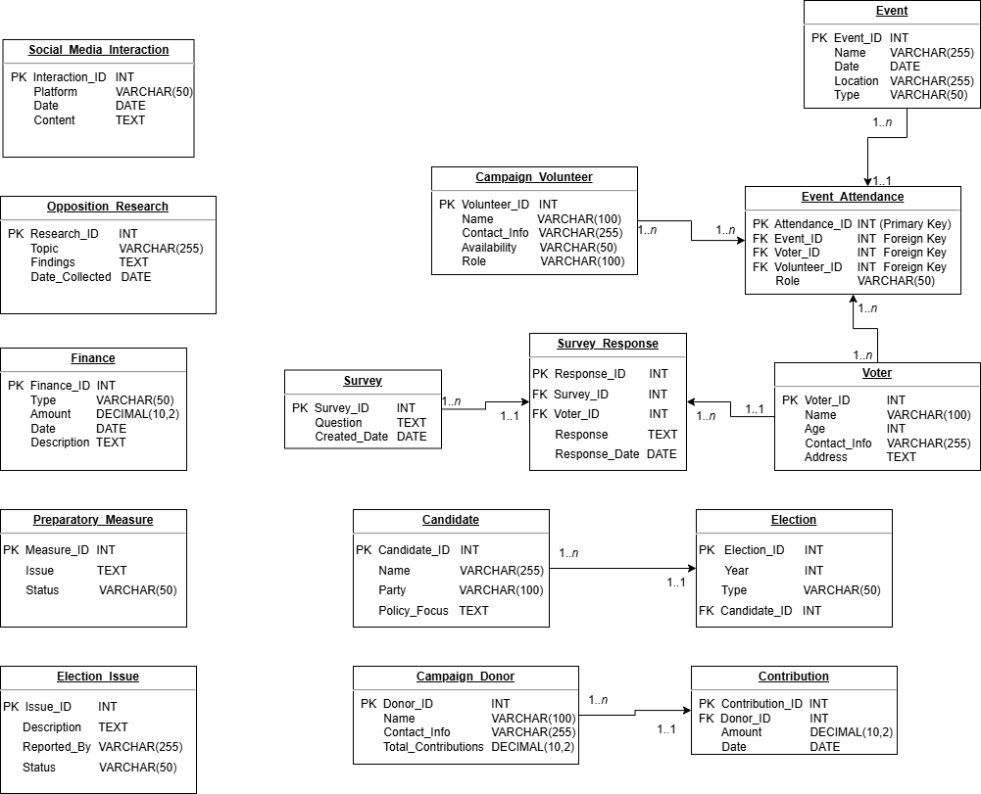

Objects

Table Description
Stores details of registered voters.

Table Name | Field name | Field Description | Data Type
Voter | Voter_ID | Auto Increment, NOT NULL, PK | INT
 | Name | NOT NULL | VARCHAR(100)
 | Age | CHECK(Age >= 18) | INT
 | Contact_Info | UNIQUE, NOT NULL | VARCHAR(255)
 | Address |  | TEXT

A voter can submit multiple survey responses

Example with data

Voter_ID | Name | Age | Contact_Info | Address
1 | John Doe | 18 | john.doe@example.com | 539 Pennsylvania Road Middleton, WI 53562

Table Description
Stores donor information.

Table Name | Field name | Field Description | Data Type
Campaigm_Donor | Donor_ID | Auto Increment, NOT NULL, PK | INT
 | Name | NOT NULL | VARCHAR(100)
 | Contact_Info | UNIQUE, NOT NULL | VARCHAR(255)
 | Total_Contributions | DEFAULT 0 | DECIMAL(10,2)

A campaign donor can make multiple contributions

Example with data

Donor_ID | Name | Contact_Info | Total_Contributions
1 | Jane Smith | jane.smith@example.com | 12345678.90

Table Description
Tracks donations made by donors.

Table Name | Field name | Field Description | Data Type
Contribution | Contribution_ID | Auto Increment, NOT NULL, PK | INT
 | Donor_ID | FK(Campaign_Donor) | INT
 | Amount | CHECK (Amount > 0) | DECIMAL(10,2)
 | Date | NOT NULL | DATE

Each contribution belongs to only one donor

Example with data

Contribution_ID | Donor_ID | Amount | Date
1 | 1 | 98765432.12 | 2022-09-30

Table Description
Tracks campaign volunteers.

Table Name | Field name | Field Description | Data Type
Campaign_Volunteer | Volunteer_ID | Auto Increment, NOT NULL | INT
 | Name | NOT NULL | VARCHAR(100)
 | Contact_Info | UNIQUE, NOT NULL | VARCHAR(255)
 | Availability | NOT NULL (e.g., "Weekends", "Full-time") | VARCHAR(50)
 | Role | NOT NULL | VARCHAR(100)

A volunteer can attend multiple events.

Example with data

Voter_ID | Name | Contact_Info | Availability | Role
1 | Michael Johnson | michael.j@example.com | Full-time | Content Writer

Table Description
Tracks campaign events like rallies, town halls.

Table Name | Field name | Field Description | Data Type
Event | Event_ID | Auto Increment, NOT NULL, PK | INT
 | Name | NOT NULL | VARCHAR(255)
 | Date | NOT NULL | DATE
 | Location | NOT NULL | VARCHAR(255)
 | Type | CHECK (Type IN ('Rally', 'Town Hall', 'Debate')) | VARCHAR(50)

An event can have multiple attendees.

Example with data

Event_ID | Name | Date | Location | Type
1 | Spring Rally | 2023-04-15 | Central Park, New York, NY | Rally
Table Description
The Attendance table tracks participation in events.

Table Name | Field name | Field Description | Data Type
Event_Attendance | Attendance_ID | Auto Increment, NOT NULL, PK | INT
 | Event_ID | FK (Event) | INT
 | Voter_ID | FK (Voter) (Nullable) | INT
 | Volunteer_ID | FK (Campaign_Volunteer) (Nullable) | INT
 | Role | (e.g., "Speaker", "Attendee", "Organizer") | VARCHAR(50)

Event_Attendance is the junction table tracking which volunteers attend which events. A voter can attend multiple events. A volunteer can attend multiple events.

Example with data

Attendance_ID | Event_ID | Voter_ID | Volunteer_ID | Role
1 | 1 | 1 | NULL | Attendee

Table Description
Tracks campaign-related social media activity.

Table Name | Field name | Field Description | Data Type
Social_Media_Interaction | Interaction_ID | Auto Increment, NOT NULL, PK | INT
 | Platform | CHECK (Platform IN ('Twitter', 'Facebook', 'Instagram')) | VARCHAR(50)
 | Date | NOT NULL | DATE
 | Content | NOT NULL | TEXT

This table has no relationships.

Example with data

Interaction_ID | Platform | Date | Content
1 | Facebook | 2023-03-08 | Happy national women's days, for all the ladies.
Table Description
Stores research about the opposition.

Table Name | Field name | Field Description | Data Type
Opposition_Research | Research_ID | Auto Increment, NOT NULL, PK | INT
 | Topic | NOT NULL | VARCHAR(255)
 | Findings | NOT NULL | TEXT
 | Date_Collected | NOT NULL | DATE

This table has no relationships.

Example with data

Research_ID | Topic | Findings | Date_Collected
1 | Voter Engagement Strategies | Interactive town halls boost community involvement. | 2023-04-15

Table Description
Tracks campaign finances.

Table Name | Field name | Field Description | Data Type
Finance | Finance_ID | Auto Increment, NOT NULL, PK | INT
 | Type | CHECK (Type IN ('Income', 'Expense')) | VARCHAR(50)
 | Amount | CHECK (Amount > 0) | DECIMAL(10,2)
 | Date | NOT NULL | DATE
 | Description |  | TEXT

This table has no relationships.

Example with data

Finance_ID | Type | Amount | Date | Description
1 | Income | 1500.00 | 2023-01-10 | Donation from local business

Table Description
Stores campaign survey questions.

Table Name | Field name | Field Description | Data Type
Survey | Survey_ID | Auto Increment, NOT NULL, PK | INT
 | Question | FK (Event) | TEXT
 | Created_Date | FK (Voter) (Nullable) | DATE

A survey can have multiple responses.
Example with data

Survey_ID | Question | Created_Date
1 | How do you feel about the current policies? | 2023-04-17

Table Description
Stores responses to surveys from voters.

Table Name | Field name | Field Description | Data Type
Survey_Response | Response_ID | Auto Increment, NOT NULL, PK | INT
 | Survey_ID | FK (Survey) | INT
 | Voter_ID | FK (Voter) | INT
 | Response | NOT NULL | TEXT
 | Response_Date | NOT NULL | DATE

Each response belongs to only one survey
Example with data

Response_ID | Survey_ID | Voter_ID | Response | Response_Date
1 | 1 | 101 | I believe healthcare is the top issue. | 2023-01-15

Table Description
Tracks problems that arose during the election.

Table Name | Field name | Field Description | Data Type
Election_Issue | Issue_ID | Auto Increment, NOT NULL, PK | INT
 | Description | NOT NULL | TEXT
 | Reported_By | NOT NULL | VARCHAR(255)
 | Status | CHECK (Status IN ('Open', 'Resolved')) | VARCHAR(50)

This table has no relationships.
Example with data

Issue_ID | Description | Reported_By | Status
1 | Voter registration issues | Maria Garcia | Open

Table Description
Tracks problems during campaign preparation.

Table Name | Field name | Field Description | Data Type
Preparatory_Measure | Measure_ID | Auto Increment, NOT NULL, PK | INT
 | Issue | NOT NULL | TEXT
 | Status | CHECK (Status IN ('Pending', 'Completed')) | VARCHAR(50)

This table has no relationships.
Example with data

Issue_ID | Description | Status
1 | Repair malfunctioning voting machines | Completed

Table Description
Stores candidates running for election.

Table Name | Field name | Field Description | Data Type
Candidate | Candidate_ID | Auto Increment, NOT NULL, PK | INT
 | Name | NOT NULL | VARCHAR(255)
 | Party | NOT NULL | VARCHAR(100)
 | Policy_Focus |  | TEXT

A candidate can participate in only one election
Example with data

Candidate_ID | Name | Party | Policy_Focus
1 | Bob Smith | Republican | Tax cuts, national security

Table Description
Tracks election details.

Table Name | Field name | Field Description | Data Type
Election | Election_ID | Auto Increment, NOT NULL, PK | INT
 | Year | CHECK (Year >= 1900) | INT
 | Type | CHECK (Type IN ('Presidential', 'Congressional', 'Local')) | VARCHAR(50)
 | Candidate_ID | FK (Candidate) | INT

An election can have multiple candidates
Example with data

Election_ID | Year | Type | Candidate_ID
1 | 2024 | Local | 2

