System Design Exam1

Rokas Pazera 551495

Overview
The battle engine is the part of the game that runs a single battle between the player’s characters and the computer opponent. The game keeps track of what is happening in the battle: whose turn it is, what actions a unit can do, what happens when an action is used, and a log of everything that happened.
The battle engine doesn’t know anything about the rest of the game. It doesn’t know how the player presses a button, and it doesn’t decide what the computer AI will do. It only does the action it receives, checks if the turn order allows it, and gives back the new state of the battle. The client, input system and AI can only talk to the battle engine through the six methods (StartBattle, GetBattleState, GetAvailableActions, ApplyAction, NextTurn, GetBattleLog).
The game is always played online, and every battle happens inside one game instance. Because of this, the battle engine must also work well in a bigger online system. It runs inside an instance that can be started and stopped at any time, and it must send data that needs to stay (like character level, stats and equipment) to a separate part of the system that stores this data.

C4 Layer 1 – Context
This layer shows the game as a single system and the actor that uses it from the outside.

System Context Diagram
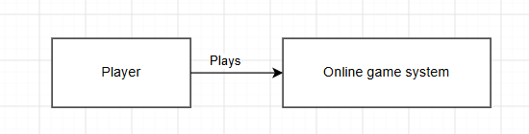

Use Case Diagram
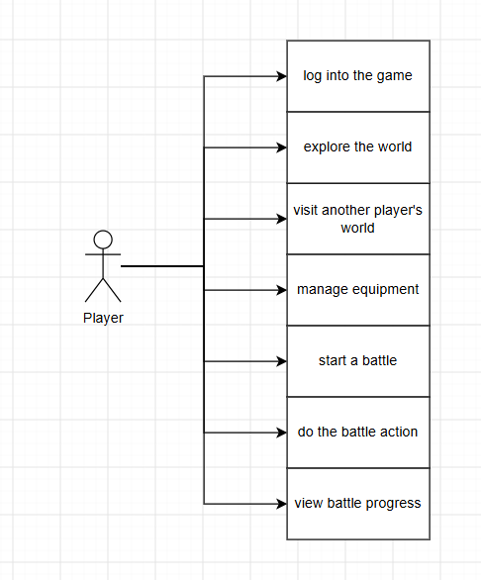

Design notes
The only actor is the player. The computer opponent and the AI system that calls ApplyAction() are not shown as actors here. The assignment says this AI system is “outside the battle engine”, but this means outside the battle engine part, not the whole game. So, this AI system is still part of the game system, however, at this level, I only drew actors that are outside the whole system.

C4 Layer 2 – Container
This layer breaks the single system box from layer 1 into the containers that make it up and shows how they are physically deployed. At this level, the Battle Engine is not shown separately yet. It exists inside the “Game Instance” container and is treated as one of the container’s internal components.

Deployment diagram

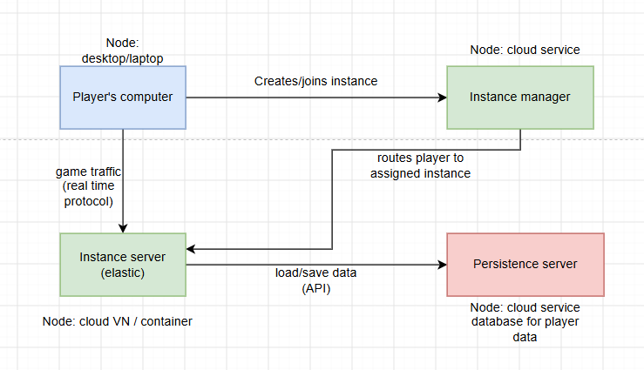
The player’s computer creates or joins a game instance by contacting the instance manager. The instance manager routes the player to the assigned instance server – an elastic cloud VM or container that runs the actual game session and exchanges game traffic with the player’s computer over a real time protocol. The instance server loads and saves player data via an API call to the persistence server.

Component diagram
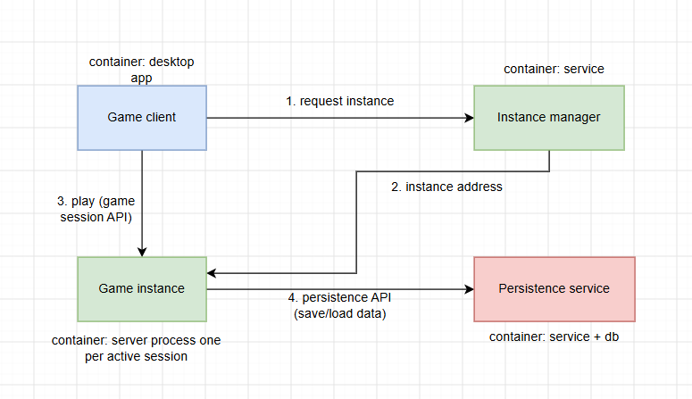

The game client sends a request to the instance manager asking for an instance to play on. The instance manager responds with the address of the assigned instance and returns it to the client. The client then connects directly to that game instance via a game session API to play. During play, the game instance calls the persistence service (a service backed by a database) to save and load player data through a persistence API.

Design notes (deployment diagram)

I added these nodes to my deployment diagram:

Player’s computer/game client
According to the assignment, the game is never player through a browser, and the player installs a client application on their own computer.

Instance Manager
Instance creation and routing is a separate action from running a battle or world simulation.

Persistence server/Persistence service

This node exists because “no permanent data can be stored on an instance” even though players constantly switch between instances. If character levels, weapons, or position were saved on the instance itself, that data would be lost or become inconsistent the moment a player moved to a different instance. By making it persistent, reachable by any instance, it makes a player’s data always correct, no matter which instance they’re currently on. If I were to combine persistence with instance server, it would mean losing player data every time an instance shuts down.

