Act Report
In this report we will dive through our journey in analyzing and visualizing our data to gain powerful insights and converting our raw data into helpful information. So, let’s get started:
First, setting the questions which represents the needed data from our analyzation, which are:
- What is the most frequent dog age?
- What is the top 5 frequent dog breed?
- What are the top 5 rated breed?
- What is the top favorite age?
Let’s start answering them:
Q1: What is the most frequent dog age?
Here I started to get the number of each value for (doggo, pupper, floofer, puppo):
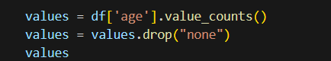
The result is that: pupper : 225 values, doggo : 77 values, puppo : 24 values and floofer : 10 values. So the most frequent age is Pupper. And was represented like follows:
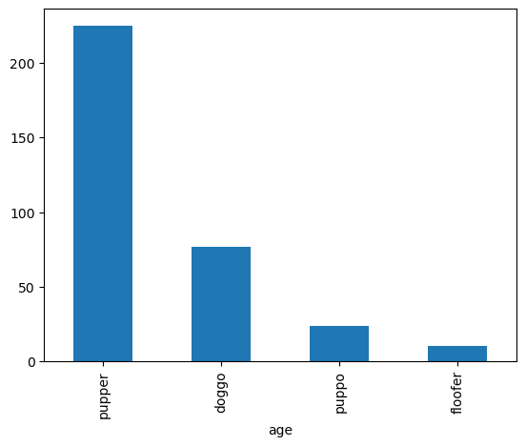
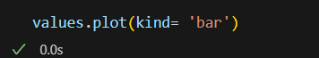

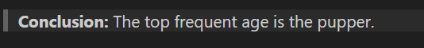

Q2: What is the top 5 frequent dog breed?
Here I started to get the number of each value for each breed then filtering them to the top 5:
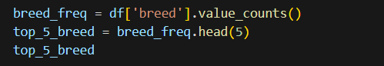
The result is that: golden_retriever : 196 values, Labrador_retriever : 137 values, Pembroke : 115 values, Chihuahua : 110 values and pug : 80 values.

And was represented like follows:
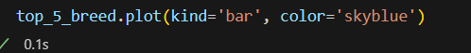
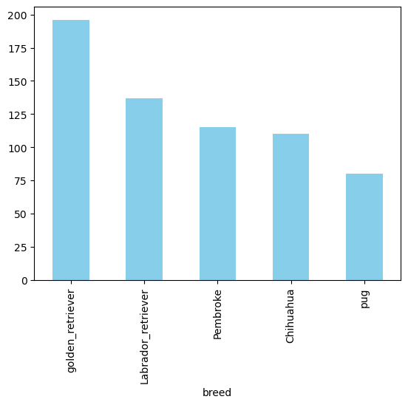
Q3: What are the top 5 rated breed?
Here I started to sum the rating values for each breed then filtered them to the top 5:
It was visualized as follow:
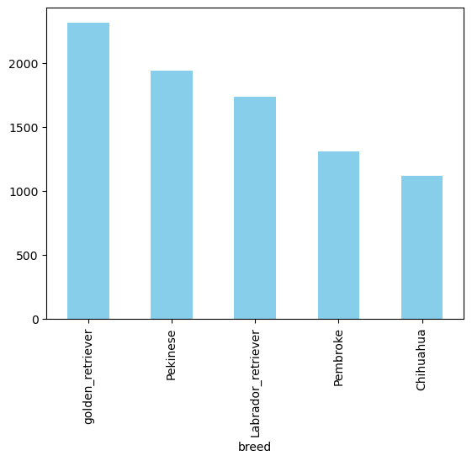
The result is that: The top-rated breeds are:
golden_retriever with total ratings = 2314
Pekinese with total ratings = 1940
Labrador_retriever with total ratings = 1733
Pembroke with total ratings = 1304
Chihuahua with total ratings = 1116

Q4: What is the top favorite age?
Here I started to sum the favorite count values for each age as follows:
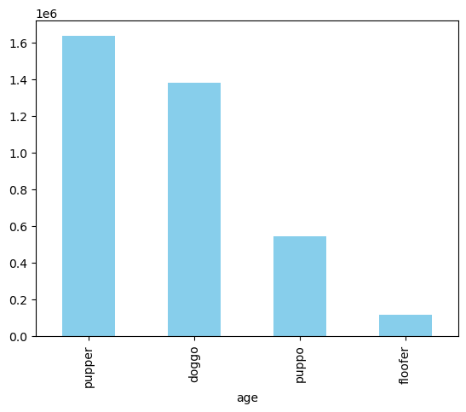
The result is that:
pupper got total favorite counts = 1635894
doggo got total favorite counts = 1380351
puppo got total favorite counts = 545163
floofer got total favorite counts = 116749

