Wrangle Report
In this report we will dive through my journey in gathering and cleaning the data by addressing the work needed, the process and the key challenges that faced me and how it was solved. So let’s start:
First: Gathering Data:
In this project I had to work on 3 databases which are (twitter-archive-enhanced.csv), (image-predictions.tsv) and (tweet-json.txt).
- Importing (twitter-archive-enhanced.csv) file:
This database contains information about the tweets, including the tweet text, source, tweet ID, retweet ID, and details about the dogs featured in the tweets, such as their names and ages.
- Code for importing:

- Importing (image-predictions.tsv) file:
This file provides information about the AI predictions made for the dog images included in each tweet.
- Code for importing:
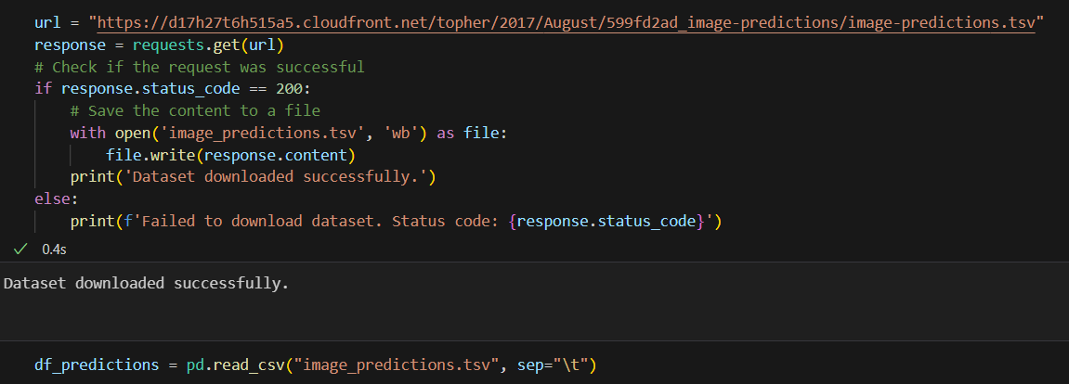
In this code we requested the data from the URL and saved it to a data frame
- Importing (tweet-json.txt) file:
This file includes additional data about each tweet, such as the number of likes and retweets.
- Code for importing:
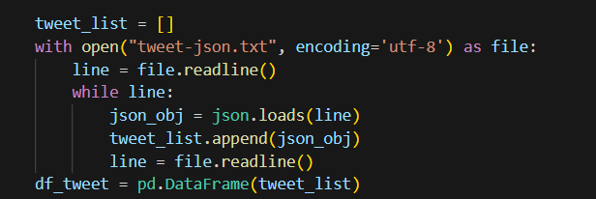
In this code I used readline() to read file line by line and load it as a json object as this is a text file for a json one. By these steps I then created a data frame for this data.
Second: Data Assessment:

- Results of assessing (twitter-archive-enhanced.csv) file:
In this file I found many issues. First, deleting the retweets row:
to remove retweets there are many signs refer to that they are retweets columns like (in_reply_to_status_id,retweeted_status_user_id) have values. and text begins with RT.
After deleting retweets rows I should also delete columns related to them to remove these null values.
Second, dealing with nan values in columns refer to dogs' age. I should melt them to one column called age. Some dogs have values of 2 ages so I should check the validity of them by checking their texts. Others have wrong values others don’t have any values referring to the dog age.
Third, there are too many columns which are not necessary to my analyzation so i should remove them.
Forth, checking for duplicates and handling them.
Fifth, wrong data types for (tweet_id and timestamp) columns.
- Results of assessing (image-predictions.tsv) file:
In this file we found: First, creating column called breed that gather the dog breed data from the predictions with considering making sure that this prediction is a dog.
Second, there are too many columns which are not necessary to my analyzation so I should remove them.
Third, wrong data type for tweet_id column.
Forth, deleting rows that don’t have values for breed.
Fifth, checking for duplicates and found there is no duplicates.
- Results of assessing (tweet-json.txt) file:
In this file we found: First, removing retweets rows.
Second, there are too many columns which are not necessary to my analyzation so I should remove them.
Third, checking for duplicates and found there is no duplicates.
# Summary for assessment results:
Quality issues:
- In twitter archive database:
1. Removing retweets rows.
2. Removing columns related to retweets after removing them to handle NAN values.
3. Remove the unnessary columns for our analyzation.
4. Handle duplicates.
5. Handling rows that doesn't have values for age.
6. wrong data types for ['tweet_id', 'timestamp']
- In image predictions database:
7. I need only ['tweet_id', 'breed'] columns only from this database.
8. wrong data types for tweet id.
- In tweet-json database:
9. Removing retweets rows.
10. I need only ['id', 'retweet_count', 'favorite_count'] columns.
Tidiness issues:
- In twitter archive database:
1. combine the columns['doggo', 'floofer', 'pupper', 'puppo'] to one column called age.
- In image predictions database:
2. create breed column and gather its data from the other columns
Third: Cleaning Data:
In this section I get copy for all my data frames as follow:
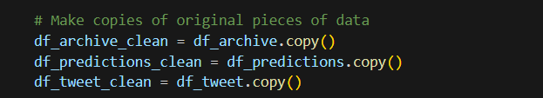
Then started Solving the addressed issues above and structuring my workflow by separating the define, code, and test tasks into distinct cells until obtaining my clean data frames which are ready for merging. You can check the cleaning process in the (wrangle_act.ipynb) file with all details.
Finally: Merging and storing our data:
First, Merging my data frames using merge(). And it was according twitter archive database. As follows:
Then I handled the NAN values to get my master clean data frame.
Second, converting this data frame to a csv file and storing it on the computer so I can use it to gain insights and do visualizations.
