Abstract
To be added
Introduction
Along with technology improvements, every aspect of life is being transformed. We are witnessing huge digitalization everywhere whereby vast amounts of data are being collected. Learning is no exception [1] as learners engage in “anytime, anywhere any device” learning consequently generating a lot of log data [2], [4], [5], what enables learning analytics, the process of developing actionable insights through problem definition and the application of statistical models and analysis against existing and/or simulated future data [9].
With the logs of three types of virtual lessons: competitive, collaborative, and augmented reality, in this study, it will be checked if there exists a correlation between student’s success in solving virtual lessons with student’s background data and correlations among student’s success in solving different types of virtual lessons. Iterative convergence method will be used for calculation of lessons’ difficulty weights and students’ success.
Lessons are given to primary school students through applications on tablet devices that are collecting and sending logs to the server while students are solving lessons.
In chapter … it will be …

Theoretical background
Learning analytics
Siemens (2010) defines Learning Analytics as “the use of intelligent data, learner-produced data, and analysis models to discover information and social connections, and to predict and advise on learning.” [1]. Learning analytics consider collection, measurement, analysis and reporting of data about learners with the final goal of better understanding learning and enhancing learning efficiency.
In one amongst a vast array of studies, students are taking virtual lessons in Yuan Ze University, whereby logs of data are being recorded, parsed and analysed using intelligent algorithms and then displayed in human readable format (usually graphs and tables). Results of learning analytics give better insight for teachers in form of student profiles [6]. By creating a profile for each student and by comparing data of similar students, systems can give feedback about lessons took, suggest next steps in learning or predict learning progress.
Prediction algorithms
Following the log data collection, a learning analytics system tries to extract important information from the data. The field of computer science dealing with extracting important information from datasets is called machine learning. Machine learning algorithms use diverse approaches to analysing the data using algorithms made of three parts: the model, loss function, and the optimising method. In the model, (not necessarily finite) solution set, is to be searched for the one that has the smallest loss using specified optimising algorithm. In case where there is success data throughout time, the learning curve could be predicted. The problem of predicting learning curve is equivalent to interpolation between points or finding the function that is the best approximation of the points in time trend. Regression is, arguably, the best-known algorithm that finds which function from the function space best approximates the points [7], [8].
Algorithms for analysing
Data collection via logs and log processing algorithms
In this study, the students from the second and third grade of a primary school have taken three different types of lessons: gamified (competitive), augmented reality and collaborative lessons. In each of this types, there are different groups of learning exercises and each of these has a different type of logging. Logs are stored in a database as a single row with attributes with the information about students, date and time of a log and a lesson characteristic information characteristic of the lesson. Images img1, img2 and img3 depict the structure of such objects for each of type of the logs.
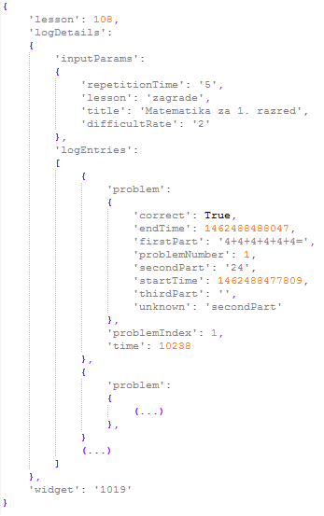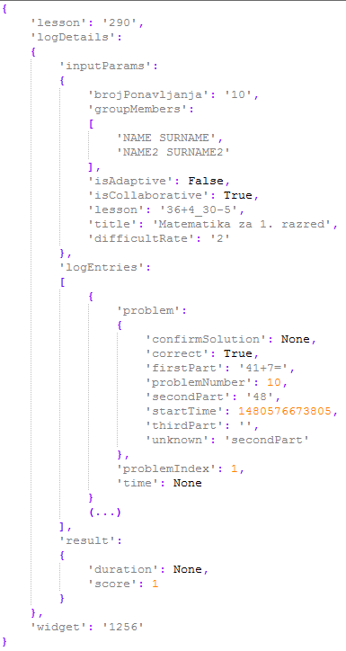
img1 competitive loges img 2 colaborative lesson log
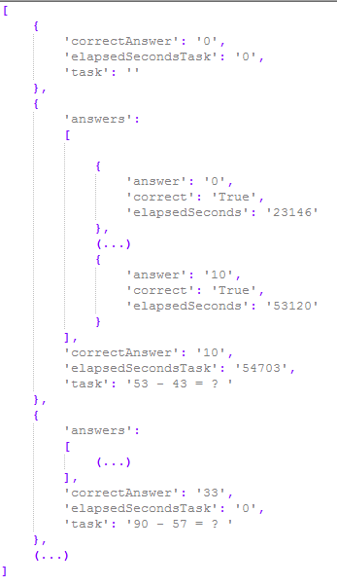
img 3 AR lesson log

Amongst other data, all the logs contain information about whether a student solved exercise correctly and the recorded solution time which are used for evaluation of students and lessons.
Student learning success and task difficulty computation algorithms
Calculating student success is always a difficult task in case when there is no prior information if lessons differ in difficulty and especially if all students did not take the same set of lessons. The difficulty coefficient of lessons could be extracted from data only if the same set of students attempted to solve them (i.e. lessons that have been solved two times more successfully than some other lessons are two times easier). Furthermore, if there were information available about differences in terms of difficulty between lessons it would be possible to calculate student’s success coefficient. Analogously, if there were information about the efficacy of students (so we could mathematically compare students’ efficacy), lessons’ difficulties could be calculated. In other words, there is a circular dependency of lessons’ difficulties and students’ success.
The above mentioned recursive dependency can be written as follows:
 | $$S=f\left(L\right)$$  $$L=f\left(S\right)$$  S – Students’ success (vector)  L – Lessons’ difficulties (vector) | (1)
Student success is rated with a real number from [0, 1], where 1 means 100% success and 0 means 0% of success (students with 0.5 are referred as average successful). Lesson difficulty is also rated with a real number from [0, 1] where 0 means 0% of average successful students successfully completed and 1 means 100% of average successful students successfully manage to complete. Average difficult lessons are weighted with 0.5. Information on whether a student at index i solved lesson j is stored in a matrix at position T(i, j) with values:
$$T_{i,j}=T(i, j)=\left\{\begin{aligned}-1, & student i falied j lesson \\ 0, &student i {didn}^{'}t attempt lesson j \\ 1, &student i solved lesson j \\ \end{aligned}\right.$$
Accuracy and time of solving an exercise in a lesson j for student i is stored in a matrix at position $P\left(i, j\right)$ with a real number ranging from [0, 1], where 1 is the best accuracy and time. $P\left(i, j\right)$ is a function of time and accuracy which differ from lesson to lesson. For $P\left(i, j\right)$ the following formula is used:
 | $$P_{i,j}=P\left(i, j\right)=1-\frac{\min\left(t_{max},\max\left(0, t-t_{min}+f*(n-1)\right)\right)}{t_{max}}$$ | (2)

Where t, t_{min}, t_{max}, f and n are:
$t-time for solving the exercise$,
$$t_{min}-expected time to solve the exercise,$$
$$t_{max}-expected maximum time to solve the exercise,$$
$$f-penalty factor,$$
$$n-number of attempts$$
The formula has the following properties:
- $P\left(i, j\right)=1$ if it took the student less than t_{min} time to solve the exercise and he/she solved it in first attempt.
- $P\left(i, j\right)=0$ if it took the student more than t_{max} time to solve the exercise.
- $P\left(i^{(k)}, j^{(k)}\right)> P\left(i^{(l)}, j^{(l)}\right)$ if the student k had less attempts than the student l and in same time as the student l solved the exercise.
t_{min},t_{max} and f are lesson-specific and should be wisely chosen (i.e. t_{min} could be the time in which at least 60% of students solved the problem, t_{max} is two times t_{min} , while f equals 2 seconds).
Applying the iterative method of convergence, which with each iteration generates better approximation of the original problem (1), problem is transformed into:
 | $$S\left(i+1\right)=f\left(L\left(i\right)\right), i≥0$$  $$L\left(i+1\right)=f\left(S\left(i\right)\right), i≥0$$  $$\lim_{n→∞}{S\left(n\right)}= ?$$  $$\lim_{n→∞}{L\left(n\right)}= ?$$ | (3)
Following the above, recursive formulas for a student’s success S and a lesson’s difficulty L, respectively, are:
 | $${S(k+1)}_{i}=\frac{\sum_{j=1}^{m}{\left(f_{a}\left(T_{i,j}\right)f_{t}\left(T_{i,j}\right){f_{p}\left({L(k)}_{j}\right)}^{T_{i,j}}* P_{i,j}\right)}}{\sum_{j=1}^{m}{\left(f_{a}\left(T_{i,j}\right){f_{p}\left({L(k)}_{j}\right)}^{T_{i,j}}* P_{i,j}\right)}}$$ | (4)
 | $${L(k+1)}_{j}=\frac{\sum_{i=1}^{n}{\left(f_{a}\left(T_{i,j}\right)f_{t}\left(T_{i,j}\right){f_{p}\left({S(k)}_{i}\right)}^{T_{i,j}}* P_{i,j}\right)}}{\sum_{i=1}^{n}{\left(f_{a}\left(T_{i,j}\right){f_{p}\left({S(k)}_{i}\right)}^{T_{i,j}}* P_{i,j}\right)}}$$ | (5)
where
m is number of lessons (size of $L(i)$),
n is the number of students (size of $S(i)$),
$$f_{a}\left(x\right)=x^{2}$$
is a function which returns 1 if a student attempted to solve the lesson and otherwise 0, while
$$f_{t}\left(x\right)=\frac{x+1}{2}$$
is a function that returns 1 if a student correctly solved and 0 if otherwise, and
$$f_{p}\left(x\right)=k^{1-2x}$$
is the projection function that has following properties:
- $f_{p}(0)=k$, (the student i gets k points for solving the hardest exercise (weight equal to 0), but loses $\frac{1}{k}$ points for failing)
- $f_{p}\left(0.5\right)=1$, (the student i gets 1 point for solving an average exercise (weight equal to 0.5), but loses 1 for failing)
- $f_{p}\left(1\right)=\frac{1}{k}$, (the student i gets $\frac{1}{k}$ point for solving the easiest exercise (weight equal to 1), but loses k for failing)

In order to find a solution to this problem an iterative approach to first fixing S and calculating L, then fixing L and calculating S, and repeating the procedure until S and L converge is used. Experimentally, the proof has been made that this problem always converges, but not always to same values, whereby they depend on initial values of L and S. This was expected (i.e. if all students solved all lessons, it could mean all students know the lessons or lessons are too easy, or even both). To solve this non-deterministic problem, the initial values of S will be set to 0.8 and of L to 0.5 (an assumption is being made that students are more likely to be successful then that problems are easy). With that assumption, the system will rather mistake by showing better than worse success for a student.

Prediction algorithms
Once periodical data with information on students’ success are available, one can assume that it can be used for future prediction of the same type of data. The assumption is correct only when difficulties of lessons do not change over time. The data needs to be preprocessed and lesson difficulties need to calculated, fixed and the success of students need to be calculated. Machine learning algorithm based on regression with its model being in the family of logarithmic functions is used. Loss function of the algorithm is a square loss (L2 loss), and the optimising method is the gradient descent method.
Methodology
Settings and participants
Virtual lessons have been given to second and third-grade students of a primary school. There were three types of lessons with corresponding logs as described in the previous chapter. Logs were collected while students were solving virtual lessons for tablets, and they are used for extracting useful info about students’ success and lessons’ difficulty weights by using iterative convergence method described in the previous chapter. Lesson weights were calculated (trained) with iterative convergence method on first ten dates containing logs, which are afterwards used (the weights) in per-date evaluation (for each date, student’s success is separately evaluated).
Data collection
Data is being collected while students are solving exercises on their tablets in form of JSON logs explained in the previous chapter. Logs that contain information of correctness, student identification, lesson identification, and data for calculating accuracy using formula (2) are selected and grouped by lesson type. Using iterative convergence method explained in previous chapter lessons’ weights are calculated and used for student’s success evaluation. Student success is evaluated for each date separately using formula (4) and displayed in radar charts with average values for each type. Knowing lessons’ weights makes student’s success calculation possible.
Data analysis
Descriptive statistics
Table depicts descriptive statistics of students’ success per lesson type as well as students’ background (general) info: academic grade (ranging from 1 to 10), engagement (ranging from 1 to 3), socioeconomic status (ranging from 1 to 3), working habits (ranging 1 to 3) and family support (ranging from 1 to 3). The table contains info about the number of students for specified info (N), the minimum and maximum values of the info (Min, Max), mean and standard deviation including zeros (Mean0, Std. Deviation0) and mean and standard deviation excluding zeros. Students that haven’t attempted any lesson of a specific type have values equal to zero. Those zeros are included in columns Mean0 and Std. Deviation0 while excluded in columns Mean and Std. Deviation.
Descriptive Statistics
 | N | Min | Max | Mean0 | Std. Deviation0 | Mean | Std. Deviation
Academic grade (1-10) | 57 | 2 | 10 | 7,88 | 2,472 | 7,88 | 2,472
Engagement | 80 | 1 | 3 | 2,16 | ,645 | 2,16 | ,645
Socioeconomic status | 80 | 1 | 3 | 2,21 | ,688 | 2,21 | ,688
Working habits | 80 | 1 | 3 | 2,13 | ,700 | 2,13 | ,700
Family support | 80 | 1 | 3 | 2,36 | ,767 | 2,36 | ,767
AVG_COMP | 99 | ,0000 | 1,0000 | ,482752 | ,4057026 | ,6025450 | ,2415531
AVG_COLLAB | 99 | ,0000 | ,9307 | ,298608 | ,3020878 | ,4408126 | ,2509115
AVG_AR | 99 | ,0000 | ,9938 | ,683250 | ,3515555 | ,5527399 | ,2157667
Valid N (listwise) | 57

The table shows the best success students achieved in competitive lectures, then in augmented reality lectures, while the most unsuccessful results were from collaborative lectures.

Correlations

 |  | Engagement | Socioeconomic status | Working habits | Family support | AVG_COMP | AVG_COLLAB | AVG_AR
Academic grade (1-10) | Pearson Correlation | ,493** | ,400** | ,065 | ,356** | -,211 | ,111 | -,151
Academic grade (1-10) | Sig. (2-tailed) | ,000 | ,002 | ,632 | ,007 | ,115 | ,412 | ,262
Engagement | Pearson Correlation |  | ,274* | ,346** | ,327* | -,178 | ,149 | -,100
Engagement | Sig. (2-tailed) |  | ,039 | ,008 | ,013 | ,186 | ,270 | ,461
Socioeconomic status | Pearson Correlation |  |  | ,327* | ,502** | -,366** | ,116 | -,332*
Socioeconomic status | Sig. (2-tailed) |  |  | ,013 | ,000 | ,005 | ,389 | ,012
Working habits | Pearson Correlation |  |  |  | ,494** | -,072 | -,132 | ,085
Working habits | Sig. (2-tailed) |  |  |  | ,000 | ,597 | ,328 | ,531
Family support | Pearson Correlation |  |  |  |  | -,398** | ,056 | -,415**
Family support | Sig. (2-tailed) |  |  |  |  | ,002 | ,679 | ,001
AVG_COMP | Pearson Correlation |  |  |  |  |  | -,392** | ,635**
AVG_COMP | Sig. (2-tailed) |  |  |  |  |  | ,003 | ,000
AVG_COLLAB | Pearson Correlation |  |  |  |  |  |  | -,227
AVG_COLLAB | Sig. (2-tailed) |  |  |  |  |  |  | ,089
**. Correlation is significant at the 0.01 level (2-tailed).
*. Correlation is significant at the 0.05 level (2-tailed).
a. Listwise N=57

The table depicts correlations among students’ success in lessons per type with students’ background (general) info such as academic grade, engagement, working habits, family support and socioeconomic status. Interestingly, there is no correlation between average student success in any lesson type with any basic student info (what suggests there is no linear dependency between success in virtual lessons and background data).
Another interesting fact is there is a negative correlation between students’ success in competitive lessons with collaborative lessons and a positive correlation between competitive lessons and augmented reality lessons which leads to conclusion that, in general, students that are showing better results in competitive lessons will show worse results in collaborative lessons, but at same time also good results in augmented reality lessons.
Conclusion
As a consequence of huge digitalisation and technology improvements e-Learning is taking huge step among schools and a big amount of log data is being collected. Learning analytics helps students in learning and gives better insight in students’ learning progress to their teachers by using collected logs.
In this study, competitive, collaborative and augmented reality lesson logs have been analysed using iterative convergence method in which lessons’ difficulty weights were calculated and students’ success were evaluated. Results showed that there is no correlation between student’s success on virtual lessons and student’s background data. Also, results showed there is a negative correlation between competitive lessons and collaborative lessons, and a positive correlation between competitive lessons and augmented reality lessons.

[1] http://ifets.info/journals/15_3/4.pdf

[2] http://ieeexplore.ieee.org/document/6982089/

Big Log Analysis for E-Learning Ecosystem

[3] http://www.jstor.org/stable/pdf/jeductechsoci.15.3.58.pdf
Dyckhoff A., Zielke D., Bültmann M., Chatti M, Schroeder U. "Design and Implementation of a Learning Analytics Toolkit for Teachers", Journal of Educational Technology & Society, 15(3), Learning and Knowledge Analytics (2012), pp. 58-76

[4] L. Breslow, D. E. Pritchard, J. DeBoer, G. S. Stump, A. D. Ho, and D. T. Seaton. " Studying learning in the worldwide classroom: Research into edXs first MOOC, " Research & Practice in Assessment, vol.8, 2013, pp: 13-25.
[5] T. KARSENTI, " What the research says, " International Journal of Technologies in Higher Education, vol.10(2), 2013, pp. 23-37

[6] http://ieeexplore.ieee.org/stamp/stamp.jsp?arnumber=7335629
Open Student Models of Core Competencies
at the Curriculum Level: Using Learning
Analytics for Student Reflection
[7] Introduction to Machine Learning - Ethem Alpaydin
[8] STRUCE_Bishop_-_Pattern_Recognition_and_Machine_Learning
[9] What is Analytics? Definition and Essential Characteristics, Vol. 1, No. 5. CETIS Analytics Series, Cooper, A., http://publications.cetis.ac.uk/2012/521

For learning curve prediction:
http://www.aclweb.org/anthology/P12-1003
http://ac.els-cdn.com/S1877042814021338/1-s2.0-S1877042814021338-main.pdf?_tid=5388cb4e-44a5-11e7-9fa7-00000aacb360&acdnat=1496086432_7856d0e3edad5bbf449f8bc6c9011c76

http://www.sciencedirect.com/science/article/pii/S016981411100062X

