Learning analytics (0,5)
Along with technology improvements, every aspect of human's life is being transformed. We are witnessing huge digitalization everywhere. A huge amount of data is being collected. Learning is no exception [1]. Learners can achieve “anytime, anywhere any device” learning to satisfy their individual demands and consequently a lot of logs are being collected [2], [4], [5]. Siemens (2010) defines Learning Analytics as “the use of intelligent data, learner-produced data, and analysis models to discover information and social connections, and to predict and advise on learning.” [1]. In other words, learning analytics consider collection, measurement, analysis and reporting of data about learners for better understanding and enhancing learning efficiency. While students are taking virtual lessons in Yuan Ze University, logs of data are being taken and afterwards parsed and analysed using different intelligent algorithms and then displayed in human readable format (usually graphs and tables). Results of learning analytics give better insight for teachers in student profile [6]. By creating a profile for each student and by using data of similar students, system can give feedback about lessons student took, suggest next steps in learning or predict learning progress.
Prediction algorithms (0,5)
Once enough student’s data is collected, the system tries to extract important information from the data. Field of computer science that extracts important information from datasets is called machine learning. In machine learning, there have been developed different algorithms that use different approaches to analysing the data. Every algorithm is made of three parts: model, loss function, and optimising method. In the model, (not necessarily finite) set solution is defined which is being searched of for the one that has the smallest loss using specified optimising algorithm. In case where there is data of student success through time, it is possible to predict learning curve. The problem of predicting learning curve is equivalent to interpolation between points, which finds the function that approximates the points the best. Regression is the algorithm finds a function from function space that the best approximates the points [7], [8].
Data collection via logs and log processing algorithms (1)
Currently, our students have taken three different type of lessons: gamified, augmented reality and collaborative lessons. In each of this types, there are different groups of learning exercises and each of these has a different type of logging. Logs are stored in a database as a single row with attributes to get information of student, date and time of a log and JSON object which contains the characteristic info of the lesson action. On following images (img1, img2 and img3) are shown structures of characteristic JSON object for each of type of the logs.
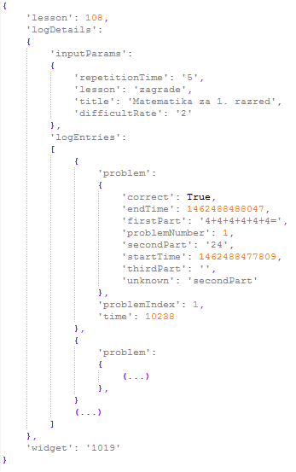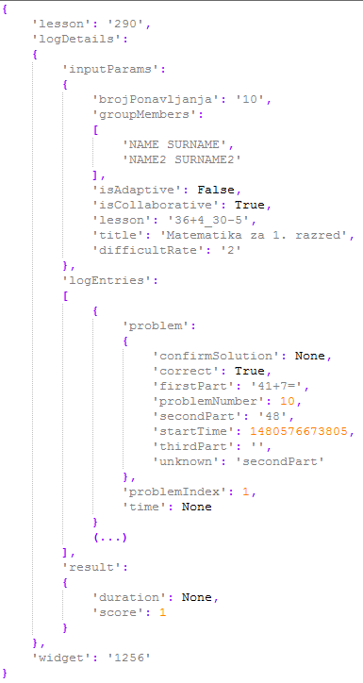
img1 competitive loges img 2 colaborative lesson log
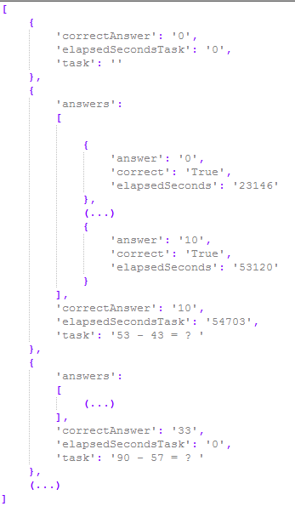
img 3 AR lesson log

As it is visible from images, information of whether student solved exercise correctly and thinking time is easily calculated from the object which is used in rating students and lessons (more in next chapter).
Student learning success and task difficulty computation algorithms (1)
Calculating student success is not an easy task in case when there is no prior information of difficulties differences between lessons if all students didn’t take the same set of lessons. Difficultness rate of the lessons could be statistically extracted from data if same students attempted to solve them (i.e. lessons that have been solved twice times more than some other lessons are two times easier). The Same thing can be said for extracting student success in lessons if all took same lessons. Also, if there was an information about difficulties differences between lessons it would be possible to calculate students’ success. Analogously, if there was an information about the efficacy of students (so we could mathematically compare students’ efficacy) we could calculate lessons difficulties. The recursive dependency can be written as follows:
$$S=f\left(L\right)$$
$$L=f\left(S\right)$$
S – Students’ success (vector)
L – Lessons’ difficulties (vector)
Student success is rated with a real number from [0, 1], where 1 means 100% success and 0 means 0% of success. Lesson difficulty is also rated with a real number from [0, 1] where 0 means 0% of (average) students successfully completed and 1 means 100% of (average) students successfully manage to complete. Information whether student at index i solved lesson j is stored in a matrix at position T(i, j) with values:
$$T_{i,j}=T(i, j)=\left\{\begin{aligned}-1, & student i falied j lesson \\ 0, &student i {didn}^{'}t attempt lesson j \\ 1, &student i solved lesson j \\ \end{aligned}\right.$$
Accuracy and time of solving an exercise in a lesson j for student i is stored in a matrix at position P(i, j) with a real number from [0, 1], where 1 is the best accuracy and time. P(i, j) is a function of time and accuracy which differ from lesson to lesson. For P(i, j) we used
$$P_{i,j}=P\left(i, j\right)=1-\frac{\min\left(t_{max},\max\left(0, t-t_{min}+f*(n-1)\right)\right)}{t_{max}}$$
where
$t-time for solving the exercise$,
$$t_{min}-expected time to solve the exercise,$$
$$t_{max}-expected maximum time to solve the exercise,$$
$$f-penalty factor,$$
$$n-number of attempts$$
because it has the following properties:
- P(i, j) = 1 if it took student less than t_{min} time to solve the exercise and they solved it in first attempt.
- P(i, j) = 0 if it took student more than t_{max} time to solve the exercise.
- P(i^{(k)}, j^{(k)}) > P(i^{(l)}, j^{(l)}) if student k had less attempts then student l and same time as student the student l.
t_{min},t_{max} and f are lesson-specific and should be wisely chosen (i.e. t_{min} could be the time that is higher than 60% of students’ time and t_{max} is two times t_{min} , while f equals 2 seconds).
That is everything needed for state the recursive formula for student’s success S and lesson’s difficulty L:
$$O_{i}=\frac{\sum_{j=1}^{m}{\left(f_{s}\left(T_{i,j}\right)f_{t}\left(T_{i,j}\right){f_{p}\left(L_{i,j}\right)}^{T_{i,j}}* P_{i,j}\right)}}{\sum_{j=1}^{m}{\left(f_{s}\left(T_{i,j}\right){f_{p}\left(L_{i,j}\right)}^{T_{i,j}}* P_{i,j}\right)}}$$
$$L_{j}=\frac{\sum_{i=1}^{n}{\left(f_{s}\left(T_{i,j}\right)f_{t}\left(T_{i,j}\right){f_{p}\left(O_{i}\right)}^{T_{i,j}}* P_{i,j}\right)}}{\sum_{i=1}^{n}{\left(f_{s}\left(T_{i,j}\right){f_{p}\left(O_{i}\right)}^{T_{i,j}}* P_{i,j}\right)}}$$
where
m is number of lessons (size of L),
n is number of students (size of S),
$$f_{s}\left(x\right)=x^{2}$$
is solving function that returns 1 if student attempted to solve the lesson otherwise 0,
$$f_{t}\left(x\right)=\frac{x+1}{2}$$
which is function that returns 1 if student solved correctly and 0 if they didn’t, and
$$f_{p}\left(x\right)=k^{1-2x}$$
is projection function that has properties:
- $f{\left(0\right)}^{T_{i,j}}$ = k, (student i gets k points for solving hardest exercise j, but loses $\frac{1}{k}$ points for failing)
- $f{\left(0.5\right)}^{T_{i,j}}$= 1, (student i gets 1 point for solving average exercise j, but loses 1 for failing)
- $f{\left(1\right)}^{T_{i,j}}$= $\frac{1}{k}$, (student i gets $\frac{1}{k}$ point for solving easiest exercise j, but loses k for failing)
To find a solution for this problem we used an iterative approach by first fixing S and calculating O, then fixing O and calculating S, and repeating the procedure until S and O converge. Experimentally we showed that this problem will always converge but not always to same values, they depend on initial values of O and S what was expected (i.e. if all students solved all lessons, it could mean all students know the lessons or lessons are too easy, or even both). To solve non-deterministic problem, we will set initial values of S to 1 and of O to 0.5 (it’s better to say that students and mistake than to say that opposite case).

Prediction algorithms (1)
Once there are periodical data that give information of student’s success one can assume that it can be used for future prediction of the same data. The assumption is correct only when difficulties of lessons don’t change over time. So, the final move that is expected is to first preprocess data and calculate lessons’ difficulties, fix them and calculate success of students. Machine learning algorithm for drawing a function that best approximates given dots is called regression. Model of the algorithm is the family of logarithmic functions. Loss function of the algorithm is a square loss (L2 loss), while optimising method is gradient descent method.

[1] http://ifets.info/journals/15_3/4.pdf

[2] http://ieeexplore.ieee.org/document/6982089/

Big Log Analysis for E-Learning Ecosystem

[3] http://www.jstor.org/stable/pdf/jeductechsoci.15.3.58.pdf

[4] L. Breslow, D. E. Pritchard, J. DeBoer, G. S. Stump, A. D. Ho, and D. T. Seaton. " Studying learning in the worldwide classroom: Research into edXs first MOOC, " Research & Practice in Assessment, vol.8, 2013, pp: 13-25.
[5] T. KARSENTI, " What the research says, " International Journal of Technologies in Higher Education, vol.10(2), 2013, pp. 23-37

[6] http://ieeexplore.ieee.org/stamp/stamp.jsp?arnumber=7335629
Open Student Models of Core Competencies
at the Curriculum Level: Using Learning
Analytics for Student Reflection
[7] Introduction to Machine Learning - Ethem Alpaydin
[8] STRUCE_Bishop_-_Pattern_Recognition_and_Machine_Learning

For learning curve prediction:
http://www.aclweb.org/anthology/P12-1003
http://ac.els-cdn.com/S1877042814021338/1-s2.0-S1877042814021338-main.pdf?_tid=5388cb4e-44a5-11e7-9fa7-00000aacb360&acdnat=1496086432_7856d0e3edad5bbf449f8bc6c9011c76

http://www.sciencedirect.com/science/article/pii/S016981411100062X

