AI Driven Platform For University Registrar’s Transactions



A Project Study Presented to the Faculty of the

School of Engineering and Architecture

Holy Angel University

In partial fulfillment of the requirements

for the degree of

Bachelor of Science in Computer Engineering

Peralta, Freiderich

Jandali, Abdul Wahab

Miranda, Vincent Lee

October 2, 2025

TABLE OF CONTENTS

**Title Page**………………………………………………...……………………...……….…...…..1 **Acceptance Form**…………………………………………………………….…..………………3 **Workplan**………………………………………………………………………..….……….……4 **Introduction**………………………….……………………………………………...…………....5

**Background of the study**

**Related Literature/Studies**

**Problem Statement**

**Statement of the Problem**……………………………………….……………….……………..10

**General Objectives**

**Specific Objectives**

**Conceptual Framework**……………………………………………………………………….11 **System’s Block Diagram**…………………………………………………..………..…………..12

**Systems’ Flowchart**………………………………………..………………….………….……..13

**Significance of the Study**……………………………………………...…………………….….14

**Sustainable Development Growth**

**Triple Bottom Line (THL)**

**Methodology**………………………………………………………………………………….…15

**Research Methods**

**Research Design**

**Procedures**………………………………………………………………………………………16 **Hardware Design and Development**

**Software Design and Development**

**Instruments/Tools**………………………………….……………………………………………17**Sources of Data**………………………..………………………………………………………...18 **Participants**

**Data Analysis Plan**………………………………………………………………...……………19 **Standard Set**………………………………………...………………………...………………...20 **References**……………………………………………………………………………………….21



In many educational institutions, the financial registration process is plagued by issues such as prolonged processing times, and inefficiencies. Artificial intelligence (AI) can enhance automation and decision-making. Recent advancements in digital governance highlight the potential of these technologies to modernize financial systems. By leveraging AI for automated verification, the financial registration process can become more reliable and efficient. This study explores how AI can improve school financial registration by reducing processing times, enhancing security, and preventing fraudulent transactions.

The financial registration process in educational institutions is often hindered by inefficiencies, long processing times, and security concerns. Traditional systems rely on centralized databases, manual verification, and paper-based documentation, leading to delays, errors, and the risk of fraudulent transactions. Artificial intelligence (AI) can automate verification processes, optimize payment scheduling, and improve user experience through intelligent chatbots and automated decision-making.

Artificial intelligence (AI) has become one of the most trending and disruptive technologies. AI offers intelligence and decision-making capabilities for machines like humans.

In the realm of educational financial management, integrating advanced technologies like AI has shown promise in enhancing transparency, efficiency, and security.

AI applications are transforming school administration by automating repetitive financial tasks such as data entry, invoice processing, and reconciliation. This automation not only reduces errors but also allows finance teams to focus on strategic planning and analysis. Furthermore, AI-powered tools can provide real-time updates on financial processes, answer queries through chatbots, and predict financial aid eligibility, thereby enhancing the overall efficiency of financial operations in educational settings.

**AI in Financial School Registration**

AI enhances efficiency by automating tasks such as student identity verification and tuition fee processing (Chen et al., 2024; Kumar & Sharma, 2023). These technologies streamline administrative processes, reduce errors, and enhance transparency in school financial management (Alammary et al., 2021).

In educational financial management, artificial intelligence (AI) automates and optimizes tasks traditionally performed manually (Martinez-Maldonado et al., 2024). AI applications, such as machine learning algorithms and natural language processing, have been employed to enhance financial operations, including real-time data analysis, risk assessment, and decision-making processes (Popescu et al., 2025). The integration of AI enables educational institutions to process and manage financial data more efficiently, reducing errors and improving overall operational efficiency (Zawacki-Richter et al., 2019).

Integrating technology into educational financial management has garnered attention for its potential to enhance transparency and accountability (El Koshiry et al., 2023). Its decentralized and immutable ledger provides verifiable proof of authentication and an unalterable record of financial transactions, thereby reducing fraud and data manipulation risks (Turkanović et al., 2018). A study published in al-Fikrah: Jurnal Manajemen Pendidikan highlights that implementing it in educational finance can streamline administrative processes and bolster trust in financial operations (Sahib et al., 2024).

Technology also plays a key role in improving university financial services (Wu & Li, 2017). Studies show that it enhances efficiency and transparency in financial transactions, reducing manual processing errors and administrative delays (Zhang, 2022). It enables decentralized and transparent funding systems, ensuring fair and efficient allocation of financial aid (Rahman et al., 2021). By securely recording transactions, it minimizes fraud, prevents unauthorized alterations, and streamlines resource distribution. Smart contracts can also automate financial agreements, ensuring compliance and timely disbursement of funds (Williams, 2024).

Integrating it in educational finance boosts transparency, strengthens security, and improves operational efficiency, making financial processes more reliable and effective (Rane et al., 2023). It creates a trustworthy, tamper-proof system that benefits students, institutions, and funding organizations alike (Bansal et al., 2024).

Integrating artificial intelligence (AI) offers transformative potential in educational financial management (Wang & Li, 2024). AI automates tasks such as transaction categorization and anomaly detection, enhancing accuracy and reducing human error (Kumar et al., 2024). For instance, AI's predictive analytics and machine learning capabilities enable real-time data analysis, risk assessment, and decision-making, optimizing financial processes within educational institutions (Chen et al., 2024). When combined with secure and transparent record-keeping capabilities, AI enhances the precision and reliability of financial data, fostering a more secure and transparent ecosystem within educational finance (Zhang & Schmidt, 2019).

Furthermore, its decentralized and immutable ledger provides verifiable proof of authentication and an unalterable record of financial transactions, reducing fraud and data manipulation risks (Alammary et al., 2019). Implementing it in educational finance can streamline administrative processes and bolster trust in financial operations (Breitbarth et al., 2025). For example, the EduCTX platform proposes a higher education credit system, demonstrating how it can be utilized to create decentralized and transparent systems for managing educational credits and potentially extending to financial transactions within academic institutions (Turkanović et al., 2018).

In addition to that, Dohrnii Labs has developed a decentralized, gamified educational platform that leverages AI to craft customized learning journeys, ensuring users receive content that matches their interests and pace (OneSafe, 2023). This tailored approach enhances educational outcomes and enables users to make informed financial decisions, bridging the knowledge gap across various demographics (Duke, 2024).

Furthermore, the intersection of AI is fundamentally reshaping the financial industry by creating new models of banking, investing, and risk management (Heidt, 2025). As digital transformation accelerates, professionals in the financial sector must adapt to remain competitive (Hui et al., 2025).

In Vaughn Miles' point of view, the concept of cryptocurrency kiosks aligns with the planned interactive kiosks for this project (Miles, 2024). Just as cryptocurrency kiosks offer secure methods for users to buy and sell digital assets, the kiosks in this school environment will provide secure interfaces for users to make payments for various services. Both systems rely on touchscreen displays, payment processing modules, and robust network connectivity to ensure smooth and secure transactions (INFI, 2024).

The significance of this study lies in its potential to transform financial management practices in educational institutions through the development and implementation of a kiosk-based system integrated with Artificial Intelligence (AI) (Klystron Global, 2024). By introducing a self-service kiosk platform, the study addresses key issues such as manual processing delays, fraud risks, and inefficiencies in record-keeping (Consumer Financial Protection Bureau, 2024). This research contributes meaningful solutions for several key stakeholders.

1. **Educational Institutions and Administrators**

• Increased Efficiency – The kiosk system automates financial transactions and record-keeping, reducing paperwork, manual errors, and administrative burden.

• Enhanced Security – Ensures tamper-proof data storage, while kiosk access limits human interference, reducing the risk of fraudulent transactions.

•Data Integrity & Transparency – The combination of kiosk interfaces creates an immutable and auditable record of all financial activities.

• Cost Reduction – By minimizing the need for physical counters and manual staff intervention, kiosks lower operational expenses and resource consumption.

1. **Students and Faculty**

• Faster Processing Times – AI-driven kiosks enable instant tuition payments, scholarship applications, and financial aid approvals, reducing long queues and wait times.

• Improved Accessibility – The kiosk system offers an on-site, user-friendly platform for conducting financial transactions, even for users without internet access.

• Reduced Fraud and Errors – Automated verification through AI and secured recording ensures accurate records and prevents unauthorized modifications.

• Better User Experience – Smart kiosk interfaces with AI-powered assistance guide users through each step, making financial processes simple, quick, and accessible.

AI enhances efficiency by automating tasks such as student identity verification and tuition fee processing. Innovative systems integrate AI-powered document verification to ensure secure and tamper-proof financial records. These technologies streamline administrative processes, reduce errors, and enhance transparency in school financial management. In educational financial management, artificial intelligence (AI) automates and optimizes tasks traditionally performed manually. AI applications, such as machine learning algorithms and natural language processing, enhance financial operations by enabling real-time data analysis, risk assessment, and decision-making. The integration of AI allows educational institutions to manage financial data more efficiently, reducing errors and improving overall operational effectiveness. This study aims to enhance the school financial registration process by developing an AI-powered system to improve security, efficiency, transparency, and automation, ultimately reducing delays, fraud risks, and record-keeping errors.

The purpose of this study is to develop an integration of AI into a **kiosk-based system** that can enhance registrar operations in university settings. To achieve this, the following research questions will be addressed:

1. How can a kiosk-based system improve the security, transparency, and efficiency of registrar transactions in universities?
2. In what ways can AI, integrated into a self-service kiosk, enhance automation and reduce processing time in registrar services such as transcript requests, enrollment verification, and credential authentication?
3. What are the major challenges and limitations in implementing an AI-powered kiosk system for managing university registrar operations?
4. How can the integration of AI in kiosks help prevent fraud, unauthorized modifications, and errors in academic records and credential issuance?
5. What are the potential impacts of an AI kiosk system on user experience, regulatory compliance, and the overall efficiency of university registrar operations?

This study aims to enhance registrar operations in universities by developing a kiosk-based system powered by AI to improve security, efficiency, transparency, and automation, ultimately reducing processing delays, credential fraud risks, and record-keeping errors.

1. To develop how technology, when integrated into a kiosk system, can improve the security, transparency, and integrity of university academic records and registrar documents.
2. To examine the role of AI in a kiosk environment for automating and optimizing registrar transaction processing, reducing human intervention and processing time for services such as transcript requests and enrollment verification.
3. To identify potential challenges and limitations in developing and implementing an AI-powered kiosk system within the university registrar framework.
4. To evaluate how a kiosk-based AI system can help prevent fraud, unauthorized modifications, and errors in academic credential issuance and registrar transactions.
5. To propose a secure and efficient AI-integrated kiosk model for enhancing the university's registrar service delivery system.

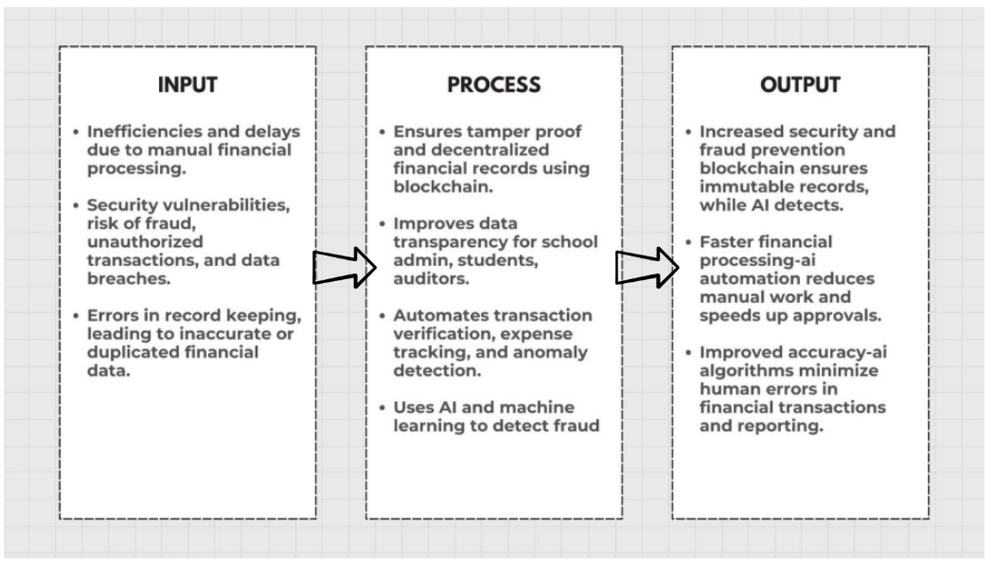

**Figure 1.** *Conceptual Framework*

The study's conceptual framework demonstrates how the integration of artificial intelligence (AI) enhances financial management in educational institutions by addressing key issues such as fraud, inefficiencies, and security threats. The Input-Process-Output (IPO) framework identifies challenges in traditional financial management systems as inputs, including inefficiencies caused by manual record-keeping, security vulnerabilities such as unauthorized transactions and financial fraud, and errors in data management leading to discrepancies and lack of transparency.

The input stage highlights the limitations of traditional financial management, including inefficiencies caused by manual record-keeping, security risks such as unauthorized transactions and financial fraud, and errors in data management that result in discrepancies and lack of transparency.

In the process stage, it ensures tamper-proof and decentralized financial records, enhancing transparency and security. Meanwhile, AI automates transaction verification, anomaly detection, risk assessment, and fraud prevention using machine learning, reducing human intervention and improving accuracy.

As an output, the integration of AI results in a more secure, efficient, and accurate financial management system. Its immutable records and AI-driven fraud detection enhance security, automation reduces processing times and manual workload, and AI minimizes human errors, ensuring accurate financial data management.

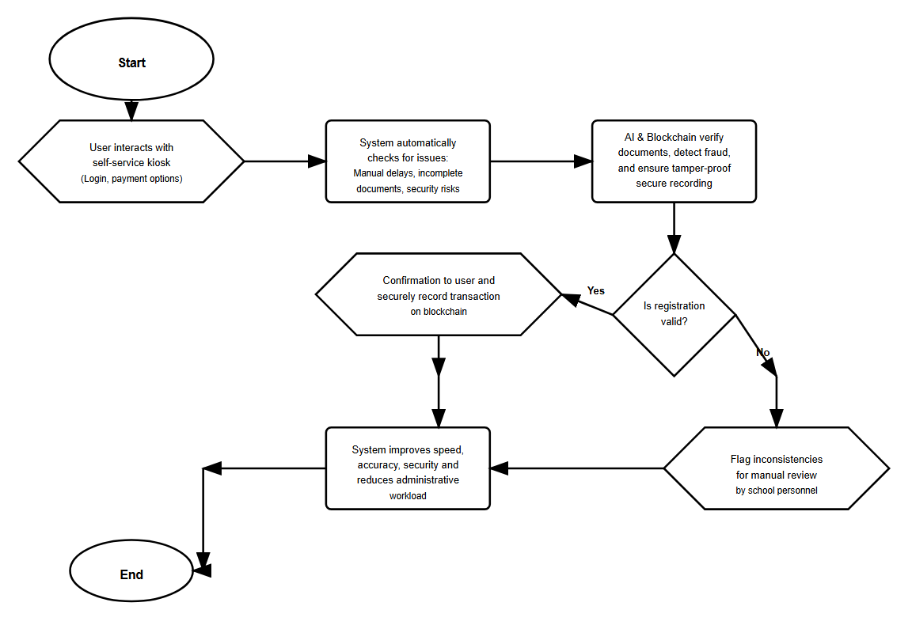

**Figure 2.** *Flow Chart*

The flowchart illustrates the operational process of a kiosk-based school financial registration system enhanced by AI technologies, ensuring secure, efficient, and accurate transactions.

The process begins when a user interacts with the self-service kiosk, which allows basic features such as logging in, selecting payment options, and submitting a financial registration request. Upon receiving the request, the system automatically checks for common issues such as manual delays, incomplete documents, and security risks.

AI-powered verification tools are used to scan and analyze the submitted information, helping detect inconsistencies or possible fraudulent data. Simultaneously, the technology is used to ensure that all transaction data is securely recorded and tamper-proof.

If the system confirms the registration is valid, a confirmation message is displayed on the kiosk and optionally printed or sent via email. The transaction details are then securely logged. If any errors or mismatches are found, the system notifies the user through the kiosk interface and flags the request for manual review by school personnel. By combining the convenience of a self-service kiosk with the power of AI, this system improves the speed, accuracy, and security of the financial registration process, while reducing administrative workload and enhancing transparency.

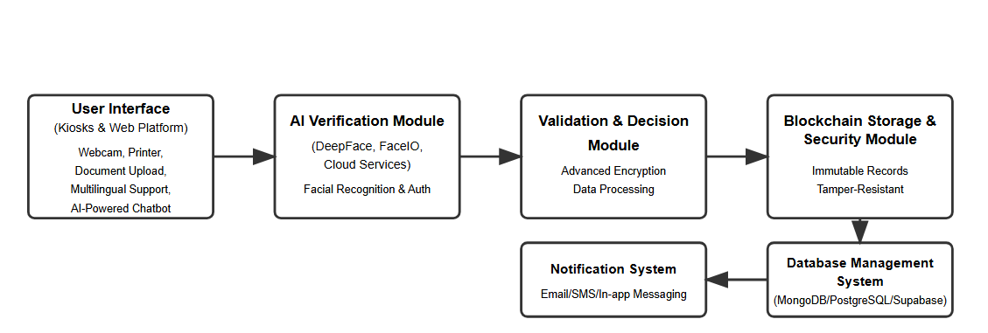

**Figure 3.** *System Diagram*

The system diagram illustrates a comprehensive and streamlined approach to school financial registration through the strategic integration of artificial intelligence technologies. Users can seamlessly access the system through multiple channels, including strategically positioned self-service kiosks equipped with webcams and small printers, as well as a user-friendly web platform that enables remote financial registration and secure document uploads.

The system leverages AI-powered facial recognition frameworks such as DeepFace and FaceIO for identity verification and authentication, ensuring that only authorized individuals can access and process financial transactions. It also incorporates cloud-based services (e.g., AWS, Google Cloud, Microsoft Azure) to provide hosting, scalability, and secure data processing. API integrations ensure smooth communication across kiosks, servers, and external services, while multilingual support and an AI-powered chatbot improve accessibility and enhance user interaction. Upon successful verification, the validated data undergoes advanced encryption protocols before being immutably recorded, guaranteeing transparency, security, and resistance to tampering. In cases where verification fails, the system provides real-time feedback and guidance, enabling users to correct and resubmit their information efficiently. The system architecture relies on cloud-hosted or hybrid databases such as MongoDB, PostgreSQL, or Supabase to securely store transaction histories, user profiles, system metadata, and audit logs. This multi-layered storage approach ensures reliability, performance optimization, and regulatory compliance.

Finally, an intelligent notification system delivers updates through email, SMS, chatbot prompts, and in-app messaging, ensuring users remain informed with real-time confirmations, status updates, and reminders. This comprehensive integration creates a secure, transparent, and user-friendly financial registration process, while minimizing fraudulent activities and operational inefficiencies across the workflow.

**Economic:** By automating school financial registration, reducing administrative costs, and minimizing the need for manual processing, the integration of AI enhances efficiency. The faster registration process benefits students and parents by reducing waiting times and improving financial transaction accuracy. Additionally, fraud detection mechanisms help prevent unauthorized transactions, ensuring that only legitimate payments are processed.

**Environmental:** Transitioning to a digital registration system significantly reduces paper usage, supporting sustainability efforts and lowering the environmental impact associated with document printing and storage. The reduced need for in-person transactions also decreases transportation-related emissions, as students and parents can complete financial registration remotely instead of traveling to school offices.

**Social:** The system enhances trust in the financial registration process by ensuring security, transparency, and fairness. It reduces opportunities for corruption while providing equal access to all users. Additionally, the streamlined process improves user experience by shortening processing times, reducing stress for students and parents, and making financial transactions more accessible and convenient.

The scope of developing this integrated application for school financial registration includes designing, implementing, and evaluating a secure and efficient digital system. The application will feature web, mobile, and kiosk-based interfaces where users can submit financial registration requests and required documents. AI-powered facial recognition tools, such as DeepFace and FaceIO, will be utilized for secure identity verification, while cloud-based services will ensure scalability, hosting, and secure data processing. A validation and decision module will assess the accuracy and completeness of submissions, approving valid records for storage while notifying users of any discrepancies. To enhance accessibility and user experience, the system will also include multilingual support and an AI-powered chatbot to guide users, answer queries, and provide real-time assistance throughout the process.

The system integrates artificial intelligence (AI) to enhance efficiency, security, and transparency in the school financial registration process. AI tools will verify document authenticity and detect potential fraud. A database management system (MySQL, PostgreSQL, or MongoDB) will store transaction history, user details, and metadata. Additionally, a notification module will inform users of successful registrations or necessary corrections. The application will prioritize security, scalability, and user accessibility while focusing solely on technological implementation, excluding policy changes or manual processing outside the system.

The system integrates artificial intelligence to enhance efficiency, security, and transparency in the school financial registration process. Using facial recognition tools like DeepFace and FaceIO for identity verification, it prevents fraudulent access while ensuring secure, tamper-resistant storage of validated records. A cloud-based database (e.g., MongoDB, PostgreSQL, Supabase) manages transactions and user data, with API integrations enabling smooth communication between kiosks, web platforms, and servers. To improve accessibility and user experience, the system incorporates multilingual support, an AI-powered chatbot, and a notification module that provides real-time updates. The application prioritizes security, scalability, and usability, focusing on technological implementation while excluding policy changes or manual processes outside the system.

**Methods**

**Research Design**

This study employs a developmental research design to investigate the integration of artificial intelligence (AI) in the school financial registration process. The study involves system development, where a prototype will be designed and implemented to evaluate its efficiency, security, and feasibility. Additionally, quantitative methods will be used to measure system performance and effectiveness.

The primary requirement for the project’s advancement involves identifying the software components necessary for developing the AI system.

The system will be deployed in a controlled testing environment within select school administrative offices and online platforms. School administrators, students, and system developers will be introduced to the AI system and provided detailed instructions on its features and functionalities. Participants will be given time to explore the system, including automated document verification, smart contract-based processing, and fraud detection mechanisms.

To assess the effectiveness of the system, quantitative data will be collected. This includes measuring processing time before and after implementation, tracking error rates in document verification and fraud detection, and analyzing transaction completion rates and system uptime.

The study will gather quantitative data by evaluating processing times before and after system implementation, monitoring error rates in document verification and fraud detection, and analyzing transaction completion rates and system uptime. Participants will include school administrators and finance officers responsible for student registrations, IT personnel managing the institution’s digital infrastructure, as well as students and parents involved in the financial registration process.

**Hardware Design and Development**

The system will consist of interactive kiosks placed around the school. These kiosks will have touchscreen interfaces for easy user interaction and payment processing options. They will also include high-quality displays to guide users, a built-in webcam for identity verification or capturing images, and a small printer for generating receipts, tickets, or other printouts. Each kiosk will be connected to a secure network and linked to a central server infrastructure that supports AI processing for intelligent services and secure data storage to protect sensitive information.

**Software Design and Development**

The study will require various materials to support the development, testing, and evaluation of the AI system for financial school enrollment. This includes software and development tools such as facial recognition frameworks like DeepFace and FaceIO for identity verification and authentication, as well as cloud-based services such as Amazon Web Services (AWS), Google Cloud, or Microsoft Azure for hosting, scalability, and secure data processing. In addition, API integrations will be utilized to connect different system components and enable smooth communication between kiosks, servers, and external services.

To enhance accessibility and user experience, the system will incorporate multilingual support, allowing users to interact with the kiosks in different languages. An AI-powered chatbot will also be integrated to provide real-time assistance, answer queries, and guide users through the enrollment and payment processes.

For data management, the system will rely on cloud-hosted or hybrid database solutions to ensure reliability, availability, and security of transaction records. Finally, survey and evaluation materials will consist of pre-test and post-test questionnaires to measure processing efficiency, along with interview guides and survey forms to gather user feedback and assess system usability.

The development process begins with a requirement analysis to identify user needs and legal constraints, followed by system design, which includes UI mockups, database schema definition, and smart contract development. The implementation phase covers frontend and backend development, AI-powered document verification integration, and secure storage. This is followed by testing phases, including unit testing for individual modules and system testing to ensure AI accuracy, security, and overall performance. The system's key functionalities include secure user authentication, AI-driven document verification, an automated validation and approval workflow, immutable storage, and a notification system that alerts users of successful renewals or required corrections.

**Figure 4.** *Iterative**Waterfall Software Development Cycle*

This research follows the **Iterative Waterfall software development cycle**, a structured methodology that progresses through sequential phases, but allows limited iteration and refinement between stages based on feedback or testing results.

**Analysis Stage:** This phase involves identifying user needs, defining system objectives, and ensuring compliance with institutional policies and financial regulations. Technical specifications for AI verification and database management are also gathered.

**Design Stage:** The system’s architecture is outlined by creating UI mockups for user interactions, defining a database schema for structured financial records, and designing logic to improve security and transparency. Design elements may be refined based on technical feedback during development.

**Development Stage:** This phase focuses on programming and integration, including frontend and backend development, facial recognition (DeepFace, FaceIO), cloud services, API integration, and the addition of multilingual support and an AI-powered chatbot. Feedback from early testing will guide necessary adjustments.

**Testing Stage:** Comprehensive testing is conducted to validate AI accuracy in document recognition and assess overall system performance. Testing includes unit testing, system integration testing, and security testing. Identified issues may lead to modifications in the design or development stages for improvement.

**Deployment Stage:** Upon successful testing, the system is deployed for real-world use. Web platforms are made accessible for school financial registration. Final configurations for hosting and database management are applied. Post-deployment evaluations may result in refinements to prior components.

**Maintenance Stage:** Continuous monitoring ensures system reliability, performance, and adaptability. Tasks include bug fixes, AI model fine-tuning, updates to security protocols, and support for policy-driven or technical enhancements. Feedback gathered during maintenance can inform future iterations of analysis and design.

**Tools and Equipments**

|  |  |
| --- | --- |
| **Category** | **Tools/Materials** |
| **Hardware** | **- Laptop/Desktop (Windows/Mac OS) or Ipad/Table (IO/Android)**  **- Kiosk Terminal/Touchscreen Display**  **- Document Scanner (for OCR testing)**  **- Network Router/Internet Connection**  **- USB Flash Drive (for data backup)** |
| **Software** | **-Python Programming Language**  **-Node.js and Express.js (backend development)**  **-React.js (frontend development)**  **-MongoDB or cloud-hosted databases (database management)**  **-Solidity (smart contract development)**  **-DeepFace and FaceIO (AI-powered facial recognition)**  **-Cloud-based services (e.g., AWS, Google Cloud, Microsoft Azure)**  **-API integrations (for seamless communication across system components)**  **-Multilingual support frameworks**  **-AI-powered chatbot platforms** |
| **Participants** | **- School administrators (registrars, finance officers)**  **- Students and parents/guardians**  **- IT personnel and technical staff- Subject matter experts (for validation)** |

**Source of Data**

**Primary Source**

The primary sources of data for this research include school finance administrators, accounting staff, and IT personnel responsible for managing financial transactions and student fee processing. Additionally, students and parents who actively engage in tuition payment and financial transactions will provide insights into user challenges and expectations. System performance data will also be gathered through real-time testing of the application, measuring processing time, AI verification accuracy, and error rates to assess overall efficiency.

**Secondary Source**

The secondary sources of data for this research include financial policy documents, institutional reports, and existing studies on AI applications in digital financial management. Scholarly articles and industry reports analyzing the efficiency and security of similar systems in educational finance and document verification will also be referenced.

**Participants**

The participants of this study will consist of school finance administrators, accounting personnel handling student payments, IT professionals specializing in AI integration, and students or parents who will provide user feedback on the system’s usability, efficiency, and effectiveness.

**Data Analysis Plan**

A structured survey using rating-scale questions will be administered to these participants. School administrators and accounting staff will provide insights into the system’s accuracy and efficiency in handling transactions, while IT professionals will evaluate the technical reliability and security of AI integration. Students and parents will rate their experiences in terms of usability and overall satisfaction. Collected responses will be cleaned to remove incomplete or inconsistent data. Descriptive and comparative analyses will then be applied to identify trends and differences across participant groups, enabling the study to highlight potential strengths and challenges in the integration of AI.

**Prior Art Search: AI Integration in School Financial Registration Systems**

1. **Technological Landscape Analysis**

**1.1 Current Technological Trends (2022-2025)**

* • **Education Technology**: Growing adoption for credential verification, student records management, and secure transaction processing
* **AI-Powered Document Verification**: Increasing use of computer vision and machine learning for identity authentication and fraud detection
* **Smart Contract Implementation**: Automated payment processing, enrollment workflows, and compliance management
* **Self-Service Kiosk Evolution**: Integration of biometric authentication, cloud connectivity, and real-time processing capabilities
* **Hybrid Cloud Architecture**: Scalable solutions combining traditional databases with secure, immutable storage

**1.2 Key Technologies Convergence**

* Facial Recognition Systems: DeepFace, FaceIO, AWS Rekognition for identity verification
* Platforms: Ethereum, Hyperledger Fabric, Polygon for educational applications
* Cloud Integration: Multi-cloud strategies (AWS, Google Cloud, Azure) for scalability • API Ecosystem: RESTful services enabling seamless component integration

1. **Competitive Analysis & Existing Solutions**

**2.1 Educational Platforms**

* EduCTX Focus: Academic credentials Features: Certificate verification, tamper-proof records Limitations: Limited to academic records, no financial integration
* Disciplina Focus: Educational ecosystem Features: Student progress tracking, talent recruitment Limitations: Lacks financial enrollment automation
* Dohrnii Focus: Knowledge verification Features: Skill assessment, competency validation Limitations: No payment processing or kiosk integration
* MIT Digital Diplomas Focus: Credential verification Features: Digitally issued certificates Limitations: Academic focus only, no financial services

**2.2 Financial Technology Solutions**

* PayMyTuition Technology: Digital payments Strengths: International payment processing Gaps: Limited AI
* Flywire Technology: Payment platform Strengths: Multi-currency support, compliance Gaps: Traditional architecture, no kiosk support
* TouchNet Technology: Campus commerce Strengths: Integrated financial services Gaps: Legacy system, minimal AI capabilities
* CashNet Technology: Payment processing Strengths: PCI compliance, reporting Gaps: Limited automation

**2.3 Kiosk Technology Providers**

* Olea Kiosks Features: Touchscreen, printing Applications: Basic transactions Technology Gaps: No AI integration
* Advanced Kiosks Features: Biometric options Applications: Identity verification Technology Gaps: Limited cloud connectivity
* Meridian Kiosks Features: Interactive displays Applications: Information services Technology Gaps: No financial processing
* KIOSK Information Systems Features: Secure enclosures Applications: Payment processing Technology Gaps: Basic functionality only

1. **Innovation Gap Analysis**

**3.1 Technical Gaps Identified**

* Integration Deficiency: No existing solution combines kiosk hardware with AI verification storage
* Limited Automation: Current systems require significant manual intervention for verification and approval processes
* Fragmented Security: Existing solutions lack end-to-end encryption from input to secure storage
* Scalability Issues: Most platforms cannot handle high-volume, simultaneous transactions across multiple locations
* User Experience Limitations: Lack of multilingual support and intelligent assistance in financial enrollment processes

**3.2 Functional Gaps**

* Real-time Fraud Detection: Insufficient AI-powered analysis for identifying fraudulent documents and identities
* Seamless Workflow Integration: Missing automated decision-making systems for enrollment approvals
* Comprehensive Audit Trails: Limited immutable logging of all transaction steps and user interactions
* Multi-modal Verification: Absence of combined facial recognition, document analysis, and behavioral authentication

**3.3 Market Gaps**

* Educational Sector Specialization: General fintech solutions lack understanding of educational enrollment complexities
* Regulatory Compliance: Limited solutions addressing FERPA, data privacy, and educational financial regulations
* Cost-Effectiveness: High implementation costs and complexity barriers for educational institutions
* Interoperability: Poor integration capabilities with existing Student Information Systems (SIS)

1. **Patent Landscape & Intellectual Property Analysis**

**4.1 Relevant Patent Areas**

* Identity Verification Systems: US Patents focusing on decentralized identity management
* AI-powered Document Authentication: Computer vision patents for fraud detection in financial documents
* Smart Contract Automation: Patents covering automated workflow execution in educational contexts
* Kiosk-based Biometric Systems: Hardware and software patents for secure self-service transactions

**4.2 Patent Opportunities**

* Kiosk-AI Integration Patentability: High Market Potential: Very High Priority Level: Critical
* Multi-modal Verification System Patentability: High Market Potential: High Priority Level: High
* Educational Smart Contracts Patentability: Medium Market Potential: High Priority Level: Medium
* Hybrid Storage Architecture Patentability: Medium Market Potential: Medium Priority Level: Medium
* Real-time Fraud Detection Engine Patentability: High Market Potential: Very High Priority Level: Critical

**4.3 Freedom to Operate Analysis**

* Low Risk Areas: General AI implementation, basic AI verification, standard kiosk hardware
* Medium Risk Areas: Specific facial recognition algorithms, proprietary smart contract frameworks
* High Risk Areas: Patented biometric fusion techniques, licensed cloud service integrations

1. **Market Research & Commercial Viability**

**5.1 Market Size & Opportunity**

* Global Education Technology Market: $404.8 billion (2025), growing at 16.3% CAGR
* Kiosk Market in Education: $2.8 billion (2024), 8.2% annual growth
* Target Addressable Market: $850 million for integrated financial enrollment systems

**5.2 Commercial Advantages**

* First-Mover Advantage: No comprehensive solution currently exists in the market
* High Barrier to Entry: Complex integration requirements create competitive moat
* Scalable Revenue Model: SaaS licensing, transaction fees, and hardware leasing opportunities
* Global Applicability: Solution adaptable to various educational systems worldwide

**5.3 Implementation Strategy**

* Phase 1: Patent filing and prototype development (6 months)
* Phase 2: Pilot testing with 3-5 educational institutions (12 months)
* Phase 3: Regulatory compliance and certification (6 months)
* Phase 4: Commercial launch and scaling (12+ months)

1. **Regulatory & Compliance Considerations**

**6.1 Educational Regulations**

* FERPA Compliance: Student privacy protection requirements
* ADA Accessibility: Kiosk design and interface accessibility standards
* Financial Regulations: PCI DSS compliance for payment processing
* International Standards: GDPR compliance for global deployment

**6.2 Technology Standards**

* Security Standards: ISO/IEC 27001 for information security
* AI Ethics: Responsible AI implementation guidelines
* Biometric Standards: ISO/IEC 19795 for biometric performance testing
* Cloud Security: SOC 2, ISO 27001 compliance requirements

1. **Research & Development Recommendations**

**7.1 Technical Development Priorities**

1. Core Integration Platform: Develop unified architecture connecting kiosk, and AI components
2. Advanced Security Framework: Implement end-to-end encryption and zero-trust security model
3. Scalability Infrastructure: Design cloud-native architecture for institutional deployment
4. User Experience Optimization: Create intuitive interfaces with accessibility features

**7.2 Academic Research Opportunities**

* Performance Benchmarking: Comparative studies against traditional enrollment systems
* Security Analysis: Penetration testing and vulnerability assessments
* User Acceptance Studies: Usability research with diverse student populations
* Economic Impact Analysis: Cost-benefit analysis for educational institutions

1. **Conclusion & Strategic Recommendations**

**8.1 Innovation Potential**

The convergence of kiosk technology and AI verification represents a significant innovation opportunity in educational financial services. No existing solution provides comprehensive integration of these technologies specifically for school enrollment processes.

**8.2 Strategic Actions**

1. Immediate: File provisional patents for core innovations
2. Short-term: Develop minimum viable product (MVP) for pilot testing
3. Medium-term: Establish partnerships with educational institutions and technology providers
4. Long-term: Scale solution globally with regulatory compliance framework

**8.3 Success Factors**

* Technical Excellence: Robust, secure, and user-friendly system design
* Regulatory Compliance: Proactive adherence to educational and financial regulations
* Market Validation: Successful pilot implementations demonstrating clear value proposition
* Strategic Partnerships: Collaborations with established educational technology providers

## References

**Duke, M.** (n.d.). *Unlocking potential: AI's role in financial management for independent schools.* *LinkedIn Pulse*.<https://www.linkedin.com/pulse/unlocking-potential-ais-role-financial-management-independent-duke-ugzpc>

**Miles, V.** (n.d.). *Your Bitcoin on every block: An introduction to cryptocurrency kiosks*. National Association of Attorneys General. Retrieved from <https://www.naag.org/attorney-general-journal/your-bitcoin-on-every-block-an-introduction-to-cryptocurrency-kiosks/>

**Duke, M.** (2024). Unlocking potential: AI's role in financial management for independent schools. *LinkedIn Pulse*.<https://www.linkedin.com/pulse/unlocking-potential-ais-role-financial-management-independent-duke-ugzpc>

**Klystron Global.** (2024). Self service kiosks for the education sector: Smart campus solutions.<https://www.klystronglobal.com/kiosks/kiosk-for-education-sector>

**Solidity Academy.** (2023, June 30). Revolutionizing education with smart contracts. *Medium*.<https://medium.com/@solidity101/revolutionizing-education-with-smart-contracts-742e570a414f>

**Williams, C.** (2024, April 18). How smart contracts are transforming crypto payment solutions in 2024? *Coinmonks*.<https://medium.com/coinmonks/how-smart-contracts-are-transforming-crypto-payment-solutions-in-2024-79dd2ebb221a>