**Used Routes, Related Database Tables, and HTML Templates**

1. **Home Page (/)**
   * HTML Template: home.html
   * No database interaction.

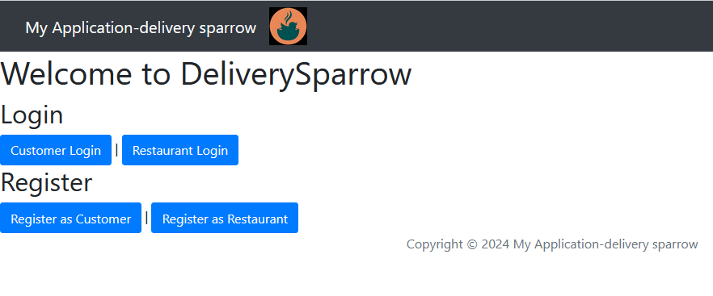

1. **Customer Login (/customer/login)**
   * Database Table: Customer
   * HTML Template: customer_login.html

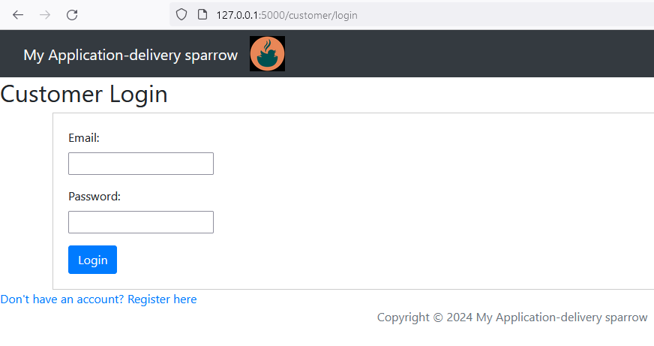

1. **Show Restaurants (/show_restaurants)**
   * Database Table: Restaurant
   * HTML Template: Not provided in the uploads but expected to be restaurants.html

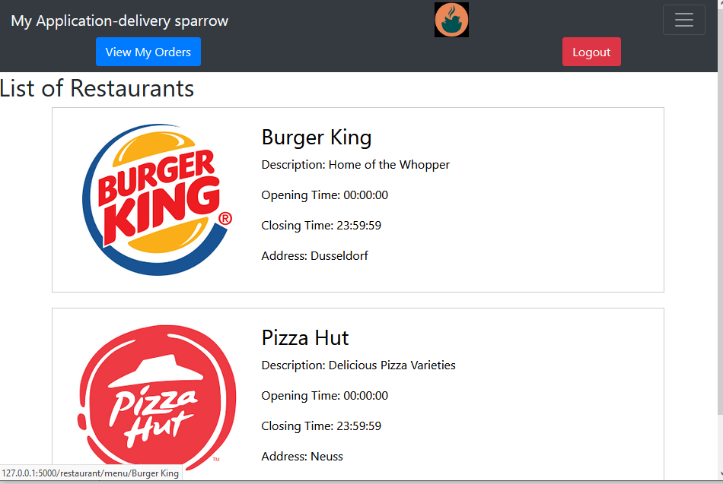

1. **Show Menu (/restaurant/menu/<string:restaurant_name>)**
   * Database Tables: Restaurant, Item
   * HTML Template: menu.html

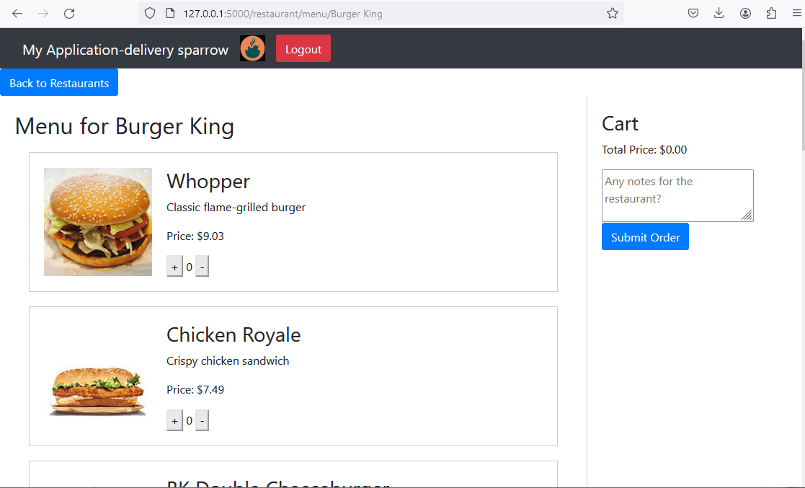

1. **Process Cart (/process_cart, /process_cart1)**
   * Database Tables: OrderC, order_items
   * No specific HTML template; redirects or responds with JSON.
2. **Order Confirmation (/order_confirmation/<int:order_nr>)**
   * Database Tables: OrderC, order_items
   * HTML Template: Not provided in the uploads but expected to be order_confirmation.html

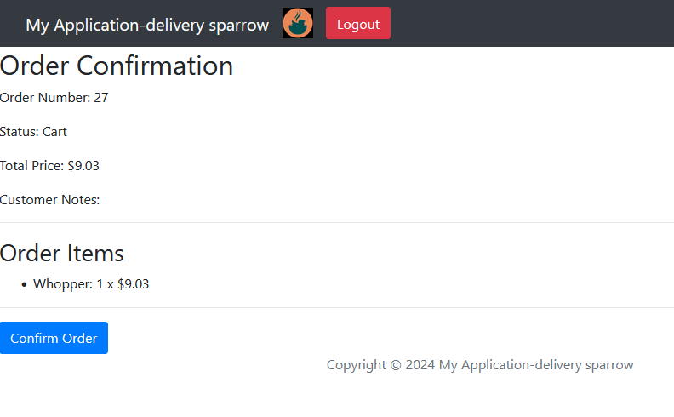

1. **Customer Orders (/customer_orders)**
   * Database Table: OrderC
   * HTML Template: customer_orders.html

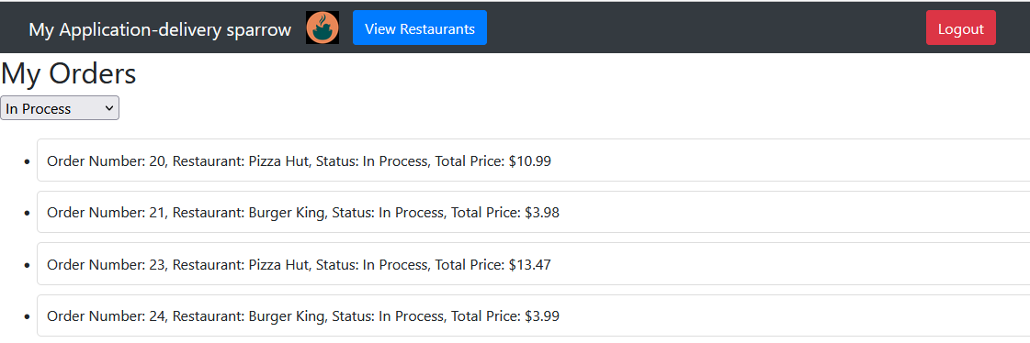

1. **Customer Register (/customer/register)**
   * Database Table: Customer
   * HTML Template: customer_register.html

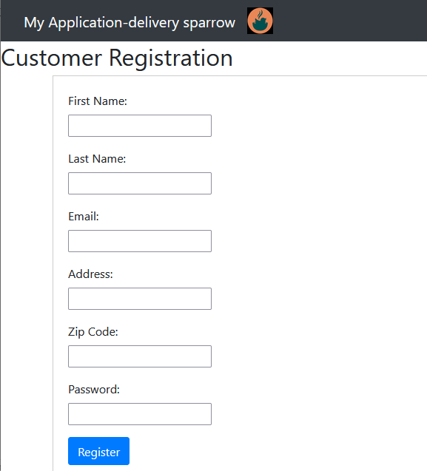

1. **Restaurant Register (/restaurant/register)**
   * Database Table: Restaurant
   * HTML Template: restaurant_register.html

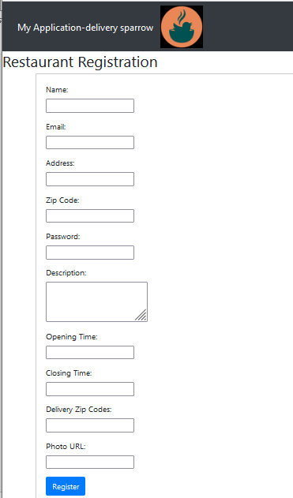

1. **Restaurant Login (/restaurant/login)**
   * Database Table: Restaurant
   * HTML Template: restaurant_login.html

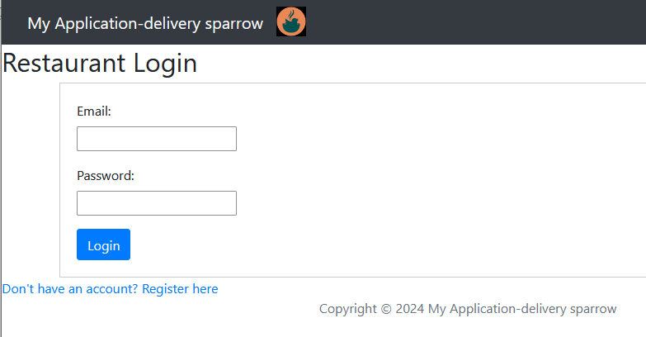

1. **Restaurant Dashboard (/restaurant/dashboard)**
   * Database Table: Restaurant
   * HTML Template: restaurant_dashboard.html

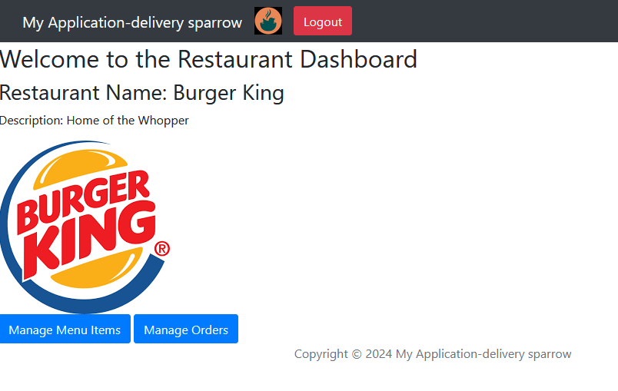

1. **Manage Orders (/restaurant/manage_orders), View Order Items (/restaurant/view_order_items/<int:order_id>), Update Order Status (/restaurant/update_order_status/<int:order_id>)**
   * Database Tables: OrderC, order_items
   * HTML Template for Managing Orders: Not provided but expected to be manage_orders.html
   * HTML Template for Viewing Order Items: Not provided but expected to be view_order_items.html

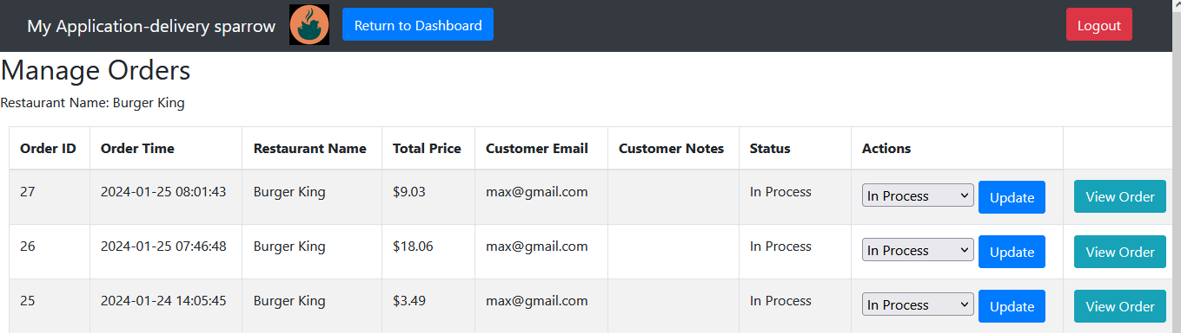

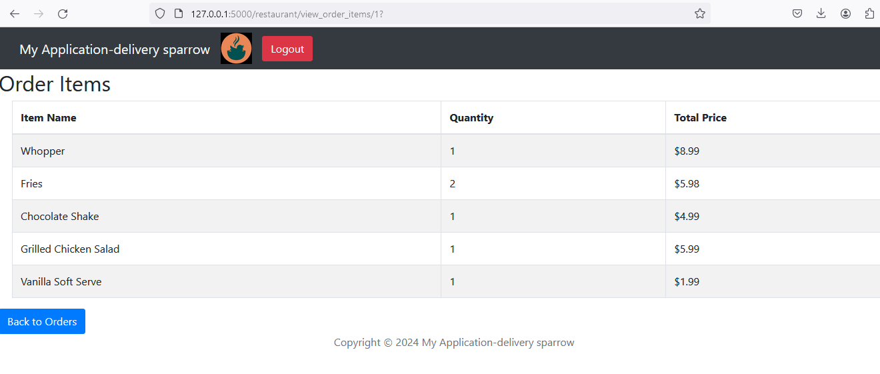

1. **Manage Menu Items, Add Menu Item, Update Menu Item, Delete Menu Item (/restaurant/manage_menu_items, /restaurant/add_menu_item, /restaurant/update_menu_item/<item_name>, /restaurant/delete_menu_item/<item_name>)**
   * Database Table: Item
   * HTML Templates: Not provided but expected to be related to menu item management such as manage_menu_items.html, add_menu_item.html, update_menu_item.html, confirm_delete_menu_item.html

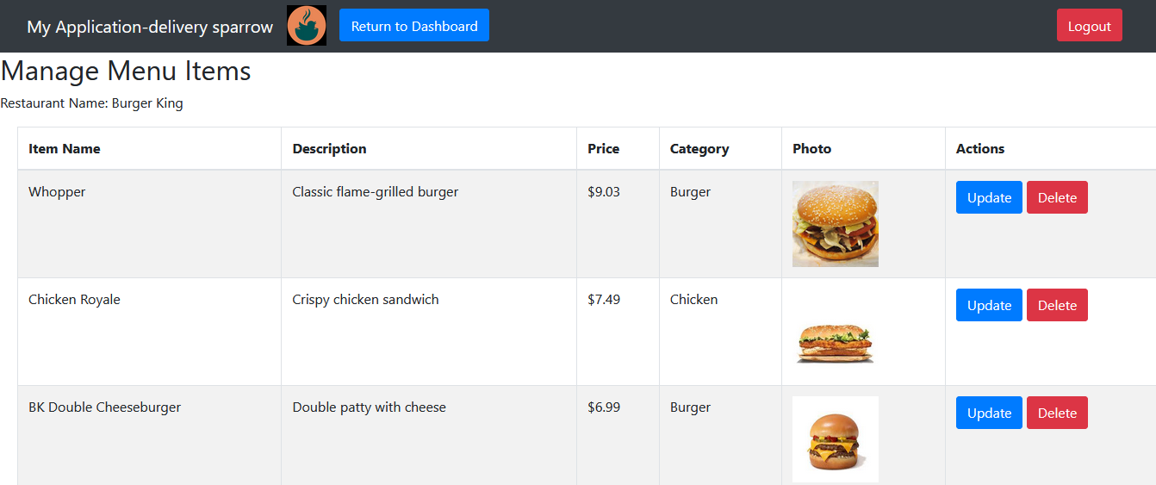

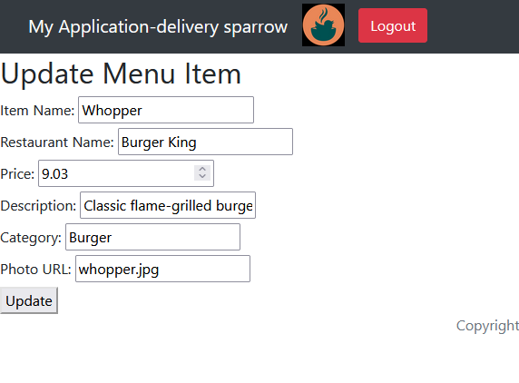

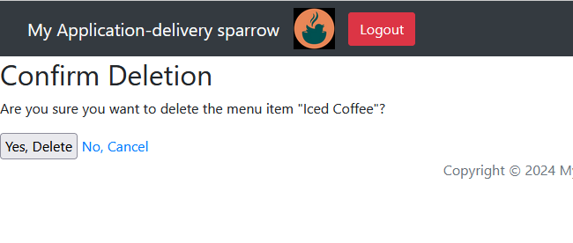

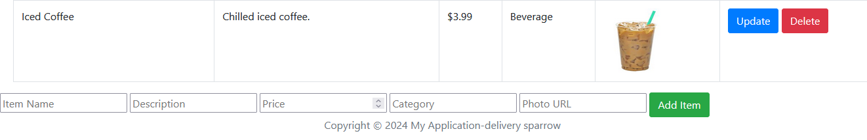

1. **Logout (/logout)**
   * No database interaction directly; clears session.
   * Redirects to the home page.