Lab Class 1
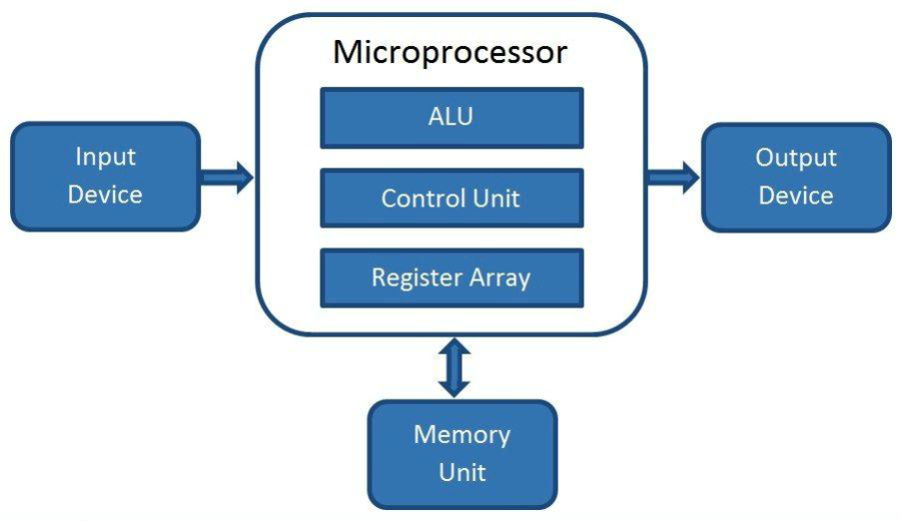
Language : Mips

Processor have ALU, Control Unit, Register

Primary memory -> Registers

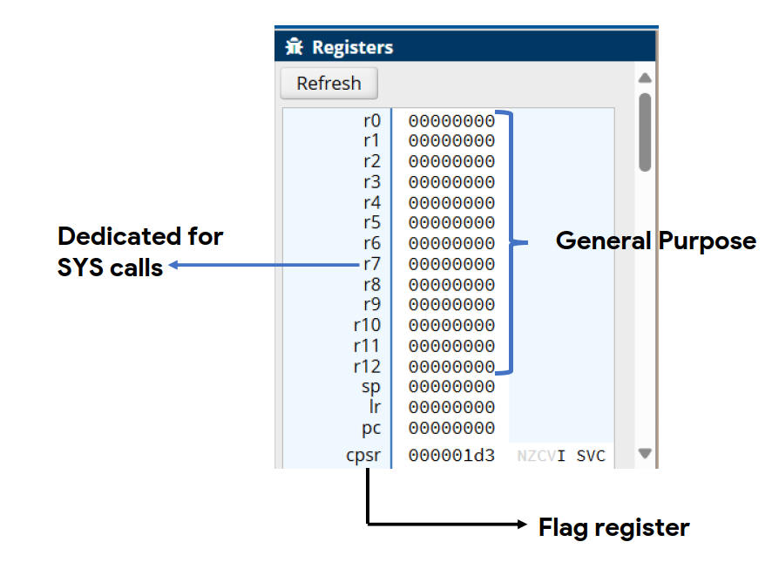
Arm v7
-> 32Bit
-> 32 Binary
-> 8 Hex
-
> r0 00000000

- We can Use any r0-r12 except r7
- We use cpsr only for flag register

Simulation Site name: CPULator ( ALTERA DE-1 Board )
CPULator : A code snippet to go through :
.global _start
_start:
Mov r0,#7 <-------- Immediate Value
Mov r7,#1
Add r8,r7,r0
Sub r9,r0,r7
Swi 0 <--------> .end (swi 0 : meaning (Softwere intrupt))

Instruction
Example | Label | OP CODE | Operand / Operands / Immediate | Destination
Mov r7,#1 | _start: | Mov | #1 (Immediate) | r7
Add r8,r7,r0 | _start: | Add | r7,r0 (Operands) | r8
Sub r9,r0,r7 | _start: | Sub | r0,r7 (Operands) | r9
Swi 0 | _start: | Swi | 0 (Immediate)

