Name: MD. Rokib Hasan Oli
ID: 2211950642
Practice (Lab 4)
Q1
.global _start
.data
SONGKHA: .word 1,0x13,5,4,0x12,0x17
array_min: .word 0
array_sum: .word 0
.text
_start:
ldr r0, = SONGKHA
ldr r1, = array_min
ldr r2, = array_sum
mov r4,#0 @Sum --> value 0
mov r12,#0 @MAX --> Value 0
mov r11,#6 @counter
loop1:
ldr r3,[r0]
cmp r3,r12
bgt update @Update When r10 lass then r3 , Or Skip this step.
b adding

update:
mov r12,r3
b adding

adding:
add r4,r3,r4
add r0,r0,#4
sub r11,r11,#1
cmp r11,#0
bgt loop1
str r12,[r1]
str r4,[r2]
.end
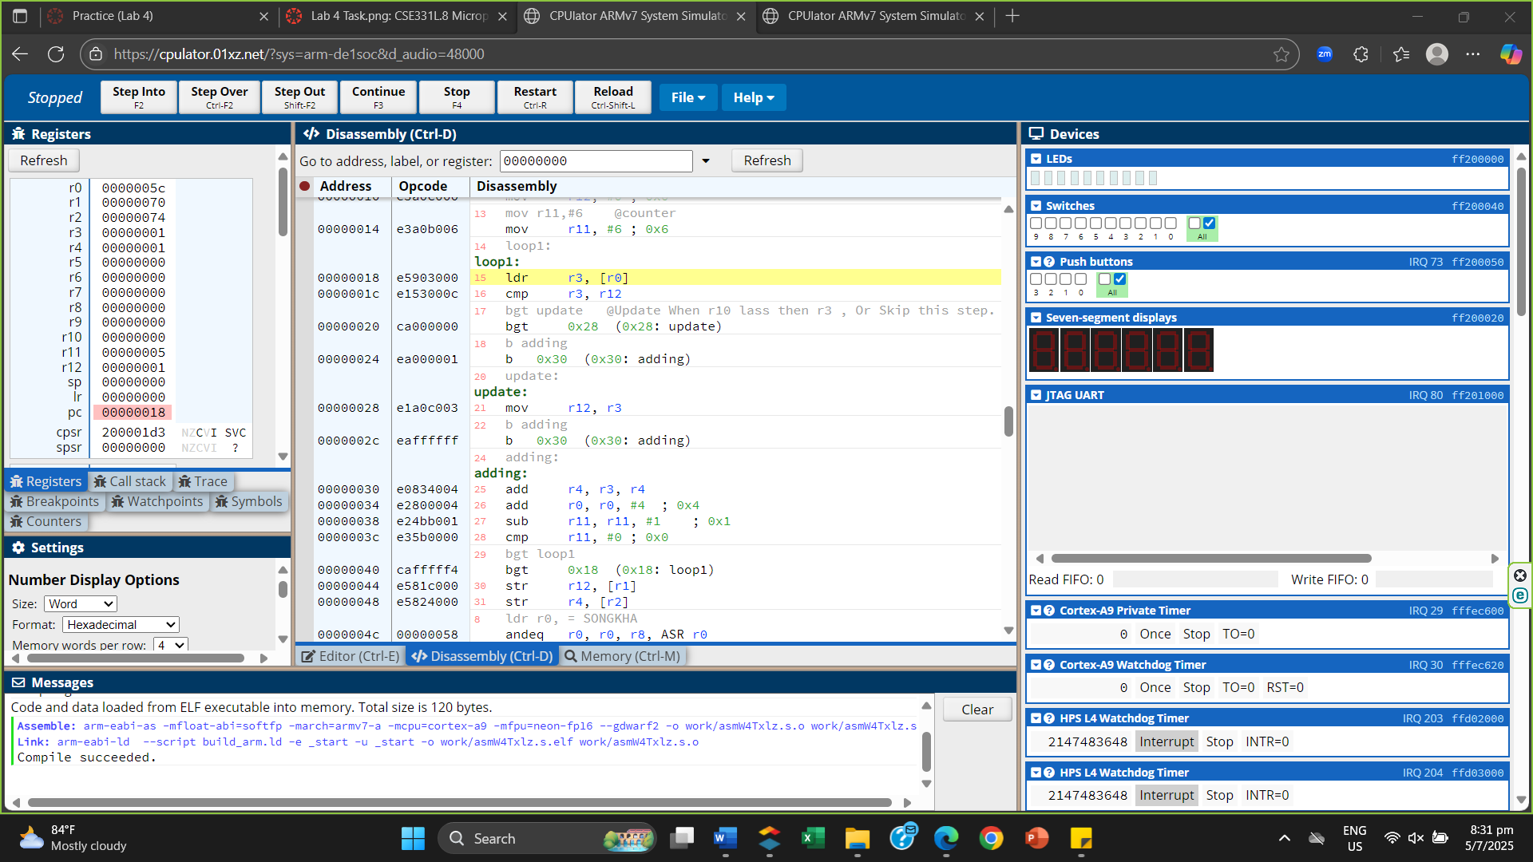
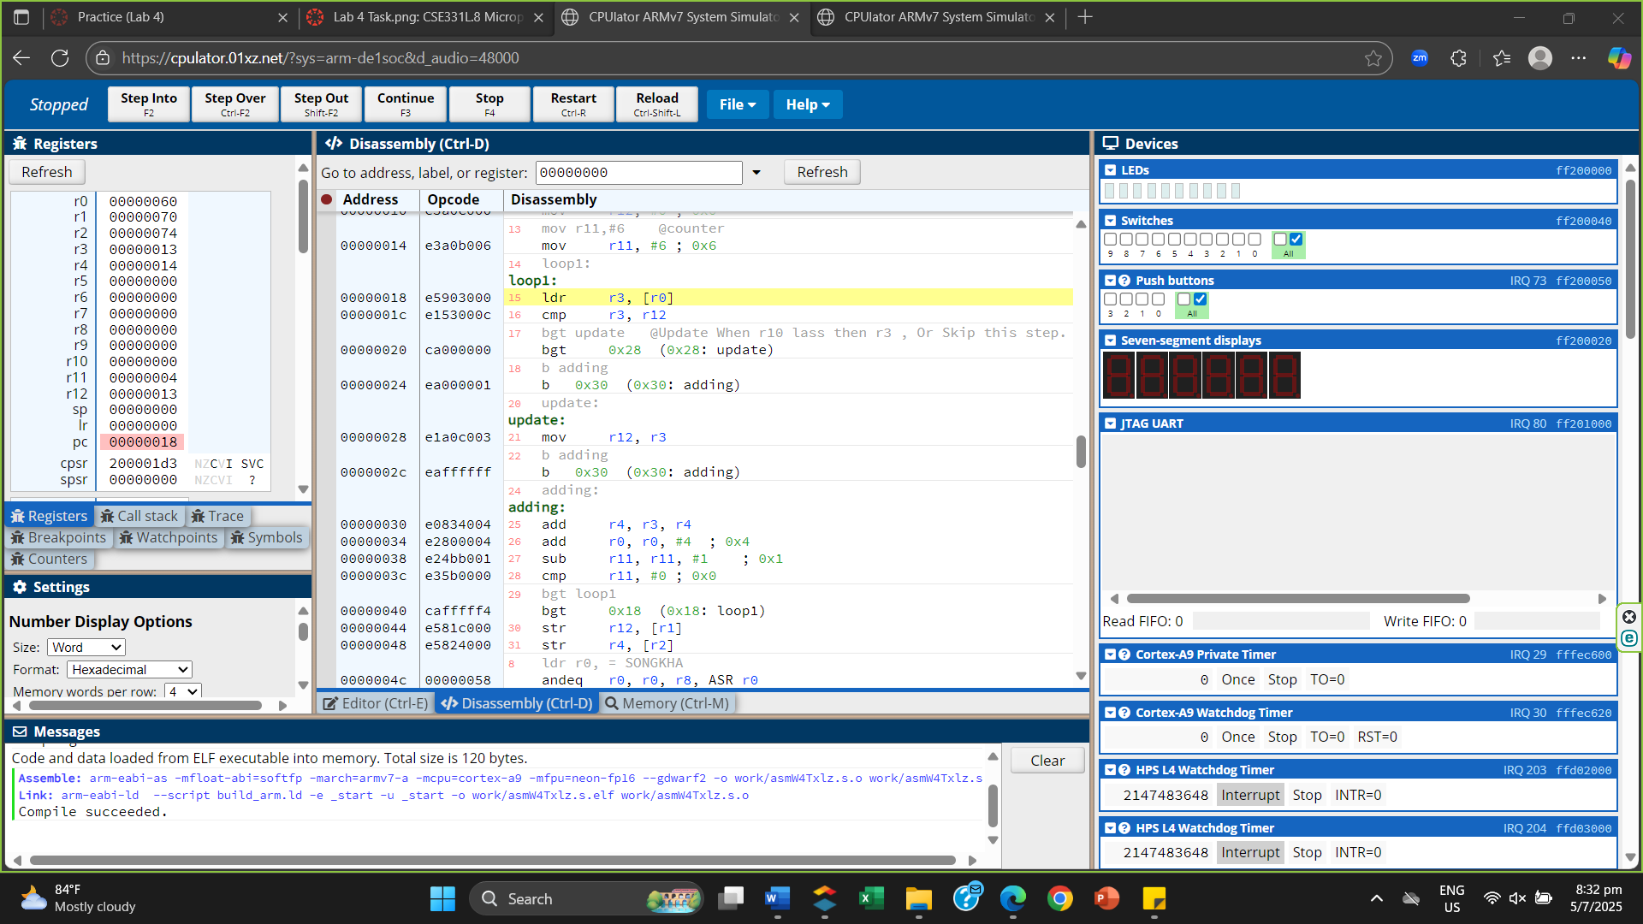
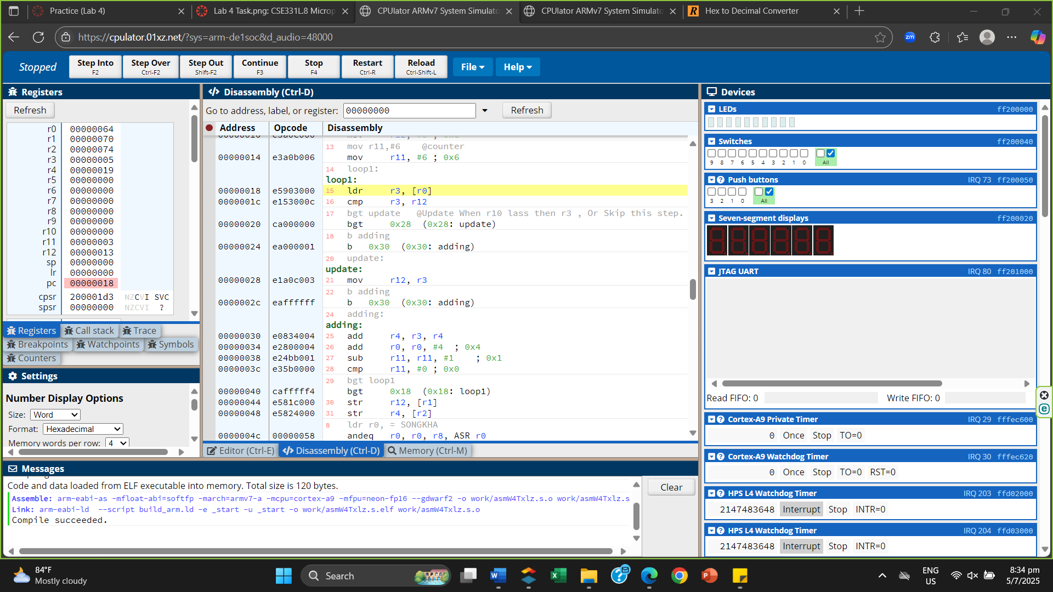
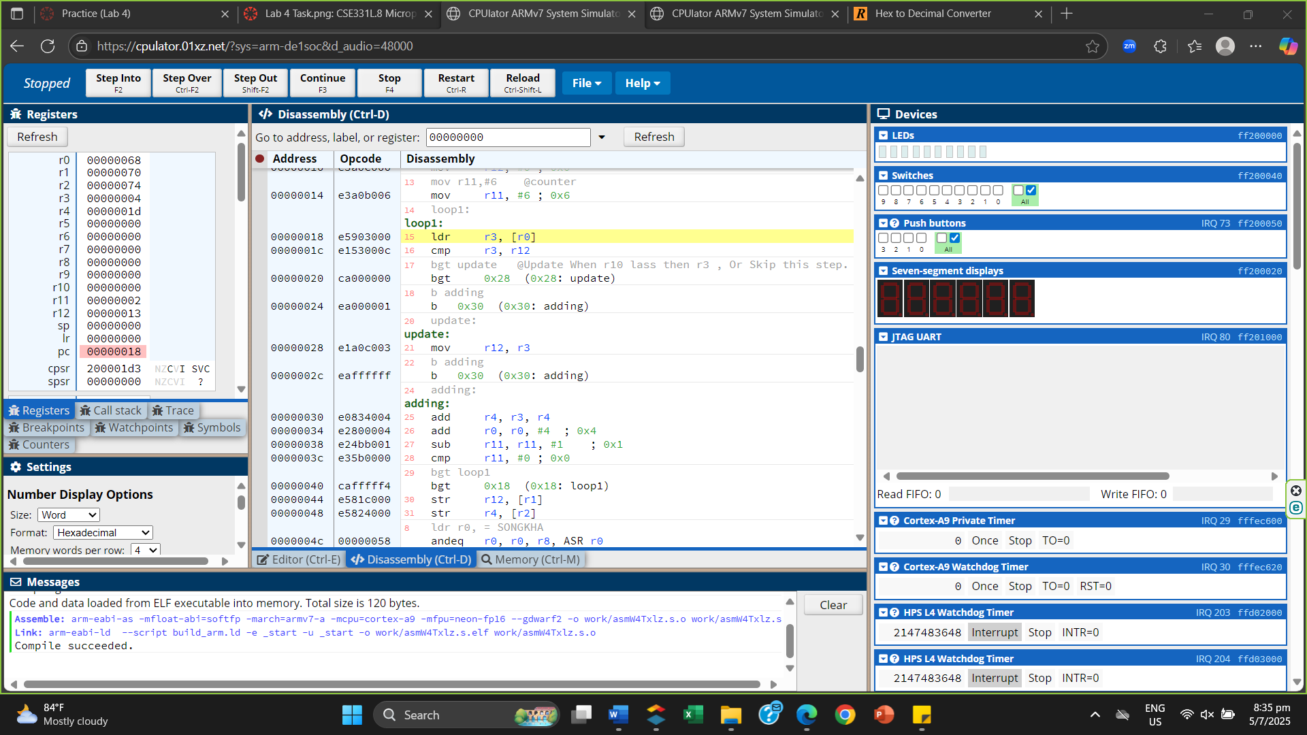
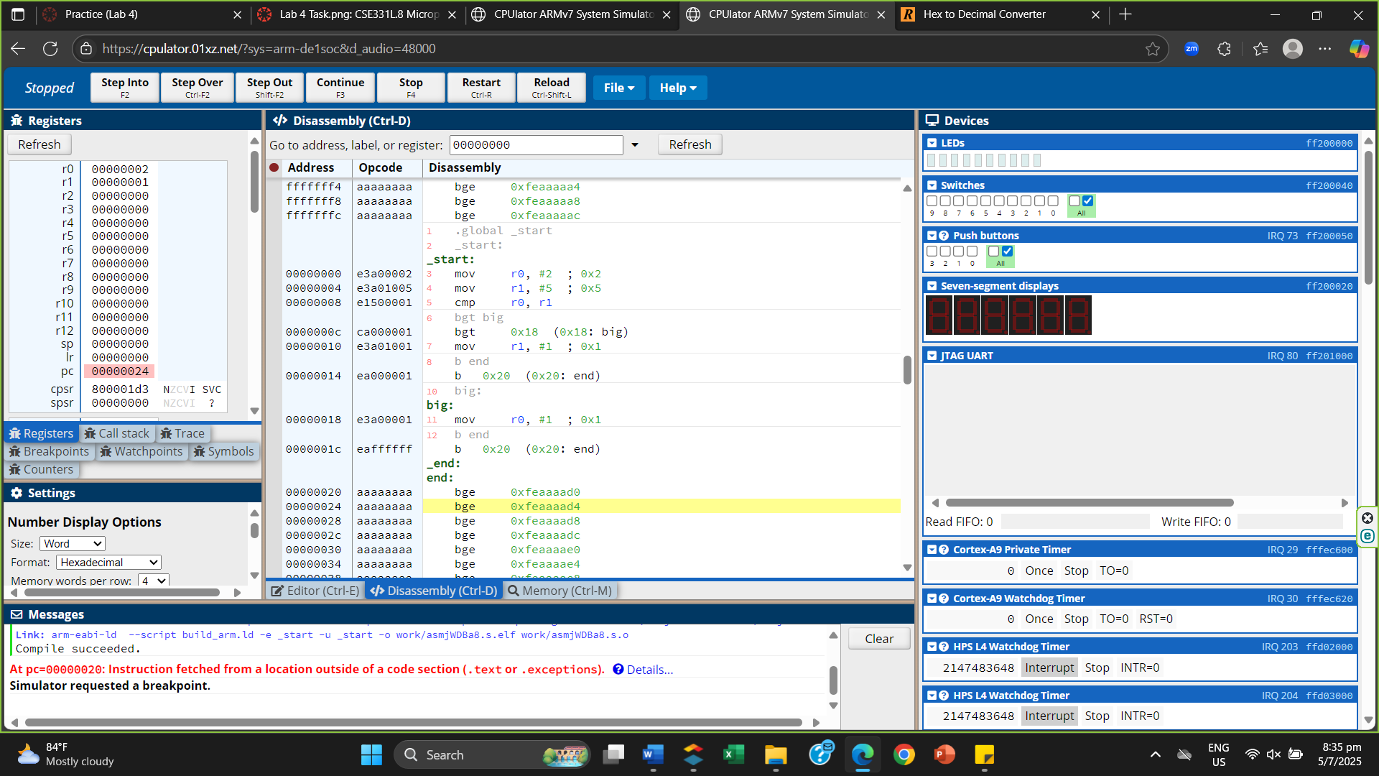
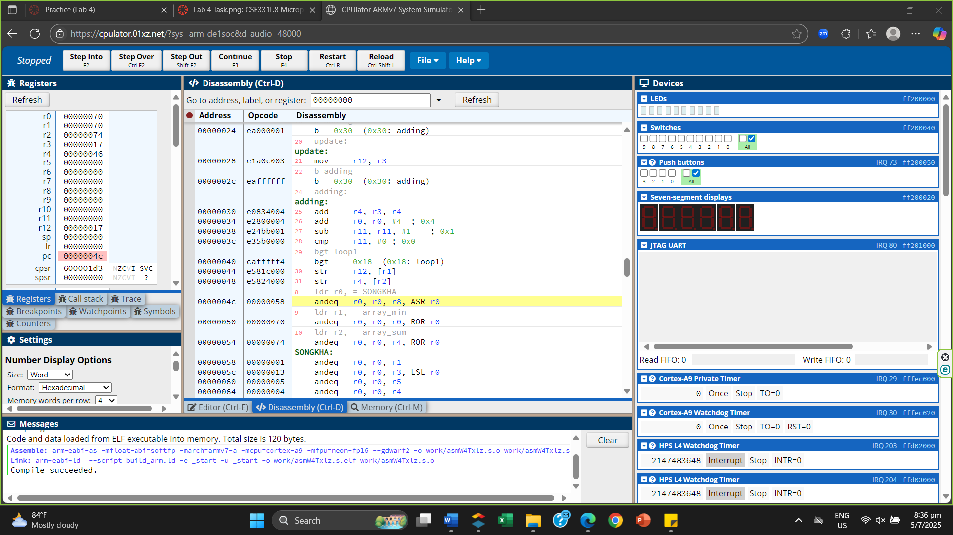
Memory
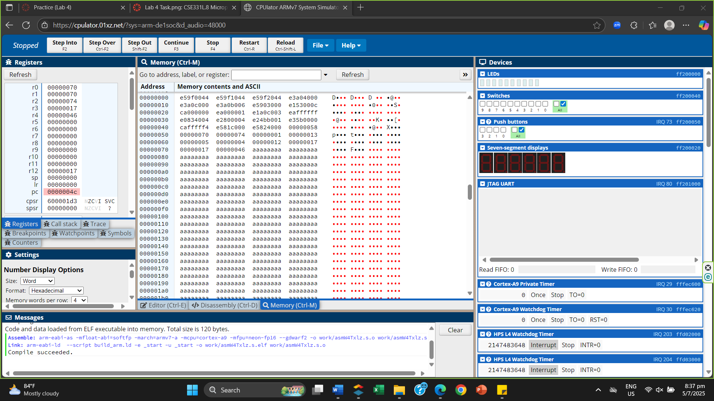

Q2
.global _start
_start:
mov r6,#-5
cmp r6,#0
bmi negative
mov r1,#0
b end

negative:
mov r1,#1
b end

end:
.end
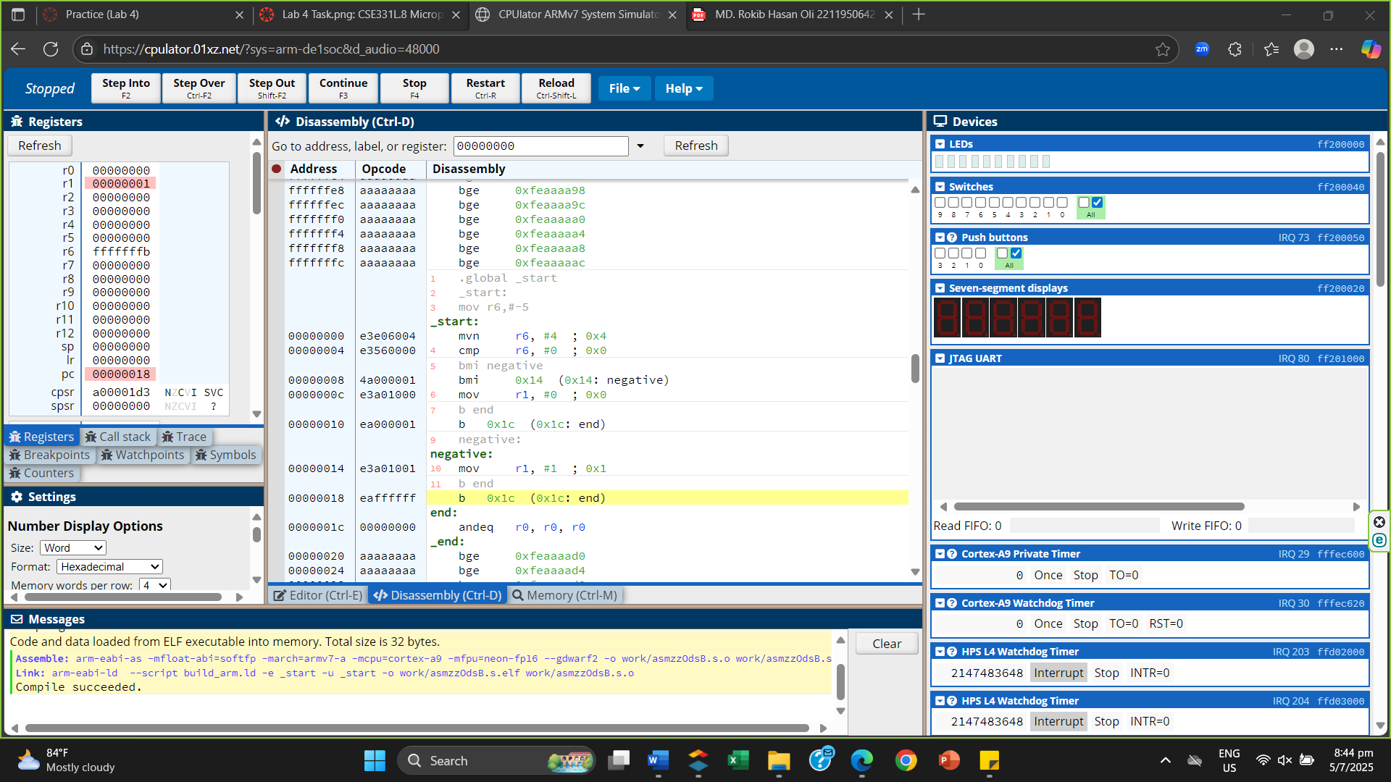
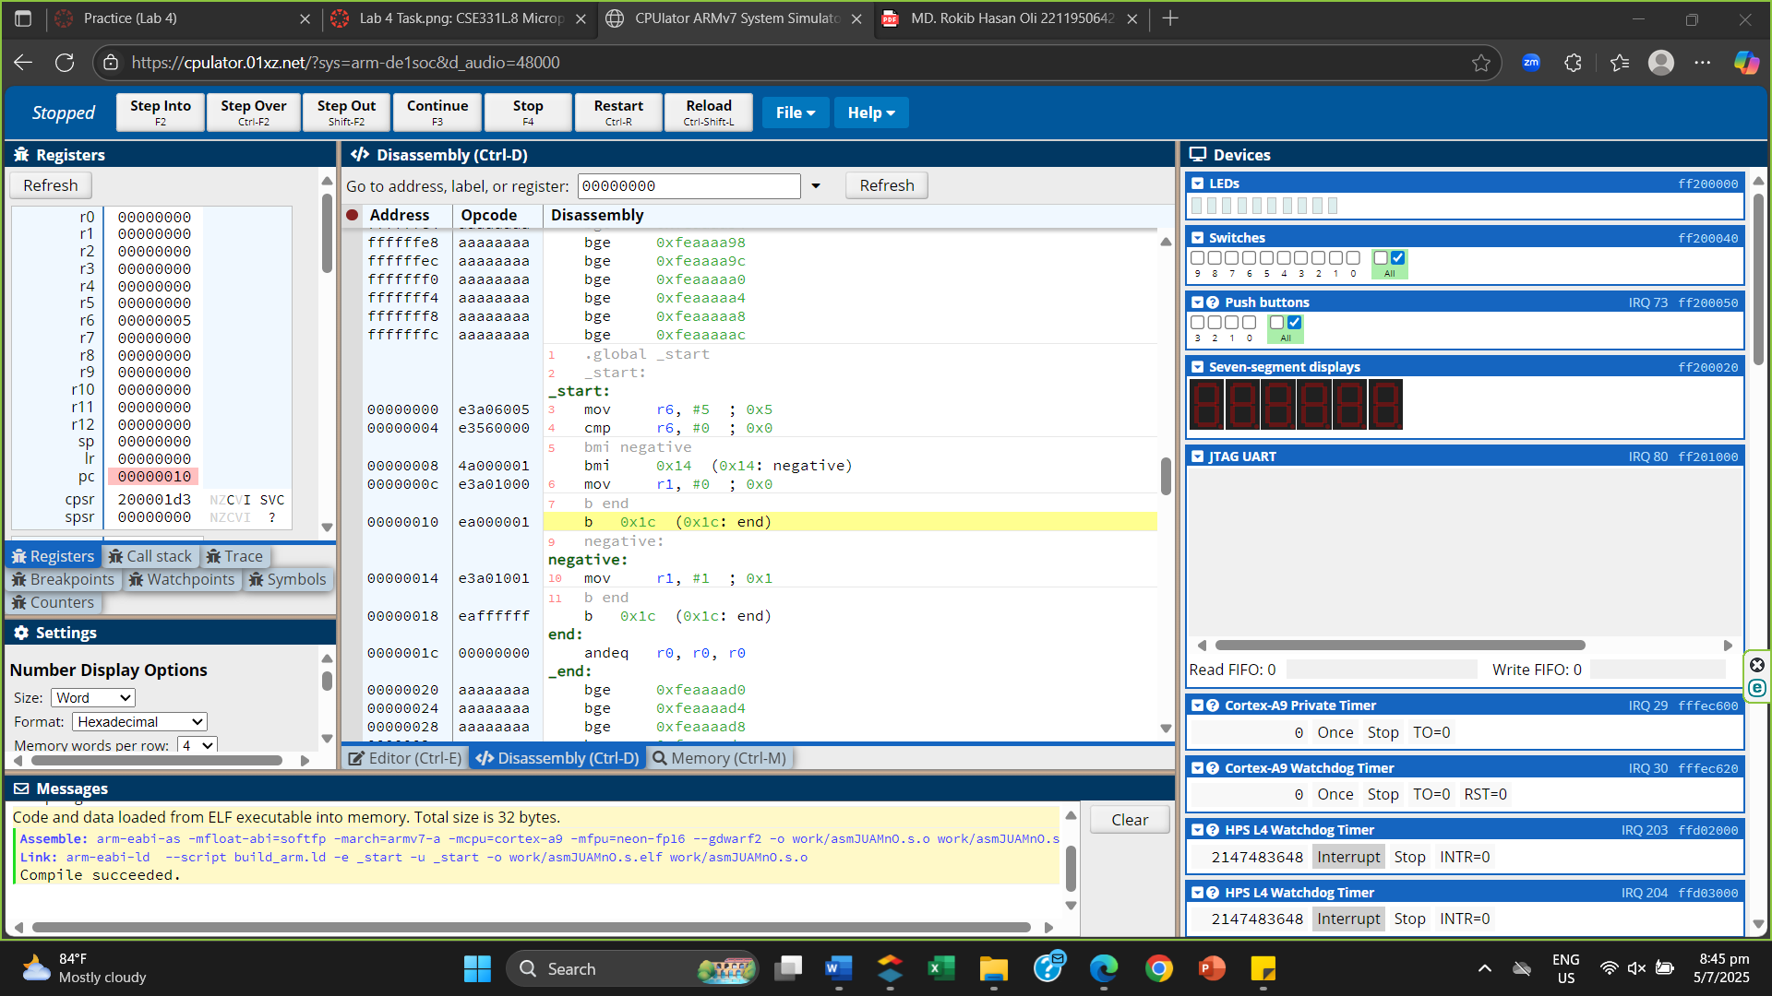
Q3
CPU later don’t support function.
.global _start
_start:
mov r1,#3
bl 8_diya_vaag

8_diya_vaag:
lsr r1,r1,#3
cmp r1,#0
beq check

mov r8,#3
b end

check:
mov r8,#2
b end

end:
.end
