QuizRush
Technical Documentation
Roko Pejo Bozic · Matej Pilic · Pavlo Nerekov · Maksym Moroz · Goran Jr. Skoric

Contents
1. Solution Overview 2
2. Solution Scope and Components 2
3. Architecture Overview 2
4. Environment Prerequisites 3
5. Installation and Setup 3
5.1 Database setup 3
5.2 API setup 4
5.3 Web and mobile setup 4
6. Database Design 4
7. API Reference 5
8. Real-Time Gameplay Reference 5
9. Key Workflows 6
9.1 Host creates quiz and launches session 6
9.2 Player joins and plays 6
9.3 Profile and statistics 6
10. Testing and Verification 7
11. Security, Privacy, and Data Handling 7
12. Limitations and Future Improvements 7
13. Appendix: Manual Test Checklist 7

Figures
Figure 1. QuizRush high-level architecture. 4
Figure 2. Entity relationship diagram for the final database model. 5
Figure 3. Main live gameplay sequence. 6

1. Solution Overview
QuizRush is a cross-platform real-time quiz platform. A registered host creates a quiz, opens a live game session, shares a six-character PIN code, and controls the flow of questions while players join from a browser or Android mobile app.
The final implementation combines a REST API for authentication, quiz management, profile updates, and session setup with SignalR for low-latency gameplay events such as joining, gambling decisions, question broadcast, answer submission, answer reveal, and leaderboard refresh.
Area | Final implementation
Primary clients | Blazor Server web application and .NET MAUI Android application
Backend platform | ASP.NET Core 8 Web API with JWT authentication and SignalR
Persistence | SQL Server / LocalDB with Entity Framework Core code-first migrations
Core differentiator | Real-time multiplayer gameplay with score-based virtual gambling

2. Solution Scope and Components
The system is scoped as a full-stack course project that demonstrates web, mobile, backend, database, real-time communication, authentication, and testing responsibilities. Real-money betting, payments, social networking, and production-grade cloud operations are outside the core scope.
Component | Technology | Responsibility
API | ASP.NET Core 8 | REST endpoints for authentication, quiz CRUD, profile updates, and game session creation.
Real-time hub | SignalR | Join flow, host controls, gambling phase, question lifecycle, answer reveal, and live scoreboards.
Web app | Blazor Server | Host dashboard, player join/play flow, quiz creation, account screens, and statistics views.
Mobile app | .NET MAUI Android | Mobile hosting, quiz builder, gameplay, account and statistics screens.
Database | SQL Server / LocalDB | Stores accounts, quizzes, questions, answers, sessions, players, answers, and gambling actions.
Tests | xUnit + WebApplicationFactory | Service tests, selected integration checks, and manual verification.

3. Architecture Overview
QuizRush follows a layered architecture. The client layer contains the Blazor web UI and the Android-targeted MAUI client. The application layer contains REST controllers, the SignalR GameHub, view models, and shared contracts. The infrastructure layer contains EF Core data access, password hashing, scoring, and session services. The data layer is SQL Server.
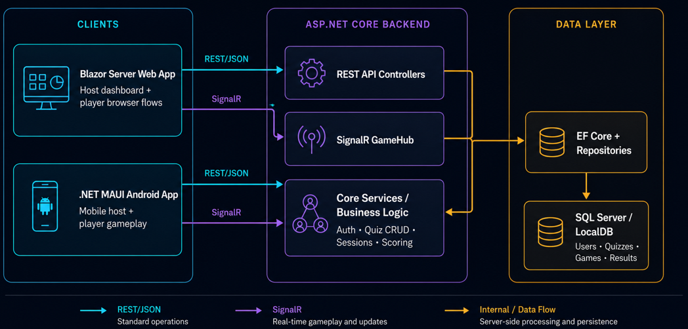
Figure 1. QuizRush high-level architecture.
Standard operations use HTTPS JSON requests. Live gameplay uses the /hub/game SignalR endpoint. This separation keeps normal CRUD operations simple while allowing synchronized multiplayer game events.

4. Environment Prerequisites
Target | Required software | Notes
Shared | .NET 8 SDK for API/web/tests; .NET 9 MAUI Android workload for the mobile app | Required for API, web, shared libraries, and tests.
Database | SQL Server LocalDB or SQL Server Express | Default development connection uses (localdb)\mssqllocaldb.
Mobile | .NET MAUI Android workload + Android SDK | Required to build and run the Android target.
Optional | Visual Studio 2022 or VS Code | Useful for debugging, migrations, and Android deployment.

5. Installation and Setup

5.1 Database setup
- Install SQL Server LocalDB or SQL Server Express.
- Confirm ConnectionStrings:Default in QuizRush.Api/appsettings.json or appsettings.Development.json.
- Start QuizRush.Api in Development mode. The application applies EF Core migrations automatically using db.Database.Migrate().
- For manual migration, run: dotnet ef database update --project QuizRush.Infrastructure --startup-project QuizRush.Api
Default development connection string:
Server=(localdb)\mssqllocaldb;Database=QuizRushDb;Trusted_Connection=True;TrustServerCertificate=True;MultipleActiveResultSets=true

5.2 API setup
- Install the .NET 8 SDK and verify the database connection string.
- Set Jwt:Key through configuration for non-development environments.
- Run the API with: dotnet run --project QuizRush.Api
- Open /swagger in Development mode to inspect the REST API.

5.3 Web and mobile setup
- Start the API first.
- Confirm QuizRush.Web/appsettings.json points QuizRush:ApiBaseUrl to the running API.
- Run the web app with: dotnet run --project QuizRush.Web
- Install MAUI Android workload and configure the mobile API base address so the emulator/device can reach the API.
- Build and deploy the Android target from Visual Studio or configured CLI tooling.

6. Database Design
The model separates reusable quiz content from runtime game data. This makes it possible to preserve quiz libraries independently from live session history and results.
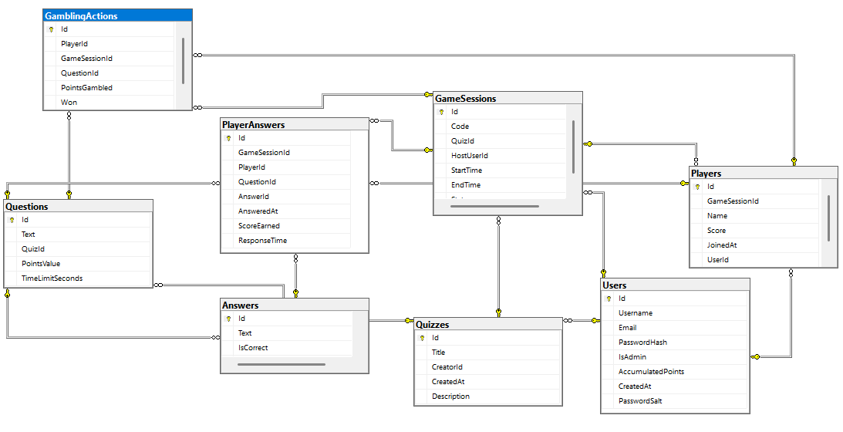
Figure 2. Entity relationship diagram for the final database model.
Entity / table | Key fields | Purpose
Users | Id, Username, Email, PasswordHash, PasswordSalt, IsAdmin, CreatedAt | Registered accounts used for authentication, ownership, and statistics.
Quizzes | Id, Title, Description, CreatorId, CreatedAt | Quiz metadata owned by a registered user.
Questions | Id, QuizId, Text, PointsValue, TimeLimitSeconds | Question bank entries linked to one quiz.
Answers | Id, QuestionId, Text, IsCorrect | Answer options for each question.
GameSessions | Id, Code, QuizId, HostUserId, Status, StartTime, EndTime | One live or completed session with a unique PIN/code.
Players | Id, GameSessionId, Name, Score, UserId, JoinedAt | Joined players, including anonymous and registered participants.
PlayerAnswers | Id, GameSessionId, PlayerId, QuestionId, AnswerId, ScoreEarned, ResponseTime | Answer submissions and earned points.
GamblingActions | Id, PlayerId, GameSessionId, QuestionId, PointsGambled, Won | Virtual point-risk decisions and outcomes.

7. API Reference
Method | Route | Auth | Purpose
POST | /api/auth/register | Public | Register a user after duplicate username/email checks and password hashing.
POST | /api/auth/login | Public | Authenticate and return JWT plus basic identity data.
GET | /api/quiz | JWT | Return quizzes owned by the authenticated user.
GET | /api/quiz/{id} | JWT | Return one owned quiz.
POST | /api/quiz | JWT | Create a quiz with questions and answers.
PUT | /api/quiz/{id} | JWT | Update an owned quiz.
DELETE | /api/quiz/{id} | JWT | Delete an owned quiz.
POST | /api/gamesession | JWT | Create a host session and generate a six-character PIN/code.
GET | /api/gamesession/{code} | Public | Return public session metadata by PIN.
GET | /api/gamesession/{id}/results | Public | Return final ranked results.
GET | /api/user/profile | JWT | Return current user profile.
PUT | /api/user/profile | JWT | Update username and email.
PUT | /api/user/change-password | JWT | Change password after validating the current password.
GET | /api/user/stats | JWT | Return personal statistics and completed game history.

8. Real-Time Gameplay Reference
The SignalR hub is the central coordinator for live gameplay. It accepts host commands and player events, updates session state, calculates scoring outcomes, and broadcasts state changes to connected clients.
Category | Methods / events
Host actions | HostGame, RejoinGame, StartGame, EndGamblingPhase, NextQuestion, EndGame
Player actions | JoinGame, SubmitAnswer, PlaceGamble
Server-to-client events | QuestionReady / QuestionDisplayed, GamblingPhaseStarted, AnswerRevealed, ScoresUpdated, HostSelfAck / HostPlayerNotice, GameEnded
Authentication detail | SignalR bearer authentication supports access_token query parameters because WebSocket clients cannot always send a standard Authorization header.

9. Key Workflows
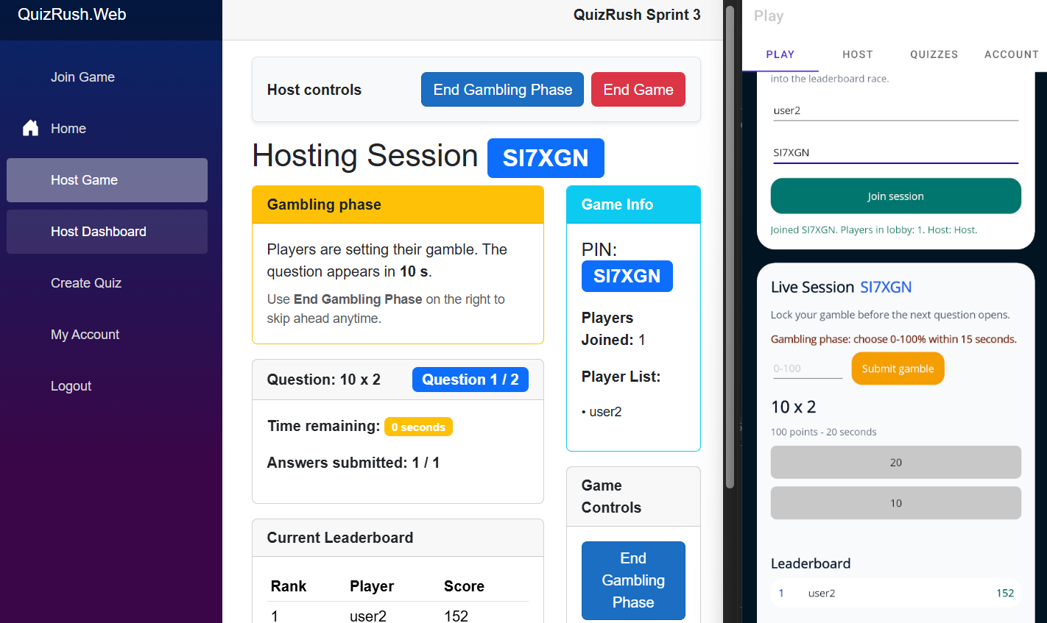
Figure 3. Main live gameplay sequence.

9.1 Host creates quiz and launches session
- Host signs in and receives JWT.
- Host creates or selects a quiz with questions, answers, timers, and points.
- API creates GameSession and generates a unique PIN/code.
- Host connects to SignalR GameHub and waits for players.
- Host starts game and advances through rounds.

9.2 Player joins and plays
- Player enters PIN and display name.
- SignalR registers player in the active session.
- In later rounds, the player can optionally gamble virtual points before the question is displayed.
- Player answers within the time limit.
- Hub calculates score, sends immediate answer feedback to the answering player, reveals the correct answer to the host, and broadcasts leaderboard updates.

9.3 Profile and statistics
- Registered user signs in from web or mobile.
- Client requests profile and statistics endpoints.
- User updates profile data or changes password.
- API validates ownership and persists changes securely.

10. Testing and Verification
Test area | Verification approach | Status
Score calculation and gambling | Unit tests for service logic and score outcomes. | Covered
Quiz service behavior | Unit tests for selected CRUD/service scenarios. | Covered
User profile and password changes | Service tests and manual verification. | Covered
Game session creation | Service-level tests and API startup/integration checks. | Covered
Swagger and API startup | WebApplicationFactory integration check. | Covered
SignalR hub connectivity | Integration check confirms hub accepts connection. | Covered
Full multiplayer UX | Manual web/mobile tests for host, join, play, and leaderboard flows. | Required for final demo

Manual verification remains important because live multiplayer behavior depends on real client timing, network conditions, and multiple simultaneous connections. The automated suite focuses on service/unit tests, selected integration checks, and API/SignalR connectivity rather than a full controller-by-controller test suite.

11. Security, Privacy, and Data Handling
Area | Current implementation | Assessment note
Authentication | JWT bearer tokens protect owner-only operations. | Appropriate for course-level API security and cross-client authentication.
Password handling | Passwords are hashed and salted using PBKDF2. | Plaintext passwords are not stored.
Authorization | Quiz ownership and user profile operations are restricted to authenticated users. | Prevents users from managing another host’s content.
Guest participation | Anonymous players join with a display name and session PIN. | Supports low-friction gameplay while limiting stored guest data.
Personal data | Registered users store username, email, password hash/salt, and history/statistics. | Future work should add full self-service account deletion and export.
Transport and configuration | Local development uses HTTP; production should enforce HTTPS and secure JWT secrets. | Important deployment requirement beyond local demo.

12. Limitations and Future Improvements
Limitation / opportunity | Recommended improvement
Mobile platform limited to Android target | Add iOS support once MAUI configuration and testing time allow.
Manual deployment process | Add repeatable Docker/cloud deployment pipeline for staging and production.
Limited load evidence | Perform realistic load testing with simulated concurrent players.
No full right-to-be-forgotten flow | Add self-service account deletion and data export.
No LMS or corporate platform integration | Expose integration hooks and LMS-compatible exports.
No public quiz marketplace | Add sharing/discovery features while preserving self-hosting option.

13. Appendix: Manual Test Checklist
- Register a new user and log in successfully.
- Create a quiz with multiple questions and valid answers.
- Launch a game session and confirm a six-character PIN/code appears.
- Join the session from a browser as a guest player.
- Join the same session from the Android client.
- Start the game and confirm all players receive the same question.
- Place a gamble before a question and verify lock behavior.
- Submit answers from multiple players and verify scoring.
- Advance to the next question and confirm leaderboard updates.
- End the game and verify final rankings/results.
- Update profile and change password as a registered user.
- Review personal statistics/history after a completed game.

