**RESUME** 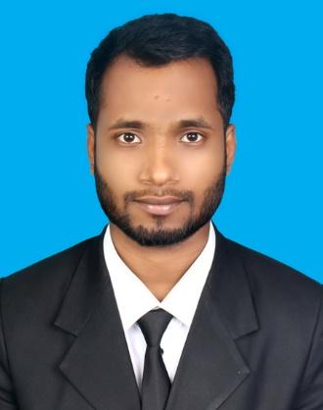

**OF**

***Md.Rokonuzzaman***

**Mailing Address:**

7/12C, Block-B, Lalmatia, Dhaka-1207

Contact No: +8801767303353

E-mail Address: rokonuzzaman254@gmail.com

**OBJECTIVE**

Intend to work in a challenging and creative environment where strong sense of responsibility and commitment is required. I wish to contribute my knowledge, efficiency and creativity strengthening your organization and besides, I get an opportunity to build up own career also.

**EDUCATIONAL BACKGROUND**

|  |  |  |  |
| --- | --- | --- | --- |
| **Degree** | **Institution** | **Score** | **Passing Year** |
| Bachelors of Science (B.Sc) in  Computer Science & Engineering | Daffodil International University | Cgpa-3.47 (Out of 4) | 2019 |
| Higher Secondary Certificate (HSC) | Kurigram Government College | 4.63 (Out of 5.00) | 2015(Dinajpur) |
| Secondary School Certificate (SSC) | Kurigram Government High School | 4.81 (Out of 5.00) | 2013(Dinajpur) |

**EXPERIENCES**

* **MyStore** Android application (For semester final project)
* **Teacher Info**. Android application (For semester final project)
* **TicTacToe** Android application (From personal interest)
* **Snake Game** by only C language (For semester final project)
* **Restaurant Management System** by only JAVA language with GUI (For semester final project)
* **College Database** by SQL (For semester final project)
* **Train with Moving plane** Open GL Project by C++ (For semester final project)
* **SVM on Iris Flower Dataset** with python (For semester final project)
* **Lab Prefect** at Daffodil International University (6 semester)

**UNDERGRADUATE THESIS**

“Rice Disease Classification using Deep Convolutional Neural Networks”

**Supervisor**: Nafis Neehal(Lecturer at DIU)

**TECHNICAL SKILLS**

* Programming languages: Python, C, Java
* Web Languages: HTML, CSS, PHP
* Version Control: GitHub
* OS: Linux (Ubuntu)
* Machine Learning
* Android App Development
* Database: SQL, Oracle 11g

**COMPETITIVE PROGRAMMING**

* Problem Solving: URI Online Judge(200+)
* Major Programing Contest: Take Off Programing Contest of DIU

**LANGUAGES**

**Speaking Listening Reading Writing**

* Bengali Excellent Excellent Excellent Excellent
* English Excellent Excellent Excellent Excellent

**PERSONAL INTERESTS**

I have interest in reading books & papers, watching drama, playing Cricket, Football, Traveling & Browsing Internet.

**PERSONAL SKIL**

* Self-Motivated.
* Social Service
* Energetic.
* Manage & Maintain.
* Good Relation with Friend Circle.
* Have an Excellent Presentation skill both Bangla and English.

**PERSONAL DETAILES**

Name : Md. Rokonuzzaman

Father’s name : Md. Amir Hossain

Mother’s name : Mst. Rohima Begum

National ID number : 1996492520000057

Permanent Address : Vill: Hospitalpara, P.O: Kurigram,

P.S: Kurigram Sadar, Dist: Kurigram

Religion : Islam

Date of birth : 29 July, 1996

Sex : Male

Nationality : Bangladeshi (By birth)

Marital Status : Single

Religion : Islam

Height : 5 ft 6 inc.

Blood group : O+ (positive)

**REFERENCES**

* Majidur Rahman

Lecturer, Daffodil International University

Tel: +8801913808126

Email: majidur.cse@diu.edu.bd

* Aniruddha Rakshit

Senior Lecturer, Daffodil International University

Tel: +8801712937997

Email: aniruddha.cse@diu.edu.bd

**CERTIFICATION**

I, the undersigned, certify that according to the best of my knowledge and belief, this resume correctly describes my qualifications, and me.



……………………

(MD. Rokonuzzaman)