ClarinHelp
Teaching a computer to listen to my clarinet

Roland Fontanes

Table of contents
Introduction 3
What is ClarinHelp? 3
A bit of music and physics 4
What method? 5
Checking YIN with a neural network 6
Appendices 8
Glossary 9

Introduction
Nowadays, apps that listen to music are everywhere. Your phone can recognize a song playing in a café in a few seconds with Shazam, and a tuner app tells you when your guitar is out of tune. I study Artificial Intelligence at EFREI and I play the clarinet, so one question always came back to me: how does a program actually know that I am playing a C, and that I am a bit too high? I never had a real excuse to find out, so I created one: build my own app, from scratch, mixing my two passions : music and AI.
This project is called ClarinHelp. In this report I will explain how it works and more importantly what I learned : cleaning and organizing data, signal processing, getting deeper in deep learning and all those three while staying organized. I tried to keep it readable for anyone, even if you have never touched a clarinet or written a line of code, I hope you will enjoy it.

What is ClarinHelp?
ClarinHelp is a web app that listens to a clarinettist through a simple microphone. The final goal is to:
- recognize the piece being played from a few seconds of melody, wherever the player starts, even with another tempo, another key or a few wrong notes;
- follow the score in real time while the player plays;
- give feedback on every note: too high, too low, wrong note, missed note;
- show a summary at the end of the piece.
The target user is a beginner who plays simple folk tunes like Au clair de la lune or Ode to Joy. Everything runs directly in the web browser and the sound you record never leaves your computer.
I did not build all of this at once. The project is split into small milestones, and each one has to work, and be measured, before moving to the next one:
# | Milestone | Status
1 | Real-time tuner | Done
2 | Note transcription and its evaluation | In progress
3 | Score display and alignment | To do
4 | Real-time score following | To do
5 | Piece recognition from the melody | To do
6 | Deployment and demo | To do

Today the first part works: a real-time tuner that shows the note being played and how many cents (see below) it is too high or too low. I also recorded and annotated my own dataset of 42 recordings, to measure everything I build on a real clarinet.

A bit of music and physics
Before talking about AI, we need to understand what a note is for a computer. So let’s start from the beginning.
A sound is a vibration of the air. When I play a note, the reed vibrates and the air inside the clarinet vibrates with it, hundreds of times per second. The microphone measures the air pressure 48,000 times per second (sample rate), so in the end the computer only sees a very long list of numbers.
If we zoom on 43 milliseconds of my first note (Figure 1, bottom), we can see that the same shape repeats again and again. The duration of one repetition is the period, and the number of repetitions per second is the frequency (in Hertz Hz). Here the shape repeats every 4.27 ms, which gives us 234 Hz.
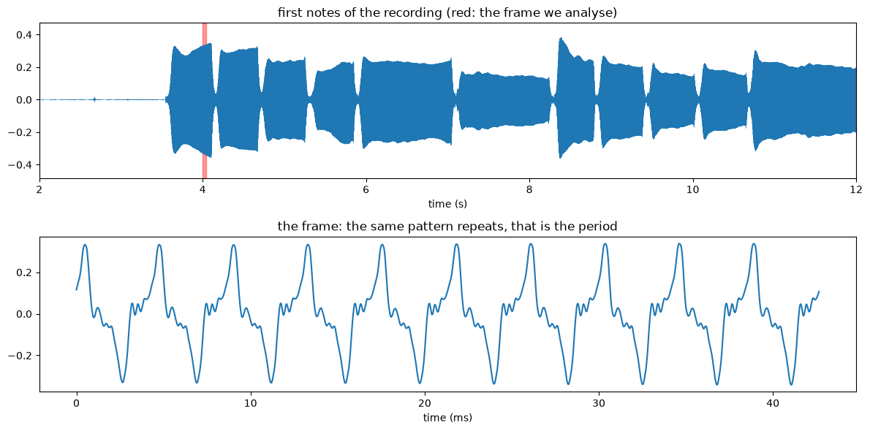
Figure 1 : The first notes of Au clair de la lune that I recorded (top) and 43 ms of the first C (bottom)
So finding the note means finding the period. But a few things make it less simple than it looks.
Notes are not linear. Going up one octave means doubling the frequency: the A in the middle of the piano is 440 Hz, the next A is 880 Hz. An octave is divided into 12 semitones, so each semitone multiplies the frequency by about 1.06. To work with notes more easily, musicians and programs use MIDI numbers: one number per semitone, 60 for middle C and 69 for the A at 440 Hz.
Cents measure how out of tune you are. A cent is one hundredth of a semitone. A few cents are very hard to hear, while a quarter of a semitone (25 cents) already sounds clearly out of tune. The tuner shows this deviation with a needle, from −50 to +50 cents.
The clarinet is a transposing instrument. My clarinet is in B, so when I read and play a written C, the sound that comes out is a B♭, two semitones lower. That is why the 234 Hz above is a B♭3 for a physicist, but a C4 for me. ClarinHelp always displays the written note, the one the clarinettist reads on the sheet. And since a perfect B♭3 is 233.1 Hz, I was 9 cents too high on this note.
Every note contains several frequencies. The bumps inside each period are the harmonics: frequencies 2, 3, 4… times the fundamental, all played at the same time. Their balance is the timbre, which is why a clarinet and a flute playing the same note do not sound the same. The clarinet is special because its low notes have mostly odd harmonics (3, 5, 7 times the fundamental). This matters a lot for pitch detection, as we will see now.

What method?
Now that we know what we are looking for, how do we find the pitch in a list of numbers? Reading about pitch detection, I found three big families of methods.
First, the spectrum. The Fast Fourier Transform (FFT) splits a sound into all the frequencies it contains; this is what a spectrogram shows. The simplest idea is to take the strongest frequency. The problem: the strongest one is not always the fundamental. If the third harmonic is louder, the program finds a note an octave and a fifth too high.
Then, the time domain. Instead of looking at frequencies, we compare the signal with a shifted copy of itself: when the shift is exactly one period, the two copies line up. This is the idea of autocorrelation and of YIN : an algorithm published by Alain de Cheveigné and Hideki Kawahara in 2002, which adds a few clever steps to avoid the classic mistakes (Figure 2).
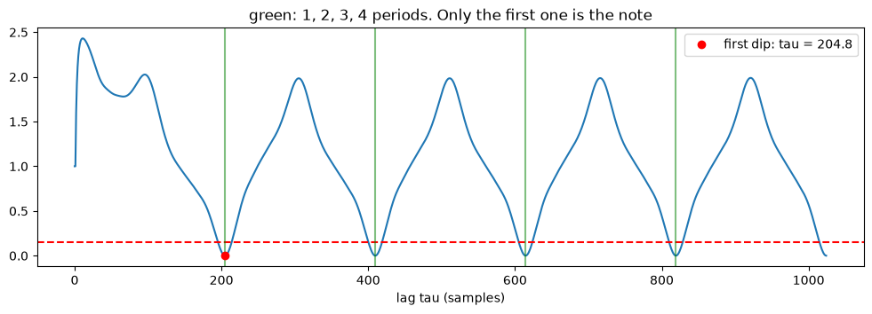
Figure 2 : YIN on the frame of Figure 1. The curve goes down at 1, 2, 3 and 4 periods (green lines); YIN keeps the first dip under the threshold (red dot)
The curve of Figure 2 goes down at every multiple of the period, and all the dips are almost as deep. Taking the lowest one could give a note one or two octaves too low, so YIN takes the first dip under a threshold. On my C, it finds a period of 204.8 samples, and 48,000 / 204.8 gives the 234 Hz we saw.
Finally, learning. Neural networks like CREPE (Kim et al., 2018) are trained on thousands of recordings where the pitch is known, and learn to recognize it by themselves. They are very robust, but heavier.
For the app, I chose YIN: it is fast enough to run in real time in any web browser, it does not need any model to download, and I can understand and test every line of it. CREPE is not forgotten though. I use it offline as an independent reference to check YIN, which turned out to be one of the most interesting things I learned in this project, as we will see later.

Checking YIN with a neural network
At this point, the tuner worked and YIN seemed right when I played in front of it. But “it seems right” is not a measure. I wanted a number: how often does YIN find the right pitch on a real clarinet?
The problem: who checks the checker? To measure YIN, you need a ground truth: the list of the notes I really played, with their start and end times. I recorded 42 files (chromatic scales and 12 simple tunes, played clean, freely, with deliberate mistakes or in another key) and annotated them. The names of the notes come from the scores, which I played as written, so they are exact. But the times were placed automatically, on the segments found by… YIN itself. So when I first compared YIN to these annotations, I got 100% of right pitches. It looks great, but it means nothing: it is like grading your own exam. During evaluation, the ground truth must never come from the system you are evaluating.
A second opinion is needed because if two methods that have nothing in common give the same answer, it is very unlikely that they both make the same mistake at the same moment. So I needed a pitch detector that does not work like YIN at all. That is CREPE (not the sweet treat, actually… I might need one after this project).
What is CREPE? CREPE (Kim et al., 2018) is a convolutional neural network (CNN). It takes 1024 samples of sound (64 ms, at 16,000 samples per second) and passes them through six layers of filters. The first layers learn to detect small patterns in the waveform, the next ones combine them into more complex shapes. At the end, the network gives 360 probabilities, one for each slice of 20 cents between a very low C1 and a high B7. It learned all of this by itself, from thousands of recordings where the pitch was known. I used torchcrepe, a version of CREPE written with PyTorch, the deep learning library I will also use later in the project. Everything runs on the CPU of my laptop.
First surprise: always test your tools before using them! I gave it a perfect 440 Hz sound, where I know the answer. With its default settings, it was wrong by up to 24 cents. The probable cause is that by default torchcrepe returns the centre of the most likely 20-cent slice, so its answer jumps from slice to slice. With a weighted average around the best slice, as in the original CREPE, the error dropped to about 5 cents (+4.9 cents at 440 Hz, −1.7 cents at 234 Hz)
Second surprise: deep learning is heavy. The full CREPE model has about 22 million parameters. On my CPU it needs around 20 seconds to analyse 10 seconds of audio, so it could never run live in the browser. That is fine here: CREPE runs once on each recording, offline, and its results are saved.
Finally I compared YIN to CREPE on the 16 recordings of my validation set. I only kept the middle half of each annotated note, where the note is stable, without its attack and its end: 9,975 moments in total.
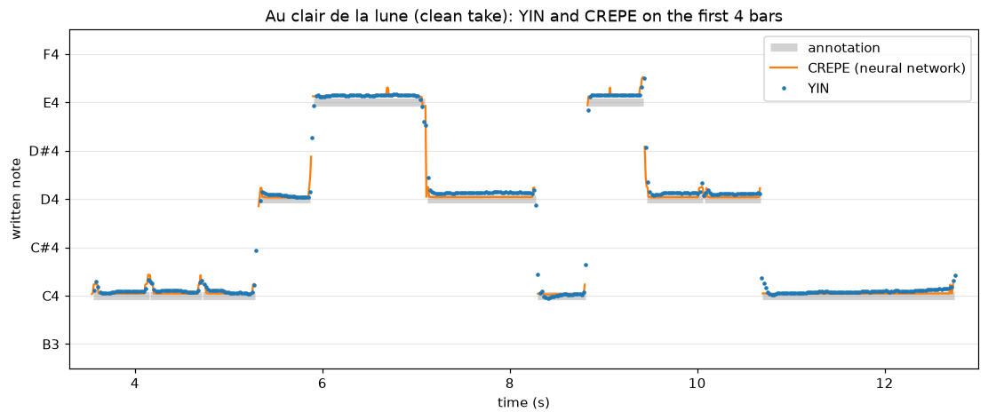
Figure 3 : YIN (blue dots) and CREPE (orange line) on my clean take of Au clair de la lune, with the annotated notes in grey
Measure | Result
Moments compared | 9,975 (16 recordings)
YIN and CREPE more than 50 cents apart (wrong note, octave error) | 0 (largest gap: 20.6 cents)
Median gap between YIN and CREPE | 5.1 cents
YIN and CREPE within 10 cents | 84.1% of the moments
CREPE finds the annotated note (within 50 cents) | 100% of the moments
My tuning according to YIN / CREPE | +12.5 / +7.7 cents
Table 1 : YIN vs CREPE on the validation set (details per recording in Appendix A)
What does it tell us?
- YIN never picks the wrong note on sustained notes: not a single moment more than 50 cents away from CREPE, so no octave error which can be a classic trap of pitch detection based on what I read.
- The annotations are confirmed. CREPE, which has nothing to do with YIN, finds the annotated note 100% of the time. The 100% that meant nothing before is now backed by an independent method.
- I play a bit sharp. Both detectors agree that I am too high, by about 8 to 13 cents. They differ by about 5 cents on the exact value, which is the precision of CREPE I measured on the pure sound, so I cannot say which one is closer at that level.

Appendices
Appendix A : Structure of a clarinet and reed
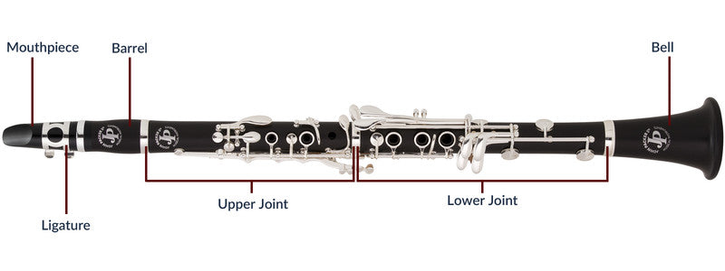
https://johnpacker.co.uk/cdn/shop/files/clarinet_buyers_guide.jpg?v=1662635931

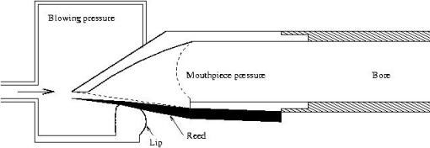
https://acoustics.org/pressroom/httpdocs/146th/clarinet.jpg

Appendix B : YIN vs CREPE, recording by recording
Results of ml/scripts/compare_pitch.py on the 16 recordings of the validation set. Gaps and tuning are in cents; “< 10 c” and “< 50 c” are the share of moments where YIN and CREPE are within 10 and 50 cents, “CREPE note” the share where CREPE is within 50 cents of the annotated note.
Recording | Moments | Median gap | < 10 c | < 50 c | CREPE note | Tuning YIN | Tuning CREPE
scale_chromatic_01 | 772 | 4.5 | 93.8% | 100.0% | 100.0% | +9.2 | +6.4
scale_chromatic_02 | 769 | 3.2 | 94.0% | 100.0% | 100.0% | +2.3 | +5.0
au_clair_clean_01 | 820 | 6.9 | 75.0% | 100.0% | 100.0% | +12.7 | +4.5
au_clair_free_01 | 597 | 6.7 | 85.3% | 100.0% | 100.0% | +12.1 | +4.6
au_clair_errors_01 | 790 | 4.5 | 92.3% | 100.0% | 100.0% | +10.2 | +4.1
au_clair_transposed_01 | 796 | 4.5 | 81.0% | 100.0% | 100.0% | +12.5 | +6.1
frere_jacques_clean_01 | 391 | 4.2 | 87.2% | 100.0% | 100.0% | +15.1 | +8.6
frere_jacques_free_01 | 442 | 5.5 | 76.5% | 100.0% | 100.0% | +12.0 | +6.4
frere_jacques_errors_01 | 390 | 3.7 | 91.8% | 100.0% | 100.0% | +11.3 | +5.6
twinkle_clean_01 | 605 | 5.4 | 76.0% | 100.0% | 100.0% | +17.6 | +13.0
twinkle_free_01 | 616 | 7.1 | 70.0% | 100.0% | 100.0% | +16.9 | +7.5
twinkle_errors_01 | 585 | 6.1 | 85.3% | 100.0% | 100.0% | +15.2 | +6.8
twinkle_transposed_01 | 589 | 6.5 | 82.2% | 100.0% | 100.0% | +14.1 | +6.6
jingle_bells_clean_01 | 679 | 3.6 | 89.4% | 100.0% | 100.0% | +12.7 | +13.2
jingle_bells_free_01 | 473 | 5.4 | 79.1% | 100.0% | 100.0% | +11.5 | +12.0
jingle_bells_errors_01 | 661 | 3.5 | 87.6% | 100.0% | 100.0% | +14.0 | +13.3
mean (16 recordings) | 623 | 5.1 | 84.1% | 100.0% | 100.0% | +12.5 | +7.7

Glossary
Sample rate: number of measurements of the sound per second (48,000 here).
Frequency: number of vibrations per second, in Hertz (Hz).
Period: duration of one repetition of a periodic sound; frequency = 1 / period.
Octave: interval between two notes whose frequencies differ by a factor of 2.
Semitone: one twelfth of an octave, the smallest step between two notes on a piano.
MIDI number: one number per semitone (60 = middle C, 69 = A at 440 Hz).
Cent: one hundredth of a semitone, used to measure tuning.
Transposing instrument: instrument whose written notes differ from the notes that sound (B♭ clarinet: two semitones lower).
Harmonics: frequencies that are multiples of the fundamental; their balance gives the timbre.
FFT (Fast Fourier Transform): fast algorithm that splits a signal into the frequencies it contains.
YIN: pitch detection algorithm working in the time domain (de Cheveigné & Kawahara, 2002), used by the ClarinHelp tuner.
CREPE: neural network for pitch detection (Kim et al., 2018), used offline as a reference.
CNN (Convolutional Neural Network): neural network made of layers of filters that learn to detect patterns, first simple then more complex.
PyTorch: Python library to build, train and run neural networks.
Ground truth: the correct answers a system is compared to (here, the notes I really played and their times).
Annotation: the work of writing down the ground truth for each recording.
Validation set / test set: recordings used to tune and check the system / recordings kept aside and used only once, at the end, for the final numbers.

