**Los Santos Customs**

By Max Bortolotti & Roland Fontanes

Prom 2027 - 5th Semester Advanced Web Programming

**Table of contents**

Gant Diagram 3

Entity Relation Diagram 3

Use Case Diagrams 4

UC CRUD 4

UC Login 5

Activity Diagrams 6

Customize & Buy 6

Login 6

Sequence Diagrams 7

Sequence Filter 7

Sequence Login 8

Wireframes 9

Home Page 9

Purchase Page 10

Component Diagrams 11

Customize 11

Authentication 11

Class Diagram 12

# Gant Diagram

The Gantt Diagram is used to predict the schedule of the project. But as the project evolves, the diagram evolves too to match the deadlines and the advancement of the team.

# Entity Relation Diagram

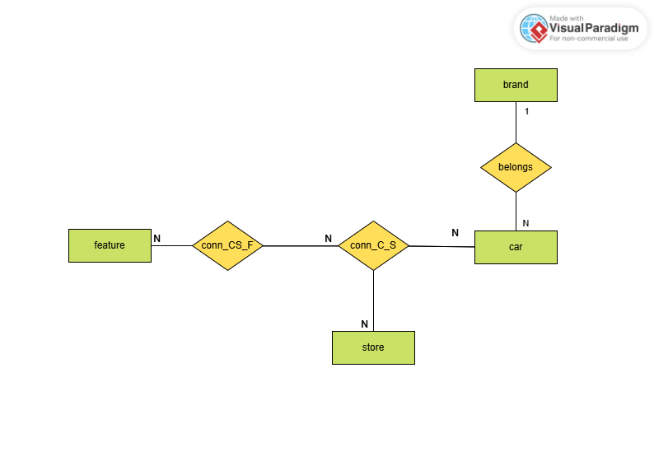

This ER helps to understand how our DataBase is structured by mapping the relations between the different entities such as feature, store, car and brand. The connection tables (conn_CS_F & conn_C_S) helps to customize the car with features and decide in which store is this car

# Use Case Diagrams

## UC CRUD

This Use Case Diagram details the create, read, update, and delete operations available for the different actors involved. Here, guest can only list all cars, brands and features. Users can process the same operations but by creating an account, they can also manage their orders and purchase cars. Finally, the admin can edit every features, cars and brands.

## UC Login

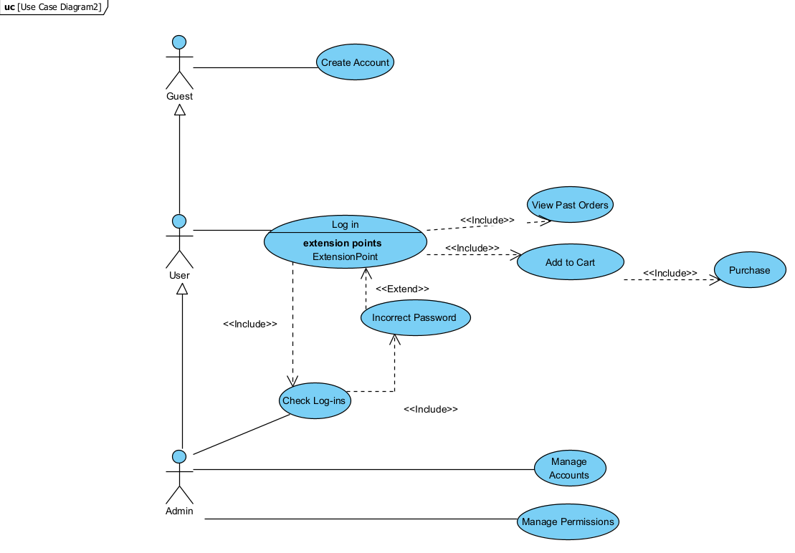

To focus more on authentication, we create this Use Case Diagram to simulate the different options to register and the different permissions of each guests, user and admin people.

# Activity Diagrams

## Customize & Buy

This diagram focuses on the different steps to customize a car and buy it. The user can make several decision that will impact his experience. For example you can either select one car and purchase it or select one car, continue shopping, purchase the second car, and then view the order.

## Login

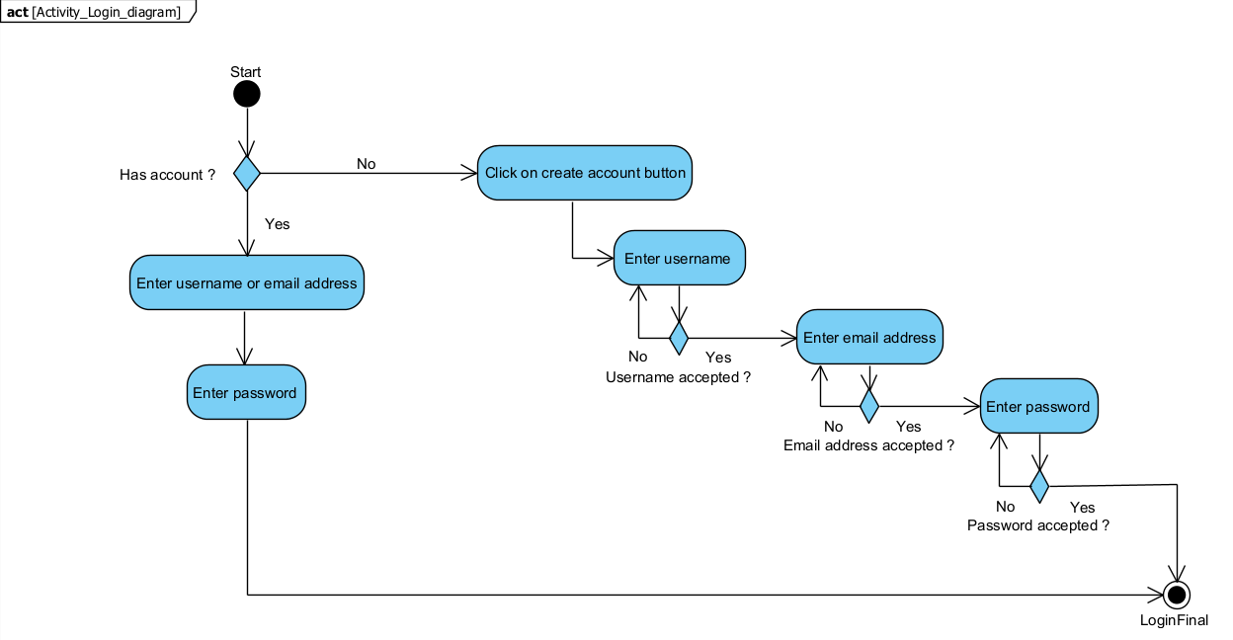

Similar to the Use Case Login Diagram, this activity diagram provides a more detailed sequence of the actions taken Register/Login. You can see that several steps are needed because we need at least a username, an email address and a password to ensure the security of our website and our customers.

# Sequence Diagrams

## Sequence Filter

This diagram illustrates the interactions between the system components when a user applies filters to search for specific car models or customization options. We implemented filtering by brand, sort by price and a search option to simplify the user’s actions.

## Sequence Login

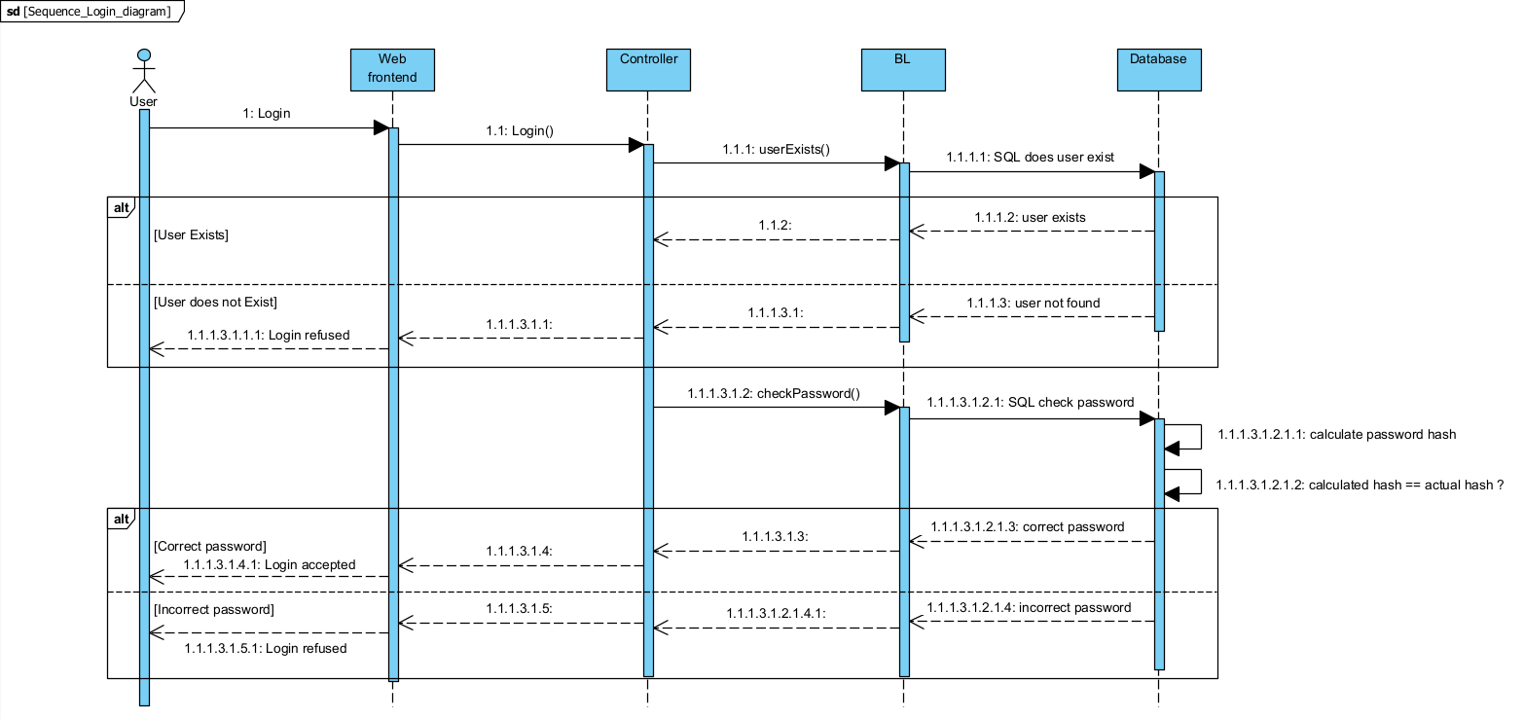s

The Sequence Login depicts the flow of operations during the login process, showing the interaction between the user, the web front-end, the controller, the Business Logic and the database. It shows the different operations between each layer.

# Wireframes

## Home Page

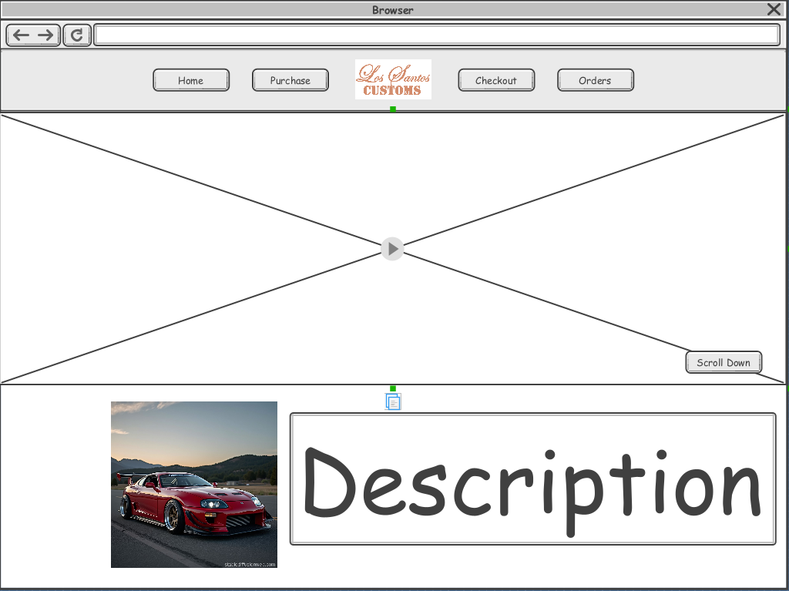

## Purchase Page

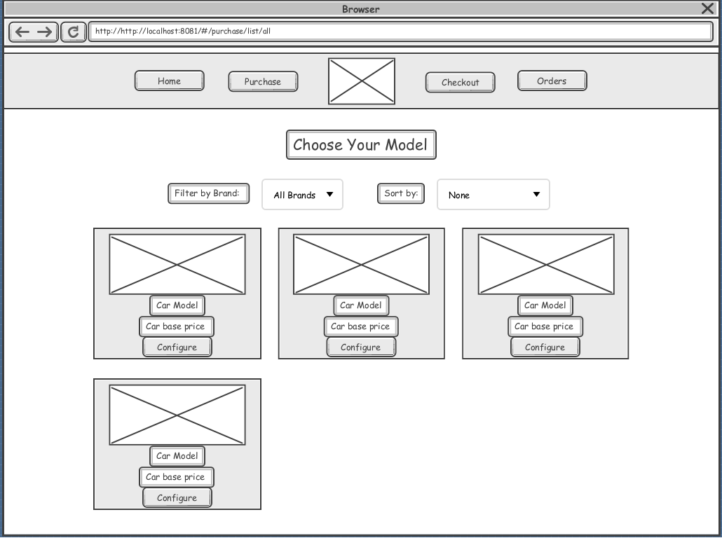

# Component Diagrams

## Customize

This diagram displays how the editing, listing and choosing actually works. It shows the links between our database and website when someone tries to perform these actions.

## Authentication

This one shows the different request send to the database and the different accesses each process can have depending on the type of connection the customer is using. As an example, for a simple guest the website do not need to access the account component but can still list the cars.

# Class Diagram

The Class Diagram shows the interactions between every entities in all the processes involved in our website. You have the basic entities of our database but they are ruled by the manager which obey to the customer’s will.