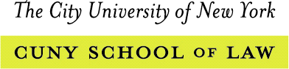
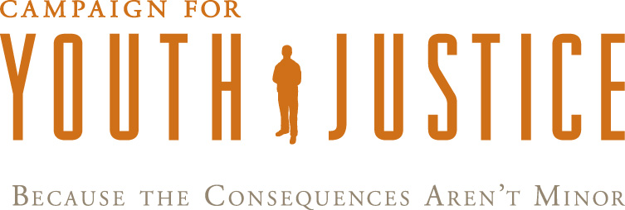

United States Report Card: Youth Justice Issues

UN Human Rights Committee Review
One-Year Follow-Up

May 1, 2015

In the spring of 2014, the U.S. was reviewed by the U.N. Human Rights Committee on its compliance with the International Covenant on Civil and Political Rights. Following the review, the Committee issued Concluding Observations and Recommendations that expressed serious concern about a number of human rights issues, including youth justice. One year after the review, this report card describes actions taken at the federal and state level that respond to the youth justice recommendations and the urgent further actions that must be taken to bring the U.S. into compliance with its human rights obligations.

Submitted by:

International Women’s Human Rights Clinic
City University of New York Law School
ACLU Michigan/Juvenile Life Without Parole Initiative
Campaign for Youth Justice
The Project on Addressing Prison Rape
American University, Washington College of Law

Contact:
Cynthia Soohoo, cynthia.soohoo@law.cuny.edu; 01-718-340-4329

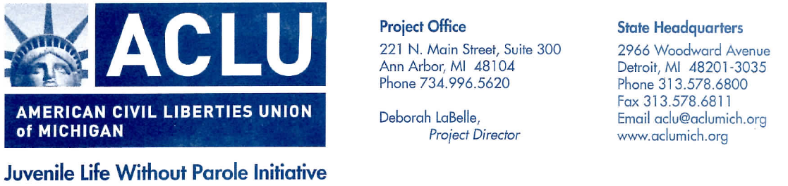
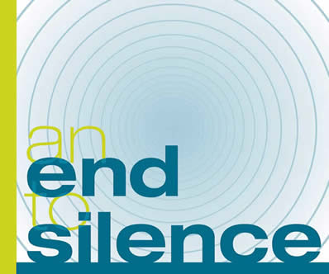

Juvenile Life Without Parole Sentences
Committee Recommendation
“The State party should prohibit and abolish the sentence of life imprisonment without parole for juveniles, irrespective of the crime committed, as well as the mandatory and non-homicide related sentence of life imprisonment without parole.” ¶ 23

Grade
C (Reply/action by the state party is not satisfactory)

Action Taken By the State
In 2014, West Virginia and Hawaii completely abolished juvenile life without parole sentences, bringing the total number of states that do not impose juvenile life without parole sentences to 13 states and the District of Columbia.
In Miller the Supreme Court limited the imposition of juvenile life without parole sentences to instances where children have been convicted of homicide offenses and have been given an individualized sentencing hearing. However, as of June 2014, only thirteen of the 28 states that imposed mandatory life parole sentences for juveniles convicted of homicide offenses had passed laws to change their sentencing structures.
In addition, not all states are giving Miller a retroactive effect. Courts in four states have ruled that Miller is not retroactive and continue to enforce mandatory life without parole sentences imposed on juveniles. In a shadow report to the Human Rights Committee, prior to the March 2014 review, CUNY Law School’s International Women’s Human Rights Clinic identified three state supreme courts that had ruled that Miller is retroactive. Since then state supreme courts in seven additional states have also ruled that Miller is retroactive, bringing the total number to ten states. In addition, in four states, there have been legislative efforts to make Miller retroactive by allowing for resentencing hearings. On March 23, 2015, the United States Supreme Court agreed to hear Montgomery v. Louisiana for the purpose of clarifying whether Miller should be applied retroactively in all fifty states.
Further Actions Needed
- All states should follow the lead of West Virginia and Hawaii and abolish life without parole for juveniles.
- States should ensure full compliance with Miller by amending their sentencing laws and applying the decision retroactively.
- States should prohibit juvenile sentences of extreme length that constitute de facto life without parole sentences.
Separation of Juveniles in Detention and Transfers to Adult Courts
Committee Recommendation
“[The State party] should also ensure that juveniles are separated from adults during pretrial detention and after sentencing, and that juveniles are not transferred to adult courts.” ¶ 23

Grade
C- (Reply/action by the state party is not satisfactory)

Action Taken By the State
Separation. The federal government set May 15, 2014 as the deadline for states to submit compliance certifications or assurances in response to standards developed for the Prison Rape Elimination Act (PREA). The standards include a requirement that children be separated from adults in jails and prison facilities. As of the deadline, only two states certified full compliance with these standards. Seven states and one territory refused to comply with PREA altogether. The majority of states (46 states and territories) remain somewhere in between, submitting assurances to work toward compliance. A few (notably Nevada, Texas and Ohio) undertook action toward compliance in 2014, but it is unclear when, or if, the majority of states that issued assurances will be in compliance.

Transfer. In 2013-14, fourteen states and Washington, D.C. engaged in legislative efforts to reform and limit the ways that youth can be transferred into adult courts. Out of these jurisdictions, New York, Missouri, Maryland, and Nevada developed task forces to: (1) identify the ways that youth end up in the adult criminal system and (2) suggest more rehabilitative options for youth. To date, New York and Missouri have introduced legislation based on the task force recommendations. Nebraska and Indiana passed legislation making it more difficult to try youth as adults for certain offenses. In Indiana, legislation was passed to give juvenile courts jurisdiction over youth charged with gang related activity and to require that youth tried as adults serve their sentences in juvenile facilities.
Further Actions Needed
- The federal government should encourage states to take meaningful steps to comply with PREA standards using both incentives and penalties.
- The federal government should protect the integrity of the assurance system, including by requiring audits as part of all future assurances submitted.
- States undertaking reform efforts to limit or abolish the transfer of youth to adult courts should be encouraged to continue their efforts. Other states should consider taking steps to ensure that youth are not tried in adult courts.
Exclusion of Juveniles from Juvenile Court Jurisdiction

Committee Recommendations
“[The State party] should encourage states that automatically exclude 16 and 17 year olds from juvenile court jurisdictions to change their laws.” ¶ 23

Grade
C (Reply/action by the state party is not satisfactory)

Actions taken by the state
Six states looked at changing their laws to raise the upper limit of juvenile court jurisdiction in 2014. New Hampshire passed a law requiring all cases involving children under the age of 18 originate in juvenile courts, leaving nine states where youth under 18 are excluded from juvenile court jurisdiction. New York and North Carolina, the two states that exclude 16 year olds from juvenile court jurisdiction, began discourse to make changes. A New York Governor's task force issued recommendations for progressive change to the justice system, and legislation has been proposed that would raise the upper limit of juvenile court jurisdiction to 17. North Carolina passed a bill in the House of Representatives to raise the age for misdemeanors only, which if passed, would reflect a small but significant step forward for the state. However, Wisconsin’s attempt to pass a similar bill was thwarted before its legislature could vote on the bill. Texas has started conducting hearings to consider extending juvenile jurisdiction to 18.

Further Action Needed
States should be encouraged to reform their laws to ensure that juvenile court jurisdiction extends to age 17 in all states.

Youth justice was not an issue that was included in the required one year follow up report submitted by the U.S. government.
The Campaign for Youth Justice, STATE TRENDS: Updates from the 2013-2014 State Legislative Session, 7, available at http://www.campaignforyouthjustice.org/research/cfyj-reports.
Prior to Miller, 7 states (Alaska, Colorado, Kansas, Kentucky, Montana, New Mexico and Oregon) and the District of Columbia had banned juvenile life without parole. Sentencing Project, Slow to Act: State Responses to 2012 Supreme Court Mandate on Life Without Parole (June 2014), 2, available at. http://sentencingproject.org/doc/publications/jj_State_Responses_to_Miller.pdf. After Miller, an additional 6 states banned juvenile life without parole sentences (Hawaii, Delaware, Massachusetts, Texas, West Virginia and Wyoming). Id.; Equal Justice Initiative, Hawaii Becomes Latest State to Abolish Juvenile Life Without Parole Sentences (July 7, 2014), available at http://www.eji.org/node/924.
Sentencing Project, Slow to Act, 2.
See International Women’s Human Rights Clinic et al., Children in Adult Jails and Prisons Shadow Report to U.N. Committee Against Torture, 7, ¶ 33-34 and n. 52. The four states are Louisiana, Pennsylvania, Minnesota, and Michigan.
Id. The three states are Iowa, Mississippi, and Illinois. IWHR et al., Children in Adult Jails and Prisons, n. 52.
The seven additional states are Nebraska, Texas, Massachusetts, New Hampshire, Wyoming, South Carolina, and Florida. See CFYJ, 2013-2014 State Trend Report, 7 (Nebraska and Texas); The Sentencing Project, Juvenile Life Without Parole: An Overview, 2, available at http://www.sentencingproject.org/doc/publications/jj_Juvenile%20Life%20Without%20Parole.pdf (Massachusetts and Mississippi); In re Petition of State of New Hampshire, No. 2013-0566 (N.H. Aug. 29, 2014); Wyoming v. Mare, 2014 WY 126 (Wyo. Oct. 9, 2014), Tyrone Aiken, et. al v. William Bryers, et. al, No. 27465 (S.C. Nov. 12, 2014, opinion filed); Falcon v. Florida, No. SC13-865 (Fla. March 19, 2015).
The Sentencing Project, Slow to Act, 2. The states are Delaware, North Carolina, Washington and Wyoming.
Montgomery v. Louisiana, No. 14-280, 2015 WL 1280236 (U.S. Mar. 23, 2015).
See, Department of Justice List for PREA State Certifications (May 28, 2014) available at: http://www.wcl.american.edu/endsilence/documents/PREAStateList.pdf.
Id.
Id.
Id.
CFYJ, 2013-2014 State Trend Report, 3-4
The fourteen states are Arizona, Colorado, Connecticut, Delaware, Illinois, Nevada, Indiana, Utah, Virginia, Washington, Ohio, Maryland, Nebraska, and New York. Id. at 2.
Id. at 5.
See id. at 5 and Final Report of the Governor’s Commission on Youth, Public Safety, and Justice: Recommendations for Juvenile Justice Reform in New York State, available at: https://www.governor.ny.gov/sites/governor.ny.gov/files/atoms/files/ReportofCommissiononYouthPublicSafetyandJustice_0.pdf?src=web. Missouri House Bill 300/SB213 available at http://house.mo.gov/billsummary.aspx?bill=HB213&year=2011&code=R. New York Opportunity Agenda available at https://www.governor.ny.gov/sites/governor.ny.gov/files/atoms/files/2015_Opportunity_Agenda_Book.pdf, 279.
See CFYJ, 2013-2014 State Trend Report, at 5-6. The Legislation passed in Nebraska incrementally allows youth charged with misdemeanors and certain felonies (including those under 18 charged with low-level felonies) to originate in juvenile courts.
CFYJ, 2013-2014 State Trend Report, 4. MO Bill No. 300 introduced on Feb. 10, 2015 would extend juvenile jurisdiction in MO to 18, for full text of bill see supra note 16.
CFYJ, 2013-2014 State Trend Report, 4.
Id. For the full report see supra note 15.
Press Release, ACLU-NC, ACLU-NC Praises House Passage of Bill to Raise the Age of Juvenile Jurisdiction in North Carolina (May 21, 2014), available at: https://acluofnorthcarolina.org/blog/aclu-nc-praises-house-passage-of-bill-to-raise-the-age-of-juvenile-jurisdiction-in-north-carolina.html
CFYJ, 2013-2014 State Trend Report, 4-5.
See, Maurice Chammah, Texas Among the States Facing “Raise the Age” Debate, The Texas Tribune, March 4, 2015, available at:https://www.texastribune.org/2015/03/04/texas-among-states-facing-raise-age-debate/

