Famous Infrared Bond Scene
This Raspberry Pi infrared project comes close, but not entirely, to this level:
James Bond, The World Is Not Enough (1999) - Ending Scene
e.g.: https://www.youtube.com/watch?v=q4HwJuz_b5Y

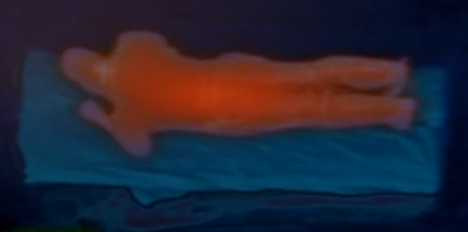
Q (dame Judy Dench): That is Bond (Pierce Brosnan) … It is getting redder ... But where is dr Jones (Denise Richard)?
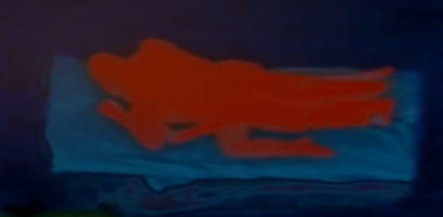
Q: Ooohw
R (John Cleese) presses the ESC button to interrupt the video stream: sorry, must be a premature form of a millenium bug

