Viewer App
This document describes the usage of the viewer application with a sample test photo.
The viewer app is started from the pc folder with the command line: ./viewer.py &
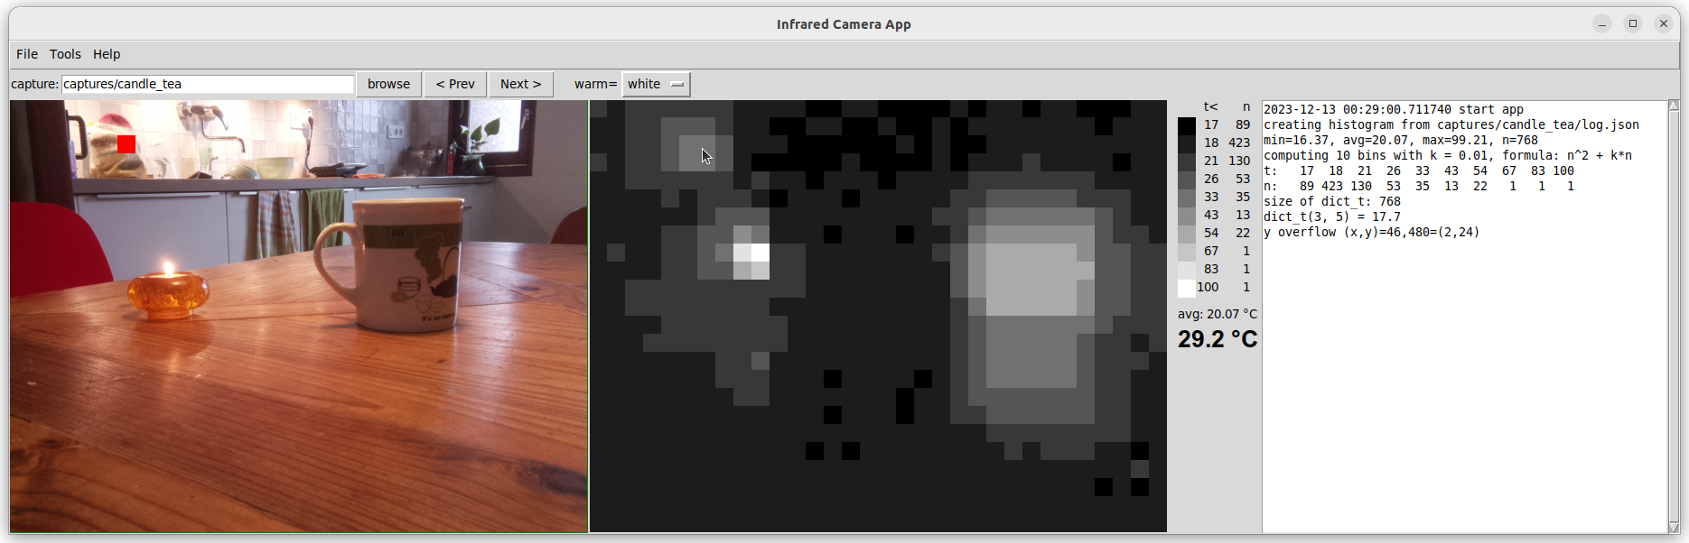

Menu bar
The menu bar has the usual options for closing the application, and for displaying the About info.

Button bar
Right below the menu bar there is a Browse button to select a folder with the files of a capture. Note that that button invites you to select a folder, not an image file. The viewer is designed to show TWO pictures, made with a visible light camera and an infrared sensor. Such folder could also contain debug output files and additional stuff, such as this description, which is not used by this app.
You can also select a folder that contains one or more capture folders. The app will show the first capture, and with the Prev and Next buttons you can easily walk throught the remaining folders.
Currently, the app is hard-coded to start looking at the subfolder: captures.

Displays
The viewer has several displays. From left to right: the visible light photo, the infrared thermal image, the palette with the greyscale or color tones for the infrared image, with the temperatures for each color, and the number of pixels with that color. The right-most panel is the text output of the Gui.log calls with some debug info.

Test Scene
The test scene is my working table in the kitchen, with a candle on the table, and a tea mug. The tea pot is on the kitchen counter, with a woolen hood to keep it warm.
The hottest spot, white on the infrared photo, is the flame of the candle. You also see an infrared reflection of the candle in the wooden table surface which is a bit shiny.

Above the candle, on the kitchen counter, is the teapot which appears a bit warm on the infrared photo. This indicates that the wooden hood is not a very god thermal insulator.

The mug on the table is filled with hot tea and appears as a large warm object on the infrared photo, also with a fairly warm reflection on the table.

The infrared picture is shown in black and white, but using the “warm =” button, you can also display using inversed grey scale, or with a red-blue heat map.

On the tea pot hood on the kitchen counter, in the left top corner, you see a small red square at the same location as the mouse pointer in the infrared picture, to see the exact location of the infrared pixel. Also, the actual measurement of that infrared pixel is shown in large font below the temperature scale, the “palette”, right next to the infrared picture.

Just looking at the infrared picture, you cannot really tell, e.g., how large the tea pot is. But together with the visible light picture, you can infer a lot about the temperatures of the various objects.

