Should the temporal model carry a camera-location grouping term?

Should the temporal model carry a camera-location grouping term?
A question for Arielle and Krishna, with the supporting counts.

Take-home points
- The non-temporal model groups camera deployments that share a physical location; the temporal model does not. Goldstein et al. include a random intercept shared by all deployments occurring at the same unique location in any year. Our model loops over deployments with an independent occupancy draw for each one and no term linking repeat visits to the same place.
- The location identifier exists in our prep and is dropped at the model boundary. prep_data_for_spoccupancy.R builds loc_ID from distinct(longitude, latitude) and passes it as spOccupancy’s grid.index. It is not among the constants our NIMBLE model receives.
- 97.8% of the variance in deployment year is between locations, 2.2% within them. The trend coefficient multiplies a per-deployment year covariate, so almost everything identifying the trend is a comparison between different places sampled in different years.
- Only 1,862 of 21,206 camera locations were sampled in two or more years. Those locations hold 6,234 of 26,776 deployments, 23.3%. They are the part of the data that can speak to change at a fixed place.
- Adding the term would widen the credible intervals and could unresolve some trends. Four deployments at one trail currently enter as four independent statements about occupancy there. Grouping them makes the intervals reflect the number of places observed rather than the number of deployments.
- The repeat-location data are concentrated in recent years and in under half the projects. 5,752 of the 6,234 repeat-location deployments are from 2019 onward against 482 before, and they come from 27 of 60 projects.

What the two models do
Goldstein et al. (2025), non-temporal. The camera detection submodel contains a grouping random effect shared by detections associated with all deployments occurring at the same unique location in any year. It sits in the detection linear predictor, which is separate from the intensity predictor, so it absorbs site idiosyncrasy without competing with abundance.
Our model, with the trend added. The camera submodel loops over deployments. For each one it builds a detection probability from day of year, its square, canopy height and distance to road; builds an occupancy probability from the cell-level spatial intercept, the two climate effects, the occupancy covariates, and the trend term year_beta * year_occ[i]; and evaluates the detection history with dOcc_v. The index runs over deployments: 20,531 for bobcat, 21,559 for white-tailed deer, 1,654 for moose. A location deployed in 2019 and again in 2022 contributes two rows with two independent occupancy values, differing in their year covariate, and nothing ties them together.

Definitions
Location. A distinct pair of coordinates. Matched here at five decimal places, about 1 m, which treats a camera re-hung at the same tree as the same location and two cameras 50 m apart as different ones.
Deployment. One camera placement with a start and end date, identified by project and deployment identifier. There are 26,776 of them.
Location grouping random effect. A normally distributed intercept, one per location, shared by every deployment at that location. It states that deployments at one place are more like each other than like deployments elsewhere, for reasons the covariates do not capture.
Within-location and between-location year contrast. Split the year of each deployment into its location mean year and the deviation from that mean. The within-location part is what a revisit provides. The between-location part is the difference between places sampled at different times.
Pseudo-replication. Treating correlated observations as independent, which narrows credible intervals below what the data support.

Evidence
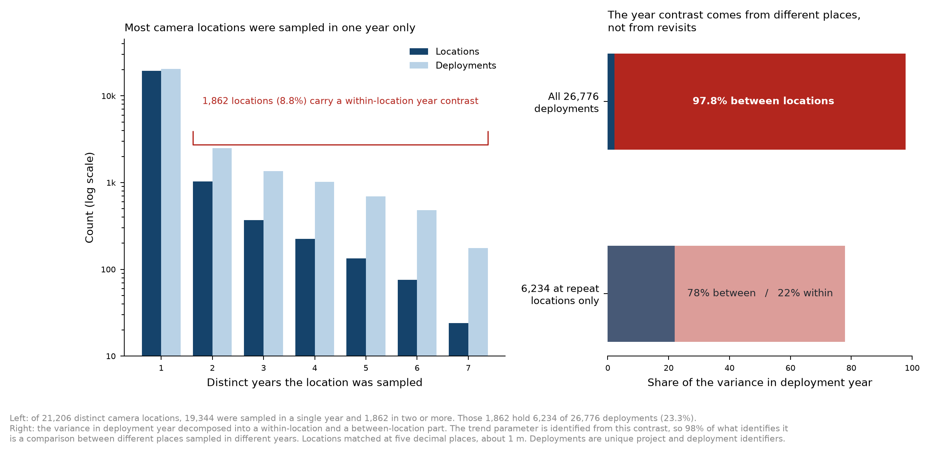
Repeat-location structure in the camera data

How much repeat sampling exists
Years sampled | Locations | % of locations | Deployments | % of deployments
1 | 19,344 | 91.22 | 20,542 | 76.72
2 | 1,033 | 4.87 | 2,500 | 9.34
3 | 371 | 1.75 | 1,359 | 5.08
4 | 224 | 1.06 | 1,025 | 3.83
5 | 134 | 0.63 | 694 | 2.59
6 | 76 | 0.36 | 481 | 1.80
7 | 24 | 0.11 | 175 | 0.65
Across 26,776 deployments there are 21,206 distinct locations, 1.26 deployments per location. The 1,862 locations sampled in two or more years span a median of 2 years and at most 11.

How the trend is identified
Decomposing the variance in deployment year gives 2.2% within locations and 97.8% between them. Restricting to the 6,234 deployments at repeat locations raises the within-location share to 22.0%.
The practical reading: if the places sampled in 2024 differ from the places sampled in 2012 in any way the covariates do not capture, that difference enters the trend coefficient as though it were change over time. The term that would prevent this is the location intercept, which absorbs between-place differences and leaves the trend to be carried by revisits.

Where the repeat data sit
The repeat-location deployments come from 27 of the 60 projects. 5,752 of them are from 2019 onward and 482 from 2018 or earlier, so the within-location signal is concentrated in the recent part of the record.

The question for Arielle and Krishna
Two readings are available and they lead to different actions.
If the omission was a considered choice, the argument would be that with 91% of locations sampled once, a location intercept is estimable for only 8.8% of them and the rest contribute a prior draw each, adding 21,206 parameters for little gain. There may also have been a convergence or runtime reason. That belongs in the methods, because a reviewer who knows the Goldstein model will ask why the term is absent.
If it was incidental, lost when the temporal structure was added, then the trend is currently identified from a contrast we would not choose, and the fix is one index vector the prep already computes.
A middle option exists: group at the array or project level rather than the location level. That estimates far fewer intercepts, absorbs the project-specific protocol differences that are plausibly the largest source of between-place variation, and is identifiable for every deployment.

Proposed test
Bobcat and moose at the 18-year window, each fitted with and without the location grouping term.
Bobcat has 20,531 deployments and dense repeat coverage, so it shows the largest change if pseudo-replication is inflating precision. Moose has 1,654 deployments in a sparse northern footprint, so it shows whether the term is estimable when repeat locations are few. Both are fitted and converged, so each comparison runs against a known baseline.
Three quantities decide the answer:
- The change in the trend estimate. A shift means between-location differences were loading onto the trend.
- The change in its interval width. A widening is the pseudo-replication being corrected.
- The standard deviation of the location effect. If it is indistinguishable from zero, locations are not idiosyncratic once covariates are accounted for and the current model stands. If it is large, the current intervals are too narrow.
Two chains per fit at current settings, four fits, roughly a week of queue time alongside the windowed refits.

Limitations
The variance decomposition uses deployment year, which is what the trend covariate encodes. It describes how the trend is identified and does not measure how much the estimate would move, which requires the refit.
Locations are matched on exact coordinates at about 1 m. A camera moved 50 m between years counts as two locations, so the repeat-sampling figures are a lower bound. Matching within a radius would raise both the count of repeat locations and the within-location share.
The detection submodel was not examined for the same issue. Whether detection also needs a location term is a separate question.
Nothing here tests the opposite risk, that a location intercept absorbs real local abundance variation the spatial fields should carry. With the intensity at 50 km and locations at metres these operate at different scales, but only the refit would show whether the spatial fields change.

