Does the link between iNaturalist records and animal abundance hold steady over time?

Does the link between iNaturalist records and animal abundance hold steady over time?

Take-home points
- The strength of the link between iNaturalist records and animal abundance is not a fixed property of a species. Of 23 species with enough camera data to test, 7 show a change over 2019-2025 large enough that the estimate’s 95% interval excludes zero: 4 strengthen and 3 weaken.
- American badger changes most, and changes sign. Its coupling runs from +0.52 in 2019 to -0.15 in 2025, a drift of -0.119 per year. A positive value means records are more numerous where badgers are more common; a negative one means they are more numerous where badgers are scarcer. Badger crosses from the first state to the second inside seven years.
- Coyote strengthens at +0.044 per year, from +0.22 to +0.46, on 356 cells per year – the largest sample of any species here, so this is the best-supported single result in the set.
- The fitted models assume this cannot happen. Both parameters that link the two data streams are declared as single numbers in the model code, held fixed across all 18 years. Any real change over time has nowhere to go except the parameter that carries the iNaturalist-only population trend, which means a changing reporting relationship and a changing population are currently indistinguishable.
- The species where this matters most cannot yet be tested. Eleven of 34 species have too few camera-monitored cells, and they include every species in the steep-decline group that prompted the question – pronghorn, rock squirrel, white-tailed antelope squirrel, kit fox and grey wolf.

Background and definitions
This project estimates population trends by fitting camera-trap detections and iNaturalist records to one shared surface. The two data streams are linked by an equation that says how many records to expect given how many animals are present:
log(expected iNaturalist records) = theta0 + theta1 x log(camera-side abundance)
theta1 is an exponent, so the clean way to read it is as a multiplier: a place with twice the abundance of another yields 2^theta1 times the records. At theta1 = 1 records rise in proportion to abundance. At theta1 = 0.5 a doubling of animals produces only a 41% rise in records. At theta1 = 0 records carry no information about abundance at all – the expected count is the same everywhere regardless of how many animals are there. Below 0 the relationship is inverted: more records where the species is scarcer, which is what an observer effect looks like when people are concentrated somewhere the animal is not.
Two names are used here to keep the two versions apart:
- theta_space is the version in the fitted models: one number per species, estimated from all years at once. It answers “across the country, do records track abundance?”
- theta_time is the same quantity estimated separately for each year. It answers “is that relationship the same now as it was six years ago?”
theta_space already exists for every fitted species and is reported elsewhere. theta_time is what this report measures.

Why the question matters
The model’s trend has two parts. One is anchored to the camera data; the other is an increment identified only by the iNaturalist records, which absorbs any difference between what the two streams say about change over time. Because theta_space is a single number, a species whose reporting relationship strengthened over the record cannot express that anywhere in the model. The extra records that strengthening produces look exactly like extra animals, and are absorbed into the iNaturalist-only trend increment.
That is not a hypothetical concern for this fleet. Several species carry an iNaturalist trend their camera data does not corroborate, and until theta_time is measured there is no way to say whether those are real disagreements about abundance or an artifact of the reporting relationship changing.

Methods
What is computed. For each species and each year from 2019 to 2025:
- Build a reference measure of how common the species is in each 50 km grid cell, from camera data alone: the proportion of camera deployments in that cell that recorded the species at least once. Only cells with at least five deployments are used, so the proportion is not based on one or two cameras. This reference is built once from all 2019-2025 deployments and held fixed across years, so that any change detected is a change in the record-abundance relationship rather than a change in the reference.
- For the same cells, compute the iNaturalist rate in that year: the species’ records in the cell divided by all mammal records in the same cell and year. Dividing by the local mammal total is the effort correction – it accounts for how many people were posting observations in that place that year, which rose steeply over the period.
- Regress the log of the iNaturalist rate on the log of the camera reference across cells, weighted by the local mammal record total so that well-observed cells count more. The slope of that line is theta_time for that species and year.
- Fit a straight line through the seven annual estimates, weighted by their precision. Its slope is the drift, in units of theta per year, and it is reported with a 95% interval.
What it assumes. That the species’ spatial pattern of abundance is roughly stable over the seven years, so that a changing slope reflects changing reporting rather than animals redistributing. For a national-scale fit where the modelled trend is close to spatially uniform, this is reasonable; for a species genuinely expanding into new country it would not be.
Where it fails. It needs enough cells with both camera coverage and iNaturalist records in every year. Species with sparse camera data give annual estimates too noisy to detect any drift, which is why 11 species are absent.
What it is not. These are estimates made outside the fitted model, using a raw camera detection rate rather than the model’s full camera submodel with its covariates and spatial smoothing. They are therefore on a different scale from theta_space: the pooled version of this estimator ranges 0.16 to 0.83 across species where the fitted models give 0.42 to 0.56. Read the slope over time, not the level, and do not quote these as theta values.

Results
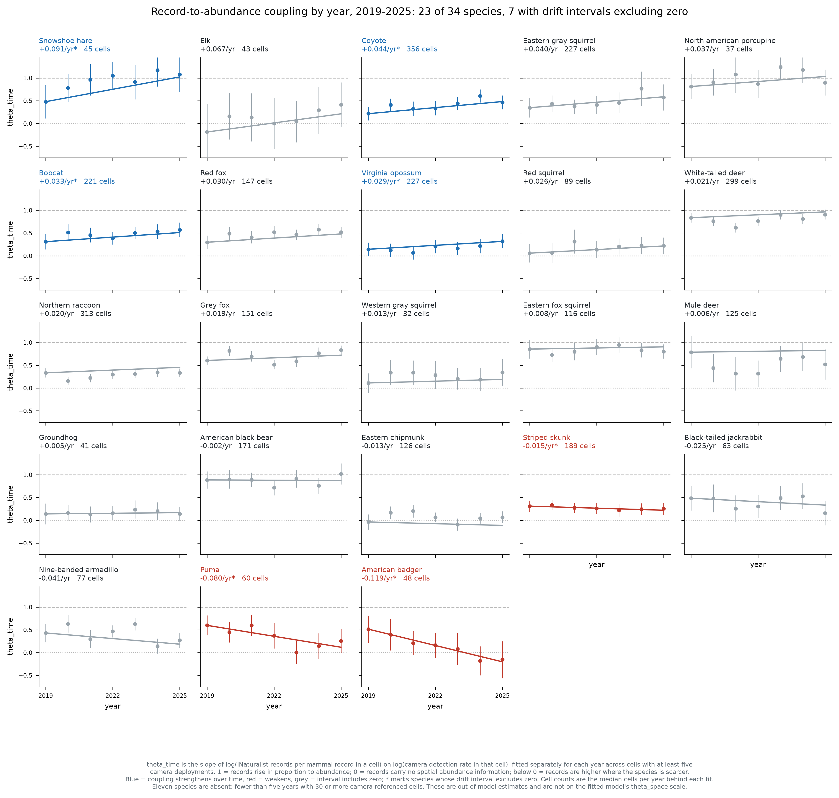
Coupling by year, all testable species
Figure 1. Each panel is one species. Points are the coupling estimated for that year alone, with 95% intervals; the line is the fitted drift. The dashed line at 1 marks records rising in proportion to abundance, the dotted line at 0 marks records carrying no abundance information. Blue means the coupling strengthened over the period, red means it weakened, grey means the interval includes zero. Panels are ordered from the strongest strengthening to the strongest weakening. Take-home: the relationship is stable for most species but demonstrably moves for seven of them, in both directions.
Seven species show drift whose interval excludes zero:
Species | 2019 | 2025 | Drift per year | 95% interval | Cells per year
Snowshoe hare | 0.48 | 1.08 | +0.091 | +0.023 to +0.158 | 45
Coyote | 0.22 | 0.46 | +0.044 | +0.002 to +0.086 | 356
Bobcat | 0.31 | 0.57 | +0.033 | +0.001 to +0.066 | 221
Virginia opossum | 0.14 | 0.32 | +0.029 | +0.001 to +0.056 | 227
Striped skunk | 0.31 | 0.26 | -0.015 | -0.028 to -0.001 | 189
Puma | 0.60 | 0.25 | -0.080 | -0.154 to -0.006 | 60
American badger | 0.52 | -0.15 | -0.119 | -0.149 to -0.089 | 48
A drift of +0.044 per year, coyote’s value, means the exponent rises by about 0.26 over the six-year span. In practical terms a cell with twice the coyote abundance of another produced about 1.16 times the records in 2019 and about 1.38 times the records in 2025 – the records became a meaningfully better guide to where the animals are.
Badger is the only species to cross zero. In 2019 its records were more common where badgers were more common; by 2025 the relationship had inverted, so its records now point away from the animals. On its own this makes badger’s iNaturalist data unusable for locating badgers in recent years.
The sixteen species whose intervals include zero are consistent with a stable relationship, though for the sparser ones – porcupine at 37 cells, western gray squirrel at 32, groundhog at 41 – the test has little power and “no detected drift” should not be read as “no drift”.

What to do differently
Add a drift term to the model, rather than reporting this as a caveat. The minimal change is one additional parameter:
theta1 in year t = theta1 + theta1_drift x (year - midpoint)
One number, testable against zero, and interpretable directly. Its value is that it separates the iNaturalist-only trend increment into two parts that are currently fused: genuine disagreement between the streams about how abundance is changing, and change in how well records track abundance.
Estimating 18 free annual values instead is not advisable. The early years are far too thin – several species have only single-digit record counts before 2012 – and the parameters would not be identified.
Validate by simulation before fitting the fleet. The established practice on this project is that no estimator ships without a simulation study that generates data from known truth and reports absolute error, interval coverage and root-mean-square error across a grid of scenarios. The existing simulation design cannot serve here: it holds the record-abundance relationship fixed by construction, so it can neither recover a drift parameter nor show what ignoring one costs. Generating data with drifting coupling is a new scenario axis.
Test on coyote first. It has the largest sample of any species, a clear strengthening signal, and an iNaturalist trend its cameras contradict – so it is the case where the new parameter should make the most visible difference.

Limitations
- Eleven of 34 species could not be tested, because fewer than five years had at least 30 cells carrying both camera coverage and iNaturalist records. The absent species include the entire group of steep western declines that motivated this question: pronghorn, rock squirrel, white-tailed antelope squirrel, kit fox and grey wolf. For those, whether the coupling is stable is unknown rather than confirmed.
- The window is seven years. The model’s record runs 18 years, and the earlier period cannot be tested this way because camera coverage before 2019 is too sparse to build a reference from. Drift over the full record may be larger or smaller than what is measured here.
- The camera reference carries its own error, which is not propagated into the annual estimates. Measurement error in the reference biases a regression slope toward zero, so the annual values are likely conservative and the drift estimates could be understated.
- Species redistribution is not separable from reporting change. A species genuinely shifting its range toward or away from camera-monitored areas would produce the same signature. Nothing in this analysis distinguishes the two.
- These estimates are not on the fitted model’s scale and are not a substitute for fitting the drift parameter. They establish that the relationship moves; they do not quantify by how much within the model.

Glossary
- Coupling – the strength of the relationship between iNaturalist record counts and animal abundance across space, measured as theta1.
- theta0, theta1 – the intercept and exponent linking the two data streams. theta0 sets the overall level of records and is not interpreted; theta1 is the quantity of interest.
- theta_space – theta1 as the fitted models estimate it: one value per species, pooled over all years.
- theta_time – theta1 estimated separately within each year.
- Drift – the change in theta_time per year, from a line fitted through the annual estimates.
- Effort correction – dividing a species’ records in a cell-year by all mammal records in that same cell-year, to account for how many observers were active there.
- Cell – a 50 km grid square, the spatial unit of the intensity process.

