Estimator choice for camera-trap trend models: a simulation study
Table of Contents

Estimator choice for camera-trap trend models: a simulation study
Question. When camera-trap data are integrated with opportunistic iNaturalist records to estimate a population trend, does it matter whether the camera side is modelled at the level of the individual camera or the level of the camera array, and whether occupancy or Royle-Nichols is used? The array-level question matters practically because array-level data are far cheaper to assemble across projects.

1. Design
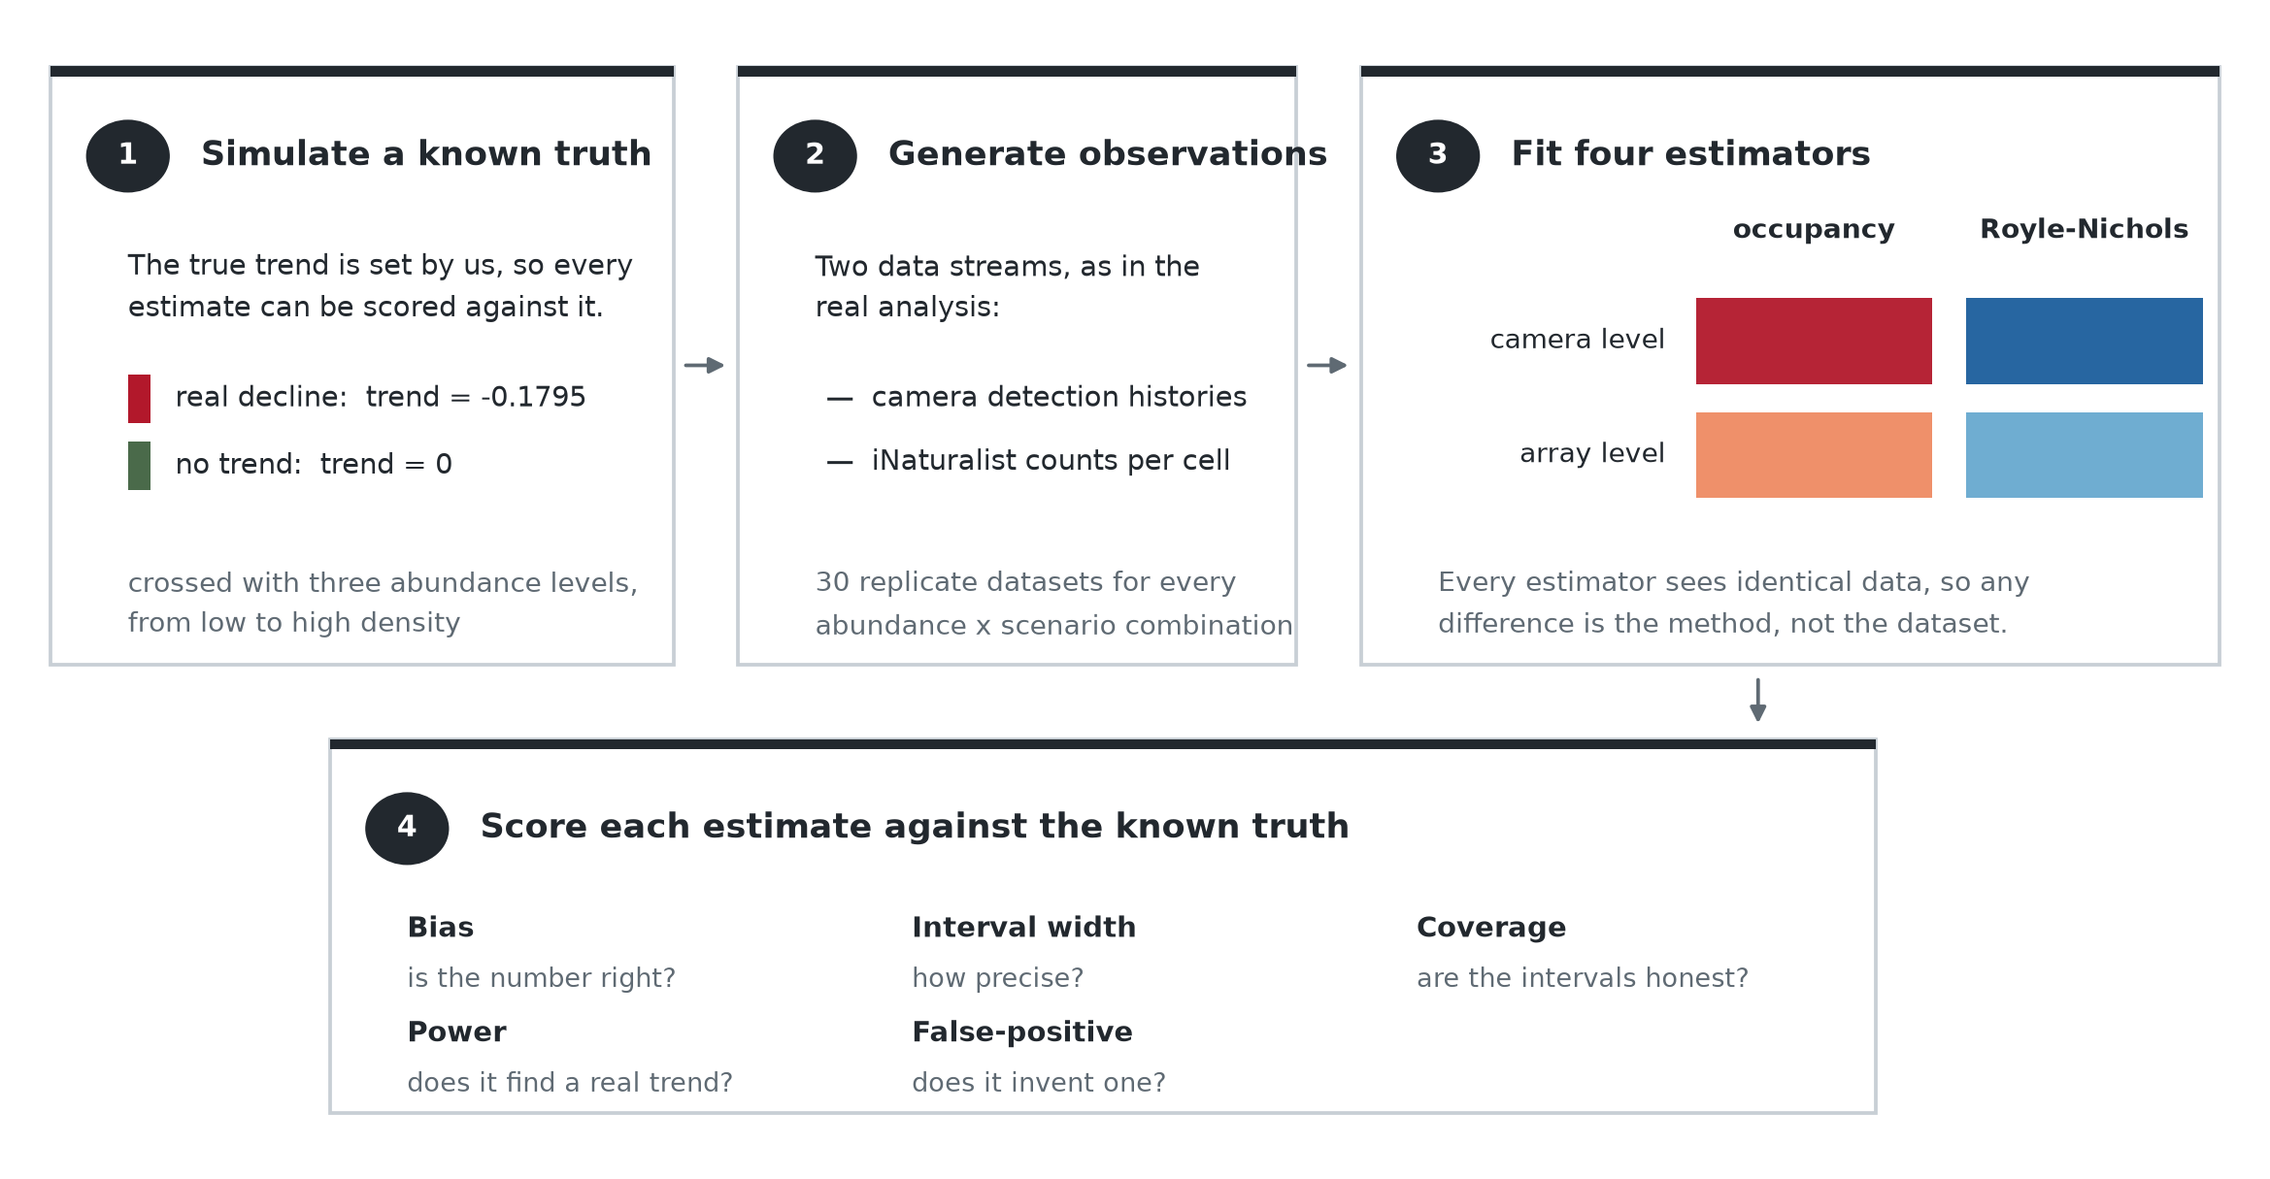
Simulation design
Four estimator arms — camera-level occupancy, camera-level Royle-Nichols, array-level occupancy, array-level Royle-Nichols — were each fitted to the same simulated datasets, at three abundance levels, under two spatial scenarios, with 60 replicates per cell.
The arms differ only in the camera-side observation model. The iNaturalist likelihood is identical in all four: a negative-binomial count model with the effort offset, y_inat ~ dnbinom(size = 1/overdisp_inat, prob = f(effort, mu)). Royle-Nichols is never applied to the iNaturalist records; they are a count per unit effort throughout, which is the only sensible treatment of them. What changes across arms is whether the camera stream enters as detection/non- detection (dOcc_v) or as a latent-abundance count (N ~ dpois), and whether the unit is the individual camera or the array.
Replicates are generated from model_code_national_scalar with parameters taken from a real converged bobcat fit, so the truth is known exactly. The trend enters as two components: a camera-anchored slope (year_beta, truth +0.0645) that the camera occupancy submodel contains, and an iNaturalist-only increment (year_var, truth −0.2440) that appears in no camera likelihood term. Their sum, −0.1795, is the slope the iNaturalist count stream observes. The two components have opposite signs in the truth.

2. Recovery of the camera-anchored trend
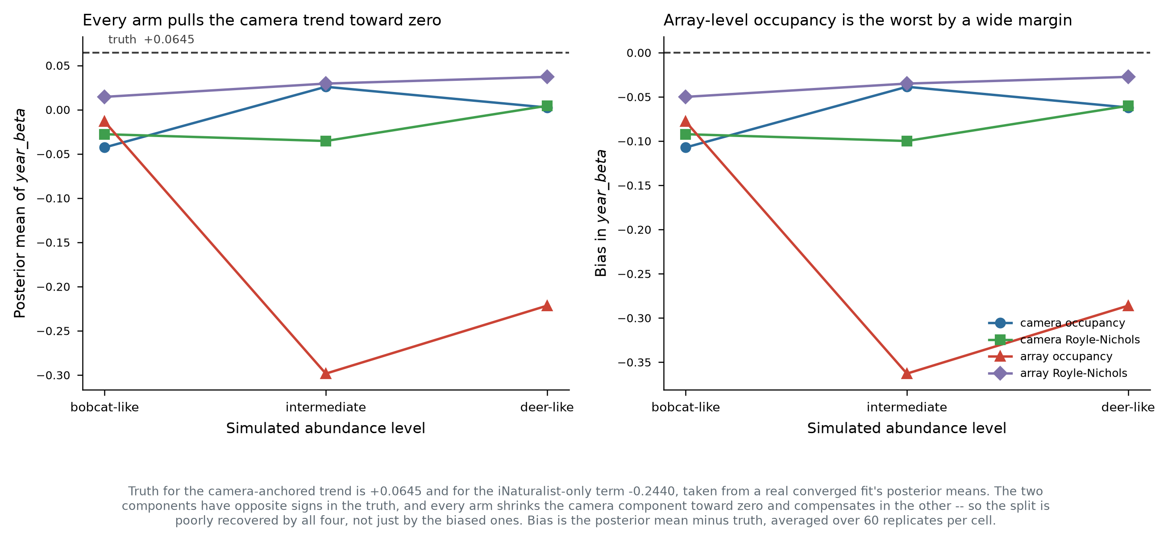
Camera-anchored trend recovery
Every arm shrinks the camera-anchored trend toward zero. Truth is +0.0645; posterior means range from −0.30 to +0.04 and the bias is negative in all twelve arm-by-abundance cells. The split between the two components is therefore poorly identified even in a correctly-specified simulation, with each arm compensating in the iNaturalist term.
Array-level occupancy is much worse than the other three. Its bias reaches −0.363 at intermediate and −0.286 at deer-like abundance, against −0.027 to −0.107 for every other arm. Array-level Royle-Nichols is the most accurate at every abundance level (−0.050, −0.035, −0.027) and improves as abundance rises. The two camera-level arms are close to each other throughout and show no clear abundance trend.
The practical reading: aggregating cameras to the array is what damages the camera-anchored trend, and only when combined with occupancy. Array-level Royle-Nichols recovers the trend as well as camera-level modelling does, which is the result that matters for reusing array-level data.

3. How the camera-side specification propagates into the summed slope
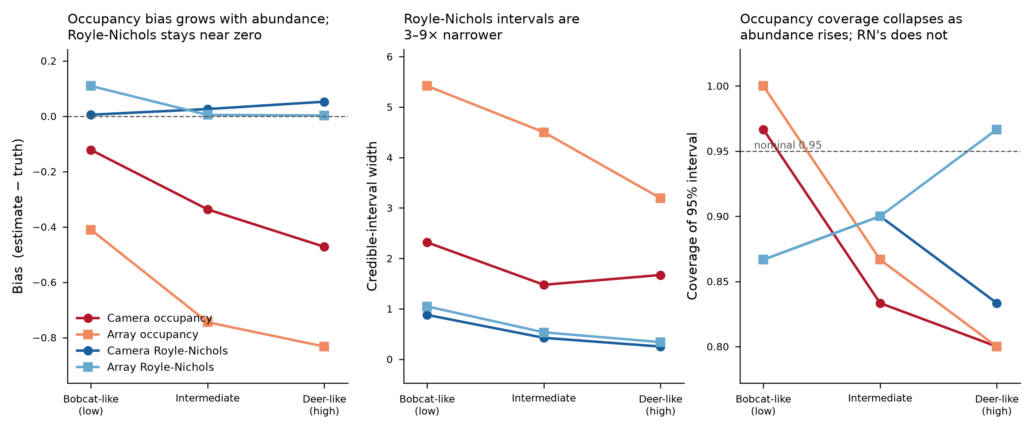
Estimator performance
The summed slope total_var_beta is the coefficient the iNaturalist count model carries, and the iNaturalist likelihood is the same in every arm — so any difference between arms here is not a difference in how the iNaturalist records were analysed. It arises because the model is fitted jointly: the summed slope is tied to the camera-anchored slope by construction over a shared latent abundance surface, so a camera-side specification that estimates its own slope poorly displaces the sum as well.
That displacement is large. Both arms using a latent-abundance camera model recover the summed slope close to its true value at every abundance level, while both occupancy-based arms overstate the decline and do so increasingly with abundance — camera-level occupancy reaching roughly three times the true slope at deer-like abundance, array-level occupancy up to six times. Interval widths follow the same pattern.
Occupancy saturation is the plausible mechanism on the camera side: occupancy reads presence and absence, so once most sites are near-certain detections its information about log abundance collapses, whereas detection frequency across replicate windows keeps discriminating past that point. This section should be read as a diagnostic that a saturating camera model distorts the joint fit, not as a recommendation about how to model opportunistic records.

4. Error rates
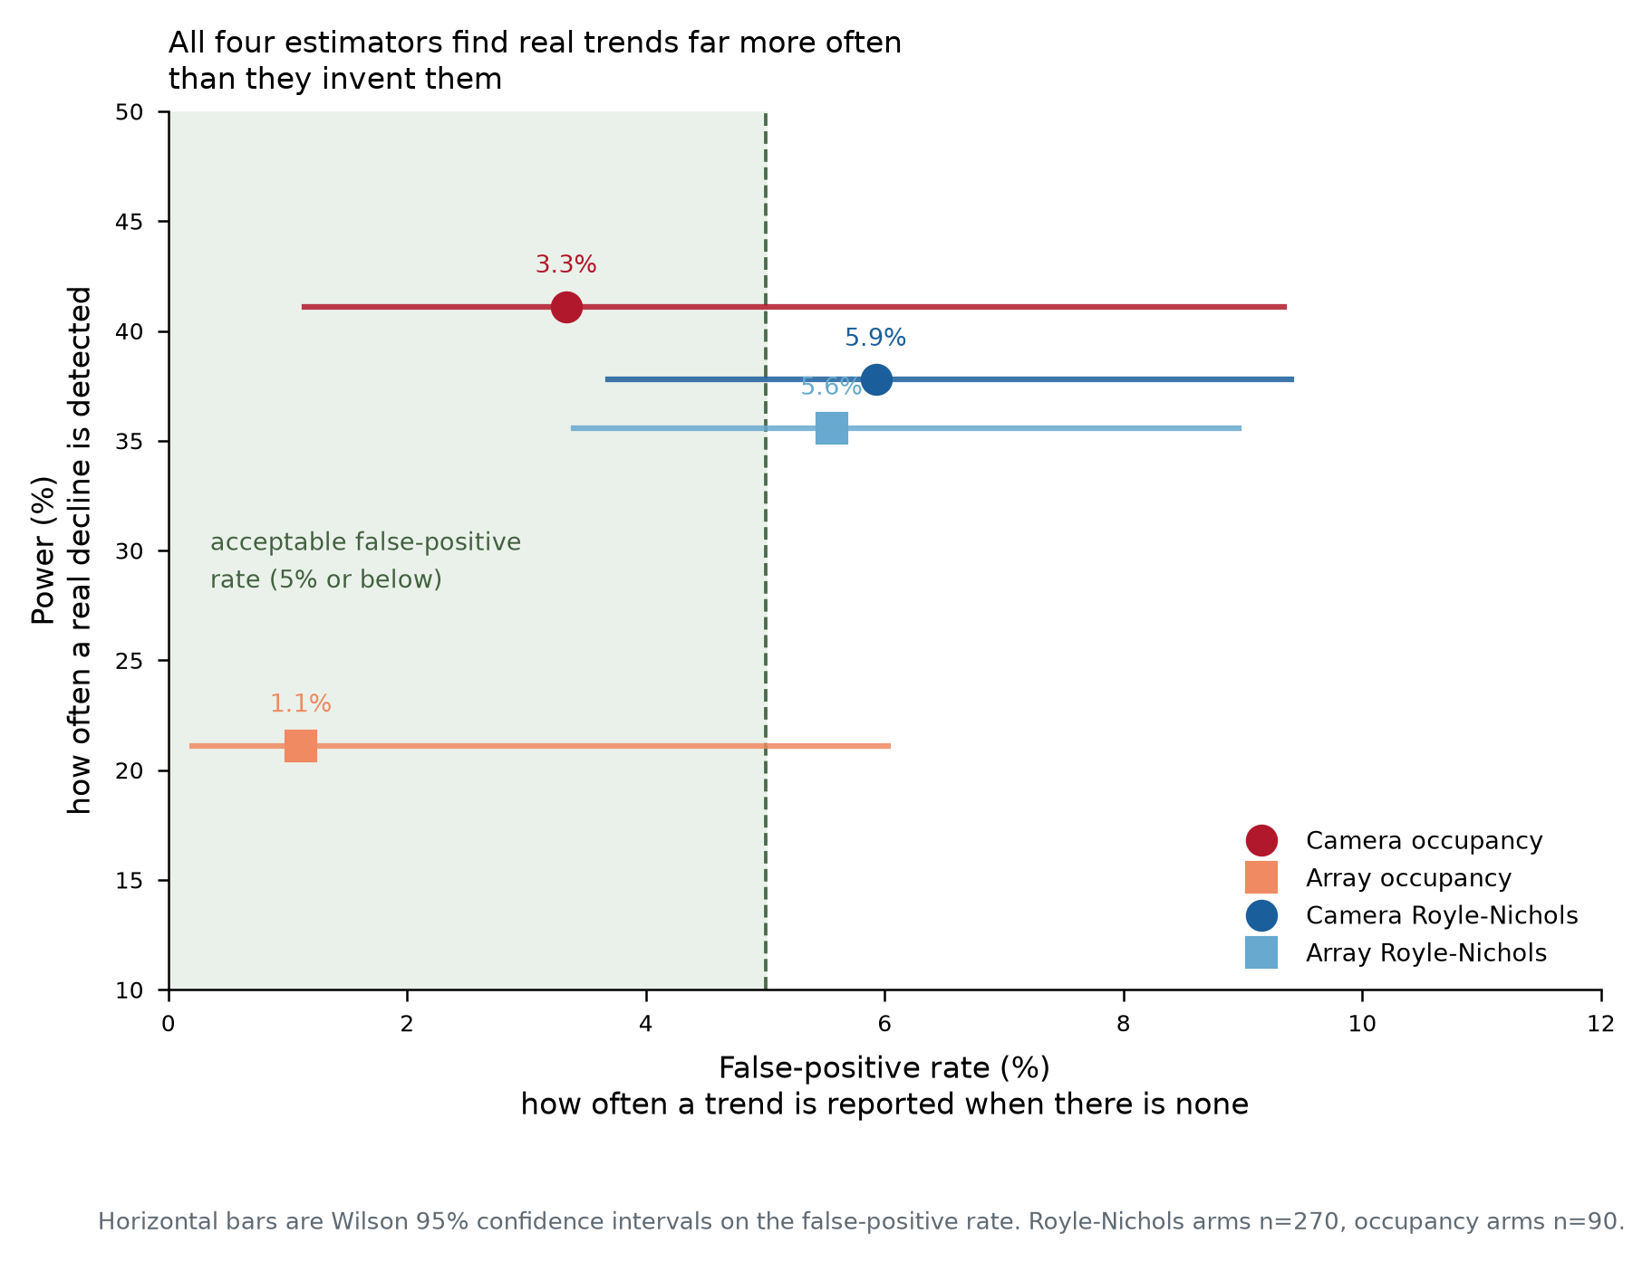
Error rates
All four arms detect real trends far more often than they report absent ones. Note that detection rate alone is a misleading criterion here: at deer-like abundance camera-level occupancy’s detection rate matches or exceeds Royle-Nichols’ while its point estimate is roughly three times too negative. Detection rate conflates bias with precision and should not be used to rank these estimators.
One column in the collected output requires care. A camera-corroboration indicator was computed as a threshold on the ratio of the two trend components. Because the generating truth has those components in opposite signs, that ratio is negative by construction and the indicator cannot fire in any arm. It therefore measures a property of the simulated truth, not of any estimator.

5. Applicability to real camera data
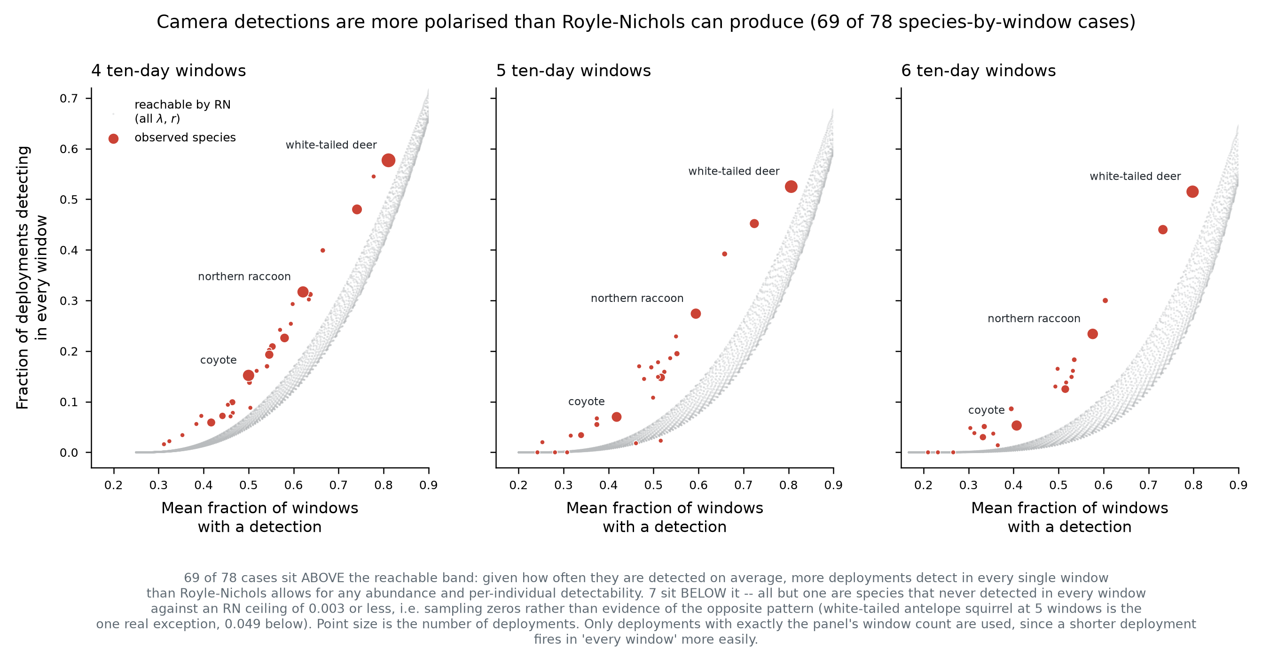
Estimator diagnostic
The simulation generates data from the occupancy model, so its heterogeneity is Poisson-consistent by construction. Real camera detection histories are not.
Comparing two statistics among detecting deployments — the mean fraction of 10-day windows with a detection, and the fraction of deployments detecting in every window — against the region reachable by Royle-Nichols across all combinations of abundance and per-individual detectability: 69 of 78 species-by-window-count cases fall above the reachable band, two inside, and seven below, of which six are sampling zeros against a ceiling of 0.003 or less. Real detections are more polarised than Poisson abundance with a constant per-individual detection probability can generate: given how often a species is detected on average, far more deployments detect in every single window than the model permits.
Two limits on that diagnostic. Abundance and per-individual detectability are not separately identified at our window counts — at four windows, (25, 0.03) and (0.11, 0.52) reproduce the same two statistics to machine precision — so no per-species abundance cutoff follows from it. And the band is built from two summary statistics rather than the full detection-history likelihood; a formal goodness-of-fit test would likely reject more strongly, not less.
Occupancy’s saturation limit is real but reached by only one species in the fleet. From fitted per-site occupancy, white-tailed deer sits at a median of 0.952 with 68% of sites above 0.9; bobcat (0.156) and moose (0.033) are far below. Across all 34 fleet species, range-restricted naive occupancy puts deer at 0.794 and the next species, eastern gray squirrel, at 0.478. Commonly detected species such as gray squirrel and raccoon sit near occupancy’s most informative point rather than past it.

6. Conclusions
- Array-level Royle-Nichols is a viable substitute for camera-level modelling of the camera-anchored trend, and array-level occupancy is not.
- A saturating camera model distorts the jointly-fitted iNaturalist slope, increasingly so at higher abundance, even though the iNaturalist likelihood is identical across arms. This is a reason to avoid an occupancy camera submodel for abundant species, not a statement about modelling opportunistic records — those are a count per unit effort in every arm.
- Neither result licenses Royle-Nichols on our real data as specified. Its observation model is rejected for essentially every fleet species, in the direction of unmodelled overdispersion.
- The trend split is poorly identified in simulation by all four arms, which bounds how much confidence any of them supports in separating a camera-anchored trend from an opportunistic-only one at this replicate count.
- Occupancy saturation is a single-species concern in this fleet, not a general one.
Candidate next steps, in order of cost: a detection-rate count model (negative binomial on events per camera-night, giving both streams the same functional form and no saturation, at the cost of conflating abundance with activity); Royle-Nichols with negative-binomial abundance; or Royle-Nichols with a site-level random effect on detectability, which is testable rather than assumed since deployment records include whether a camera was placed on a trail.

7. Limitations
- Coverage, interval width, power and false-positive rate are available for the summed trend only. Per-replicate posterior quantiles for the individual components were not retained, so for the camera-anchored trend only point- estimate bias can be computed.
- The two trend components multiply differently standardised year covariates, in both the simulation and the real fits, so their raw coefficients are not directly comparable and their sum mixes two scales. Conclusions here are stated per component, never on the sum of the two.
- Replicates are generated from the same model that the occupancy arms fit, which favours those arms; the Royle-Nichols arms are misspecified throughout and still match or beat them.

