Population trends for three North American mammals
Table of Contents

Population trends for three North American mammals from integrated camera-trap and iNaturalist data
Species and models. Bobcat, white-tailed deer and moose, each fitted under two parameterisations of the temporal trend: a single national slope, and a national slope with partially-pooled ecoregion deviations. All six fits are single continuous MCMC chains.

1. How the two data streams combine
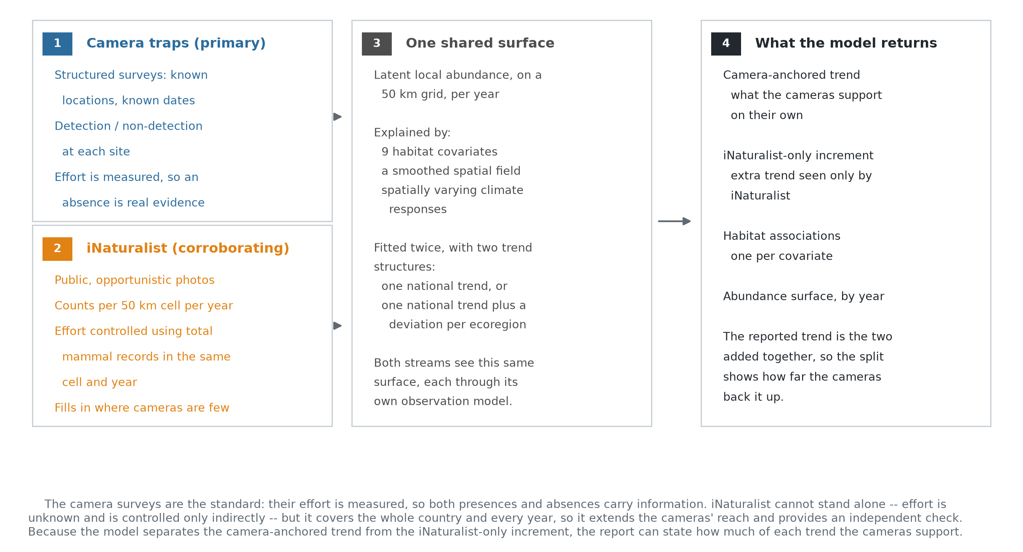
Data integration
Camera-trap surveys are the primary stream: effort is measured, so both detections and non-detections carry information. iNaturalist records cannot stand alone — effort is unknown and is controlled only indirectly, using total mammal records per 50 km grid cell per year as an effort offset — but they cover the whole country and every year of the study period.
Both streams inform one latent relative-abundance surface on a 50 km grid, each through its own observation model. The camera stream enters through an occupancy submodel; the iNaturalist stream sees the same surface through a power-law link whose exponent is estimated, which attenuates its influence when the two streams disagree. That exponent is estimated between 0.41 and 0.61 across the six fits, with every interval excluding 1.0, so the attenuation is active and substantial.
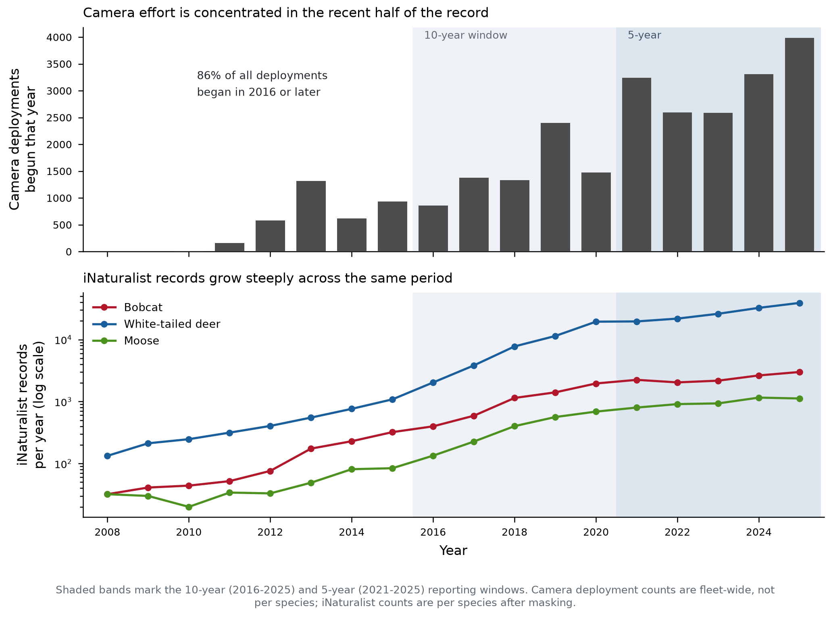
Survey effort
Camera deployments are concentrated in recent years. This is the reason trends over the full 18-year window rest more heavily on the iNaturalist stream in the early period, and it bears directly on how far each species’ camera-anchored trend extends: bobcat and deer have 16 distinct camera years, moose only 7 (cameras from 2019).
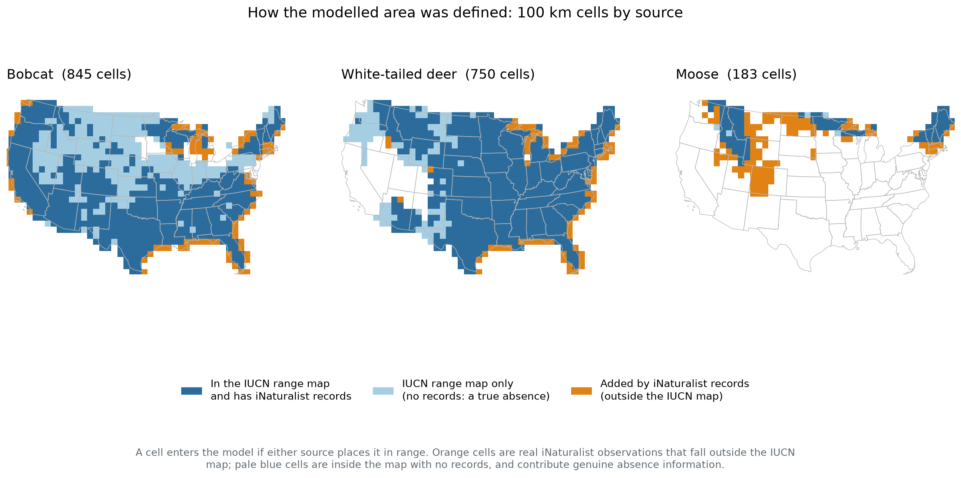
Range mask construction
The modelled area for each species is the union of its published range polygon and grid cells with iNaturalist records, which retains true-absence cells that a records-only mask would discard.

2. Why two parameterisations, and how each is set up
Each species is fitted twice, differing only in how the temporal trend is allowed to vary in space.
National-scalar. One trend for the whole modelled area. The camera occupancy submodel carries year_beta * year_occ[i]; the iNaturalist intensity carries total_var_beta * year_vals[t], where total_var_beta = year_beta + year_var and year_var is a free parameter appearing in no camera likelihood term. This maximises precision on the national trend and assumes the trend is spatially constant.
Ecoregion. Adds a partially-pooled deviation per EPA Level I ecoregion, year_region[r] ~ dnorm(0, sd = sigma_region), inherited by each 100 km cell as year_effect[c] <- year_region[ecoregion_of_cell100[c]] and added to the iNaturalist-side trend. Partial pooling means each region’s estimate borrows strength from the shared national mean, so a data-poor region is shrunk toward it rather than estimated independently. This relaxes the constant-trend assumption at the cost of precision on the national mean.
Everything else is identical between the two: the same 50 km latent abundance grid, the same nine occupancy covariates, the same spatially varying intercept and climate-response fields on the 100 km grid, the same detection model, the same iNaturalist negative-binomial count likelihood with its effort offset, and the same union range mask. Both are run as single continuous MCMC chains with no checkpoint-and-resume boundary.
Why fit both rather than choose. The pair is a sensitivity check on the constant-trend assumption. If the national estimate is stable across the two, that assumption is not doing load-bearing work and the simpler model can be reported; if it moves, the regional structure matters and the national number alone would be misleading. Fitting both is the right procedure even where only one is ultimately reported.
One scope decision, documented in the model code, has consequences for what the ecoregion fit can deliver and is stated where it bites, in Section 4: the regional deviation was added to the iNaturalist pathway only, leaving the camera submodel with the global trend.

3. National trends
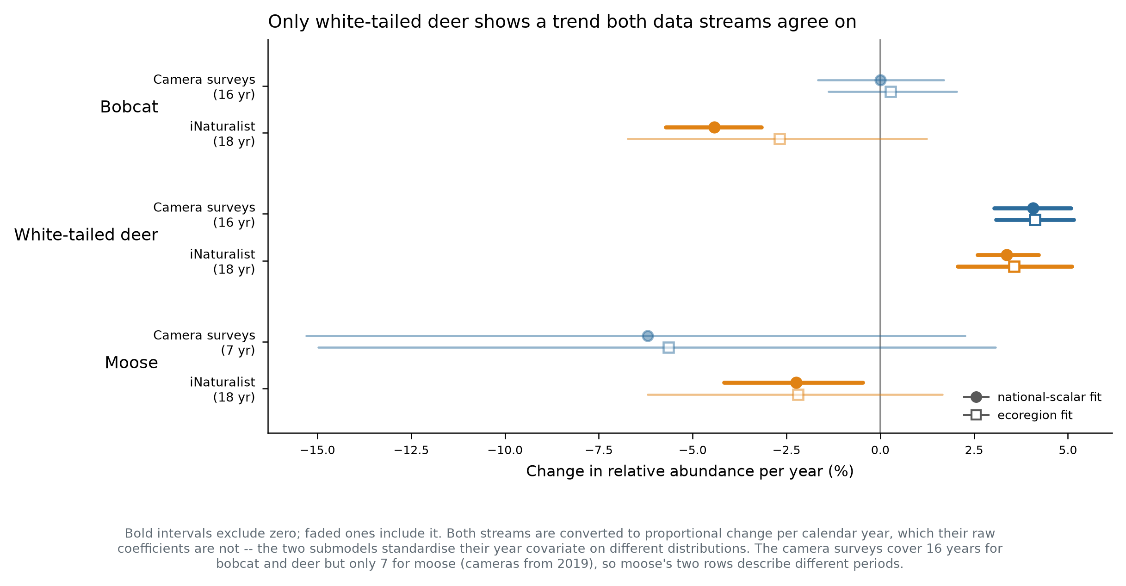
National trends per year
Both streams are shown as proportional change per calendar year. Their raw coefficients are not comparable — the two submodels standardise their year covariate on different distributions, so one coefficient unit is 5.34 years on the iNaturalist side but 1.88 years for moose’s cameras, 3.65 for bobcat’s and 3.88 for deer’s. Converting to per-year units first is required before the two streams can be compared at all.
Species | Camera surveys | iNaturalist | Agreement
Bobcat | 0.00%/yr (−1.7, +1.7) | −4.43%/yr (−5.7, −3.2) | streams disagree
White-tailed deer | +4.07%/yr (+3.0, +5.1) | +3.37%/yr (+2.6, +4.2) | streams agree
Moose | −6.20%/yr (−15.3, +2.3) | −2.24%/yr (−4.2, −0.5) | same direction, cameras unresolved
White-tailed deer is increasing, and both streams agree. The camera surveys give +4.07% per year over 16 years and iNaturalist +3.37% over 18; both intervals exclude zero and overlap each other. This is the only species in the set whose trend is supported independently by each stream.
Bobcat’s streams disagree. The camera surveys give a trend indistinguishable from zero with a tight interval (−1.7% to +1.7% per year), while iNaturalist gives a clear decline of 4.4% per year. Since the camera data are the standard, the defensible statement is that the camera surveys detect no bobcat trend, and that the iNaturalist decline is not corroborated. An iNaturalist-specific change in observer behaviour or reporting that the effort offset does not capture would produce exactly this pattern, and cannot be distinguished from a real decline invisible to cameras.
Moose is declining on the iNaturalist stream and unresolved on cameras. The camera-anchored estimate is steeper, at −6.2% per year, but its interval spans zero, and it describes only 2019–2025 rather than the full period. The two rows are not measuring the same interval for this species.
Robustness to parameterisation. The camera-anchored trend barely moves between the two parameterisations — bobcat 0.00% versus +0.27%, deer +4.07% versus +4.12%, moose −6.20% versus −5.64% — because the camera submodel is identical in both. The iNaturalist-side estimate moves more, and loses significance for bobcat and moose under the ecoregion parameterisation.

4. Regional trends
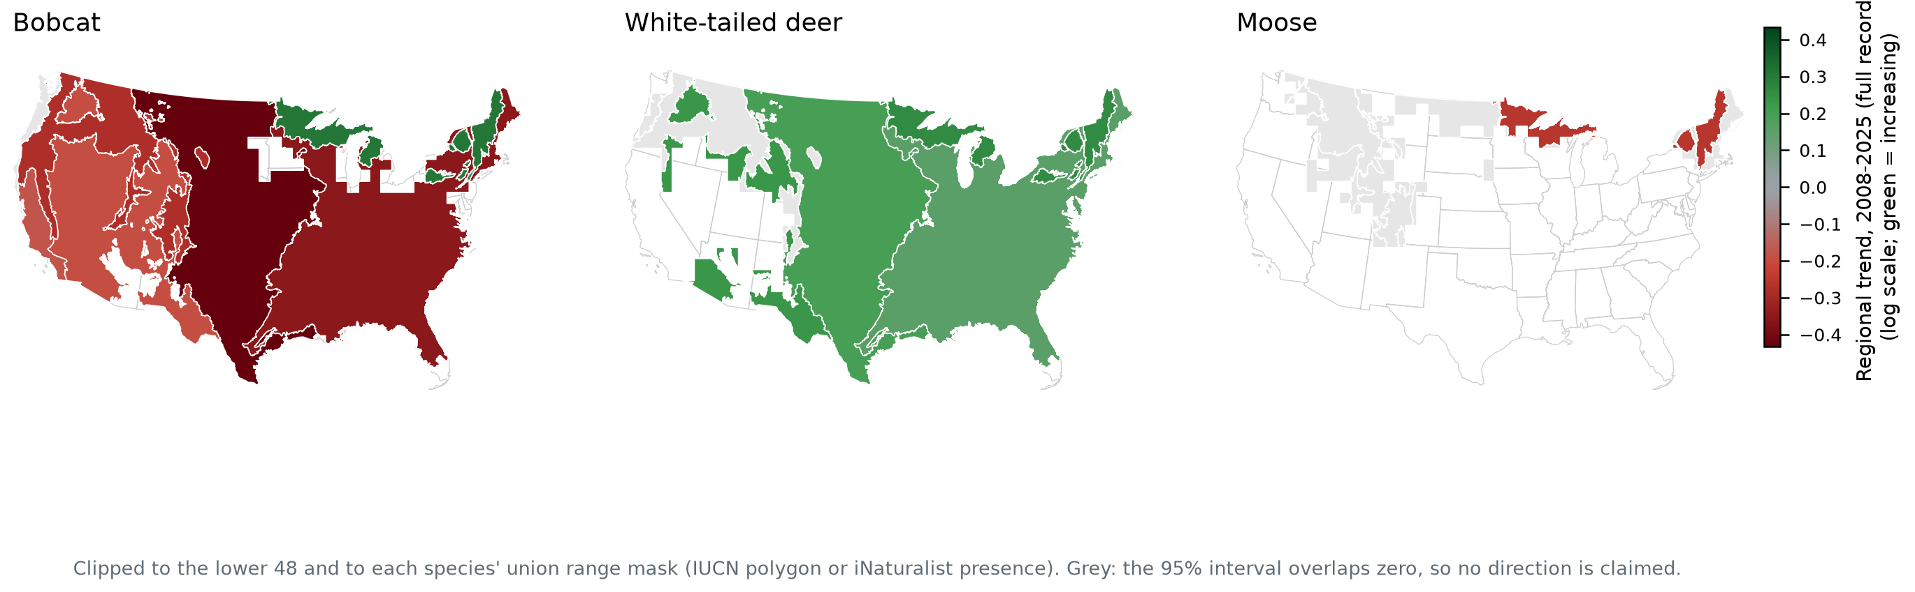
Regional trends
The camera data informs the ecoregion fit throughout: the spatially varying intercept field, both climate-response surfaces, all nine occupancy covariates, the detection model, and the global trend year_beta are all estimated with the camera likelihood contributing. So regional differences in abundance level are camera-informed, and are what the abundance surfaces in Section 5 display.
The constraint is narrower and applies to the regional trend deviation specifically. year_region is added to the trend inside the iNaturalist likelihood only, while the camera submodel carries the global year_beta with no regional term — a deliberate prototype scope decision recorded in the model code, not an oversight. So how much a region’s trend departs from the national trend is identified by iNaturalist alone, and these maps should be read accordingly: regional variation in trend carries the same caveat as bobcat’s national iNaturalist estimate, while the regional pattern in abundance does not. Regions shown in grey have intervals overlapping zero.
Two related questions are worth answering explicitly, because the obvious alternatives do not supply a camera-anchored regional trend either.
Regional prediction from covariates gives levels, not trends. The occupancy covariates enter as occ_covars[i, 1:numOccCovars] — indexed by site, with no year dimension. They are static per location, so they cannot generate a temporal trend of any kind, regional or national. Covariate-based regional prediction is camera-informed and useful, but it predicts where a species is more or less abundant, not where it is changing faster.
A camera-anchored regional trend would require a model change, adding a regional deviation to the occupancy submodel. It cannot be extracted from the present fits.
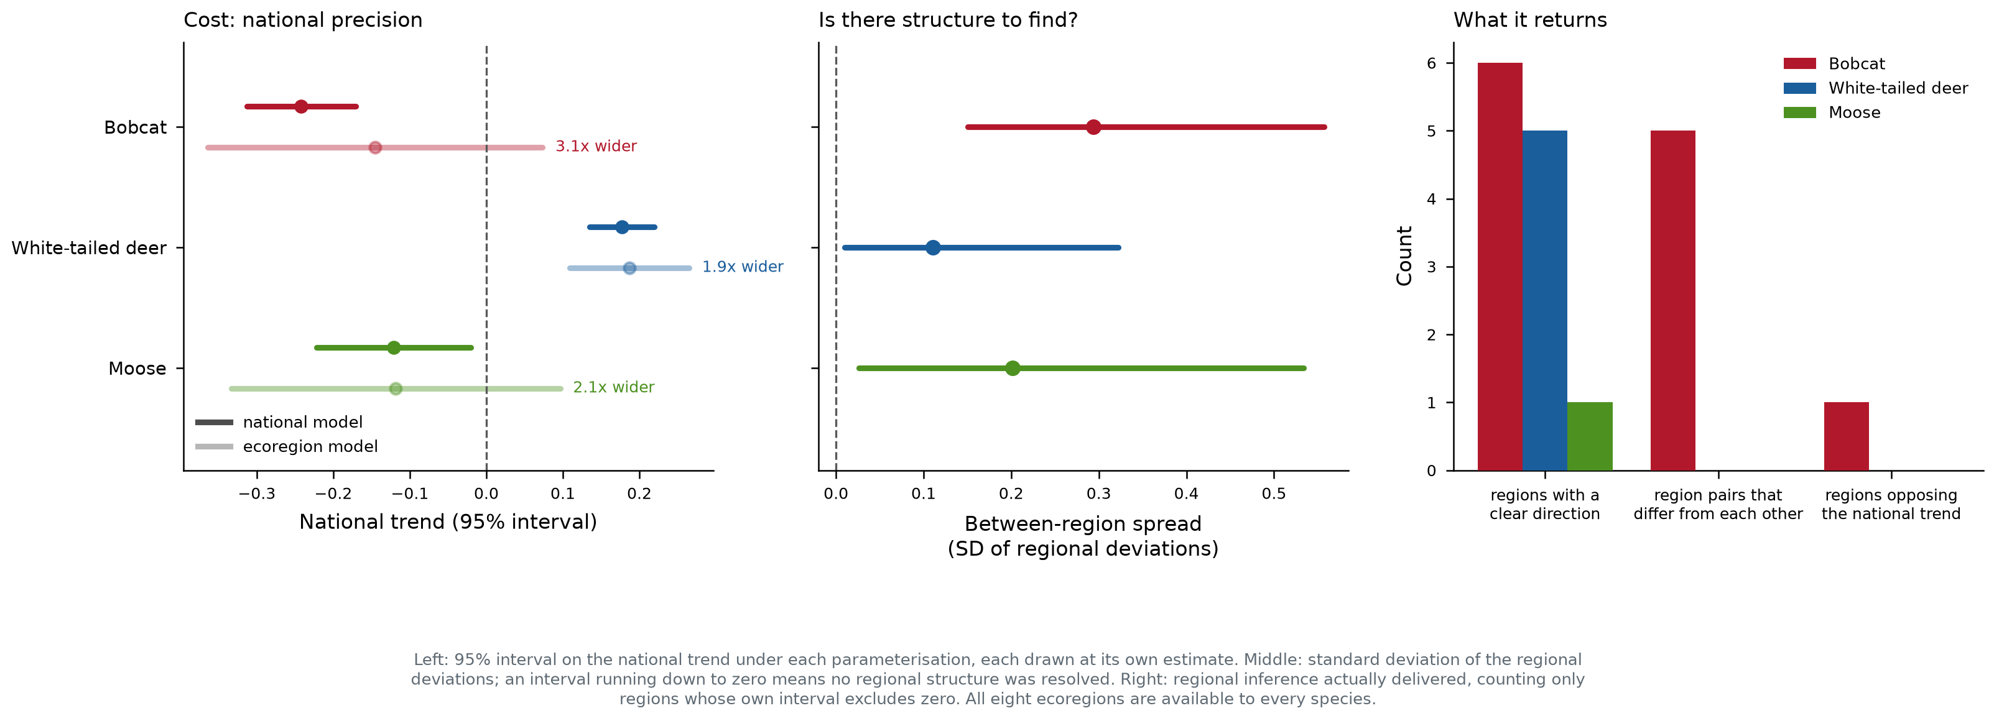
Value of the regional parameterisation
Whether the regional layer earns its cost is species-dependent: it resolves genuine between-region structure for some species and only widens the interval on the same national quantity for others, and regions with little data are shrinkage toward the national mean rather than independent evidence.

5. Relative abundance surfaces
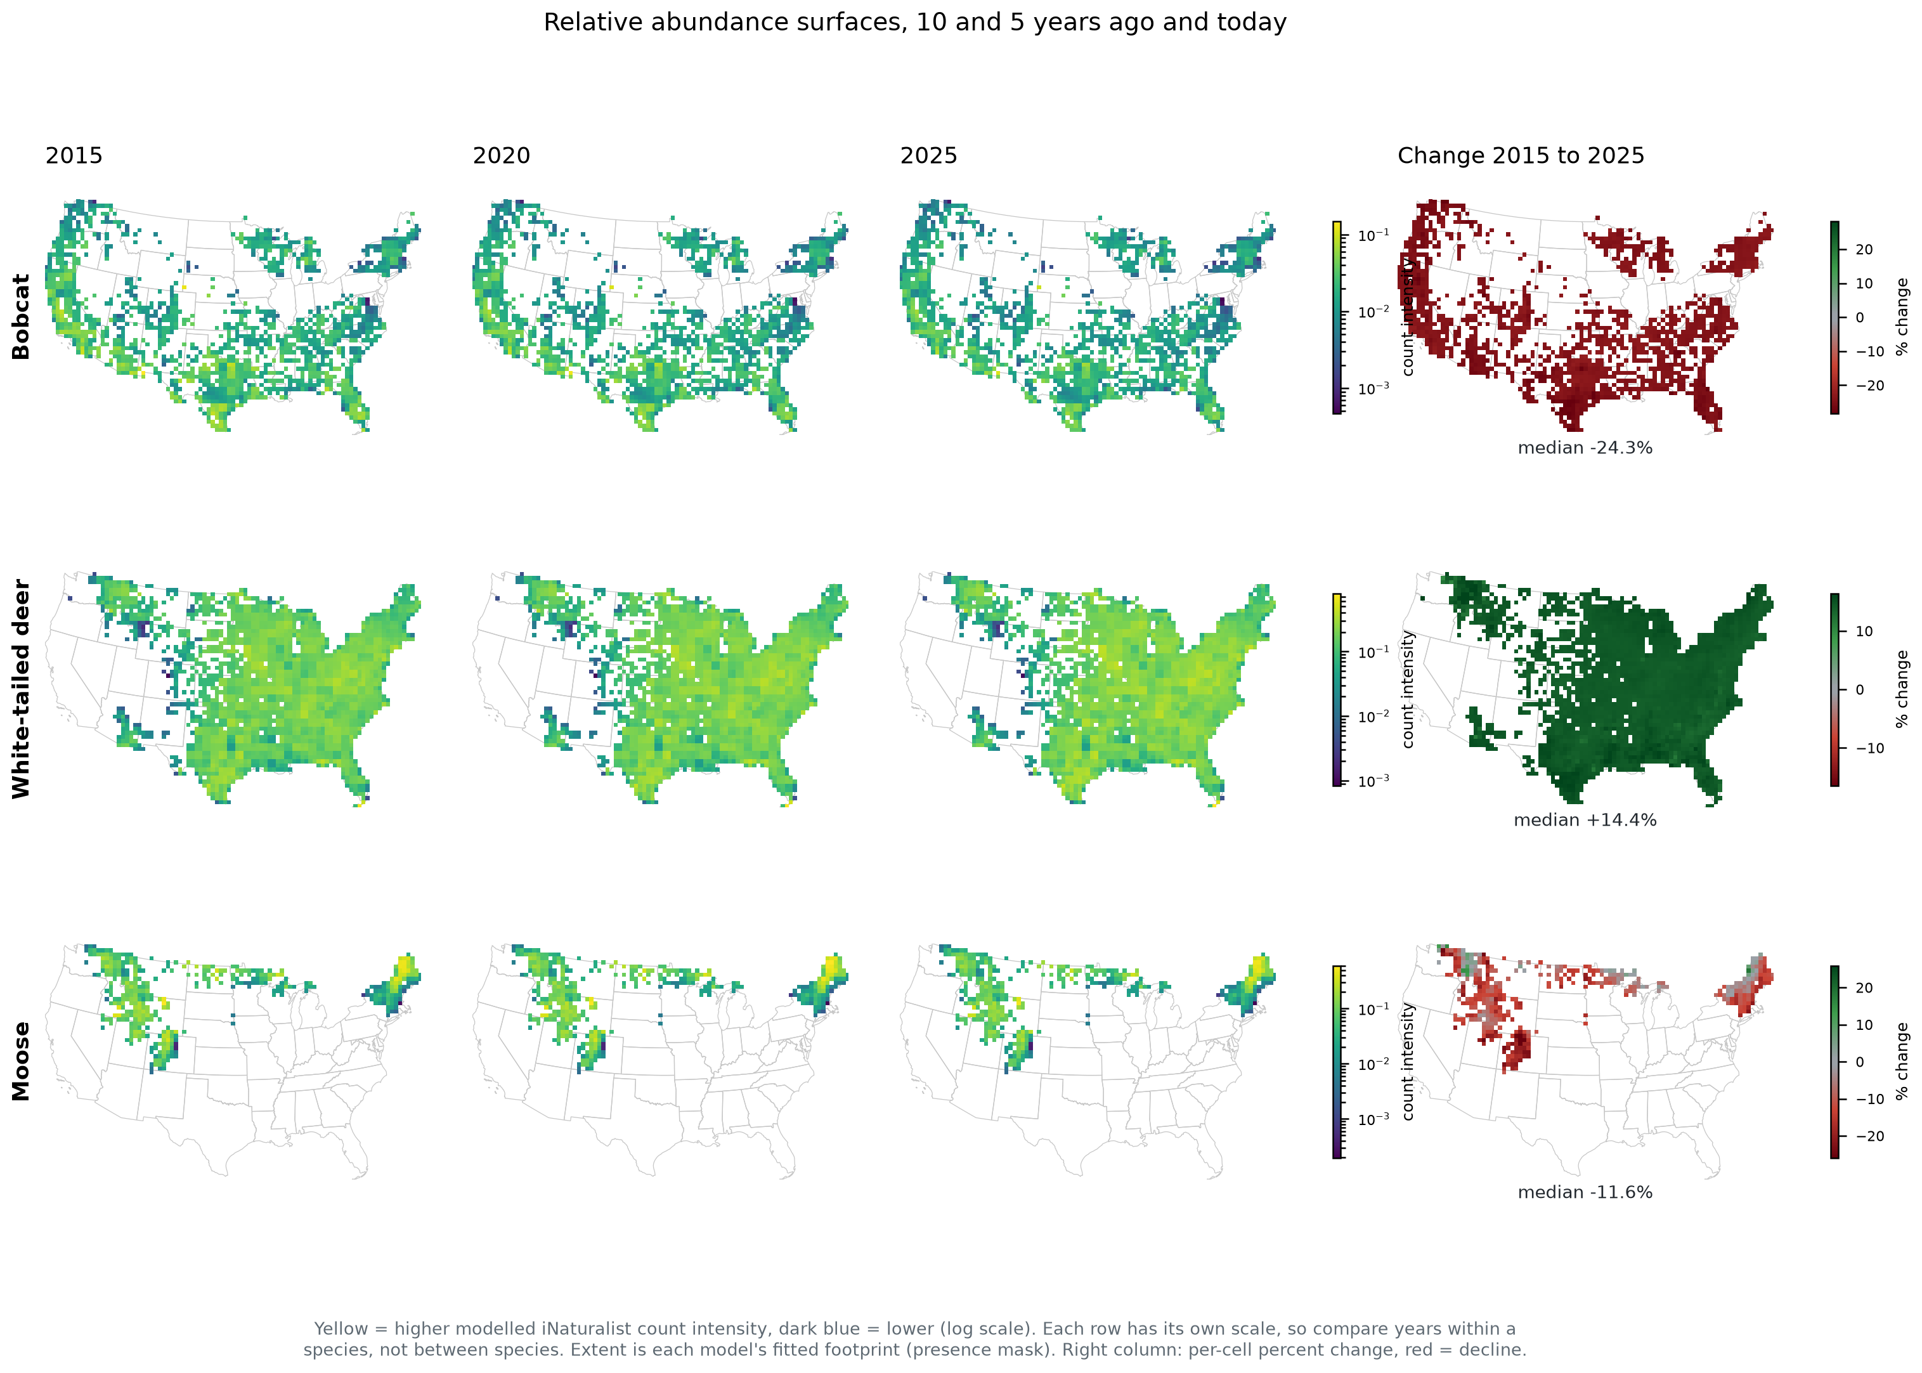
Abundance surfaces
Per-year surfaces are informed by both streams: their spatial pattern comes from the covariates, the spatially varying intercept and the climate fields, all of which the camera data helps estimate. These maps are the camera-informed regional picture of abundance.
The change panel is not a regional trend, and should not be read as one. In the national-scalar parameterisation the trend is a single number applied to every cell, so the proportional change is very nearly uniform in space: across cells it has a standard deviation of 1.1% for bobcat around a median of −24.3%, 0.6% for deer around +14.4%, and 4.8% for moose around −28.2%. The map appears spatially structured only because the baseline abundance surface is, not because the rate of change varies. The small residual variation is a consequence of summarising a nonlinear function by its posterior mean, not regional signal.
The change is also driven by the trend in the latent intensity field, which is the iNaturalist-side quantity, so it carries the same caveat as the corresponding national estimate — most consequentially for bobcat. A camera-anchored change surface is constructible from the fitted occupancy snapshots, which exist at 2015/2020/2025 for bobcat and deer and 2019/2025 for moose, but at camera sites rather than on the full grid.

6. Comparison with state agency assessments
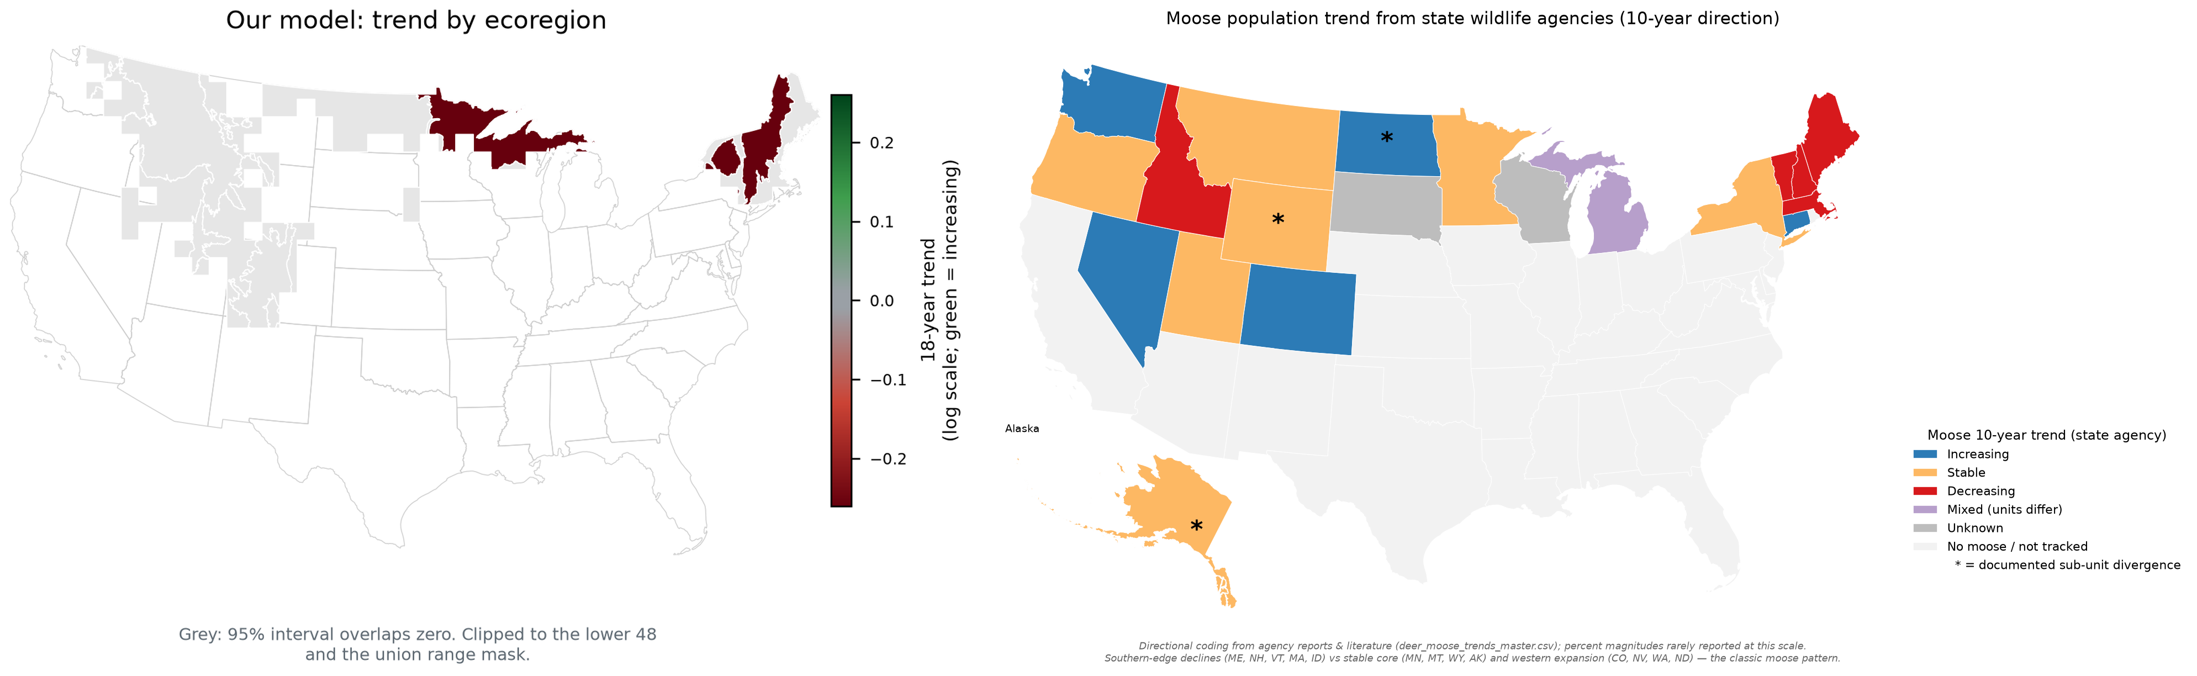
Moose versus agency reports
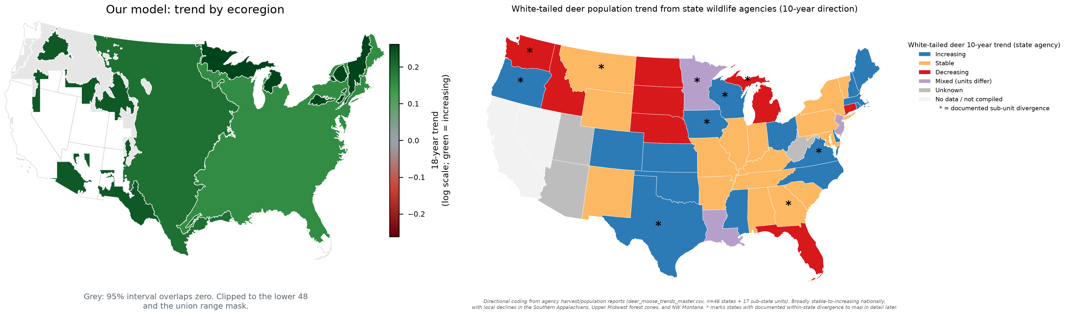
White-tailed deer versus agency reports
Modelled regional direction beside state agencies’ own reported 10-year directions, as compiled and without re-aggregation. No state-survey dataset exists for bobcat, so no comparison is possible for that species.

7. Habitat and climate associations
These are estimated from the full record deliberately: unlike the trend, habitat and climate associations improve with more years of data.
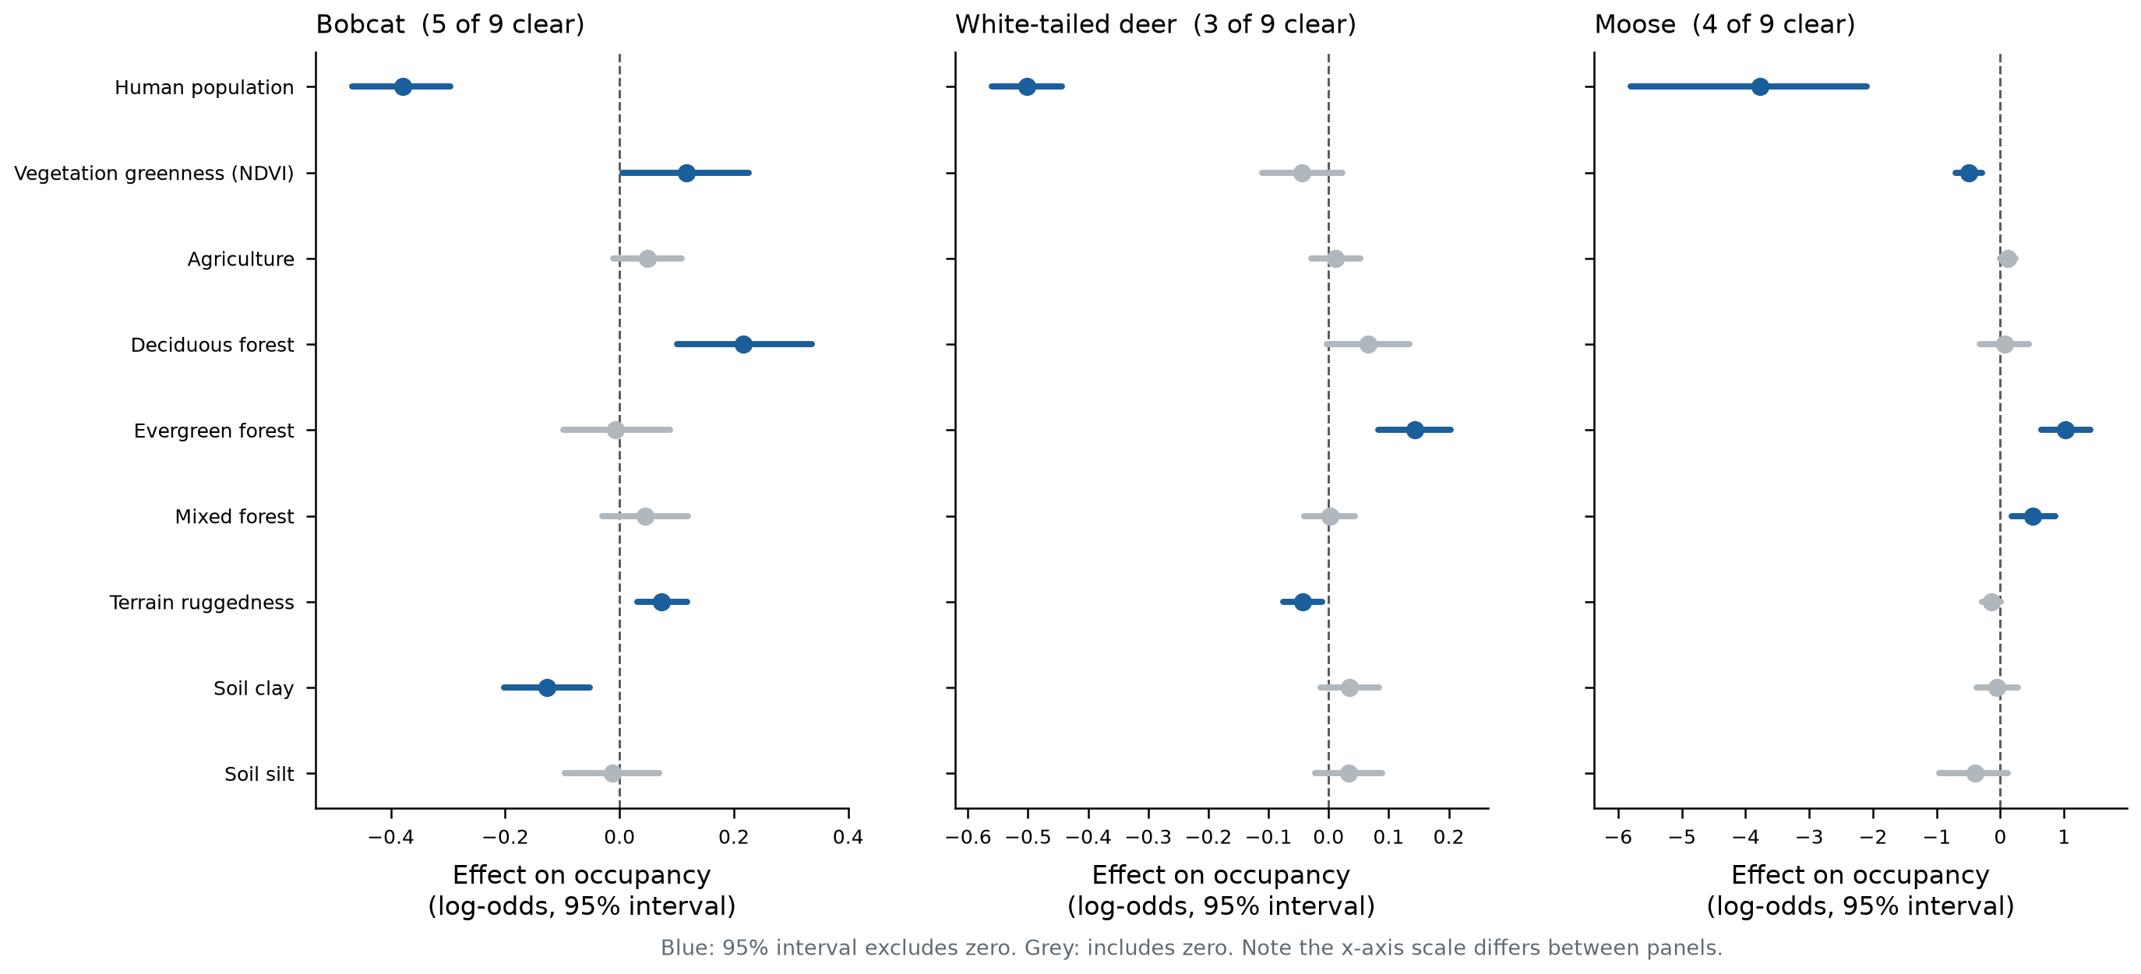
Covariate effects
Nine occupancy covariates per fit. Sign agreement between the two parameterisations is complete across all species and covariates.
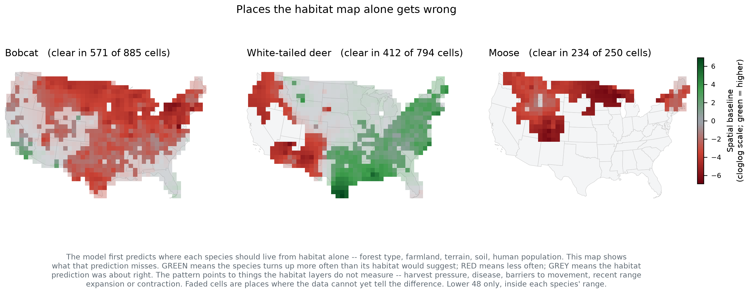
Spatial baseline field
Where each species occurs more, or less, than the habitat covariates alone predict — the smoothed spatial residual. Cells are at full opacity where the 95% interval excludes zero.
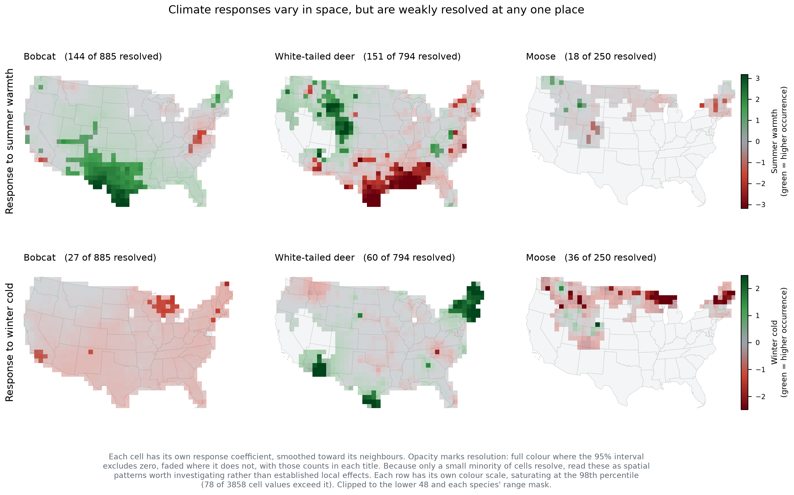
Climate responses
Spatially varying responses to summer warmth and winter cold. Only a small minority of cells resolve individually, so these are spatial patterns worth investigating rather than established local effects. Colour scales are per row, since the two climate variables are not on a common scale.

8. Data-stream congruence and convergence
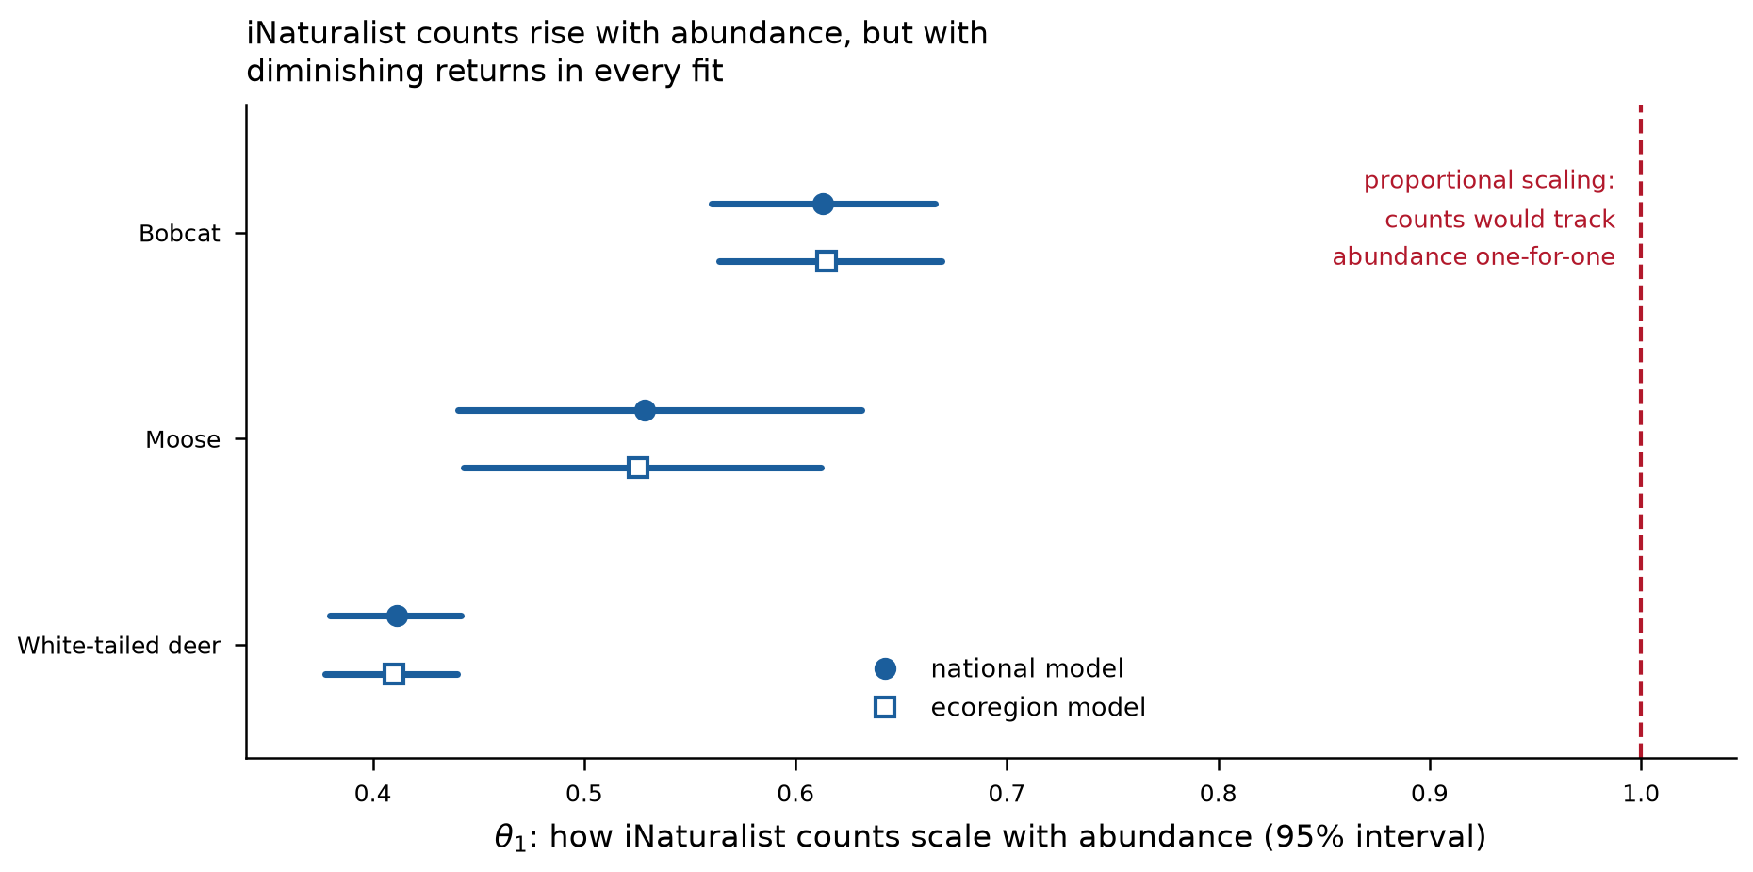
Congruence
The power-law exponent linking the iNaturalist counts to the latent intensity is sub-linear in every fit (0.41–0.61, all intervals excluding 1.0), meaning iNaturalist counts rise less than proportionally with modelled abundance.
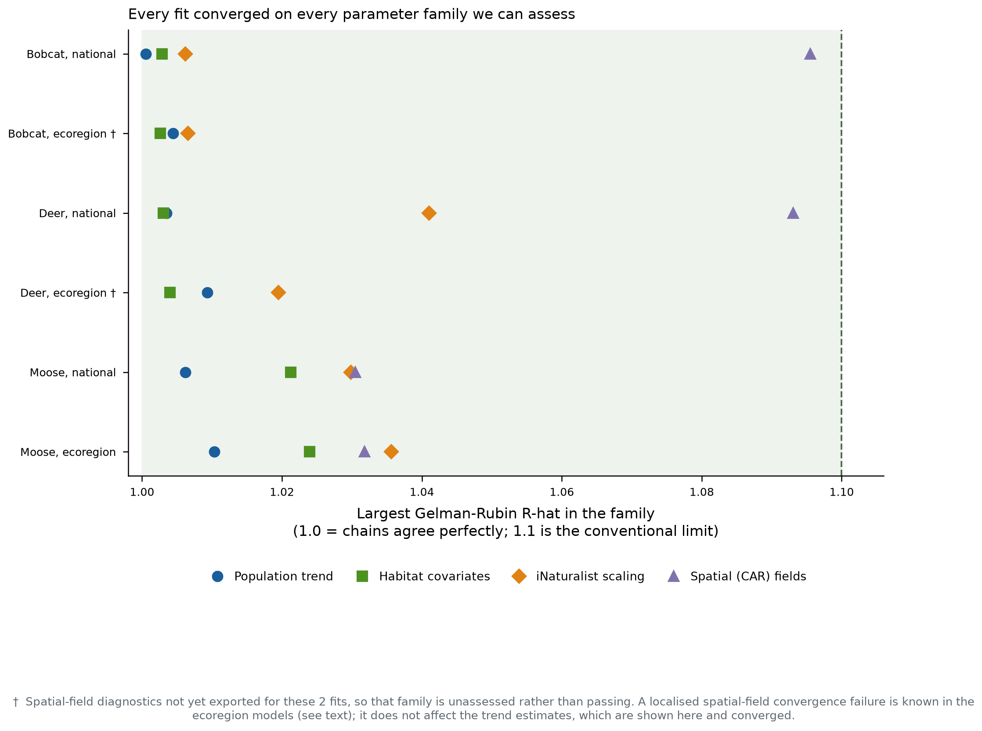
Convergence
Trend and covariate parameters converged in all six fits. Both ecoregion fits carry a localised convergence failure in one contiguous patch of the spatial field, with substantial overlap between species, indicating a property of the spatial adjacency graph rather than of either species’ data. Trend estimates are unaffected; the spatial intercept field and climate surfaces from the ecoregion fits are excluded from the conclusions above.

9. Summary
- White-tailed deer is increasing at about 4% per year, corroborated independently by camera surveys and iNaturalist.
- Camera surveys detect no bobcat trend. The iNaturalist decline of 4.4% per year is not corroborated and should not be reported as a population trend on its own.
- Moose declines on the iNaturalist stream; the camera surveys cannot resolve it, partly because moose camera data begin only in 2019.
- Regional differences in abundance are camera-informed; regional differences in trend are identified by iNaturalist alone, because the regional deviation was scoped to the iNaturalist pathway. The three-period change maps are one national trend applied to a spatially varying baseline, not a regional trend.
- Habitat and climate associations are consistent across parameterisations and are the most robust outputs of these models.
Known limitations. Camera effort is concentrated in recent years, so the 18-year iNaturalist window and the shorter camera window are not the same period; 5- and 10-year windowed refits are pending. No agency comparison exists for bobcat. The two streams’ trend coefficients required unit conversion before comparison, and their model-level sum mixes two scales, so it is not reported here.

