Revised interpretation: camera-anchored trends
Table of Contents

Revised interpretation: camera-anchored trends
Status: revision of the trend sections of MOOSE_v2b_RESULTS.md, BOBCAT_WTD_v2b_RESULTS.md, and the array-level simulation summary. Model code and fits are unchanged; what changes is which parameter is reported as the ecological result. No refit was required to produce anything in this document.

1. What changed
The model contains two trend parameters. The camera occupancy submodel carries one of them:
cloglog(psi[i]) = link_occ_intercept[cell[i]] + ... + year_beta * year_occ[i]
The iNaturalist count submodel carries their sum:
log(lambda[s]) = ... + total_var_beta * year_vals[t]
total_var_beta = year_beta + year_var
year_var therefore appears in no camera likelihood term. It is identified by iNaturalist alone, and it is the mechanism by which the two streams’ trends are permitted to diverge — the temporal analogue of the divergence Goldstein et al. build in spatially, where iNaturalist influences the latent intensity only through theta0/theta1 and the camera data is the gold standard. Our fits estimate theta1 between 0.41 and 0.61 with every interval excluding 1.0, so that attenuation is active and substantial.
Earlier drafts reported total_var_beta. That is the iNaturalist-side quantity. Following the same rule the ISDM paper applies to occupancy — report the camera submodel’s parameter — the ecological result is year_beta, and year_var is context: a large year_var says the iNaturalist stream diverged, not that the population changed.
This is a reporting correction on our side, not a defect in the model. The divergence design worked exactly as intended, and bobcat demonstrates it: the camera-anchored trend stayed pinned at zero while year_var absorbed the entire iNaturalist decline, rather than the drift contaminating year_beta.

2. Revised species results
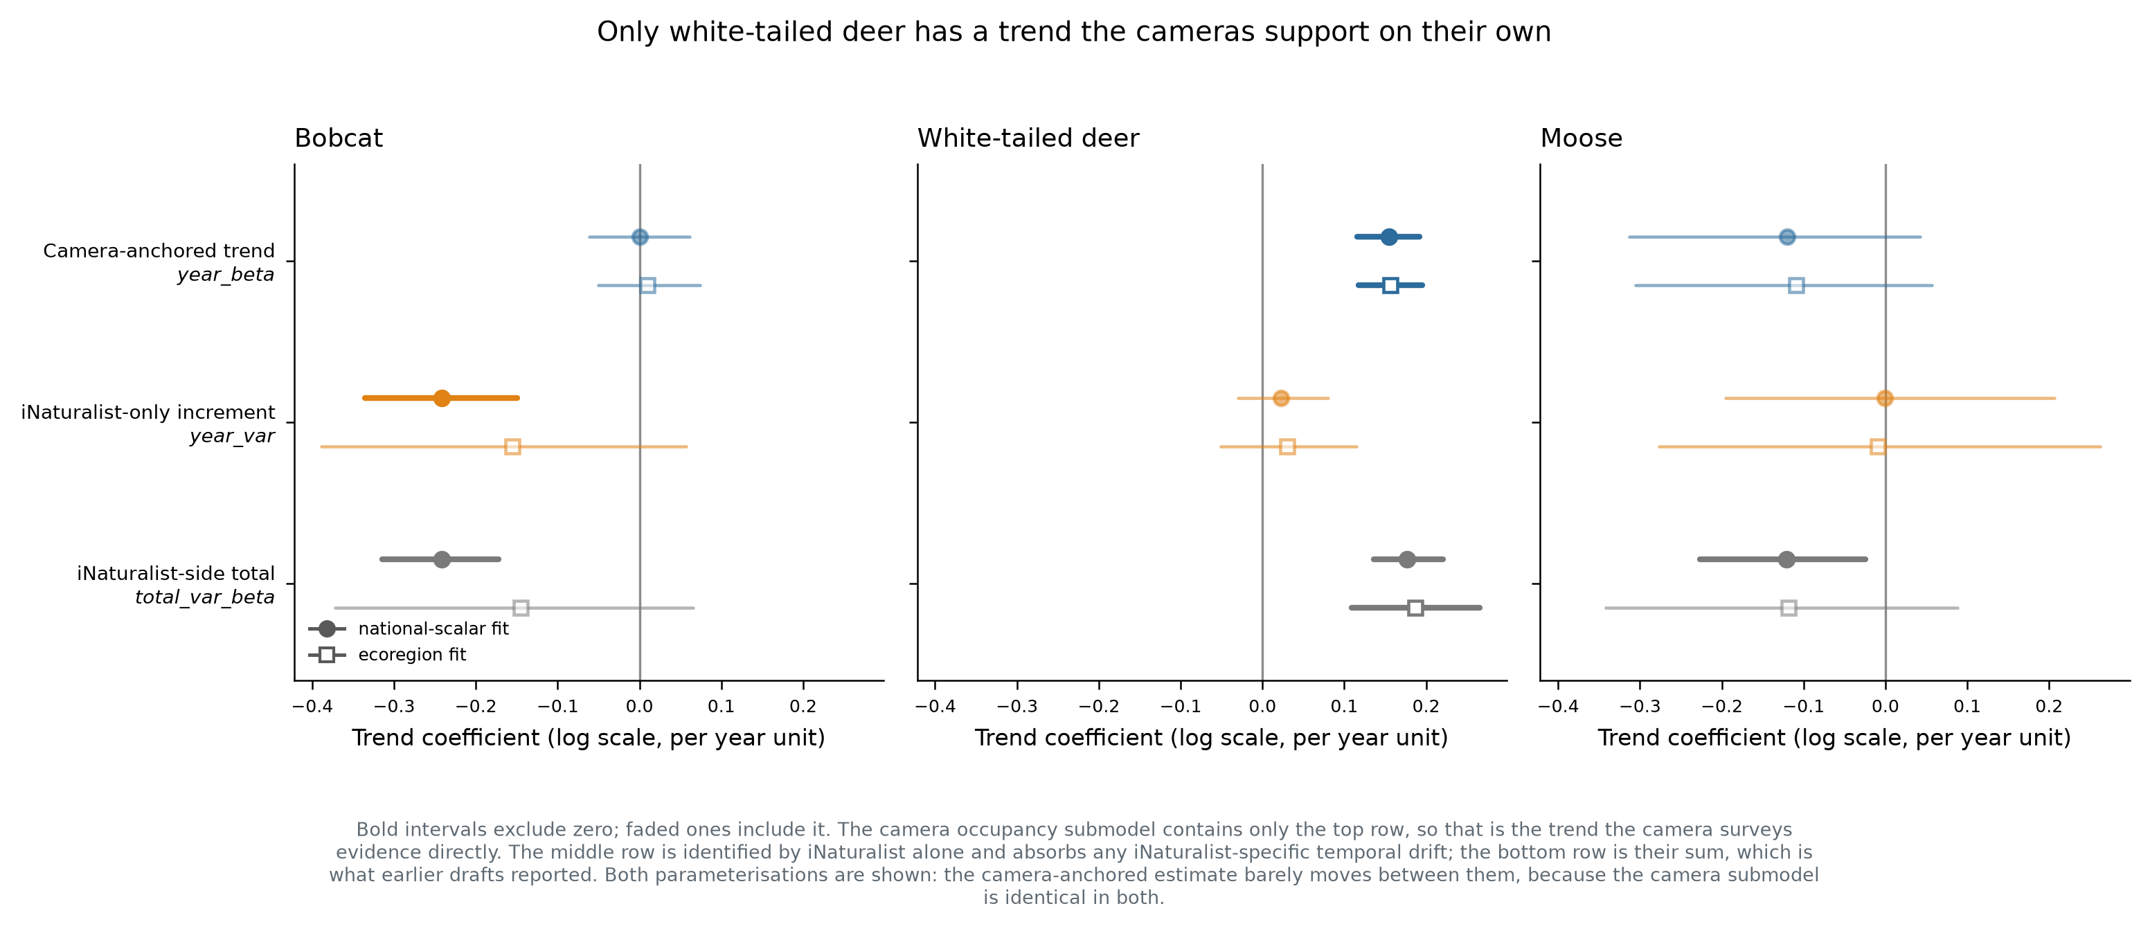
Trend decomposition
Species | year_beta (camera-anchored) | year_var (iNat-only) | previously reported
Bobcat | −0.0001 (−0.061, 0.061) | −0.242 (−0.336, −0.150) | −0.242, “clear decline”
White-tailed deer | +0.155 (0.116, 0.192) | +0.022 (−0.030, 0.080) | +0.177, increase
Moose | −0.121 (−0.313, 0.042) | −0.001 (−0.195, 0.206) | −0.121, “significant decline”
Bobcat: no camera-detected trend. The camera-anchored estimate is −0.0001 with a tight interval around zero, and the ecoregion fit agrees (+0.0098, −0.051 to 0.074). The reported 24% decline is entirely the iNaturalist-only term. Under the divergence rule this reads as no trend, with iNaturalist indicating a decline that the cameras do not corroborate.
White-tailed deer: an increase, camera-anchored. +0.155 (0.116, 0.192) with year_var indistinguishable from zero. This is the project’s one trend that the camera surveys evidence directly, and the revision strengthens rather than weakens it — the result no longer depends on the iNaturalist term at all.
Moose: declining but unresolved. The camera-anchored interval spans zero in both parameterisations. total_var_beta excluded zero in the national fit only because the two components trade off in the posterior; note it does not exclude zero in the ecoregion fit (−0.342, 0.088), so even the old headline was parameterisation-dependent for moose.
A robustness result worth keeping. year_beta barely moves between parameterisations — bobcat −0.0001 vs +0.0098, deer +0.155 vs +0.157, moose −0.121 vs −0.109 — because the camera submodel is identical in both. The camera-anchored trend is insensitive to a modelling choice that visibly moves the iNaturalist-side total.

3. Regional trends have no camera-anchored version
This is a consequence of the same structure and it is more restrictive than the national case. In model_code_ecoregion_trend.R the regional deviation enters the iNaturalist likelihood only:
total_var_beta = total_var_beta + year_effect[inat_cell100[g]] # iNat side
year_beta * year_occ[i] # camera side
The camera submodel carries the global year_beta with no regional term at all. year_region is therefore identified by iNaturalist alone, and abs_trend_mean in the ecoregion outputs is total_var_beta + year_region — wholly an iNaturalist-side quantity.
So there is no camera-anchored regional trend to report, and none can be obtained from these fits. The regional trend maps carry exactly the caveat bobcat’s national trend carries, by construction rather than by accident. They should be labelled as iNaturalist-side spatial variation in trend, not presented as regional population trends. Producing a camera-corroborated regional trend would require adding a regional deviation to the occupancy submodel — a model change, not a re-extraction.

4. Abundance surfaces: the spatial pattern stands, the change does not
mu is built from log(lambda), which contains total_var_beta * year. The temporal change in the abundance surfaces is therefore driven by the iNaturalist-side total, and bobcat’s median −24.3% change panel is the same uncorroborated signal in map form. The spatial pattern in any single year is camera-informed through lambda’s spatial terms and is unaffected. Keep the per-year surfaces; either drop the change column or label it explicitly as iNaturalist-side.

5. Revised simulation interpretation
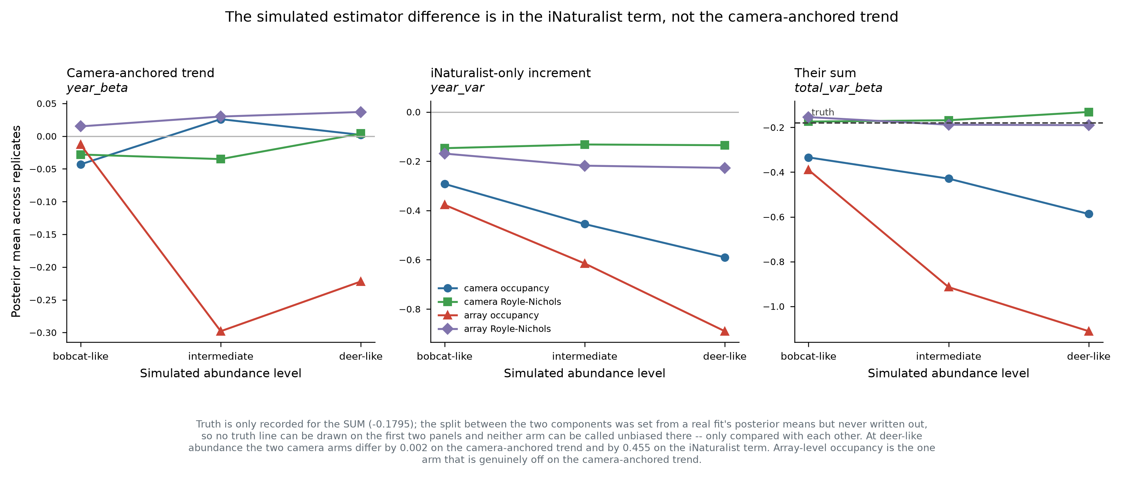
Simulation components
The sweep scored bias, interval width, coverage, power and false-positive rate on total_var_beta. Decomposed, the four arms agree closely on year_beta and diverge on year_var. At deer-like abundance the two camera-level arms differ by 0.002 on the camera-anchored trend and by 0.455 on the iNaturalist term.
Retracted as stated: “camera occupancy overstates declines 3–6× at deer abundance.” That is a statement about year_var, not about the trend we report. On year_beta the two camera arms are indistinguishable at every abundance level (gaps of 0.015, 0.061, 0.002).
What survives, and is the sweep’s real result: the aggregation effect, not the estimator effect. Array-level occupancy’s year_beta reaches −0.222 at deer-like and −0.298 at intermediate abundance, while both camera-level arms stay within 0.06. Array-level aggregation genuinely damages the camera-anchored trend; camera-level occupancy does not. This was previously confounded with the occupancy-versus-Royle-Nichols comparison and now separates cleanly.
Also unaffected: the finding that detection rate is the wrong lens for judging these estimators, since it conflates bias with precision.
A limit on how far this can be taken. Truth was recorded only for the sum (tvb_true = −0.1795). The split was set from a real fit’s posterior means (sim_helpers.R: year_beta = rp$year_beta, year_var = rp$year_var) but never written out, so no arm can be called unbiased on year_beta — only compared with the others. Recovering that one number completes the re-scoring from rows already on disk.
And a scope limit on the whole sweep. Replicates were generated from model_code_national_scalar — the occupancy model — so the simulated data carry Poisson-consistent heterogeneity. The sweep answers “if the occupancy model is true, which estimator recovers the trend best.” It does not answer “which estimator works on our data,” and in particular it never exposed Royle-Nichols to the overdispersion measured in Section 6. Worth noting that Royle-Nichols was the misspecified model there and still matched the correctly-specified one, which is evidence for its robustness on trends.

6. Royle-Nichols is not a drop-in alternative
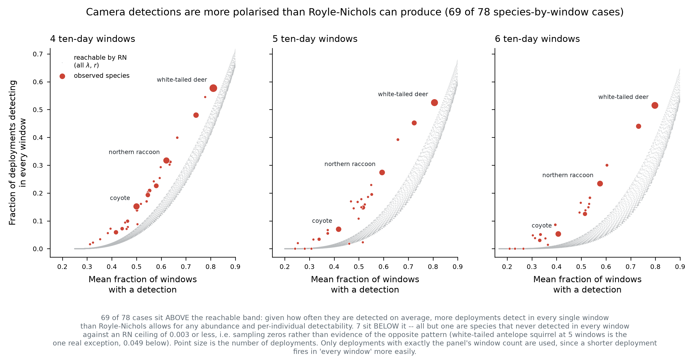
Estimator choice diagnostic
Occupancy saturates: psi = 1 − exp(−lambda), so its information about log(lambda) collapses once most sites are near-certain detections. That is a real limitation, and it is species-specific. From the fitted per-site psi, white-tailed deer sits at a median of 0.952 with 68.2% of sites above 0.9 and half above lambda = 3; bobcat (0.156) and moose (0.033) are far from saturation and are in occupancy’s better operating range. Range-restricted naive occupancy across all 34 fleet species puts deer at 0.794 and the next species — eastern gray squirrel — at 0.478, so deer is an outlier rather than the top of a gradient. Commonly-detected species such as gray squirrel and raccoon are near occupancy’s most informative point, not past it.
Royle-Nichols avoids saturation by reading detection frequency, but its observation model does not fit our camera data. Comparing two statistics among detecting deployments — mean fraction of 10-day windows with a detection, and fraction of deployments detecting in every window — against the region reachable by RN over all (lambda, r): 69 of 78 species-by-window-count cases fall above the reachable band, 2 inside, and 7 below of which 6 are sampling zeros against an RN ceiling of 0.003 or less. Real detections are more polarised than Poisson abundance with constant per-individual detectability can generate.
Two further limits worth stating. lambda and r are not separately identified from these data at our window counts — at J=4, (25, 0.03) and (0.11, 0.52) reproduce the same two moments to machine precision — so no per-species abundance cutoff can be derived this way. And the band is built from two summary statistics rather than the full detection-history likelihood; a proper goodness-of-fit test would probably reject harder, but not in the other direction.
Candidate alternatives, in the order we would try them: a detection-rate count model (negative binomial on events per camera-night, which gives both streams the same form and no saturation, at the cost of conflating abundance with activity); Royle-Nichols with negative-binomial abundance; or Royle-Nichols with a site-level random effect on r, which is testable rather than assumed since feature_type records on-trail versus random placement.

7. Unaffected by this revision
- Covariate effects (occ_beta, 9 covariates × 8 fits) — occupancy submodel parameters, unchanged, with perfect sign agreement across parameterisations.
- Convergence diagnostics, including the shared CAR-field convergence failure in the ecoregion fits.
- The theta0/theta1 congruence results, and the spatial baseline and climate response fields — all estimated from the full record and independent of the trend parameters.
- Habitat and climate associations generally: these improve with more years of data, whereas the trend is compromised by the sparse early camera years. The report draws them from the full-record fits deliberately.
One correction to the congruence section: trend_robust_indicator is reportable, contrary to an earlier note here. It has real posterior means (bobcat 0.0005, moose 0.2599, deer 0.7836); it is snr_derived, the raw year_beta/year_var ratio, whose mean is undefined. The indicator’s weakness is narrower than “cannot be computed”: it thresholds a ratio whose denominator sits near zero, so where year_var spans zero the resulting probability is unstable rather than undefined. Moose is the example — year_var = −0.0006 (−0.195, 0.206) with an indicator of 0.26. Testing year_var against zero directly is the better-behaved replacement, and it is exactly the question the indicator was built to answer.

8. Outstanding
- truth$year_beta from inputs$real_post_means — one value, completes the sweep’s bias re-scoring from existing rows with no new compute.
- Per-replicate year_beta quantiles for coverage, power and false-positive rate on the camera-anchored trend. Only means were recorded (sim_helpers_estimator_metrics.R:84), so this needs a re-collect if the sample files persist on Hazel, and a re-run only if they do not.
- Deer restricted-site refit — drop camera sites above psi ≈ 0.95 and check whether year_beta moves. Deer’s posterior SD of 0.019 against a prior scale of order 1 says the data dominate the prior, so we expect stability; this would confirm it. One species, one fit.
- A regional deviation in the occupancy submodel, if camera-corroborated regional trends are wanted. Model change, needs team agreement.
- The 5- and 10-year windowed refits remain blocked on the base-bundle reconstruction, unchanged by this revision.

