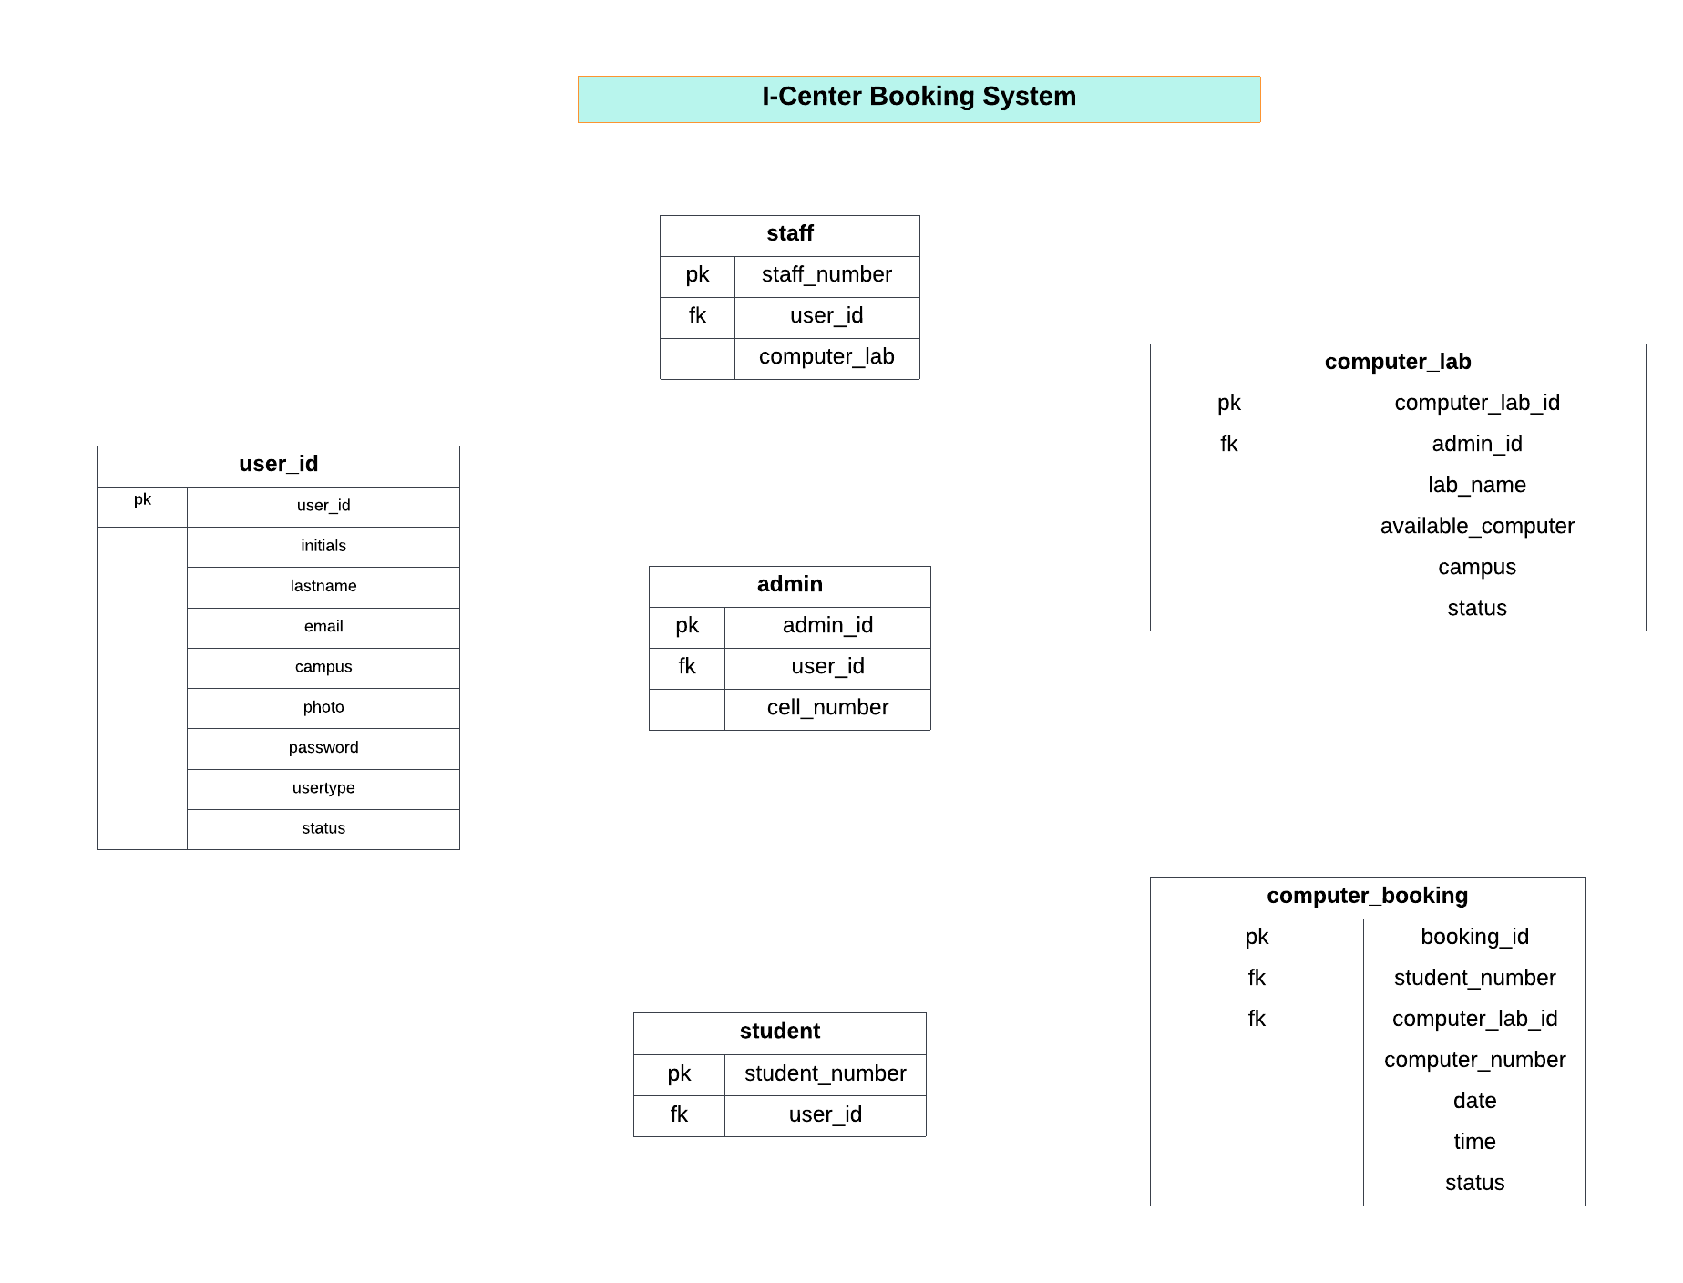

handles

assigned

assigned

books

Signs up as

Signs up as

Sings up as