* Confusion Matrix:

[[10460 755]

[ 1297 2134]]

* Classification Report

|  |  |  |  |  |
| --- | --- | --- | --- | --- |
|  | Precision | Recall | F1-score | Support |
| 0 | 0.89 | 0.93 | 0.91 | 11215 |
| 1 | 0.74 | 0.62 | 0.68 | 3431 |
|  |  |  |  |  |
| Accuracy |  |  | 0.86 | 14646 |
| Macro avg | 0.81 | 0.78 | 0.79 | 14646 |
| Weighted avg | 0.85 | 0.86 | 0.86 | 14646 |

* ROC-AUC Curve

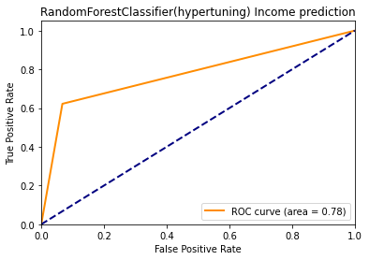

* ROC-AUC Score: 0.77732