# MoonPanoramaMaker for the Automatic Exposure of High-Resolution Panoramas of the Moon

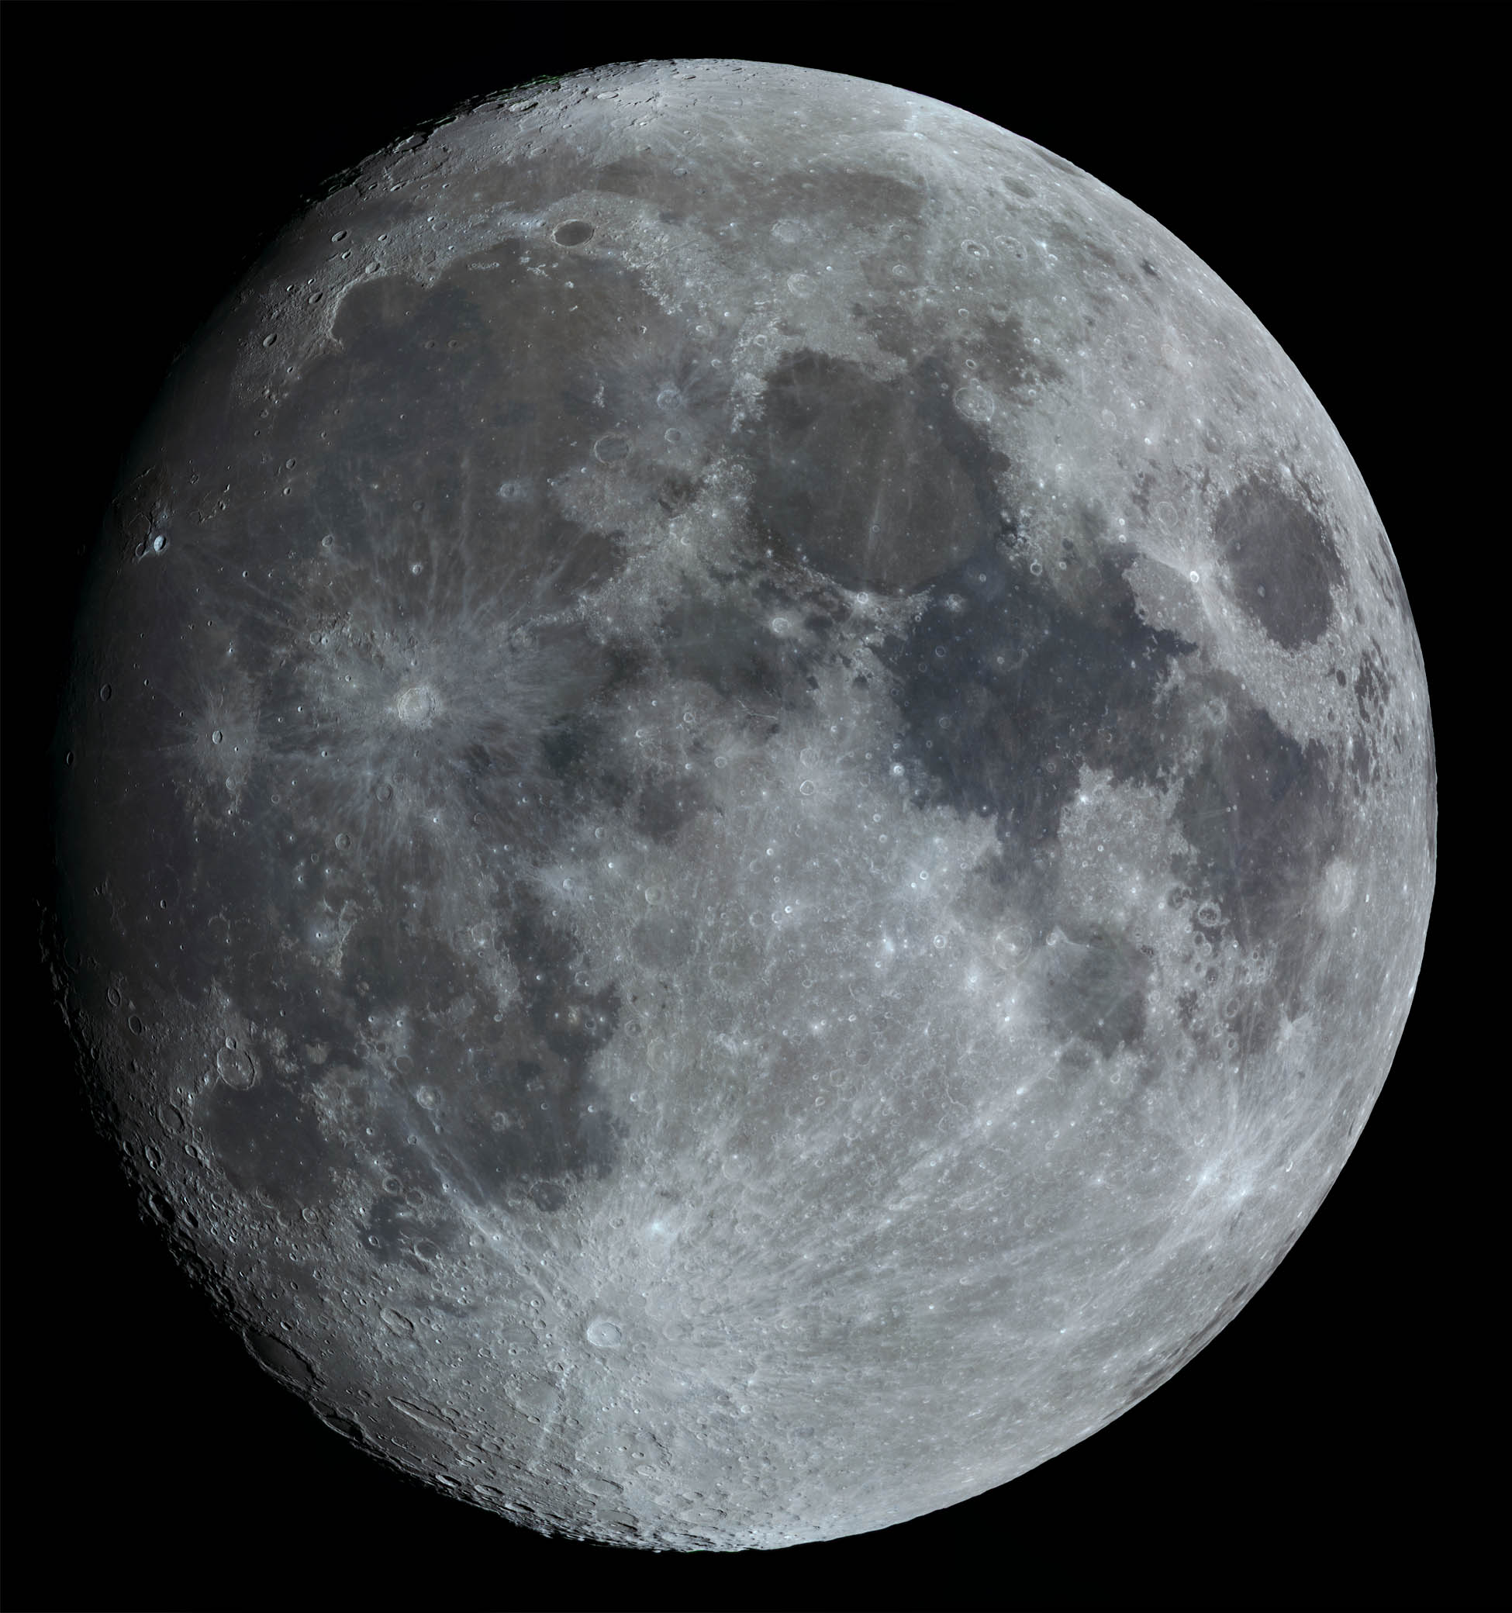

February 27, 2018, 21:00 CET. Celestron 11, ASI178MC, panorama of 27 tiles. © Rolf Hempel, 2018

## 

## User Guide (Version 1.0.0, March 30, 2018)

Rolf Hempel

#### *Table of Contents*

[1. Introduction 2](#_Toc510165760)

[2. Changelog 3](#_Toc510165761)

[2.1 Changes since version 0.9.5 (October 2017) 3](#_Toc510165764)

[2.2 Changes since version 0.9.3 (October 2016) 4](#_Toc510165765)

[3. System Requirements and Software Installation 4](#_Toc510165766)

[3.1 Windows (7 / 8 / 10) 4](#_Toc510165770)

[3.2 Linux 6](#_Toc510165771)

[3.3 Connection to FireCapture 7](#_Toc510165772)

[4. Program Execution 8](#_Toc510165773)

[4.1 Program Start 8](#_Toc510165778)

[4.2 Layout of the Main Window 10](#_Toc510165779)

[4.3 Selecting a Landmark on the Moon for Mount Alignment 10](#_Toc510165780)

[4.4 Camera Rotation 12](#_Toc510165781)

[4.5 Selection and Positioning of the Focus Area 13](#_Toc510165782)

[4.6 Image Acquisition 13](#_Toc510165783)

[4.7 Determining and Correcting the Coordinate System Drift 16](#_Toc510165784)

[4.8 Automatic Alignment 18](#_Toc510165785)

[4.9 End of Program 20](#_Toc510165786)

[Appendix A: Parameters at the Configuration Dialog 21](#_Toc510165787)

[Appendix B: Algorithms Used by the Program 28](#_Toc510165788)

[Appendix C: Determination of the Focal Length of the System 35](#_Toc510165789)

## Introduction

MoonPanoramaMaker automates the process of taking high-resolution panoramas of the Moon. Since the USB cameras employed cover a very small field of view, multiple views must be combined to produce a complete panorama. MoonPanoramaMaker covers the current Moon phase with an optimal grid of single views and automatically steers the telescope mount and camera during their exposure.

With the introduction of digital image technology the photography of the Moon has taken a great leap forward. The so-called “Lucky Imaging” technique today allows amateur astronomers to record surface details which in the old days of analog photography were out of reach even to professional astronomers with access to the best earth-bound telescopes. For high-resolution work today the camera of choice is a video module which connects to the USB interface of a portable computer. With such a camera one can take many images in a short time and store them without compression artefacts in a video file. On the negative side, however, the image sensors are quite small and exhibit relatively low pixel counts.

The natural domain of these cameras is, therefore, the photography of selected surface features at high spatial resolution. For a panorama of the whole Moon, many of those views – hereafter referred to as “tiles” – must be stitched together. While good software products are readily available for the automatic combination of even large numbers of tiles into a panorama, taking the video files is still left to the skillful hands of the observer. For every tile this involves steering the telescope to the location of the tile center and triggering the video acquisition using some video capturing software.

As long as the camera field of view is not much smaller than the diameter of the Moon, taking the video files manually is no problem. The situation is different, however, if the whole Moon panorama is composed of more than 100 tiles. This can happen easily if a telescope with an aperture of 10” or more is used for diffraction-limited imaging. In such a situation it is nearly impossible to steer the telescope manually such that the tiles form a uniform coverage of the Moon, with similar overlaps between tiles and no holes in between. This is where MoonPanoramaMaker comes into play. The program computes an optimal coverage of the current Moon phase with tiles, and then controls the telescope and camera during video acquisition.

MoonPanoramaMaker supports two workflow variants: In semi-automatic mode, the program steers the telescope to the next tile location but leaves the camera control to the observer. This may make sense if the observer wants to use his or her own video control software, or if the camera is not connected to the computer. The observer acknowledges the end of each exposure, and MoonPanoramaMaker moves the telescope to the next tile. In fully automatic mode MoonPanoramaMaker controls both the telescope and camera, by triggering the external camera control software FireCapture.

## Changelog



### Changes since version 0.9.5 (October 2017)

* The graphical user interface (GUI) was revised substantially. Keys were renamed and arranged in a more logical way. New keys “Mark tile(s) processed” and “Exit” were added. In the configuration dialog windows, drop-down lists replace text input wherever possible.
* If the user changes a configuration parameter during the workflow, re-initialization is limited to an absolute minimum, as required by the parameter change.
* Error handling has been extended considerably. Problems in accessing external software (e.g. drivers, FireCapture program) should not cause the program to crash anymore. Instead, human-readable error messages are issued, and the program waits for a user response.
* As an alternative to ASCOM there is the option to use INDI for telescope control. Therefore, MoonPanoramaMaker can be used on Linux systems as well now.
* MoonPanoramaMaker and FireCapture can now run on different computers, even using different operating systems. In the case of INDI telescope control, the INDI server might run on a third system.
* The configuration parameter set and some default values have changed.
* The entire Python code was ported from Python 2.7 to Python 3.4. The GUI toolkit Qt4 was replaced with Qt5.
* The Windows installer (as well as the Linux tarfile) was produced with PyInstaller 3.3.1 instead of Py2exe.

### Changes since version 0.9.3 (October 2016)

* Introduction of auto-alignment (see Section 4.8). A new GUI button “Auto-Alignment on/off” was added. Several new parameters were included in the configuration dialog window.
* New option to record more than one video at each tile location (see Section 4.6).
* New option to focus on a star rather than on a lunar surface area (see Section 4.5).
* Introduction of four protocol levels with increasing level of detail (see Section 4.1). Also, readability of the protocol file was improved.
* A new landmark can be selected during the recording workflow without invalidating the tiles recorded so far. This works with both manual and automatic alignment.

If MoonPanoramaMaker at startup finds a configuration file “.MoonPanoramaMaker.ini”, created by MoonPanoramaMaker 0.9.3 or 0.9.5, in the user’s home directory, it converts it into the new 0.9.6 format automatically. The reverse does not work, though: If a later MoonPanoramaMaker version is de-installed and replaced with an older one, the configuration file must be deleted before running the program.

## System Requirements and Software Installation

MoonPanoramaMaker controls both the telescope mount and the camera (via the external FireCapture software). For telescope control there are two options: ASCOM and INDI. Since ASCOM is based on Microsoft’s “Common Object Model”, MoonPanoramaMaker in this mode can be used on Windows systems only.

For users who want to use MoonPanoramaMaker on Linux systems there is now the option to control the telescope mount via INDI.



### Windows (7 / 8 / 10)

The whole software was tested on an Acer laptop computer (type “Acer Aspire V5-573G”, Intel Core i5-4200U, 8 GBytes RAM) running Windows 7 Professional, and on a PC (Intel Core i7-7700K, 64GBytes RAM) running Windows 10 Professional, version 1709. MoonPanoramaMaker has much lower requirements on RAM size and CPU speed than the camera control software FireCapture. Since MoonPanoramaMaker is active mostly when FireCapture is not taking videos, it increases the peak load only very slightly.

The ASCOM software can be downloaded from the website <http://ascom-standards.org/>. The tests were performed using the “ASCOM Platform 6.1SP1” (laptop) and “ASCOM Platform 6.3” (PC). Additionally, an ASCOM driver for the telescope mount is required. On the official ASCOM web page <http://ascom-standards.org/Downloads/ScopeDrivers.htm> drivers for many popular mountings can be found.

MoonPanoramaMaker assumes that the telescope is mounted equatorially. It operates it by using a minimal set of ASCOM instructions only, and therefore in principle should work with almost any driver. It assumes, however, that the driver in a GoTo operation always approaches the target position from the same side in the declination coordinate, i.e. either from the North or from the South. Otherwise backlash in the declination gear could greatly reduce the pointing accuracy.

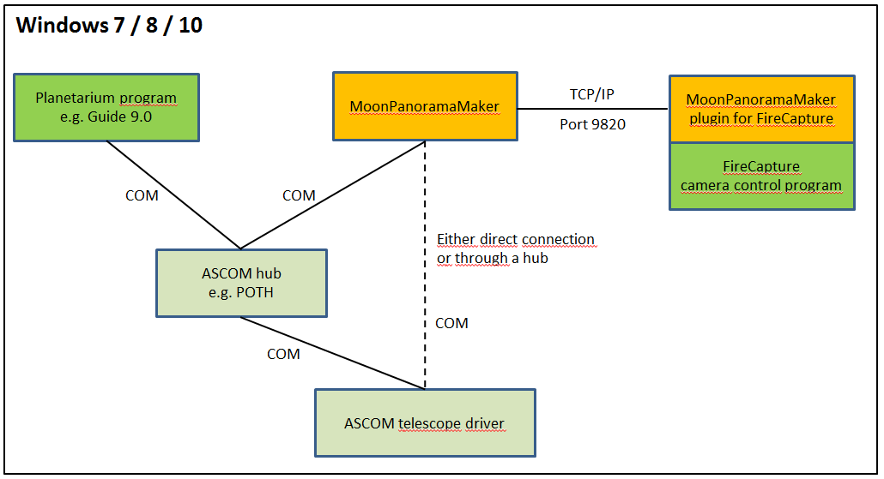

In order to allow other application programs, e.g. a planetarium program, to access the ASCOM interface of the telescope mount alongside MoonPanoramaMaker, it may be useful to place an ASCOM hub between the mount driver and the application programs. The ASCOM platform includes the hub named POTH (“Plain Old Telescope Handset”). It is fully sufficient for this purpose. Many ASCOM drivers function as a hub themselves and can be accessed from more than one application program at the same time.

The MoonPanoramaMaker software itself is distributed as a single file: the Windows installer [“MoonPanoramaMaker\_V1.0.0\_Windows-Installer.exe”](https://github.com/Rolf-Hempel/MoonPanoramaMaker/releases). Before installation, any earlier MoonPanoramaMaker version should be de-installed first using the “Uninstall” entry in the program menu. When the installer is started, a wizard guides the user through the installation process. Apart from the program start entries, MoonPanoramaMaker does not write any parameters into the Windows Registry and can be installed at any file system location. An uninstaller is provided with the software. It removes all installed files. The following temporary files which are created at execution time in the user’s home directory are not removed:

* .MoonPanoramaMaker.ini (configuration at the latest MoonPanoramaMaker run)
* MoonPanoramaMaker.log (logfile)
* MoonPanoramaMaker\_xxx\_Tile-Layout.png (with xxx denoting the time stamp when the layout was created)
* directory .MoonPanoramaMaker\_alignment\_images (if auto-alignment was used)

Those files can be deleted manually at any time. Please note that all configuration parameters are lost if the .MoonPanoramaMaker.ini file is deleted.

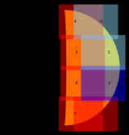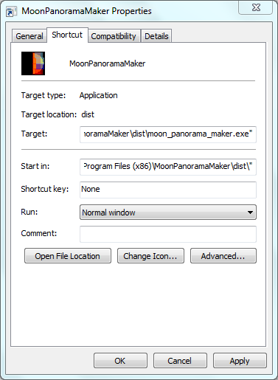

Properties dialog of the program starter: Configuring the starter icon has to be done manually (see text below).

The Windows installation wizard offers to place a program starter on the desktop. It is recommended to replace its standard icon with the MoonPanoramaMaker icon, which can be found under the filename “MoonPanoramaMaker.ico” in the installation folder.

### Linux

With MoonPanoramaMaker version 1.0.0 the option was introduced to control the telescope mount via [INDI](http://indilib.org/). Since installation packages for the Python interface (called “pyindi”) are currently only available for Linux, the use of INDI is restricted to Linux as well.

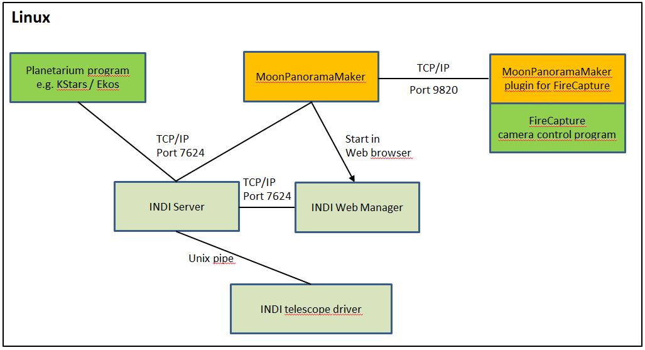

Please note that INDI is still in an early development state, and as such it cannot be expected to be as mature as ASCOM. The availability of telescope drivers is much less complete, available drivers might not function as expected, and there is only limited documentation. The INDI implementation of MoonPanoramaMaker was developed using the [Celestron driver](http://indilib.org/devices/telescopes/celestron/celestron-nexstar.html). To make it work correctly at all, polling loops had to be inserted at several places in the code. As a result, the program is much less responsive in INDI mode as compared to ASCOM. Therefore, if you have the choice it is preferable to run MoonPanoramaMaker on a Windows system using ASCOM.

The complete MoonPanoramaMaker software for Linux can be obtained from Github as a gzipped tarfile ([“MoonPanoramaMaker\_V1.0.0\_Linux.gz”](https://github.com/Rolf-Hempel/MoonPanoramaMaker/releases)). The tarfile can be unpacked at any file system location. This will create the directory “moon\_panorama\_maker” which contains the executable “moon\_panorama\_maker”, the Icon file “moon\_panorama\_maker.ico”, and the directory “documentation” with this user guide. The software has been tested with Ubuntu 16.04 LTS.

Not included is the INDI software which is needed for telescope mount control. In Ubuntu (Version 16.04 or later) it can be [downloaded and installed](http://indilib.org/download/ubuntu.html) with the following commands:

sudo apt-add-repository ppa:mutlaqja/ppa

sudo apt-get update

sudo apt-get install indi-full

### Connection to FireCapture

During program execution in fully automatic mode MoonPanoramaMaker communicates with the camera control software FireCapture (<http://www.firecapture.de/index.html>), developed by the German amateur astronomer Torsten Edelmann. The software is freely available at the website given above. In order to make both programs communicate with each other, the folder “MoonPanoramaMaker” (it only contains the single file “MoonPanoramaMaker.jar”) must be copied from the “plugins” folder in MoonPanoramaMaker’s installation directory into FireCapture’s “plugins/x64” directory (see illustration below). Make sure to copy the complete folder, and not only the jar file. And do not forget to copy the plugin directory again when you have installed a new MoonPanoramaMaker version.

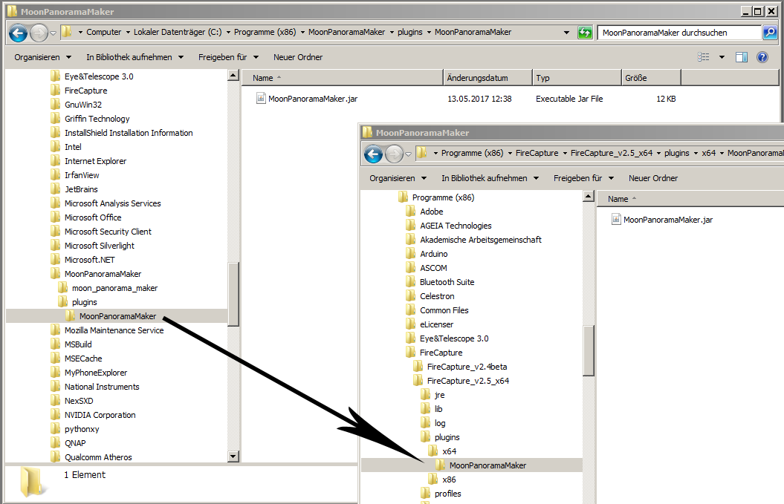

The FireCapture plugin is copied from the MPM installation folder into the plugin folder “x64” of FireCapturre.

MoonPanoramaMaker 1.0.0 is consistent with FireCapture’s plugin interface version “1.1” which was introduced with the FireCapture version “v2.5Beta09.x64”. It will not work with older FireCapture versions. Therefore, MoonPanoramaMaker only works with FireCapture version v2.5 or later (64bit).

MoonPanoramaMaker and FireCapture may run on different computers, or in different Virtual Machines on the same host computer. It is even possible for MoonPanoramaMaker running on Linux to communicate with FireCapture running on Windows. The IP address of the system where FireCapture is executed is entered as a configuration parameter. Communication is via TCP/IP port 9820. Please make sure that this port is not blocked by a firewall.

## Program Execution

MoonPanoramaMaker communicates with the user via a graphical user interface (GUI). To ease its use in an outdoor environment, almost all functions can be invoked by single key strokes and do not require mouse operations.



### Program Start

When the program is started for the first time, a window opens automatically for the input of individual parameters. The parameters are arranged in groups relating, for example, to the geographic location, the telescope used and the workflow control. Specific parameters describing some popular USB cameras are predefined. They can be modified, and parameters for other camera models can be added. The model actually used is then selected from the list.

Predefined parameter values give the user an impression of the required formatting. If the mouse pointer hovers over a parameter name, a tooltip appears describing its meaning. A detailed explanation of all parameters can be found in “Appendix A: Parameters at the Configuration Dialog”.

When the user acknowledges the complete parameter input by pressing the “OK” button, all parameters are tested for formatting and plausibility. If an error is detected, a popup window appears with the appropriate request for correction. If no more errors are detected, MoonPanoramaMaker writes the configuration file “MoonPanoramaMaker.ini” into the user’s home directory. At later program invocations the parameters are loaded from this file silently, and the input dialog does not open, and the main GUI opens immediately:

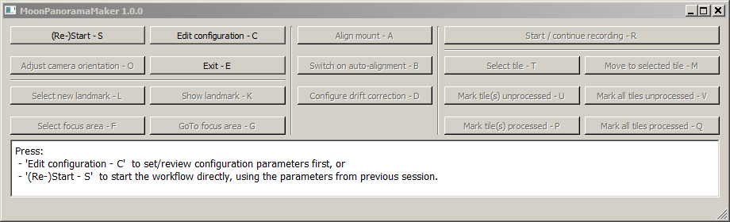

At this point the user can either modify the configuration or start the workflow directly. GUI buttons which do not make sense yet are disabled. Please note that the user can change parameters or add new cameras also later by pressing the button “Edit configuration” (shortcut: C).

When MoonPanoramaMaker starts the workflow, it performs a thorough check of its environment. If it detects an anomaly, such as a non-functioning telescope mount driver, it issues an error message and gives control back to the user. The user can then modify the configuration and try a re-start.

If the parameter “Camera automation” is set to “Trigger FireCapture automatically”, during initialization MoonPanoramaMaker requests the user to start the external FireCapture program:

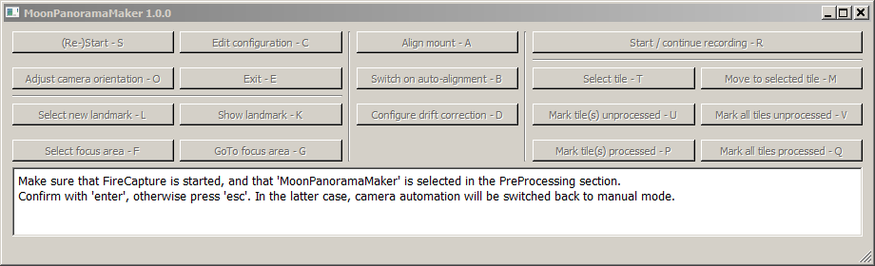

It is important that in FireCapture’s “PreProcessing” menu the entry “MoonPanoramaMaker” must be selected (see below). If the entry is missing, a wrong FireCapture version is used, or the MoonPanoramaMaker plugin folder has not been copied correctly into FireCapture’s plugin directory (see Section 3).

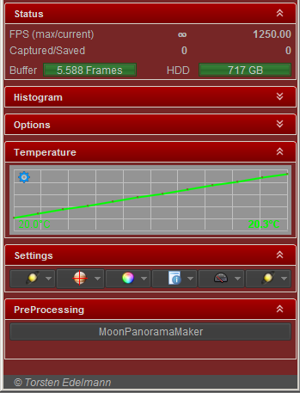When the user has acknowledged the FireCapture startup by pressing “Enter”, MoonPanoramaMaker checks the connection and in case of success continues with the workflow preparations. If the user answers the prompt with pressing “Esc”, camera automation is changed to manual mode, and the workflow continues.

Selecting the option “MoonPanoramaMaker” in FireCapture’s PreProcessing menu.

MoonPanoramaMaker offers to write a detailed protocol of the observing session to “standard output” or a file. If output to a file is selected (see Appendix A for details), the name of the protocol file is “MoonPanoramaMaker.log” in the user’s home directory. MoonPanoramaMaker always appends new output at the end of the protocol file. If the file gets too long, feel free to move the existing file to an archive folder or delete it before starting the program.

The user can choose different levels of detail by setting parameter “Session protocol level” to:

1. No protocol output
2. Only major activities
3. Major activities with additional details
4. Detailed protocol (mainly for debugging)

### Layout of the Main Window

The MoonPanoramaMaker main window can be controlled entirely without using a mouse. For using the shortcuts, make sure that the focus is on this window.

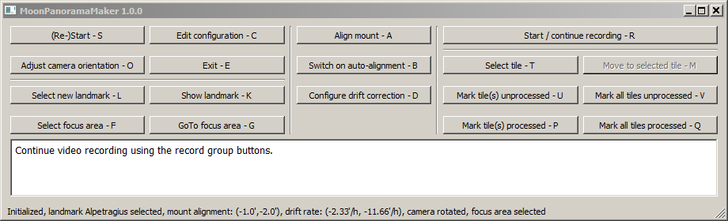

The main window contains three sections (from top to bottom):

* The control section contains buttons to start the various program functions. If at a given time a function does not make sense or cannot be used, the corresponding button is grayed out and de-activated. Every button shows the shortcut letter by which it can be invoked from the keyboard. For every button a tooltip gives a short explanation of its function.
* Via the text window MoonPanoramaMaker prompts the user to start the next action, displays error messages, or gives warnings in case of a dangerous user input. If the user is requested to do something, he or she is asked to acknowledge the successful completion by pressing the “Enter” key.
* The status line summarizes the state of the whole system. It lists actions that have been performed, gives quantitative information on the mount alignment and drift rates, and it shows the number of the tile at which the telescope is pointing.

### Selecting a Landmark on the Moon for Mount Alignment

Since the equatorial coordinate system of the telescope mount will never be perfectly aligned with the coordinates in the sky, the difference between the computed Moon position and the read-out values returned by the mount has to be taken into account. Measuring this deviation in the following is called “alignment”. Since the coordinate difference depends on the position in the sky, the alignment procedure must be repeated occasionally. If several alignment points have been determined, MoonPanoramaMaker offers to extrapolate the development of the coordinate differences into the future. This process in the following is called “drift”.

Since MoonPanoramaMaker deals with the alignment itself, this step can be left out when the telescope is set up and the mount is initialized. It is sufficient to aim the polar axis of the mount approximately at the celestial North Pole.

Ideally one would perform the alignment by comparing the computed and measured positions of the Moon center. This location, however, is difficult to identify in the telescopic view. It may even be within the unlit part of the Moon. Therefore, MoonPanoramaMaker performs the alignment using some well-defined surface feature selected by the user, in the following called “landmark”. For this to work, two things are necessary: First, the selenographic coordinates of the landmark must be known. MoonPanoramaMaker, therefore, keeps a list of the selenographic coordinates of many potential landmarks. Second, these coordinates must be translated into equatorial coordinate offsets (in right ascension and declination) relative to the Moon center. This coordinate transformation is not straightforward and requires as input the Moon’s topocentric libration angles and the position angle of its rotational axis. The algorithmic details are summarized in Appendix B.

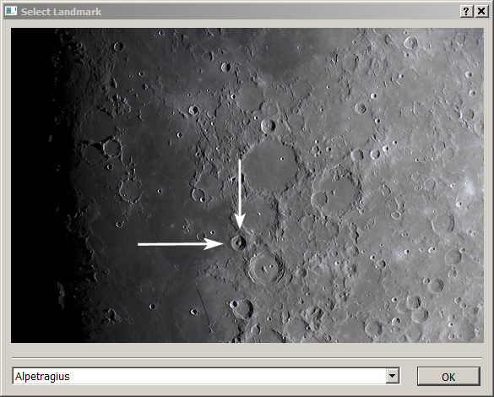

Selection of the landmark to be used for aligning celestial coordinates with the coordinate system of the telescope mount.

At the beginning of the workflow, MoonPanoramaMaker offers the user a list of landmarks to choose from. Apart from the Moon Center which is always included, the list only shows landmark candidates which are currently located within the sunlit part of the Moon. When the user selects an entry from the drop-down list, a picture of the Moon with arrows pointing at the selected feature is shown. The choice is acknowledged by pressing the “OK” button. A view of the selected landmark can be recalled later at any time by pressing the button “Show Landmark”. A different landmark can be chosen at any time during the recording workflow by pressing the button “New Landmark Selection”. MoonPanoramaMaker then performs a new alignment with the new landmark, and the recording workflow can continue.

The choice of the landmark requires special attention if the user plans to use “auto-alignment”. In this case it is important that the landmark lies in an area with enough surface detail for the automatic shift determination to work properly. Additionally, it is best if the landmark is in an area of average brightness, so that it will not be heavily over- or underexposed during the whole observing session.

Next, MoonPanoramaMaker slews the telescope to a position in the sky close to the Moon. For a first alignment of the celestial coordinates with the internal coordinate system of the telescope mount, the user is requested to center the selected landmark in the telescope. This is done best using the camera live view in FireCapture. The FireCapture option to display central cross hairs greatly facilitates this process. The telescope mount can be moved using either the direction buttons of its hand controller, or the arrow keys of the computer with the focus being on the main MoonPanoramaMaker window. **It is important to approach the landmark in declination from the same side as the telescope does during a GoTo operation. Otherwise any backlash of the declination gear would reduce the alignment precision.**

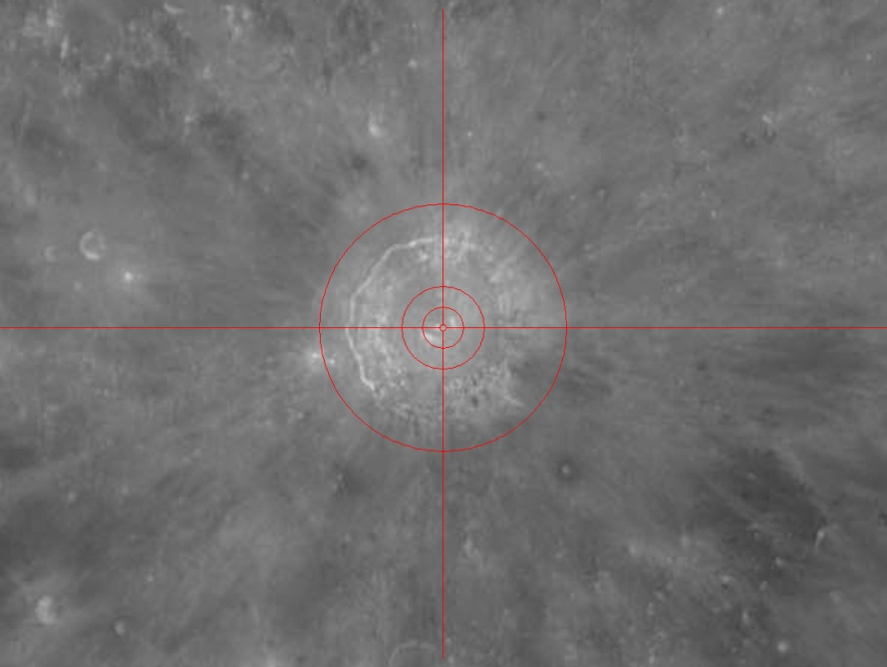

The landmark is centered in the camera live-view window.

When the landmark is properly centered, the user acknowledges this by pressing “Enter”. MoonPanoramaMaker now knows both the celestial landmark coordinates and those returned by the telescope mount. The difference between the two coordinate sets provides the first alignment point. The offset values (in minutes of arc) in right ascension and declination are displayed in the status line under the keyword “mount alignment”.

### Camera Rotation

After the first alignment the orientation of the camera must be adjusted. To this end MoonPanoramaMaker drives the telescope to the point on the sunlit Moon limb where the limb should run parallel to the short side of the field of view.

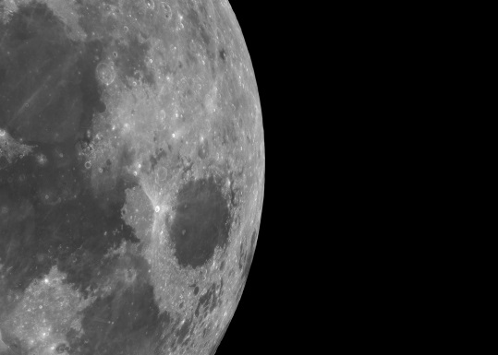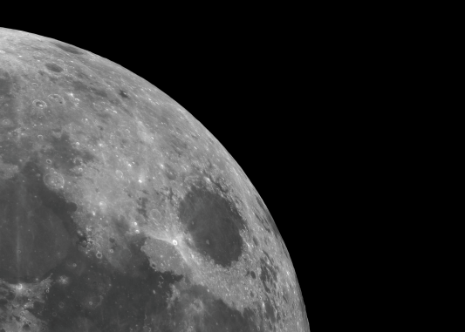

The user is requested to turn the camera in the eyepiece holder until the Moon’s limb runs vertically through the center of the live view window (see the illustration above), and to acknowledge with “Enter”. It does not matter if the Moon is standing upright or upside down. The example in the above pictures is unusual in that it shows the Moon at very low magnification. Usually the camera field of view contains a much smaller fraction of the Moon’s surface. In that case, the limb will be almost a straight line. With the proper camera adjustment the limb stands vertically in the field of view. **From now on, the orientation of the camera should not be changed any more throughout the whole recording session.** If for any reason the user chooses to adjust the camera rotation later (by pressing the button “Adjust camera orientation”), all tiles recorded so far get invalidated and the recording starts again with the first tile.

After these preparatory steps MoonPanoramaMaker has gathered all the information needed to compute the optimal tile coverage of the sunlit part of the Moon, and to steer the telescope towards them. The GUI buttons for controlling the video acquisition (“record group buttons”) get activated.

### Selection and Positioning of the Focus Area

Before recording the videos, the precise telescope focus has to be set. In the configuration dialog the user can choose to focus on a nearby star or on a surface area. If a surface area on the Moon is used for focusing, it should be bright enough and contain sufficient high-contrast features, so that focus errors are recognized as easily as possible. MoonPanoramaMaker can record the position of the focus area or star and move the telescope back to this position later in the workflow for refocusing. To register the focus position, the user presses the GUI button “Select focus area” / “Select focus star” and moves the telescope to the selected place using the arrow keys (either on the hand controller or computer, see above). When the telescope points at the desired position, the user registers it by pressing “Enter”. Later on, when during the image acquisition process the focus is to be re-adjusted, the GUI button “GoTo focus area” / “GoTo focus star” brings the telescope back to the selected position.

The option to focus on a star was added because some users prefer using a Bahtinov mask for focusing. Mounting and removing the mask during the workflow, however, is dangerous since touching the telescope could change the mount alignment. Therefore, the mask must be handled with extreme care, and the telescope should always be re-aligned after focusing.

### Image Acquisition

Now, finally, the image acquisition process can begin. The GUI buttons of the “record group”

* “Start / continue recording – R”,
* “Select tile – T”,
* “Move to selected tile – M”,
* “Mark tile(s) unprocessed – U”,
* “Mark all tiles unprocessed – V”,
* “Mark tile(s) processed – P”, and
* “Mark all tiles processed – Q”

are activated. The visualization window named “Tile Arrangement” shows a complete coverage of the sunlit part of the Moon, with field of view of the selected camera defining the size of the tiles. If the configuration parameter “Write the protocol to a file” is selected, MoonPanoramaMaker stores an image of the tile arrangement in a file “MoonPanoramaMaker\_xxx\_Tile-Layout.png”, with xxx denoting the time stamp when the layout was created. This image can be used later to identify the location of a tile on the Moon, and the sequence numbers of its neighbors.

During a recording session the tile arrangement window shows the status of each tile with the following color codes:

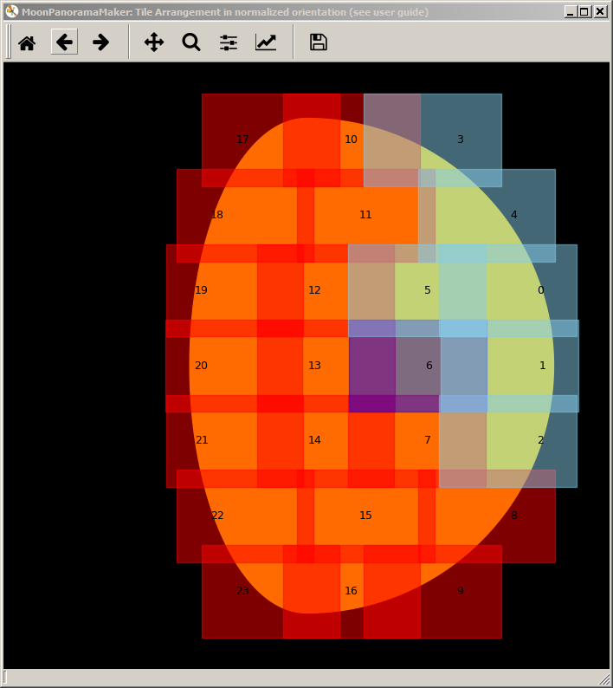

The “Tile Arrangement” window shows the Moon in the so-called “normalized orienta­tion”, i.e. with the sunlit limb pointing to the right. **Please note that for the waning Moon this means that South is up.**

* Red: Tile not processed, no video file recorded yet
* Light Blue: Recording finished
* Dark Blue: Active tile, recording may begin or is underway

When the button “Start / continue recording” is pressed, MoonPanoramaMaker selects the next unprocessed tile and steers the telescope towards it. Depending on the configuration parameter “Camera automation”, MoonPanoramaMaker either triggers the camera itself, or it requests the user to do so, and to acknowledge the successful completion of each video by pressing “Enter”. When a tile is finished, the program automatically selects the next unprocessed tile and repeats the process.

If the videos are recorded in automatic mode, the user selects the video file name format using the GUI of the FireCapture program. MoonPanoramaMaker appends to each file name the string “\_Tile-nnn”, where “nnn” is the current tile number. An example of a full file name is “Moon\_210531\_Tile-023.ser”. If a tile is recorded more than once during an observing session, the encoded tile number makes it easier to identify the corresponding video files.

With version 0.9.5 the option was added to trigger FireCapture more than once at every tile location. This can be useful if each tile should be recorded through different filters in succession. In this case the parameter “Repetition count” in the camera configuration dialog must be set to the desired number of triggers (see Appendix A). The details of the filter cycling are configured via the FireCapture GUI.

During video acquisition, MoonPanoramaMaker automatically sends guiding corrections in both coordinates to the telescope mount. The topocentric movement of the Moon among the stars is accounted for, as well as the coordinate system drift (see below). Since the algorithm is based on the computed path of the Moon and does not use video feedback from the camera or a guide scope, periodic worm gear errors or backlash in declination are not corrected.

The acquisition process can be interrupted at any time by pressing the “Esc” key. If “Camera automation” is switched off, the program stops issuing guiding corrections immediately and awaits a new command. This could be, for example, a new alignment request or moving the telescope to the focus area for a focus adjustment. If “Camera automation” is on, the program waits until FireCapture has finished the current exposure. The color of the active tile changes to light blue, and the program awaits the next instruction. The recording workflow is resumed by pressing the “Start / continue recording” button again.

The configuration parameter “Begin at moon limb or terminator” determines the order in which the tiles are processed. In any case the tiles are processed column-wise to reduce inconsistencies caused by changing shadows. Which choice is better depends on the particular situation. If, for example, the recording session starts during evening twilight, it is best to begin with the bright limb. When later on the process arrives at the dimly lit tiles close to the terminator, the surrounding sky will be darker. Starting at the terminator is better, for example, if a recording session at dawn proceeds well into the morning twilight.

All tiles are shown with their numbers in the window “Tile Arrangement”. Numbering starts with zero. If the “Start / continue recording” button is pressed, the program usually continues with the unprocessed tile with the lowest number.

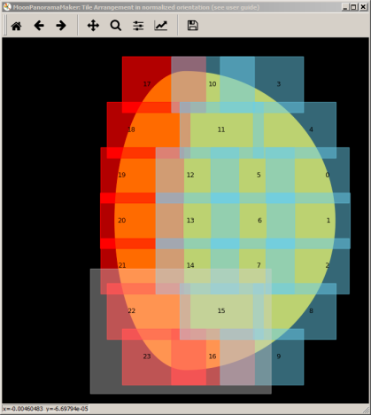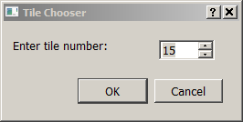Hitting the “Select tile” key opens a dialog where the user can select a tile number, either by entering a number, or by browsing through the available numbers using the “up” and “down” keys. The choice is acknowledged either by pressing the “OK” button or the “Enter” key. If the chosen tile has already been processed (shown as light blue), it can be reset to unprocessed (red) by pressing “Set tile(s) unprocessed”. If the selected tile is marked unprocessed, pressing “Start / continue recording” instructs the program to continue with the selected tile. Pressing “Set all tiles unprocessed” resets all tiles to red color. Conversely, pressing “Set all tiles processed” marks all tiles as processed (light blue).

As an alternative to using the “Select tile” key, contiguous tile patterns can be selected in one go by drawing a rectangular area in the “Tile Arrangement” window while keeping the left mouse key pressed. The rectangle is colored light grey. Pressing “Set tile(s) unprocessed” will reset all tiles which lie completely within the rectangle. A double mouse click in the “Tile Arrangement” window resets the selection rectangle.

Recording can be restricted to a limited area from the outset by pressing the “Set all tiles processed” button, drawing the appropriate tile selection rectangle in the “Tile Arrangement” window, and then pressing “Set tile(s) unprocessed”. “Start / continue recoding” will start recording the selected tiles only.

Pressing “Move to selected tile” instructs the program to steer the telescope to a tile without the need to invalidate a previous recording. If, after moving to the tile, the user decides to repeat the video acquisition, he or she can do so by pressing “Set tile(s) unprocessed” followed by “Start / continue recording”.

### Determining and Correcting the Coordinate System Drift

If after the initialization phase no additional alignment has been performed, the program assumes that the offset between the celestial coordinates and the internal system of the telescope mount is constant along the Moon’s path across the sky. Obviously, this can only be a first approximation. Therefore, it makes sense to repeat the alignment procedure every once in a while during a recording session. This could, for example, be done each time a column of tiles is processed. The interruption of the recording process could also be used to adjust the camera focus (see Section 4.5).

Please note that the only purpose of repeating the alignment is to update the offset between the coordinate systems. The motion of the Moon among the stars is always accounted for with high precision automatically.

As described in the previous section, the user can interrupt the recording session at any time by pressing the “Esc” key. If a video acquisition is running in automatic mode, the program waits until it is finished, before giving back the control to the user. Pressing “Align mount” then instructs the program to steer the telescope to the landmark selected during initialization. If the landmark is not placed precisely at the center of the camera live view, the deviation gives an impression of the accuracy with which currently the telescope hits the pre-computed tile positions. If this offset is too large, a non-uniform tessellation of the Moon surface or even gaps between tiles may be the result.

By means of the arrow keys (of the hand controller or computer), the user moves the landmark under the cross hairs in the camera live view. Please remember to approach the landmark in the same direction as the telescope does during a GoTo operation (see Section 4.3 above). When the user acknowledges by pressing “Enter”, MoonPanoramaMaker stores an additional alignment point.

As soon as more than one alignment point is available, MoonPanoramaMaker can predict how the coordinate system offset will change with time. This change is called “drift”. It is predicted by using linear extrapolation. In order to base the extrapolation on as long a time span as possible, by default the program uses the first and last alignment points for the computation. If the time span is shorter than ten minutes, the extrapolation would not be reliable enough, so no drift correction is applied.

If drift correction is active, the status line in the main window displays the computed values under the keyword “drift rate”. They are defined as the change of the alignment offsets in right ascension and declination, respectively, expressed in arc minutes per hour.

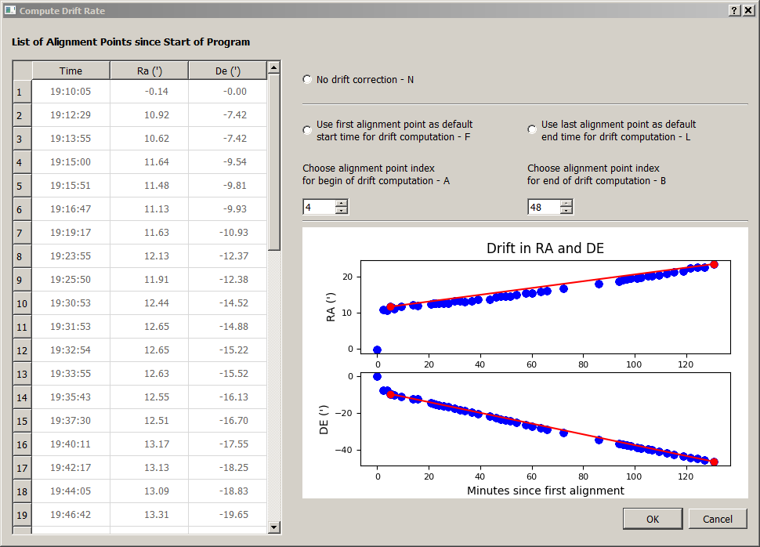

Dialog for drift  
correction

If for any reason the user does not want the drift rate to be computed according to the standard procedure, he or she can call a dialog window by pressing the “Configure drift correction” button. As soon as the focus switches to this window, its keyboard shortcuts are activated for input. The user may choose to switch off drift correction altogether (uppermost radio button, or “N”). If this button is toggled off (i.e. drift should be accounted for), by default the first and last alignment points are used to compute the drift rate. The user can override this choice, individually for the begin and the end of the time interval, by un-checking the corresponding radio button. Pressing a button activates a chooser box, where the number of the first or last alignment point, respectively, can be set manually.

Deviating from the default choice can make sense to exclude an unreliable alignment point from the drift determination. If, for example, the camera is not centered precisely in the eyepiece holder, rotating the camera as described in Section 4.4 may render the previous alignment point useless. In this case it is a good idea to begin the determination of the drift rate with the first alignment point after turning the camera. The illustration above shows this scenario: Most alignment points very closely follow a linear trend. Only the first one (at 0 minutes), taken before camera rotation, is way off.

The change of the alignment with time is visualized by a viewgraph in the lower right corner of the dialog window. Colored dots show for all available alignment points the offsets in right ascension (top) and declination (bottom). The two red alignment points are currently selected for drift computation. They are connected by red lines showing the drift in both coordinates. All the other alignment points are colored blue.

Please note that the last alignment point always plays a special role: Even if not used in drift rate computation, it is still used as the starting point for computing the current alignment offset. If the last alignment point is known to be inaccurate and, therefore, should not influence the offset computations any more, this can only be achieved by performing an additional alignment.

Since no drift corrections are applied before the alignment points cover a time span of at least ten minutes, in the beginning the telescope pointing is usually less accurate. Especially if the telescope mount is not well aligned with the North Pole, it therefore makes sense to wait with video recording until drift compensation has been established. In practice this waiting time may be necessary anyway to get the telescope close enough to thermal equilibrium with its environment.

### Automatic Alignment

The most important new feature in MoonPanoramaMaker version 0.9.5 is the so-called “auto-alignment”. It takes the burden off the user to check the mount alignment repeatedly. Auto-alignment can be activated after the camera has been oriented properly (see Section 4.4). To start auto-alignment when a video acquisition loop is active, the loop has to be interrupted first by pressing the “Esc” key. Auto-alignment can then be started by pressing the GUI button “Switch on auto-alignment”. When “Enter” is pressed as confirmation, the button changes its color to red and now reads “Switch off auto-Alignment”. The telescope moves to the landmark position and asks the user to center the landmark, exactly as with manual alignment.

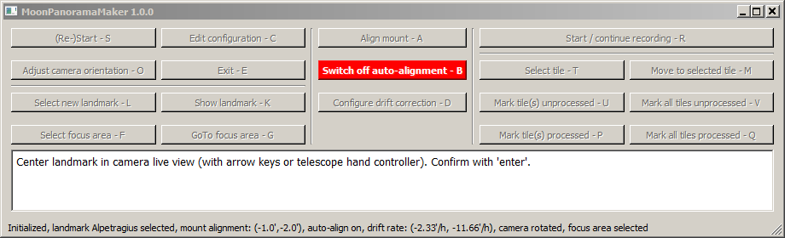

When the user has centered the landmark and pressed “Enter”, auto-alignment initialization begins. Instead of recording an alignment point, MoonPanoramaMaker uses the video camera to take a still picture of the area around the landmark. This “reference frame” is stored for automatic alignment operations which the program from now on inserts between video recordings automatically.

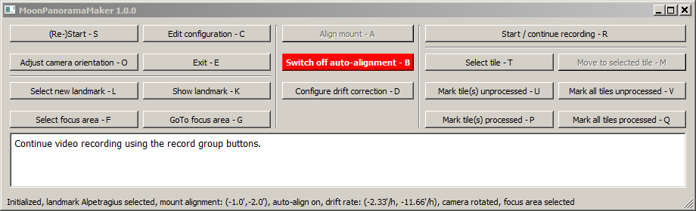

After a successful auto-alignment initialization, the user can start the video acquisition loop (“Start / continue recording”) which the program will interrupt at certain intervals for new alignments. When this happens, the program slews the telescope to the expected landmark position, takes a still image of that area and determines the shift between the new image and the reference frame. This shift (in image pixels) is translated into the current pointing error in equatorial coordinates. The result is stored as a new alignment point, and video acquisition continues. Fortunately, the details of this rather complex operation are hidden from the user.

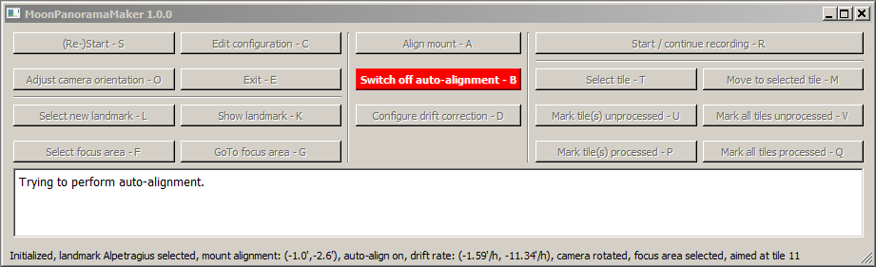

The user may interrupt the video loop at any time by pressing the “Esc” key. When control is given back to the GUI, the user can switch off auto-alignment by pressing the red button again. After confirmation, the auto-alignment button changes back to its original state and color, and the (manual) “Align mount” button is re-activated. The user can now do the alignment manually, or start auto-alignment again.

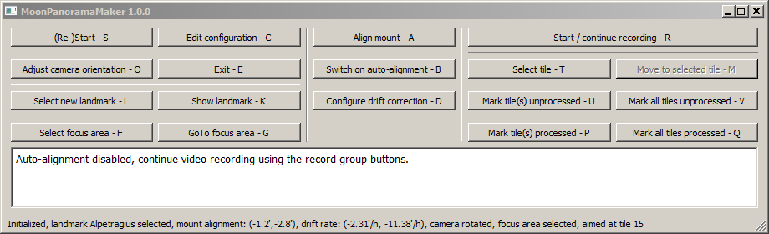

Some details are important to know when using auto-alignment. First of all, auto-alignment can fail. This can happen already during initialization or later during an auto-alignment operation. The most likely reasons are too little contrast around the landmark or bad seeing during still image acquisition. It might help to try auto-alignment with a more conspicuous landmark. Another reason for auto-alignment initialization to fail is if the focal length of the telescope system as measured by MoonPanoramaMaker differs too much from the value specified in the configuration dialogue. In this case, and if the “session protocol level” parameter is greater than 1, the measured values in x and y directions are documented in the protocol file. If auto-alignment fails, MoonPanoramaMaker automatically switches back to manual alignment, leaving the system in the same state as if the user had switched off auto-alignment manually (see above).

Camera settings, such as exposure time or contrast, should not be changed too much when auto-alignment is on. MoonPanoramaMaker tries to normalize the image brightness before measuring the image shift relative to the reference frame. If the change is too large, however, the images may look too different for shift detection to work. In this case it may help to switch auto-alignment off and back on.

Another problem arises if auto-alignment detects a very large image shift. (What “very large” means can be specified in the configuration GUI, see Appendix A.) The criterion is the relative size of the detected pointing error as compared to the width of the overlap between tiles. If the error is too large, MoonPanoramaMaker repeats the videos taken since the last successful alignment. It also tries to shorten the time interval between auto-alignments. Reversely, if the alignment error is very small, the program increases the time interval between alignments.

### End of Program

If all tiles are processed and marked light blue in the tile visualization window, the program gives the control back to the user. All tiles needed for the panorama have been recorded, and the program may be closed. Alternatively, the user may decide to repeat the acquisition of some or all tiles. To this end he or she selects (as described in Section 4.6) the corresponding tile numbers and resets them. Pressing “Start / continue recording” starts the repeated acquisition of only the selected tiles. Another choice is to reset all tiles by pressing “Mark all tiles unprocessed”. After that, a whole new panorama may be recorded. This can be achieved as well by pressing the “(Re-)Start” button. The only difference is that in this case the program repeats the whole initialization procedure, keeping only the alignment points recorded so far.

Of course, a new panorama can be recorded as well by closing the program and starting all over again. In this case, however, all alignment points are lost, so they cannot be used any more for drift corrections. Therefore, it is recommended to stay in a program session for as long as possible.

If the telescope is mounted on a “German Equatorial Mount” and the Moon during the recording session crosses the meridian, the mounting will perform a meridian flip when the target coordinates of a GoTo command are located on the other side of the meridian. If possible, this situation should be avoided during the acquisition of a panorama. Otherwise, the following points need to be considered:

* Make sure that the cabling of the telescope, camera and all other accessories allows the meridian flip without unplugging, and that no moving part will collide with the telescope pier or any other obstacle.
* After the meridian flip a new alignment point must be set before the next tile is recorded. Generally it is a good idea to wait a few minutes until the whole Moon has crossed the meridian. Otherwise the mounting in GoTo operations could flip back and forth repeatedly. If drift correction is enabled, it must be computed using alignment points which both were set either before or after the flip. This can be achieved by selecting non-default values in the dialog window which opens on pressing the “Configure drift correction” button. If one alignment point was set before the flip and the other one afterwards, mechanical imperfections of the telescope and mounting can lead to very inaccurate drift rates.
* If the videos are taken in auto-alignment mode, switch off auto-alignment at the meridian flip. After the flip, auto-alignment may be switched on again.
* Videos taken after the meridian flip will be turned upside-down as compared to the ones taken before the flip. This can be corrected by turning all the images of one set by 180 degrees before the panorama construction.

## Appendix A: Parameters at the Configuration Dialog

The main window of the configuration dialog allows entering user-specific values for various parameters. They are arranged in the following groups:

* Geographic Position
* Camera
* Telescope
* Workflow
* Tile Visualization
* Alignment

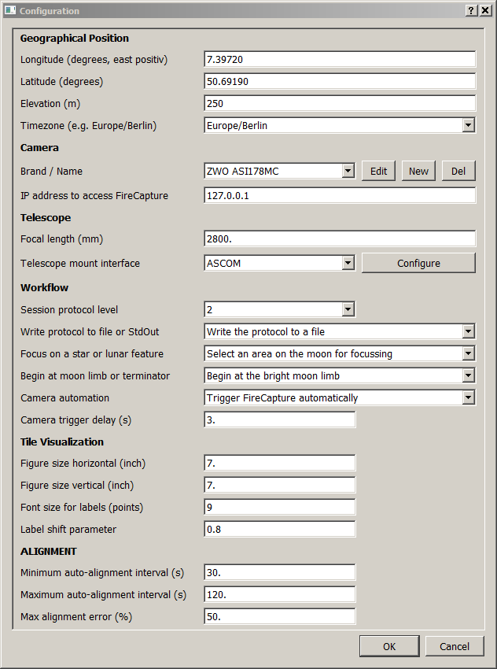

In the following, definitions for all parameters are given. Please note that for fractional values a decimal point (no comma) is used.

#### Geographical Position

|  |  |
| --- | --- |
| **Longitude:** | Geographic longitude (in degrees and fractional part), counted from the Greenwich meridian, positive to the East. |
| **Latitude:** | Geographic latitude (in degrees and fractional part). Northern latitude positive. |
| **Elevation:** | Elevation above sea level (in meters, no decimal point). |
| **Timezone:** | Drop-down list. Choose the time zone in which the geographical position is located. |

#### Camera

|  |  |
| --- | --- |
| **Brand / Name:** | Drop-down list of all camera models for which specifications have been entered. With the buttons “Edit”, “New” and “Del” the user can modify parameters for existing models, add specifications for new models, or delete models from the list. |
| **IP address to access FireCapture:** | If camera automation is selected, MoonPanoramaMaker triggers the FireCapture program for video recording. The two programs communicate via TCP/IP and may run on different computers. The IP address of the system where FireCapture is located can either be “localhost”, i.e. both programs run on the same system, or a fully qualified IP address, such as “192.168.0.1”. Make sure that port 9820 is not blocked by a firewall. |
|  | The sub-dialog for entering new models or editing existing ones additionally contains the following parameters:  D:\Python\MoonPanoramaMaker\Documentation\Screenshots_1-0-0\1-0-0_Configuration-dialog-camera.PNG |
| **Pixel size:** | Horizontal or vertical distance (“pitch”) of two adjacent pixels of the camera sensor. In general this is not the size of the light-sensitive cell itself. It is assumed that the distance is the same in both directions. Please note that the value is given in millimeters, not in microns. |
| **Pixel count horizontal / vertical:** | Number of sensor pixels in horizontal and vertical direction, respectively. |
| **Repetition count** | Number of videos to be taken in succession at each tile location. This parameter can be used, for example, to take three videos of the same area through RGB filters. FireCapture can be configured such that it cycles through the different filters. Please note that setting the repetition count in MoonPanoramaMaker does not change the FireCapture settings. This is left to the user. |
| **External margin pixels:** | Minimal width of the area surrounding the Moon to be recorded (in pixels). If this value is chosen too small, sunlit mountain peaks beyond the terminator could lie outside the recorded area. Also, less than perfect mount alignment could cause marginal areas of the Moon to be lost. Too large a value unnecessarily increases the number of tiles to be recorded. |
| **Tile overlap pixels:** | Minimal overlap between neighboring tiles in pixels. Again, experience is needed to strike the right balance between safety and too much overhead. |

#### Telescope

|  |  |
| --- | --- |
| **Focal length:** | Focal length of the complete optical system in millimeters, including any projection system between objective lens and sensor. If such a projection lens is used, the resulting focal length of the overall system is difficult to predict. In “Appendix C: Determination of the Focal Length of the System” it is shown how the focal length can be determined experimentally.  Please note that the precision of the focal length entered is critical if auto-alignment is used. If the error is too large, auto-alignment initialization will fail. Also, the translation of measured image shifts into equatorial coordinate corrections will be less accurate. |
| **Telescope mount interface:** | Drop-down list. Choose the interface through which the telescope mount can be operated. If MoonPanoramaMaker runs on a Windows computer, ASCOM must be selected, on Linux it is INDI. Make sure that the appropriate ASCOM or INDI software is installed.  Press the “Configure” button to enter specific values for mount driver operations. The sub-dialog which opens is different for ASCOM and INDI: |
|  | **Case “ASCOM”:**  The “Configure” button opens the following sub-dialog:  D:\Python\MoonPanoramaMaker\Documentation\Screenshots_1-0-0\1-0-0_Configuration-dialog-ASCOM.PNG |
| **Select and configure the ASCOM telescope driver:** | Press this button to open the (external) ASCOM chooser. It offers a selection of all available drivers (or hubs). Please do not forget to configure the selected driver by pressing the “Properties” button.  D:\Python\MoonPanoramaMaker\Documentation\Screenshots_1-0-0\1-0-0_Configuration-dialog-ASCOM-chooser.PNG |
| **Guide pulse duration:** | Duration (in seconds) for tracking corrections issued during video recording. This prevents the Moon from drifting away for videos longer than a few seconds. The longer the pulses, the less frequent they are inserted. Pulses which are too long result in a jerky motion. |
| **Pulse guide speed RA:** | Speed of guiding corrections in right ascension. The range of values allowed depends on the driver software. The value is given in degrees per second. |
| **Pulse guide speed DE:** | Speed of guiding corrections in declination (see above). |
| **Wait interval:** | Looking up the current coordinates where the telescope mount points to is implemented as an iterative loop. The loop finishes when the readouts stop changing. This way it is avoided that a moving mount “on its way” returns some intermediate readouts. The parameter sets the length of one iteration step (in seconds). |
| **Telescope position lookup precision:** | As explained for the “Wait interval” parameter, the mount position lookup is implemented iteratively. Two consecutive readouts are interpreted as being “equal” if their difference both in right ascension and declination is not greater than specified by this parameter (in arc seconds). For some telescope mounts (e.g. Vixen Sphinx NexSXD) the readout keeps on changing in very small erratic steps even if it is running in constant siderial tracking mode. In this case, too small a value can cause an infinite loop. |
|  | **Case INDI:**  It is assumed that the INDI Web Manager is installed on the same system where the INDI server is running. |
| **Start / configure INDI server and select telescope driver:** | Press this button to open the INDI Web Manager in the standard web browser. There you can choose the drivers to be connected to the INDI server. Please note that if more than one driver of type “Telescope” is connected, MoonPanoramaMaker will use the first one it finds. Usually it is a good idea not to open more than one telescope driver at the same time. |
|  | D:\Python\MoonPanoramaMaker\Documentation\Screenshots_1-0-0\1-0-0_Configuration-dialog-INDI-webserver.PNG |
| **IP address of the INDI server:** | The IP address of the system where the INDI server and the INDI Web manager are located can either be “localhost”, i.e. both programs run on the same system, or a fully qualified IP address, such as “192.168.0.1”. Make sure that ports 7624 and 8624 are not blocked by a firewall. |
| **Pulse guide speed:** | The speed of pulse guide operations used by MoonPanoramaMaker for tracking the Moon. “SLEW\_GUIDE”, “SLEW\_CENTERING”, “SLEW\_FIND” or “SLEW\_MAX” can be selected from the drop-down list. |
| **Guide pulse duration:** | Duration (in seconds) for tracking corrections issued during video recording. This prevents the Moon from drifting away for videos longer than a few seconds. The longer the pulses, the less frequent they are inserted. Pulses which are too long result in a jerky motion. |
| **Wait interval:** | Same parameter as in the ASCOM case. It is referred to the explanation given there. |
| **Telescope position lookup precision:** | Same parameter as in the ASCOM case. It is referred to the explanation given there. |

#### Workflow

|  |  |
| --- | --- |
| **Session protocol level:** | The drop-down list offers four levels of detail for session logging. If set to 0, no log info is printed. If set to 1, 2 or 3, the observing session is documented with increasing level of detail. Wall clock time is printed along with every log record. |
| **Write protocol to file or StdOut:** | Drop-down list with two choices:   * Write the protocol to a file: This is the standard case. The protocol is appended to the file “MoonPanoramaMaker.log” in the user’s home directory. * Write the protocol to standard output: The protocol appears in the window from where MoonPanoramaMaker is started. This option is mainly used for debugging. |
| **Focus on a star or lunar feature:** | Drop-down list. For a detailed explanation please refer to Section 4.5. Please note that the labeling of the GUI buttons used for focusing changes, according to the choice of this parameter. |
| **Begin at moon limb or terminator:** | Drop-down list. For a detailed explanation please refer to Section 4.6 |
| **Camera automation:** | Drop-down list with two choices:   * Trigger FireCapture automatically. In this case make sure that the FireCapture program is running, and that the option “MoonPanoramaMaker” is selected in its “PreProcessing” menu. * Trigger the camera manually.   For a detailed explanation please refer to the discussion in Section 4.6 |
| **Camera trigger delay:** | Time in seconds between moving the telescope to a new tile and triggering the camera (has no effect if “Camera automation” is set to manual mode). The optimal value is found experimentally. The goal is to trigger the camera not before the view has become steady. |

#### Tile Visualization

|  |  |
| --- | --- |
| **Figure size horizontal / vertical:** | Width and height (in inches) of the “Tile Arrangement” window, respectively. |
| **Font size for labels:** | Size (in points) of the tile numbers in the “Tile Arrangement” window. Large values in case of a fine tessellation can cause overlapping labels. |
| **Label shift parameter:** | This parameter causes the tile numbers to be printed centrally (value = 0.) or shifted horizontally (maximal shift for value = 1.) into the tiles. In the case of large tile overlaps shifting the labels can help avoiding that labels overlap in print. |

#### Alignment

|  |  |
| --- | --- |
| **Minimum auto-alignment interval:** | If auto-alignment is active, MoonPanoramaMaker automatically inserts new alignments between video recordings as necessary. The time between alignments is adapted dynamically. It will not drop below the value given by this parameter (in seconds). |
| **Maximum auto-alignment interval:** | The time between automatic alignments will not exceed the value given by this parameter (see above). |
| **Maximum alignment error:** | Criterion if an image shift detected during an auto-alignment is accepted or not. It is expressed as the fraction of the overlap width between tiles. The rationale behind this is that the panorama creation will fail if the overlap between adjacent tiles is too small. This is likely to happen if the detected pointing error is above a certain threshold. If auto-alignment detects that the current alignment error is too large, all videos taken since the last successful auto-alignment are repeated. (See the discussion in Section 4.8) |

## Appendix B: Algorithms Used by the Program

#### Shape and Orientation of the Sunlit Part of the Moon

For the construction of an optimal tessellation of the sunlit part of the Moon, the precise shape and orientation of the Moon phase must be known. To this end, the following quantities have to be determined:

|  |  |
| --- | --- |
|  | Elongation of the Moon from the Sun ( |
| : | Distance between the Moon and the Sun |
| : | Phase angle of the Moon (. A value of corresponds to new Moon, to half Moon und to full Moon. |
| : | Position angle of the great circle through the Moon and the Sun, as measured at the Moon’s position in topocentric equatorial coordinates, counted from North counterclockwise. |
| : | Position angle of the “upper” pole of the sunlit Moon phase, counted from equatorial North counterclockwise. The upper pole (“N” in the illustration below) is defined as follows: If it is pointing up, the sunlit Moon limb is pointing to the right. The terminator runs from top to bottom somewhere between the right and left Moon limbs. The construction of the optimal tessellation is based on this normalized orientation of the Moon. |

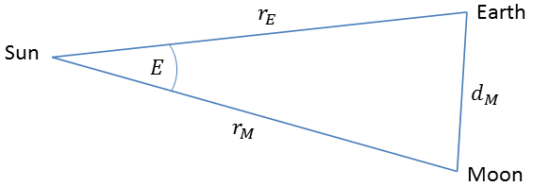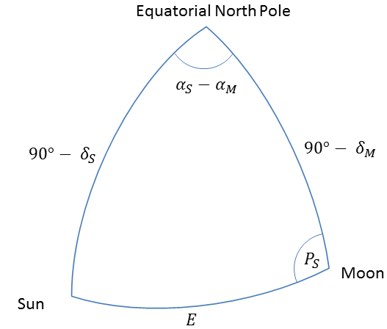

In the spherical triangle Moon-Sun-Celestial North (left illustration) the following equation holds:

= (1)

And from the plain triangle Sun-Moon-Earth (right illustration):

= (2)

From the spherical triangle Moon-Sun-Celestial North it also follows:

= (3)

= (4)

= (5)

= (6)

= (7)

with the following definitions:

|  |  |
| --- | --- |
|  | Topocentric right ascension and declination of the Moon (true coordinates referring to the current epoch and equinoctium) |
|  | Topocentric right ascension and declination of the Sun (true coordinates referring to the current epoch and equinoctium) |
| : | Topocentric distance between Earth and Sun |
| : | Topocentric distance between Earth and Moon ( have to be defined using the same units) |

The input values for are computed for the observing site by using the astronomy program package “PyEphem” (<http://rhodesmill.org/pyephem/index.html>).

As explained above in the definition of the angle , the tile layout is constructed for a normalized orientation of the Moon phase. The center coordinates of all tiles are computed in the corresponding plane first. Only at the end they are converted into offsets from the Moon center in right ascension and declination . Please note that in the normalized orientation the sunlit limb is on the right side, even for waning Moon phases. denotes the angle between the two coordinate systems. This situation is depicted in the illustration below.

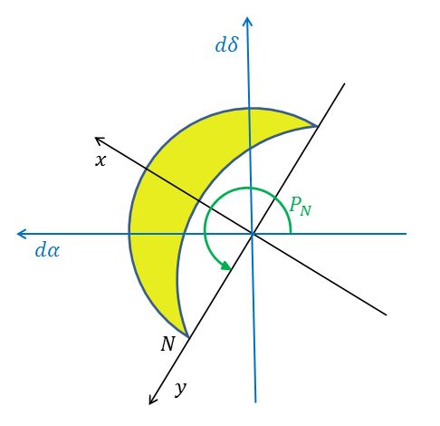

Apart from the ephemeris data mentioned above, the construction of the tile layout is based on the following variables which are either provided by the user directly, or computed using simple transformations from user-defined parameters:

|  |  |
| --- | --- |
|  | Height and Width of the camera’s field of view (angle). These variables are computed from the linear pixel size, the horizontal and vertical pixel counts, and the focal length of the telescope system. |
|  | Minimal width of the space around the Moon to be covered by the tiles, given as an angle (same in vertical and horizontal directions). The user specifies the minimal number of pixels. From this is computed using the linear pixel size and focal length of the telescope system. |
| : | Minimal overlap between neighboring tiles (angle, both in vertical and horizontal direction). Again, this value is computed from the corresponding pixel count as specified by the user. |

The definition of these parameters is illustrated in the following picture. Tiles are constructed row-wise, starting with the upper boundary in the plane. When the user requirements given above lead to non-integer numbers of tiles in x and y direction, they are rounded up to the next higher integer value by slightly enlarging the tile overlaps. Larger overlaps will help later when the panorama is produced from the tiles. The external margin width is not increased.

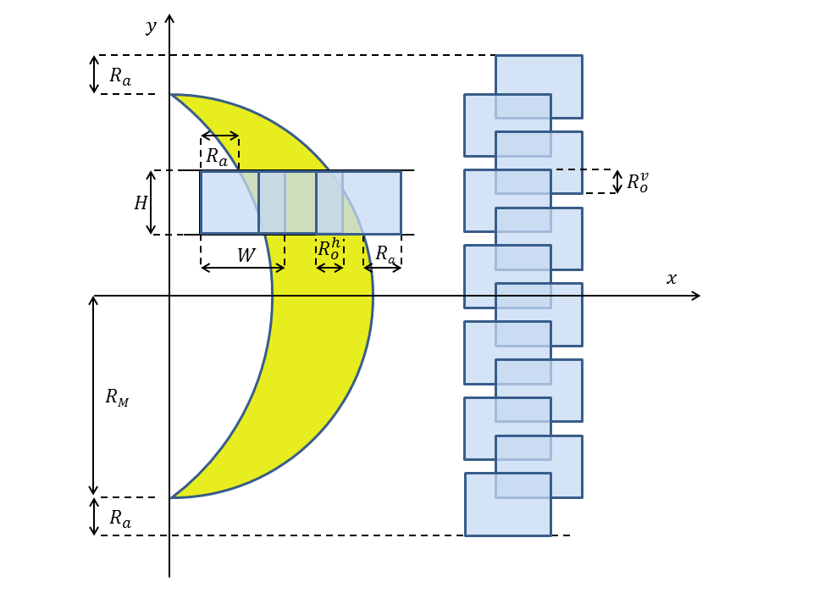

The following algorithm computes for all tiles the center coordinates and the corresponding angular offsets relative to the Moon center in right ascension and declination . Here denotes the row index and the column index, both counted from zero. is the topocentric radius of the Moon (angle). It is provided by PyEphem as part of the Moon ephemeris.

= ⌈ ⌉ (8)

= (9a)

= (9b)

= (10)

= (11)

= (12)

= (13)

= (14)

(15)

(16a)

(16b)

= ⌈ ⌉ (17)

= (18a)

= (18b)

(19)

(20)

(21)

= (22)

#### Coordinate Offset of the Landmark Relative to the Moon Center

In the mount alignment process MoonPanoramaMaker needs to know the coordinate differences in right ascension and declination between the landmark and the Moon center. The computation of these quantities depends on the selenographic coordinates of the landmark and the orientation of the Moon as seen from the observer. The Moon’s orientation is quantified by its topocentric (observer-centered) libration angles in longitude and latitude , and the position angle of its rotational axis in the Earth’s equatorial coordinate system. The following algorithm provides these three quantities with sufficient accuracy to determine the coordinate offsets of the landmark to about 3” in right ascension and declination. This accuracy is achieved by, on the one hand, including the topocentric correction of libration angles, while on the other hand neglecting the effect of nutation.

First, using the algorithm in (Simon, Bretagnon, Chapront, Chapront-Touzé, Francou, & Laskar, 1994), the obliquity of the ecliptic and the mean elements and of the Moon’s orbit referred to the mean ecliptic and equinox of date are computed:

(23)

(24)

(25)

(26)

(27)

Now, using the algorithm presented in (Taylor, Bell, Hilton, & Sinclair, 2010), and omitting the higher-order corrections due to nutation, the position angle of the rotational axis and the libration angles are computed:

(28)

(29)

(30)

(31)

(32)

(33)

(34)

(35)

with the following definitions:

|  |  |
| --- | --- |
|  | Current obliquity of the ecliptic |
|  | Inclination of the ecliptic to the mean lunar equator |
| : | Longitude of the ascending node of the ecliptic w.r.t. the lunar equator |
|  | Mean longitude of the Moon |
|  | Inclination of the lunar equator to the equator of the Earth |
|  | Topocentric longitude and latitude of the Moon (true coordinates referring to the current epoch and equinox). These quantities are computed using the PyEphem software. |
|  | The arc of the true equator of the Earth from the true equinox of date to the ascending node of the mean equator of the Moon on the true equator of the Earth |
|  | Position angle of the axis of rotation of the Moon in the equatorial coordinate system of the Earth |
|  | Topocentric libration angles in longitude and latitude, respectively, in the equatorial coordinate system of the Moon |

The computation of the equatorial coordinate offsets of the lunar landmark starts from the landmark’s coordinates in a rectangular coordinate system with its origin at the Moon’s center, the positive axis pointing east, the positive axis lying in the equatorial plane and pointing away from the Earth, and the positive axis pointing North. First, the position vector of the landmark is rotated by , then by , and finally by :

(36)

(37)

(38)

(39)

(40)

(41)

(42)

with the following variable definitions:

|  |  |
| --- | --- |
|  | Selenographic longitude and latitude of the landmark on the Moon |
| : | Topocentric radius of the Moon (angle) |
|  | Offsets in right ascension and declination of the landmark from the Moon center, as measured in the true topocentric equatorial coordinate system of the Earth |

#### References:

Simon, J., Bretagnon, P., Chapront, J., Chapront-Touzé, M., Francou, G., & Laskar, J. (1994). Numerical expressions for precession formulae and mean elements for the Moon and the planets. *Astronomy and Astrophysics, 282*, pp. 663-683.

Taylor, D.B., Bell, S., Hilton, J., & Sinclair, A. (2010). *Computation of the Quantities Describing the Lunar Librations in the Astronomical Almanac.* United Kingdom Hydrographic Office, Taunton, Great Britain.

## Appendix C: Determination of the Focal Length of the System

The precise focal length of the complete telescope system (from the objective lens to the sensor) determines the field of view of the camera and is thus an important input parameter for the construction of the optimal tile layout. Unfortunately, this figure usually is not known a priori if some kind of projection system (e.g. a Barlow lens) is inserted into the light path.

The easiest way to determine this figure is by experiment. In the following two possible techniques, both based on test exposures of the Moon, are presented.

#### Absolute Method:

This method starts from an exposure of some area on the Moon, using the complete optical system. Two well-defined landmarks are identified in this image, e.g. small and bright craterlets on the mare floor. In some image processing program, e.g. Photoshop, rectangular coordinates und of both landmarks are measured. Using Pythagoras’ theorem their distance is computed as

(43)

In the same image processing program one measures the width of the camera’s field of view (in the same measurement unit as the (x,y) coordinates).

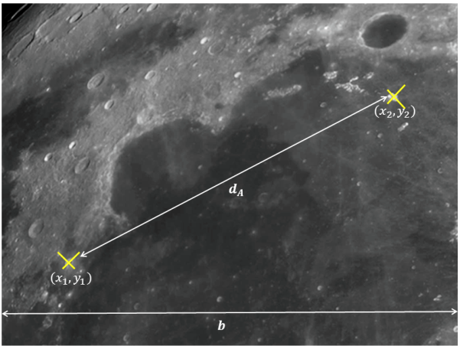

In a planetarium program (e.g. Guide 9.0) the Moon’s appearance is simulated for the time when the exposure was taken. Here the angular distance of the two landmarks is measured. In the example below the distance is found to be arc seconds.

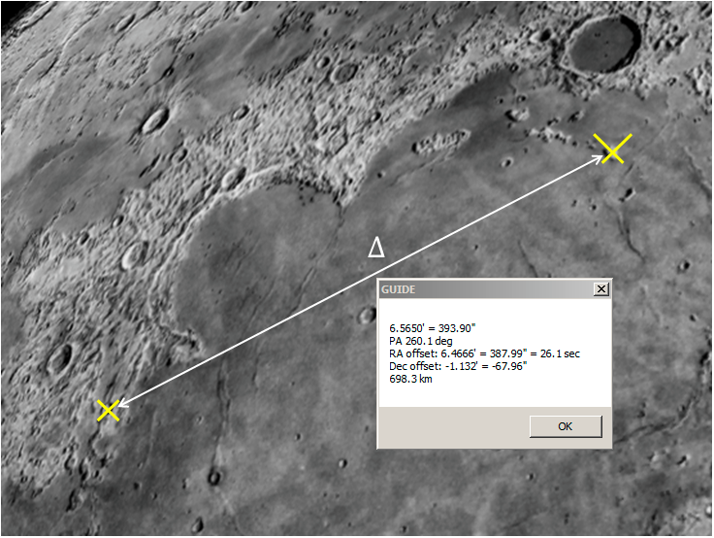

With the known camera parameters (see Appendix A: Parameters at the Configuration Dialog)

: “Pixel count horizontal” and

: “Pixel size” (pitch)

the sought focal length of the overall system is computed as:

(44)

Please note that published values for are notoriously unreliable. As explained in “Appendix A: Parameters at the Configuration Dialog”, this parameter defines the horizontal or vertical distance of two adjacent sensor pixels, and not the size of the light-sensitive cell itself.

If no reliable value for is available, it can be found experimentally if a telescope with well-known focal length is available. For this purpose a refractor or Newtonian reflector is to be preferred. (Using a Schmidt-Cassegrain telescope is not recommended because its effective focal length depends on the location of the sensor in the light path behind the primary mirror cell.) As explained above, from an image taken with such a telescope is derived as:

(44a)

Obviously it is impossible to measure both the focal length and pixel distance at the same time. Fortunately, for the purpose of MoonPanoramaMaker the absolute values of both parameters do not matter, as long as they are consistent according to equation 44. A wrong value for leads to a wrong value for . If used as input for MoonPanoramaMaker, however, both errors cancel out each other.

#### Relative Method:

There is an easier way if the primary focal length of the telescope (i.e. without projection system) is known precisely enough. In this case two exposures are taken, one at the prime focus, the other one with the projection system installed.

As described above for the full optical system, the linear distance of the two landmarks is measured in the prime focus exposure as well. The resulting distance is denoted .

With these measurements, the focal length of the overall system is computed as:

(45)