Comparison Exponential Distribution and Central Limit Theorem

Rolf Eleveld

Sunday, May 24, 2015

# Comparison Exponential Distribution and Central Limit Theorem

## by Rolf Eleveld

## Summary

This report investigates the exponential distribution in R and compares it with the Central Limit Theorem. Using 1000 experiments and taking the average of 40 samples with the R function rexp(n,lambda). The central limit theorem states that for large n the average means results in a bell shaped Normal distribution.

## Simlations

This report will gather the data for 1000 simulations and take the average of 40 samples of the rexp(n, lambda) function. The exponential distribution can be simulated in R with rexp(n, lambda) where lambda is the rate parameter. The mean of exponential distribution is 1/lambda and the standard deviation is also 1/lambda. Set lambda = 0.2 for all of the simulations. You will investigate the distribution of averages of 40 exponentials. Note that you will need to do a thousand simulations.

### Generating data

nosim <- 1000  
n<-40  
lambda <- 0.2  
funcmean = 1/lambda  
standard_deviation<-1/lambda  
standard_error<-standard_deviation/sqrt(n)  
rexp_means = numeric(length=nosim)  
for (i in 1:nosim) {  
 rexp_means[i] <- (mean(rexp(n, lambda)) - funcmean) / standard_error  
}

### Show the sample mean and compare it to the theoretical mean of the distribution.

The means are already subtracted as is common in the Central Limit Theorem. The histogram shows fairly normal distributed data.

hist(rexp_means,xlab="SD")

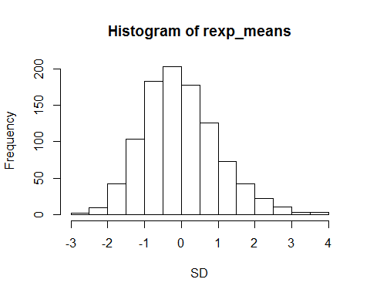

### Show how variable the sample is (via variance) and compare it to the theoretical variance of the distribution.

The variance of the mean is defined in the central limit theorem by sigma squared divided by n

c(variance = var(rexp_means), CLT_variance = standard_deviation^2/n)

## variance CLT_variance   
## 1.033723 0.625000

Which states that the tails are wider than from the rexp function than purely defined by the CLT.

### Show that the distribution is approximately normal.

The number of measurements is from a sample of 40 taken 1000 times. thehistogram below is the measure overlaid with a normal distribution curve.

hist(rexp_means,xlab="SD", prob=TRUE)  
curve(dnorm(x, mean=0, sd=1), add=TRUE, col="red")

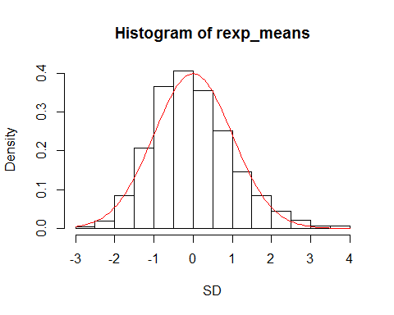

### Sample Mean versus Theoretical Mean

The average deviation from the theoretical mean 5 and the sampled means is:

c(sample_mean_deviation = mean(rexp_means))

## sample_mean_deviation   
## -0.01272512