Tootgrowth Analysis

Rolf Eleveld

Monday, May 25, 2015

# analysis of tooth growth data

Generic analysis of toothgrowth data

## processing data

Loading data

library(UsingR)

## Loading required package: MASS  
## Loading required package: HistData  
## Loading required package: Hmisc  
## Loading required package: grid  
## Loading required package: lattice  
## Loading required package: survival  
## Loading required package: Formula  
## Loading required package: ggplot2  
##   
## Attaching package: 'Hmisc'  
##   
## The following objects are masked from 'package:base':  
##   
## format.pval, round.POSIXt, trunc.POSIXt, units  
##   
##   
## Attaching package: 'UsingR'  
##   
## The following object is masked from 'package:ggplot2':  
##   
## movies  
##   
## The following object is masked from 'package:survival':  
##   
## cancer

data(ToothGrowth)

Initial analysis of tooth growth

dim(ToothGrowth)

## [1] 60 3

Contains 3 dimensions and 60 findings in total

names(ToothGrowth)

## [1] "len" "supp" "dose"

"len", "supp", and "dose" are column names

Getting a summary

summary(ToothGrowth)

## len supp dose   
## Min. : 4.20 OJ:30 Min. :0.500   
## 1st Qu.:13.07 VC:30 1st Qu.:0.500   
## Median :19.25 Median :1.000   
## Mean :18.81 Mean :1.167   
## 3rd Qu.:25.27 3rd Qu.:2.000   
## Max. :33.90 Max. :2.000

There are 2 levels on the Supplement

## histograms

Seeing a histogram of the values

par(mfrow = c(1, 3))  
hist(ToothGrowth$len)  
hist(ToothGrowth$dose)

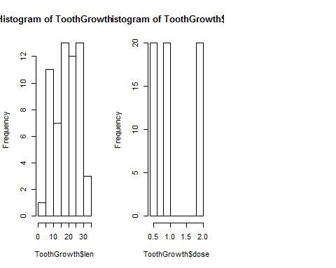

Looks like dose is discrete as well

unique(ToothGrowth$dose)

## [1] 0.5 1.0 2.0

We see there are 3 unique values here.

Looks like the data uses 2 segments for treatment with a supplement and having 3 doses on each. lets see each one separate as a confidence interval ##Confidence and p-values

#treatment on OJ  
X0<-ToothGrowth[ToothGrowth$supp=="OJ",c(1,3)]  
#treatment on VC  
Y0<-ToothGrowth[ToothGrowth$supp=="VC",c(1,3)]  
summary(lm(X0$len ~ X0$dose))

##   
## Call:  
## lm(formula = X0$len ~ X0$dose)  
##   
## Residuals:  
## Min 1Q Median 3Q Max   
## -7.2557 -3.7979 -0.0643 3.3521 7.9386   
##   
## Coefficients:  
## Estimate Std. Error t value Pr(>|t|)   
## (Intercept) 11.550 1.722 6.708 2.79e-07 ***  
## X0$dose 7.811 1.302 6.001 1.82e-06 ***  
## ---  
## Signif. codes: 0 '***' 0.001 '**' 0.01 '*' 0.05 '.' 0.1 ' ' 1  
##   
## Residual standard error: 4.446 on 28 degrees of freedom  
## Multiple R-squared: 0.5626, Adjusted R-squared: 0.547   
## F-statistic: 36.01 on 1 and 28 DF, p-value: 1.825e-06

summary(lm(Y0$len ~ Y0$dose))

##   
## Call:  
## lm(formula = Y0$len ~ Y0$dose)  
##   
## Residuals:  
## Min 1Q Median 3Q Max   
## -8.2264 -2.6029 0.0814 2.2288 7.4893   
##   
## Coefficients:  
## Estimate Std. Error t value Pr(>|t|)   
## (Intercept) 3.295 1.427 2.309 0.0285 *   
## Y0$dose 11.716 1.079 10.860 1.51e-11 ***  
## ---  
## Signif. codes: 0 '***' 0.001 '**' 0.01 '*' 0.05 '.' 0.1 ' ' 1  
##   
## Residual standard error: 3.685 on 28 degrees of freedom  
## Multiple R-squared: 0.8082, Adjusted R-squared: 0.8013   
## F-statistic: 117.9 on 1 and 28 DF, p-value: 1.509e-11

Both show very small p values hence without knowing what the supplement was I can say that there is very little support for this study to take the supplement for growth of teeth.

## Plot of supplement "OJ"

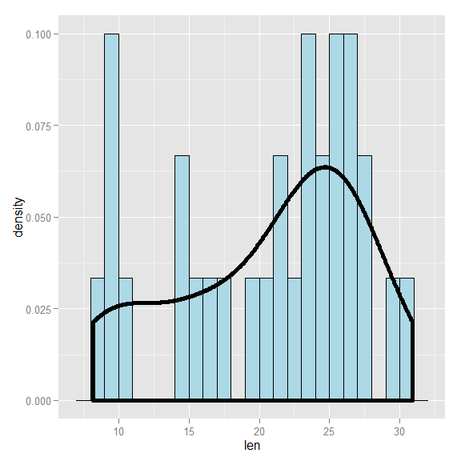

## Plot of supplement "VC"

