Brno University of Technology
Faculty of Information Technology

Computer Communication and Networks
Project no. 2 documentation
ZETA: Packet Sniffer

Jan Zbořil
xzbori20@stud.fit.vutbr.cz
April 2021
Table of Contents
1. Program ipk-sniffer 3
1.1 Running the program 3
1.2 Program Capabilities 4
1.3 Program Limitations 4
2. Implementation 5
2.1 Function Main 5
2.2 Function ArgCheck 5
2.3 Function WriteInterface 5
2.4 Function CheckInterface 6
2.5 Function CreateSocket 6
2.6 Function Sniff 6
2.7 Function doPacket 6
2.8 Function MrProper 7
2.9 Function getCurrentTimeRFC3339 7
2.10 Functions print_hex_ascii_line and print_payload 7
3. Testing 8
3.1 Methodology 8
3.2 Testing Examples 8
4. Conclusion 11
5. Bibliography 12
6. Table of Figures 13

Program ipk-sniffer
Goal of this project has been to create a working console user interface program, which is able to sniff network traffic on one of the devices interface and display captured information in form of ASCII and HEX output.
Program was created using C++ and C programming languages in VS Code IDE. Compilation is done via Makefile located in root directory.

Running the program
Program C++ code has to be compiled using given Makefile using command make. Compiled program can be run using command line. Command to run program is ./ipk-sniffer. Due to nature of this project it is advised to run this program as an administrator.
Program accepts these arguments:
- -i/--interface
  - specifies on which interface the traffic is to be captured
  - accepts one string parameter
- -p
  - specifies if the traffic is to be captured only on one selected port
  - accepts one string parameter, specifying more ports is forbidden
- -t/--tcp
  - capture only TCP packets
- -u/--udp
  - capture only UDP packets
- --arp
  - capture only ARP frames, output the differs from others, more at 2.7
- --icmp
  - capture only ICMP packets
- -n
  - specifies how many packets/frame to capture, default value is 1
Due to the nature of this project (root privileges and network sniffing) it is expected of user to know what they are doing and not to mix parameters not compatible (e. g. ARP and port numbers). If parameters not compatible are given and program is stuck, it can be safely closed using CTRL+C shortcut ("interrupt", SIGINT).

Program Capabilities
This program is able to capture traffic on Ethernet and Wi-Fi interfaces. It can sniff TCP, UDP and ICMP packets and ARP frames as well. For it to be able to capture network traffic it is required to run this program with administrator privileges.
List of program functions:
- choose interface
- list interfaces (--interface/-i given without value, not given at all)
- sniff TCP (--tcp/-t)
- sniff UDP (--udp/-u)
- sniff only on defined ports (-p)
- sniff given number of packets (-n) or 1 if n not given
- sniff ICMPv4 messages (--icmp) - do not have port numbers
- sniff ARP messages (--arp) - outputs MAC addresses instead of IP addresses
- combine more options
- write packet info
  - time as specified in RFC 3339 with milliseconds
  - source and destination IPv4 addresses
  - source and destination ports
  - frame length in bytes
- end program runtime using ctrl+c with safe memory handling
- can sniff these interfaces: Ethetnet, WiFi, DLT_LINUX_SLL, DLT_SLIP, DLT_PPP, DLT_RAW

Program Limitations
Program is limited to capture IPv4 traffic only. This decision has been made due to the capabilities of authors own home network for testing.
Program will not end itself when bad combination of protocol and port argument is selected. It is needed to exit the program using CTRL+C shortcut. More on this at 1.1.

Implementation
Program source code is divided to two files located in root folder. These files are ipk-sniffer.cpp and ipk-sniffer.h. File with .cpp extension contains implementation and program logic whereas ipk-sniffer.h is home for data structures, function definitions and include directives. Both files are heavily commented. Functions as whole are more described in .h file. Comments in .cpp file are trying to explain logic behind program structure.
There is also the README file containing brief description of program and its capabilities. Licenses for used code are also written there.

Function Main
Function Main is first to be execute after program starts. It does not compute anything itself given its function as hub of sorts for other functions which are sequentially called from it. These are: ArgCheck(), WriteInterface(), CheckInterface(), CreateSocket(), Sniff() and MrProper() named after brand of cleaning products, symbolizing its function.
It handles errors and creates signal handlers before it gives a green light to start sniffing.

Function ArgCheck
This function handles parsing and handling each of given program arguments. It uses getopt and getopt_long for this purpose. It has been written using Linux manual page example [1]. For it purpose it uses while loop and nested switch statement. Data from parsed arguments are stored in params_data structure. It also builds up string which is later used as PCAP filter used to choose right traffic to capture. It has to be differentiated while building this string, whether its element is first in string or not due to syntax rules (example: tcp at start of the string, or tcp in middle and at the end of the string).
Main difficulty was to make -i/--interface argument work with and without parameter. Its functionality has been achieved with a bit of code from [2].

Function WriteInterface
This is called after argument checking only if -i/--interface argument has not been given at all or it has been given without parameter. It is the first place in code where PCAP library is used. Function in question is pcap_findalldevs specifically. Here it is used to find information about all network devices in host. It is later cycled through every of these devices and their info is written out to the standard output. PCAP list is then safely closed and program is terminated.

Function CheckInterface
Determines if device name submitted in form of -i/--interface argument exists and terminates if the device in question is invalid. pcap_findalldevs function has been used again here.

Function CreateSocket
Goal of this function is to create functional PCAP device which is later used for frame capturing. First it opens the given device for capturing and saves its IP address and network mask for future use. It then creates PCAP filter from string created in 2.2 and applies it to the freshly created PCAP device.

Function Sniff
This is the heart of the ipk-sniffer. It is called after CreateSocket creates PCAP device and system signal handlers are setup to capture signals for program terminating.
First it determines the length of L2 header which is later used to get the right offset to access the right data in frame/packet. This header length varies between used protocol/medium. It is 14 bytes for Ethernet and 24 for Wi-Fi for example. These numbers are taken from [3].
PCAP loop is then initiated and run as many times as specified via -n argument. pcap_loop uses doPacket function to do its job of processing packets.

Function doPacket
DoPacket is called every time program reaches PCAP loop in function Sniff (2.6). First it gets current time in RFC3339 format with milliseconds in string type from function getCurrentTimeRFC3339 (2.9).
If ARP is set to be captured, it reads source and destination MAC addresses and prints main data line. It shows MAC addressees instead of IP addresses because ARP is working on L2 so it does not work with IP addressees. First main output line is outputted, then print_payload (2.10) is called to print frame data. Here I used snprintf function to store char MAC address data in std::string for easier output.
If ARP is not selected it uses value of L2 header from 2.6 and sets pointer after this section so L3 header can be read. From now accessible L3 header IP addresses and port numbers can be read. Protocol used is also read from this header and next procedure is decided on its value because TCP, UDP and ICMP use different headers it is important to differentiate between them to get the right data and offsets.
All is then set to be outputted. Main data line is written out first, then print_payload (2.10) handles writing out the rest of data.

Function MrProper
Named after famous brand of cleaning product this function does what its name suggests. It frees all PCAP resources and cleans after itself. Then it safely terminates the program.

Function getCurrentTimeRFC3339
This function has been taken from [4] and then modified to write its data to std::string and add milliseconds which were missing in original solution. [5] has also been heavily consulted in making of this program as a whole.

Functions print_hex_ascii_line and print_payload
These two functions handle the output of frame data in HEX and ASCII forms. I have completely taken these functions from [6]. No my modifications have been made. They are taken from licensed program which license can be found in README or ipk-sniffer.h.

Testing
I tested my implementation locally on my machine using comparison method. Two outputs to compare were 1) ipk-sniffer output and 2) Wireshark output.

Methodology
Comparison data has been generated by original traffic originating from or delivered to my own PC running Kubuntu 20.04. First I opened Wireshark as superuser and started capturing data from Ethernet interface. Immediately after that I ran my ipk-sniffer set up to capture 20 frames. After the capturing has been done I tried to locate same frames manually and compare them. For testing TCP, UDP and ARP data I used normal network traffic. For capturing ICMP messages I had to run ping utility originating at my PC with destination address of my LANs default gateway. This method helped me with setting the right offset for writing out HEX and ASCII data, because I could a) repeat the proccess and b) visually see differences in output and compensate for them.

Testing Examples
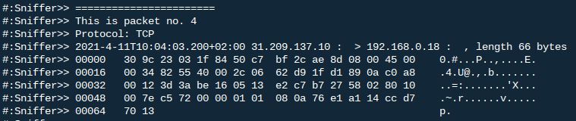Figure 1: TCP packet captured with ipk-sniffer

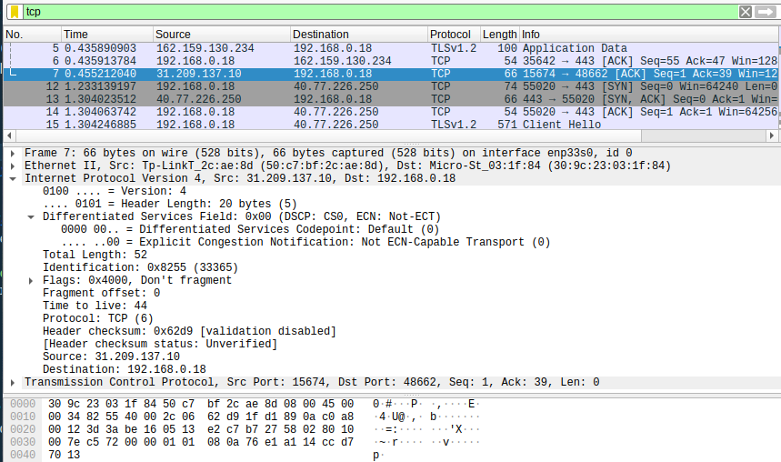Figure 2: Same TCP packet captured with Wireshark
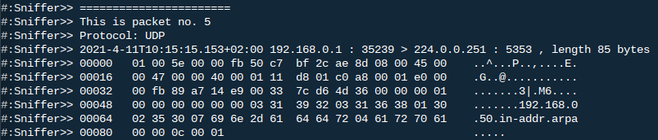Figure 3: UDP packet captured with ipk-sniffer
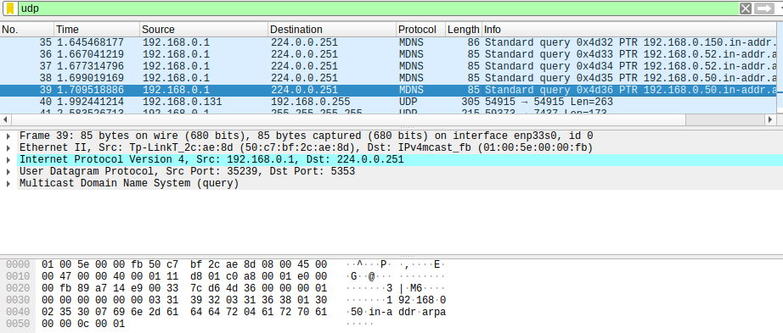Figure 4: Same UDP packet captured with Wireshark
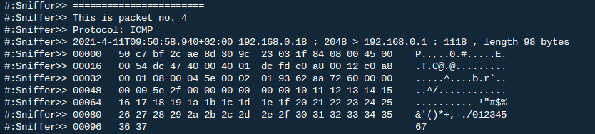Figure 5: ICMP packet captured with ipk-sniffer
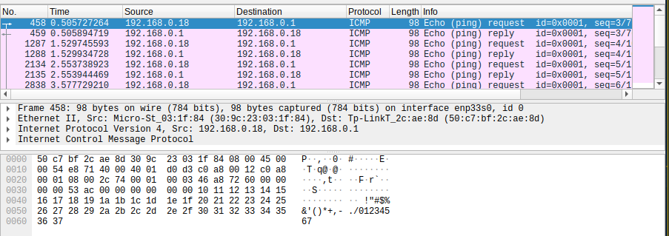Figure 6: Same ICMP packet captured with Wireshark
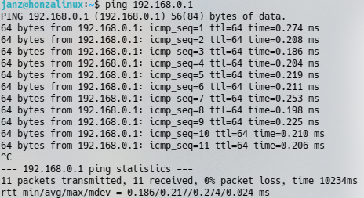Figure 7: Ping used to generate ICMP traffic
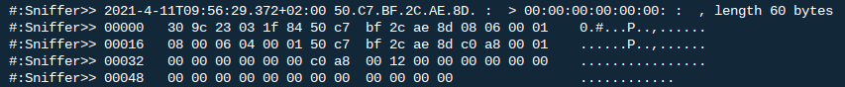Figure 8: ARP frame captured with ipk-sniffer - notice MAC addresses instead of IP addresses
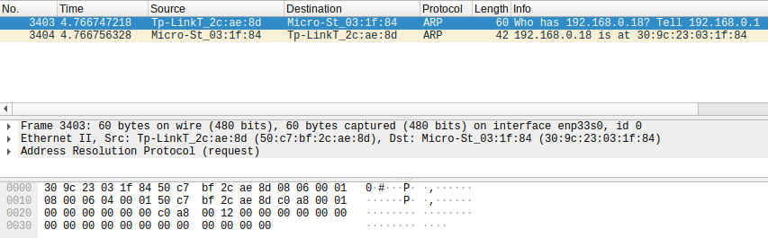Figure 9: Same ARP frame captured with Wireshark

Conclusion
This project has given me a lot of knowledge of working with network structures in C programming language as it was my first time using these capabilities of PCAP library. It has given me a look into working with in my opinion outdated and not so greatly made library documentation. This project helped me to understand the difference in multiple programming languages and their intended use and their workflow. For example now I know that Python (which syntax I truly hate with my whole hearth) which I used to make first IPK project is made to be more user friendly does not provide complete control like C/C++ with its pointer arithmetic.
Main takeaway from this project is the realization that protocol structured listed in many sources are real and internal data representation of these protocol really have the same data fields an length etc.

Bibliography
- getopt(3) - Linux manual page. 2021. URL https://man7.org/linux/man-pages/man3/getopt.3.html
- haystack: c - getopt does not parse optional arguments to parameters - Stack Overflow. 2009. URL https://stackoverflow.com/questions/1052746/getopt-does-not-parse-optional-arguments-to-parameters
- Link-Layer Header Types — TCPDUMP/LIBPCAP public repository. 2021. URL https://www.tcpdump.org/linktypes.html
- rfc3339.c GitHub. 2021. URL https://gist.github.com/jedisct1/b7812ae9b4850e0053a21c922ed3e9dc
- Klyne, G.: Date and Time on the Internet: Timestamps. RFC 3339, RFC Editor, 7 2002. URL https://tools.ietf.org/html/rfc3339
- The Tcpdump Group: tcpdump-htdocs/sniffex.c at master·the-tcpdump-group/tcpdump-htdocs·GitHub. 2021. URL https://github.com/the-tcpdump-group/tcpdump-htdocs/blob/master/sniffex.c

Table of Figures
Figure 1: TCP packet captured with ipk-sniffer 8
Figure 2: Same TCP packet captured with Wireshark 8
Figure 3: UDP packet captured with ipk-sniffer 9
Figure 4: Same UDP packet captured with Wireshark 9
Figure 5: ICMP packet captured with ipk-sniffer 9
Figure 6: Same ICMP packet captured with Wireshark 9
Figure 7: Ping used to generate ICMP traffic 10
Figure 8: ARP frame captured with ipk-sniffer - notice MAC addresses instead of IP addresses 10
Figure 9: Same ARP frame captured with Wireshark 10

