SOFTWARE REQUIREMENTS SPECIFICATION
IRO
Issues Reporting Outlet
A web-based platform for reporting and resolving issues concerning
AAUA students and Akungba, Iwaro, Etioro and Ayegunle indigenes
Student Name | AJAYI EZEKIEL YOMI
Matric Number | 220404167
Department | Computer Science
Faculty | Computing
Course Code | CSC426
Course Title | Software Engineering
Lecturer | Dr. O. O. Ajayi
Submission Date | 10th July, 2026

Table of Contents
Table of Contents 2
1. Introduction 4
1.1 Purpose 4
1.2 Scope 4
1.3 Definitions, Acronyms and Abbreviations 4
1.4 References 5
1.5 Document Overview 5
2. Overall Description 5
2.1 Product Perspective 5
2.2 Product Functions 5
2.3 User Classes and Characteristics 5
2.4 Operating Environment 5
2.5 Design and Implementation Constraints 6
2.6 Assumptions and Dependencies 6
3. Functional Requirements 6
3.1 Register 6
3.2 Login 7
3.3 Report an Issue 7
3.4 View Submitted Reports 7
3.5 Track Report Status 8
3.6 Review Reports 8
3.7 Update Report Status 8
3.8 Manage Users 9
3.9 Logout 9
4. External Interface Requirements 9
4.1 User Interfaces 9
4.2 Hardware Interfaces 10
4.3 Software Interfaces 10
4.4 Communications Interfaces 10
5. Non-Functional Requirements 10
5.1 Performance 10
5.2 Security 10
5.3 Usability 10
5.4 Availability and Reliability 10
5.5 Maintainability and Scalability 10
6. System Architecture and Component Interactions 11
6.1 Architectural Overview 11
6.2 Major Components 11
6.3 Component Interaction Flows 11
7. Use Case Diagram 13
7.1 Actor Summary 13

1. Introduction

1.1 Purpose
This document specifies the software requirements for IRO (Issues Reporting Outlet), a web-based system developed to allow students and indigenes of the AAUA community — including Akungba, Iwaro, Etioro and Ayegunle — to report issues affecting their environment, and to allow designated administrators to review, act on, and resolve those reports. It is intended to guide the development, testing, and evaluation of the mini web interface submitted as part of the CSC426 Weekend 3 assignment.

1.2 Scope
IRO provides two classes of user: a general User (student or indigene) who can register, log in, submit issue reports, view their own submitted reports, and track the status of those reports; and an Admin who can log in, review all reports submitted across the community, update the status of any report, and manage registered user accounts. The system is implemented as a client-side web application using HTML, CSS and JavaScript, backed by Firebase Authentication for identity management and Cloud Firestore for real-time data storage.
Out of scope for this version: payment processing, SMS/email notifications, native mobile applications, and multi-language support.

1.3 Definitions, Acronyms and Abbreviations
Term | Definition
IRO | Issues Reporting Outlet — the name of the system described in this document.
SRS | Software Requirements Specification.
AAUA | Adekunle Ajasin University, Akungba-Akoko.
Admin | A user with elevated privileges who reviews and manages reports and user accounts.
User | A registered student or community indigene who can report and track issues.
Firestore | Google Firebase's cloud-hosted NoSQL document database, used for data persistence.
UID | Unique Identifier assigned by Firebase Authentication to each registered account.
CRUD | Create, Read, Update, Delete — the basic operations performed on stored data.

1.4 References
- CSC426 Weekend Dev — Weekend 3 assignment brief, issued by Dr. O. O. Ajayi.
- Firebase Authentication and Cloud Firestore official documentation.

1.5 Document Overview
Section 2 describes the product from a high level. Section 3 details functional requirements by system feature. Section 4 covers external interface requirements. Section 5 specifies non-functional requirements. Section 6 explains the system architecture and how major components interact. Section 7 presents the use-case diagram and actor summary.

2. Overall Description

2.1 Product Perspective
IRO is a standalone, self-contained web application. It is not a component of a larger system, though it depends on two external managed services: Firebase Authentication (for account creation, login and session management) and Cloud Firestore (for storing user profiles and issue reports). The frontend runs entirely in the user's browser and communicates with these services directly over HTTPS.

2.2 Product Functions
- Account registration and authentication for community members.
- Submission of issue reports with a title, category, location and description.
- Real-time viewing of a user's own submitted reports and their current status.
- Visual tracking of an individual report's progress through defined status stages.
- Administrative review of all reports submitted across the community.
- Administrative update of a report's status as it progresses toward resolution.
- Administrative management of user accounts, including deactivation of access.

2.3 User Classes and Characteristics
User Class | Characteristics
User (Student / Indigene) | General members of the AAUA community who need to raise and follow up on issues. Assumed to have basic familiarity with web forms; no technical expertise required.
Admin | A designated staff member responsible for triaging and resolving reported issues, and for maintaining the user base. Account is provisioned manually and is not self-registered.

2.4 Operating Environment
- Client: any modern desktop or mobile web browser (Chrome, Edge, Firefox, Safari) with JavaScript enabled and an internet connection.
- Backend: Firebase Authentication and Cloud Firestore (Google Cloud infrastructure).
- No server-side application code is hosted by the developer; all business logic runs client-side or is enforced through Firestore security rules.

2.5 Design and Implementation Constraints
- Must be implemented using HTML, CSS, JavaScript and Firebase, per the developer's existing technology stack.
- Kept intentionally simple in scope and interaction design, in line with the assignment's submission timeline.
- No dedicated backend server is used; all data access rules are enforced through Firebase's client SDK and Firestore security rules.

2.6 Assumptions and Dependencies
- Users have access to a device with a web browser and internet connectivity.
- The Firebase project (Authentication and Firestore) is correctly configured and available.
- Exactly one admin account is provisioned manually by editing a user's role directly in Firestore.

3. Functional Requirements
This section lists the functional requirements of IRO, organised by the system feature (use case) each belongs to, as shown in the use-case diagram in Section 7.

3.1 Register
Actor: User
Allows a new community member to create an account by providing their personal and community details.
ID | Functional Requirement | Priority
FR-3.1.1 | The system shall allow a user to create an account using full name, email address, community and password. | High
FR-3.1.2 | The system shall require the user to confirm their password before account creation. | High
FR-3.1.3 | The system shall reject registration if the email address is already in use. | High
FR-3.1.4 | The system shall store the new account's profile, with role set to 'user', in the database. | High
FR-3.1.5 | The system shall display a clear error message if registration fails, without crashing the page. | High

3.2 Login
Actor: User, Admin
Allows a registered account holder to authenticate and access the dashboard appropriate to their role.
ID | Functional Requirement | Priority
FR-3.2.1 | The system shall authenticate a user by email and password. | High
FR-3.2.2 | The system shall determine the account's role (user or admin) after successful authentication. | High
FR-3.2.3 | The system shall redirect a user-role account to the User Dashboard. | High
FR-3.2.4 | The system shall redirect an admin-role account to the Admin Dashboard. | High
FR-3.2.5 | The system shall block login and display a message if the account has been deactivated. | High
FR-3.2.6 | The system shall display a clear error message on invalid credentials, without crashing the page. | High

3.3 Report an Issue
Actor: User
Allows a logged-in user to submit a new issue report describing a problem in their community.
ID | Functional Requirement | Priority
FR-3.3.1 | The system shall provide a form capturing title, category, community/location and description. | High
FR-3.3.2 | The system shall require all fields to be completed before submission. | High
FR-3.3.3 | The system shall save the report with the submitting user's ID, an initial status of 'pending', and a timestamp. | High
FR-3.3.4 | The system shall confirm successful submission and return the user to their list of reports. | High

3.4 View Submitted Reports
Actor: User
Allows a logged-in user to see all issue reports they have personally submitted.
ID | Functional Requirement | Priority
FR-3.4.1 | The system shall display all reports submitted by the currently logged-in user. | Medium
FR-3.4.2 | The system shall show each report's title, description, category, location, status and submission date. | Medium
FR-3.4.3 | The system shall update the displayed list automatically when a report's status changes. | Medium

3.5 Track Report Status
Actor: User
Allows a user to follow the progress of a specific report through its resolution stages.
ID | Functional Requirement | Priority
FR-3.5.1 | The system shall allow a user to select one of their reports to track. | Medium
FR-3.5.2 | The system shall visually indicate the report's current stage among Submitted, In Review and Resolved. | Medium
FR-3.5.3 | The system shall reflect status changes made by an admin without requiring the user to resubmit anything. | Medium

3.6 Review Reports
Actor: Admin
Allows an admin to view all issue reports submitted by every user across the community.
ID | Functional Requirement | Priority
FR-3.6.1 | The system shall display all submitted reports regardless of which user submitted them. | High
FR-3.6.2 | The system shall show the submitting user's name alongside each report. | High
FR-3.6.3 | The system shall allow the admin to filter reports by status (All, Pending, In Review, Resolved). | High

3.7 Update Report Status
Actor: Admin
Allows an admin to change the status of any report as work progresses toward resolution.
ID | Functional Requirement | Priority
FR-3.7.1 | The system shall allow the admin to change a report's status directly from the review list. | High
FR-3.7.2 | The system shall persist the updated status immediately to the database. | High
FR-3.7.3 | The system shall reflect the updated status to the reporting user in real time. | High

3.8 Manage Users
Actor: Admin
Allows an admin to view all registered accounts and control their access to the system.
ID | Functional Requirement | Priority
FR-3.8.1 | The system shall display all registered users with their name, email, community and role. | Medium
FR-3.8.2 | The system shall allow the admin to deactivate a user account, preventing further login. | Medium
FR-3.8.3 | The system shall allow the admin to reactivate a previously deactivated account. | Medium
FR-3.8.4 | The system shall prevent an admin account from being deactivated through this feature. | Medium

3.9 Logout
Actor: User, Admin
Allows any authenticated account to end their session securely.
ID | Functional Requirement | Priority
FR-3.9.1 | The system shall terminate the authenticated session when logout is triggered. | Low
FR-3.9.2 | The system shall redirect the account to the login page after logout. | Low

4. External Interface Requirements

4.1 User Interfaces
- A registration page and a login page, each presenting a single form.
- A User Dashboard with sidebar navigation for Report an Issue, My Reports and Track Status.
- An Admin Dashboard with sidebar navigation for Review Reports and Manage Users.
- All interfaces are responsive and usable on both desktop and mobile screen sizes.

4.2 Hardware Interfaces
None beyond a standard device (desktop, laptop, tablet or smartphone) capable of running a modern web browser.

4.3 Software Interfaces
- Firebase Authentication — handles account creation, credential verification and session state.
- Cloud Firestore — stores and synchronises user profile and issue report data in real time.

4.4 Communications Interfaces
All communication between the client application and Firebase services occurs over HTTPS, secured using Firebase's SDK-managed connections.

5. Non-Functional Requirements

5.1 Performance
- Report and status updates shall reflect on affected dashboards within a few seconds, using Firestore's real-time listeners rather than manual page refreshes.
- Pages shall load within an acceptable time on a typical mobile data connection.

5.2 Security
- Passwords shall never be stored or transmitted in plain text; authentication is delegated entirely to Firebase Authentication.
- A user shall only be able to view and manage their own submitted reports; only an admin may view or modify all reports.
- Deactivated accounts shall be prevented from accessing any dashboard, even with valid credentials.

5.3 Usability
- The interface shall use clear, plain-language labels and a consistent visual design across all pages.
- Forms shall validate required fields and present specific, actionable error messages rather than failing silently or crashing.

5.4 Availability and Reliability
- The system shall depend on Firebase's managed infrastructure for uptime, rather than a self-hosted server.
- The application shall degrade gracefully and show a readable error message if a network or database request fails.

5.5 Maintainability and Scalability
- Code shall be organised by page and responsibility (authentication, dashboard, reports) to simplify future changes.
- The data model (Firestore collections for users and reports) shall support additional fields or report categories without structural changes.

6. System Architecture and Component Interactions

6.1 Architectural Overview
IRO follows a client-heavy, serverless architecture. There is no custom backend server: the browser-based frontend communicates directly with two managed Firebase services. This keeps the system simple to build and deploy while still supporting real-time, multi-user data synchronisation.

6.2 Major Components
Component | Responsibility
Frontend (HTML/CSS/JavaScript) | Renders all pages, captures user input, and calls Firebase SDK functions.
Firebase Authentication | Creates accounts, verifies credentials, and maintains the logged-in session.
Cloud Firestore | Stores user profile documents and issue report documents; pushes live updates to any listening client.
users collection | One document per account: full name, email, community, role (user/admin), active flag.
reports collection | One document per issue report: reporting user's ID and name, title, category, community, description, status, timestamp.

6.3 Component Interaction Flows

Registration Flow
- User submits the registration form in the browser.
- Frontend calls Firebase Authentication to create a new account.
- Frontend writes a corresponding profile document to the users collection in Firestore, with role set to 'user'.
- User is redirected to the login page.

Login Flow
- User submits email and password.
- Frontend calls Firebase Authentication to verify the credentials.
- On success, frontend reads the matching document from the users collection to determine role and active status.
- Frontend redirects to the User Dashboard or Admin Dashboard accordingly, or blocks access if the account is deactivated.

Report Submission and Live Status Sync
- User completes the Report an Issue form on the User Dashboard.
- Frontend writes a new document to the reports collection with status 'pending'.
- Firestore's real-time listener pushes this new document to the user's own My Reports and Track Status views immediately.
- Separately, the same document is picked up by the Admin Dashboard's live listener on the full reports collection, appearing under Review Reports.
- When the admin changes the report's status, Firestore updates the single source-of-truth document.
- The change propagates back to the user's dashboard in real time, updating both the report card and the status tracker, with no manual refresh required.

User Deactivation Flow
- Admin selects Deactivate on a user in Manage Users.
- Frontend updates that user's document in the users collection, setting active to false.
- On the affected user's next login attempt, the frontend reads active as false and blocks access with an explanatory message.

7. Use Case Diagram
The diagram below summarises all interactions between the two system actors — User and Admin — and the system's use cases, as implemented.
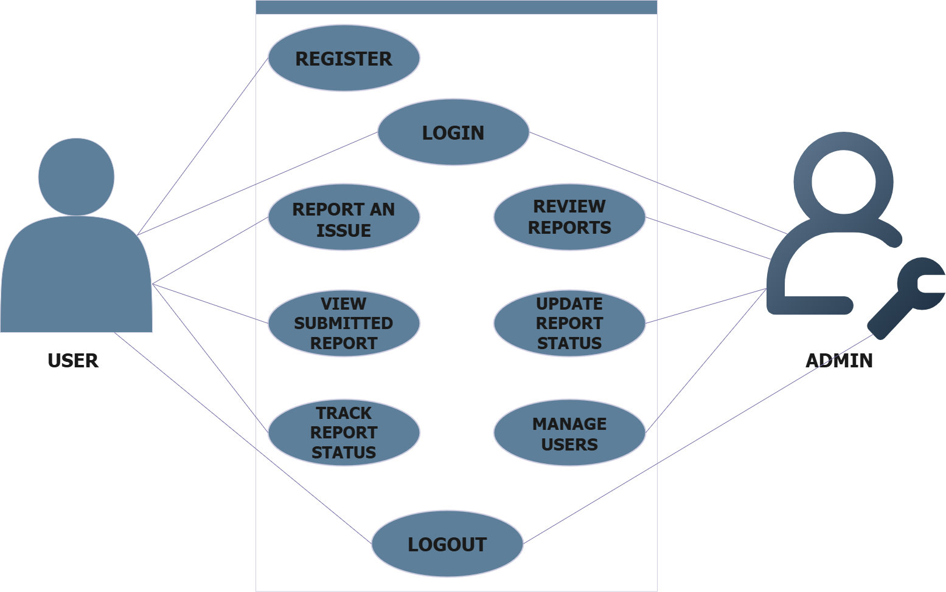
Figure 1: IRO Use Case Diagram — User and Admin actors

7.1 Actor Summary
Actor | Use Cases
User | Register, Login, Report an Issue, View Submitted Report, Track Report Status, Logout
Admin | Login, Review Reports, Update Report Status, Manage Users, Logout

