**PROJECT REPORT**

**Project Team**

* **Leader:** Ozgen Tastan
  + **Id**: 300294837
* **Team member:** Pedro Rendon
  + **Id:** 300304473

**Project Description**

• System Overview

POS (POINT OF SALE) system for small restaurants.

It will allow users to ring in food checks on the system, with the ability to add or change food items on check in real time, and later on, it will allow the user to settle different kind of payments, and review payment and check reports.

• Deliverables

1. User Interface with Menu, Summary, Payment and Manager tabs.
2. PDF or Excel with daily Sales Report.

• Scope

Customer will be able to manage accountability of items, products, or meals sold daily with possibility of expansion to monthly and annually accountability.

• Requirements

1. Customer will need to provide inventory of items to be managed on the POS system.
2. When opening the app for the first time, customer will need to provide an item and employee List, from a Json File Type.

**Process Model**

User roles and processes used by each

* Server (employee)
  + Login
  + Rings in food items on the system
  + Selects payments and send orders to database.
* Manager (Admin)
  + Login
  + Rings in food items on the system
  + Selects payments and send orders to database.
  + Creates or Delete food items and saves them into the database
  + Add or Delete Employees
  + Check Settled Orders
  + Back up database.

**Flow Diagram** 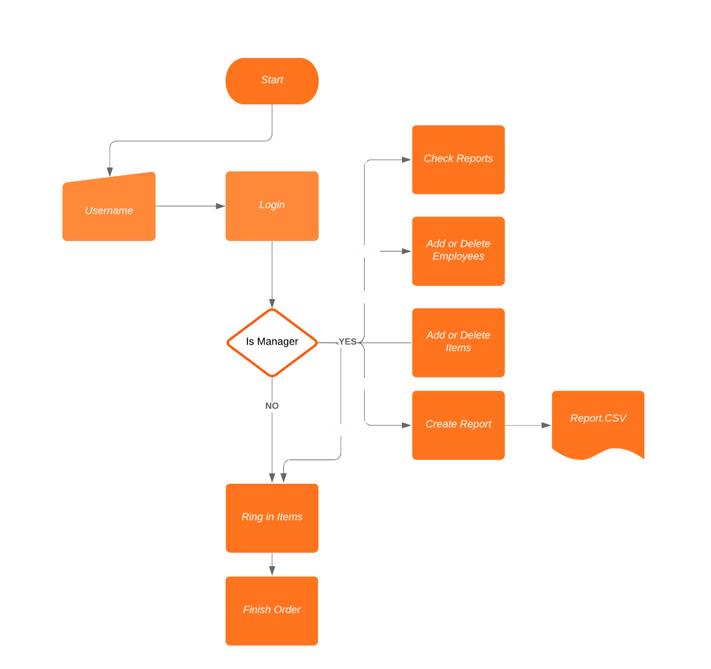

**Database model**

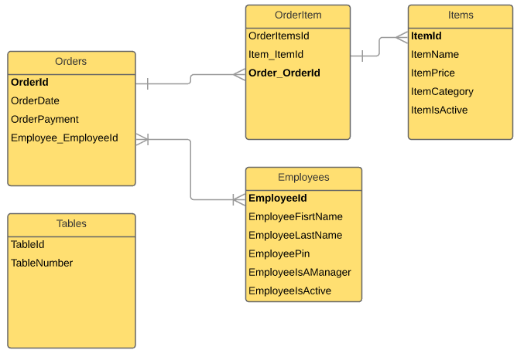

**User interface Manual Guide.**

1. **Log In Tab Screen**.

User may enter its PIN code previously provided by a Manager or System Administrator. (For testing issues, please use **6027** Manager PIN number)

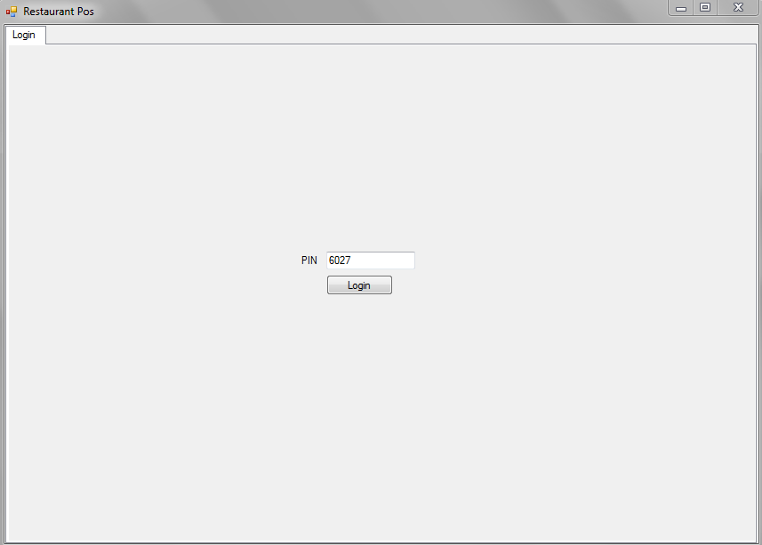

1. **Menu/ Summary/Payment Tab Screen:**

This is the main Screen of the system. It provides an easy access list of all inventory items which can be ordered and added to an order (receipt). It also allows choosing payment methods and settling or voiding orders.

* 1. Select a Table where you want place an Order.

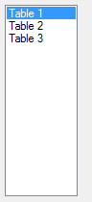

* 1. If requested by the client, select a seat per each person or individual request on the same table. If no seat is selected then all items will be assigned to the NONE general order.

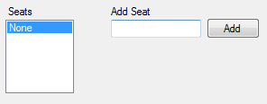

Seats can be added as numbers or as clients Names.

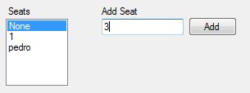

* 1. Add the items to each seat or table. If Seats are created, items will be assigned to the selected seat on the Seat List.

1. Use the search bar over each category Item List to filter and look for the particular item that is being ordered.



1. Select the Item or the items to be added then click on the add button on each category, to add it to the order. If more quantity of the same item is needed click on the add button as many times as the item is requested.

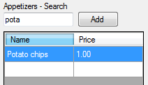

* 1. Order Summary.

It provides a detailed list of all the items ordered under a same check. To edit the order, Items have to be first deleted using the “Delete Selected Items” button and then added from the category lists as needed.

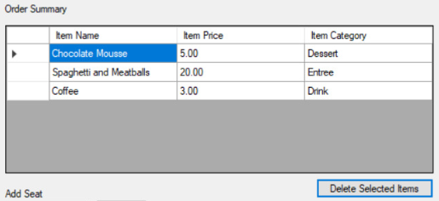

To see information of a different Table Order, re-select the desire table on the Table List.

To see information per seat, re-select the desire table on the Seat List.

* 1. Payment and Payment Options.

It Provides 3 payment options (Cash, Debit, Credit). Before settling any check a payment option needs to be selected.

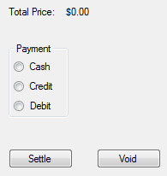

When Settle button is click, the order will be saved on the database, and can be accessed by managers from the “Completed Orders” tab.

1. **Completed Orders Tab Screen:**

Completed orders tab screen, allow managers to check on restaurant sales per order and what was sold on each order. On the Completed orders datagridview list, shows by date, a summary of all the orders that has been settled successfully.

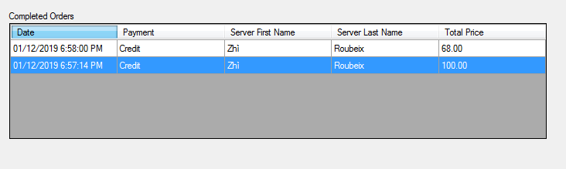

The Items datagridview list will show all the items sold and that belongs the order that is being selected on the completed orders datagridview.

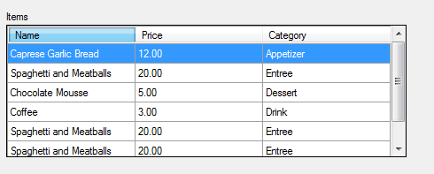

1. **Manager Tab Screen:**

The Manager tab screen, allows any employee set up as a Manager, to:

* Add Items from a JSON file.
* Add or Delete Items.
* Add, Edit or Delete Employees.
* Add or Remove Tables.

4.1. Add Items from a Json File.

If user already counts with a Item List or inventory file, it has the possibility to add it to the database. This File needs to be JSON file type, and count with the appropriate list columns such as ItemName, ItemPric, ItemCategory.and ItemIsActive.

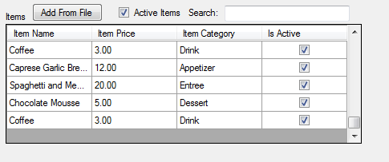

4.2. Add Items

Users also can add new individual items when needed. If an Item needs to be edited, them it needs to be deleted, and re-created as a new Item.

Under the Item List GridView, type in an item name and price for the new item being added, then select a category type from the dropdown list and click on the “AddItem” button. Item will be automatically saved and a “Succesfully Added” message should appear for a few seconds.

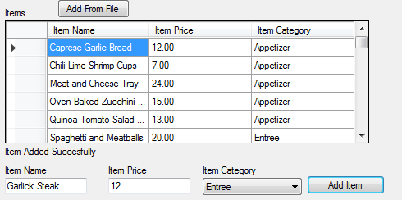

4.3. Delete Items

To delete Items, user needs to select the entire row and hit the “Delete” key on the Keyboard.

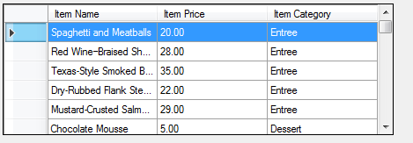

A “Succesfully Deleted” Message should appear.

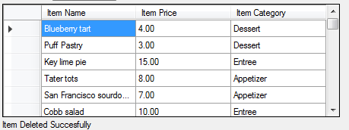

4.4 Items Search

Items also can be search by “Active” items or using the search bar over the Item list gridview.



4.5 Add or Edit Employees.

To add new employees select a new and empty row on the Add or Edit Employee DataGriView List and type in, all the requested fields. Any field can be left empty.

To edit, scroll and select the employee which is going to be edited and type in the employee info to be adjusted.

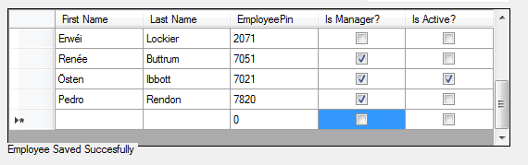

After pressing the “Enter” key on the Keyboard or clicking or selecting a different row a “Succesfully Added or Edited” Message should appear.

4.6 Remove Employees.

To remove employees from the Gridview and Database, select the entire employee row to be deleted and press the “Delete” key on the keyboard.

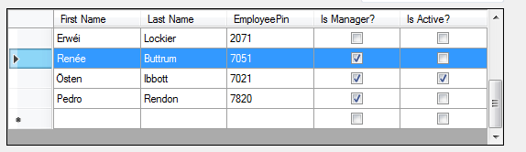

A “Succesfull Deleted” message should appear.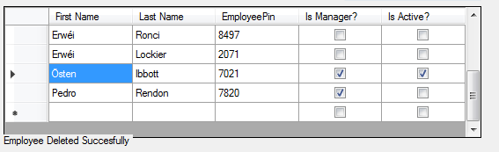

4.7 Add or Remove Tables.

User can add new tables or remove then when needed. To add a table, click on the “Add Table” button. A new table will be added to the table list, and table name can also be edited when need it.

