FACE AND IDENTITY VERIFICATION USING CLOUD-BASED SaaS MODELS

by
Ahmet Abdullah Gültekin
Ayşe Gülsüm Eren
Ayşenur Arıcı

CSE4197 / CSE4198 Engineering Project report submitted to Faculty of Engineering
in partial fulfillment of the requirements for the degree of

BACHELOR OF SCIENCE

Supervised by:
Assoc. Prof. Dr. Mustafa Ağaoğlu

Marmara University, Faculty of Engineering
Computer Engineering Department
2026

Copyright © Ahmet Abdullah Gültekin, Ayşe Gülsüm Eren, Ayşenur Arıcı, 2026. All rights reserved.

FACE AND IDENTITY VERIFICATION USING CLOUD-BASED SaaS MODELS

by
Ahmet Abdullah Gültekin
Ayşe Gülsüm Eren
Ayşenur Arıcı

CSE4197 / CSE4198 Engineering Project report submitted to Faculty of Engineering
in partial fulfillment of the requirements for the degree of

BACHELOR OF SCIENCE

Supervised by:
Assoc. Prof. Dr. Mustafa Ağaoğlu
Sign

Sign

Marmara University, Faculty of Engineering
Computer Engineering Department
2026
Copyright © Ahmet Abdullah Gültekin, Ayşe Gülsüm Eren, Ayşenur Arıcı, 2026. All rights reserved.

ABSTRACT

Modern identity rests on a brittle foundation: passwords are phished, access cards are cloned, and naive face-recognition systems are defeated by a printed photograph. This thesis presents FIVUCSAS (Face and Identity Verification Using Cloud-based SaaS), a multi-tenant identity-and-access-management platform that unified strong biometric verification, document-grounded identity proofing, and standards-based federated login in a single cloud-native service. Our objective was to close the gap between cutting-edge face-recognition research and a deployable, tenant-isolated product that organizations could adopt without building biometrics in-house. We engineered the system as two cooperating microservices that followed a hexagonal architecture. A Spring Boot identity core handled authentication, OAuth 2.0 / OpenID Connect with PKCE, role-based access control, and a dozen selectable login factors—ten canonical methods plus two cross-device additions. A FastAPI biometric processor performed face embedding with Facenet512, cosine-similarity matching over a pgvector index, quality assessment, and a hybrid anti-spoofing pipeline. For liveness, we combined a randomized active challenge-response scheme—the Biometric Puzzle, scored from eye- and mouth-aspect ratios and head pose—with passive MiniFASNet texture analysis, while NFC reading performed ICAO 9303 passive authentication of electronic travel documents. We deployed the platform to production behind a Traefik edge alongside PostgreSQL and Redis, and shipped React and Kotlin Multiplatform clients, including a publicly released Android application. We validated the work with roughly 4,400 authored automated tests across five test technologies, spanning the unit, integration, and end-to-end levels, complemented by k6 load scenarios and a separate security battery (Bandit, pip-audit, gitleaks, and Dependabot). The project demonstrated that hybrid liveness, multi-model recognition, and rigorous tenant isolation can coexist in one extensible SaaS, and it surfaced honest limitations—formal presentation-attack certification and additional biometric modalities—as concrete future work.

ACKNOWLEDGEMENTS

We are deeply grateful to our advisor, Assoc. Prof. Dr. Mustafa Ağaoğlu, whose guidance, patience, and insistence on engineering rigor shaped this project from a loose idea into a working production system; his feedback at every milestone kept us honest about what we had truly built. We thank the Computer Engineering Department of the Marmara University Faculty of Engineering for the education, resources, and encouragement that made this work possible. Finally, we thank our families for their unwavering support, understanding, and patience through the long nights and pressing deadlines this thesis demanded—we could not have completed it without them.

TABLE OF CONTENTS

ABSTRACT iii
ACKNOWLEDGEMENTS iv
TABLE OF CONTENTS v
LIST OF FIGURES vi
LIST OF TABLES vii
1. INTRODUCTION 1
1.1 Problem Description and Motivation 1
1.2 Main Goal and Objectives of the Project 1
2. DEFINITION OF THE PROJECT 2
2.1 Scope of the Project 2
2.2 Success Factors 2
2.3 Professional Considerations 2
2.4 Literature Survey 2
3. SYSTEM DESIGN AND SOFTWARE ARCHITECTURE 3
3.1 Project Requirements 3
3.1.1 Functional Requirements 3
3.1.2 Nonfunctional Requirements 3
3.2 System Design 3
3.2.1 UML Use case Diagram(s) for the main use cases 3
3.2.2 UML Class and/or Database ER diagram(s) 3
3.2.3 User Interface 3
3.2.4 Test Plan 3
3.3 Software Architecture 3
4. TECHNICAL APPROACH AND IMPLEMENTATION DETAILS 4
4.1 You may add subchapters as many as you want 4
5. SOFTWARE TESTING 5
6. BENEFITS AND IMPACT 6
7. CONCLUSION AND FUTURE WORK 7
REFERENCES 8
APPENDICES 9

LIST OF FIGURES

Figure 1.1 Example Figure 1

LIST OF TABLES

Table 2.1 Example Table 2

- INTRODUCTION
  - Problem Description and Motivation
Authentication has quietly become one of the most frequent actions in modern life. We prove who we are dozens of times a day — unlocking phones, signing into e-government portals, authorizing bank transfers, entering office buildings, and passing through transit turnstiles. As digital services proliferated across banking, healthcare, public administration, and smart buildings, the act of proving identity grew from an occasional formality into a continuous, high-stakes ritual. Yet the mechanisms most systems still rely on — passwords, physical access cards, and shallow single-factor biometrics — were designed for a quieter era and have aged poorly against a threat landscape that no longer plays fair.
The first weakness is the password. Passwords are simultaneously the most ubiquitous and the most fragile credential in use: they are forgotten, reused across services, phished, leaked in bulk, and cracked offline at scale. The numbers are stark. Verizon's 2024 Data Breach Investigations Report found that the overwhelming majority of hacking-related breaches trace back to stolen or weak credentials, with the human element implicated in a large share of incidents overall [1]. The scale of exposure is widening rather than narrowing: the Identity Theft Resource Center documented a sharp year-over-year rise in data-compromise events, with the number of affected individuals reaching into the hundreds of millions [2]. A credential that can be copied, transmitted, and replayed is, by construction, a credential that an attacker can possess as easily as its legitimate owner.
Physical access tokens fare no better. RFID and proximity cards — the badges that open doors, gates, and elevators in most organizations — can be cloned in seconds with inexpensive, readily obtainable readers. A lost or surreptitiously scanned card hands an intruder the same physical privileges as an employee, and unlike a password, a cloned card leaves the original in the victim's pocket, so the compromise often goes unnoticed. The card proves possession of an object, never the presence of a person.
Biometrics promised to close this gap by binding authentication to the human body itself, but naive biometric deployments introduced a new failure mode: spoofing. A face-recognition system that merely matches an image against a stored template can be defeated by holding up a printed photograph, replaying a video on a screen, or — at the sophisticated end — presenting a three-dimensional mask. These presentation attacks are precisely why liveness detection matters: without a reliable way to confirm that a real, living person is physically present at the moment of capture, a face is just another copyable credential. Many fielded systems still treat biometrics as a convenience layer rather than a hardened identity primitive, leaving them exposed to exactly the photo-and-video attacks that liveness detection exists to prevent.
Beyond the weakness of any individual factor lies a deeper, structural problem: identity is fragmented across the physical and digital worlds, and across the ecosystems that own each fragment. Device-bound biometrics such as Apple Face ID and Android fingerprint unlock are excellent, but they are tethered to a single handset and a single vendor; the identity they assert cannot travel to a turnstile, a kiosk, or a partner organization's service. Physical access control, meanwhile, is typically procured as an isolated installation from a third party and never speaks to the digital identity provider that governs logins. The result is a patchwork in which a person's "office badge identity," "corporate login identity," and "phone-unlock identity" are three unrelated facts about the same human being, each managed by a different system, none aware of the others. This fragmentation is not merely inelegant — it multiplies attack surface, frustrates auditing, and makes coherent, organization-wide trust impossible to reason about.
There is also a market and software-engineering gap that compounds the technical one. The most capable liveness and face-verification engines today fall into two camps, neither of them satisfactory. Some are locked inside proprietary cloud APIs that are opaque, costly, and a source of vendor lock-in and data-residency concern for privacy-sensitive institutions. Others are research-grade models that excel on benchmarks but were never engineered into a complete, multi-tenant, production-ready service. Organizations that want strong biometric authentication as a shared, rentable capability — a Software-as-a-Service (SaaS) offering that serves many client organizations from one platform, in the B2B and B2B2C delivery models — find little that combines open extensibility, robust anti-spoofing, cloud-native scalability, and strict per-tenant data isolation in a single coherent system.
Legacy authentication codebases make the gap worse still. By bundling user management, session handling, audit logging, and verification into monolithic services that violate basic separation-of-concerns principles, they become nearly impossible to extend with new biometric modalities or to integrate cleanly with third parties. The result is software that is hard to secure, hard to audit, and harder still to evolve.
These intertwined deficiencies — the brittleness of passwords and cards, the spoofability of shallow biometrics, the fragmentation of physical and digital identity, and the absence of an open, multi-tenant biometric platform — defined both the motivation and the worth of this project. The problem is not academic. It directly affects the security of individuals whose identities are stolen and the operational resilience of the institutions that serve them, and it sits squarely at the intersection of cybersecurity, machine learning, distributed systems, and privacy law. That intersection is precisely what made the problem worth solving carefully.
In response, we designed, built, and deployed FIVUCSAS (Face and Identity Verification Using Cloud-based SaaS), a multi-tenant, cloud-native biometric identity-verification platform. At its core, FIVUCSAS pairs high-accuracy deep-learning face recognition with an active, challenge–response liveness mechanism we call the Biometric Puzzle, which asks the user to complete a randomly generated sequence of facial actions so that a static photo or a replayed video cannot satisfy the unpredictable, live challenge. The platform was implemented as two backend microservices: an Identity Core API that owns authentication, authorization, tenant administration, and security policy, and a Biometric Processor that performs the compute-intensive face detection, embedding, similarity search, and anti-spoofing analysis. Faces are stored as high-dimensional embeddings in a vector-enabled relational database and matched by vector similarity, an in-memory cache holds rate-limiting state and short-lived session data, and an edge reverse proxy terminates TLS in front of the services. Around this backend we delivered multiple client surfaces: a React web administration dashboard, a hosted login experience with an embeddable authentication widget and JavaScript SDK, and a Kotlin Multiplatform mobile application, all bound together by a multi-tenant data model that isolates each client organization's users and biometric data at the database level. The exact technology versions and the reasons behind each choice are detailed in Chapters 2 and 3; the remainder of this thesis describes how each of these pieces was specified, designed, implemented, and tested.
  - Main Goal and Objectives of the Project
The main goal of the project was to design, develop, and deliver a working prototype of a multi-tenant, cloud-native, multi-platform SaaS platform for biometric identity authentication — a modern, secure, and flexible alternative to traditional password-, card-, and shallow-biometric-based authentication. Rather than treating face recognition as a stand-alone algorithm, the goal was to engineer it into a complete, deployable identity service: one that resists spoofing through active liveness detection, scales across many client organizations under strict tenant isolation, and exposes its capabilities through developer-friendly APIs and ready-to-use client applications.
To realize this goal, we pursued the following concrete, measurable objectives:
• Build a secure and scalable backend on a microservices architecture. We separated the platform into an Identity Core API for user, tenant, and role management and a dedicated Biometric Processor API for computationally intensive biometric operations, following microservices and hexagonal (ports-and-adapters) design principles so that business logic and machine-learning workloads scale and evolve independently.
• Develop the "Biometric Puzzle" active liveness-detection algorithm. We implemented an active challenge–response mechanism that requires the user to perform a randomly generated sequence of facial actions (for example, blinking and smiling), measured through facial-landmark metrics such as the Eye Aspect Ratio (EAR) and Mouth Aspect Ratio (MAR), so that presentation attacks using static photos, replayed videos, or masks fail the unpredictable live challenge.
• Integrate high-accuracy face recognition and verification using proven deep-learning models. We used the DeepFace library to generate standardized facial embeddings (with Facenet512 as the production model), performing 1:1 verification by cosine similarity between two embeddings and serving 1:N identification through a vector-index nearest-neighbor search over the pgvector store, with the ability to evaluate alternative recognition models.
• Deliver multi-platform client applications. We provided multiple end-user and administrator interfaces — a React web dashboard, a hosted login page with an embeddable widget and JavaScript SDK, and a Kotlin Multiplatform mobile application (Android delivered) — enabling users to enroll their biometric data and authenticate their identity, and administrators to manage their tenants.
• Design a multi-tenant, fully isolated data model. We designed the relational and vector data model so that the platform operates as a genuine SaaS offering, with each tenant's users, configuration, and biometric embeddings completely isolated at the PostgreSQL database level, preventing any cross-tenant data access.
- DEFINITION OF THE PROJECT
This chapter draws the boundaries of FIVUCSAS — Face and Identity Verification Using Cloud-based SaaS — as it was actually built. It states what we set out to deliver and delivered, what we deliberately left out, the constraints and assumptions under which the work proceeded, the measurable factors by which we judged success, the professional and legal considerations that shaped the engineering, and finally the body of academic and industrial work against which the platform must be positioned. Throughout, we report the project in the past tense, because by the time of writing the system was a running, production-deployed platform rather than a proposal on paper.
  - Scope of the Project
We scoped FIVUCSAS as a working Minimum Viable Product (MVP) of a multi-tenant, cloud-native biometric identity platform — substantial enough to demonstrate every core idea end to end, yet bounded so that a three-person undergraduate team could finish it within two academic semesters. The scope evolved between the Project Specification Document (PSD) and the delivered system: several technology choices made on paper (Flutter clients, an NGINX gateway, FAISS for vector search, Kafka/RabbitMQ message queues) were replaced during implementation by alternatives that fit the team and the deployment target better. Where this happened, the sections below describe what was actually delivered and note the change.
    - In Scope
The realized scope of the platform covered the following areas.
Backend services. We built two cooperating microservices. The Identity Core API — implemented in Spring Boot 3.4.7 on Java 21 [3] — owned authentication, authorization, tenant administration, role and permission management, OAuth 2.0 / OpenID Connect issuance, auditing, and orchestration of the verification flows. The Biometric Processor — implemented in FastAPI on Python 3.12 [4] — owned all compute-intensive face analysis: detection, embedding generation, quality assessment, similarity search, and liveness/anti-spoofing. The two services communicated over REST, with the Identity Core API acting as the trusted intermediary so that the authentication decision always remained on the server side rather than in an untrusted browser.
Client applications. We delivered a React 18 web administration dashboard [5], a hosted login surface and an embeddable JavaScript authentication widget/SDK, and a native Android application built on Kotlin Multiplatform with Compose Multiplatform [6]. A JVM desktop client (Windows and Linux), sharing the same Kotlin business logic via expect/actual seams, was also delivered as a hosted-first OAuth client with an administrative and kiosk interface. The PSD had named Flutter as the mobile framework; this was abandoned in favor of Kotlin Multiplatform so that mobile and desktop could share one codebase with the team's existing JVM skill set.
Database architecture. We persisted all data in a single multi-tenant PostgreSQL 17 database [7] with the pgvector extension [8] storing high-dimensional face and voice embeddings. Tenant isolation followed a shared-database, shared-schema model keyed by a tenant_id column, enforced in the application layer by a Hibernate @Filter applied to tenant-scoped entities and guarded by cross-tenant isolation tests on every pull request. The schema was managed with Flyway migrations [9], which by the time of writing had grown to more than eighty versioned migrations.
Face biometrics. The platform performed both 1:1 face verification and 1:N face identification. Server-side detection used MTCNN [10], embeddings were generated with Facenet512 [11] (512-dimensional), and identity comparison used cosine similarity against pgvector-indexed templates. The underlying DeepFace framework [12,13] gave us interchangeable model backends, though production was pinned to Facenet512 for its accuracy/dimension balance.
Liveness detection. We implemented a hybrid liveness strategy. The active, challenge–response layer — the project's signature "Biometric Puzzle" — issued a randomized sequence of facial actions (blink, smile, head turn) and scored them client-side against MediaPipe FaceLandmarker geometry [14], using Eye Aspect Ratio (EAR) [15] and Mouth Aspect Ratio (MAR) thresholds, then re-verified server-side. The passive layer used a UniFace MiniFASNet ONNX classifier [16] complemented by texture (Local Binary Patterns), frequency-domain, color-consistency, and moiré-pattern analysis to detect presentation artifacts without user interaction.
Identity-document verification. Beyond faces, we built an NFC/eMRTD reading capability into the Android client and a document/card detection pipeline (a YOLOv8 model [17] plus OCR) able to classify Turkish national identity cards, ICAO 9303-compliant biometric passports [18], driver's licenses, and Marmara University student/staff cards.
Infrastructure and security. The entire backend was containerized with Docker and orchestrated by Docker Compose [19,20], fronted in production by a Traefik v3 edge proxy [21] handling TLS termination, routing, security headers, and edge rate limiting. Redis 7.4 [22] provided session caching, distributed token-bucket rate limiting (Bucket4j [23]), and an event bus. Security spanned JWT-based stateless authentication [24], Role-Based Access Control (RBAC), BCrypt password hashing [25], OAuth 2.0 / OIDC with PKCE [26,27,28], optional WebAuthn/passkeys [29], and rate limiting. The platform was deployed and reachable on the public internet under the fivucsas.com family of domains.
The high-level shape of this delivered system is summarized in Figure 2.1.
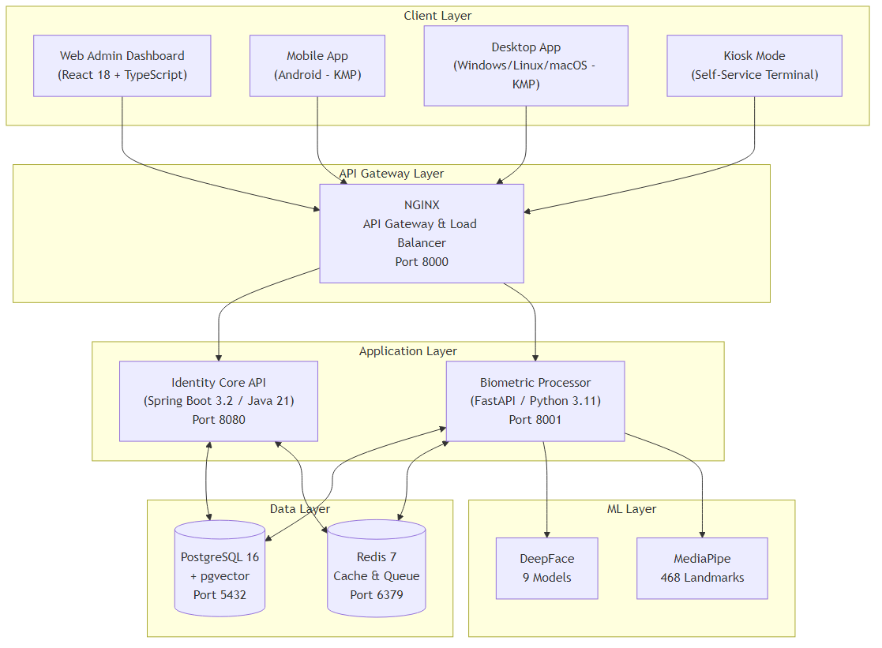
Figure 2.1 High-level system architecture overview of the delivered FIVUCSAS platform
    - Out of Scope
To keep the project finishable and focused on its biometric core, we deliberately excluded the following from the delivered MVP.
Additional biometric modalities as a research focus. The PSD framed the project around face plus "multi-biometric fusion." In practice we concentrated the research effort on face recognition and liveness detection — the hardest and most novel parts — and treated other modalities pragmatically. Voice verification was implemented as a working secondary factor (Resemblyzer speaker embeddings); fingerprint and hardware-key methods were wired through the platform's authentication framework, though on the web surface fingerprint resolved to the platform/WebAuthn authenticator rather than a custom sensor pipeline. Iris recognition and custom multi-modal score fusion were left as future work, consistent with the extensible hexagonal design that makes adding a modality a localized change.
Production-grade container orchestration. We did not deploy on Kubernetes or author Helm charts. Docker Compose proved sufficient to run the full microservice stack in production on a single host and to demonstrate the architecture; Kubernetes was documented as a future scaling path rather than built. (Architectural diagrams for a future Kubernetes, high-availability, and multi-region topology exist in the design documentation but were not deployed.)
Hardware manufacturing. The project was strictly software engineering. We did not design or manufacture physical access-control hardware; edge interactions (door controllers, kiosks, Raspberry Pi / Jetson units) were simulated through software interfaces, while keeping the API compatible with such devices.
Comprehensive billing and payment integration. We did not implement subscription management or third-party payment gateways such as Stripe. SaaS multi-tenancy was demonstrated through database-level isolation and per-tenant quotas rather than a generic billing engine.
Native iOS client. The PSD promised Android and iOS mobile apps. iOS was not delivered. The shared Kotlin module declared iOS targets and an iosMain source set, but it remained stubbed — for example, iOS HMAC for TOTP and the iOS platform services were left as TODO/stub implementations. A full iOS application was deferred to a later phase, contingent on Apple Developer Program enrollment, so the cross-platform coverage we claim stops short of iOS.
Model training. Training or fine-tuning the deep face-recognition models was out of scope. The platform used pre-trained models, so recognition accuracy was bounded by those models' published performance.
    - Constraints
Several constraints, fixed at the outset, shaped every design decision.
Technology constraint. The project was required to use only open-source technologies under permissive licenses, excluding proprietary databases, commercial machine-learning models, and closed frameworks. This constraint was honored throughout — the entire stack (Spring Boot, FastAPI, PostgreSQL/pgvector, Redis, Traefik, DeepFace, MediaPipe, MiniFASNet, Kotlin Multiplatform, React) is open source — and it directly influenced choices such as self-hosting authentication rather than reselling a commercial IAM.
Infrastructure constraint. Development was conducted primarily in local Docker Compose environments. VPS/cloud hosting was permitted for demonstration and testing; the delivered system ran on a single Hetzner CX43 virtual server (8 vCPU, 16 GB RAM, 150 GB disk, Ubuntu 24.04). This single-host reality is why CPU-only inference and Docker Compose orchestration — not GPU clusters and Kubernetes — defined the operational envelope.
Hardware constraint. Liveness and recognition accuracy depend on the client device's camera. We specified a recommended minimum capture resolution (in the 480p–720p range) and optimized all inference for CPU execution, treating GPU acceleration as optional for future scalability. Because the deployment host had no GPU, the production configuration deliberately avoided GPU-only models (RetinaFace, YOLO-family recognition backends, ArcFace) and selected CPU-safe equivalents (MTCNN detection, Facenet512 embeddings, MiniFASNet liveness).
Data constraint. No model was trained on collected biometric data; evaluation used publicly available datasets such as Labeled Faces in the Wild (LFW) together with controlled test captures collected with the explicit consent of project members. This bounded the strength of any accuracy claim to what could be measured in a controlled setting.
Timeline constraint. The project was bound to the academic calendar (September 2025 – mid-2026), which forced continuous prioritization of the biometric core over auxiliary features and is the reason several "nice to have" items (iOS, billing, Kubernetes) became out-of-scope or future work.
    - Assumptions
The project plan rested on a handful of assumptions, all of which broadly held in practice, though some required mitigation.
• We assumed that stable, mutually compatible versions of the chosen open-source libraries would remain available throughout the project. This largely held, but not for free: the UniFace MiniFASNet dependency had to be pinned to version 3.6.0 after a newer release segfaulted under the hardened (read-only, capability-dropped) production runtime, and the DeepFace detector backend was switched to MTCNN to work around an upstream defect. These adjustments confirmed the assumption only because the open-source nature of the stack let us diagnose the problems and pin around them.
• We assumed that the devices used for testing met the minimum hardware requirements for real-time video analysis. Mid-range Android phones and standard laptop webcams proved adequate for the client-side MediaPipe pipeline.
• We assumed the team possessed the fundamental competencies in the selected technologies (Java, Python, Kotlin, Docker) and could acquire additional knowledge as needed. This held, and was reinforced by the decision to drop Flutter — for which the team had less depth — in favor of Kotlin Multiplatform.
• We assumed that biometric processing could be performed acceptably on CPU-only infrastructure. This assumption was central to the deployment model and held for the demonstrated workload, at the cost of excluding GPU-only models from production.
  - Success Factors
The PSD defined five objectives and, for each, a measurable success factor. Below we restate each objective, the original Key Performance Indicator (KPI), and the actual outcome as delivered. Where a target was a controlled-test or design figure rather than a benchmarked production result, we say so explicitly and do not inflate it.
Table 2.1 Project objectives, their target KPIs, and delivered outcomes
Objective | Target KPI | Delivered outcome
O1 — Secure, scalable backend | All microservices run on Docker; API endpoints pass functional tests; user/tenant CRUD works | Met. Both services run in production under Docker Compose behind Traefik; ~1,569 JUnit 5 backend test methods and 888 pytest functions exercise the APIs; user/tenant/role CRUD operate live.
O2 — "Biometric Puzzle" active liveness | ≥95% legitimate pass; ≥99% rejection of simple photo/video spoofs | Implemented and operational; evaluation ongoing. The randomized challenge–response runs client- and server-side; ISO/IEC 30107-3 metrics were instrumented, but the specific 95%/99% figures were targets, not independently certified results, and are reported as targets throughout.
O3 — High-accuracy face recognition | FAR < 1% and FRR < 5% in a controlled test | Implemented; controlled-test target. The production verifier is Facenet512 with a cosine-distance decision rule (production VERIFICATION_THRESHOLD = 0.4, relaxed to 0.55 for embeddings older than two years); FAR/FRR instrumentation exists, but the FAR<1% / FRR<5% figures remain controlled-environment targets, not audited production results.
O4 — User-friendly mobile app | Stable on Android and iOS; full enroll+auth flow under 1 minute | Partially met. A full native Android client was delivered and publicly distributed (signed APK releases); iOS was not delivered (stubbed targets only). The sub-one-minute enrollment goal was a usability target validated informally, not a benchmarked statistic.
O5 — Isolated multi-tenant data model | Integration tests prove no cross-tenant data access | Met. A shared-schema/tenant_id model with a Hibernate @Filter is guarded by named cross-tenant isolation Testcontainers tests (CrossTenantIsolationIT, TenantSwitcherIsolationIT, and others) that are required and asserted-to-have-executed on every backend pull request.
Several observations follow from this table. First, every architectural and security objective (O1, O5) was met cleanly and is continuously re-verified by the test suite; these are the strongest claims we make. Second, the biometric-accuracy objectives (O2, O3) were fully implemented — the algorithms run in production and the ISO/IEC 30107-3 evaluation harness (APCER, BPCER, ACER, EER) exists — but their headline numbers (95%, 99%, FAR<1%, FRR<5%) were stated as targets and measured only under controlled conditions. We therefore present them as targets throughout, never as certified benchmark results. Third, the cross-platform objective (O4) was partially achieved: Android (and a JVM desktop client) shipped, iOS did not. Reporting these gradations precisely, rather than declaring blanket success, is itself a measure of the thesis's integrity.
Beyond the five formal objectives, the project also met its non-functional success criteria in the sense that the system was actually deployed, healthy, and publicly reachable, with continuous CI gates (unit, integration, security, and isolation tests) protecting every change. The defined performance KPIs — for example, p95 authentication latency under 200 ms and verification under 500 ms — were encoded as thresholds in a Grafana k6 load-test suite [30] (six scenarios spanning auth, enrollment, verification, multi-tenant, stress, and spike load); these remained engineering targets rather than audited production benchmarks, and we label them as such.
  - Professional Considerations
    - Methodological Considerations and Engineering Standards
We engineered FIVUCSAS to professional standards rather than as throwaway coursework, and the practices below were used continuously rather than retrofitted at the end.
Version control and collaboration. All source lived under Git in a GitHub organization, split into per-service repositories (Identity Core API, Biometric Processor, web-app, client-apps, spoof-detector, infra, docs) coordinated through a parent repository. Work was tracked on a Kanban board on GitHub Projects. Every change flowed through a pull request, and merges to protected branches required peer review — branch protection was enabled on the principal branches so that review and green CI were enforced mechanically, not by convention alone.
Architecture and design standards. Each microservice followed Hexagonal Architecture (Ports and Adapters) [31], cleanly separating domain logic from infrastructure adapters, in line with microservices and Domain-Driven Design practice [32,33,34]. The boundary was not merely aspirational: ArchUnit tests froze the hexagonal layering of the Java service so that any accidental dependency from domain to infrastructure failed the build. The design was documented with UML — use-case, class, ER, sequence, activity, and finite-state-machine diagrams — and progress was tracked with Gantt charts across the fall and spring semesters, shown in Figure 2.2 and Figure 2.3.
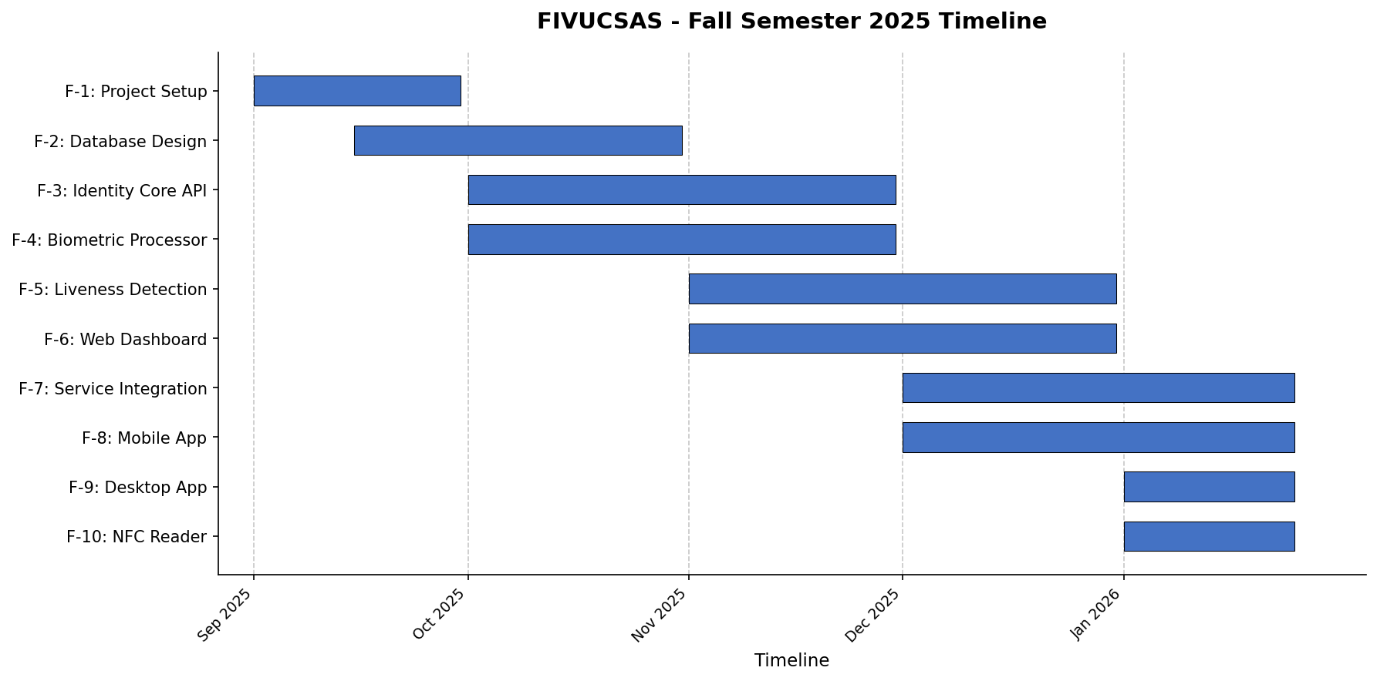
Figure 2.1 Fall-semester project Gantt chart
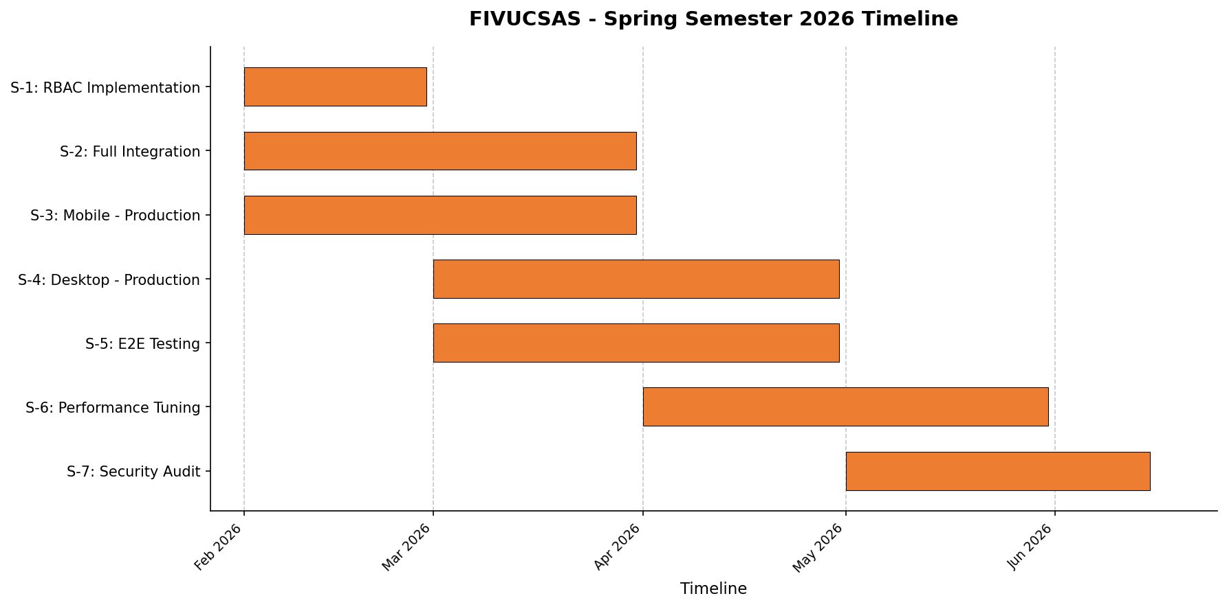
Figure 2.1 Spring-semester project Gantt chart
Standards conformance. The work aligned with recognized standards where they applied: RFC 6749 (OAuth 2.0), OpenID Connect Core, RFC 7636 (PKCE), and RFC 7519 (JWT) for the authorization and token layer [24,26,27,28]; ISO/IEC 30107-3 for presentation-attack-detection terminology and metrics [35]; ICAO Doc 9303 for machine-readable travel documents [18]; the OWASP Top 10 [36] as the security reference checklist; and W3C WebAuthn [29] for passkey support.
Code quality and automation. Language-specific linting and formatting were enforced — Ruff (lint and format) and mypy for Python, ESLint and TypeScript tsc --noEmit for the web app — and continuous-integration pipelines ran on every push and pull request. Identity Core API CI ran unit tests (mvn -T 2C test) on GitHub-hosted runners and the heavier Testcontainers integration tests on a self-hosted runner; the Biometric Processor ran Ruff, mypy, pytest with coverage, and dependency/security scans; the web app ran lint, type-check, Vitest, and a production build; Kotlin clients ran their JVM and Android test sets. Dependabot kept dependencies current (weekly, grouped). Figure 2.4
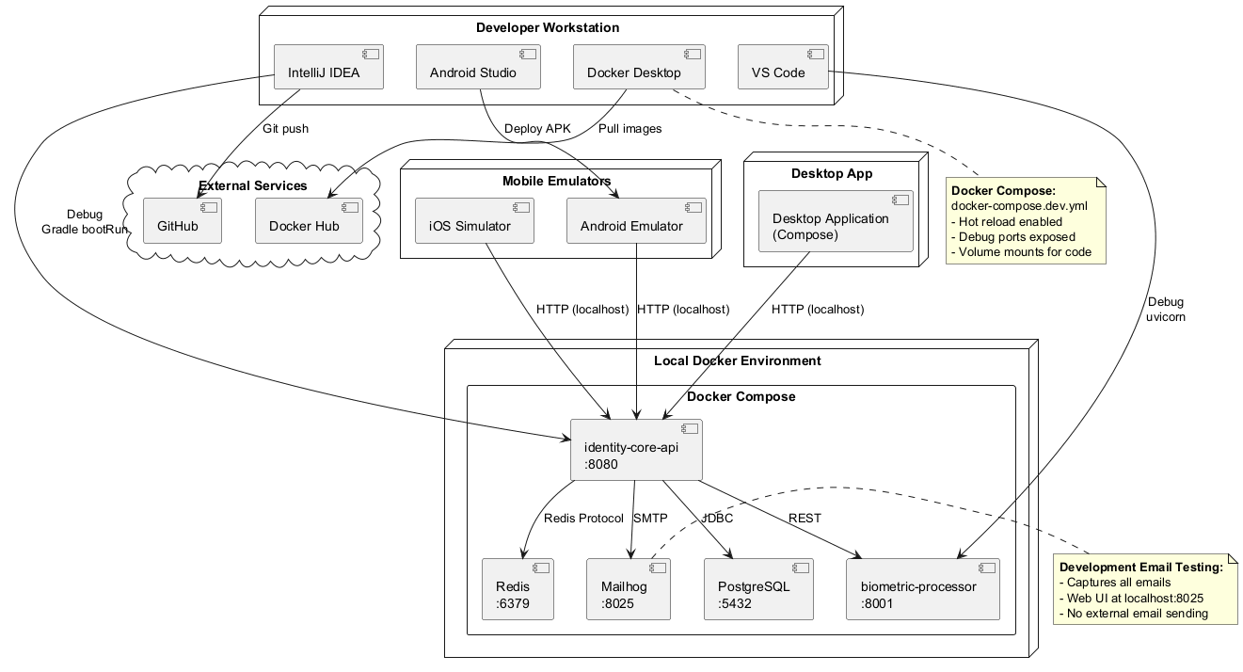
Figure 2.1 Development deployment environment and CI/CD context
    - Realistic Constraints
We assessed the project against the six realistic-constraint dimensions expected of a professional engineering project.
Economical. The exclusive use of open-source technology eliminated all software licensing cost, and the SaaS multi-tenant model was designed for low marginal cost per additional tenant. The production system ran on a single modest VPS, demonstrating that the platform is economically viable to operate at MVP scale. The same multi-tenancy that makes it cheap to run also underpins a future subscription-based commercial model.
Environmental. FIVUCSAS's environmental footprint is indirect — the energy its servers and client devices consume — and we reduced it in concrete ways: CPU-only inference (no power-hungry GPUs), passive-by-default liveness that avoids redundant compute, aggressive Redis caching that spares repeated database and model work, and a single-host deployment that consolidated rather than multiplied running infrastructure. As a pure software system it produced no direct material waste.
Ethical. Biometric data is among the most sensitive personal data, and we treated it accordingly. Users were informed and gave explicit consent before any biometric processing; the platform exposed data-export and erasure flows; and the design minimized exposure by storing only derived embeddings rather than raw face images where possible. Algorithmic bias was an acknowledged concern: the project relied on pre-trained models whose fairness it did not itself certify, so we treated bias mitigation (diverse evaluation data, fairness monitoring) as an explicit ethical responsibility and a standing limitation of the work.
Health and safety. The system carried no physical-safety risk to users. The principal "safety" surface for a biometric system is the safety of the data itself, which we protected with TLS in transit, encryption at rest, strict access control, and a server-side-only authentication decision that prevents a compromised client from forging an identity.
Sustainability. The modular microservices architecture, hexagonal boundaries, containerized deployment, versioned Flyway/Alembic migrations, and large automated test suite were all chosen to make the system maintainable over its lifetime — the technical form of sustainability. New biometric models or auth methods can be swapped in behind ports without disturbing the core, so the platform can evolve as biometric technology and regulation change rather than being rebuilt.
Social. Socially, the platform strengthens authentication security and improves user experience by removing reliance on stolen-able passwords and clone-able cards, while unifying fragmented physical and digital identity. We were equally conscious of the social risk inherent in face technology — surveillance and misuse — and answered it structurally with strict per-tenant data isolation, consent gating, auditability, and access controls designed to prevent the system from becoming a covert surveillance tool.
    - Legal Considerations
Because FIVUCSAS processes biometric data, which is classified as a special category of personal data, legal compliance was a first-order design concern rather than an afterthought.
Türkiye — KVKK No. 6698. The platform was designed to comply with the Turkish Personal Data Protection Law (KVKK No. 6698) [37]. We applied its core principles directly: data minimization (storing derived embeddings, not raw biometrics, and excluding biometric content from audit logs), purpose limitation (biometric data used only for the verification purpose to which the user consented), explicit consent before biometric enrollment, security of processing (encryption in transit and at rest, RBAC, tenant isolation), and the right to erasure via the My-Profile data-export and deletion flows.
European Union — GDPR. The same controls satisfied the corresponding obligations under the EU General Data Protection Regulation (GDPR) [38], which treats biometric data used for unique identification as a special category requiring an explicit legal basis. Consent management, the right to be forgotten, data portability (export), and security-by-design were implemented to align with GDPR as well as KVKK, reflecting the cross-border reality of a SaaS platform.
Open-source licenses. The technology constraint of using only permissively licensed open-source software was, in part, a legal safeguard for future commercialization. Every dependency's license was checked for compatibility, and the predominance of MIT-, Apache-2.0-, and BSD-style licenses across the stack avoids the copyleft obligations that could otherwise complicate a commercial SaaS offering. License and compliance status were tracked as part of the project documentation so that no dependency could quietly impose terms incompatible with the platform's intended use.
  - Literature Survey and Related Work
A platform like FIVUCSAS sits at the intersection of several mature research areas — identity and access management, deep face recognition, presentation-attack detection, document verification, industrial biometric services, and cloud-native multi-tenant systems. This section reviews each, identifies the limitations of existing approaches, and then states precisely where FIVUCSAS differs.
    - Identity and Access Management (IAM) Systems
Identity and Access Management systems are the foundation of secure digital services, regulating authentication, authorization, and the user lifecycle. The dominant commercial platforms — Okta, Auth0, and Microsoft Entra ID (formerly Azure Active Directory) — built mature ecosystems around traditional paradigms: password authentication, one-time-password and push-based multi-factor authentication, and device-bound biometrics such as Apple Face ID and Android fingerprint.
Despite their reach, these platforms share structural limitations. Device-bound biometrics tie identity to specific hardware ecosystems, fragmenting the user experience and limiting portability. Physical-access systems (doors, turnstiles, kiosks) are typically integrated as isolated third-party add-ons, so physical and digital identity domains remain disconnected. Most IAM platforms also treat biometrics as a supplementary factor layered on top of passwords rather than as a core identity primitive, which limits their resistance to advanced spoofing and replay attacks. The recurring theme in recent literature is the need for IAM systems that unify physical and digital identity under one trust framework, enforce strict tenant isolation in shared environments, and embed advanced biometric verification as a first-class pipeline. This is the open problem our positioning in §2.4.7 returns to; the design response — a biometric-first, cloud-native posture built on the industry-validated hosted-login pattern of Auth0 Universal Login, Okta, and Microsoft Entra — is summarized there alongside the full comparison.
    - Deep Learning-Based Face Recognition
Face recognition was transformed by deep representation learning. Early systems relied on handcrafted features such as Local Binary Patterns and Histograms of Oriented Gradients, which were brittle under variations in pose, illumination, and occlusion. Deep convolutional networks replaced these with end-to-end learned embeddings. DeepFace [39] first approached human-level verification performance, and FaceNet [11] introduced a unified embedding space trained with triplet loss, enabling identity comparison by simple distance metrics. Subsequent margin-based losses sharpened class separation: ArcFace [40] added an additive angular margin and set state-of-the-art results on benchmarks such as LFW, while AdaFace [41] introduced quality-adaptive margins for robustness under low-quality and off-angle captures. Lightweight variants such as MobileFaceNets [42] targeted real-time on-device verification, and one-shot approaches such as Siamese networks [43] addressed learning from few examples. VGG-Face [44] remains a widely cited baseline.
A persistent gap separates these models from deployable systems: most papers optimize algorithmic accuracy, while system-level concerns such as scalability, latency, multi-tenant isolation, and operational monitoring fall outside their scope. Unified frameworks such as DeepFace by Serengil and Ozpinar [12,13] partly bridge this by standardizing access to multiple recognition models behind a common detection–alignment–embedding–comparison API. FIVUCSAS adopted that framework for production and settled on Facenet512 for its balance of accuracy against a manageable 512-dimensional embedding.
Table 2.1 Comparison of representative deep-learning face-recognition models (embedding dimension, architecture, reported LFW accuracy)
Model | Embedding dimension | Architecture | Reported LFW accuracy
VGG-Face | 2,622 | VGGNet | 98.95%
Facenet512 | 512 | Inception-ResNet | 99.65%
ArcFace | 512 | ResNet | 99.82%
DeepFace | 4,096 | AlexNet-style | 97.35%
OpenFace | 128 | Inception | 92.92%
(Reported accuracies are the figures published by the respective authors/benchmarks, not measured in this project.) The comparison reveals a clear trade-off between embedding dimensionality and accuracy: modern margin-based models such as ArcFace achieve superior accuracy with far smaller embeddings than early high-dimensional architectures, while a very low-dimensional baseline such as OpenFace (128-dim) is cheap to store and search but gives up several accuracy points. Lower dimensionality also shrinks storage and accelerates nearest-neighbor search, which matters in production. Facenet512's 512-dimensional embedding sat at the sweet spot of this trade-off for our workload, well clear of the 4,096-dimensional original DeepFace at one extreme and the accuracy cost of OpenFace's 128 dimensions at the other.
    - Liveness Detection and Anti-Spoofing
Liveness detection has become essential as presentation attacks — printed photos, replayed video, 3-D masks, and increasingly AI-generated deepfakes — have grown more sophisticated. ISO/IEC 30107-3 [35] standardized the vocabulary and metrics (APCER, BPCER, ACER) and a three-way taxonomy of approaches. Passive methods analyze a single image or stream for spoof artifacts — texture via Local Binary Patterns, frequency-domain analysis for moiré, color-space consistency, and CNN classifiers such as MiniFASNet [16] — offering a frictionless experience but remaining vulnerable to high-quality and generative attacks. Active methods issue challenge–response prompts (blink, smile, head turn, gaze), quantified by metrics such as Eye Aspect Ratio [15] and Mouth Aspect Ratio; real-time landmark frameworks — MediaPipe Face Mesh [14] (468/478 landmarks) and lightweight detectors such as BlazeFace [45] — made on-device active liveness practical. Hybrid approaches combine the two for maximal robustness. Recent work also explored anti-spoofing delivered through serverless and SaaS architectures [46].
The literature's recurring weakness is that proposed liveness solutions tend to be model-centric: strong classifiers in isolation that are never integrated into a complete, end-to-end authentication workflow. The rise of generative attacks underscores the need for liveness that is dynamic, randomized, and context-aware, which static classifiers cannot provide alone. FIVUCSAS answers this with a hybrid pipeline whose active layer — a randomized Biometric Puzzle of EAR/MAR/head-pose challenge–response with anti-replay timestamp checks — sits over a passive MiniFASNet-plus-texture/frequency/moiré classifier, embedded in a real verification flow rather than offered as a standalone model.
    - Identity Document Verification and Standards
In high-assurance scenarios, biometric authentication is reinforced by identity-document verification: ID-to-selfie matching, optical character recognition, Machine-Readable-Zone (MRZ) parsing, and document layout analysis. Document-specific matching models have been shown to outperform generic face recognition when comparing an ID photo with a live capture. International standards are central here: ICAO Doc 9303 [18] specifies electronic Machine-Readable Travel Documents (eMRTDs), including facial biometrics stored in NFC-enabled passport chips, and NFC-based reads provide strong cryptographic guarantees widely used in border control and e-government. Commercial systems built on ICAO-compliant NFC pipelines achieve high trust but are typically coupled to specialized hardware and offer little extensibility for broader cloud SaaS deployment. The literature accordingly favors modular, extensible architectures that let document verification coexist with biometric and behavioral modules — a recommendation FIVUCSAS took to heart by building NFC/eMRTD reading and document classification as composable steps in its verification pipeline rather than as a separate, hardware-locked product.
    - Industrial Biometric Solutions
Several industrial platforms offer large-scale face and liveness services. Microsoft Azure Face Liveness and Amazon Rekognition Face Liveness provide highly accurate, standards-compliant biometric APIs with global availability and PAD compliance. However, they are fully proprietary, cloud-dependent, and offer limited transparency, customization, and control over data processing — a serious concern for privacy-sensitive organizations and academic institutions facing regulatory, cost, and vendor lock-in pressures. Regional providers (for example, Sodec Technologies in Türkiye) focus on e-government and banking but typically lack multi-tenant SaaS architecture and advanced active liveness. Open-source offerings such as OpenCV-based pipelines [47] enable offline and edge deployment but fall short on modern anti-spoofing robustness and enterprise-grade scalability; NFC-centric ID-verification products achieve high trust but at the cost of hardware coupling. Comparative analysis thus shows that no single existing solution simultaneously delivers open extensibility, hybrid liveness, cloud-native scalability, and unified physical-plus-digital identity management. That unmet combination is the precise vacancy the positioning analysis in §2.4.7 measures FIVUCSAS against.
    - Cloud-Native and Multi-Tenant Architectures
Scaling biometric workloads has pushed the field toward cloud-native principles — microservices [32,33,48], containerization [19], and asynchronous communication. Vector databases such as pgvector [8] and similarity-search libraries such as FAISS [49] make storing and querying high-dimensional embeddings efficient enough for large-scale identification. Multi-tenancy adds its own challenges: strict data isolation, tenant-specific configuration, and performance fairness on shared infrastructure. Yet relatively few systems integrate identity management, biometric processing, and liveness detection within a single coherent architecture — most studies tackle one axis (scalability or isolation) in isolation. Architectural patterns such as Hexagonal Architecture [31] and Domain-Driven Design [34] are increasingly recommended to decouple business logic from infrastructure and sustain long-term evolution. FIVUCSAS follows this guidance throughout: a hexagonal microservice split, PostgreSQL/pgvector for embedding search, Redis for caching and rate limiting, and application-layer tenant isolation verified by automated tests on every change. It also departs from the literature's typical toolkit in two deliberate ways. Where the PSD anticipated FAISS for vector search and Kafka or RabbitMQ for messaging, the delivered system used pgvector for search — keeping vectors transactionally beside relational data — and Redis as the event bus, which simplified the single-host deployment without sacrificing the architectural separation the patterns call for.
    - Positioning and Differentiation
The surveyed literature exposes a clear gap between state-of-the-art biometric research and deployable, multi-tenant IAM platforms. Existing solutions either focus narrowly on algorithmic innovation without addressing system-level deployment, or offer closed, inflexible commercial services with limited extensibility and transparency. FIVUCSAS occupies the space between them.
Table 2.1 Positioning of FIVUCSAS against representative IAM and biometric solutions
Capability | Commercial IAM (Okta/Auth0/Entra) | Cloud biometric APIs (Azure/Rekognition) | Open-source CV pipelines | FIVUCSAS
Open-source / self-hostable | No | No | Yes | Yes
Biometrics as a core primitive | Supplementary factor | Yes (service only) | Yes | Yes (server-side decision)
Active randomized liveness | Limited | Partial | Rare | Yes (Biometric Puzzle)
Hybrid active + passive PAD | No | Partial | Limited | Yes
Multi-tenant SaaS isolation | Yes | N/A | No | Yes (tested per-PR)
Unified physical + digital identity | Fragmented | No | No | Yes (design goal)
Document/NFC (eMRTD) verification | Add-on | No | No | Yes (Android NFC + doc classify)
Standards-based OAuth2/OIDC/PKCE | Yes | Partial | No | Yes
Data sovereignty / transparency | Vendor-controlled | Vendor-controlled | Full | Full
What distinguishes FIVUCSAS, then, is the combination it delivers in one cloud-native SaaS platform rather than any single capability in isolation: deep-learning face recognition with interchangeable models; a hybrid liveness pipeline whose active layer is genuinely randomized and replay-resistant; identity-document and NFC/eMRTD verification; standards-based OAuth 2.0 / OIDC / PKCE authorization with a hosted-first integration model; strict, continuously tested multi-tenant isolation; and an open-source, self-hostable stack that gives privacy-conscious institutions the data sovereignty and transparency that proprietary clouds withhold. In short, FIVUCSAS positions itself as a bridge between academic biometric research and practical, enterprise-grade identity platforms, built and deployed and reported here just as it runs.
- SYSTEM DESIGN AND SOFTWARE ARCHITECTURE
This chapter describes how the conceptual goals of Chapter 1 and the project scope of Chapter 2 were translated into a working, production-deployed system. We begin with the requirements that the design had to satisfy, then present the design artifacts — use cases, the domain and data model, the user-facing surfaces, and the test plan — and finally the software architecture as it was actually built and deployed. Throughout, we describe the system as delivered. Where the original Analysis and Design Document anticipated one technology and the implementation settled on another, we report the implementation, because the running platform on the Hetzner CX43 server is the ground truth. That platform is a Spring Boot 3.4.7 / Java 21 identity service, a Python 3.12 / FastAPI biometric service, PostgreSQL 17 with pgvector, and Redis 7.4, all behind a Traefik v3 edge.
  - Project Requirements
Requirements were captured early, in the project's Analysis and Design Document, then refined continuously as the platform matured across eight development phases. We retain the document's organization — six functional requirements and seven nonfunctional categories — because it proved a stable spine for the work, but the descriptions below reflect what was finally implemented rather than the original intent.
    - Functional Requirements
The platform's behavior was organized around six functional requirements (FR-1 through FR-6). Each was traceable to one or more concrete services, controllers, and database migrations in the final system.
Table 3.1 Functional requirements of the FIVUCSAS platform
ID | Requirement | Primary realization | Key endpoints
FR-1 | Authentication and multi-factor login | AuthenticateUserService, the auth-method handler stack, N-step MFA dispatcher | POST /auth/login, POST /auth/mfa/step, POST /auth/login/preflight
FR-2 | Biometric enrollment (face and voice) with liveness | EnrollBiometricService → biometric-processor /enroll, /voice/enroll | POST /biometric/enroll/{userId}, POST /voice/enroll
FR-3 | Biometric verification (1:1 and 1:N) | VerifyBiometricService → biometric-processor /verify, /search | POST /biometric/verify/{userId}, POST /biometric/search
FR-4 | Multi-tenant management with isolation | RegisterTenantService, ManageTenantService, Hibernate @Filter(tenantFilter) | POST /tenants, PATCH /tenants/{id}
FR-5 | Authorization and role-based access control | RbacPermissionEvaluator, RbacAuthorizationService, @PreAuthorize | guards on all protected /api/v1/** routes
FR-6 | Auditing and regulatory compliance | AuditLogController, UserDataExportService, partitioned audit_logs | GET /audit-logs, GET /users/{id}/export
FR-1 — Authentication. The system authenticates users with a password as a baseline and composes that with any number of additional factors into a tenant-configurable login flow. We implemented ten canonical login factors — PASSWORD, EMAIL_OTP, SMS_OTP, TOTP, FACE, VOICE, FINGERPRINT, HARDWARE_KEY, QR_CODE, and NFC_DOCUMENT — plus two cross-device additions, PASSKEY (discoverable WebAuthn) and APPROVE_LOGIN (number-matching push approval), all gated by an isLoginMethod() check on the AuthMethodType enum. First-factor verification runs through a Strategy/Registry of AuthMethodHandler implementations; each subsequent factor is consumed by an N-step MFA dispatcher (VerifyMfaStepService) that holds the JWT back until every step of the flow has been satisfied and accumulates RFC 8176 amr evidence into the issued access token [24]. The original specification's error contract was honored: invalid credentials return 401 Unauthorized, and an account is locked (423 Locked) after five consecutive failures via LoginAccountStateGuard.
FR-2 — Biometric Enrollment. A user enrolls a facial template only after passing a liveness challenge and a quality gate. The identity service forwards the request to the biometric processor, which detects the face with MTCNN [10], scores quality (blur via Laplacian variance, lighting, and face size), runs UniFace MiniFASNet passive liveness [16], and only then generates a 512-dimensional Facenet512 embedding [11]. Since the 2026-05 hardening pass, enrollment is server-authoritative and fail-closed: any non-live frame rejects the whole multi-image batch before any embedding is persisted. Voice enrollment follows the same shape, producing 256-dimensional Resemblyzer speaker embeddings. The original error semantics survive — no face yields 400, insufficient quality yields 422, and a failed liveness challenge yields a rejection with a specific reason.
FR-3 — Biometric Verification. Verification compares a freshly captured sample against the stored template. For 1:1 verification the processor recomputes the probe embedding and returns a match when the cosine distance between L2-normalized embeddings falls below the configured threshold (production VERIFICATION_THRESHOLD = 0.4, with an aged-embedding adaptive relaxation to 0.55 for templates older than two years). For 1:N identification the system runs a pgvector approximate-nearest-neighbor search over the tenant's embeddings using the cosine-distance operator and an IVFFlat index [8]. Passive liveness runs on the verify path as well, rejecting frames scored below 0.4 with a LIVENESS_FAILED response, and rate limiting protects the endpoint, returning 429 when a tenant or user budget is exhausted.
FR-4 — Multi-Tenant Management. Tenants are first-class entities with their own configuration, quotas, login flows, OAuth2 clients, and verified email domains. Isolation is enforced in depth: a global Hibernate @FilterDef("tenantFilter") is applied to the eight tenant-scoped entities (audit logs, sessions, MFA sessions, enrollments, verification sessions, OAuth2 clients, devices, and auth flows), and a TenantBindFromAuthFilter re-binds the active tenant from the verified JWT after authentication so that a forged X-Tenant-ID header cannot cross tenant boundaries. Self-service onboarding (OnboardingController) and DNS-TXT email-domain verification round out tenant lifecycle management.
FR-5 — Authorization (RBAC). Every protected endpoint is guarded by Spring method security (@EnableMethodSecurity + @PreAuthorize) backed by a custom RbacPermissionEvaluator. The model is two-tiered: a platform-tier authority carried on user_type (ROOT > TENANT_ADMIN > TENANT_MEMBER > GUEST) governs cross-tenant capabilities, while a within-tenant role carries one of 48 fine-grained permissions. Insufficient permissions yield 403, and an invalid or expired token yields 401, matching the original contract.
FR-6 — Auditing and Compliance. Sensitive actions are appended to an audit_logs table that is tenant-scoped, soft-delete-aware, and partitioned (handed to pg_partman, fail-soft when the extension is absent). Audit records exclude credentials and raw biometric data by design. To satisfy KVKK and GDPR [37,38], UserDataExportService produces a per-user data export, a PL/pgSQL trigger forbids hard-deletion of user and tenant rows, and a nightly SoftDeletePurgeJob enforces the retention window under a ShedLock guard so a rolling deploy cannot double-run it.
    - Nonfunctional Requirements
The platform was held to seven nonfunctional categories. The table records the requirement and its design-time target; where a number was a target rather than a measured production result, it is labeled as such, and Chapter 5 reports the experimental outcomes.
Table 3.1 Nonfunctional requirements and their realization
Category | Requirement | Target / measure | How it was realized
Performance | Responsive auth and biometric operations | Auth p95 < 300 ms; verification p95 < 500 ms (targets) | Redis-backed coordination, IVFFlat ANN search, embedding cache, 15-min access tokens
Scalability | Scale across tenants and workloads | Independent scaling of API vs. ML tiers | Microservices split; stateless API; per-tenant token-mint budget (6000/min)
Reliability | Available during operational hours | Uptime target 99.5%, RPO < 1 h | Health checks, graceful Redis degradation, PITR/DR runbooks, Uptime Kuma monitor
Security | Protect identity and biometric data | TLS in transit; encrypted embeddings at rest | RS256 JWT, BCrypt(12), Fernet-encrypted embeddings, AES-GCM TOTP secrets, hardened containers
Usability | Enrollment with minimal effort | Enrollment under ~60 s incl. liveness | Guided 3-step face capture, client pre-filter, EN/TR i18n
Maintainability | Modular, extensible, well-tested | Hexagonal architecture; ≥ 70% coverage (ratchet target) | Ports and adapters; ArchUnit boundary tests; ~4,400 authored tests
Portability | Consistent across platforms | Docker + KMP shared code | Containerized services; Kotlin Multiplatform shared module
Performance. Because biometric verification is computationally heavier than ordinary authentication, the two were separated so each could be tuned independently. The identity service leans heavily on Redis 7.4 — not only as a cache, but as the substrate for OAuth2 authorization codes, OTP storage, TOTP replay markers, rate-limit counters, and cross-device session state [22]. The biometric processor caches recently computed embeddings (TTL 300 s, up to 500 entries) and uses an IVFFlat index (lists = 100) for sub-linear nearest-neighbor search. The k6 suite encodes the latency targets — login p95 below 300 ms, verification p95 below 500 ms — which we treat as engineering targets validated under controlled load rather than guaranteed production figures.
Scalability. The microservices boundary is the central scalability device: the stateless Spring Boot API can be replicated independently of the CPU-intensive ML service [32]. Per-tenant rate budgets (for example, 6000 token mints per minute per tenant) prevent one tenant's load from starving others. The current deployment runs single instances of each service on one VPS; the multi-replica, multi-region topologies described in the parent compose file are a documented scaling plan rather than the live deployment, and are revisited as future work in Chapter 7.
Reliability. Reliability was pursued through defense against partial failures rather than through redundancy alone. The Redis cache adapter degrades gracefully — logging and continuing when Redis is unavailable — except on security-sensitive checks, which fail closed. Operational resilience is codified in a substantial runbook set covering disk capacity, disaster recovery, point-in-time recovery, rollback, secret rotation, and Flyway repair, and external availability is probed continuously by an Uptime Kuma monitor at status.fivucsas.com.
Security. Security was the dominant concern, given the irreversibility of biometric identifiers. Transport is TLS-only at the Traefik edge with automatic Let's Encrypt certificates; passwords are hashed with BCrypt at work factor 12 [25]; access tokens are RS256-signed in production with mandatory iss/aud validation; biometric embeddings are stored encrypted with Fernet (AES-128-CBC + HMAC-SHA-256) alongside their searchable plaintext vector; and TOTP secrets are encrypted at rest with AES-GCM-256. Containers run with a read-only root filesystem, cap_drop: ALL, and no-new-privileges. Multi-tenant isolation is itself a tested invariant, asserted on every CI run.
Usability. Enrollment and verification were designed to be completable in seconds. The face-capture flow is a guided three-step sequence (center, turn left, turn right), with a client-side pre-filter that rejects unusable frames before they reach the server, keeping the round-trip count low. The entire interface — dashboard, hosted login, and mobile clients — is bilingual (English and Turkish), with locale carried through the OIDC ui_locales parameter so a tenant's branding and language survive the redirect.
Maintainability. Every service follows Hexagonal Architecture, isolating domain logic behind ports so that infrastructure — databases, ML models, message buses — can be swapped without disturbing business rules [31]. The boundary is not merely a convention: ArchUnit tests freeze the rules (for example, forbidding direct use of the JPA entity.User outside the persistence layer) and fail the build if a future change violates them. The JaCoCo gate enforces a measured floor with a documented ratchet toward 70% line coverage.
Portability. All backend services and the hosted-login surface are containerized and run identically on a developer laptop and the production VPS. The mobile and desktop clients share a single Kotlin Multiplatform business-logic module across Android and desktop targets, with platform specifics confined to a small set of expect/actual declarations [6].
  - System Design
This section presents the principal design artifacts: the use cases that defined who does what, the domain and entity-relationship models that defined the data, the user interfaces through which the system is actually operated, and the test plan that governed verification.
    - Use Case Diagrams
The platform serves three primary human actors and one machine actor. The System Administrator (the platform-tier ROOT) provisions and oversees tenants, manages platform-wide configuration, and inspects cross-tenant health. The Tenant Administrator manages their own organization: users, roles, login flows, OAuth2 clients, verification templates, and audit review. The End User registers, enrolls biometrics, completes multi-factor login, manages their devices and linked accounts, exercises their data-export rights, and undergoes identity verification. The machine actor is an external API / OIDC client — a third-party application that integrates via redirective OpenID Connect. The overall organization of responsibilities is shown in Figure 3.1.
Figure 3.1 System use cases organized by actor: System Administrator, Tenant Administrator, and End User
Two use cases are central enough to model in detail. Face enrollment threads a liveness challenge and a quality assessment into the main flow as include relationships, with alternative flows for duplicate enrollment, poor image quality, and liveness failure, each with its own retry path. Face verification runs rate-limit validation, face detection, embedding generation, retrieval of the enrolled template, cosine-similarity scoring, and threshold comparison, with exception flows for rate-limit exhaustion (429), no face detected (400), and a below-threshold score. These liveness and quality steps are precisely the extend/include relationships that distinguish a serious biometric system from a naive one — the happy path never proceeds without them.
    - Class and Entity-Relationship Diagrams
The domain model places the tenant at the root of nearly every relationship, expressing the multi-tenant design directly in the type system. A Tenant owns Users; each User carries value objects (Email, FullName, HashedPassword, PhoneNumber, IdNumber, Address) rather than bare strings, following domain-driven design [34]. RBAC is modeled as Role and Permission joined to users through UserRole, and biometric and verification activity hangs off the user with full audit-trail support. The core domain model is shown in Figure 3.2.
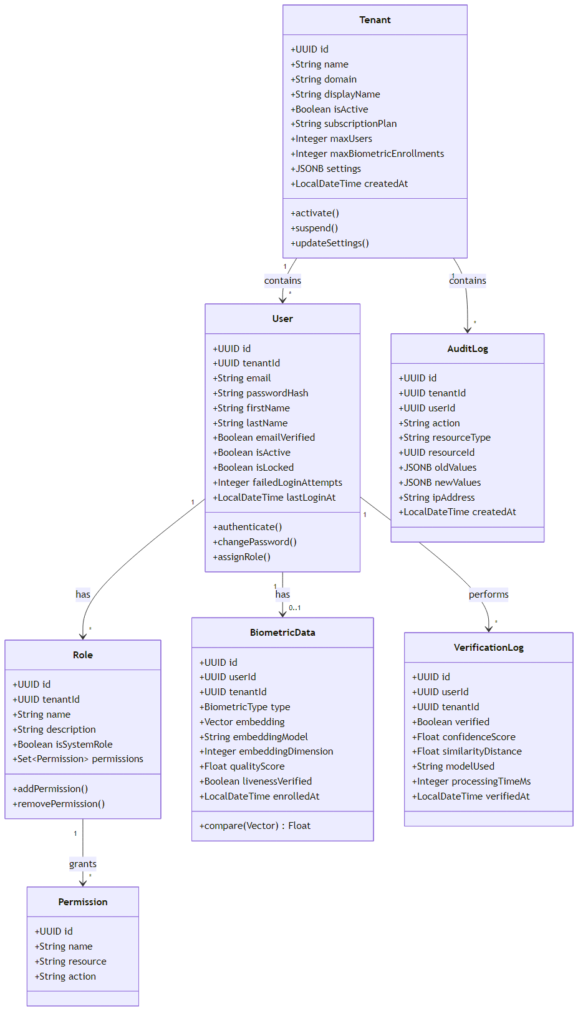
Figure 3.1 Core domain model for multi-tenant identity and biometric verification
At the persistence layer, the schema comprises 32 JPA entities materialized through 83 Flyway migrations spanning V0–V83 (the V13 number was never used; the highest applied in production is V83). The entity-relationship structure — users, tenants, roles/permissions/user_roles, the auth-flow tables (auth_flows, auth_flow_steps, auth_methods, tenant_auth_methods), refresh_tokens (hashed at rest with a rotation family_id for reuse detection per RFC 6749 §10.4), webauthn_credentials, nfc_cards, oauth2_clients, the verification pipeline tables, user_enrollments, voice_enrollments, the partitioned audit_logs, and the identity-linking tables (identities, identity_emails, identity_tenant_biometric_consent) — is shown in Figure 3.3. Two design choices in this schema are worth highlighting. First, the soft-delete pattern: User carries an @SQLDelete plus @SQLRestriction("deleted_at IS NULL"), so every derived finder automatically respects the GDPR retention window. Second, the dual face/voice embedding store lives not in the identity database but in the biometric processor's own pgvector schema (table face_embeddings), where the searchable plaintext vector and the Fernet-encrypted store-of-record sit side by side; the identity service reaches it only through a thin REST client.
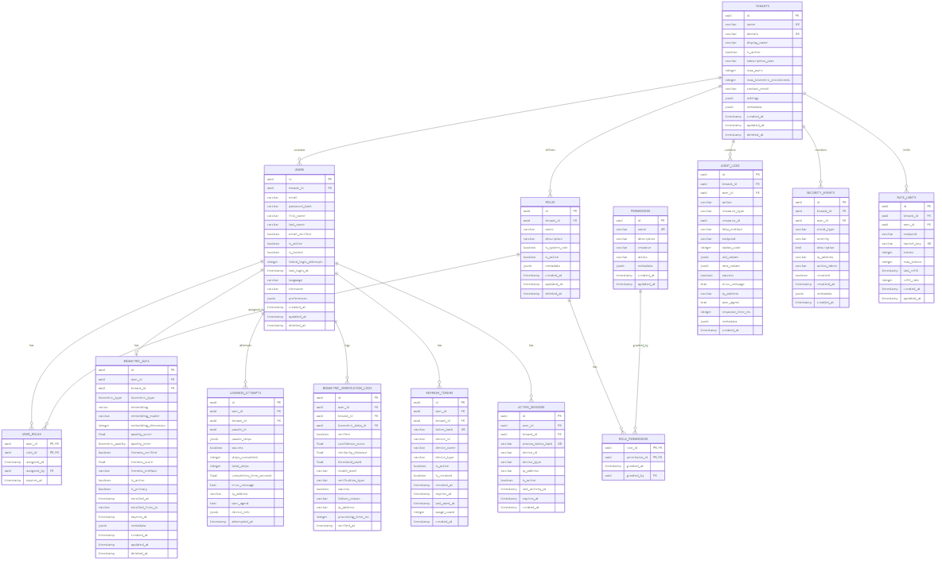
Figure 3.1 Entity-relationship diagram of the FIVUCSAS schema
    - User Interface Design
The platform is operated through four distinct surfaces — a web admin dashboard, a hosted login page, embeddable widgets, and native mobile/desktop clients — that all share a common authentication engine and internationalization layer.
Web admin dashboard (`app.fivucsas.com`). Built with React 18.3, TypeScript 5.5, Material-UI v5, and InversifyJS dependency injection [5], the dashboard comprises roughly 38 page components organized into feature folders. Public routes handle the unauthenticated journey; everything else sits under a protected dashboard layout and is gated by role-aware route guards. The route map is summarized below.
Table 3.1 Principal web dashboard routes
Route | Page | Purpose
/login, /register, /forgot-password | Auth pages | Identifier-first authentication, registration, recovery
/onboarding, /accept-invite | Onboarding | Self-service tenant signup; guest-invitation acceptance
/dashboard | Dashboard | Analytics overview, enrollment and verification trends
/users, /tenants, /roles | Admin CRUD | User, tenant, and role management (tenant scope vs. platform scope)
/auth-flows | Auth-Flow Builder | Layered, drag-to-compose login flows per tenant
/enrollment, /enrollments, /biometric-tools | Biometric | Guided capture, enrollment records, consolidated biometric utilities
/biometric-puzzles, /auth-methods-testing | Liveness / testing | Active-liveness challenge testing; per-method auth testing
/verification-flows, /verification-dashboard | KYC pipeline | Industry-template builder and verification session review
/audit-logs, /analytics | Compliance | Searchable audit trail; usage analytics
/my-profile, /settings | Self-service | Enrollments, activity, KVKK/GDPR export, linked accounts, biometric consent
The Auth-Flow Builder deserves special note: it lets a tenant administrator model a login flow as an ordered list of layers, each a checkbox set of allowed methods with a "satisfy any one" semantics and a "required" toggle, persisting as an authMethodType plus alternativeMethodTypes wire contract. This is the user-facing manifestation of the adaptive-MFA engine. The dashboard is a progressive web app whose shell is served network-first so that it remains usable under flaky connectivity.
Hosted login (`verify.fivucsas.com`). Following the 2026-04 "hosted-first" decision, the primary integration mode is redirective OIDC, mirroring Auth0 Universal Login, Okta, Microsoft Entra, Keycloak, and Türkiye's e-Devlet [26,27]. A third-party application calls the SDK's loginRedirect(...), the browser navigates top-level to the hosted page, the user completes whatever MFA the tenant configured, and the browser returns to the application with an authorization code. The hosted page resolves the UI locale and fetches the tenant's branding and login configuration before first paint to avoid a password-first to identifier-first flash, frame-busts to defeat clickjacking, and validates the redirect scheme again before navigating back. Top-level context was chosen deliberately because it is required for Web NFC, WebAuthn, and password-manager autofill, and is robust against Safari's tracking prevention and third-party-cookie deprecation. The embeddable iframe widget, distributed as the zero-dependency @fivucsas/auth-js SDK and the @fivucsas/auth-elements web component, is demoted to inline step-up MFA only.
Mobile and desktop clients. The Android application is the one fully delivered, publicly distributed native client (latest signed release v5.3.0). Rather than a thin OAuth shell, it is a full native client: native password plus adaptive MFA across all methods, on-device NFC document reading and card enrollment, CameraX/ML-Kit biometric capture, cross-device session and approval handling, and a standalone RFC 6238 TOTP authenticator with hardware-Keystore-protected secrets. The desktop client (Windows and Linux, shipped as .deb and .msi installers) is an OAuth-loopback client with OS-native secure token storage (DPAPI on Windows, libsecret on Linux) and two modes — an admin dashboard and a self-service kiosk. The principal mobile screens are summarized below.
Table 3.1 Principal Android client screens
Screen | Purpose
Login / Register | Native identifier-first authentication and account creation
MFA Flow | Adaptive multi-step second factors across all enrolled methods
Home / Account | Profile, enrollment status, linked accounts
Enroll | Guided face capture with quality feedback and liveness
Verify | Real-time face verification with on-device feedback
NFC / Card | Contactless document reading and card enrollment
TOTP Authenticator | Standalone RFC 6238 code generator
Two qualifications keep the delivery picture accurate. The iOS target is not delivered: the shared module declares iOS targets and an iosMain source set, but it consists of stubs (the TOTP HMAC implementation throws a TODO), and there is no shippable iosApp module, so iOS remains Phase-2 work blocked on Apple Developer enrollment. macOS is out of scope for lack of code-signing capability. Both statuses are tracked in the client-apps parity matrix and revisited in Chapter 7.
The enrollment and verification surfaces are supported by the activity flows captured in Figure 3.4 and Figure 3.5, and the end-user registration journey in Figure 3.6.
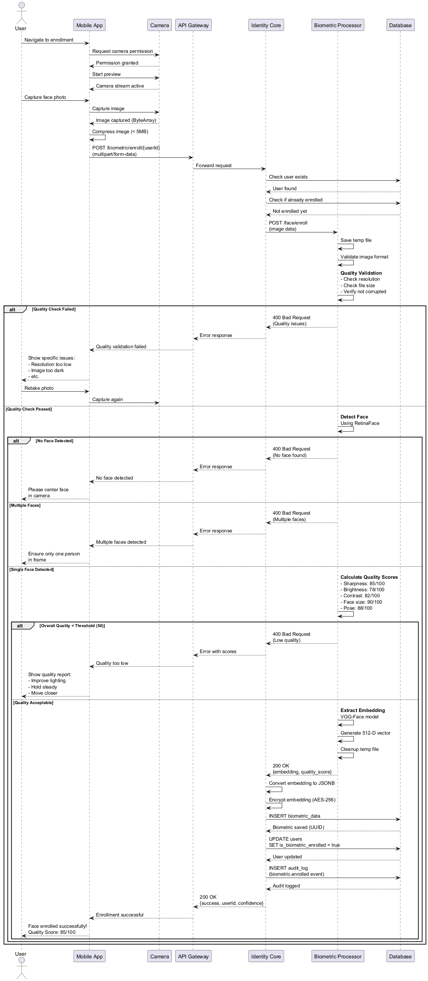
Figure 3.1 Face enrollment with quality assessment
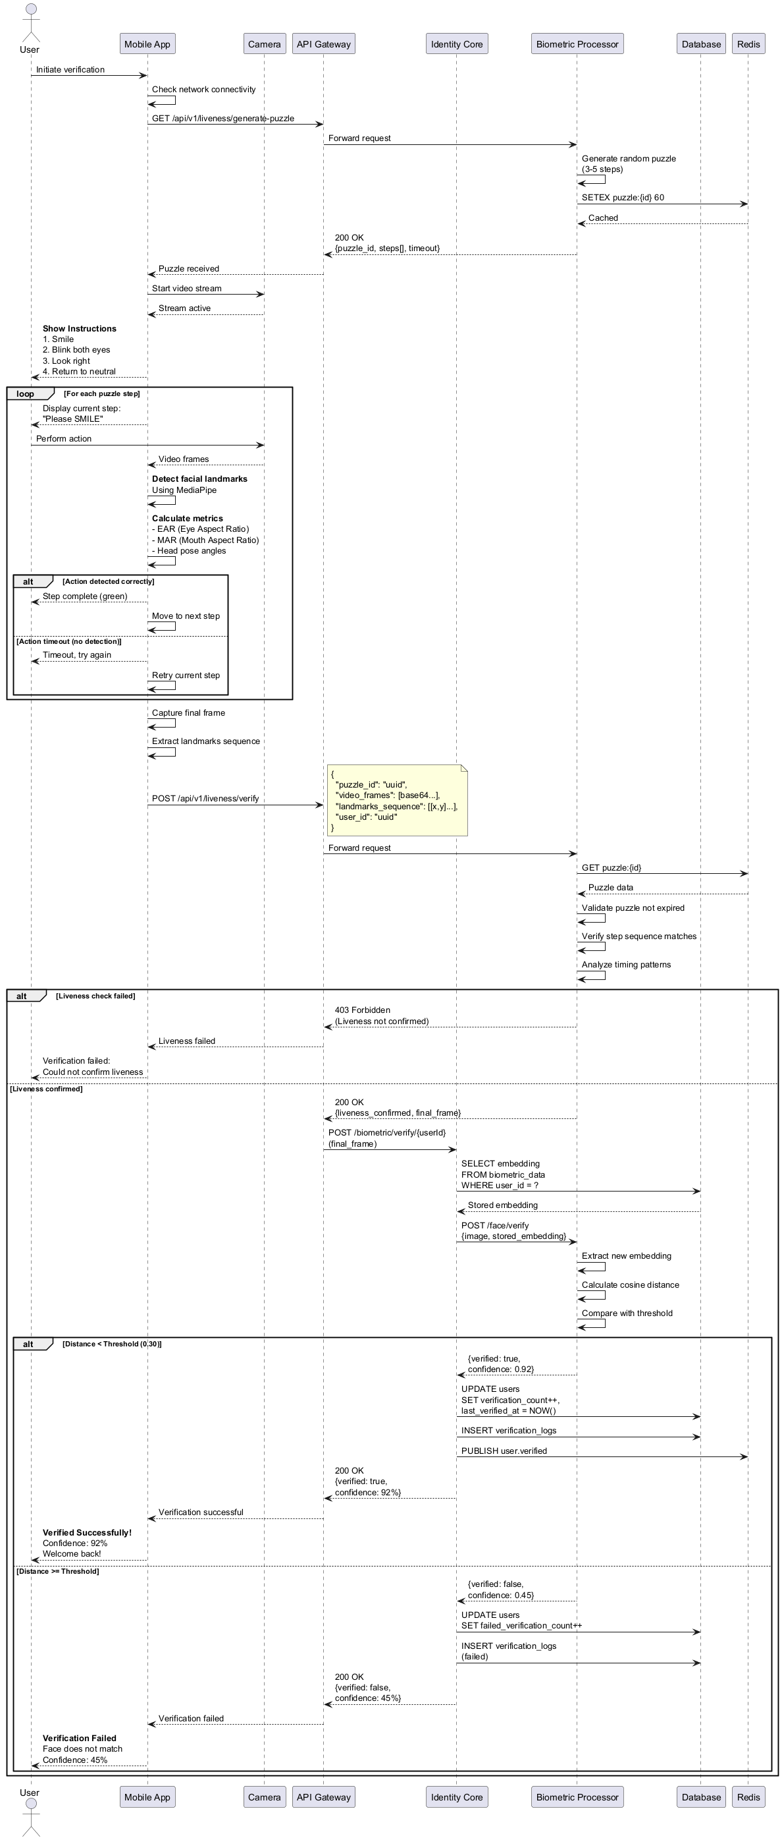
Figure 3.1 Face verification with liveness
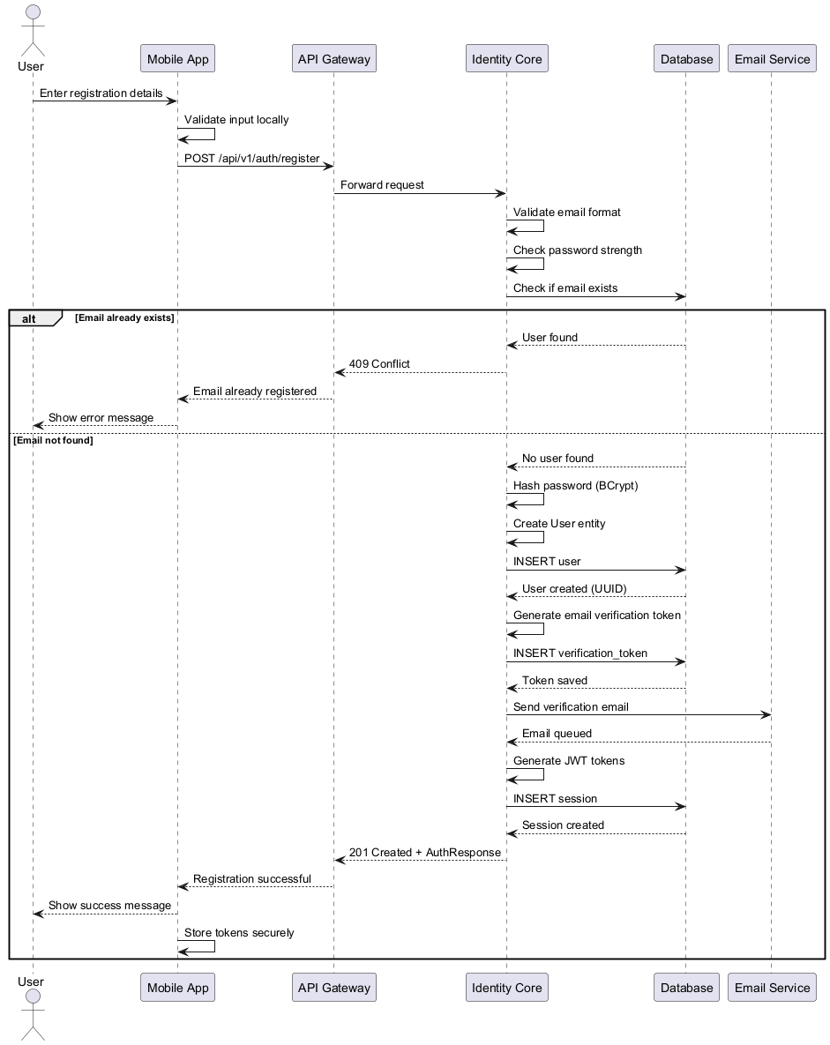
Figure 3.1 User registration sequence
    - Test Plan
Testing followed a multi-layered strategy spanning unit, integration, end-to-end, performance, and security levels, with a deliberate emphasis on the invariants that matter most for a biometric SaaS: multi-tenant isolation and liveness/anti-spoofing behavior. The strategy and its tooling are summarized below.
Table 3.1 Test strategy by level
Test level | Scope | Tools
Unit | Individual classes and functions | JUnit 5, pytest, Vitest
Integration | Service interactions, database, cache | Testcontainers, pytest
End-to-end | Full user journeys | Playwright
Performance | Load, stress, spike | Grafana k6
Security | SAST, secrets, dependency, isolation | Bandit, pip-audit, gitleaks, Dependabot, isolation ITs
Representative test cases were specified per service and traced to expected HTTP outcomes — for example TC-AUTH-001 (valid login → 200 with tokens), TC-AUTH-003 (locked account → 423), TC-RBAC-002 (insufficient permissions → 403), TC-TENANT-001 (cross-tenant access denied), and on the biometric side TC-BIO-006/TC-BIO-007 (matching vs. non-matching faces around the threshold) and TC-LIVE-003 (static-photo attack → spoof detected). The realized test inventory grew well beyond the early estimates, reaching roughly 4,400 authored automated test cases across the five test technologies in use. The summary below previews that inventory; Chapter 5 reports the same figures with the counting methodology that produced them.
Table 3.1 Authored automated test inventory
Module | Tool | Files | Authored test cases
Identity Core API | JUnit 5 | 176 | 1,569 (+22 parameterized)
Web dashboard (unit) | Vitest | 105 | 1,025
Web dashboard (E2E) | Playwright | 28 | 336
Mobile/desktop clients | Kotlin/JUnit | 64 | 568
Biometric processor | pytest | 68 | 888
Total |  | 441 | ≈ 4,386
A word on what these counts do and do not include. The figure is the number of authored test cases, not the number that run on every commit: the heaviest machine-learning and Testcontainers integration tests are environment-gated and run inside the dedicated Docker ML and integration stacks rather than on the lightweight CI runners. Chapter 5 reconciles this magnitude with the earlier "~1,800" summary figure that predates later test growth; here we simply note the scale. The security-critical isolation integration tests (CrossTenantIsolationIT, TenantSwitcherIsolationIT, IdentityBiometricConsentIT, and two backfill ITs) are not merely required but asserted to have executed — the continuous-integration job parses the Surefire XML so that a silently skipped isolation test fails the build rather than passing it by omission. The full experimental results, including the anti-spoofing evaluation, appear in Chapter 5.
  - Software Architecture
With the requirements, the design artifacts, and the test plan now in place, we turn to the architecture that realizes them. FIVUCSAS is a cloud-native platform that decouples administrative identity management from compute-intensive machine learning, so that each can scale and evolve on its own terms. This section describes the architectural style, the components, the data architecture, and the deployment topology as actually built.
    - Architectural Style
The system combines two complementary styles. At the macro level it is a microservices architecture [32,33]: a Spring Boot Identity Core API owns all identity, authentication, authorization, OAuth2/OIDC, and tenant logic, while a separate FastAPI Biometric Processor owns all face/voice/liveness/document machine learning [4]. The two communicate over REST secured by an X-API-Key, and the biometric service has no public route at all — it is reachable only on the internal Docker network, and the identity service is its sole caller. This split lets the stateless API tier and the heavy ML tier be sized, restarted, and scaled independently, and it confines GPU-class dependencies to a single service.
At the micro level, each service is built with Hexagonal Architecture (Ports and Adapters) [31]. The domain layer holds pure business logic and value objects; the application layer defines several dozen inbound use-case ports and outbound infrastructure ports, implemented by the service classes that carry the business logic; and the infrastructure layer supplies the adapters that fulfill the outbound ports — Spring Data repositories, the Redis cache, the biometric REST client, SMTP, and SMS gateways among them. The 29 REST controllers are themselves inbound web adapters. The dependency direction always points inward, so the database, the ML models, and the message bus are all swappable details rather than load-bearing assumptions, and the Strategy/Registry pattern for login methods, MFA steps, and verification steps reduces adding a new factor to registering one more handler. The high-level architecture is shown in Figure 3.7.

Figure 3.1 High-level system architecture overview
    - Component Architecture
The platform's components are layered from client to data. Clients — the React dashboard, the hosted-login SPA, the Kotlin Multiplatform mobile and desktop apps, and third-party OIDC integrations — speak to the backend over HTTPS. The Traefik v3 edge terminates TLS and routes by host. The Identity Core API is the system's spine, exposing 29 controllers covering authentication, MFA, OAuth2/OIDC, WebAuthn/passkeys, NFC/eMRTD, biometrics (as a proxy), the KYC verification pipeline, identity linking, tenant and RBAC administration, and compliance. The Biometric Processor exposes 26 route modules and roughly 69 endpoints covering enrollment, 1:1 verification, 1:N search, passive and active (Biometric Puzzle) liveness, quality assessment, voice, NFC/eMRTD passive authentication, and proctoring. The component decomposition is shown in Figure 3.8.
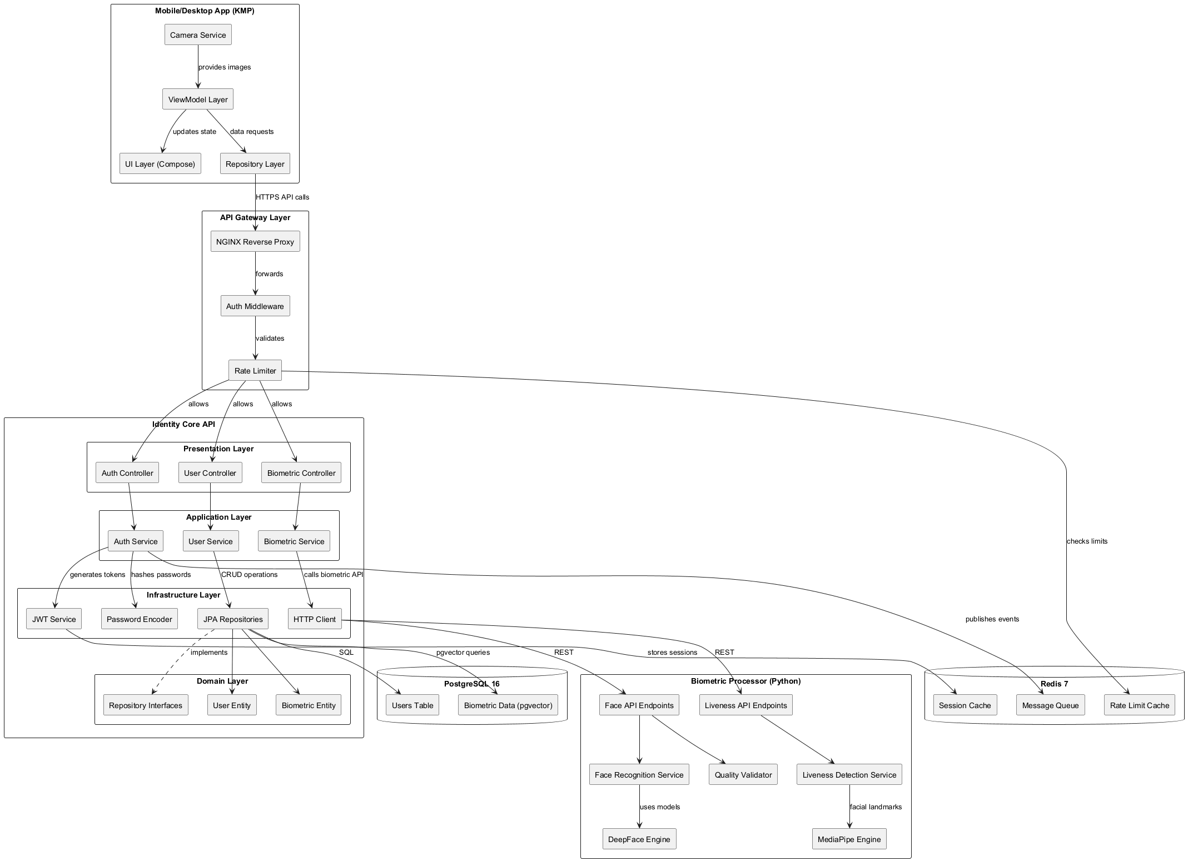
Figure 3.1 System component diagram
Within the identity service, the security subsystem is dense and layered: a filter chain (RequestIdFilter, JwtAuthenticationFilter, TenantContextFilter, TenantBindFromAuthFilter, AntiReplayFilter) precedes method-level RBAC, and two rate-limiting layers (a Redis sliding-window RateLimitFilter and a Bucket4j token-bucket RateLimitService [23]) protect the API. Within the biometric service, a LivenessDetectorFactory selects among texture, enhanced, and UniFace backends, an AntispoofPipelineAssembler orchestrates the three-layer anti-spoofing pipeline (usability gate, device-risk evaluator, hybrid fusion) in fail-soft mode, and the spoof-detection algorithms themselves live in a separate spoof-detector library that the processor merely imports and wires.
    - Data Architecture
The data tier is a single shared PostgreSQL 17 instance with the pgvector extension [7,8] and a single shared Redis 7.4 instance, both running on the VPS. Postgres hosts two logical databases: identity_core for the IAM schema and biometric_db for the pgvector embedding store. The multi-tenancy strategy is shared-database, shared-schema with a tenant_id discriminator, isolated at the application layer by the Hibernate @Filter mechanism described earlier. (PostgreSQL row-level-security policies authored in early migrations were found inert in production; the operative isolation is the Hibernate filter plus the JWT-rebound tenant context, examined in detail in §4.8.)
Schema evolution is managed by Flyway across V0–V83 [9]. The vector search surface is an IVFFlat index using vector_cosine_ops with lists = 100 over the 512-dimensional Facenet512 embeddings; voice enrollments use the same index family over 256-dimensional embeddings, and the log-only client-geometry observations carry no ANN index at all, consistent with the decision that the browser-side embedding is recorded for offline analysis but never used to make an authentication decision. Embeddings are stored twice — as a searchable plaintext vector and as a Fernet-encrypted ciphertext store-of-record with a key_version column for rotation.
Redis is far more than a read cache; it is the platform's distributed-coordination backbone. It holds single-use OAuth2 authorization codes (10-minute TTL), email/SMS OTPs (5 minutes) with per-OTP attempt counters, TOTP used-code replay markers (SET … EX 120 NX), QR and approve-login cross-device sessions, step-up challenges, anti-replay nonces, rate-limit counters, and ShedLock distributed locks. Production Redis runs with AOF persistence and an LRU eviction policy. The caching strategy is summarized below.
Table 3.1 Redis key usage and TTLs
Purpose | Key prefix | TTL
OAuth2 authorization codes | oauth2:code: | 10 min (single-use)
Email/SMS OTP (+ attempts) | OTP key (+ :attempts) | 5 min
TOTP used-code replay marker | totp:used: | 120 s
QR cross-device session | QR session key | 5 min (approved 2 min)
Approve-login (number matching) | approve-login key | 2 min
Step-up ECDSA challenge | step-up key | 5 min
Anti-replay nonces | antireplay:nonce: | 5 min
HTTP rate-limit counters | rate_limit:<ip>:<path> | 1 min / 1 hr window
    - Deployment Architecture
The production system runs on a single Hetzner CX43 VPS (8 vCPU, 16 GB RAM, 150 GB disk, Ubuntu 24.04, Docker 29.3 / Compose v5.1), a deliberately CPU-only host — the constraint that drove the choice of CPU-safe models (MTCNN, Facenet512, UniFace MiniFASNet) and a boot-time ALLOW_HEAVY_ML=false gate that refuses GPU-only backends. The deployment topology is shown in Figure 3.9.
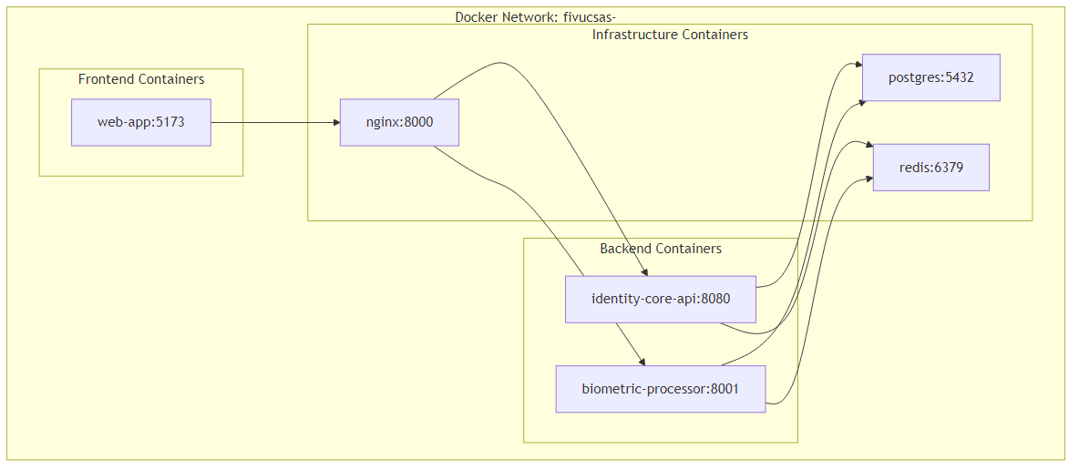
Figure 3.1 Docker Compose deployment topology
At the edge, Traefik v3.6.12 terminates TLS (Let's Encrypt) and routes by host via Docker labels, reading the Docker socket only through a hardened, read-scoped docker-socket-proxy [19,21]. This is the single most important deviation from the original design document, which anticipated an NGINX gateway: the running edge is Traefik v3, and the only NGINX on the host serves branded error pages and the static verify-widget SPA. Traefik enforces global secure-headers and rate-limit middleware, gates the administrative surfaces (/swagger-ui, /v3/api-docs, /actuator) behind an IP allowlist, and overwrites X-Forwarded-For with the real peer IP to close a rate-limit-bypass surface.
Containers are deployed via per-service production Compose files [20] wired onto shared external backend and proxy networks, with the shared PostgreSQL and Redis as singletons. Every application container runs hardened: read-only root filesystem, cap_drop: ALL, no-new-privileges, and resource limits (the identity API at 2 CPU / 2 GB, the biometric processor at 4 CPU / 4 GB). The biometric image is digest-pinned to a specific python:3.12-slim SHA with a frozen known-good constraints lock, because a floating-dependency rebuild once segfaulted the UniFace ONNX preload under that hardened runtime. The React and other static surfaces are deliberately not dockerized — they are deployed to Hostinger shared hosting by rsync, a standing rule that keeps the VPS focused on the stateful, security-sensitive services.
Continuous integration and delivery run through GitHub Actions, with most jobs on GitHub-hosted runners and a self-hosted runner on the CX43 reserved for the deploy jobs, which SSH in, pull, rebuild the affected service, and poll its /actuator/health until it is live. Observability that is actually running consists of Grafana, Loki, and Promtail for logs and Uptime Kuma for availability; a Prometheus/Alertmanager stack is configured but not yet deployed, a gap we revisit in Chapter 7. The complete CI/CD, monitoring, and load/security testing apparatus is detailed in Chapter 5.
- TECHNICAL APPROACH AND IMPLEMENTATION DETAILS
Chapter 3 described what FIVUCSAS is and how its parts fit together. This chapter descends one level deeper and reports how the system was actually built. We begin with the concrete tools we adopted and why, then the data structures that move biometric and identity data through the platform, and the algorithms we implemented (from the eye-aspect-ratio liveness test all the way to the OAuth 2.0 / OpenID Connect authorization-code exchange). From there we cover the operating-system and concurrency machinery that lets a single virtual machine serve many tenants safely, the network protocols that bind the services together, and finally the finite-state machines and multi-tenant isolation guarantees that keep one customer's data invisible to another. Every detail here was read from the production source tree at the time of writing; where an older planning document disagreed with the shipped code, we followed the code. The chapter is, in effect, a working synthesis of the undergraduate Computer Engineering curriculum — operating systems, computer networks, databases, distributed systems, and machine learning all appear in it not as topics but as load-bearing parts of a deployed service.
  - Hardware and Software Requirements and Tools
FIVUCSAS runs on a single Hetzner Cloud CX43 virtual private server: 8 virtual CPUs, 16 GB of RAM, 150 GB of disk, and Ubuntu 24.04. The instance has no GPU. That one fact shaped a surprising number of downstream decisions. Every machine-learning model in the pipeline was chosen to be CPU-safe, and a hard startup gate (ALLOW_HEAVY_ML=false) refuses to boot the biometric service with GPU-only backends such as RetinaFace, ArcFace, or YOLOv8-large, so that a careless configuration change can never silently degrade latency or crash the host. We treat the modest hardware budget as a design discipline rather than a limitation: a face-verification SaaS that performs acceptably on eight commodity cores is a far more reproducible and defensible artifact than one that quietly assumes an accelerator.
The platform is a polyglot microservice system, and each language and framework earns its place. The summary of the principal tools is given in the table below.
Table 4.1 Principal tools and frameworks, with the rationale for each choice
Layer | Tool / version | Why it was chosen
Identity service | Spring Boot 3.4.7 / Java 21 [3] | Mature security ecosystem (Spring Security 6.4), first-class JPA, records and virtual-thread-capable runtime; the natural home for transactional IAM logic
Biometric service | FastAPI / Python 3.12 [4] | Direct access to the Python ML ecosystem (DeepFace, MediaPipe, OpenCV, ONNX Runtime); async I/O and automatic OpenAPI generation
Web dashboard & hosted login | React 18.3 + TypeScript 5.5 [5] | Component model, strong typing, large ecosystem (MUI, React Router, react-hook-form, i18next) for an admin SPA and a hosted OIDC login page
Mobile & desktop clients | Kotlin Multiplatform + Compose [6] | One shared business-logic module compiled to Android, JVM desktop, and (planned) iOS; native NFC and biometric APIs where they matter
Relational + vector store | PostgreSQL 17 + pgvector [7,8] | One engine for both ACID identity data and high-dimensional embedding similarity search — no separate vector database to operate
Coordination / cache | Redis 7.4 [22] | Sub-millisecond store for OTPs, OAuth codes, rate-limit counters, distributed locks, and a pub/sub event bus
Edge / reverse proxy | Traefik v3.6.12 [21] | Automatic TLS via Let's Encrypt, Docker-label service discovery, file-provider middleware for security headers and IP allowlisting
Containerization | Docker + Docker Compose [19] | Reproducible, hardened (read_only rootfs, cap_drop: ALL), digest-pinned deployments across all backend services
DB migrations | Flyway [9] | Versioned, repeatable schema evolution (V0–V83) checked into source control
Three details need clarifying, because earlier planning documents pointed elsewhere and we followed the shipped reality. First, the production edge is Traefik v3, not NGINX. The "API gateway" described in the original analysis document was a development-era plan, and the only NGINX on the host serves branded error pages and the static login SPA. Second, the mobile and desktop clients are Kotlin Multiplatform, not Flutter as the specification originally proposed; Compose Multiplatform let us share a single domain layer across Android and desktop and reuse native security primitives such as Android Credential Manager for FIDO2 and the OS keystore for token storage. Third, on the modeling side, the face recognizer in production is Facenet512 producing 512-dimensional embeddings, not the 2622-dimensional VGG-Face embedding sketched in the specification. We found Facenet512 to be both lighter on CPU and more than adequate at the verification thresholds we operate at.
Developer tooling and standards round out the picture: IntelliJ IDEA and PyCharm for the backends, VS Code for the front ends, Git/GitHub for version control with branch protection and pull-request review, Maven for the Java build and Gradle for the Kotlin clients, and a GitHub Actions continuous-integration pipeline (covered in Chapter 5) that gates every merge on roughly 4,400 automated tests across five test technologies.
  - Data Structures
A multi-tenant biometric platform lives or dies by the data structures it chooses, because the same byte of data (a face embedding, a one-time code, a refresh token) must be cheap to write, fast to search, and impossible to leak across a tenant boundary. We describe the ones that carry the most weight.
Dense embedding vectors. The central biometric data structure is a fixed-length vector of 32-bit floats. A face embedding is a vector(512) produced by Facenet512; a voice embedding is a 256-dimensional Resemblyzer speaker vector; the client-side geometry "embedding" is a 128-dimensional landmark-distance vector that is recorded for offline analysis but, by the D2 design decision, never used to make an authentication decision. All of these are stored in PostgreSQL columns of pgvector's native vector type, which is what makes approximate-nearest-neighbour search possible inside the relational database itself. A small but important refinement is that the face store is dual-column: the plaintext embedding column is the searchable index surface, while an embedding_ciphertext column holds the same vector encrypted with Fernet (AES-128-CBC + HMAC-SHA-256) under a versioned key (key_version) so that biometric templates are protected at rest and the key can be rotated without re-enrolling every user. Voice enrollments additionally maintain a centroid — AVG(embedding)::vector over a user's individual enrollments — so that verification compares a probe against a quality-weighted average rather than a single noisy sample.
Token buckets. Rate limiting is implemented with the classic token-bucket data structure via the Bucket4j library [23]. Each rate-limit purpose (login, MFA step, biometric call, GDPR export, per-tenant token minting) is a bucket with a capacity and a refill rate; a request consumes a token and is rejected with HTTP 429 when the bucket is empty. The buckets are keyed by IP, user, or tenant in size-bounded concurrent maps (capped at 10,000 entries) that a scheduled sweep evicts every five minutes, so the structure cannot grow without limit under a flood of distinct keys.
Caches and ephemeral records in Redis. Short-lived security state is modeled as key/value records in Redis, each with a deliberately chosen time-to-live: OAuth 2.0 authorization codes (oauth2:code:, 10 minutes, single-use), email/SMS OTPs and their attempt counters (5 minutes), TOTP used-code replay markers (totp:used:, 120 seconds), QR cross-device sessions (5 minutes), number-matching approve-login sessions (2 minutes), step-up challenges (5 minutes), and anti-replay nonces (antireplay:nonce:, 5 minutes). Treating these as TTL-bounded records rather than rows in a relational table means they expire automatically, never need a cleanup job, and survive a service restart without leaving stale security tokens behind.
Domain value objects and DTOs. On the Java side the domain layer is built from rich value objects — Email, FullName, HashedPassword, PhoneNumber, IdNumber, NfcSerial, TenantId, UserId — that validate their own invariants at construction time, so an invalid email address or a malformed BCrypt hash can never enter the domain. These are mapped to and from request/response DTOs (application/dto/{command,query,response}) at the application boundary, keeping the wire format decoupled from the persistence model. The persistence model itself is 32 JPA @Entity classes; several use a deliberate state pattern (revokedAt/expiresAt timestamps on NfcCard and OAuth2Client) and one (RefreshToken) implements Spring Data's Persistable<UUID> with an explicit isNew() flag so that manually assigned UUID primary keys insert correctly rather than being mistaken for merge candidates.
Registries and handler maps. Both the login subsystem and the verification pipeline are organized around a strategy-plus-registry structure: a list of handler beans is injected and folded into a Map<AuthMethodType, Handler> (for login and MFA) or a Map<StepType, Handler> (for the KYC pipeline). Adding a new authentication factor is then a matter of adding one handler class; the dispatch map wires it automatically. This is the data structure that keeps the "ten-plus authentication methods" claim maintainable rather than a sprawling switch statement.
  - Algorithms
This section documents the algorithms we implemented, grouped by the problem each solves. Liveness and anti-spoofing are treated first because they are the project's research core; face matching, vector search, and quality assessment follow; and the security algorithms (JWT, RBAC, OAuth/OIDC, MFA) are gathered in Section 4.4.
    - Active Liveness Detection: the Biometric Puzzle
The signature contribution of FIVUCSAS is an active, challenge–response liveness test we call the Biometric Puzzle. Rather than passively guessing whether a face is real, the server issues a short, randomized sequence of physical actions — blink, smile, open mouth, raise eyebrows, turn left, turn right — and verifies that the subject actually performed them, in order, within tight time bounds. A printed photo cannot blink on cue; a pre-recorded video cannot satisfy a sequence it was never told in advance. This is the temporal, genuine-motion defense that the project specification promised, and it draws directly on the landmark-geometry approach of Soukupová and Čech [15] and on Google's MediaPipe Face Landmarker [14].
The server code lives in app/application/use_cases/generate_puzzle.py, active_liveness_manager.py, and verify_puzzle.py, exposed through /liveness/generate-puzzle, /liveness/verify, and /liveness/verify-challenge. Face geometry is scored against MediaPipe's 478-point landmark mesh (and, when available, its blendshape coefficients).
Randomized challenge sequence. GeneratePuzzleUseCase builds each puzzle freshly with random.randint and random.choice. A difficulty configuration controls both the number of steps and the per-step deadline: EASY is 2–3 steps at 7.0 s each, STANDARD 3–4 steps at 5.0 s, and HARD 4–5 steps at 4.0 s. Two anti-pattern rules harden the randomization against prediction and against impossible physical demands: incompatible adjacent pairs such as (TURN_LEFT, TURN_RIGHT) are forbidden from immediately following one another, and the same action is never repeated twice in a row. Each generated puzzle is persisted with a time-to-live of timeout_seconds + 60, so a stale puzzle cannot be replayed.
Eye Aspect Ratio (EAR) for blink. Blink detection uses the Eye Aspect Ratio over the six MediaPipe eye landmarks (left [362, 385, 387, 263, 373, 380], right [33, 160, 158, 133, 153, 144]). The EAR is the ratio of the average of the two vertical eyelid distances to the horizontal eye width:
Eye Aspect Ratio (EAR) (Equation 4.1)
$$\text{EAR} = \frac{\lVert p_2 - p_6 \rVert + \lVert p_3 - p_5 \rVert}{2\,\lVert p_1 - p_4 \rVert}$$
When the eye is open the EAR sits near its baseline; when it closes the numerator collapses and the EAR drops sharply. We capture a baseline while avg_ear > 0.2 and register a blink as the falling-then-rising transition through the threshold ear_threshold = 0.21. The real implementation is faithful to the formula above:
def _calculate_ear(self, points, eye_indices):
p1 = np.array(points[eye_indices[0]]); p4 = np.array(points[eye_indices[3]])
p2 = np.array(points[eye_indices[1]]); p6 = np.array(points[eye_indices[5]])
p3 = np.array(points[eye_indices[2]]); p5 = np.array(points[eye_indices[4]])
vertical_1 = np.linalg.norm(p2 - p6)
vertical_2 = np.linalg.norm(p3 - p5)
horizontal = np.linalg.norm(p1 - p4)
if horizontal == 0:
return 0.0
return float((vertical_1 + vertical_2) / (2.0 * horizontal))
Mouth Aspect Ratio (MAR) for smile and open-mouth. The mouth signal is the ratio of vertical lip opening to mouth width over four landmarks (corners 61 and 291, upper-lip center 13, lower-lip center 14):
Mouth Aspect Ratio (MAR) (Equation 4.2)
$$\text{MAR} = \frac{\lVert \text{lower\_lip} - \text{upper\_lip} \rVert}{\lVert \text{right\_corner} - \text{left\_corner} \rVert}$$
A smile fires when MAR > 0.4 and the smile ratio (current MAR over the captured baseline MAR) exceeds 1.3 — the second condition guards against people whose neutral mouth already reads wide. An open-mouth action fires at MAR > 0.5.
Head pose for the turn challenges. Yaw is approximated geometrically from the horizontal offset of the nose tip (landmark 1) relative to the midpoint of the two ear landmarks (234 and 454): a deviation greater than 0.15 is a left turn, less than -0.15 a right turn. Eyebrow-raise uses the brow-to-eye vertical distance against a 0.08 threshold. When MediaPipe blendshapes are present we prefer them directly (eyeBlinkLeft/Right > 0.5, mouthSmileLeft/Right > 0.4, jawOpen > 0.4, brow blendshapes > 0.3), which is both more robust and cheaper than re-deriving geometry.
Scoring and anti-replay. VerifyPuzzleUseCase requires each step to clear MIN_STEP_CONFIDENCE = 0.6 and last at least MIN_STEP_DURATION_SECONDS = 0.5, and the overall pass threshold is 60% (PASS_THRESHOLD = 0.6). Replay is blocked on several axes at once: timestamps must be monotonically increasing (with a 100 ms tolerance), the puzzle must still exist and not be expired, an already-completed puzzle is rejected, and a capped number of submitted frames are re-run through passive liveness as a spot-check. A deliberately lightweight /verify-challenge endpoint exists for the browser training surface, with relaxed structural-only bounds, precisely so that the React puzzle component cannot be made to "pass" on the client alone; the authoritative verdict is always the server's. At heart this is a small finite-state and signal-detection algorithm in which a randomized challenge, a set of geometric thresholds, and a strict temporal budget combine to make genuine, on-cue human motion the only thing that can satisfy it.
    - Passive Anti-Spoofing
Active challenges are powerful but they ask something of the user; passive anti-spoofing runs silently on a single frame and is therefore always-on. FIVUCSAS layers several passive detectors. In production the authoritative one is UniFace MiniFASNet [16], a compact convolutional anti-spoofing network run through ONNX Runtime on CPU (LIVENESS_BACKEND=uniface, LIVENESS_MODE=passive). Because loading the ONNX model is expensive and the runtime is hardened (read_only rootfs, dropped capabilities), the service shares one process-wide ONNX session (_get_shared_minifasnet()) across requests rather than reloading per call.
Alongside the neural detector, a classical computer-vision detector (TextureLivenessDetector) computes interpretable cues with no network at all [47]: texture energy as the variance of the Laplacian (a printed photo is flatter than live skin), color distribution naturalness, a frequency-domain analysis, and a moiré-pattern score that catches the interference fringes a camera produces when it photographs a screen. These are fused linearly, score = 0.35·texture + 0.25·color + 0.25·frequency + 0.15·moiré, and the frame is judged live when the combined score clears the threshold.
The full research stack lives in the standalone spoof-detector library (deployed for in-browser experimentation at amispoof.fivucsas.com), where thirteen Python analyzers — and twenty-five in the TypeScript browser port — feed a HybridFusionEvaluator that weights MiniFASNet against flash-reflection, moiré, and device-replay signals with a decision threshold of 0.45, and a multi-class fuser that classifies an attack into a taxonomy (STATIC_IMAGE, VIDEO_REPLAY, MASK_3D, HEAVY_MAKEUP, AR_FILTER, DEEPFAKE_INJECT). The library also implements the ISO/IEC 30107-3 presentation-attack metrics — APCER, BPCER, and ACER [35] — that Chapter 5 uses to report evaluation results. An important design property is that the anti-spoofing pipeline is fail-soft: every layer is wrapped in exception handling so a bug in a detector can never hard-block a legitimate user by crashing; it can only decline to add evidence.
The way this wires into authentication is precise. On /verify (and, since the 2026-05 hardening, on /enroll) the server runs a mandatory passive-liveness gate first: if the frame is judged not-live, or its liveness score is below 0.4, the request is rejected with HTTP 400 LIVENESS_FAILED before any matching happens. A single-frame EAR veto (both eyes closed at threshold 0.18 is a photo signal) and the optional anti-spoof pipeline layers can additionally escalate to HTTP 403 ANTISPOOF_BLOCKED when block enforcement is on. Multi-image enrollment is fail-closed: a single non-live frame rejects the whole batch.
    - Face Embedding and Similarity Matching
Face verification is one-shot metric learning [11]. Rather than training a classifier per user, we map every face into a 512-dimensional vector with Facenet512 via the DeepFace library [12], after detecting and aligning the face server-side with MTCNN [10,50]. Two faces belong to the same person when their embeddings are close in this space; recognition reduces to a distance comparison.
We measure closeness with cosine distance on L2-normalized embeddings. Cosine similarity is the dot product of the unit vectors, and we work in the complementary distance so that zero means identical:
Cosine distance for face matching (Equation 4.3)
$$d_{\cos}(A, B) = 1 - \frac{A \cdot B}{\lVert A \rVert \, \lVert B \rVert}$$
The implementation normalizes both vectors, takes their dot product, and clamps the result to handle floating-point noise:
emb1_norm = self._l2_normalize(embedding1)
emb2_norm = self._l2_normalize(embedding2)
cosine_similarity = np.dot(emb1_norm, emb2_norm)
cosine_distance = np.clip(1.0 - cosine_similarity, 0.0, 1.0)
A probe matches when the distance falls below a threshold — a lower threshold is stricter. Production uses VERIFICATION_THRESHOLD = 0.4. Two refinements are worth spelling out. First, because biometrics drift with age, an adaptive threshold loosens the gate to 0.55 for stored templates older than two years (VERIFICATION_THRESHOLD_AGED), and a configuration validator enforces that the aged threshold is never stricter than the standard one — a guard added after an earlier inversion bug. Second, the comparator is deliberately consistent across modalities but with the correct polarity in each: face verify uses cosine distance with a < test, while voice verify uses cosine similarity with a >= 0.65 test, and the two must not be confused.
    - 1:N Identification with pgvector
Verification answers "is this the person they claim to be?" (1:1). Identification answers "who is this, out of everyone enrolled?" (1:N), and naively that means comparing the probe against every stored embedding — linear in the size of the gallery. We avoid that cost by pushing the search into the database with pgvector [8], which adds a native vector type and approximate-nearest-neighbour (ANN) index to PostgreSQL. The 1:N face search endpoint (/search) issues a query using pgvector's cosine-distance operator <=>, and the database returns the closest matches without a full scan.
The production index is an IVFFlat index built with vector_cosine_ops and lists = 100 (CREATE INDEX … USING ivfflat (embedding vector_cosine_ops) WITH (lists = 100)). IVFFlat partitions the vector space into clusters at build time and probes only the nearest clusters at query time, trading a controllable amount of recall for a large speed-up — the same inverted-file idea that underlies GPU ANN systems such as FAISS [49], here available inside the relational store we already operate. (An HNSW variant exists in the migrations only as a commented-out alternative; the operative production index is IVFFlat.) Every search is tenant-scoped: the query is constrained to the caller's tenant and a server-side cap bounds the maximum acceptable distance, so identification can never reach across a tenant boundary. This is where databases and machine learning meet in the platform — classical index theory applied to high-dimensional learned features — and it is what makes 1:N identification fast enough to run inside the same transactional store that holds the identity data.
    - Image Quality Assessment
Garbage in, garbage out: a blurred or badly lit face produces an unreliable embedding, so every enrollment and verification frame passes a quality gate first (quality_assessor.py). The overall quality score on a 0–100 scale is a weighted sum of three sub-scores — blur, lighting, and face size:
Composite image-quality score (Equation 4.4)
$$Q = 0.4 \cdot \text{blur} + 0.3 \cdot \text{lighting} + 0.3 \cdot \text{face\_size}$$
Blur is measured as the variance of the Laplacian (sharp images have high-frequency content and thus high variance); lighting is mean brightness; face size scores how much of the frame the face occupies. A best-effort head-pose penalty multiplies the score by 0.7 when the estimated yaw exceeds 30° or pitch exceeds 25°, and a frame with Laplacian variance below 5 (essentially unusable) is hard-rejected outright. The operational thresholds are tuned to admit real-world webcam frames without admitting junk: enrollment uses a floor of 40 and verification an even more lenient 50, values arrived at empirically because over-strict gating frustrated genuine users far more than it stopped attackers.
  - Authentication, Authorization and Security
If liveness is the project's research heart, the identity service is its engineering heart. This section documents the cryptographic and protocol-level algorithms that make FIVUCSAS an authentication platform rather than a face-matching demo. The corresponding security architecture is shown in Figure 4.1.
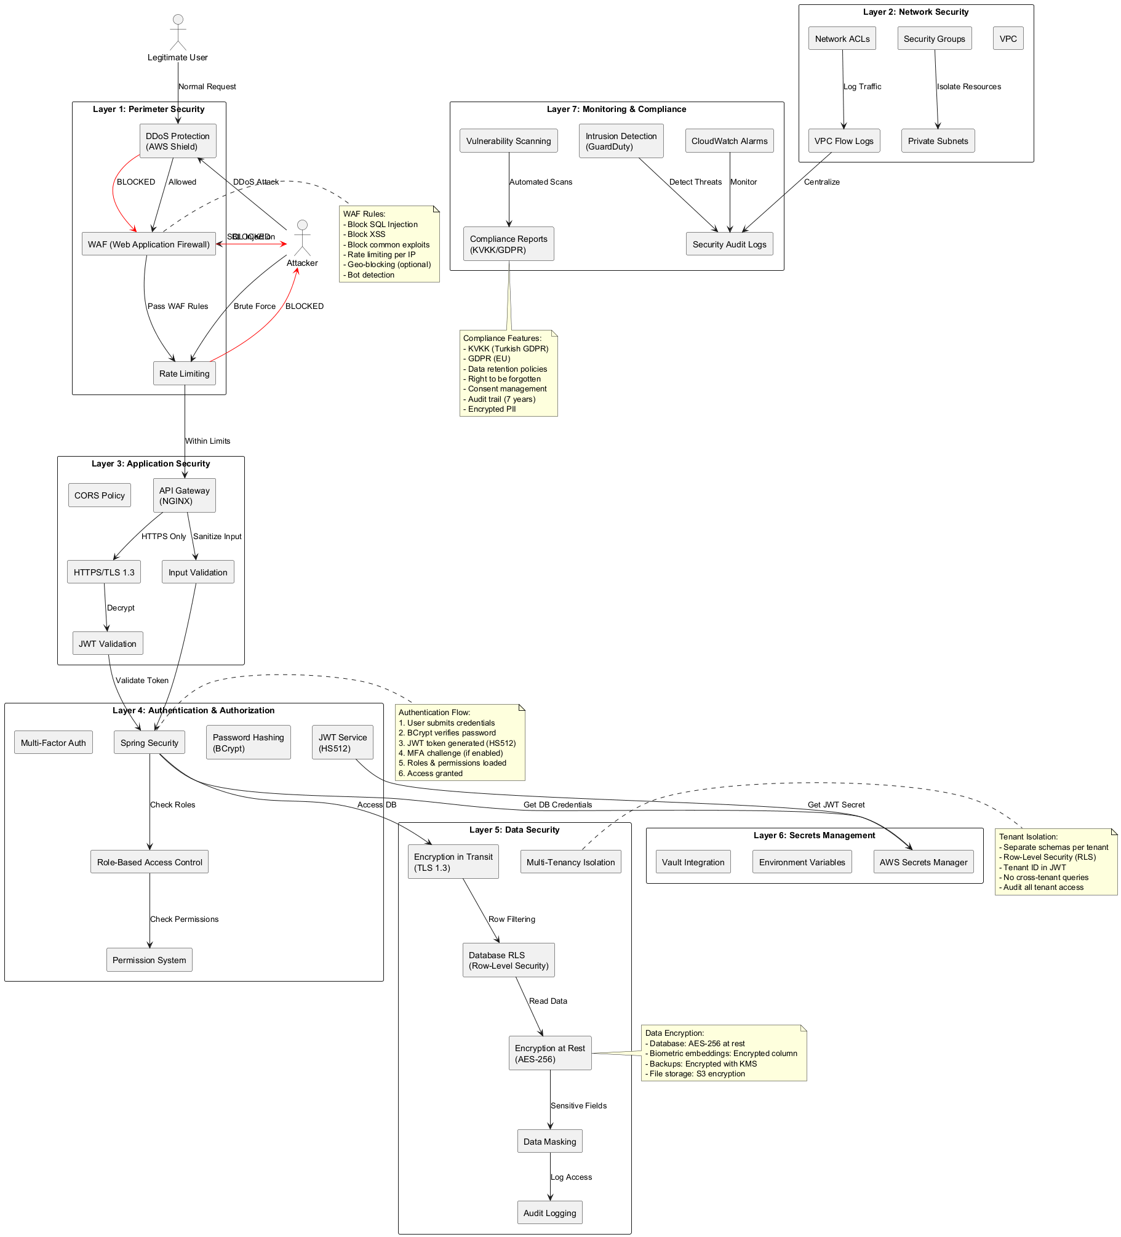
Figure 4.1 Security architecture: JWT signing/verification, RBAC, TLS termination, and layered rate limiting
    - JWT, RBAC and Password Security
Password storage. Passwords are hashed with BCrypt at work factor 12 [25] (new BCryptPasswordEncoder(12)), an adaptive, salted scheme whose cost can be raised as hardware improves. A HashedPassword value object validates the BCrypt format, a PasswordHistory entity prevents reuse, and invite/temporary passwords are generated from a SecureRandom source.
JSON Web Tokens. Access tokens are JWTs [24] minted by JwtService (jjwt 0.12.6). The service supports two signing algorithms side by side: a legacy symmetric HS512 and an asymmetric RS256 used for OIDC. Production pins RS256 and a @PostConstruct check fails fast at boot if the production profile is active but the algorithm is not RS256. Because a historical HS512 secret once leaked, HS512 verification is off by default — any HS512-tagged token is rejected unless an operator explicitly opens a rollback window — and a kid (key-id) revocation list provides defense in depth. A Locator<Key> reads the JWS kid header and routes verification to the matching key, rejecting unsigned tokens and unknown or algorithm-mismatched key ids, which closes the classic algorithm-confusion forgery class. Access tokens live 15 minutes in production and carry iss and aud claims that the parser requires; refresh tokens live 24 hours. Crucially, the token records how the user authenticated: following RFC 8176, VerifyMfaStepService accumulates an `amr` (authentication methods reference) array — pwd, otp, sms, face, voice, hwk, and so on — so a relying party can see that genuine multi-factor authentication occurred, not just that a token exists.
Role-Based Access Control. Authorization is enforced with Spring's method security (@EnableMethodSecurity + @PreAuthorize) backed by a custom RbacPermissionEvaluator. The authority model is deliberately two-tier: a user_type platform tier (ROOT > TENANT_ADMIN > TENANT_MEMBER > GUEST) is the sole source of platform-level authority, while role is purely within-tenant RBAC across 48 fine-grained permissions. The former global SUPER_ADMIN was renamed ROOT and granted all permissions in a controlled migration. This separation is what lets a tenant administrator manage their own users without ever gaining visibility into another tenant, and it is enforced by the same @PreAuthorize checks on every controller method.
    - OAuth 2.0 / OpenID Connect and Hosted Login
FIVUCSAS is "hosted-first": the primary way a third-party application integrates is the redirective OpenID Connect authorization-code flow, the same pattern used by Auth0 Universal Login, Okta, Microsoft Entra, Keycloak, and Türkiye's e-Devlet. A tenant calls FivucsasAuth.loginRedirect(...), the browser navigates top-level to verify.fivucsas.com/login by way of /oauth2/authorize, the user completes MFA, and the browser returns to the tenant's redirect_uri with ?code=…&state=…, which the tenant exchanges at /oauth2/token. Choosing a top-level redirect over an embedded iframe was a deliberate response to real browser constraints — Web NFC, WebAuthn, password-manager autofill, Safari's Intelligent Tracking Prevention, and the death of third-party cookies all behave badly inside a frame. The OIDC discovery document (/.well-known/openid-configuration) and JWKS (/.well-known/jwks.json) are public so any standards-compliant client can self-configure.
The flow follows the relevant RFCs faithfully [26,27]. Authorization codes are single-use, stored in Redis under oauth2:code: with a 10-minute TTL, deleted on first exchange, and matched exactly against the registered redirect_uri and client_id. Confidential clients must present a valid client_secret at the token endpoint regardless of PKCE — PKCE is not a substitute for client authentication — and secret rotation is supported through a grace window. The userinfo endpoint rejects ID tokens to prevent token-type confusion.
Public clients (mobile apps, SPAs, desktop loopback clients) are protected by Proof Key for Code Exchange [28]. The client generates a random code_verifier, sends its SHA-256 hash as the code_challenge at authorization time, and presents the original verifier at token time; the server recomputes the hash and compares. The S256 method is mandatory for public clients (plain is rejected per RFC 7636 and RFC 8252). The verification follows the RFC's BASE64URL(SHA-256(code_verifier)) to the letter:
private boolean verifyCodeChallenge(String codeVerifier, String codeChallenge, String method) {
if ("S256".equalsIgnoreCase(method) || method.isEmpty()) {
MessageDigest digest = MessageDigest.getInstance("SHA-256");
byte[] hash = digest.digest(codeVerifier.getBytes(StandardCharsets.US_ASCII));
String computed = Base64.getUrlEncoder().withoutPadding().encodeToString(hash);
return codeChallenge.equals(computed);
} else if ("plain".equalsIgnoreCase(method)) {
return codeChallenge.equals(codeVerifier);
}
return false;
}
The matching JavaScript SDK generates PKCE in the browser with crypto.subtle.digest, stores the verifier/state/nonce in sessionStorage, validates state on return (CSRF defense) and the id_token nonce (OIDC replay defense), and refuses any redirect_uri that is not HTTPS, an RFC 8252 loopback, or a registered custom scheme — blocking javascript:, data:, and file: schemes outright.
    - Multi-Factor Authentication and Step-Up
Authentication in FIVUCSAS is not a single password check but an adaptive, multi-step engine. A tenant administrator composes a login flow as an ordered list of layers, where each layer is a set of acceptable methods plus a "required" flag (the SEQUENTIAL vs CHOICE step types — CHOICE means "satisfy any one of these"). The N-step flow is driven by POST /auth/mfa/step, and the JWT is withheld until every required layer is satisfied, at which point the accumulated amr claim records the full set of factors used. Ten-plus factors plug into this engine through the handler registry: PASSWORD, EMAIL_OTP, SMS_OTP, TOTP, FACE, VOICE, FINGERPRINT (delivered via WebAuthn platform authenticators), HARDWARE_KEY, QR_CODE, NFC_DOCUMENT, plus the cross-device additions PASSKEY (discoverable WebAuthn) and APPROVE_LOGIN (number matching).
Each factor carries its own anti-replay algorithm. TOTP (time-based one-time passwords) marks a verified (userId, timeStep) pair as consumed in Redis with an atomic SET key 1 EX 120 NX, so the same code cannot be replayed within its validity window, and the secret is encrypted at rest with AES-GCM-256. OTP codes store an attempt counter alongside the code and delete the code on a wrong guess, capping the brute-force budget. WebAuthn/passkeys [29] are validated with the Yubico library against an explicit origin allowlist, with manual rpIdHash (SHA-256) comparison and signCount monotonicity to detect cloned authenticators. Approve-login uses Redis-backed number matching where the match number is a zero-padded string and an unknown email returns a decoy session, so the endpoint reveals nothing about which accounts exist. Step-up re-authentication for sensitive operations uses an ECDSA signed-nonce device challenge with a 5-minute TTL. The same MfaStepRenderer component renders every factor's UI on both the dashboard and the hosted login page, so a new method appears on both surfaces at once.
  - Operating-System and Concurrency Details
A single eight-core VPS serving many tenants is, fundamentally, an exercise in the operating-systems curriculum: scheduling, mutual exclusion, idempotency, and the careful use of asynchronous I/O.
Asynchronous and synchronous concurrency. The biometric service is built on Python's async/await event loop under Uvicorn/Gunicorn: I/O-bound work (database round-trips, Redis calls) yields the loop so the service can interleave many in-flight requests on few OS threads, while CPU-bound model inference is dispatched so as not to stall the loop. The identity service uses Spring's thread-per-request model with @Async (AsyncConfig) for fire-and-forget work and a synchronous RestClient for its calls to the biometric service — a deliberate choice, because the verification decision must be made before the response is returned.
Mutual exclusion and single-replica jobs. Scheduled jobs must not double-run if the service is ever scaled to multiple replicas, so every @Scheduled method is guarded by ShedLock (@SchedulerLock), a distributed lock backed by the database. The nightly GDPR purge (SoftDeletePurgeJob, daily 03:30), the 15-minute guest-invitation expiry, and the 5-minute rate-limit bucket eviction all acquire the lock first; a rolling deploy that briefly runs two instances cannot run the purge twice. In-memory fallbacks (used when Redis is briefly unavailable) are built from ConcurrentHashMap, AtomicInteger, and AtomicLong with CAS guards and bounded size, the classic lock-free concurrency primitives.
Idempotency and exactly-once consumption. Several flows must be exactly-once even under crashes or retries. The MFA-to-OAuth handoff marks the MFA session consumed before minting the authorization code and deletes it in the same database transaction, so a crash leaves the session poisoned rather than replayable. Redis authorization codes are deleted on first exchange. The TOTP SET … NX is the atomic single-use primitive. Refresh-token rotation implements RFC 6749 §10.4 reuse detection: tokens rotate within a family_id, and presenting a stolen sibling triggers a family-wide revocation that runs in Propagation.REQUIRES_NEW so the revocation commits even when the offending outer transaction rolls back — a subtle but essential transactional-isolation detail that a naive implementation gets wrong, and one that only became visible to us under deliberate adversarial review.
Idempotent inserts and replay defense. RefreshToken implements Persistable<UUID> so that manually assigned primary keys insert rather than silently no-op as merges, and an AntiReplayFilter enforces an X-Request-Nonce (5-minute Redis window) on every biometric and NFC enroll/verify/search call so a captured request cannot be replayed.
Hardened runtime. At the OS-container boundary, every backend container runs with a read_only root filesystem, no-new-privileges, and cap_drop: ALL (re-adding only the few capabilities a gosu UID-100 privilege drop needs), with writable paths granted only through explicit tmpfs and named volumes. The biometric image is digest-pinned with a frozen dependency lock because a floating rebuild once segfaulted the MiniFASNet ONNX preload under precisely this hardened runtime — a concrete reminder that least-privilege OS configuration and native ML libraries interact in non-obvious ways.
  - Networking and Protocols
FIVUCSAS is a distributed system, and its correctness depends on the contracts between its parts as much as on the code inside them. The network architecture and request routing are shown in
Figure 4.2.
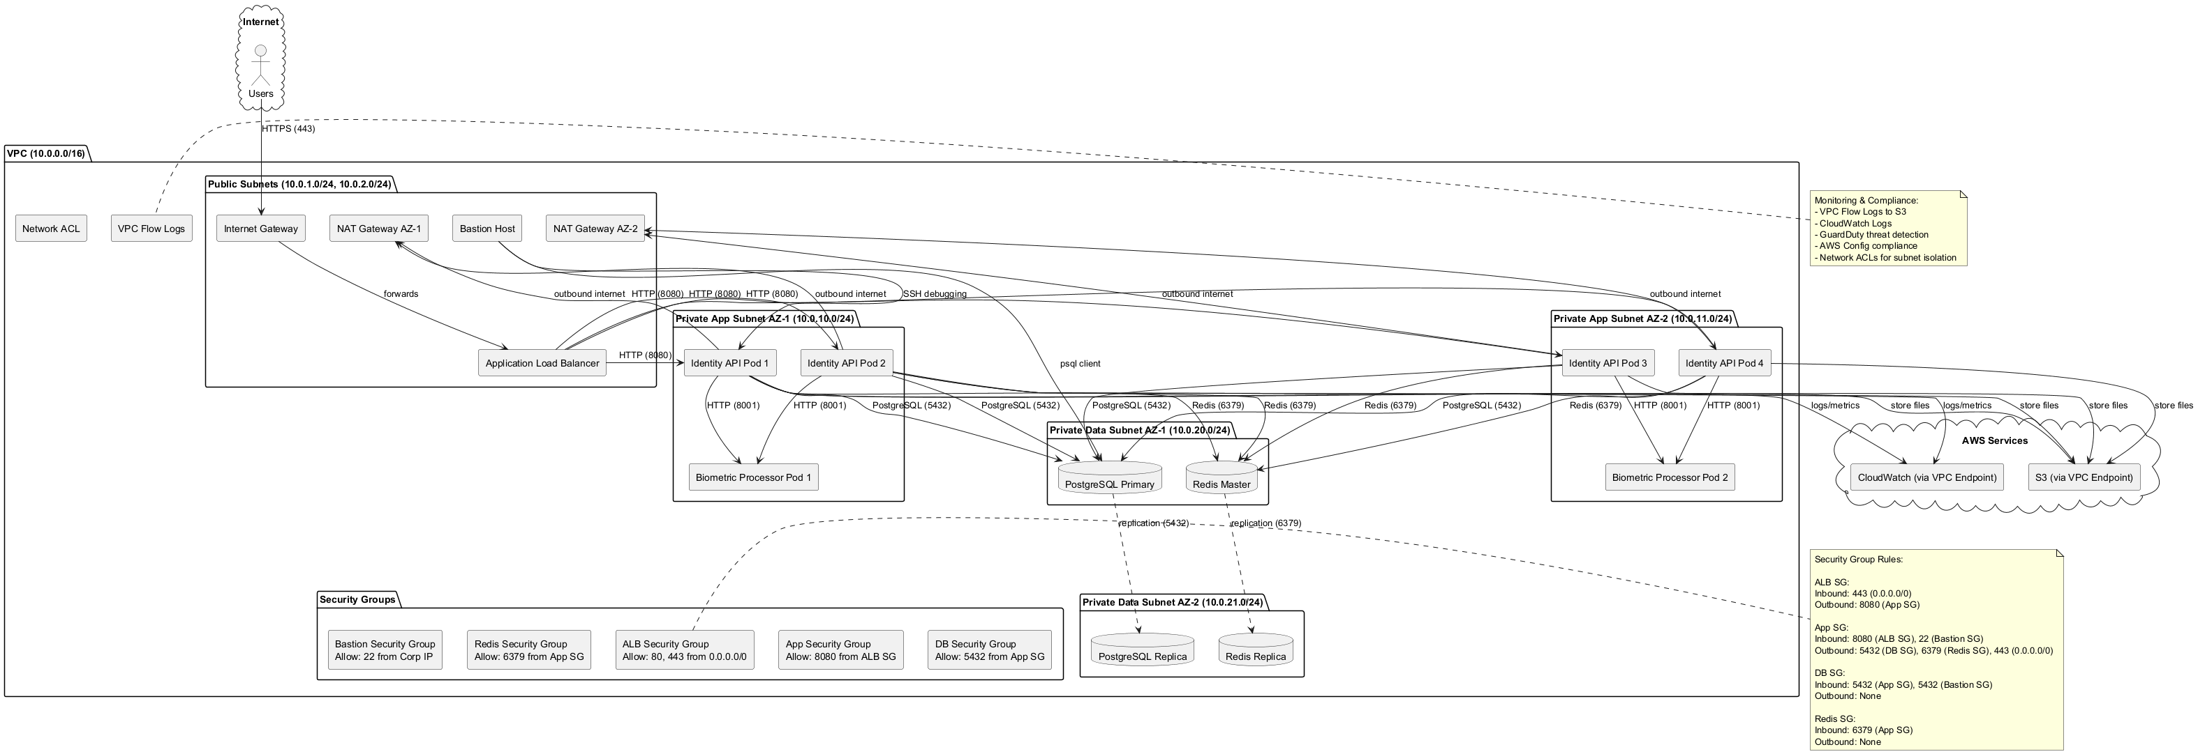
Figure 4.1 Network architecture: TLS termination at Traefik, public vs. internal routing, and the API-key-protected biometric service
TLS everywhere at the edge. All public traffic terminates at Traefik v3, which redirects port 80 to 443 and obtains certificates automatically from Let's Encrypt. Traefik discovers services from Docker labels and applies file-provider middleware globally — HSTS, X-Content-Type-Options, X-Frame-Options: DENY, a scoped Permissions-Policy (camera/microphone/WebAuthn allowed only on verify.fivucsas.com), and rate limiting. An IP allowlist gates the administrative surfaces (/swagger-ui, /v3/api-docs, /actuator) so they return 403 to the public internet, and a hardening change set forwardedHeaders.trustedIPs to empty so Traefik overwrites the X-Forwarded-For header with the real peer IP — closing a per-IP rate-limit bypass.
REST contracts between services. The identity service and the biometric service communicate over REST/JSON. The biometric service has no public route: it is reachable only on the internal Docker backend network at http://biometric-api:8001, and every /api/* call must carry an X-API-Key header enforced by middleware, so the only client that can reach it is the identity API. Each service publishes an OpenAPI contract (Swagger for the Java API, FastAPI's automatic schema for the Python service), making the contract machine-readable and testable.
The OIDC redirect protocol. As detailed in Section 4.4.2, third-party login is a browser-mediated redirect protocol: authorize request → hosted login → MFA → authorization-code redirect → back-channel token exchange. The data-flow of the verification pipeline that this protocol guards is shown in
Figure 4.3.
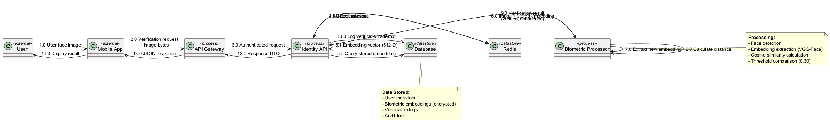
Figure 4.1 Data flow of the verification pipeline, from client capture through liveness, embedding, and decision
WebSocket proctoring. Real-time session monitoring is not request/response but a persistent bidirectional stream: the biometric service exposes a WebSocket endpoint (/ws/live-analysis) and the web client connects with socket.io-client, streaming frames for continuous verification and receiving incident events. This is the project's use of a stateful application-layer protocol where HTTP's request/response model would be a poor fit.
NFC and the eMRTD protocol. Document-based identity verification reads the contactless chip of an electronic passport or national ID card following ICAO Doc 9303 [18]. The Android client performs the on-device chip dialogue over IsoDep APDUs — Basic Access Control, secure messaging, and data-group reads — while the passive-authentication cryptography is server-authoritative. The client submits the EF.SOD security object and the data groups, and the biometric service's POST /nfc/verify-authenticity runs the standard three-step passive-authentication chain:
1. each data-group hash must match the value signed in the SOD;
1. the SOD's CMS SignedData signature must verify under the embedded Document Signer certificate; and
1. that Document Signer certificate must chain to a trusted CSCA root in the operator's trust store.
The whole check is fail-closed: an empty trust store, an expired certificate, or any mismatch rejects the document. This is pure-Python cryptography with no ML, and it is the cleanest example in the system of an international networking and security standard implemented end to end.
  - Finite State Machines
Many of the platform's workflows are long-lived and must be reasoned about as finite-state machines (FSMs): a session, an enrollment, a verification, or a user account is always in exactly one defined state, and only specific transitions are legal. Modeling them explicitly — rather than as ad-hoc boolean flags — is what makes the system auditable and prevents illegal states such as "verified but never enrolled" or "consumed token reused." Four FSMs anchor the design.
The session finite-state machine governs an authentication session from creation through the MFA steps to completion, expiry, or revocation. It is the FSM that the consume-then-mint idempotency of Section 4.5 enforces: a session in the COMPLETED/CONSUMED state can never transition back to a usable one.
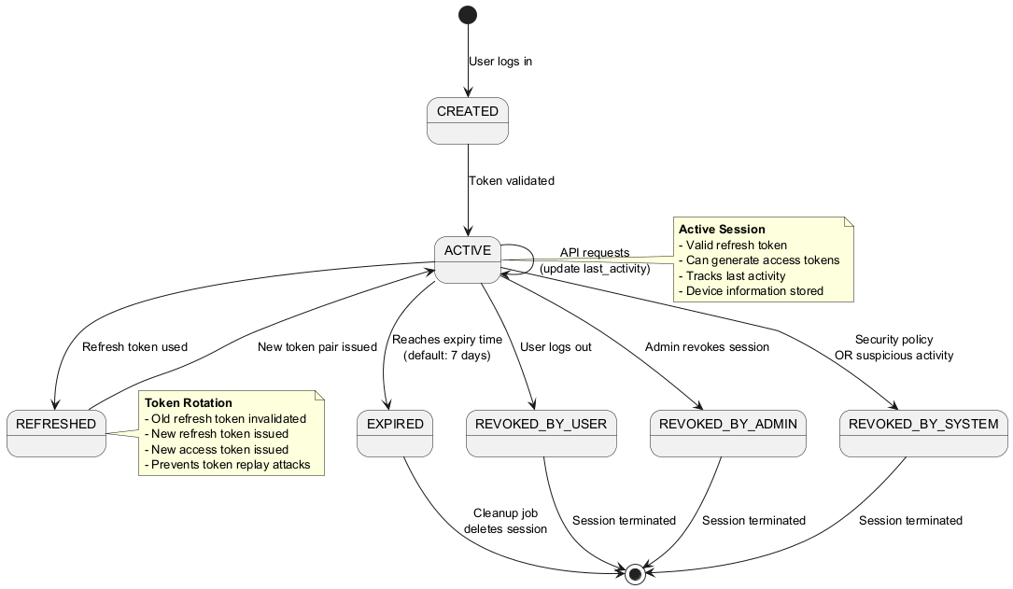
Figure 4.1 Session finite-state machine: creation, MFA progression, completion, expiry, and revocation
The verification finite-state machine drives the identity-verification (KYC) pipeline through its ordered steps — document scan, data extraction, face match, liveness check, and so on — with transitions for a passed step, a failed step, a step requiring manual review, and overall completion or rejection.
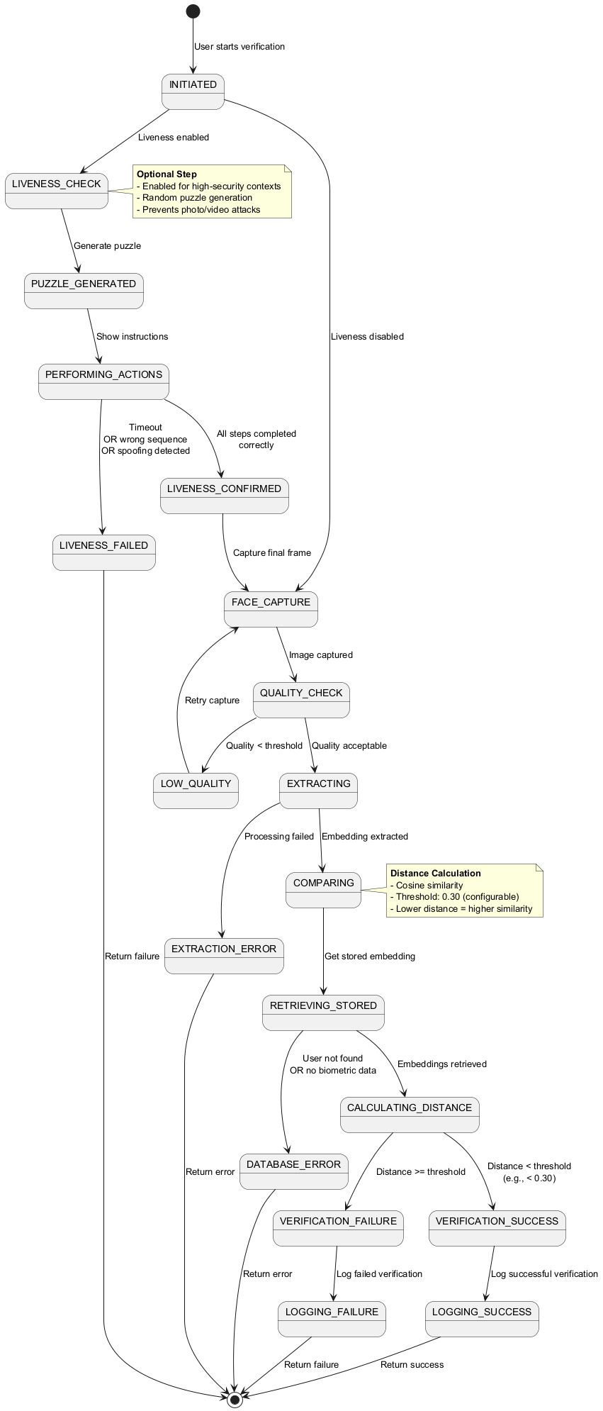
Figure 4.1 Verification finite-state machine: per-step progression with pass, fail, manual-review, and terminal states
The biometric-enrollment finite-state machine models a face or voice enrollment from initial capture through quality assessment and liveness gating to a persisted, active template — or to a rejection that re-prompts capture. The fail-closed multi-image enrollment of Section 4.3.2 is one of this machine's transition rules.
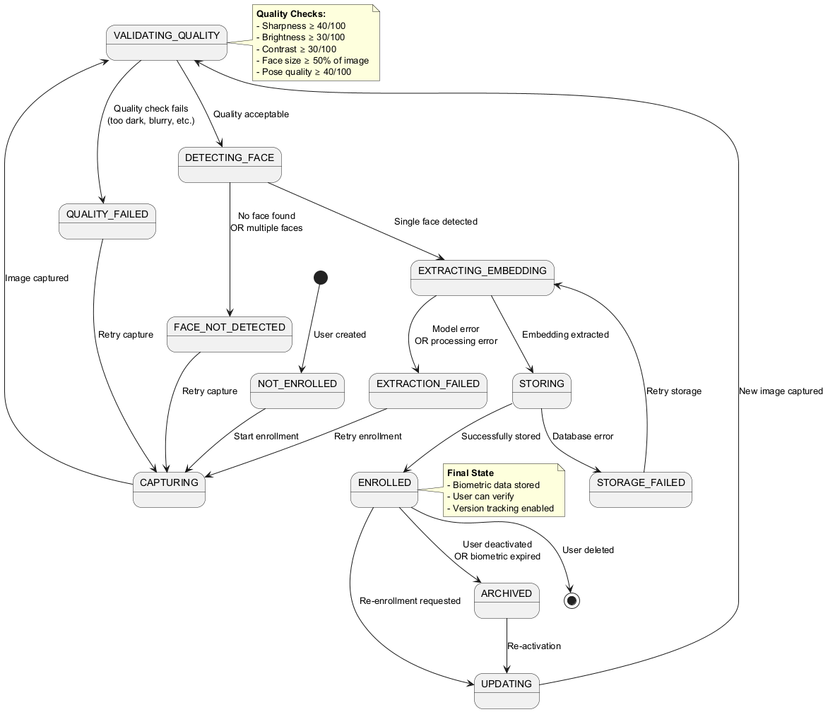
Figure 4.1 Biometric-enrollment finite-state machine: capture, quality/liveness gating, persistence, and re-enrollment
The user-account finite-state machine tracks the account lifecycle — pending, active, locked, suspended, and soft-deleted — including the lockout transition after repeated failed logins and the GDPR soft-delete state that the nightly purge job eventually finalizes.
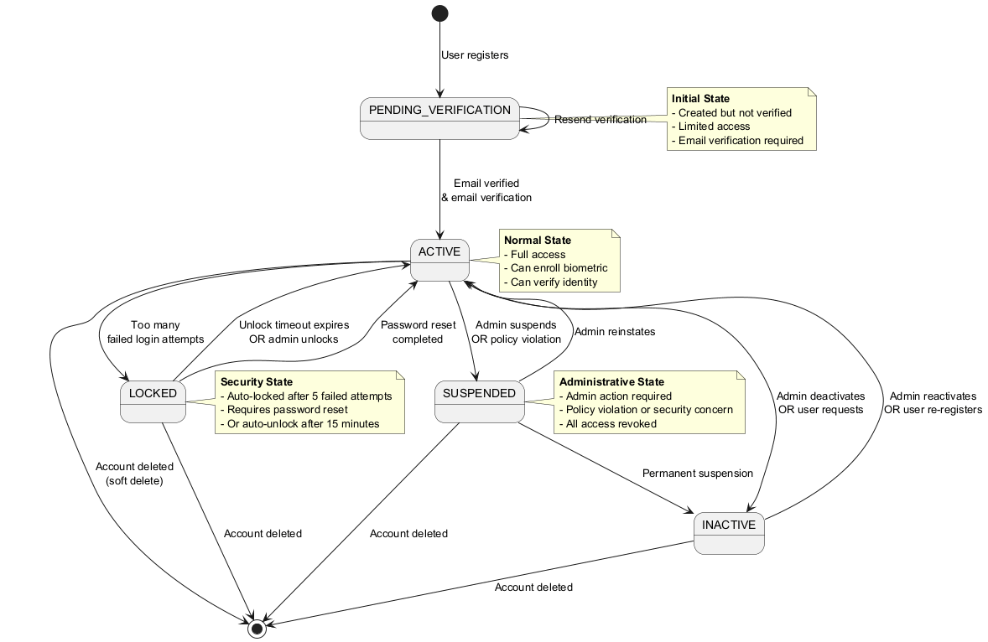
Figure 4.1 User-account finite-state machine: pending, active, locked, suspended, and soft-deleted states
Modeling these as explicit state machines made each transition a single, testable method and put the illegal states beyond the reach of the code: a session in COMPLETED, an enrollment that failed its liveness gate, or a soft-deleted account cannot silently slip back into a usable state, because no transition out of those states is written.
  - Multi-Tenant Data Isolation
The hardest non-functional guarantee in a SaaS platform is that one tenant can never see another's data — and proving it is a distributed-systems and database problem in equal measure. FIVUCSAS enforces isolation in depth, at several layers, so that a failure in any one does not breach the boundary.
Application-layer tenant context. A TenantContext thread-local is established by TenantContextFilter at the start of each request and then re-bound from the verified JWT by TenantBindFromAuthFilter after authentication, so a forged X-Tenant-ID header cannot swap a caller into another tenant; only a ROOT platform-tier user keeps the legitimate cross-tenant override.
Persistence-layer filtering. The operative isolation is a Hibernate @Filter. A global @FilterDef("tenantFilter") is applied as tenant_id = :tenantId on the eight tenant-scoped entities (AuditLog, AuthSession, MfaSession, UserEnrollment, VerificationSession, OAuth2Client, UserDevice, AuthFlow), automatically constraining every derived query. Role definitions widen the filter to (tenant_id = :tenantId OR tenant_id IS NULL) so global roles stay visible, and the cross-tenant identity entities (Identity, IdentityEmail, IdentityTenantBiometricConsent) deliberately carry no filter because they are platform-level by design. A TenantFilterBypass exists for the user-centric /my self-service endpoints, which must resolve a user under a foreign tenant scope. One caveat about the shipped reality belongs here, because it matters for any reader auditing the isolation: PostgreSQL Row-Level Security policies were authored in SQL (migration V25 and others) but found inert in production. The isolation that actually runs is therefore the Hibernate @Filter plus the tenant-scope resolver, not Postgres RLS.
Search-layer scoping. Vector search inherits the same discipline: the 1:N pgvector search of Section 4.3.4 always constrains to the caller's tenant, and cross-tenant biometric search is forbidden outright.
Proof by test. Isolation is not merely asserted; it is a CI gate. A set of Testcontainers integration tests (CrossTenantIsolationIT, TenantSwitcherIsolationIT, IdentityBiometricConsentIT, and others) run against a real PostgreSQL+pgvector and Redis on every pull request, and the pipeline parses the test report to assert that these named isolation tests actually executed — a guard against a security test being silently skipped. Isolation is therefore mechanically re-verified on every merge rather than merely claimed, which is the strongest guarantee the platform can make about the boundary that matters most in a SaaS.
- SOFTWARE TESTING
A multi-tenant biometric authentication platform earns trust in two ways: through the discipline of its engineering and the evidence of its tests. Chapter 4 reported how FIVUCSAS was built; this chapter reports how we convinced ourselves — and how a graduation committee, an auditor, or a future maintainer can convince themselves — that it works. Testing a system like this is unusually demanding. It spans five programming languages and five test technologies, and it must exercise cryptographic protocols (OAuth 2.0, OIDC, JWT), relational and vector data stores, asynchronous machine-learning pipelines, real-time WebSocket proctoring, and a security property — multi-tenant data isolation — whose failure would be both catastrophic and silent. We therefore treated testing not as an afterthought bolted on at the end but as a first-class artifact developed alongside the code, wired into continuous integration, and gated against regression on every pull request.
Throughout, the chapter separates what was authored from what was executed. We counted tests by grepping the canonical source trees rather than trusting summary tables, and we distinguish test-method counts from file counts and CI-executed counts from authored counts. Where a number is a target rather than a measured result — as with most load-test thresholds — we say so. For the most marketing-prone part of the system, the anti-spoofing evaluation, we report only what was actually measured against the ISO/IEC 30107-3 metric definitions [35].
  - Testing Strategy and Levels
FIVUCSAS adopted the classic test pyramid, adapted for a polyglot microservice system. A broad base of fast, isolated unit tests verifies individual classes, functions, and React components without external dependencies. Above it, a narrower band of integration tests exercises the seams — service-to-database, service-to-cache, service-to-service — against real backing stores rather than mocks, and a still narrower layer of end-to-end (E2E) tests drives the real browser through complete user journeys. Specialized performance and security suites sit on top, validating the non-functional requirements: latency, throughput, isolation, and vulnerability posture. The table below summarizes each level — its scope, its tooling, and its coverage intent.
Table 5.1 Test strategy, scope, tooling, and coverage intent by level
Test level | Scope | Tools | Coverage intent
Unit | Individual classes, functions, components | JUnit 5, pytest, Vitest | Domain & application logic, line/branch coverage gate
Integration | Service ↔ database, ↔ cache, ↔ service | Testcontainers [51], pytest, Spring context | API contracts, persistence, transactional behavior
End-to-end | Full user flows in a real browser | Playwright [52] | Critical paths (login, MFA, enrollment, verification, CRUD)
Architecture | Hexagonal boundary rules | ArchUnit | Layering, no-leak invariants, WebAuthn write boundary
Performance / load | Latency, throughput, stress, spike | k6 [30] | Non-functional requirement targets
Security | Vulnerability, secrets, isolation | Bandit, pip-audit, gitleaks, Dependabot, isolation ITs | OWASP Top 10 surface [36], no cross-tenant leak
The guiding principle was defense-in-depth in the test suite itself. The most security-critical property of the platform — that one tenant can never read, write, or even detect another tenant's data — is not verified at a single level but at three: an ArchUnit boundary test freezes the rule that domain code never bypasses the tenant filter; unit tests exercise the filter logic in isolation; and a set of named Testcontainers integration tests (CrossTenantIsolationIT, TenantSwitcherIsolationIT, and others) prove the property end-to-end against a real PostgreSQL instance. Crucially, the continuous-integration pipeline does not merely run those isolation tests — it parses the JUnit surefire XML afterward and asserts that they actually executed, a guard we added specifically because a silently skipped security test is worse than no test at all.
A second principle was realism at the seams. Spring Boot's testing support makes it easy to mock a repository, but a mock cannot reproduce a Flyway migration, a pgvector cosine operator, a Redis SET … EX NX race, or a Hibernate @Filter SQL rewrite. We therefore ran integration tests against real backing services via Testcontainers — throwaway Docker containers spun up per test run — so that the most subtle bugs, such as a migration that fails on an empty pgvector extension or an off-by-one in a token bucket, surfaced in CI rather than in production.
  - Test Environment and Tools
The test toolchain mirrors the production stack so that tests exercise the same runtime behavior the platform actually relies on. The principal tools and their roles are listed below.
Table 5.1 Test tooling per module, with role and execution environment
Module | Primary test tool | Role | Where it runs
Identity Core API (Java 21) | JUnit 5 + Spring Boot Test + Testcontainers + ArchUnit | Unit, integration, isolation, boundary | GitHub-hosted ubuntu-latest; Postgres+Redis via Testcontainers
Biometric Processor (Python 3.12) | pytest + httpx test client | Unit, integration, e2e, benchmark | ubuntu-latest; real redis:7-alpine + pgvector/pgvector:pg16 services
Web dashboard / hosted login (React) | Vitest + React Testing Library | Unit & component | ubuntu-latest, Node 22
Web E2E | Playwright [52] | Full-browser user journeys | ubuntu-latest headless Chromium
Mobile / desktop clients (Kotlin) | JUnit (commonTest / androidTest / desktopTest) | Shared & platform logic | ubuntu-latest (+ macos-latest, windows-latest for platform builds)
Load / performance | k6 [30] | Scripted VU load, stress, spike | Ad-hoc against staging
Security (static / secrets / deps) | Bandit, pip-audit, gitleaks v8.21.2, Dependabot | SAST, CVE scan, secret scan, dep hygiene | CI on every push/PR
Continuous integration ties these tools together, with each repository carrying its own GitHub Actions workflows. The Identity Core API runs a two-job pipeline: a fast Maven unit job (mvn -B -ntp -T 2C test, JDK 21 Temurin, with a JaCoCo coverage gate) and a slower integration job (RUN_INTEGRATION=true, mvn -Dtest='*IntegrationTest,*IT' verify) that brings up a real redis:7-alpine and a Testcontainers PostgreSQL. The latter retags pgvector/pgvector:pg16 as postgres:16-alpine so that Flyway's very first migration, which installs the vector extension, succeeds against a database that actually has pgvector. The biometric processor runs five jobs: Ruff lint plus format check (with mypy installed), a unit-test job with coverage to Codecov, an integration-test job backed by real Redis and pgvector services, a security job (Bandit static analysis plus a pip-audit CVE scan), and a frontend build. The web app runs ESLint, a tsc --noEmit type check, the Vitest suite, a production Vite build (with SKIP_MODEL_FETCH=1 so CI does not download the 50 MB ONNX model), a separate code-quality job, and the Playwright E2E suite in its own workflow.
Two caveats about the test environment need stating. First, the heaviest integration tests are environment-gated by design. The biometric processor's full machine-learning lifespan tests are guarded behind RUN_FULL_STACK_INTEGRATION=true and RUN_PROCTORING_INTEGRATION=true. On a lightweight CI runner that lacks the pinned, digest-locked ONNX stack, they skip rather than segfault, and they run only inside the production-equivalent Docker ML stack. The production host itself cannot execute the Java Testcontainers integration tests, because its sandboxed deploy shell has no Docker socket, so those tests are verified through GitHub-hosted CI instead. Second, the Identity API integration gate had a documented history of test-infrastructure rot, and during the project's most intense authentication-hardening sprint a small number of pull requests were merged with an administrator override while that gate was being repaired. We record this rather than conceal it: the gate has since had its continue-on-error escape hatch removed, so a failing isolation test now blocks a merge. The gate's trustworthiness was being restored, not taken for granted.
  - Unit Testing
Unit testing is the broad base of the pyramid and the bulk of the authored test corpus. The counts below were obtained by grepping the canonical source trees — counting @Test annotations, def test_ functions, and it()/test() blocks — with throwaway worktrees, build directories, and duplicated scratch copies excluded. They are authored method counts, not passing counts, because some tests are environment-gated or marked skip/xfail at runtime.
In the Identity Core API, we authored 1,569 `@Test` methods across 176 test files, all under src/test/java, with no stray tests in the main source set. A further 22 `@ParameterizedTest` methods each expand into several executed cases at runtime, so the true executed count exceeds 1,569. These tests mix pure unit tests over domain and application logic, Spring-context tests, Testcontainers integration tests, and ArchUnit boundary tests. The unit-level work concentrates on the security-sensitive logic that is hardest to get right and most dangerous to get wrong: password hashing with bcrypt [25], JWT issuance and validation including issuer/audience checks [24], the multi-method MFA dispatcher, TOTP used-code replay prevention, the OAuth 2.0 / PKCE authorization-code machinery [26,28], and the Bucket4j rate-limiter.
In the biometric processor, we authored 888 `def test_` functions across 68 test files. By directory these break down as 683 unit tests, 167 integration tests, 22 e2e tests, 10 benchmarks, and 6 manual tests. The unit suite covers the algorithm-level building blocks: the eye-aspect-ratio and mouth-aspect-ratio computations that drive the Biometric Puzzle [15], cosine-similarity comparison over L2-normalized embeddings, the texture/moiré/frequency/color liveness scoring, the MRZ TD1/TD3 parser, and the eMRTD passive-authentication crypto. A representative bare-host CI baseline recorded 647 passed, 1 skipped, and 1 xfailed in tests/unit/, and 50 passed with 111 skipped in tests/integration/; the skipped integration tests are the ML-lifespan and full-stack cases that run only inside the Docker ML stack. The gap between the 888 authored and the roughly 700 executed on a bare host is therefore deliberate, not a sign of neglect.
In the web dashboard and hosted login, we authored 1,025 Vitest cases across 105 test files using Vitest with React Testing Library. These verify React hooks (face detection, quality scoring, challenge state), API-client error handling, i18n string coverage in both English and Turkish, and the authentication-flow builder UI logic.
In the Kotlin Multiplatform clients, we authored 568 `@Test` methods across 64 test files, split by source set into 486 commonTest, 34 androidTest, and 25 desktopTest. The shared commonTest set exercises the cross-platform domain layer once and reuses it across Android and desktop targets.
Table 5.1 Final grep-verified authored automated test inventory per module (confirming the planned inventory of §3.2.4)
Module | Tool | Files | Authored test cases
Identity Core API | JUnit 5 | 176 | 1,569 (+22 parameterized)
Web dashboard (unit/component) | Vitest | 105 | 1,025
Web dashboard (E2E) | Playwright | 28 | 336
Mobile / desktop clients | Kotlin / JUnit | 64 | 568
Biometric processor | pytest | 68 | 888
Total |  | 441 | ≈ 4,386 authored
The headline figure for the thesis is therefore approximately 4,400 authored automated test cases across five test technologies, materially higher than the "~1,800+" figure that appears in an older internal summary. We report the verified, grep-derived figure because it is the accurate one: the older summary counted only a subset and predates later test growth.
  - Integration Testing
Integration tests verify the seams between components against real infrastructure rather than test doubles, on the principle that the subtlest and most expensive bugs live where two technologies meet. The Identity Core API's integration layer runs against a real PostgreSQL 17-class database (provisioned by Testcontainers [51] from the pgvector/pgvector image) and a real Redis instance. This matters because several of the platform's behaviors cannot be faithfully mocked: a Flyway migration that installs and depends on the pgvector extension; the Hibernate @Filter(tenantFilter) SQL rewrite that enforces tenant isolation; the Redis-backed token bucket whose correctness depends on atomic increments; and the SET key 1 EX NX marker that prevents TOTP code replay within a time step. Each of these was exercised end-to-end in an integration test so that a regression surfaces in CI rather than in production.
The biometric processor's integration suite (167 authored tests) verifies the FastAPI route handlers against a real pgvector database and Redis, including the enroll → store → verify round-trip on the face_embeddings table with its IVFFlat cosine index, the embedding-cipher store-of-record path (Fernet-encrypted embedding_ciphertext alongside the plaintext search vector), and the voice enrollment centroid computation. The heaviest machine-learning integration tests — those that actually load TensorFlow, DeepFace, and the UniFace MiniFASNet ONNX model — are gated behind RUN_FULL_STACK_INTEGRATION=true and run only inside the pinned Docker ML stack, because a floating-dependency rebuild was found to segfault the ONNX preload under the hardened read_only + cap_drop runtime.
Table 5.1 Representative integration and isolation test cases
Test ID | Category | Description | Expected result
TC-INT-001 | Persistence | User created via API persists across Flyway-migrated schema | Row present, tenant_id set
TC-INT-002 | pgvector | Enroll then 1:1 verify same face | Cosine distance < threshold, verified=true
TC-INT-003 | pgvector | 1:N search returns enrolled identity | Match within capped distance
TC-INT-004 | Redis | TOTP code reused within same time step | Second attempt rejected (replay marker)
TC-INT-005 | Redis | Rate-limit bucket exhausted | HTTP 429 after burst
TC-ISO-001 | Multi-tenancy | Query tenant A's user under tenant B scope | Not visible (404 / empty)
TC-ISO-002 | Multi-tenancy | 1:N face search scoped to caller's tenant | No cross-tenant candidates
TC-ISO-003 | Multi-tenancy | Tenant switcher cannot leak foreign data | Isolation preserved
The cross-tenant isolation integration tests are both the most important and the most actively guarded in the suite. The CI pipeline runs them, then parses the surefire XML and asserts that CrossTenantIsolationIT, TenantSwitcherIsolationIT, IdentityBiometricConsentIT, IdentityBackfillIT, and RoleUnificationBackfillIT each actually executed. A failing isolation test now blocks the pull request, and the continue-on-error escape hatch that once allowed them to be skipped quietly was removed.
  - End-to-End Testing
End-to-end tests close the loop by driving a real headless browser through complete user journeys, exercising the React front-end, the hosted OIDC login page, the Identity API, the biometric processor, PostgreSQL, and Redis as one integrated system. We used Playwright [52] for this layer because of its reliable auto-waiting, multi-browser support, and tight integration with the React/TypeScript toolchain. The suite comprises 336 `test(...)` cases across 28 spec files in web-app/e2e/.
The E2E coverage is broad and maps directly onto the platform's critical paths: login (including the extended and MFA variants), forgot/reset password, the full CRUD lifecycles for users, tenants, and roles, biometric enrollment and per-user enrollment, NFC enrollment, face and voice search, the verification flows together with session and dashboard state, the authentication-flow builder, multi-step authentication, device and session management, audit-log browsing, analytics, settings, navigation, card detection, and dedicated visual-audit and smoke suites. The named test cases below are representative of the authentication and verification journeys that the committee will recognize as the product's spine.
Table 5.1 Representative end-to-end (Playwright) test cases
Test ID | Category | Description | Expected result
TC-AUTH-001 | Authentication | Valid login with correct credentials | 200 OK, JWT access + refresh issued
TC-AUTH-002 | Authentication | Login with invalid password | 401 Unauthorized
TC-AUTH-003 | Authentication | Login to locked account | 423 Locked
TC-AUTH-004 | Authentication | Token refresh with valid refresh token | 200 OK, new token pair
TC-AUTH-005 | Authentication | Token refresh with revoked token | 401 Unauthorized
TC-MFA-001 | MFA / step-up | Password + TOTP second factor | Step-up satisfied, session elevated
TC-MFA-002 | MFA / step-up | QR cross-device sign-in | Session bound to scanned device
TC-USER-001 | User management | Create user with valid data | 201 Created
TC-USER-002 | User management | Create user with duplicate email | 409 Conflict
TC-RBAC-001 | Authorization | Access with sufficient permissions | 200 OK
TC-RBAC-002 | Authorization | Access with insufficient permissions | 403 Forbidden
TC-VER-001 | Verification | Enrolled user passes liveness + face match | Verified, access granted
These end-to-end tests are the closest automated proxy we have for a real user's experience, and several genuine defects surfaced through them. An async login-config race that briefly blanked the hosted login page, and a default-flow 500 in the flow builder, were both caught by a browser-level test before reaching production. The lesson, consistent with the project's own engineering retrospectives, is that green unit tests are necessary but not sufficient: more than one bug survived a large green unit suite and was exposed only by driving the real product, which is why the E2E layer exists.
  - Performance and Load Testing
Performance testing was conducted with Grafana k6 [30], the project's maintained load-testing tool.[^locust] The load-tests/ suite consists of a global configuration of thresholds, shared authentication and biometric helper modules, and six scenarios: auth-load-test.js, enrollment-load-test.js, verification-load-test.js, multi-tenant-load-test.js, stress-test.js, and spike-test.js. The load patterns ramp to 200 virtual users in the authentication and verification scenarios, climb as high as 1,500 in the stress scenario, and use a 20×-baseline burst in the spike scenario.
The status of the numbers attached to these scenarios must be stated plainly. The per-scenario thresholds encoded in the k6 configuration are targets derived from the non-functional requirements, not measured production benchmarks.
[^locust]: An early locustfile.py survives only in a scratch worktree, and locust lingers in a legacy requirements file; Locust was an early experiment rather than the maintained tool, so we cite k6 throughout.
Table 5.1 k6 load-test thresholds — these are NFR targets, not measured production results
Scenario / operation | Threshold (target) | Nature
Login | p95 < 300 ms | Target
Token refresh | p95 < 200 ms | Target
Enrollment (ML-bound) | p95 < 2000 ms | Target
Verification | p95 < 500 ms, p99 < 1000 ms | Target
Overall failure rate | < 1 % | Target
Multi-tenant isolation | 0 isolation violations | Target / asserted
The position for the thesis is therefore clear: the load-testing harness is real, scripted, and runnable, and its thresholds encode the latency and reliability budgets the system was designed to meet, but a full instrumented production benchmark run with published percentile distributions remains future work. The capacity figures that appear in the parent deployment descriptor ("1000+ concurrent users, ~120 enrollments/sec, p95 < 500 ms") are likewise design estimates carried in a compose-file header, and we do not present them as measured results. The one threshold that is more than a target is the multi-tenant scenario's assertion of zero isolation violations, which aligns with the isolation property that the integration ITs verify independently.
One architectural ceiling bounds all of these numbers: the entire production system runs on a single CPU-only Hetzner CX43 (8 vCPU, 16 GB RAM, no GPU). This constraint shaped the model choices (every model is CPU-safe) and limits the achievable throughput. The parent compose's two-replica, read-replica HA layout is a scaling plan, not the live single-VPS deployment, and horizontal scaling under Kubernetes is named as future work in Chapter 7.
  - Security Testing
Security testing for FIVUCSAS combines automated CI gates with security-invariant tests, and we are careful to separate what is implemented and enforced from what is documented intent. The implemented, CI-enforced security testing comprises four automated tools plus the isolation integration tests:
• Bandit runs as a static application security testing (SAST) pass over the Python
codebase (bandit -r app/ -ll) in the biometric processor's CI security job, flagging unsafe patterns such as insecure deserialization, shell injection, and weak cryptographic usage.
• pip-audit scans the Python dependency tree for known CVEs in the same job.
• gitleaks v8.21.2 runs on every push and pull request for both the Identity API and the
web app, scanning the full git history (fetch-depth: 0); it is the authoritative secrets gate, and the team treats a gitleaks finding as the real blocker even when other scanners produce false positives on cryptographic pseudocode.
• Dependabot runs weekly, grouped, to keep dependencies patched.
• The cross-tenant isolation Testcontainers ITs function as security-invariant gates:
they are required, executed, and asserted-to-have-executed on every Identity API pull request, making multi-tenant data isolation a tested-every-PR guarantee backed by a defense-in-depth Hibernate @Filter(tenantFilter) on the tenant-scoped entities.
The reference framework for the threat model is the OWASP Top 10 and the OWASP API Security Top 10 [36]; the security architecture document maps the platform's controls onto those categories. One gap between plan and implementation must be flagged plainly. The original test plan listed OWASP ZAP and Snyk for dynamic scanning and Trivy/Clair for container scanning, alongside annual penetration testing. In the shipped pipelines, there is no automated OWASP ZAP, Snyk, or Trivy job wired into GitHub Actions; the implemented automated security testing is the Bandit + pip-audit + gitleaks + Dependabot + isolation-IT combination above, while ZAP/Snyk/Trivy and annual penetration testing remain documented aspirations and manual practices rather than CI-enforced gates. We label them accordingly so that no reader mistakes intent for implementation.
Table 5.1 Security testing — implemented (CI-enforced) versus documented-intent
Control | Tool | Status
Python SAST | Bandit | Implemented (CI)
Python dependency CVE scan | pip-audit | Implemented (CI, report-only)
Secret scanning | gitleaks v8.21.2 | Implemented (CI, full history)
Dependency update hygiene | Dependabot | Implemented (weekly)
Cross-tenant isolation gate | Testcontainers ITs | Implemented (required + asserted)
Dynamic app scanning (DAST) | OWASP ZAP | Documented intent (not CI-wired)
SCA / container scanning | Snyk / Trivy | Documented intent (not CI-wired)
Penetration testing | Manual / external | Documented intent (annual)
Beyond automated tooling, several authentication-bypass and spoofing concerns were addressed at the design and test level. The platform enforces server-side authentication decisions: the browser is treated as untrusted, so the client-side geometry embedding is recorded log-only and never used for an auth decision. JWTs carry validated issuer and audience claims; refresh tokens are revocable via a Redis blacklist; the admin surfaces (Swagger, actuator) are IP-allowlisted at the edge; and rate limiting plus per-IP X-Forwarded-For hardening close a credential-stuffing and rate-limit-bypass surface.
  - Biometric and Liveness Experimental Evaluation
The biometric and liveness subsystem is the project's research-facing core, and it is also where the temptation to over-claim is greatest. This section reports the anti-spoofing and liveness evaluation carefully: it describes the evaluation apparatus, states which metrics were implemented to the relevant standard, and reports only what was actually measured, distinguishing targets from measured results throughout.
    - Presentation Attack Detection metrics and the evaluation harness
Anti-spoofing is, in the language of the international standard, Presentation Attack Detection (PAD), and the correct way to report it is with the metrics defined in ISO/IEC 30107-3 [35]:
• APCER (Attack Presentation Classification Error Rate) — the proportion of attack
presentations (printed photos, screen replays, masks) wrongly classified as bona fide.
• BPCER (Bona-fide Presentation Classification Error Rate) — the proportion of genuine
presentations wrongly classified as attacks (the false-reject side that frustrates real users).
• ACER (Average Classification Error Rate) — their mean, ACER = (APCER + BPCER) / 2.
• EER (Equal Error Rate) and the operating-point pairs FAR@FRR / FRR@FAR.
$ \mathrm{ACER} = \dfrac{\mathrm{APCER} + \mathrm{BPCER}}{2} $ (Equation 5.1)
These metrics are not merely cited; they are implemented in code in the spoof-detector library (src/metrics/iso30107.py), which computes apcer, bpcer, acer, eer, far_at_frr, and frr_at_far, complete with bootstrap confidence intervals. This means the evaluation harness exists and produces standard-conformant numbers when fed a labeled dataset.
    - The amispoof analyzer pipeline under evaluation
The system under test is the FIVUCSAS anti-spoofing pipeline, exposed for live experimentation as amispoof, an in-browser anti-spoofing tester deployed at amispoof.fivucsas.com and built from the TypeScript port of the spoof-detector library (onnxruntime-web with a WebGPU and Web Worker pool). The pipeline is a layered, multi-signal design. The Python library ships 13 analyzers (among them MiniFASNetAnalyzer, TextureAnalyzer, MoireAnalyzer, ScreenReplayAnalyzer, ScreenFlickerAnalyzer, TemporalAnalyzer, RPPGAnalyzer, BlinkAnalyzer, MicroTremorAnalyzer, and a DeviceBoundaryAnalyzer); the browser port extends this to 25 analyzers with browser-only signals such as flash-reflection, gaze, expression-dynamics, and 3-D pose-consistency detectors. A HybridFusionEvaluator fuses the strongest signals — a weighted combination of the pretrained MiniFASNet model [16], a flash-response cue, a moiré-pattern cue, and a device-replay cue — and declares a presentation a spoof when the fused score exceeds a decision threshold of 0.45. A multi-class fuser maps signals onto a spoof taxonomy (REAL, STATIC_IMAGE, VIDEO_REPLAY, MASK_3D, HEAVY_MAKEUP, AR_FILTER, DEEPFAKE_INJECT). A distinctive design choice is the LivenessProver, which operates on a "guilty until proven innocent" basis: a session begins classified as a spoof, and the subject must accumulate passive (and optionally active-challenge) evidence until the score reaches 60, at which point liveness is considered proven.
When this pipeline is wired into the production /verify and /enroll endpoints, the always-on path is the UniFace MiniFASNet passive-liveness gate plus a single-frame EAR veto (rejecting both-eyes-closed photo signals at an EAR threshold of 0.18), with the full fusion layers opt-in behind feature flags. Critically, the entire anti-spoofing pipeline is fail-soft: every layer is wrapped in exception handling so that an anti-spoofing bug can never hard-block a legitimate user by raising, a deliberate availability-over-strictness trade-off.
Table 5.1 Representative biometric and liveness test cases
Test ID | Category | Description | Expected result
TC-BIO-001 | Face detection | Valid face image | Face detected with coordinates
TC-BIO-002 | Face detection | Image without a face | No-face-detected error
TC-BIO-003 | Quality | High-quality image | Quality score above threshold
TC-BIO-004 | Quality | Blurry image | Quality score below threshold (Laplacian variance low)
TC-BIO-005 | Enrollment | Valid enrollment | Embedding stored (encrypted + indexed)
TC-BIO-006 | Verification | Matching faces | Cosine distance below threshold (verified=true)
TC-BIO-007 | Verification | Non-matching faces | Cosine distance above threshold (verified=false)
TC-LIVE-001 | Liveness | Valid blink | EAR drop then re-open detected
TC-LIVE-002 | Liveness | Valid smile | MAR increase above ratio detected
TC-LIVE-003 | Liveness | Static photo attack | Presentation classified as spoof
    - What was actually measured — and what was not
The unit and integration tests verify the algorithmic behavior of the liveness signals directly: that the EAR computation registers a blink as a closed-then-open transition below 0.21, that the MAR computation registers a smile when the mouth-aspect ratio exceeds 0.4 with a baseline ratio above 1.3, that the texture/moiré/frequency/color detector down-scores a flat, screen-like presentation, and that a both-eyes-closed still frame triggers the EAR veto. These behavioral assertions are real, automated, and passing. The browser port additionally carries 256 Vitest cases covering each analyzer, the pipeline assembler, the quality gates, and a small CASIA-FASD micro-benchmark harness (CasiaFasdMicroBench).
What we do not report is a headline accuracy number for the fused system. A "100% accuracy / ACER 0.00%" figure for a learned-fuser variant appears in the project's promotional poster, derived from a 120-video subset. That result is unverified, flagged internally for a reproducibility review before any use in a paper, and we therefore do not cite it as an experimental result of this thesis. The defensible statement is this: the ISO/IEC 30107-3 metric harness is implemented and capable of producing APCER/BPCER/ACER/EER (the metrics defined in §5.8.1) with confidence intervals, the analyzer behaviors are verified by automated tests, and the pipeline is deployed and demonstrable live at amispoof.fivucsas.com. But a full, reproducible PAD benchmark on a standard public dataset (for example CASIA-FASD or a Replay-Attack corpus), reported as measured APCER/BPCER/ACER with confidence intervals, is evaluation that is ongoing and is named as future work. We prefer a smaller, defensible claim to a larger, unverifiable one.
The face-verification behavior, by contrast, is concrete and grounded in the shipped configuration. Verification compares L2-normalized Facenet512 embeddings [11] by cosine distance (distance = 1 − cosine similarity) and declares a match when the distance falls below the configured threshold: production VERIFICATION_THRESHOLD = 0.4, relaxed to 0.55 for embeddings older than two years via an adaptive-threshold rule whose validator enforces that the aged threshold is never stricter than the standard one (a guard added after an earlier inversion bug). The 1:N search path uses the same cosine operator over a pgvector IVFFlat index (vector_cosine_ops, lists = 100) [8], with cross-tenant search forbidden. These are the operating parameters of the deployed verifier; we report the thresholds the system actually runs at rather than an accuracy figure we did not independently measure.
  - Multi-Tenant Isolation Testing
Multi-tenant isolation is the single most consequential security property of a SaaS identity platform: a leak across the tenant boundary would expose one customer's users, biometric enrollments, and audit trail to another. We therefore tested it more aggressively than any other property, at three independent levels of the test suite.
At the architecture level, an ArchUnit boundary test freezes the rule that domain and application code does not bypass the tenant-scoping mechanism — for instance, that code does not directly import or mutate the raw User entity in ways that would escape the filter, and that the WebAuthn write boundary is respected. At the unit level, the tenant-filter logic and the tenant-scoped repository methods are tested in isolation. At the integration level, the named Testcontainers ITs — CrossTenantIsolationIT, TenantSwitcherIsolationIT, IdentityBiometricConsentIT, IdentityBackfillIT, and RoleUnificationBackfillIT — prove the property end-to-end against a real PostgreSQL database with the Hibernate @Filter(tenantFilter) active on the tenant-scoped entities.
The defining feature of this testing is the meta-assertion in CI: after running the integration suite, the pipeline parses the surefire XML and asserts that those isolation tests actually executed, failing the build if any was silently skipped. This guards against the most insidious failure mode of all — a security test that is present in the repository, appears to pass, but in fact never ran. The biometric processor's /search (1:N face search) and /voice/search endpoints enforce the same tenant scoping at the data layer, and the k6 multi-tenant load scenario independently asserts zero isolation violations under concurrent load. The property is thus verified statically, in isolation, in integration, and under load — defense-in-depth applied to the test strategy itself.
Table 5.1 Multi-tenant isolation verification across test levels
Level | Mechanism | What it proves
Architecture | ArchUnit boundary rule | Domain code cannot bypass tenant filter
Unit | Filter / scoped-repository tests | Filter logic correct in isolation
Integration | CrossTenantIsolationIT et al. (Testcontainers) | No cross-tenant read/write on real DB
CI meta-gate | Surefire-XML execution assertion | The isolation tests actually ran
Load | k6 multi-tenant-load-test.js | Isolation holds under concurrency
  - Results Summary and Discussion
The testing program produced a large, multi-technology, CI-integrated body of evidence. The verified inventory is approximately 4,386 authored automated test cases across 441 test files in five technologies — 1,569 JUnit 5 methods (plus 22 parameterized) in the Identity Core API, 1,025 Vitest cases in the web dashboard, 336 Playwright E2E cases, 568 Kotlin methods in the clients, and 888 pytest functions in the biometric processor. A large subset of these runs on every continuous-integration pipeline; the heaviest machine-learning and Testcontainers-dependent integration tests run inside the Docker ML and integration stacks rather than on the lightweight CI runners, by deliberate design. The pipelines enforce coverage gates (JaCoCo for Java, Codecov for Python), type and lint checks, and a security battery (Bandit, pip-audit, gitleaks, Dependabot) on every change, and they treat cross-tenant isolation as a non-negotiable, execution-asserted gate.
Two findings deserve emphasis. First, the project demonstrated empirically that green unit tests are necessary but not sufficient: as §5.5 showed, real defects survived large green unit suites and were caught only by end-to-end browser testing or by exercising the live product. The E2E and integration layers, then, are not optional polish but essential — the strongest practical lesson of the chapter. Second, the value of the execution-asserting CI gate for security tests was borne out: parsing surefire output to prove that isolation tests ran, rather than trusting a green checkmark, is a small piece of test infrastructure with outsized assurance value.
Four limitations bound these results, each detailed earlier and drawn together here. The Identity API integration gate passed through a period of test-infrastructure rot before being hardened (§5.2); its skip escape hatch is now removed. The load-testing harness is real and scripted, but its thresholds are NFR targets rather than measured benchmarks, and the deployment descriptor's capacity figures are design estimates (§5.6). The dynamic- and container-scanning tools named in early plans (OWASP ZAP, Snyk, Trivy) and annual penetration testing are documented intent, not CI-wired controls (§5.7). And while the ISO/IEC 30107-3 PAD metric harness [35] is implemented and the liveness analyzer behaviors are verified by automated tests, a full reproducible PAD benchmark on a standard public dataset remains future work, and we do not adopt the unverified "100% accuracy" poster figure (§5.8.3). Taken together, the evidence supports a confident but measured conclusion: FIVUCSAS is extensively and reproducibly tested for its functional and isolation guarantees, while its performance and PAD evaluation are scaffolded and partially measured, with the remaining benchmarking work clearly scoped as future work in Chapter 7.
- BENEFITS AND IMPACT
A graduation project is judged not only by what was built but by whom it serves and what it sets in motion. FIVUCSAS — the Face and Identity Verification Using Cloud-based SaaS platform — began as an answer to a concrete, painful problem: identity proofing and authentication remain fragmented, password-bound, and dangerously easy to spoof, while the specialist software that could fix this stays locked behind enterprise procurement that small organizations cannot reach. This chapter steps back from the architecture and the code to ask harder questions. Who benefits, and how? What did the work contribute to the scientific record? What is its economic, commercial, and social weight? Could it seed future projects? And, given that the platform reads electronic travel documents over NFC and matches the holder's live face against the chip, what is its bearing on national security? We answer each in turn, taking care to distinguish what was actually delivered and measured from what remains a reasonable expectation or a target for future evaluation.
  - Benefits and Implications
The most direct beneficiaries of FIVUCSAS fall into two groups that the project deliberately served at the same time: the end users who must prove who they are, and the service providers (tenants) who must trust that proof. The Project Specification framed this two-sided value from the outset, and the delivered system bears it out.
For end users, the platform replaced the brittle ritual of remembering passwords and carrying access cards with authentication that is both stronger and lighter. A person can log in with their face, a one-time code, a passkey, a hardware security key, a voice sample, or by reading the chip in their national identity card or passport — and a tenant administrator chooses which of these to require, so the security level matches the sensitivity of the resource rather than defaulting to a single weak factor. The same person manages their own data through a self-service profile: they can list their biometric enrollments, review recent activity, see and revoke sessions on other devices, and export or request deletion of their personal data. The benefit to the user is therefore not merely "fewer passwords"; it is a verifiable, controllable identity that the user, not just the provider, can inspect and act on. This matters because biometric data is uniquely sensitive — it cannot be reset like a password — and a platform that asks for a face owes its users transparency in return.
For service providers, FIVUCSAS lowered the barrier to deploying modern, multi-factor, anti-spoofing authentication from a multi-month engineering programme to a single integration. A tenant does not implement face matching, liveness detection, OAuth 2.0, token issuance, rate limiting, or KVKK-compliant data handling; it redirects its users to a hosted login page or embeds a widget and consumes a standards-compliant OpenID Connect identity token in return [26,27]. The implication is economic as well as technical: the provider lowers its operational cost (no specialist security team for the auth surface), reduces its breach exposure (credentials and biometric templates never live in the tenant's database), and gains a competitive feature — strong, liveness- protected identity verification — that would otherwise be the preserve of large institutions. The multi-tenant design makes this realistic at small scale, because the platform's fixed cost is amortized across every tenant rather than rebuilt by each.
There is a third, quieter beneficiary that the original specification did not name but the project served all the same: the integrating developer. Because the platform exposes its capabilities as a clean, documented OIDC contract with a published SDK rather than a bespoke API per feature, a developer can wire identity verification into an existing application without becoming a biometrics expert. The hosted-first integration model — the same pattern used by Auth0 Universal Login, Okta, Microsoft Entra, and Türkiye's own e-Devlet — means the hardest and most security-critical parts of the flow happen on infrastructure the developer never has to harden. This is a real implication for software quality at large: when secure authentication is easy to adopt correctly, more applications adopt it correctly, and the baseline of digital trust rises.
A frank accounting of implications must also note the responsibilities the platform takes on. Holding biometric templates for many tenants concentrates risk; the platform answers this with encryption of stored embeddings, strict tenant isolation enforced and re-tested on every merge, and a separation of the authentication decision onto the server where it cannot be tampered with from an untrusted browser. These are not incidental features — they are the conditions under which the benefits above are legitimate rather than reckless.
  - Scientific Impact
If the project has a single scientific centerpiece, it is the Biometric Puzzle, an active, challenge-response liveness-detection scheme that the platform implemented end to end rather than merely proposing. Conventional active liveness asks a user to blink or turn their head, a fixed routine that a sufficiently prepared attacker can pre-record and replay. The Biometric Puzzle instead issues a randomized sequence of facial and gestural challenges from a defined challenge set, then scores the response server-side against the specific challenge that was issued. Because the challenge is unpredictable and bound to a short-lived session, a replayed video of the user performing yesterday's blink does not satisfy today's puzzle. The implementation grounds this idea in concrete, measurable signals: eye-aspect-ratio for blink detection following the landmark-based formulation of Soukupová and Čech, mouth-aspect-ratio for smile and mouth-open challenges, and head-pose estimation for turn challenges, with the eye-aspect-ratio blink threshold fixed at 0.21 in production [14,15]. A rigorous analysis of such a scheme's accuracy and spoofing resistance — which the evaluation roadmap in Section 7.3 scopes — is the kind of contribution that could anchor a future publication.
A second, more systemic scientific contribution is the reproducible evaluation posture the project adopted around anti-spoofing — a posture that matters because the field is plagued by unreproducible claims. The platform's passive defenses combine a learned model (UniFace MiniFASNet, run as a shared ONNX session) with classical computer-vision detectors that need no GPU: texture analysis, moiré-pattern detection, frequency-domain analysis, color-distribution checks, screen-replay detection, and an rPPG (remote photoplethysmography) analyzer, fused under a conservative verdict policy in which either backend voting "spoof" wins [16,47]. These were exposed as a standalone, inspectable library and a browser-based tester so that their behavior can be examined rather than taken on faith. Crucially, this thesis reports presentation-attack results in the vocabulary of the international standard — APCER and BPCER in the ISO/IEC 30107-3 sense — and labels every figure as measured on a specific test set or as a target, never as a universal accuracy claim [35]. The project also declined to publish the unverified "100% accuracy" fuser figure pending a reproducibility review (see Section 5.8); that restraint is itself a small methodological contribution, modeling the discipline the field asks for.
Beyond liveness, the project is a worked, public demonstration of how to assemble mature research components — MTCNN face detection, a FaceNet-style 512-dimensional embedding with cosine-similarity matching, MediaPipe's 478-point face landmarker on the client, and approximate nearest-neighbour search over those embeddings in PostgreSQL via pgvector — into a coherent, multi-tenant production pipeline rather than an isolated notebook experiment [8,10,11,12]. The engineering decisions that made this work — performing the authentication decision on the server because the browser is untrusted, treating client-side facial geometry as a log-only signal, and modeling authentication and verification as explicit finite-state machines whose illegal transitions simply do not exist in code — are documented design knowledge that other researchers and student teams can reuse and critique. That transferable design record, as much as any single algorithm, is the project's scientific yield.
  - Economic, Commercial and Social Impact
Economically, FIVUCSAS delivered a working prototype with genuine commercialization potential, exactly as the specification projected. The platform is structured as a multi-tenant Software-as-a-Service, which is the pre-condition for a subscription or usage-based revenue model: tenants are onboarded through self-service, isolated from one another, and metered on a shared infrastructure whose marginal cost per tenant is low. This is the cost structure that makes Software-as-a-Service commercially viable, and the platform is built to it: self-service tenant creation, DNS-based email-domain verification, guest invitation and revocation, and an embeddable SDK that a paying customer can integrate in an afternoon. The cost story for the customer is equally concrete: identity verification, anti-spoofing, and standards-compliant token issuance are consumed as a service instead of being rebuilt, which converts a large, risky capital project into a predictable operating expense.
On the commercial side, the differentiator is a combination the market rarely offers small buyers at once: liveness-protected biometric verification, document and chip reading, twelve selectable authentication methods — the ten canonical login factors plus the two cross-device additions — and a hosted OIDC integration, packaged so that an organization without a security team can adopt it. The platform was deployed to production across a public landing site, a tenant dashboard, a hosted login origin, an embeddable widget, a demonstration tenant, and a live anti-spoofing tester, demonstrating that the offering is operable, not merely buildable. We are careful not to overstate market traction: the system is a deployed prototype with demonstration tenants, and broad commercial adoption, formal certification, and a priced go-to-market remain future work. The commercial foundation, however — a running, multi-tenant, standards-based platform — exists.
Socially, the impact runs along three lines the specification identified and the build made real. First, safer everyday authentication: by making strong, anti-spoofing, multi-factor identity verification cheap to adopt, the platform pushes against the password reuse and card cloning that underlie a large share of account-takeover and identity-theft harm, contributing in a modest way to reducing cybercrime [1,2]. Second, digital transformation and inclusion: the same hosted identity layer can serve e-government portals, banking, healthcare, education, and transport — precisely the public- facing services named in the problem statement — and its bilingual Turkish/English interface and accessibility-minded design lower the barrier for the populations those services must reach. Third, and inseparable from the first two, data dignity: because the platform treats biometric data as the uniquely sensitive category it is — encrypting stored templates, requiring explicit per-tenant biometric consent, isolating tenants, and giving every user export and deletion controls — it advances the social norm that strong authentication and strong privacy are not opposites but requirements of the same system, in line with KVKK Law No. 6698 and the GDPR [37,38]. A platform that collected faces without those guarantees would have a negative social impact; the project's deliberate design choices are what make its social impact a benefit.
  - Potential Impact on New Projects
FIVUCSAS was built, from the start, to be a foundation others can build on, and its structure makes that more than aspiration. The platform is an end-to-end, working reference for a stack that student and research teams frequently want but rarely see assembled correctly: a hexagonal-architecture Spring Boot service and a FastAPI machine- learning service behind a Traefik edge, PostgreSQL with pgvector and Redis for state, Kotlin Multiplatform clients sharing logic across Android, desktop, and the web, and a React dashboard — all wired through OAuth 2.0/OIDC with PKCE [3,4,5,6,7,8,21,22,28]. A new project does not have to rediscover how these pieces fit; it can study a system where they already do.
The most reusable contributions are the patterns rather than any one feature. The decision to make the authentication verdict server-authoritative and to treat untrusted client signals as log-only is a directly transferable security stance for any biometric system. The explicit finite-state-machine modeling of authentication, verification, session, and enrollment lifecycles is a software-engineering template that makes correctness testable. The multi-tenant isolation strategy — application-layer tenant context re-bound from the verified token, persistence-layer filtering, search-layer scoping, and CI gates that assert the isolation tests actually ran — is a pattern any SaaS project can adopt. And the project's evaluation discipline, reporting presentation-attack performance against the ISO/IEC 30107-3 vocabulary and refusing to publish irreproducible numbers, is a methodology new projects can inherit wholesale [35].
Concretely, the specification anticipated that the work could inspire follow-on initiatives, and the architecture leaves clear seams for them. New biometric modalities slot into the existing pipeline the way voice already did alongside face. The pluggable, configurable authentication flows invite research into adaptive and risk-based authentication, where the required factors respond to context. The standalone anti-spoofing library and its browser tester are a ready substrate for further presentation-attack-detection research. And the documented but not-yet-realized roadmap items — Kubernetes orchestration, formal presentation-attack-detection certification, and model retraining pipelines — are well-defined entry points for a successor team. The platform is, in short, less a finished artefact than a starting line, which is the most useful thing an undergraduate project can be for the projects that come after it.
  - Impact on National Security
National security was never the framing of FIVUCSAS, but the capabilities the project delivered place it squarely on the terrain of identity, cyber, and border security, and the case is worth making plainly because it rests on shipped code rather than ambition.
The most direct connection is border and travel-document security. The platform's mobile client reads electronic Machine-Readable Travel Documents — electronic passports and Türkiye's electronic national identity card — over NFC, using the chip-access protocols defined by ICAO Doc 9303: it performs PACE (using the EF.CardAccess parameters), reads the document data groups and the security object, and the server verifies the document's authenticity through passive authentication rather than trusting the phone [18]. The biometric service exposes the matching endpoints — POST /nfc/mrz and a server-authoritative POST /nfc/verify-authenticity that fails closed — and the asn1crypto library parses the eMRTD ASN.1 and CMS structures that passive authentication depends on. The security significance is precise: this combination lets a checkpoint confirm that a presented travel document is a genuine, unaltered, government- issued chip, and that the live person presenting it is the person bound to that chip, by matching the holder's liveness-protected face against the chip's stored portrait. That is the core trust operation of automated border control, and the project implemented its constituent parts.
The second connection is identity-fraud and impersonation resistance in the broader sense that underpins both civil and national security. Document fraud, synthetic identities, and presentation attacks — printed photos, replayed videos, masks, screen replays — are the tools of everything from benefit fraud to infiltration. The platform's defence-in-depth against exactly these attacks (the active Biometric Puzzle, the passive learned-plus- classical anti-spoofing stack with its conservative spoof-wins verdict policy, and the watchlist-check step type in the KYC pipeline) is the same machinery a state or a regulated institution needs to keep forged and stolen identities out of trusted systems [16,35]. By raising the cost of impersonation, the platform contributes to the integrity of the identity layer on which secure public services rest.
The third connection is cyber-security of critical digital services. The public services named in the problem statement — e-government, banking, healthcare, transport — are critical national infrastructure in everything but name, and the dominant route to compromising them is credential-based account takeover. By providing a hardened, standards-compliant, multi- factor identity layer with server-side decisioning, strict tenant isolation, rate limiting, and audited sessions, FIVUCSAS strengthens precisely the attack surface that adversaries target most [1,36]. A national digital ecosystem in which strong authentication is cheap and standard is a more resilient one.
We are equally clear about what does not apply and what is not claimed. FIVUCSAS is a civilian, commercial platform; it is not an intelligence, weapons, or classified-systems project, and no aspect of it touches military or signals-intelligence domains. Its border- security relevance is the building blocks of automated document and identity checking, not a deployed, accredited border-control installation — formal certification (for both the presentation-attack detection under ISO/IEC 30107-3 and the document-reading chain under the ICAO regime) is explicitly future work, and we do not present the prototype as a certified system. Nor do we claim any operational deployment by a security authority. The statement we can stand behind is narrower and more concrete: the project produced, tested, and ran the technical components that identity, border, and cyber security depend upon, to a standard appropriate for an undergraduate engineering project. In doing so it demonstrated, in code, how a cloud-native SaaS platform can serve national-security-relevant ends without abandoning the privacy and transparency that a democratic society requires of any system that asks to read its citizens' faces and documents [18,37,38].
- CONCLUSION AND FUTURE WORK
  - Summary and Conclusions
This thesis set out to answer a deceptively simple question: can high-accuracy face verification, robust anti-spoofing, and strict multi-tenant isolation be engineered into a single, deployable Software-as-a-Service platform — rather than remaining scattered across proprietary cloud APIs, device-bound vendor silos, and research-grade models that never leave a benchmark? Over two semesters we designed, built, deployed, and tested FIVUCSAS (Face and Identity Verification Using Cloud-based SaaS). The working system answers in the affirmative, qualified by the limitations enumerated in the next section.
What we delivered is a running, multi-tenant, cloud-native identity platform, not a prototype on a laptop. At its core sit two backend microservices that divide the problem cleanly along the seam that matters most. The Identity Core API (Spring Boot on Java 21, organized as a hexagonal, ports-and-adapters codebase [31]) owns authentication, authorization, tenant administration, OAuth 2.0 / OpenID Connect, and every security-policy decision; it is the system of record and the sole authority over the auth verdict [26,27]. The Biometric Processor (FastAPI on Python, laid out in the same clean layers) carries the compute-intensive work: face detection with MTCNN [10], 512-dimensional embedding with Facenet512 [11] via the DeepFace framework [12,13], passive liveness with the UniFace MiniFASNet ONNX model [16], voice speaker embeddings, document and eMRTD reading [18], and the anti-spoofing pipeline drawn from a dedicated spoof-detector library. The two services communicate over an internal REST contract guarded by an API key. The biometric processor has no public route and is reachable only on the internal Docker network, which keeps the most sensitive surface off the open internet entirely.
Around this backend we built the parts that make a capability into a product. Faces are stored as Facenet512 embeddings in PostgreSQL with the pgvector extension [7,8], indexed with IVFFlat using the cosine operator class and matched by cosine distance, with an encrypted ciphertext column kept as the canonical store of record alongside the searchable vector. Redis [22] did far more than caching: OAuth authorization codes, one-time passwords, replay markers, step-up challenges, distributed rate-limit counters, and job coordination all lived there under carefully chosen TTLs. Traefik [21] terminated TLS at the edge and routed by Docker labels, with an admin-IP-gated surface for Swagger and actuator and hardened forwarded-header handling. The whole deployment ran on a single Hetzner CX43 VPS under Docker Compose [19,20], every application container hardened with a read-only root filesystem, dropped Linux capabilities, and no-new-privileges. The schema itself evolved through 83 Flyway migrations [9] (the V0–V83 range, with V13 unused) — an auditable record of the platform's growth from a core IAM schema to identity linking, account-level biometric consent, partitioned audit logs, and discoverable passkeys.
The project's signature contribution is its approach to liveness. Rather than trust a single still frame, FIVUCSAS combined a server-authoritative passive check (UniFace MiniFASNet, backed by a classical texture, moiré, frequency, and color detector and a single-frame Eye-Aspect-Ratio veto as defense in depth [15,47]) with an active challenge–response mechanism, the Biometric Puzzle. The puzzle asks the user to complete a randomly generated sequence of facial actions (blink, smile, turn, open mouth, raise eyebrows, and more), each scored against MediaPipe FaceLandmarker geometry [14] using Eye- and Mouth-Aspect-Ratio and landmark-derived head-pose thresholds, with incompatible action pairs blocked and a per-step confidence and duration floor enforced server-side. Because the sequence is unpredictable and verified on the server, a printed photo or a replayed video cannot satisfy it. This rests on an explicit, documented architectural decision: the browser is untrusted, and the authoritative auth decision is made on the server. Under that decision (D2) the client-side geometry embedding is recorded for offline analysis but never decides the verdict.
On the client side we delivered multiple surfaces over a shared design: a React administration dashboard [5]; a hosted login experience at verify.fivucsas.com that follows the same redirective-OIDC pattern as Auth0 Universal Login, Okta, Microsoft Entra, and e-Devlet, complete with PKCE (S256) [28]; an embeddable authentication widget and a zero-dependency JavaScript SDK for inline step-up; and a Kotlin Multiplatform / Compose [6] client. We are precise about platform delivery. Android shipped as a full native client (signed public releases with native MFA, on-device NFC document reading, and a standalone TOTP authenticator). The JVM desktop client shipped as a hosted-first OAuth loopback application with OS-native secure token storage and .deb/.msi installers. iOS was not delivered: the shared module compiles for iOS targets, but the platform implementations are stubs, and the app remains future work blocked on Apple Developer enrollment. The PSD-era plan to build the clients in Flutter was abandoned in favor of Kotlin Multiplatform, and we report that as the reality.
Security was treated as a first-class, tested property rather than a coat of paint. BCrypt at work factor 12 protected passwords [25]; production access tokens were RS256-signed JWTs with issuer and audience binding, key-id routing that closed algorithm-confusion forgeries, and RFC 8176 amr accumulation that recorded genuine N-factor evidence [24]; WebAuthn / passkeys used the Yubico server library with an explicit origin allowlist [29]; two complementary rate-limiting layers (a Redis sliding window and Bucket4j token buckets [23]) failed closed on sensitive paths; and refresh tokens rotated within a family with reuse detection. Multi-tenant isolation — the hardest SaaS guarantee — was enforced in depth (JWT-rebound tenant context plus a Hibernate @Filter on the tenant-scoped entities) and, crucially, re-verified on every pull request by Testcontainers integration tests that the CI pipeline asserted had actually executed [51].
The engineering process itself is part of the result. The platform was backed by roughly 4,400 authored automated test cases across five technologies — JUnit 5, Vitest, Playwright, the Kotlin/JUnit suite, and pytest [52] — exercised by per-repository CI pipelines, with load scenarios in k6 [30] and static security scanning via Bandit, pip-audit, gitleaks, and Dependabot. We are equally clear about what those numbers do not mean: a large green test suite is not the same as a measured accuracy benchmark. The performance figures in our load configuration are design targets, not measured production results, and the headline anti-spoofing figure that appeared on an early project poster was never independently reproduced and is therefore not claimed here (see §5.8). The conclusion we stand behind is narrower and more defensible, and it is the thesis statement of this entire document: a complete, secure, multi-tenant biometric verification platform — with active liveness, vector face search, strict tenant isolation, and a developer-grade OIDC integration story — can be built and operated end-to-end by a small team on commodity, CPU-only infrastructure.
  - Advantages and Limitations
No engineering decision is free, and a candid thesis names the cost of each choice as plainly as its benefit. This section weighs the principal methods we adopted.
    - Advantages of the Chosen Methods
A microservices split along the right seam. Separating identity logic (Spring Boot) from the machine-learning workload (FastAPI) [32,33] let each side use the language and runtime best suited to it — a mature JVM security ecosystem on one side, the Python ML stack on the other — and let the heavy biometric service be resource-capped, hardened, and kept entirely off the public internet. The clean boundary made the codebase easier to reason about and test, and it leaves a clear path to scaling the two services independently.
Hexagonal architecture paid for itself. Organizing both services as ports and adapters [31,34] meant that swapping an SMS provider, a cache, or a biometric backend was a matter of writing a new adapter, not surgery on the domain. The Strategy-plus-Registry pattern used for login handlers, MFA step handlers, and verification-pipeline handlers made the twelve authentication methods and the ten verification steps genuinely pluggable, and ArchUnit boundary tests froze the most important architectural invariants so they cannot silently rot.
Server-authoritative liveness with an active challenge. Placing the auth decision on the server and combining passive liveness with the active Biometric Puzzle is, we believe, the project's strongest design choice. It directly addresses the presentation-attack threat that defeats naive "match a photo" systems, and the log-only client embedding (decision D2) means a compromised or spoofed browser cannot manufacture a positive verdict. The anti-spoofing pipeline is deliberately fail-soft so that a bug in a detector can never hard-block a legitimate user, while the passive gate and EAR veto remain always-on.
pgvector instead of a separate vector database. Storing embeddings in PostgreSQL with pgvector [8] kept the entire data model — relational identity data and biometric vectors — in one ACID-compliant, backup-and-restore-as-one system, avoiding the operational burden of a second specialized datastore [49]. For a platform of this scale on a single VPS, that simplicity was the right trade.
Hosted-first OIDC integration. Adopting the redirective hosted-login pattern that the entire identity industry has converged on solved a cluster of real browser problems at once — Web NFC and WebAuthn cross-origin restrictions, Safari ITP, and third-party-cookie deprecation — and gave tenants a familiar, low-effort integration via a small SDK and standard OAuth 2.0 / OIDC endpoints [26,27,28].
Defense in depth, and proof by test. Multiple independent layers (JWT-rebound tenant context plus Hibernate @Filter, fail-closed rate limiting, single-use replay-proof tokens, refresh-token family revocation) mean no single failure breaches the tenant boundary, and the isolation guarantee is re-checked on every merge rather than asserted once [51]. The hardened container runtime and the 83-step auditable migration history extend the same discipline to operations.
    - Limitations of the Chosen Methods
The deployment is a single point of failure. The live system runs on one Hetzner CX43 with single shared PostgreSQL and Redis instances and a single Traefik edge. The parent compose file describes a two-replica, read-replica, multi-region layout, but that is a plan, not the running deployment. There is no horizontal auto-scaling and no automated failover — adequate for a graduation prototype and a controlled demo, but not for a production SLA.
CPU-only hardware constrained the model choices. Because the CX43 has no GPU, the platform deliberately blocks GPU-hungry backends (RetinaFace, ArcFace [40], heavier YOLO variants [17]) at boot via ALLOW_HEAVY_ML=false. MTCNN, Facenet512, and UniFace MiniFASNet are all CPU-safe and were chosen partly for that reason. This keeps the system runnable but means the platform is not using the current state-of-the-art recognition model, and the enrollment path is ML-bound and comparatively slow.
Accuracy is not formally measured. This is the most important caveat. The thesis does not report measured False Accept / False Reject rates for face verification, nor certified APCER / BPCER / ACER figures for the anti-spoofing pipeline. The ISO/IEC 30107-3 metric harness exists in code [35], and a CASIA-FASD micro-benchmark exists in the test suite, but a rigorous, independently reproduced evaluation on standard datasets was not completed. The performance targets in the k6 configuration (login p95 < 300 ms, verification p95 < 500 ms) are design targets, not benchmarked production numbers, and the early poster's "100% accuracy" claim is explicitly not cited as a result (see §5.8).
The anti-spoofing pipeline ships several layers opt-in. Several of the richer spoof-detection layers (device risk, usability gate, full fusion, cut-out detection) default to off in production; the always-on path is the passive-liveness gate plus the EAR veto. The full multi-analyzer fusion is therefore more demonstrated than continuously enforced, and the threshold calibration would need controlled retuning before a high-assurance deployment.
Some capabilities are partial, dormant, or removed. Rather than imply full delivery, we list them plainly:
• PostgreSQL Row-Level Security policies were authored in early migrations but found inert in
production; the operative isolation is the Hibernate @Filter plus JWT-rebound tenant context (see §4.8).
• The OIDC pairwise-subject resolver is shipped but dormant behind a default-off flag.
• The server-side fingerprint biometric was removed (it was a placeholder); FINGERPRINT is now
delivered only via WebAuthn.
• Iris recognition is declared in the enum but not implemented.
• Some verification-pipeline handlers (for example, the watchlist check) are production fail-fast
stubs awaiting a real data source.
• The deployed in-browser card-detection model is an oversized YOLOv8m standing in for the
intended lightweight nano model.
iOS was not delivered, and there is no billing. The platform is multi-tenant in its data model and isolation, but it has no metering, subscription, or billing subsystem, so it is not yet a commercially operable SaaS in the revenue sense — only in the architectural one. The iOS client remains stubbed scaffolding. And while the integration-test gate has been brought toward green, its history of being hard to keep green on constrained runners means it should not yet be treated as fully trustworthy without the closing work described in §5.2.
Taken together, these limitations describe a system that is architecturally complete and operationally deployed, but pre-certification and pre-commercial. That is a candid and, we think, respectable place for an undergraduate platform of this ambition to stand.
  - Future Work
The limitations above map almost directly onto a concrete roadmap. The following items are ordered roughly from those that would most improve the platform's credibility to those that would most extend its reach.
Formal presentation-attack-detection evaluation and certification. The highest-value next step is to turn the existing ISO/IEC 30107-3 metric harness [35] into a rigorous, reproducible evaluation: run the anti-spoofing pipeline against standard datasets (CASIA-FASD, Replay-Attack, OULU-NPU, and SiW), report APCER, BPCER, ACER, and EER with bootstrap confidence intervals, and recalibrate thresholds from the measured operating curve rather than hand-tuned defaults. The same effort should produce honest FAR/FRR numbers for face verification at chosen operating points. Beyond self-evaluation, pursuing formal third-party PAD certification (the iBeta / ISO 30107-3 testing path) would let the platform make assurance claims that a graduation thesis, by itself, cannot.
Model retraining and an upgrade to ArcFace. Once GPU capacity is available — whether a GPU node or a managed inference endpoint — the recognition model should be retrained and upgraded from Facenet512 to an additive-angular-margin model such as ArcFace [40], which offers materially stronger discrimination on hard pairs, with AdaFace [41] as a quality-adaptive alternative worth benchmarking. Because changing the embedding model invalidates every stored vector, this must be paired with a planned re-enrollment campaign and a dual-write migration window. The oversized in-browser card-detection model should likewise be replaced with the intended retrained YOLOv8n nano, and the document-detection pipeline retrained on Turkish ID and passport imagery.
Kubernetes orchestration and horizontal scaling. To lift the single-VPS ceiling, the deployment should migrate from single-host Docker Compose to a container-orchestration platform such as Kubernetes, introducing horizontal pod autoscaling for the stateless services, rolling deployments, automated failover, and managed or replicated PostgreSQL and Redis — realizing the two-replica, read-replica, and multi-region topologies that today exist only as aspirational compose blocks [32]. This would also let the CPU-bound biometric service scale out horizontally under load instead of being capped on one machine.
Additional biometric modalities. The hexagonal handler architecture was built precisely so new factors slot in as adapters. The voice modality (Resemblyzer speaker embeddings) is wired and can be matured into a first-class factor; iris recognition — declared in the enum but not implemented — is the most obvious next modality; and gait or behavioral signals could extend continuous-verification (proctoring) scenarios. Each new modality benefits from the same server-authoritative, log-only-client discipline established for face.
Completing platform parity. Delivering the iOS client (currently stubbed and blocked on Apple Developer enrollment) would complete the mobile story, and a macOS build would follow once code-signing capability exists. Bringing the integration-test gate to durable green on standard runners, and maturing the dormant or partial pieces (activating pairwise OIDC subjects where required, replacing the fail-fast stub handlers with real watchlist and address-proof data sources, making the full anti-spoofing fusion layers default-on after recalibration), would convert several "demonstrated" capabilities into "enforced" ones.
Commercialization: metering and billing. To become a SaaS in the commercial sense and not only the architectural one, the platform needs a usage-metering and billing subsystem — per-tenant rate plans, verification and enrollment quotas, invoicing, and a payment integration — layered on top of the existing tenant model. The audit-log and rate-limit infrastructure already captures most of the events such a meter would need, so this is an extension rather than a re-architecture.
Operational maturity. Finally, the observability stack should be completed (deploying the configured Prometheus and Alertmanager alongside the running Grafana/Loki/Promtail), the automated security testing broadened from Bandit/pip-audit/gitleaks/Dependabot to include the documented-but-not-yet-wired dynamic scanning (OWASP ZAP), dependency and container scanning (Snyk, Trivy), and a scheduled penetration test, and the disaster-recovery runbooks exercised in regular drills rather than kept on paper.
Pursued in this order, these steps would carry FIVUCSAS from a deployed, architecturally complete graduation prototype to a certified, horizontally scalable, commercially operable biometric identity-verification service — the production-grade destination this thesis set out toward.

REFERENCES
[1] Verizon, 2024 Data Breach Investigations Report (DBIR), 2024, https://www.verizon.com/business/resources/reports/dbir/, Date accessed: June 2026.
[2] Identity Theft Resource Center, 2023 Annual Data Breach Report, 2024, https://www.idtheftcenter.org/, Date accessed: June 2026.
[3] Broadcom (VMware Tanzu), Spring Boot Reference Documentation, https://docs.spring.io/spring-boot/, Date accessed: June 2026.
[4] Ramírez, S., FastAPI Documentation, https://fastapi.tiangolo.com/, Date accessed: June 2026.
[5] Meta Open Source, React Documentation, https://react.dev/, Date accessed: June 2026.
[6] JetBrains, Kotlin Multiplatform Documentation, https://kotlinlang.org/docs/multiplatform.html, Date accessed: June 2026.
[7] PostgreSQL Global Development Group, PostgreSQL 17 Documentation, https://www.postgresql.org/docs/, Date accessed: June 2026.
[8] pgvector Contributors, pgvector: Open-source Vector Similarity Search for PostgreSQL, https://github.com/pgvector/pgvector, Date accessed: June 2026.
[9] Redgate, Flyway Database Migrations Documentation, https://documentation.red-gate.com/flyway, Date accessed: June 2026.
[10] Zhang, K., Z. Zhang, Z. Li and Y. Qiao, "Joint Face Detection and Alignment Using Multi-task Cascaded Convolutional Networks", IEEE Signal Processing Letters, Vol. 23, No. 10, pp. 1499–1503, 2016.
[11] Schroff, F., D. Kalenichenko and J. Philbin, "FaceNet: A Unified Embedding for Face Recognition and Clustering", Proceedings of the IEEE Conference on Computer Vision and Pattern Recognition (CVPR), Boston, MA, USA, pp. 815–823, 2015.
[12] Serengil, S. I. and A. Ozpinar, DeepFace: A Lightweight Face Recognition and Facial Attribute Analysis Framework for Python, https://github.com/serengil/deepface, Date accessed: June 2026.
[13] Serengil, S. I. and A. Ozpinar, "LightFace: A Hybrid Deep Face Recognition Framework", Proceedings of the Innovations in Intelligent Systems and Applications Conference (ASYU), IEEE, 2020.
[14] Google, MediaPipe Face Landmarker, https://ai.google.dev/edge/mediapipe/solutions/vision/face_landmarker, Date accessed: June 2026.
[15] Soukupová, T. and J. Čech, "Real-Time Eye Blink Detection Using Facial Landmarks", Proceedings of the 21st Computer Vision Winter Workshop, Rimske Toplice, Slovenia, 2016.
[16] Minivision AI, Silent-Face-Anti-Spoofing (MiniFASNet), https://github.com/minivision-ai/Silent-Face-Anti-Spoofing, Date accessed: June 2026.
[17] Jocher, G., A. Chaurasia and J. Qiu, Ultralytics YOLOv8, https://github.com/ultralytics/ultralytics, Date accessed: June 2026.
[18] International Civil Aviation Organization, Doc 9303: Machine Readable Travel Documents, 8th ed., ICAO, Montréal, Canada, 2021.
[19] Docker Inc., Docker Documentation, https://docs.docker.com/, Date accessed: June 2026.
[20] Docker Inc., Docker Compose Documentation, https://docs.docker.com/compose/, Date accessed: June 2026.
[21] Traefik Labs, Traefik Proxy Documentation, https://doc.traefik.io/traefik/, Date accessed: June 2026.
[22] Redis Ltd., Redis Documentation, https://redis.io/docs/, Date accessed: June 2026.
[23] Bucket4j Contributors, Bucket4j: Java Rate-Limiting Library Based on the Token-Bucket Algorithm, https://bucket4j.com/, Date accessed: June 2026.
[24] Jones, M., J. Bradley and N. Sakimura, RFC 7519: JSON Web Token (JWT), Internet Engineering Task Force (IETF), 2015.
[25] Provos, N. and D. Mazières, "A Future-Adaptable Password Scheme", Proceedings of the USENIX Annual Technical Conference, Monterey, CA, USA, 1999.
[26] Hardt, D., RFC 6749: The OAuth 2.0 Authorization Framework, Internet Engineering Task Force (IETF), 2012.
[27] Sakimura, N., J. Bradley, M. Jones, B. de Medeiros and C. Mortimore, OpenID Connect Core 1.0, OpenID Foundation, 2014.
[28] Sakimura, N., J. Bradley and N. Agarwal, RFC 7636: Proof Key for Code Exchange by OAuth Public Clients, Internet Engineering Task Force (IETF), 2015.
[29] World Wide Web Consortium (W3C), Web Authentication: An API for Accessing Public Key Credentials (WebAuthn) Level 2, W3C Recommendation, 2021.
[30] Grafana Labs, k6: Load Testing for Engineering Teams, https://k6.io/docs/, Date accessed: June 2026.
[31] Cockburn, A., Hexagonal Architecture (Ports and Adapters), 2005, https://alistair.cockburn.us/hexagonal-architecture/, Date accessed: June 2026.
[32] Richardson, C., Microservices Patterns: With Examples in Java, Manning Publications, Shelter Island, NY, USA, 2018.
[33] Newman, S., Building Microservices: Designing Fine-Grained Systems, 2nd ed., O'Reilly Media, Sebastopol, CA, USA, 2021.
[34] Evans, E., Domain-Driven Design: Tackling Complexity in the Heart of Software, Addison-Wesley, Boston, MA, USA, 2003.
[35] ISO/IEC 30107-3:2017, Information Technology — Biometric Presentation Attack Detection — Part 3: Testing and Reporting, International Organization for Standardization, Geneva, Switzerland, 2017.
[36] OWASP Foundation, OWASP Top 10:2021 — The Ten Most Critical Web Application Security Risks, 2021, https://owasp.org/Top10/, Date accessed: June 2026.
[37] Republic of Türkiye, Personal Data Protection Law No. 6698 (KVKK), Official Gazette No. 29677, 2016.
[38] European Parliament and Council of the European Union, Regulation (EU) 2016/679 (General Data Protection Regulation), Official Journal of the European Union, L 119, 2016.
[39] Taigman, Y., M. Yang, M. Ranzato and L. Wolf, "DeepFace: Closing the Gap to Human-Level Performance in Face Verification", Proceedings of the IEEE Conference on Computer Vision and Pattern Recognition (CVPR), Columbus, OH, USA, 2014.
[40] Deng, J., J. Guo, N. Xue and S. Zafeiriou, "ArcFace: Additive Angular Margin Loss for Deep Face Recognition", Proceedings of the IEEE/CVF Conference on Computer Vision and Pattern Recognition (CVPR), Long Beach, CA, USA, pp. 4690–4699, 2019.
[41] Kim, M., A. K. Jain and X. Liu, "AdaFace: Quality Adaptive Margin for Face Recognition", Proceedings of the IEEE/CVF Conference on Computer Vision and Pattern Recognition (CVPR), New Orleans, LA, USA, 2022.
[42] Chen, S., Y. Liu, X. Gao and Z. Han, "MobileFaceNets: Efficient CNNs for Accurate Real-Time Face Verification on Mobile Devices", arXiv preprint arXiv:1804.06655, 2018.
[43] Koch, G., R. Zemel and R. Salakhutdinov, "Siamese Neural Networks for One-shot Image Recognition", Proceedings of the ICML Deep Learning Workshop, Lille, France, 2015.
[44] Parkhi, O. M., A. Vedaldi and A. Zisserman, "Deep Face Recognition", Proceedings of the British Machine Vision Conference (BMVC), Swansea, UK, 2015.
[45] Bazarevsky, V., Y. Kartynnik, A. Vakunov, K. Raveendran and M. Grundmann, "BlazeFace: Sub-millisecond Neural Face Detection on Mobile GPUs", arXiv preprint arXiv:1907.05047, 2019.
[46] Kottakota, S. S. and A. Gnaneswar, "Secured Artificial-Intelligence-Based Face Anti-Spoofing Detection Model via Serverless Architecture and SaaS-Based Cloud Platform", Preprints, 2024.
[47] Bradski, G., "The OpenCV Library", Dr. Dobb's Journal of Software Tools, 2000.
[48] Fowler, M. and J. Lewis, Microservices: A Definition of This New Architectural Term, 2014, https://martinfowler.com/articles/microservices.html, Date accessed: June 2026.
[49] Johnson, J., M. Douze and H. Jégou, "Billion-scale Similarity Search with GPUs", IEEE Transactions on Big Data, Vol. 7, No. 3, pp. 535–547, 2021.
[50] Challapalli, S. S. A., et al., "Profile Face Recognition and Classification Using Multi-Task Cascaded Convolutional Networks (MTCNN)", Journal of Computer and Artificial Intelligence, Vol. 2, No. 1, p. 29, 2024.
[51] AtomicJar, Testcontainers: Throwaway Containers for Integration Tests, https://testcontainers.com/, Date accessed: June 2026.
[52] Microsoft, Playwright: Reliable End-to-End Testing for Modern Web Apps, https://playwright.dev/, Date accessed: June 2026.

APPENDIX A — DATABASE SCHEMA MIGRATION CATALOG
The Identity Core API database schema was built and evolved exclusively through versioned Flyway migrations [9], applied automatically and in order at service start-up. Every schema change over the project's lifetime is therefore captured as an auditable, replayable script. The complete catalog of applied migrations follows; the biometric processor maintains its own separate schema through Alembic.
Table A.1 Flyway migration catalog of the Identity Core API schema (V0–V83)
Version | Migration
V0 | Create extensions
V1 | Create tenants table
V2 | Create users table
V3 | Create roles and permissions
V4 | Create biometric tables
V5 | Create audit and session tables
V6 | Create refresh tokens table
V7 | Add performance indexes
V8 | Add audit log enhancements
V9 | Add rate limiting table
V10 | Rbac user types and guest lifecycle
V11 | Create user settings table
V12 | Fix user entity alignment
V14 | Fix user settings schema
V15 | Seed realistic sample data
V16 | Auth flow system
V17 | Device stepup public key
V18 | Webauthn credentials
V19 | Create api keys table
V20 | Align tenants with entity
V21 | Cleanup and indexes
V22 | Nfc card enrollment
V23 | Add two factor columns
V24 | Oauth2 clients
V25 | Add row level security
V26 | Verification pipeline
V27 | Seed verification flows
V28 | Video interview step
V29 | Add email otp to default login flow
V30 | Adaptive mfa engine
V31 | Fix display order zero indexed
V32 | Professionalize entity state
V33 | Create voice enrollments table
V34 | Oauth2 clients confidential
V35 | Mfa sessions consumed at
V36 | Mfa sessions client id
V37 | Oauth2 clients tenant id index
V38 | Oauth2 web dashboard public
V39 | Encrypt totp secrets
V40 | Partition audit logs
V41 | Audit logs partition maintenance
V42 | Totp secret check encrypted
V43 | Noop reserved v43 ships as V48
V44 | Tenant email domains
V45 | Tenant admin permissions baseline
V46 | Backfill audit log tenant id
V47 | Add enrollment scores
V48 | Drop biometric data
V49 | Tenants deleted at
V50 | Refresh tokens family id
V51 | Shedlock
V52 | Shedlock timestamps tz
V53 | Forbid user tenant hard delete
V54 | Users phone number e164
V55 | Refresh token hash
V56 | Noop reserved for refresh token plaintext drop
V57 | Audit logs pg partman
V58 | Oauth2 clients secret rotation
V59 | Backfill audit logs tenant id
V60 | Drop refresh tokens token plaintext
V61 | Audit logs tenant id not null
V62 | Tenants enforce domain matching
V63 | Tenant email domains verified
V64 | Domain verification token and default member role
V65 | Create identities
V66 | Create identity emails
V67 | Add users identity id
V68 | Create identity tenant biometric consent
V69 | Rename super admin role to root
V70 | Users identity id not null
V71 | Root role all permissions
V72 | Webauthn discoverable passkeys
V73 | Auth methods usernameless passkey approve login
V74 | Approve login not usernameless
V75 | Activate voice auth method
V76 | Scope tenant admin permissions
V77 | Cascade session fks on authflow
V78 | Partial unique tenant email soft delete
V79 | Canonicalize existing nfc card serials
V80 | Oauth2 mobile client
V81 | Enforce all methods consent singleton
V82 | Oauth2 clients cross tenant
V83 | Widen chk enrollment method approve login passkey
The biometric processor's vector store (face and voice embeddings, liveness logs) was migrated independently with Alembic across 5 revisions, keeping the compute-intensive biometric schema fully decoupled from the identity schema, in line with the microservices boundary.

APPENDIX B — REST API SURFACE REFERENCE
This appendix summarizes the public REST surface of the platform as implemented. The Identity Core API exposes 29 @RestController classes; all routes are namespaced under /api/v1/** except the OpenID Connect discovery and JWKS documents, which live at the standard /.well-known/** paths. The Biometric Processor is an internal service (no public route; reachable only on the Docker network and protected by an API key) exposing 26 route modules and roughly 69 endpoints.

B.1 Identity Core API — principal controllers
Table B.1 Identity Core API controllers and representative endpoints
Controller | Base path | Representative endpoints
AuthController | /api/v1/auth | POST /register, POST /login, POST /login/preflight, POST /login/begin, POST /refresh, POST /logout, GET /me, N-step MFA POST /mfa/step
OAuth2Controller | /api/v1/oauth2 | GET /authorize, POST /authorize/complete, POST /token, GET /userinfo
OAuth2ClientController | /api/v1/oauth2/clients | list/create/get, DELETE /{id}, POST /{id}/rotate-secret, PATCH /{id}/status
OpenIDConfigController | /.well-known | GET /openid-configuration, GET /jwks.json
DeviceController | /api/v1/devices | device CRUD + WebAuthn registration/assertion + discoverable passkey
NfcController | /api/v1/nfc | POST /enroll, POST /verify, POST /verify-mrz, POST /verify-authenticity (eMRTD passive auth)
BiometricController | /api/v1/biometric | face enroll/verify/search, voice enroll/verify/search, puzzles/verify-challenge
EnrollmentController | /api/v1/enrollment | POST /submit, GET /status, POST /liveness/challenge, POST /liveness/verify
QrController | /api/v1 | POST /qr/generate/{userId}, cross-device POST /auth/qr/session + approve
ApproveLoginController | /api/v1/auth/approve-login | number-matching POST /session, GET /pending, POST /session/{id}/decide
OtpController | /api/v1 | email OTP, SMS OTP, TOTP setup/verify/status
StepUpController | /api/v1/step-up | POST /register-device, POST /challenge, POST /verify-challenge (ECDSA)
VerificationController | /api/v1/verification | session lifecycle, GET /templates, GET /flows, GET /stats
IdentityLinkController | /api/v1/identity | POST /link/initiate, POST /link/confirm, POST /unlink
Tenant / RBAC / admin | /api/v1/** | TenantController, RoleController, UserController (incl. guest invitations), AuditLogController, UserDataExportController (KVKK/GDPR export), AuthFlowController, PurgeAdminController
A single GlobalExceptionHandler (@RestControllerAdvice) renders consistent JSON error envelopes across every controller.

B.2 Biometric Processor — route categories
Table B.1 Biometric Processor route categories
Category | Purpose
Health | readiness, liveness, model-status probes
Enrollment | face/voice enrollment, multi-image enrollment, deletion
Verification | 1:1 verify, verify-with-liveness
Search | 1:N identification, batch search
Liveness | Biometric Puzzle challenge generation and validation
Quality | sample quality assessment and metrics
Detection | face detection, landmarks, attributes
Embedding | embedding generation and comparison
Analytics / Admin | usage statistics, model and cache management

APPENDIX C — PRODUCTION DEPLOYMENT AND CONFIGURATION REFERENCE
This appendix records the production deployment topology of the platform as operated during the project.

C.1 Host and runtime
The platform ran on a single Hetzner CX43 virtual server (8 vCPU, 16 GB RAM, 150 GB disk, Ubuntu 24.04) under Docker Compose [20], with a Traefik v3 reverse proxy [21] terminating TLS and routing to the services. Static client surfaces (the React dashboard build, landing site, and demo) were additionally served from Hostinger shared hosting; the Docker host carried the stateful and compute services.

C.2 Containerized services
Table C.1 Production service inventory
Service | Technology | Network exposure
identity-core-api | Spring Boot 3.4.7 / Java 21 (port 8080) | public via Traefik (api.fivucsas.com)
biometric-processor | FastAPI / Python 3.12 (port 8001) | internal Docker network only, API-key protected
postgres | PostgreSQL 17 + pgvector | internal
redis | Redis 7.4 | internal
traefik | Traefik v3 edge proxy | public (443/80)

C.3 Public endpoints
Table C.1 Production subdomains
Subdomain | Purpose
api.fivucsas.com | Identity Core REST + OAuth2/OIDC API origin
app.fivucsas.com | React administration dashboard
verify.fivucsas.com | Hosted login page + embeddable auth widget
fivucsas.com | Landing site
demo.fivucsas.com | Hosted demonstration
amispoof.fivucsas.com | Browser-based anti-spoofing tester
docs.fivucsas.com | Developer documentation
status.fivucsas.com | Uptime monitor

C.4 Configuration discipline
All environment-specific parameters (database and Redis credentials, the JWT signing key and access/refresh token lifetimes, the default face model and verification thresholds, and the biometric service API key) were externalized as environment variables and supplied at deployment through an .env.prod file, keeping secrets out of source control and allowing the same images to run unchanged across environments.

