FACE AND IDENTITY VERIFICATION USING CLOUD BASED SAAS MODELS
by
Ahmet Abdullah Gültekin - 150121025
Ayşe Gülsüm Eren - 150120005
Ayşenur Arıcı - 150123825

CSE4297 Engineering Project 1
Project Specification Document

Supervised by:
Assoc. Prof. Mustafa Ağaoğlu

Marmara University, Faculty of Engineering
Computer Engineering Department
05.11.2025

Copyright © Group members listed above, 2025. All rights reserved.
TABLE OF CONTENTS
1. PROBLEM STATEMENT 2
2. PROBLEM DESCRIPTION AND MOTIVATION 2
3. MAIN GOAL AND OBJECTIVES 3
4. RELATED WORK 4
5. SCOPE 6
5.1. In Scope 6
5.2. Out of Scope 7
5.3. Constraints 7
5.4. Assumptions 7
6. METHODOLOGY AND TECHNICAL APPROACH 7
6.1. High-Level System Architecture 8
6.2. Technical Approach and Algorithms 11
6.3. Performance Evaluation 12
6.4. Resources 13
7. PROFESSIONAL CONSIDERATIONS 13
7.1. Methodological considerations/engineering standards 13
7.2. Realistic Constraints 14
7.3. Legal considerations 14
8. MANAGEMENT PLAN 15
8.1. Description of Task Phases 15
8.2. Division of Responsibilities 17
8.3. Timeline 18
9. SUCCESS FACTORS AND RISK MANAGEMENT 18
9.1. Measurability/Measuring Success 18
9.2. Risk Management 19
10. BENEFITS AND IMPACT OF THE PROJECT 19
10.1. Benefits/Implications 19
10.2. Scientific Impact 20
10.3. Economic/Commercial/Social Impact 20
10.4. Potential Impact on New Projects 20
REFERENCES 21

1. PROBLEM STATEMENT

Authentication processes have become an integral part of our daily lives with the proliferation of e-government systems, online banking, healthcare portals, public transportation systems and smart buildings. However, widely used methods such as passwords, access cards, or single-factor biometric systems harbor various security risks and usability issues. Passwords can be stolen, cards can be cloned, and simple biometric systems can be easily circumvented by spoofing attacks using static photos or videos. This situation creates significant security gaps for both individual users and corporate entities, establishing the clear importance and worth of developing more robust solutions.

2. PROBLEM DESCRIPTION AND MOTIVATION
Contemporary biometric systems often lack the advanced liveness detection mechanisms required to counter increasingly sophisticated spoofing attempts. The absence of multi-modal biometric fusion further exposes these systems to presentation attacks, while their reliance on centralized data storage architectures renders them attractive targets for cybercriminals. Moreover, integration challenges between physical access control infrastructures and digital authentication platforms contribute to fragmented and heterogeneous security ecosystems that are difficult to monitor, manage, and scale effectively. (Figure 1)
From a distributed systems perspective, conventional authentication services encounter substantial performance bottlenecks when handling high volumes of concurrent verification requests. The absence of effective caching mechanisms, inadequate load balancing strategies, and suboptimal database query patterns collectively result in increased latency and diminished user experience. Furthermore, many legacy authentication systems violate essential software engineering principles, complicating maintenance and extensibility. The breach of the Single Responsibility Principle leads to monolithic services that encompass diverse functionalities, ranging from user management to audit logging, producing rigid and complex codebases. The lack of abstraction layers and proper dependency inversion further impedes modularity, making the integration of new biometric modalities or system components highly challenging without extensive refactoring. Additionally, insufficient API documentation hinders third-party integrations and increases the likelihood of implementation errors.
The primary motivation for this project is to create a secure, flexible, and user-friendly platform that consolidates these fragmented and insecure authentication methods. We plan to develop a cloud-native Software as a Service (SaaS) platform targeting B2B (Business-to-Business) and B2B2C (Business-to-Business-to-Consumer) markets. The project aims to unify both physical and digital access control for a wide range of applications, from residential complexes to corporate offices. The platform is intended to differentiate itself and fill a significant market gap through its unique liveness detection mechanism against fraud and its high accuracy achieved by fusing multiple biometric modalities.
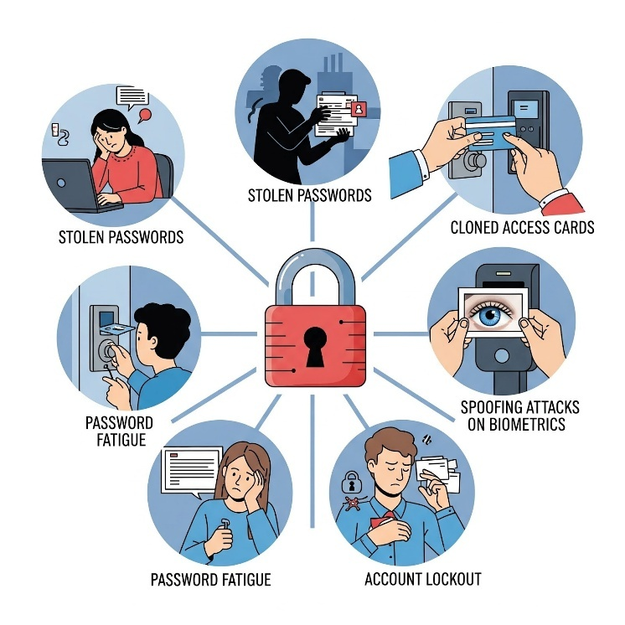
Figure 1: Problems in Contemporary Biometric Systems

3. MAIN GOAL AND OBJECTIVES
The project aims to develop a multi-platform, multi-tenant, and cloud-native SaaS platform for secure and flexible multi-biometric identity authentication.
The specific objectives set to achieve this main goal are as follows:
- To design and develop a secure and scalable backend infrastructure. This infrastructure will consist of a main service (Identity Core API) responsible for user, tenant, and role management, and a specialized service (Biometric Processor API) for handling computationally intensive biometric operations, in accordance with microservices architecture principles.
- To develop an innovative and active liveness detection algorithm, the "Biometric Puzzle," which requires the user to complete a randomly generated sequence of actions (e.g., smiling, blinking) to prevent spoofing attacks using static photos, video recordings, or masks.
- To integrate high-accuracy face recognition and face verification capabilities into the system using proven deep learning models, such as those provided by the DeepFace library, and to evaluate their performance.
- To develop a user-friendly mobile application for both Android and iOS platforms that allows end-users to enroll their biometric data and authenticate their identity.
- To design the necessary multi-tenant data model for the system to operate as a SaaS platform and to ensure that each tenant's data is completely isolated at the PostgreSQL database level.
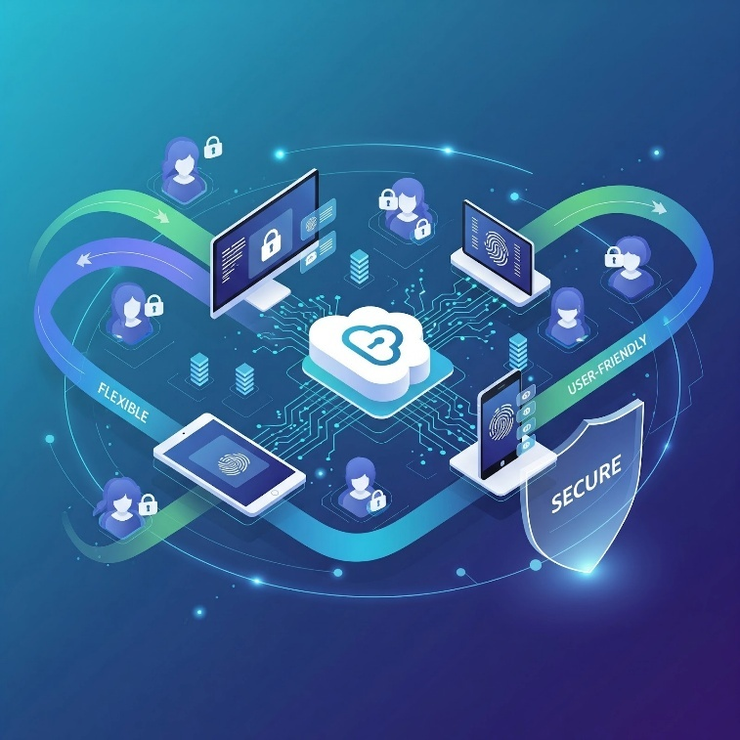
Figure 2: Secure and Multi-Platform Support

4. RELATED WORK
The field of automated identity verification and biometric authentication has progressed rapidly, driven by advances in deep learning, liveness detection, and cloud-native deployment. Foundational frameworks such as DeepFace and FaceNet demonstrated that deep networks could encode facial images into numerical embeddings for comparison, establishing the basis of modern face recognition. However, these systems were limited to single-device operation without scalability, modularity, or compliance with enterprise requirements. Our project extends these principles into a multi-service, distributed platform designed for real-time verification, data isolation, and tenant-based scalability [12],[13].
Significant model-level improvements emerged with ArcFace, which introduced angular margin loss for more discriminative facial embeddings [4]. Further developments such as AdaFace and MagFace improved robustness under low-quality and off-angle conditions through adaptive margin learning [7]. While these methods enhanced verification accuracy, they mainly addressed algorithmic precision rather than system-level deployment. Our implementation combines these approaches through InsightFace, embedding them in a microservices architecture where the biometric inference engine operates independently of identity management, supporting concurrent and secure operations across multiple tenants [5], [8], [11].
Beyond recognition accuracy, liveness detection remains essential to prevent spoofing. Recent studies using ResNet-18 or MobileNetV3 architectures with AdMSoftmax Loss achieved high detection accuracy for presentation attacks, but most function as isolated models. Our system merges both passive texture-based and active challenge–response verification, integrating ResNet-18 and Google MediaPipe in a two-stage liveness pipeline [6]. This hybrid approach ensures resilience against photo, video, and deepfake attacks with minimal latency [3].
In addition to academic research, industrial solutions have advanced the field. Microsoft Azure Face Liveness Detection offers PAD-compliant active and passive verification; Amazon Rekognition Face Liveness analyzes selfie videos to detect spoofs via deepfake and mask resistance; and Sodec Technologies (Türkiye) provides ID verification with passive liveness for e-government and banking applications. FaceAuth Vision, an open-source OpenCV-based system, demonstrates offline flexibility but lacks industrial-grade spoof detection, while BioGATE Pass (Proline) integrates NFC chip reading under ICAO compliance for high-trust ID verification [9]. (See Table 1 for comparison.)
Compared to these systems, our project aims to bridge the gap between commercial reliability and open research flexibility by providing a cloud-native, multi-tenant, and multi-platform SaaS framework. It integrates both active and passive liveness detection, multi-biometric fusion, and official ID photo-based verification within a scalable microservices architecture. This approach ensures alignment with ISO/IEC Presentation Attack Detection (PAD) standards, enabling robust protection against spoofing attempts such as masks, deepfakes, or printed photos. It supports customizable deployments for privacy-conscious institutions and offers a transparent alternative to proprietary cloud solutions through open-source technologies.
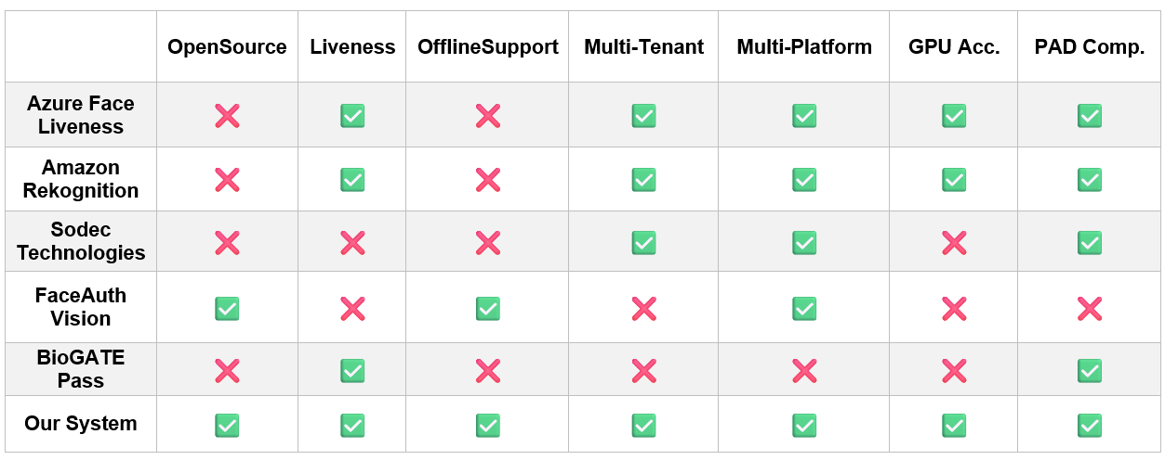
Table 1: Comparison of Face Recognition and Liveness Systems

5. SCOPE
The scope of this project includes the development of a Minimum Viable Product (MVP) of the platform, encompassing its core functionalities. The items that are within and outside the scope of this project are clearly defined below.

5.1. In Scope
- Backend Development: Development of the Identity Core API and Biometric Processor API microservices using Spring Boot and FastAPI.
- Database Architecture: Design of a multi-tenant data model on PostgreSQL, including user, role, and tenant tables, and the storage of biometric vectors using the pgvector extension.
- Face Biometrics: Integration of face recognition (1: N) and face verification (1:1) functionalities using the DeepFace library.
- Liveness Detection: Development of the on-device "Biometric Puzzle" algorithm using Google MediaPipe.
- Mobile Application: Development of basic user interfaces for both Android and iOS platforms using Flutter, enabling end-user enrollment and authentication.
- Infrastructure: Containerization of the entire system using Docker and Docker Compose for local development and execution.

5.2. Out of Scope
- Hardware Production: Design and manufacturing of dedicated Edge devices for physical access control are excluded. These interactions will be simulated using a Raspberry Pi or Jetson Nano.

5.3. Constraints
- Hardware Constraints: The performance of the verification and liveness detection algorithm will be limited by the processing power and camera quality of the mobile devices used for testing.
- Data Constraints: The training of the face recognition model is out of scope. The system's accuracy will be limited by the performance of the pre-trained models provided by the DeepFace library.
- Image Quality Constraint: For optimal performance in face recognition and liveness detection, input images should have a resolution higher than 480p. Lower-quality images may reduce detection accuracy and reliability.

5.4. Assumptions
- It is assumed that stable versions of the chosen open-source libraries (DeepFace, MediaPipe, Spring, FastAPI) will be accessible and compatible throughout the project lifecycle.
- It is assumed that the mobile devices used for testing meet the minimum hardware requirements for real-time video analysis.
- It is assumed that the team members possess the fundamental competencies in the selected technologies (Java, Python, Flutter, Docker) and can acquire any necessary additional knowledge during the project.

6. METHODOLOGY AND TECHNICAL APPROACH
The system employs a microservices-based architecture that ensures modularity, scalability, and fault isolation while forming a cloud-native multi-biometric SaaS platform with maintainability, resilience, and secure tenant isolation.

6.1. High-Level System Architecture
The platform follows a distributed microservices model operating behind a unified API Gateway.
Services communicate via REST APIs for synchronous requests and Redis-based message queues for asynchronous workflows. The data layer combines relational and vector databases for structured and biometric data management.
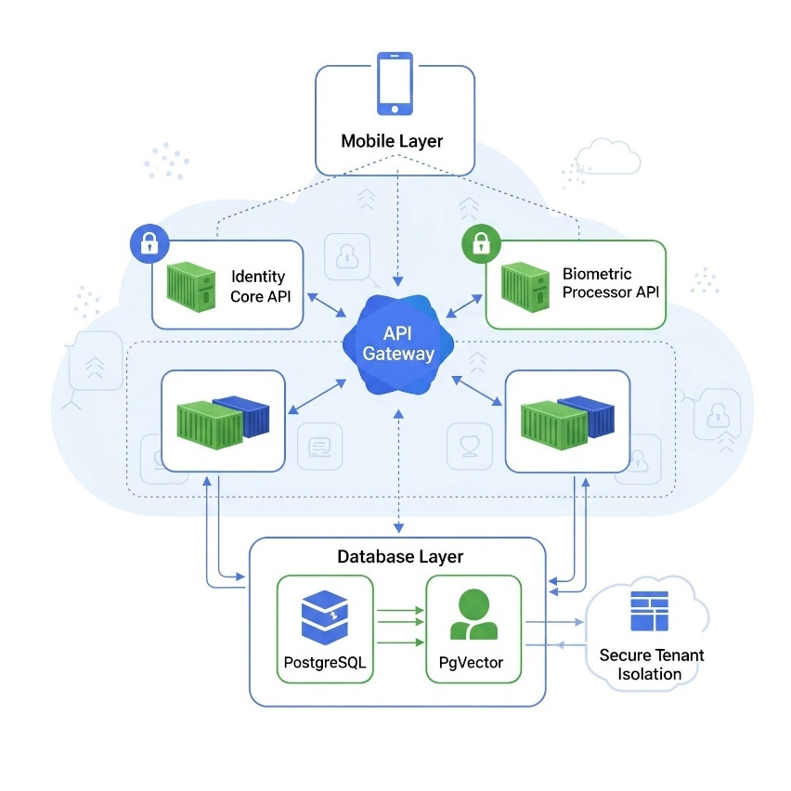
Figure 3: Cloud-Native Multi-Biometric Authentication Architecture
According to Figure 3:
Identity Core API (Spring Boot)
Architecture: Hexagonal Architecture pattern implementing Domain-Driven Design principles.
Core Responsibilities:
- Authentication & Authorization: JWT-based token management with refresh token mechanism and role-based access control (RBAC)
- Tenant Management: Multi-tenant data isolation and tenant-specific configuration management
- User & Role Administration: CRUD operations for users, roles, and permission assignments
- Service Orchestration: Central coordination point for all platform services, managing the workflow between frontend and Biometric Processor API
Biometric Processor API (FastAPI)
Architecture: Event-driven microservice optimized for compute-intensive ML workloads, implementing Clean Architecture principles.
Core Responsibilities:
- Feature Extraction: Deep learning-based facial embedding generation.
- Identity Matching: 1:1 verification and 1:N identification using cosine similarity metrics.
- Liveness Detection: Multi-modal anti-spoofing analysis combining passive and active detection.
Database Layer: PostgreSQL serves as the primary datastore for transactional operations with ACID compliance and multi-tenant isolation through Row-Level Security (RLS). The pgvector extension enables sub-millisecond similarity searches on high-dimensional facial embeddings (2622-d vectors) using HNSW indexing, supporting both 1:1 verification and 1:N identification queries.
Mobile Layer: Flutter-based cross-platform application implementing MVVM architecture with BLoC pattern for state management. Key features include on-device liveness detection via Google MediaPipe (reducing latency from 500ms to 50ms), real-time facial landmark tracking, and encrypted biometric data transmission. The Repository Pattern abstracts backend communication while maintaining offline capability for critical flows.
Infrastructure Layer: Containerized microservices architecture using Docker Compose for development and Kubernetes-ready deployment manifests for production. Implements horizontal auto-scaling through HPA, service mesh for inter-service communication, and centralized logging.
Figure 4 illustrates the comprehensive flow of our system, detailing the interactions between system components. It highlights the step-by-step process for liveness detection, face image enrollment, and embedding generation.
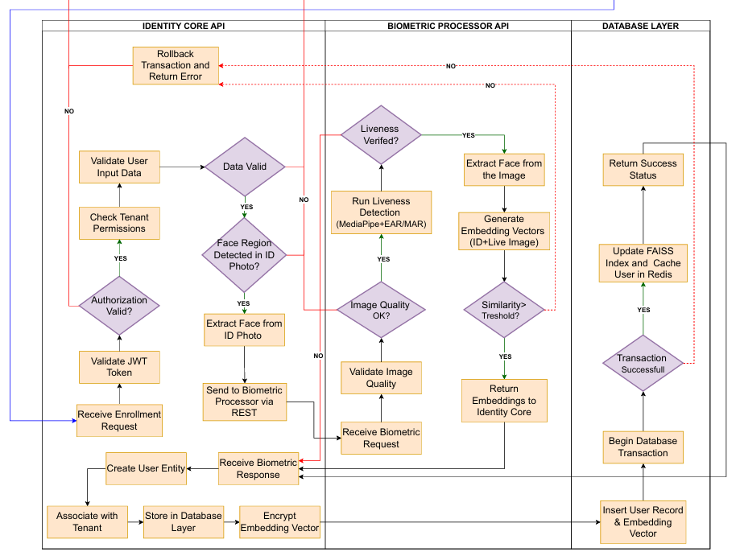
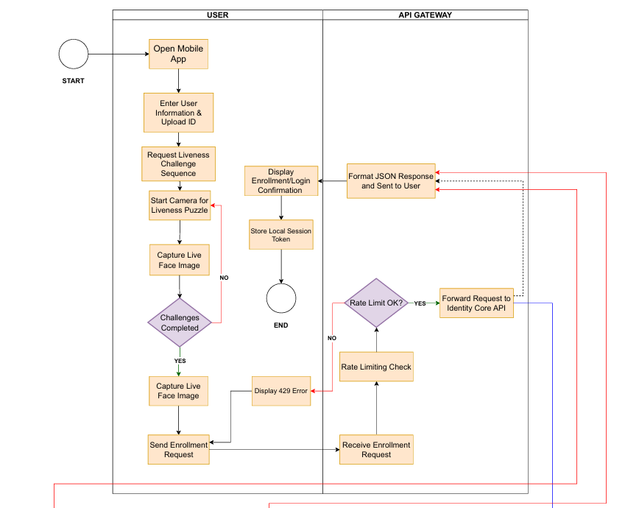
Figure 4: Flow Chart of Our System

6.2. Technical Approach and Algorithms

6.2.1. Biometric Puzzle (Liveness Detection) Algorithm
Liveness detection runs on the mobile device to improve responsiveness and privacy through an active challenge–response combined with passive texture cues:
- The backend sends random challenges (e.g., blink, smile, turn head).
- The app captures video via OpenCV and processes frames with Google MediaPipe to track 468 facial landmarks. (Figure 5)
- Metrics like Eye Aspect Ratio (EAR) and Mouth Aspect Ratio (MAR) detect specific actions.
- Once all challenges succeed, the app confirms liveness and securely transmits the validated frame to the backend.
This hybrid approach, illustrated in Figure 6, prevents spoofing attempts using photos, video replays, or deepfakes by requiring genuine facial motion and temporal consistency.

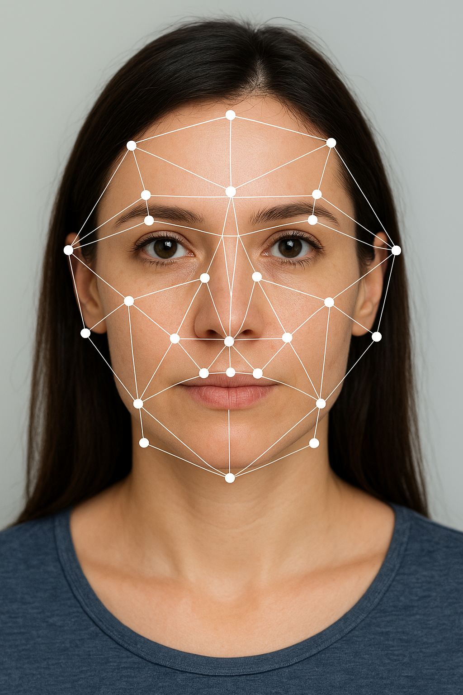
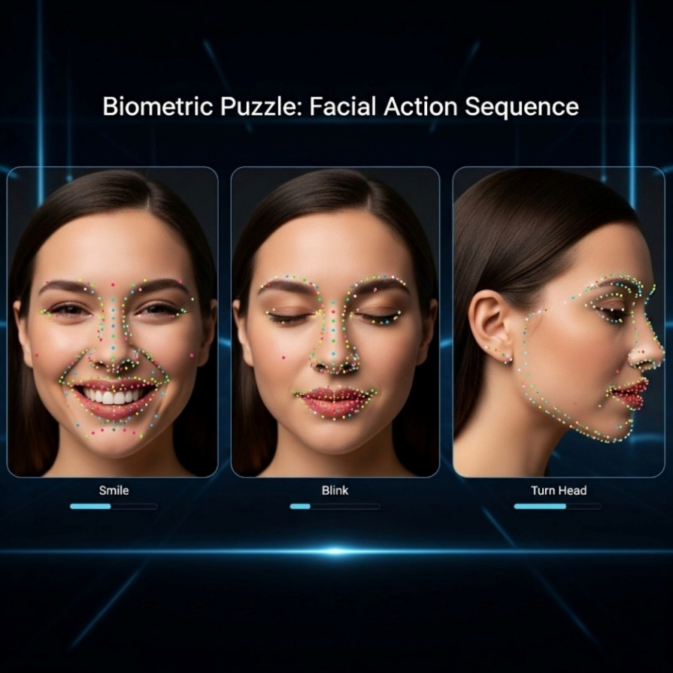

Figure 5: Face Landmarking Figure 6: Biometric Puzzle, Facial Action Sequence

6.2.2. Face Recognition and Identity Verification
During enrollment, the user’s face is extracted from an ID photo and converted into a 2622-dimensional embedding via DeepFace.represent(), stored in a pgvector column.
At authentication, a live embedding is generated from the liveness-verified image, and cosine similarity is computed:
$$\text{Similarity}=1-\frac{A⋅B}{∥A∥∥B∥}$$
Equation 1: Similarity
If similarity exceeds the tuned threshold, verification succeeds. For 1:N searches, FAISS enables sub-millisecond nearest-neighbor retrieval among stored embeddings.

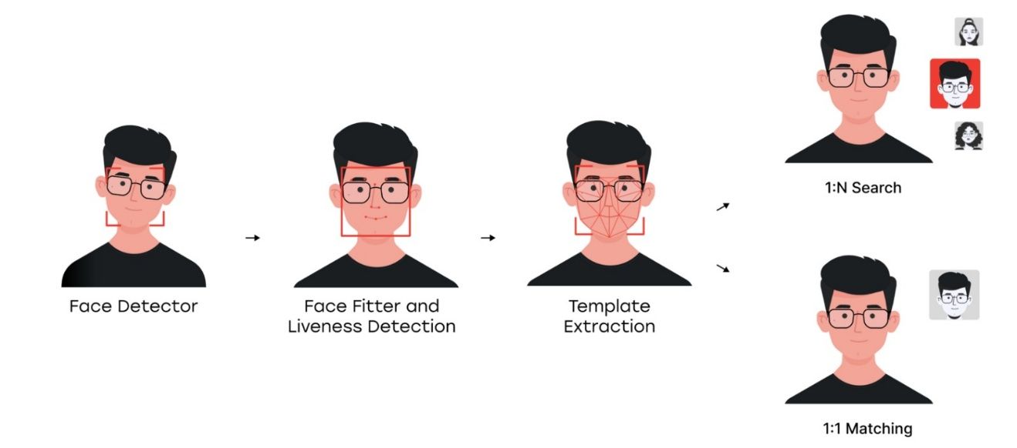
Figure 7: Identification Steps

6.2.3. System Integration and Security
All inter-service communication will occur over HTTPS with token-based authentication. Sensitive biometric embeddings are encrypted before storage, and role-based access control (RBAC) ensures that tenants can only access their isolated data domain.
Continuous integration and testing pipelines verify API integrity after each deployment using Postman and Pytest/JUnit test suites.

6.3. Performance Evaluation
System performance will be assessed for both biometric accuracy and operational efficiency:

- Biometric Metrics:
  - FAR (False Acceptance Rate)
  - FRR (False Rejection Rate)
  - EER (Equal Error Rate)
- Liveness Metrics:
Evaluated using spoofing tests (printed photos, videos, masks) with APCER and BPCER metrics.
- System Metrics:
  - Average API response < 300 ms
  - Query latency < 100 ms
  - Stable throughput under simulated multi-tenant load
Load testing will employ Apache JMeter or similar tools.

6.4. Resources
- Software & Development Tools: IntelliJ IDEA (Java), PyCharm (Python), Visual Studio Code (Flutter), Docker Desktop, Postman, Git and GitHub for version control.

- Libraries / Frameworks: Spring Boot, FastAPI, Flutter, DeepFace, InsightFace, Google MediaPipe, OpenCV, PostgreSQL, Redis, FAISS, pgvector.

- Hardware: Personal computers for development. Two Android and two iOS devices for mobile testing and performance comparison.
Data: Publicly available datasets such as Labeled Faces in the Wild (LFW) and controlled test images collected with consent from project members. Synthetic data will be generated to simulate enrollment and authentication events.

7. PROFESSIONAL CONSIDERATIONS

7.1. Methodological considerations/engineering standards
The project follows modern software engineering principles to ensure quality, maintainability, and reproducibility. Project management will be conducted via a Kanban board on GitHub Projects, with source control and versioning managed through Git within a GitHub Organization. All code changes will undergo peer review through pull requests before merging. System design and documentation will use UML diagrams to visualize workflows, while a Gantt chart will track progress. Language-specific linting and formatting rules will ensure code quality, and testing frameworks will verify functionality and reliability.

7.2. Realistic Constraints
The project design has been made considering economic, environmental, ethical, health and safety, sustainability, and social factors.
Economic: Open-source technologies eliminate software costs. The SaaS model supports scalable and low-cost commercial deployment.
Environmental: As a software system, it generates no direct waste. Energy efficiency is prioritized to reduce the indirect impact of server and device usage.
Ethical: Users are informed and provide explicit consent for biometric data processing. Algorithmic bias will be mitigated by testing diverse datasets and monitoring fairness metrics.
Health & Safety: The system poses no physical risks. All personal and biometric data are encrypted both in transit (TLS) and at rest (AES-256).
Sustainability: The modular microservices architecture and Docker-based deployment support maintainability and long-term scalability.
Social: The platform enhances security and user experience while enforcing strict data access controls to prevent misuse for surveillance.

7.3. Legal considerations
As the platform processes biometric data, it will comply with the Turkish Personal Data Protection Law (KVKK No. 6698) and the EU General Data Protection Regulation (GDPR). Data handling will adhere to principles of data minimization, purpose limitation, explicit consent, security, and the right to be forgotten. All open-source dependencies will be checked for license compatibility to prevent legal conflicts in future commercialization. Documentation will include each dependency’s license and compliance status.

8. MANAGEMENT PLAN

8.1. Description of Task Phases

8.1.1 Requirements Analysis & Literature Review
Academic Literature Survey: Research contemporary facial recognition architectures such as DeepFace, FaceNet, ArcFace, InsightFace; privacy threat modeling methodologies (LINDDUN), GDPR compliance requirements, serverless computing patterns, and anti-spoofing techniques.
Technology Stack Evaluation: Compare facial recognition libraries, embedding search solutions, cloud platforms, and message queue systems.
Requirements Documentation: Define functional requirements, non-functional requirements, security requirements, and prepare Project Specification Document.

8.1.2 System Architecture Design
Microservices Architecture Design: Design Authentication Service, Biometric Processing Service, Identity Verification Service, and Data Management Service.
Hexagonal Architecture Implementation: Define ports and adapters for external dependencies. Establish dependency injection patterns and inter-service communication protocols.
Database & Security Design: Design relational schema for user management, embedding storage in FAISS, Redis caching structures, and data retention policies. Plan end-to-end encryption, API authentication, and audit logging.

8.1.3 Core Services Development
Authentication Service: Implement user registration with BCrypt hashing, JWT authentication with refresh tokens.
Biometric Processing Service: Integrate Deepface, MediaPipe Face Mesh, anti-spoofing module, active liveness detection.
Identity Verification Service: Implement 1:1 verification (cosine similarity >0.6), 1:N identification (FAISS top-k), enrollment with ID parsing, verification history.
Data Management Service: Implement PostgreSQL repository pattern, FAISS index management, Redis caching, Kafka event publishing, and transactional consistency.

8.1.4 Frontend Development
Web Application: Authentication UI, enrollment wizard with ID upload and live capture, verification interface with real-time camera, admin dashboard, responsive design.
Mobile Application: Native camera integration, real-time face detection overlay, enrollment flow, verification with challenge-response UI, push notifications, and offline capability.
Desktop Application: Kiosk mode for self-service, admin interface for bulk operations, reporting with JFreeChart, and configuration management UI.

8.1.5 System Integration
API Gateway Configuration: Rate limiting, request routing, API key authentication, and CORS policies.
Message Queue Integration: Configure Kafka topics, implement producers/ consumers, set up RabbitMQ for task queues, and DLQ handling.
Caching Strategy: Configure Redis cluster, implement cache-aside pattern, and optimize TTL values.
8.1.6 Testing & Quality Assurance
Functional Testing: Validate the accuracy of face recognition, liveness detection, and identity verification features to ensure correct functionality across all modules.
Performance Testing: Assess system responsiveness, scalability, and stability under high user loads to confirm efficient operation.
Security Testing: Conduct penetration and vulnerability tests to verify data protection, encryption, and system resilience against potential attacks.
Usability Testing: Perform user acceptance testing to evaluate accessibility, interface clarity, and overall user experience for continuous improvement.

8.1.7 Deployment & Documentation
Production Deployment: Deploy the system on a Kubernetes-based cloud environment with secure networking, database replication, and service scalability.
Monitoring & Logging: Implement monitoring dashboards and centralized logging to track performance, detect errors, and ensure system reliability.
Backup & Disaster Recovery: Set up automated backups and disaster recovery procedures to maintain data integrity and minimize downtime.

8.1.8 Final Testing & Presentation
End-to-End Validation: Execute complete user journeys, verify failure scenarios, validate data consistency, and confirm all acceptance criteria.
Deliverables Preparation: Finalize source code, package deployment artifacts, complete documentation, and prepare presentation materials.

8.2. Division of Responsibilities
The project adopts a cross-functional team structure where all members contribute to every component while maintaining weighted responsibilities based on expertise. Ahmet Abdullah Gültekin serves as primary owner for backend development, Ayşe Gülsüm Eren drives application development, and Ayşenur Arıcı leads AI/ML implementation. However, each member actively participates in all project areas ensuring no single point of failure. This shared ownership model promotes knowledge distribution, enables parallel development, and maintains project continuity.

Figure 8:Task Distribution Chart

8.3. Timeline
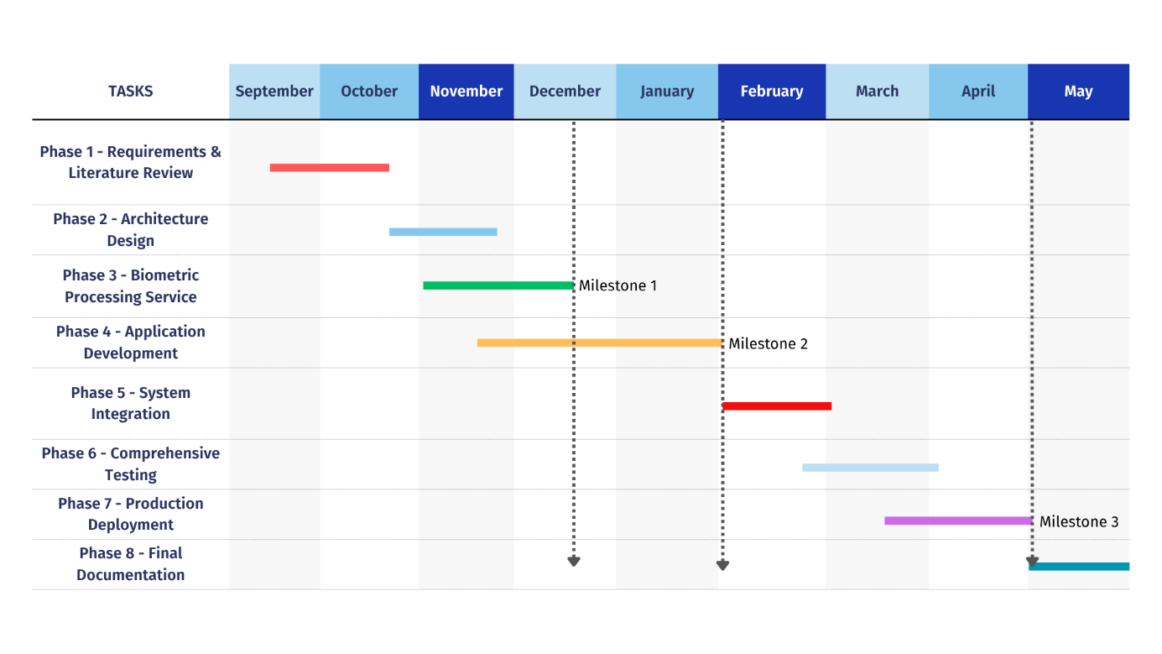
Figure 9: Project Timeline

9. SUCCESS FACTORS AND RISK MANAGEMENT

9.1. Measurability/Measuring Success
The success of the project will be evaluated based on the extent to which each objective defined in Section 3 is met. The success criteria for each objective are defined below:
- Objective 1: To design and develop a secure and scalable backend infrastructure. Success Factor: All microservices run smoothly on Docker, API endpoints pass Postman tests successfully, and basic user/tenant CRUD operations function as expected.
- Objective 2: To develop an innovative and active liveness detection algorithm ("Biometric Puzzle"). Success Factor: The developed algorithm can be completed by legitimate users with a success rate of over 95%, and it rejects simple spoofing attacks, such as static photos or videos held up to the camera, with a rate of over 99%.
- Objective 3: To integrate high-accuracy face recognition capabilities into the system. Success Factor: The system operates in a controlled test environment with a False Acceptance Rate (FAR) of less than 1% and a False Rejection Rate (FRR) of less than 5%.
- Objective 4: To develop a user-friendly mobile application. Success Factor: The mobile application runs stably on both Android and iOS devices, and an end-user can complete the enrollment and authentication flow smoothly in under 1 minute.
- Objective 5: To design the multi-tenant data model. Success Factor: Integration tests prove that a user belonging to one tenant cannot access the data of another tenant under any circumstances.

9.2. Risk Management
Potential risks that may be encountered during the project and the contingency plans (Plan B) for these risks are listed below:
- Risk 1: Insufficient Technical Competency Description: Team members encounter more difficulty than expected with one of the selected technologies, slowing down the development process. Plan B: Undertake intensive online training and seek support from relevant technology communities (forums, Discord channels). If necessary, simplify the scope of the feature.
- Risk 2: Library Performance Issues Description: Google MediaPipe fails to deliver adequate performance for real-time analysis on the low-end devices used for testing. Plan B: Reduce the number of landmarks to be analyzed, decrease the resolution of the video stream, or reduce the number of steps in the "Biometric Puzzle" to lighten the processing load.
- Risk 3: Integration Problems Description: Unexpected issues arise in communication between microservices written in different languages (Java and Python) or with the mobile application. Plan B: Define API contracts (OpenAPI) in detail from the very beginning. Consider a stricter protocol for inter-service communication, such as gRPC.

10. BENEFITS AND IMPACT OF THE PROJECT

10.1. Benefits/Implications
The project will benefit both end-users and service providers. End-users will experience secure and seamless authentication without dealing with passwords or access cards. Service providers will lower operational costs, enhance security, and gain a competitive edge by offering a modern authentication solution.

10.2. Scientific Impact
The “Biometric Puzzle” algorithm introduces an innovative approach to active liveness detection. Analysis of its performance, accuracy, and spoofing resistance could make valuable contributions to the field. If successful, the results may be presented at conferences or published in scientific journals.

10.3. Economic/Commercial/Social Impact
The project will yield a prototype with strong commercialization potential. The SaaS platform can adopt a subscription-based revenue model and form the foundation of a start-up. Socially, it will promote secure authentication, support digital transformation, and help reduce cybercrime.

10.4. Potential Impact on New Projects
Combining modern practices such as microservices, cloud-native technologies, and mobile machine learning, the project’s open-source infrastructure can guide future student projects. It may inspire new initiatives integrating other biometric modalities or developing adaptive authentication systems.

REFERENCES
[1] Beltrán, M., & Calvo, M. (2023). A privacy threat model for identity verification based on facial recognition. Computers & Security, 132, 103324.
https://doi.org/10.1016/j.cose.2023.103324
[2] Challapalli, S. S. A., et al. (2024). Profile Face Recognition and Classification Using Multi-Task Cascaded Convolutional Networks (MTCNN). Journal of Computer and Artificial Intelligence, 2(1), 29. https://doi.org/10.69996/jcai.2024029
[3] Chen, Y., et al. (2018). MobileFaceNets: Efficient CNNs for Accurate Real-Time Face Verification on Mobile Devices. arXiv preprint arXiv:1804.06655.
https://arxiv.org/abs/1804.06655
[4] Deng, J., Guo, J., Xue, N., & Zafeiriou, S. (2019). ArcFace: Additive Angular Margin Loss for Deep Face Recognition. In Proceedings of the IEEE/CVF Conference on Computer Vision and Pattern Recognition (CVPR) (pp. 4690–4699).
https://arxiv.org/abs/1801.07698
[5] Fowler, M. (2014, March 25). Microservices: A Definition of This New Architectural Term. https://martinfowler.com/articles/microservices.html
[6] Google. (2023). MediaPipe Face Landmark Detection. Retrieved from https://developers.google.com/mediapipe/solutions/vision/face_landmarker
[7] Kim, K., et al. (2022). AdaFace: Quality Adaptive Margin for Face Recognition. arXiv preprint arXiv:2204.00964. https://arxiv.org/abs/2204.00964
[8] Koch, G., Zemel, R., & Salakhutdinov, R. (2015). Siamese Neural Networks for One-shot Image Recognition. In ICML Deep Learning Workshop.
https://www.cs.cmu.edu/~rsalakhu/papers/oneshot1.pdf
[9] Kottakota, S. S., & Gnaneswar, A. (2024). Secured artificial intelligence based face anti-spoofing detection model via serverless architecture and SaaS based cloud platform. Preprints. https://doi.org/10.20944/preprints202409.0740.v1
[10] LINDDUN. (n.d.). LINDDUN Privacy Threat Modeling Framework. Retrieved from https://linddun.org/
[11] Newman, S. (2021). Building Microservices: Designing Fine-Grained Systems (2nd ed.). O'Reilly Media. https://www.oreilly.com/library/view/building-microservices-2nd/9781492034018/
[12] Schroff, F., Kalenichenko, D., & Philbin, J. (2015). FaceNet: A unified embedding for face recognition and clustering. In 2015 IEEE Conference on Computer Vision and Pattern Recognition (CVPR) (pp. 815–823). IEEE.
https://doi.org/10.1109/CVPR.2015.7298682
[13] Taigman, Y., Yang, M., Ranzato, M., & Wolf, L. (2014). DeepFace: Closing the Gap to Human-Level Performance in Face Verification. Conference on Computer Vision and Pattern Recognition (CVPR).
https://www.cs.toronto.edu/~ranzato/publications/taigman_cvpr14.pdf

