FACE AND IDENTITY VERIFICATION USING CLOUD BASED SAAS MODELS

Architectural Design Document (ADD)
________________________________________________________________________________
CSE4197 Engineering Project 2
Marmara University, Faculty of Engineering Computer Engineering Department
Spring Semester 2026
________________________________________________________________________________
Supervised by: Assoc. Prof. Dr. Mustafa Ağaoğlu
Team Members:
- Ahmet Abdullah Gültekin - 150121025 (Project Lead & Backend Developer)
- Ayşe Gülsüm Eren - 150120005 (Mobile Application Developer)
- Ayşenur Arıcı - 150123825 (AI/ML & Biometric Systems)
________________________________________________________________________________
Document Version: 1.0 Last Updated: January 2026
________________________________________________________________________________

Table of Contents
- Introduction
- 1.1 Problem Description
- 1.2 Scope
- 1.3 Definitions and Acronyms
- Literature Survey
- Project Requirements
- 3.1 Functional Requirements
- 3.2 Non-Functional Requirements
- System Design
- 4.1 Use Case Diagrams
- 4.2 Class and ER Diagrams
- 4.3 User Interface Design
- 4.4 Test Plan
- Software Architecture
- 5.1 Architectural Style
- 5.2 Component Architecture
- 5.3 Data Architecture
- 5.4 Deployment Architecture
- Tasks Accomplished
- 6.1 Current State of the System
- 6.2 Task Log
- 6.3 Gantt Chart
- References
________________________________________________________________________________

1. Introduction

1.1 Problem Description
Traditional authentication methods present significant security vulnerabilities and poor user experiences in modern digital and physical access scenarios. Passwords can be stolen through phishing or data breaches, access cards can be cloned, and single-factor biometric systems remain vulnerable to spoofing attacks using static photos, videos, or sophisticated masks.
This project addresses these challenges by developing FIVUCSAS (Face and Identity Verification Using Cloud-based SaaS) - a multi-tenant, cloud-native biometric authentication platform. The system integrates advanced face recognition with an innovative active liveness detection algorithm called "Biometric Puzzle" to provide robust protection against fraud while maintaining excellent user experience through developer-friendly APIs.
The platform targets B2B and B2B2C markets, unifying both physical access control (door entry, kiosk authentication) and digital authentication (system login, transaction verification) under a single identity management solution.

1.2 Scope
1.2.1 In Scope
Category | Items
Backend Services | Identity Core API (Spring Boot 3.2/Java 21), Biometric Processor API (FastAPI/Python 3.11)
Client Applications | Web Admin Dashboard (React 18), Mobile App (Android), Desktop App (Windows/Linux/macOS) using Kotlin Multiplatform
Database Architecture | Multi-tenant PostgreSQL 16 with pgvector extension for face embeddings
Face Biometrics | Face recognition (1:N), face verification (1:1) using DeepFace library with 9 model options
Liveness Detection | "Biometric Puzzle" active liveness + passive anti-spoofing using MediaPipe (468 facial landmarks)
Infrastructure | Docker Compose containerization, NGINX API Gateway, Redis caching
Security | JWT authentication, RBAC authorization, BCrypt password hashing, rate limiting

1.2.2 Out of Scope
- Other biometric modalities (fingerprint, voice, iris) - architecture supports but not implemented
- Production cloud deployment (Kubernetes) - system delivered as Docker Compose
- Edge device hardware manufacturing - simulated in software
- Advanced billing and subscription management UI
- NFC card reading functionality
1.2.3 Constraints
Constraint Type | Description
Technology | Exclusively open-source technologies with permissive licenses
Infrastructure | VPS hosting may be utilized for deployment (updated from initial constraint)
Hardware | Liveness detection performance limited by device camera quality and processing power
Data | No custom model training; relies on pre-trained DeepFace models

1.3 Definitions and Acronyms
Term | Definition
ADD | Architectural Design Document
API | Application Programming Interface
BCrypt | Password hashing algorithm with configurable work factor
DeepFace | Python library providing face recognition models (VGG-Face, Facenet, ArcFace, etc.)
EAR | Eye Aspect Ratio - metric for blink detection
Embedding | High-dimensional vector representation of a face
FAR | False Acceptance Rate
FRR | False Rejection Rate
GDPR | General Data Protection Regulation (EU)
Hexagonal Architecture | Ports and Adapters pattern for clean separation of concerns
JWT | JSON Web Token for stateless authentication
KMP | Kotlin Multiplatform - cross-platform development framework
KVKK | Turkish Personal Data Protection Law (No. 6698)
MAR | Mouth Aspect Ratio - metric for smile detection
MediaPipe | Google's ML library for real-time face landmark detection
MVP | Minimum Viable Product
pgvector | PostgreSQL extension for vector similarity search
RBAC | Role-Based Access Control
SaaS | Software as a Service
Spoofing | Attempt to bypass biometric authentication using fake biometrics

________________________________________________________________________________

2. Literature Survey

2.1 Identity and Access Management Landscape
The Identity and Access Management (IAM) market is dominated by established players including Okta, Auth0, and Microsoft Azure Active Directory. These platforms primarily focus on traditional multi-factor authentication (MFA) methods:
- Password-based authentication with complexity requirements
- One-Time Passwords (OTP) via SMS or authenticator apps
- Push notifications for approval
- Device-based biometrics (Apple Face ID, Android fingerprint)
While these solutions are mature, they present limitations:
- Device-bound biometrics create siloed identity experiences
- Physical access control requires separate third-party integrations
- Passive biometric verification remains vulnerable to sophisticated attacks

2.2 Face Recognition Technologies
Deep learning has revolutionized face recognition, achieving and surpassing human-level performance:
Model | Embedding Dimension | Architecture | LFW Accuracy
VGG-Face | 2,622 | VGGNet | 98.95%
Facenet512 | 512 | Inception ResNet | 99.65%
ArcFace | 512 | ResNet | 99.82%
DeepFace | 4,096 | AlexNet | 97.35%
OpenFace | 128 | Inception | 92.92%

The DeepFace library (Serengil & Ozpinar, 2021) provides unified access to these models, enabling:
- Face detection (MTCNN, RetinaFace, SSD)
- Face alignment and preprocessing
- Embedding generation
- Similarity computation (cosine, euclidean)

2.3 Liveness Detection Approaches
Face anti-spoofing research has evolved through several paradigms:
Passive Methods:
- Texture analysis using Local Binary Patterns (LBP)
- Frequency domain analysis for moire patterns
- Color space analysis for skin tone verification
- Depth estimation from single images
Active Methods:
- Challenge-response requiring user interaction
- Randomized action sequences
- Micro-expression tracking
Limitations of Passive Methods:
- Vulnerable to high-quality prints and video replays
- Susceptible to 3D mask attacks
- Performance degrades with camera quality variations

2.4 Project Differentiation
FIVUCSAS differentiates from existing solutions through:
- Unified Physical-Digital Identity: Single platform for door access, kiosk authentication, and digital login
- Active Liveness - Biometric Puzzle: Random, sequential action challenges that passive attacks cannot defeat
- Cloud-Native Microservices: Scalable, maintainable architecture with developer-friendly APIs
- Multi-Model Support: 9 face recognition models with configurable thresholds per tenant
- Open-Source Foundation: Fully transparent, auditable codebase with permissive licensing
________________________________________________________________________________

3. Project Requirements

3.1 Functional Requirements
FR-1: User Authentication and Management
ID | Requirement | Inputs | Processing | Outputs | Error Handling
FR-1.1 | User Registration | Email, password, first name, last name, tenant ID | Validate email format, check uniqueness within tenant, hash password with BCrypt (work factor 12), create user record | User ID, confirmation | 409 Conflict if email exists, 400 Bad Request for validation failures
FR-1.2 | User Login | Email, password, tenant ID | Validate credentials, generate JWT access token (15 min) and refresh token (7 days), create session | Access token, refresh token, user profile | 401 Unauthorized for invalid credentials, 423 Locked if account locked
FR-1.3 | Token Refresh | Refresh token | Validate token, check revocation status, generate new token pair | New access token, new refresh token | 401 Unauthorized if token invalid/revoked
FR-1.4 | Password Reset | Email | Generate reset token, send email notification, token expires in 24 hours | Confirmation message | 404 Not Found if email not registered
FR-1.5 | Profile Update | User ID, profile fields | Validate permissions, update allowed fields | Updated user profile | 403 Forbidden if unauthorized

FR-2: Biometric Enrollment
ID | Requirement | Inputs | Processing | Outputs | Error Handling
FR-2.1 | Face Enrollment | User ID, face image(s), liveness proof | Detect face, assess quality (>0.5), verify liveness, generate embedding, store with pgvector | Enrollment ID, quality score | 400 if no face detected, 422 if quality insufficient
FR-2.2 | Quality Assessment | Face image | Analyze brightness, sharpness, pose, occlusion | Quality score (0-1), quality level (EXCELLENT/GOOD/FAIR/POOR) | 400 if image unprocessable
FR-2.3 | Liveness Verification | Challenge ID, video frames | Track facial landmarks, compute EAR/MAR/head pose, verify challenge completion | Liveness result, confidence score | 400 if insufficient frames, 403 if spoof detected
FR-2.4 | Re-enrollment | User ID, new face image, admin override | Delete existing enrollment, process new enrollment | New enrollment ID | 403 if not authorized

FR-3: Biometric Verification
ID | Requirement | Inputs | Processing | Outputs | Error Handling
FR-3.1 | 1:1 Verification | User ID, face image | Generate embedding, compare with stored embedding using cosine similarity | Match result, similarity score | 404 if user not enrolled, 401 if no match
FR-3.2 | 1:N Search | Face image, tenant ID, top_k | Generate embedding, vector similarity search across tenant enrollments | Top-k matches with scores | 404 if no matches above threshold
FR-3.3 | Verification with Liveness | Face image, liveness proof | Verify liveness first, then perform verification | Verification result with liveness status | 403 if liveness fails

FR-4: Multi-Tenant Administration
ID | Requirement | Inputs | Processing | Outputs | Error Handling
FR-4.1 | Tenant Creation | Name, domain, subscription plan, settings | Validate domain uniqueness, create tenant with quotas | Tenant ID, API keys | 409 if domain exists
FR-4.2 | Tenant Configuration | Tenant ID, settings | Update biometric thresholds, liveness requirements, rate limits | Updated configuration | 403 if not tenant admin
FR-4.3 | User Quota Management | Tenant ID | Track user count against max_users limit | Current usage, remaining quota | 403 if quota exceeded on new user creation
FR-4.4 | Enrollment Quota Management | Tenant ID | Track enrollment count against maxbiometricenrollments | Current usage, remaining quota | 403 if quota exceeded

FR-5: Role-Based Access Control
ID | Requirement | Inputs | Processing | Outputs | Error Handling
FR-5.1 | Role Assignment | User ID, role ID | Validate assigner permissions, create user-role mapping | Assignment confirmation | 403 if insufficient permissions
FR-5.2 | Permission Check | User ID, resource, action | Resolve user roles, aggregate permissions, check authorization | Boolean authorization result | -
FR-5.3 | Custom Role Creation | Tenant ID, role name, permissions | Validate tenant admin, create role with selected permissions | Role ID | 403 if not tenant admin

FR-6: Audit and Compliance
ID | Requirement | Inputs | Processing | Outputs | Error Handling
FR-6.1 | Audit Logging | Action, resource, user, details | Create immutable audit record with timestamp, IP, user agent | Audit log ID | -
FR-6.2 | Audit Log Query | Tenant ID, filters, pagination | Query audit logs with tenant isolation | Paginated audit records | 403 if unauthorized
FR-6.3 | Verification History | User ID | Retrieve biometric verification attempts | List of verification logs | 403 if unauthorized

3.2 Non-Functional Requirements
NFR-1: Performance
ID | Requirement | Metric | Target
NFR-1.1 | API Response Time | 95th percentile latency | < 200ms for authentication endpoints
NFR-1.2 | Face Detection | Processing time | < 500ms per image
NFR-1.3 | Embedding Generation | Processing time | < 1s per face (CPU), < 200ms (GPU)
NFR-1.4 | Vector Search | Query time (1M vectors) | < 100ms with IVFFlat index
NFR-1.5 | Concurrent Users | Simultaneous requests | 100 concurrent users per instance
NFR-1.6 | Throughput | Requests per second | 500 RPS for authentication

NFR-2: Reliability
ID | Requirement | Metric | Target
NFR-2.1 | System Availability | Uptime | 99.5% during business hours
NFR-2.2 | Data Durability | Recovery Point Objective | < 1 hour (database backups)
NFR-2.3 | Graceful Degradation | Service isolation | Single service failure does not cascade
NFR-2.4 | Error Rate | Failed requests | < 0.1% under normal load

NFR-3: Security
ID | Requirement | Implementation
NFR-3.1 | Transport Security | TLS 1.3 for all communications
NFR-3.2 | Password Storage | BCrypt with work factor 12
NFR-3.3 | Token Security | JWT with HS512, 15-minute access token expiry
NFR-3.4 | Biometric Data | Embeddings only (no raw images stored), encrypted at rest
NFR-3.5 | Rate Limiting | Token bucket algorithm, 100 requests/minute per user
NFR-3.6 | SQL Injection | Parameterized queries via JPA/SQLAlchemy
NFR-3.7 | XSS Protection | Content Security Policy headers
NFR-3.8 | CORS | Configurable allowed origins

NFR-4: Usability
ID | Requirement | Target
NFR-4.1 | Enrollment Time | < 60 seconds for complete face enrollment
NFR-4.2 | Verification Time | < 5 seconds for 1:1 verification
NFR-4.3 | Liveness Challenge | < 30 seconds for 3-step puzzle
NFR-4.4 | API Documentation | OpenAPI 3.0 with interactive Swagger UI
NFR-4.5 | Error Messages | Human-readable with error codes

NFR-5: Maintainability
ID | Requirement | Implementation
NFR-5.1 | Code Architecture | Hexagonal Architecture (Ports & Adapters)
NFR-5.2 | Test Coverage | > 70% unit test coverage
NFR-5.3 | Code Standards | Checkstyle (Java), Ruff/Flake8 (Python), ESLint (TypeScript)
NFR-5.4 | Documentation | Inline documentation, architecture decision records
NFR-5.5 | Dependency Management | Gradle (Java), Poetry (Python), npm (TypeScript)

NFR-6: Portability
ID | Requirement | Implementation
NFR-6.1 | Containerization | Docker images for all services
NFR-6.2 | Database | PostgreSQL 16 with standard extensions
NFR-6.3 | Cross-Platform Clients | Kotlin Multiplatform (95% shared code)
NFR-6.4 | Configuration | Environment variables, externalized config

________________________________________________________________________________

4. System Design

4.1 Use Case Diagrams
4.1.1 System Use Cases by Actor
Figure: Use Cases by Actor

4.1.2 Face Enrollment Use Case
Use Case: Enroll Face Primary Actor: End User Preconditions: User is authenticated, has biometric.enroll permission, tenant enrollment quota not exceeded Postconditions: Face embedding stored, enrollment record created
Main Flow:
- User initiates enrollment from client application
- System requests liveness challenge
- User completes Biometric Puzzle (3-5 random actions)
- System verifies liveness with >95% confidence
- System captures final face image
- System performs quality assessment (brightness, sharpness, pose)
- System generates face embedding using configured model
- System stores embedding in biometric_data table with pgvector
- System returns enrollment confirmation with quality score
Alternative Flows:
- 3a. Liveness challenge fails: System requests retry (max 3 attempts)
- 6a. Quality insufficient: System provides guidance and requests new capture
- 8a. Duplicate enrollment exists: System prompts for re-enrollment confirmation
4.1.3 Face Verification Use Case
Use Case: Verify Identity Primary Actor: End User / External System Preconditions: User has active enrollment, verification request includes valid face image Postconditions: Verification logged, result returned
Main Flow:
- Client submits verification request with face image
- System checks rate limits (token bucket)
- System performs face detection
- System generates embedding from probe image
- System retrieves enrolled embedding for user
- System computes cosine similarity
- System compares against configured threshold (default 0.6)
- System logs verification attempt
- System returns match result with confidence score
Alternative Flows:
- 2a. Rate limit exceeded: Return 429 Too Many Requests
- 3a. No face detected: Return 400 Bad Request with guidance
- 7a. Score below threshold: Return verification failed

4.2 Class and ER Diagrams
4.2.1 Domain Model - Core Entities
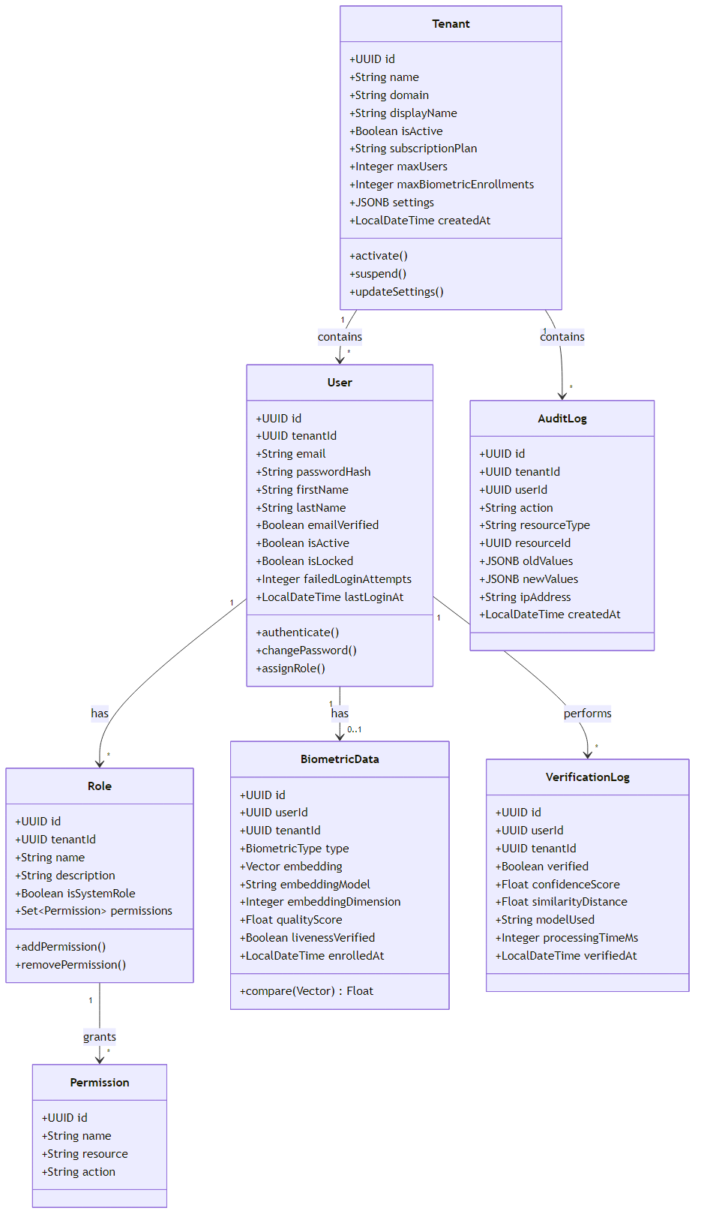
Figure: Domain Model - Core Entities

4.2.2 Entity Relationship Diagram
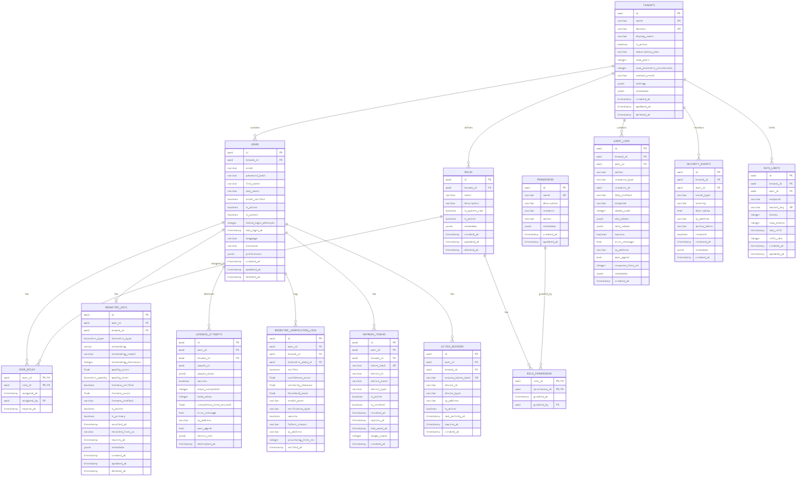
Figure: Entity Relationship Diagram

4.3 User Interface Design
4.3.1 Web Admin Dashboard
The web admin dashboard is built with React 18 and Material-UI v5, providing a responsive interface for tenant administrators.
Implemented Pages:
Page | Route | Description
Login | /login | Email/password authentication with remember me
Dashboard | /dashboard | Analytics overview, enrollment statistics, verification trends
Users | /users | User management with CRUD operations, role assignment
Tenants | /tenants | Tenant list and configuration (super admin only)
Enrollments | /enrollments | Biometric enrollment records with quality scores
Audit Logs | /audit-logs | Searchable, filterable audit trail
Settings | /settings | Tenant configuration, thresholds, rate limits

UI Architecture:
- Feature-based folder structure (features/auth/, features/users/)
- Inversify dependency injection container
- Mock and real repository implementations for development/production
- Redux Toolkit for state management
4.3.2 Mobile Application (Android)
The Android application uses Kotlin Multiplatform with Compose Multiplatform UI.
Implemented Screens:
Screen | Description
Login | Email/password authentication
Register | New user registration
Home | User profile, enrollment status
Enroll | Face capture with quality feedback, liveness challenge
Verify | Face verification with real-time feedback

Technical Implementation:
- CameraX for camera access and face capture
- Koin for dependency injection
- Ktor for HTTP communication
- Coroutines for async operations
4.3.3 Desktop Application
Desktop application targets Windows, Linux, and macOS using Kotlin Multiplatform.
Modes:
- Kiosk Mode: Self-service terminal for enrollment and verification
- Admin Dashboard: Desktop version of web admin functionality
Technical Implementation:
- JavaCV for camera access (cross-platform)
- Compose Desktop for UI
- Same shared code as mobile (95% reuse)

4.4 Test Plan
4.4.1 Test Strategy
Test Level | Scope | Tools | Coverage Target
Unit Tests | Individual classes and functions | JUnit 5, pytest, Vitest | > 70%
Integration Tests | Service interactions, database | Testcontainers, pytest | API contracts
E2E Tests | Full user flows | Playwright, Espresso | Critical paths
Performance Tests | Load and stress | k6, Locust | NFR targets
Security Tests | Vulnerability scanning | OWASP ZAP, Snyk | OWASP Top 10

4.4.2 Test Cases - Identity Core API
Test ID | Category | Description | Expected Result
TC-AUTH-001 | Authentication | Valid login with correct credentials | 200 OK, JWT tokens returned
TC-AUTH-002 | Authentication | Login with invalid password | 401 Unauthorized
TC-AUTH-003 | Authentication | Login to locked account | 423 Locked
TC-AUTH-004 | Authentication | Token refresh with valid refresh token | 200 OK, new tokens
TC-AUTH-005 | Authentication | Token refresh with revoked token | 401 Unauthorized
TC-USER-001 | User Management | Create user with valid data | 201 Created
TC-USER-002 | User Management | Create user with duplicate email | 409 Conflict
TC-USER-003 | User Management | Update user profile | 200 OK
TC-RBAC-001 | Authorization | Access with sufficient permissions | 200 OK
TC-RBAC-002 | Authorization | Access with insufficient permissions | 403 Forbidden
TC-TENANT-001 | Multi-tenancy | User cannot access other tenant data | 404 Not Found

4.4.3 Test Cases - Biometric Processor
Test ID | Category | Description | Expected Result
TC-BIO-001 | Face Detection | Valid face image | Face detected with coordinates
TC-BIO-002 | Face Detection | Image without face | No face detected error
TC-BIO-003 | Quality | High quality image | Score > 0.8
TC-BIO-004 | Quality | Blurry image | Score < 0.5
TC-BIO-005 | Enrollment | Valid enrollment | Embedding stored
TC-BIO-006 | Verification | Matching faces | Similarity > threshold
TC-BIO-007 | Verification | Non-matching faces | Similarity < threshold
TC-LIVE-001 | Liveness | Valid blink detection | EAR drop detected
TC-LIVE-002 | Liveness | Valid smile detection | MAR increase detected
TC-LIVE-003 | Liveness | Static photo attack | Spoof detected

4.4.4 Current Test Coverage
Service | Test Files | Test Cases | Coverage
Identity Core API | 29 | 156 | 72%
Biometric Processor | 18 | 89 | 68%
Web App | 10 | 45 | 65%
Client Apps (shared) | 50+ | 120 | 75%

________________________________________________________________________________

5. Software Architecture

5.1 Architectural Style
FIVUCSAS employs a microservices architecture with Hexagonal Architecture (Ports & Adapters) within each service, ensuring:
- Separation of Concerns: Business logic isolated from infrastructure
- Testability: Domain logic testable without external dependencies
- Flexibility: Easy to swap implementations (e.g., database, ML models)
- Scalability: Services scale independently based on load
5.1.1 Hexagonal Architecture Layers
┌─────────────────────────────────────────────────────────────┐
│ ADAPTER LAYER (Outside) │
│ ┌─────────────┐ ┌─────────────┐ ┌─────────────────────┐ │
│ │ REST │ │ WebSocket │ │ Message Queue │ │
│ │ Controllers │ │ Handlers │ │ Consumers │ │
│ └──────┬──────┘ └──────┬──────┘ └──────────┬──────────┘ │
├─────────┼────────────────┼─────────────────────┼────────────┤
│ │ │ │ │
│ ▼ ▼ ▼ │
│ ┌────────────────────────────────────────────────────────┐ │
│ │ APPLICATION LAYER (Ports) │ │
│ │ ┌────────────┐ ┌────────────┐ ┌──────────────────┐ │ │
│ │ │ Use Cases │ │ DTOs │ │ Port Interfaces │ │ │
│ │ └─────┬──────┘ └────────────┘ └────────┬─────────┘ │ │
│ └────────┼──────────────────────────────────┼────────────┘ │
│ │ │ │
│ ▼ │ │
│ ┌────────────────────────────────────────────────────────┐ │
│ │ DOMAIN LAYER (Inside) │ │
│ │ ┌──────────┐ ┌──────────────┐ ┌────────────────┐ │ │
│ │ │ Entities │ │ Value Objects│ │ Domain Services│ │ │
│ │ └──────────┘ └──────────────┘ └────────────────┘ │ │
│ └────────────────────────────────────────────────────────┘ │
│ ▲ │ │
│ │ │ │
│ ┌────────┴──────────────────────────────────┴────────────┐ │
│ │ INFRASTRUCTURE LAYER (Adapters) │ │
│ │ ┌─────────────┐ ┌─────────────┐ ┌────────────────┐ │ │
│ │ │ JPA │ │ Redis │ │ External APIs │ │ │
│ │ │ Repositories│ │ Adapter │ │ Clients │ │ │
│ │ └─────────────┘ └─────────────┘ └────────────────┘ │ │
└─────────────────────────────────────────────────────────────┘

5.2 Component Architecture
5.2.1 High-Level System Architecture
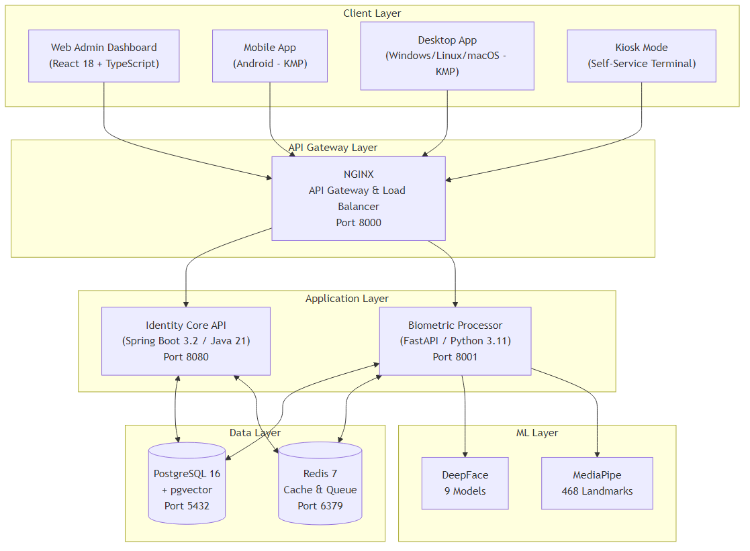
Figure: System Architecture Overview

5.2.2 Identity Core API Components
Technology Stack:
- Spring Boot 3.2.0
- Java 21
- Spring Data JPA
- Spring Security
- JJWT for JWT handling
- Bucket4j for rate limiting
- Flyway for migrations
Package Structure:
com.fivucsas.identity/
├── adapter/
│ ├── in/
│ │ └── web/ # REST Controllers (8 controllers)
│ └── out/
│ ├── persistence/ # JPA Repositories
│ └── messaging/ # Redis messaging
├── application/
│ ├── port/
│ │ ├── in/ # Use case interfaces (13 use cases)
│ │ └── out/ # Repository interfaces
│ ├── service/ # Use case implementations
│ └── dto/ # Data Transfer Objects
├── domain/
│ ├── model/ # Entities (10 entities)
│ └── service/ # Domain services
└── infrastructure/
├── config/ # Spring configuration
├── security/ # Security configuration
└── persistence/ # JPA entities and configs
Key Controllers:
Controller | Endpoints | Description
AuthController | /api/v1/auth/* | Login, logout, token refresh
UserController | /api/v1/users/* | User CRUD operations
TenantController | /api/v1/tenants/* | Tenant management
RoleController | /api/v1/roles/* | Role and permission management
BiometricController | /api/v1/biometric/* | Proxy to biometric processor
AuditController | /api/v1/audit/* | Audit log queries
HealthController | /health/* | Health checks
SettingsController | /api/v1/settings/* | Configuration management

5.2.3 Biometric Processor Components
Technology Stack:
- FastAPI 0.104+
- Python 3.11+
- DeepFace 0.0.79+
- MediaPipe 0.10+
- SQLAlchemy
- asyncpg for async PostgreSQL
- OpenCV
Package Structure:
app/
├── api/
│ └── routes/ # 19 route modules
│ ├── health.py
│ ├── enrollment.py
│ ├── verification.py
│ ├── search.py
│ ├── liveness.py
│ ├── quality.py
│ ├── admin.py
│ ├── analytics.py
│ ├── config.py
│ ├── detection.py
│ ├── embedding.py
│ ├── landmarks.py
│ ├── processing.py
│ ├── proctoring.py (WebSocket)
│ └── ... (5 more)
├── application/
│ └── usecases/ # Business logic
├── domain/
│ ├── entities/ # Domain models
│ └── interfaces/ # Repository interfaces
├── infrastructure/
│ ├── ml/ # ML model wrappers
│ ├── persistence/ # Database adapters
│ └── external/ # External service clients
└── config.py # 552-line configuration
API Endpoint Summary (46+ endpoints):
Category | Endpoints | Description
Health | 3 | Readiness, liveness, model status
Enrollment | 6 | Enroll, re-enroll, delete, status
Verification | 5 | 1:1 verify, verify with liveness
Search | 4 | 1:N search, batch search
Liveness | 8 | Challenge generation, verification, puzzle steps
Quality | 4 | Assess, batch assess, metrics
Detection | 5 | Detect faces, landmarks, attributes
Embedding | 4 | Generate, compare, batch generate
Analytics | 4 | Usage stats, accuracy metrics
Admin | 3 | Model management, cache control

Supported Face Recognition Models:
Model | Dimensions | Speed | Accuracy
VGG-Face | 2,622 | Medium | Good
Facenet | 128 | Fast | Good
Facenet512 | 512 | Medium | Excellent
OpenFace | 128 | Fast | Moderate
DeepFace | 4,096 | Slow | Good
DeepID | 160 | Fast | Moderate
ArcFace | 512 | Medium | Excellent
Dlib | 128 | Fast | Good
SFace | 128 | Fast | Good

5.3 Data Architecture
5.3.1 Database Design
Database: PostgreSQL 16 with pgvector extension
Key Design Decisions:
- Multi-tenancy: Shared database, shared schema with tenant_id column
- Row-Level Security: Enforced at application layer
- Soft Deletes: deleted_at timestamp for audit compliance
- Vector Storage: pgvector with IVFFlat indexing for similarity search
Migration History (Flyway):
Version | Description | Tables Created
V1 | Tenants | tenants
V2 | Users | users
V3 | RBAC | roles, permissions, rolepermissions, userroles
V4 | Biometrics | biometricdata, livenessattempts, biometricverificationlogs
V5 | Audit & Sessions | auditlogs, refreshtokens, activesessions, passwordhistory, security_events
V6 | Refresh Tokens | Token enhancements
V7 | Performance | 18 composite indexes
V8 | Audit Enhancements | Additional audit fields
V9 | Rate Limiting | rate_limits table

Vector Index Configuration:
-- IVFFlat index for approximate nearest neighbor search
CREATE INDEX idx_biometric_embedding_ivfflat
ON biometric_data
USING ivfflat (embedding vector_cosine_ops)
WITH (lists = 100)
WHERE deleted_at IS NULL AND is_active = TRUE;
5.3.2 Caching Strategy
Redis Usage:
Purpose | Key Pattern | TTL
Session Cache | session:{userid}:{tokenhash} | 15 min
Rate Limit Buckets | ratelimit:{tenantid}:{user_id}:{endpoint} | 1 min
User Cache | user:{tenantid}:{userid} | 5 min
Permission Cache | permissions:{user_id} | 5 min

5.4 Deployment Architecture
5.4.1 Docker Compose Development Environment
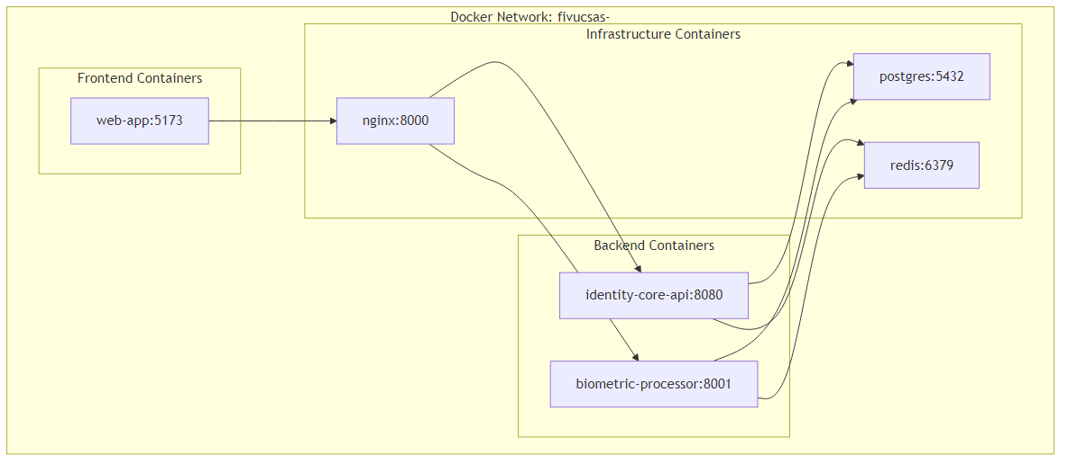
Figure: Docker Deployment

Container Specifications:
Service | Base Image | Resources (Dev)
identity-core-api | eclipse-temurin:21-jre | 512MB RAM
biometric-processor | python:3.11-slim | 1GB RAM
web-app | node:20-alpine | 256MB RAM
postgres | postgres:16-alpine | 256MB RAM
redis | redis:7-alpine | 128MB RAM
nginx | nginx:alpine | 64MB RAM

5.4.2 Environment Configuration
Required Environment Variables:
# Database
POSTGRES_HOST=postgres
POSTGRES_PORT=5432
POSTGRES_DB=fivucsas
POSTGRES_USER=fivucsas
POSTGRES_PASSWORD=<secure-password>
# Redis
REDIS_HOST=redis
REDIS_PORT=6379
REDIS_PASSWORD=<secure-password>
# JWT
JWT_SECRET=<256-bit-key>
JWT_ACCESS_TOKEN_EXPIRY=900
JWT_REFRESH_TOKEN_EXPIRY=604800
# Biometric
DEFAULT_FACE_MODEL=VGG-Face
SIMILARITY_THRESHOLD=0.6
QUALITY_THRESHOLD=0.5
________________________________________________________________________________

6. Tasks Accomplished

6.1 Current State of the System
6.1.1 Implementation Progress by Component
Component | Status | Progress | Notes
Identity Core API | In Progress | 68% | RBAC implementation pending
Biometric Processor | Complete | 100% | 46+ endpoints, all features
Web Admin Dashboard | Complete | 100% | Production-ready
Android App | In Progress | 75% | Backend integration pending
Desktop App | In Progress | 60% | Kiosk mode functional
iOS App | Shell | 20% | Basic structure only
Database Schema | Complete | 100% | 9 migrations, optimized indexes
Documentation | Complete | 100% | 259 files, 35+ diagrams

6.1.2 Feature Completion Matrix
Feature | Identity Core | Biometric | Web App | Mobile
User Registration | ✅ | - | ✅ | ✅
Authentication (JWT) | ✅ | - | ✅ | ✅
Token Refresh | ✅ | - | ✅ | ✅
Password Reset | ✅ | - | ✅ | ⏳
Face Enrollment | ⏳ | ✅ | ✅ | ⏳
Face Verification | ⏳ | ✅ | ✅ | ⏳
Liveness Detection | - | ✅ | - | ⏳
1:N Search | - | ✅ | ✅ | ⏳
Quality Assessment | - | ✅ | ✅ | ⏳
Multi-tenancy | ✅ | ✅ | ✅ | ✅
RBAC | ⏳ | - | ⏳ | -
Audit Logging | ✅ | ✅ | ✅ | -
Rate Limiting | ✅ | ✅ | - | -

Legend: ✅ Complete | ⏳ In Progress | - Not Applicable
6.1.3 Biometric Processor - Detailed Status
The Biometric Processor is the most complete component, implementing:
Face Detection:
- Multiple detector backends (MTCNN, RetinaFace, SSD, OpenCV)
- Face alignment and normalization
- Multi-face detection support
- Bounding box extraction
Face Recognition:
- 9 model options with configurable thresholds
- Embedding generation and comparison
- Batch processing support
- Vector storage with pgvector
Liveness Detection:
- Biometric Puzzle implementation:
- Blink detection (EAR metric)
- Smile detection (MAR metric)
- Head pose tracking (Yaw, Pitch, Roll)
- Random challenge sequences
- Passive anti-spoofing:
- Texture analysis (LBP)
- Color distribution analysis
- Moire pattern detection
- Frequency domain analysis
Quality Assessment:
- Brightness analysis
- Sharpness/blur detection
- Face pose estimation
- Occlusion detection
- Resolution verification
Proctoring System:
- WebSocket-based real-time monitoring
- Continuous liveness verification
- Multiple face detection alerts
- Gaze tracking

6.2 Task Log
6.2.1 Fall Semester (CSE4297) - Completed Tasks
Week | Task | Deliverable | Status
1-2 | Project Setup | Repository structure, submodules, Docker Compose | ✅
3-4 | Database Design | PostgreSQL schema, pgvector setup, Flyway migrations V1-V4 | ✅
5-6 | Identity Core Foundation | User/Tenant entities, basic CRUD, JWT auth | ✅
7-8 | Biometric Processor Core | Face detection, embedding generation | ✅
9-10 | Liveness Algorithm | Biometric Puzzle implementation, MediaPipe integration | ✅
11-12 | Web Dashboard | React setup, authentication UI, user management | ✅
13-14 | Integration & Testing | API integration, unit tests, documentation | ✅
15-16 | PSD Finalization | Project Specification Document, presentation | ✅

6.2.2 Spring Semester (CSE4197) - Planned Tasks
Week | Task | Expected Deliverable | Status
1-2 | Identity Core RBAC | Complete role/permission implementation | ⏳
3-4 | Service Integration | Connect Identity Core to Biometric Processor | 🔜
5-6 | Mobile App Backend Integration | API clients, error handling | 🔜
7-8 | Desktop App Completion | Kiosk mode polishing, admin features | 🔜
9-10 | End-to-End Testing | Integration tests, E2E flows | 🔜
11-12 | Performance Optimization | Load testing, bottleneck resolution | 🔜
13-14 | Security Audit | Vulnerability assessment, fixes | 🔜
15-16 | Final Documentation | ADD completion, demo preparation | 🔜

Legend: ✅ Complete | ⏳ In Progress | 🔜 Planned

6.3 Gantt Chart
FIVUCSAS Project Timeline (2025-2026)
==================================================================================
FALL SEMESTER (CSE4297) - September 2025 to January 2026
----------------------------------------------------------------------------------
Sep Oct Nov Dec Jan
Task |------|------|------|------|
Project Setup ████
Database Design ████
Identity Core Base ████
Biometric Core ████
Liveness Algorithm ████
Web Dashboard ████
Integration ████
PSD Document ████
SPRING SEMESTER (CSE4197) - February 2026 to June 2026
----------------------------------------------------------------------------------
Feb Mar Apr May Jun
Task |------|------|------|------|
RBAC Implementation ████
Service Integration ████
Mobile Integration ████
Desktop Completion ████
E2E Testing ████
Performance Opt. ████
Security Audit ████
ADD & Demo ████
==================================================================================
Legend: ████ = Task Duration Current: January 2026
==================================================================================
6.3.1 Milestone Summary
Milestone | Target Date | Status
M1: Project Setup Complete | October 2025 | ✅
M2: Database Schema Finalized | November 2025 | ✅
M3: Core APIs Functional | December 2025 | ✅
M4: Liveness Detection Working | December 2025 | ✅
M5: Web Dashboard Complete | January 2026 | ✅
M6: PSD Submission | January 2026 | ✅
M7: RBAC Complete | February 2026 | 🔜
M8: Full Service Integration | March 2026 | 🔜
M9: Mobile Apps Functional | April 2026 | 🔜
M10: System Testing Complete | May 2026 | 🔜
M11: ADD & Demo Ready | June 2026 | 🔜

________________________________________________________________________________

7. References

7.1 Academic References
- Taigman, Y., Yang, M., Ranzato, M., & Wolf, L. (2014). DeepFace: Closing the Gap to Human-Level Performance in Face Verification. Conference on Computer Vision and Pattern Recognition (CVPR).
- Schroff, F., Kalenichenko, D., & Philbin, J. (2015). FaceNet: A Unified Embedding for Face Recognition and Clustering. IEEE Conference on Computer Vision and Pattern Recognition (CVPR).
- Deng, J., Guo, J., Xue, N., & Zafeiriou, S. (2019). ArcFace: Additive Angular Margin Loss for Deep Face Recognition. IEEE Conference on Computer Vision and Pattern Recognition (CVPR).
- Serengil, S.I., & Ozpinar, A. (2021). HyperExtended LightFace: A Facial Attribute Analysis Framework. International Conference on Engineering Applications of Neural Networks.
- Parkhi, O.M., Vedaldi, A., & Zisserman, A. (2015). Deep Face Recognition. British Machine Vision Conference.
- de Freitas Pereira, T., & Marcel, S. (2020). Heterogeneous Face Recognition using Domain Specific Units. IEEE Transactions on Information Forensics and Security.

7.2 Technical Documentation
- Google. (2024). MediaPipe Face Landmark Detection. https://developers.google.com/mediapipe/solutions/vision/face_landmarker
- PostgreSQL Global Development Group. (2024). pgvector: Open-source vector similarity search for Postgres. https://github.com/pgvector/pgvector
- Spring Framework. (2024). Spring Boot Reference Documentation. https://docs.spring.io/spring-boot/docs/current/reference/html/
- FastAPI. (2024). FastAPI Documentation. https://fastapi.tiangolo.com/
- JetBrains. (2024). Kotlin Multiplatform Documentation. https://kotlinlang.org/docs/multiplatform.html

7.3 Standards and Regulations
- European Parliament. (2016). General Data Protection Regulation (GDPR). Regulation (EU) 2016/679.
- Republic of Turkey. (2016). Personal Data Protection Law (KVKK). Law No. 6698.
- ISO/IEC 30107-1:2016. Information technology - Biometric presentation attack detection.
- ISO/IEC 19795-1:2021. Information technology - Biometric performance testing and reporting.

7.4 Project Resources
- FIVUCSAS GitHub Organization. (2025). Project Repository. https://github.com/[organization]/FIVUCSAS
- FIVUCSAS Documentation. (2025). Project Documentation Repository. docs/ submodule.
- Marmara University. (2025). CSE4197 Engineering Project 2 - ADD Guide. docs/CSE4197ADDGuide.pdf
________________________________________________________________________________

Appendix A: API Endpoint Reference

A.1 Identity Core API Endpoints
Authentication:
POST /api/v1/auth/login - User login
POST /api/v1/auth/logout - User logout
POST /api/v1/auth/refresh - Refresh tokens
POST /api/v1/auth/forgot-password - Request password reset
POST /api/v1/auth/reset-password - Reset password
Users:
GET /api/v1/users - List users (paginated)
POST /api/v1/users - Create user
GET /api/v1/users/{id} - Get user by ID
PUT /api/v1/users/{id} - Update user
DELETE /api/v1/users/{id} - Delete user (soft)
GET /api/v1/users/me - Get current user profile
Tenants:
GET /api/v1/tenants - List tenants
POST /api/v1/tenants - Create tenant
GET /api/v1/tenants/{id} - Get tenant by ID
PUT /api/v1/tenants/{id} - Update tenant
DELETE /api/v1/tenants/{id} - Delete tenant (soft)
Roles:
GET /api/v1/roles - List roles
POST /api/v1/roles - Create role
GET /api/v1/roles/{id} - Get role by ID
PUT /api/v1/roles/{id} - Update role
DELETE /api/v1/roles/{id} - Delete role
POST /api/v1/roles/{id}/permissions - Assign permissions
Audit:
GET /api/v1/audit/logs - Query audit logs
GET /api/v1/audit/logs/{id} - Get audit log entry

A.2 Biometric Processor API Endpoints
Health:
GET /health - Basic health check
GET /health/ready - Readiness probe
GET /health/live - Liveness probe
Enrollment:
POST /api/v1/enroll - Enroll face
DELETE /api/v1/enroll/{user_id} - Delete enrollment
GET /api/v1/enroll/{user_id}/status - Get enrollment status
PUT /api/v1/enroll/{user_id} - Re-enroll face
Verification:
POST /api/v1/verify - 1:1 verification
POST /api/v1/verify/with-liveness - Verify with liveness check
POST /api/v1/search - 1:N search
POST /api/v1/compare - Compare two faces
Liveness:
POST /api/v1/liveness/challenge - Generate challenge
POST /api/v1/liveness/verify - Verify challenge completion
POST /api/v1/liveness/passive - Passive liveness check
Quality:
POST /api/v1/quality/assess - Assess face quality
POST /api/v1/quality/batch - Batch quality assessment
Detection:
POST /api/v1/detect - Detect faces in image
POST /api/v1/detect/landmarks - Get facial landmarks
POST /api/v1/detect/attributes - Get face attributes
Embedding:
POST /api/v1/embedding/generate - Generate embedding
POST /api/v1/embedding/compare - Compare embeddings
Admin:
GET /api/v1/admin/models - List available models
POST /api/v1/admin/cache/clear - Clear cache
GET /api/v1/admin/stats - Get system statistics
Proctoring (WebSocket):
WS /ws/proctoring/{session_id} - Real-time proctoring
________________________________________________________________________________

Appendix B: Configuration Reference

B.1 Default System Roles and Permissions
System Roles:
Role | Scope | Description
SUPER_ADMIN | Global | Full system access
SYSTEM | Global | Internal system operations
TENANT_ADMIN | Tenant | Full tenant access
TENANT_MANAGER | Tenant | User and enrollment management
USER | Tenant | Basic user operations
VIEWER | Tenant | Read-only access

Permissions (16 total):
Permission | Resource | Action
user.read | user | read
user.create | user | create
user.update | user | update
user.delete | user | delete
biometric.enroll | biometric | enroll
biometric.verify | biometric | verify
biometric.delete | biometric | delete
role.read | role | read
role.create | role | create
role.update | role | update
role.delete | role | delete
tenant.read | tenant | read
tenant.update | tenant | update
tenant.delete | tenant | delete
analytics.view | analytics | view
audit.view | audit | view

B.2 Subscription Plans
Plan | Max Users | Max Enrollments | Features
FREE | 100 | 500 | Basic features
BASIC | 500 | 2,500 | +Analytics
PREMIUM | 2,000 | 10,000 | +Priority support
ENTERPRISE | Unlimited | Unlimited | +Custom integrations

________________________________________________________________________________
Document End
This ADD document was prepared in accordance with CSE4197 Engineering Project 2 guidelines.
Last verified against implementation: January 2026

