Jack Rollinson

CS 112

Spring 2016

June Porto

CHAPTER 10 TEXT FILES:

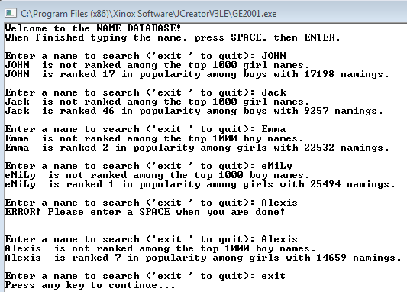PROJECT #1 - PAGE 643:

SCREENSHOTS CONTINUED ON NEXT PAGE 🡪

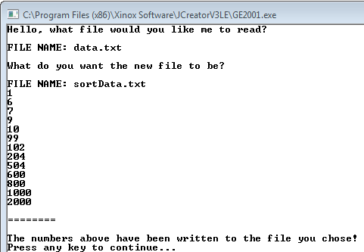PROJECTS HANDOUT #2 – PROJECT #1:

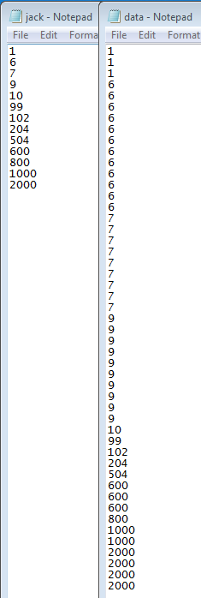

TEXT FILES BEFORE AND AFTER: