ELVTR • SOCCER PERFORMANCE ANALYTICS • GUEST LECTURE ASSIGNMENT • JORDYN KAPLAN Build a cross map for one Euro 2024 team.
Excel or Google Sheets. Four steps, one formula each. The pictures show what your result should look like; the numbers are Spain's.
End result: a crosses tab with one row per cross, a checks tab that proves the data is clean, and one cross map. Then think through how you would interpret it, and enhance it, for a coaching decision. Credit StatsBomb as the data source.
What you get
euro_2024_passes.csv : every pass from all 51 matches, one row each (53,888 rows). teams.txt : the 24 team names as they appear in the data. cross_map_starter.xlsx : optional, the formulas below already set up.
Columns you will use: E team F opponent G player I minute J x (0 to 120 along the pitch) K y (0 to 80 across) L, M end_x , end_y N cross (TRUE/FALSE) O outcome (blank = completed).
Two rules: every team attacks left to right, so nothing needs flipping; y < 40 is the left side of the attack. And a completed pass has a blank outcome, not the word "Complete".
Setup: import the CSV onto a tab called passes. Add a tab called Setup and type your team name in B1, copied from teams.txt . The four steps
1 Filter to your team's crosses
New tab crosses. Copy the header row from passes into row 1. In A2:
=FILTER(passes!A2:Q53889, passes!E2:E53889=Setu p!$B$1, passes!N2:N53889=TRUE)
Older Excel without FILTER: use the filter buttons on the passes tab (E = your team, N = TRUE) and copy the visible rows across.
2 Add three helper columns
Headers side , completed , zone in R1, S1, T1. In row 2, then fill down:
R2 =IF(K2<40,"Left","Right")
S2 =IF(O2="","Yes","No")
T2 =INT(J2/20)+1&"-"&INT(K2/16)+1
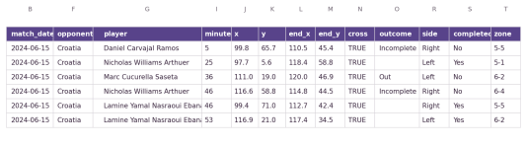The crosses tab after steps 1 and 2. Spain: 89 rows. Column letters are shown above the headers.
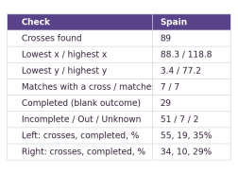
3 Check it before you draw
New tab checks. Label in A, formula in B. Compare with the
picture.
=COUNTA(crosses!A2:A300)
=MIN(crosses!J2:J300) =MAX(crosses!J2:J300)
=MIN(crosses!K2:K300) =MAX(crosses!K2:K300)
=COUNTA(UNIQUE(FILTER(crosses!A2:A300,crosses!A2:
A300<>"")))
=COUNTIF(crosses!S2:S300,"Yes")
=COUNTIF(crosses!R2:R300,"Left")
=COUNTIFS(crosses!R2:R300,"Left",crosses!S2:S30
0,"Yes")
x must sit inside 0 to 120 and y inside 0 to 80. Matches with a cross.
should equal matches played. Repeat the last two lines with "Right". The checks tab. If a number is far from these for your team, look at the filter first.
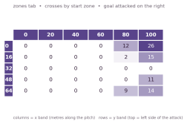
4 Draw the map: zone grid
New tab zones. Put 0, 20, 40, 60, 80, 100 in B1:G1 and
0, 16, 32, 48, 64 in A2:A6. In B2, then fill right to G and
down to row 6:
=COUNTIFS(crosses!$J$2:$J$300,">="&B$1, crosses!
$J$2:$J$300,"<"&(B$1+20), crosses!$K$2:$K$300,">
="&$A2, crosses!$K$2:$K$300,"<"&($A2+16))
Select B2:G6 and add a colour scale (conditional formatting).
Add ,crosses!$S$2:$S$300,"Yes" inside the COUNTIFS
for a second grid of completed crosses only.
The zones tab with a colour scale. Read it as the pitch from above:
goal on the right, top rows = left side of the attack.
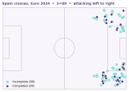
Optional: pitch scatter
On the crosses tab add U2 =IF(S2="Yes",K2,NA()) and V2
=IF(S2="No",K2,NA()) , fill down. Select J1:J300 plus U1:V300 and insert a scatter
chart, markers only. Set the x axis 0 to 120 and the y axis 0 to 80. Two series:
completed and incomplete.
Excel draws this cleanly; Google Sheets is fussier, so the zone grid is the safer choice there.
The scatter version, with pitch lines added
as an extra series.
Interpret the result
How much do they cross, and from which side? Deep, from the by-line, or the half-space? How often does it work, and is one player the main source? What would you tell the full-backs and the box defenders? What does the cross flag not tell you, and what would you add next: the end points (columns L, M), the players, first half against second half? Change Setup!B1 to another team and everything recalculates. Data: StatsBomb open data via github.com/hudl/open-data, free for non-commercial use.

