PETER J. MULLEN TIMOTHY RIZZO

*President Chairman Trustee*

BRIAN WHIPPLE TIMOTHY HIGGINS

*1st Vice President Trustee*

MATT DEARING NICK MANNIX

*2nd Vice President Trustee*

KRISTIN FLORELL EDWARD RITZ

*Secretary Inside Guard*

ROBERT YOUNG

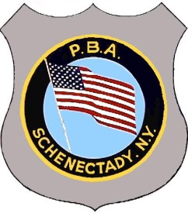*Treasurer*

*Founded Strength In*

*In 1911 Unity*

POST OFFICE BOX 460, SCHENECTADY, NY 12301-0460

Dear Friends,

The 2018 William F. Eddy Jr. Memorial Track Meet Committee and the Schenectady P.B.A. welcomes you here today for our 78th annual track meet. It is an honor to carry on a tradition started by The Schenectady P.B.A. in 1941. Over the many years, the Eddy Meet has continued to be one of the most competitive events in the Northeast and offers some of the best talent for track and field events.

The 2018 Eddy Meet would like to thank the many volunteers and sponsors for their countless hours and personal sacrifices that make this great meet possible. Many local businesses and community members have contributed throughout the years helping to make the meet successful year after year.

The 2018 William F. Eddy Jr. Memorial Track Meet Committee along with the Schenectady P.B.A. commends the many young athletes here today as they display their personal talents and diligence to succeed. The best of luck to all athletes and hope to have some record-breaking moments at this year’s meet! The P.B.A. hopes that you find this to be an exciting event and that you join us again next year.

The 2018 William F. Eddy Jr. Memorial Track Meet Committee,

Jason Slingerland

Bobby Young

Kristin Florell

Timothy Higgins

Nick Mannix