Accounting Solutions Limited
AccountingSolutions

Enterprise
Data
Warehouse

iDevWorks Technologies Limited



Document Control

Change Control

Date | Author | Version | Change Reference
March 31, 2003 | Deji Ajala | 1 | No previous document

Review

Name | Company | Date
Wasiu Oseni | iDevWorks Technologies Limited
Bopo Ogundipe | Accounting Solutions Limited

Table of Content

Document Control ii
Table of Content iii
Management Summary 1
Introduction 2
Purpose 2
Validity 2
Background 2
Proposal Overview 3
Approach 3
Services 3
Products 3
Information Delivery Strategy 4
Introduction 4
Business Intelligence 4
Framework 5
Systems and Data Stores 6
Components 7
Information Delivery Framework 9
Introduction 9
Zachman Framework 9
What-Information 9
How - Processes 10
Where - Location 10
Who - People 11
When - Time 11
Why - Objectives 11
Strategy Development 12
Introduction 12
Capability Maturity Model 12
Approach 13
Bibliography 14
Proposed Project Approach 15
Introduction 15
Assumptions 15
Critical Success Factors 15
Planning Approach 16

Management Summary

iDevWorks Technologies bid to deliver the full life-cycle consulting required to successfully deliver an Enterprise Data Warehouse(EDW). Our approach to Accounting Solutions Limited’s client’s requirements is to offer a multi-faceted solution with:

- The development services for our proposed EDW software solution in terms of the ETL and Reporting and OLAP requirements.

Our project approach is based on delivering a scaleable, world-class Enterprise Data Warehouse for Accounting Solutions.

Introduction

Purpose

IDevWorks Technologies is responding to the Accounting Solutions Request for Tender. We are submitting information on our company; our approach to designing, building and implementing an Enterprise Data Warehouse - methodologies; reference sites; recommended technologies; resources; and envisaged costs.

Validity

This tender is valid for 90 days.

IDevWorks Technologies acknowledges that there are no exceptions or deviations from the requirements or specifications of the Request-for-Tender.

Background

The Oxford Dictionary defines intelligence as intellect or understanding, and intelligential as quickness of understanding.

Based on iDevWorks Technologies’ experience in the business intelligence field, iDevWorks Technologies’ definition of business intelligence is the gathering of all the relevant and accurate data, that is stored to enable rapid access for analysis purposes to improve an organisation’s ability to make effective decisions quickly.

The importance and the business benefits that can be derived by implementing a data warehouse system is understood and accepted by the management of Accounting Solutions clients and that a data warehouse implementation is fundamental to the corporate Business
Intelligence strategy to provide the overall governance for the collation, distribution and management of the organisation’s data.

Proposal Overview

Approach

IDevWorks Technologies is focused on delivering product agnostic Business intelligence (BI) solutions.

Our approach to Accounting Solutions’ client’s requirements is to offer a multi-faceted solution with:

- EDW lifecycle consulting services,
- Business product agnostics services for the technologies already selected, eg Oracle
- Together with the development services for our proposed software solution in term the ETL and Reporting and OLAP.

Services

Using Accounting Solutions client’s existing technologies or technologies selected, iDevWorks Technologies will deliver the required solution using the following approach:

- Business Requirements or Affirmation, and Project definition;
- Design;
- Build;
- Deployment.

Products

iDevWorks Technologies has included options for Accounting Solutions clients to use ETL technologies; front-end tools including data mining technologies; that will complement Accounting Solutions client’s current database and hardware platforms for the Enterprise Data warehouse.

Information Delivery Strategy

Introduction

The Information Delivery Strategy for an organisation should be based on the generally accepted Business Intelligence Framework as discussed in this section.

Business Intelligence

The following definitions were extracted from authoritative white papers on business intelligence:

- Business intelligence describes the enterprise's ability to access and explore information (often contained in a data warehouse) and to analyze that information to develop insights and understanding, which leads to improved and informed decision making [Gartner].

- Business Intelligence applications are decision support tools that enable real-time, interactive access, analysis and manipulation of mission-critical corporate information. These applications provide users with valuable insights into key operating information to quickly identify business problems and opportunities. Users are able to access and leverage large amounts of information to analyze relationships and understand trends that, ultimately, support business decisions. These tools prevent the potential loss of knowledge within the enterprise that results from massive information accumulation that is not readily accessible or in usable form [Cherry Tree].

- Business intelligence systems focus on improving the access and delivery of business information to both information providers and information consumers [IBM].

The Oxford Dictionary defines intelligence as intellect or understanding, and intelligential as quickness of understanding.

Based on iDevWorks Technologies’ experience in the business intelligence field and on the above definitions, iDevWorks Technologies’ definition of business intelligence is:

Business intelligence is the gathering of relevant and accurate information, that is stored to enable rapid access for analysis purposes to improve an organisation’s ability to make effective decisions quickly.

Framework

The following Business Intelligence Framework would be applied in this project:

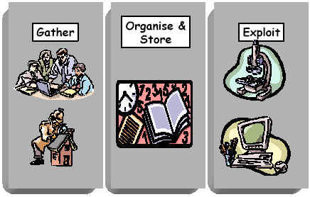

Information is gathered on a day-to-day basis by the organisation’s operational systems. Sometimes external information is sourced, e.g. price indicators, stock exchange trades. The rules and processes defining this gathering of data are of paramount importance to the success of a BI strategy.

This data is organised and stored in a number of ways, but always in such a way as to ensure a consistent view of the organisation across the business functions and systems to enable rapid access for reporting and analysis purposes. The management, measurement, access, availability/retrieval around the storage of data must be designed and implemented so as to meet the business requirements.

The organised data is then exploited by users at all levels of the business to assist in achieving the organisational objectives. The exploitation and viewing tools and the management thereof must be integral to the strategy and function of the Business Intelligence Information System.

Systems and Data Stores

In order to position the various business intelligence components within the framework, it is necessary to map the types of systems and data stores to the framework.

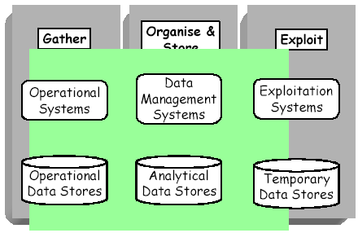

Operational Systems are the systems that are deployed within an organisation to support and/or automate steps in the business processes. They “turn the wheels of the organisation” and if they stop the company stops. Operational systems are characterised by:

- Their pre-occupation with transaction recording, They take orders, deliver goods and services, sign up new customers, enter new data, correct old data, etc.
- They almost always deal with one account at a time and information retrievals are generally “lookups” of single records of data that is current.
- The data is volatile (ever changing).
- There are a number of different users, at varying competency and management levels depending on the nature of the business process, recording transactions.

Operational Data Stores are the repositories of operational data captured through the operational systems. These repositories are structured in a way that would guarantee data integrity. The objective in the design of these repositories is to store and maintain a data item as one single instance and not to replicate it. This objective is not always achievable and it is sometimes necessary to create consolidated operational stores.

Data Management Systems are required to extract data from the operational data stores, consolidate it and change it. The amount of consolidation and change depends on the analytical requirements. This “transformed” data populates the analytical data stores. These Data Management systems can also be used to extract data from one analytical data store and populate another analytical data store.

Operational Data Stores are optimised to meet the requirements of the gathering process and similarly Analytical Data Stores are optimised to support the exploitation process. In these Analytical Data Stores where huge volumes of historical information need to be addressed it is essential to store it in such a way that quick responses to queries are provided. It is imperative to understand that in this environment the replication of data is managed through the consolidation and population process. Many Analytical Data Stores might be created depending on the user requirements of the exploitation systems, as well as the exploitation objectives.

Exploitation Systems are available to support the decision-making process in business. They can either be used to monitor and manage a known pattern or trend, or to discover new or unknown patterns or trends. These systems provide different perspectives on the business and use a number of techniques to present that to the users, such as graphical visualisation, statistical analysis, exception reporting and business “scorecard” measurement.

Temporary Data Stores are used where an Analytical Data Store, or a part of it, is copied for analysis by a user either in an off-line mode or for performance reasons.

Components
The following diagram positions the various business intelligence components within the business intelligence framework.

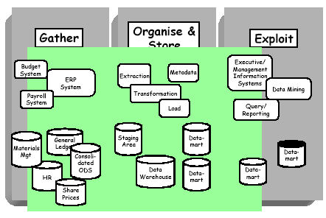

The following definitions for the above components {Kimball: 14-28}:

Extraction means reading and understanding the source data, and copying the parts that are needed to the Staging Area.

The Transformation process is the manipulation of the extracted source data to prepare it for the analytical data stores. The following steps are examples of transformation steps:

- Cleaning the data by correcting misspellings, resolving inconsistencies (e.g. postal code), dealing with missing data elements and parsing it into standard formats.

- Purging selected fields from the legacy data that are not useful for the analytical data store.

- Combining data sources.

Loading the extracted and transformed data into the target analytical data store.

Metadata is the data about data, describing the source data structures/layouts, the transformation process and the data structures of the analytical data stores.

Staging Area is a temporary storage area that is used during the extraction, transformation and loading processes to prepare data for the target analytical data store.

Data Warehouse is the queryable source of data in the organisation. The data warehouse is frequently updated on a controlled load basis as data is corrected, snapshots are accumulated, and statuses and labels are changed.

Datamart is a logical subset of a complete data warehouse.

Executive/Management Information Systems is a collection of tools that query, analyse and present information targeted to support a business need. These queries are usually presented as a set of pre-built templates.

Data Mining is a collection of tools that supports an iterative discovery process to find patterns and trends using a collection of powerful analysis techniques.

Query/Reporting is a specific kind of end user data access tool that invites the user to form their own queries.

Information Delivery Framework

Introduction

Driving business efficiency means providing access to information and notification of critical business developments. Delivery of information must be timely and relevant, personalised to the user. In addition, security measures must ensure that users receive only the information for which they are authorised.

This section highlights the components that should be considered in developing an Information Delivery Strategy.

Zachman Framework

The Zachman Framework can be used as a template to structure the development of the Information Delivery Strategy.

The Zachman Framework as it applies to organisations is simply a logical structure for classifying and organising the descriptive representations of an organisation that are significant to the management of the organisation as well as to the development of the organisation’s information systems.

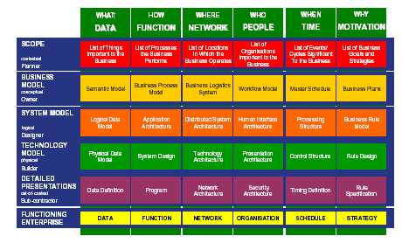

The six interrogatives should be answered from the various perspectives. Defining the Information Delivery Strategy should address the first two perspectives, namely the Planner and Owner perspectives.

What-Information
Information must be defined to clarify the scope of the Information Delivery Strategy. Information would not only include the data recorded in the organisation’s databases, but could also include printed documents, and unstructured data such as emails and electronic documents.

- Information Charter

A charter should include the organisation’s definition of information and the guiding principles for information delivery.

- Classification

Information should be classified in terms of business reliance/continuity, confidentiality and value.

- Approach

What is the approach of the organisation to information, e.g. the right information, to the right people at the right time? This could be a very expensive approach and cannot always be justified in terms of business value.

- Ownership

Information ownership and custodianship should be allocated for each information element.

How - Processes

Understanding information requires an understanding of the business processes and the information flow.

The following information processes should also be considered:

- Governance
- Acquisition
- Transformation
- Deployment
- Security
- Development

Where - Location

Where should the information be delivered? That will determine where the information should be stored and how it should be delivered in terms of the technology and connectivity issues.

Who - People

The various stakeholders in the organisation’s information should be defined as well as their use of the information, in terms of roles – one individual might have more than one role in the organisation.

When - Time
The various stakeholders in the organisation’s information should be defined as well as their use of the information, in terms of roles – one individual might have more than one role in the organisation.

Why - Objectives

The objectives for the Information Delivery Strategy must be defined and the delivery against these must be measured on an ongoing basis.

Strategy Development

Introduction

Developing an Information Delivery Strategy would depend on the organisation’s culture and maturity. This would normally be determined through a readiness assessment.

Capability Maturity Model

The Capability Maturity Model provides organisations with guidance on how to gain control of their processes for developing and maintaining software and how to evolve toward a culture of software engineering and management excellence. The CMM was designed to guide organisations in selecting process improvement strategies by determining current process maturity and identifying the few issues most critical to software quality and process improvement. By focusing on a Limited set of activities and working aggressively to achieve them, an organisation can steadily improve its organisation-wide software process to enable continuous and lasting gains in software process capability.

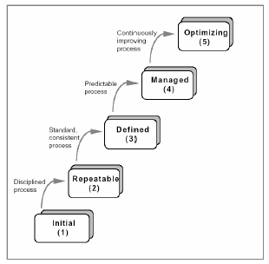

The maturity level of the organisation would determine the approach in developing the Information Delivery Strategy.

Approach

The Information Charter should be the foundation of the Information Delivery Strategy. This would commit the executives of the organisation to the information delivery, as well as communicate their approach to implementing information delivery.

Defining the first two perspectives of the Zachman Framework would provide the Information Delivery Strategy. This should be aligned to the Information Charter and would provide a framework for implementing information delivery. This can either be done top-down, based on key performance indicators, or bottom-up where information delivery is determined by operational requirements. The approach should be determined based on the organisational maturity and culture.

There is a tendency to design information requirements based on business processes. A different perspective should be to fit business processes around information requirements.

Bibliography

Cherry Tree & Co., Business Intelligence – The Missing Link, July 2000

Gartner K. Harris, H. Dresner, Business Intelligence Meets Knowledge Management,March 1999

Kimball R, Reeves L, Ross M, Thornthwaite W, The Data Warehouse Lifecycle Toolkit, Wiley, 1998

IBM C.J. White, The IBM Business Intelligence Software Solution, March 1999

Proposed Project Approach

Introduction

It is recommended that the Business Discovery or Project Definition phase of this project first be completed before any technology decisions are made. The deliverables of the first phase would impact on the technology decisions, especially the Solution Approach document.

Based on the above philosophy iDevWorks Technologies is only recommending the technology options proposed as the products we believe are best of breed.

Assumptions

The following assumptions have been made in defining the approach:

- The RDBMS platform is Oracle;
- The Accounting Solutions client sources systems to populate the Enterprise Data
- Warehouse (EDW) will include all banking applications:
  - Banking application data
  - Payroll
  - HR etc.
- The Front-end deployment strategy will include both OLAP and end user query technology.
- An Information Delivery Strategy will form part of the methodology.
- The methodology will conform to standard project management deliverables and will include quality assurance, change management control and documentation.
- Skills transfer and end user training will form part of the methodology.

Critical Success Factors

The critical success factors to meeting the goals and deadlines of the project are:

- Strong executive sponsorship and management support of the project mission and project team
- Availability of the necessary funding to include the purchase of products and services
- Adequate project staffing for the expected goals and timelines to be met
- Clear roles and responsibilities defined for the project in order to assure accountability, ownership, and quality
- A thorough understanding of known project risks and assumptions throughout the executive committee and project team.
- Availability and accuracy of the source data

Planning Approach

IDevWorks Technologies’ BI Framework Method will be used on this project. The approach consists of four major phases:

- Business Requirement/Project Definition
- Design
- Build
- Deployment

Each phase is broken down into steps that are further broken down by deliverables and typical tasks performed by the project team. This methodology also includes steps that are typically the responsibility of the client.

Although all tasks and deliverables are listed below for the four major phases, it is important to note that some of the tasks will not be required for the implementation of this project. They are listed for completeness only.
