## FINAL PROJECT: CHAT ROOM MESSAGING WEBSITE

## Submitted to: Engr. Mark Joren Guinto

## Submitted by: Romeo Joseph Navarro Micko Noriel Baldonado Marco Angelo Rodriguez Alexis John S. Meneses

## Main Objective

The primary objective of the simple messaging app is to offer an easy-to-use, reliable, and efficient platform for users to communicate through text messages. The app is designed to facilitate quick and straightforward messaging, ensuring a smooth and hassle-free user experience without overwhelming users with simple features.

**Functionalities**

1. **Instant Messaging**
2. **Group Chats**
3. **Notifications**

**Features**

1. **User-Friendly Interface**
   * Intuitive and minimalistic design for easy navigation.
   * Quick access to essential features.
2. **Dark Mode**
   * 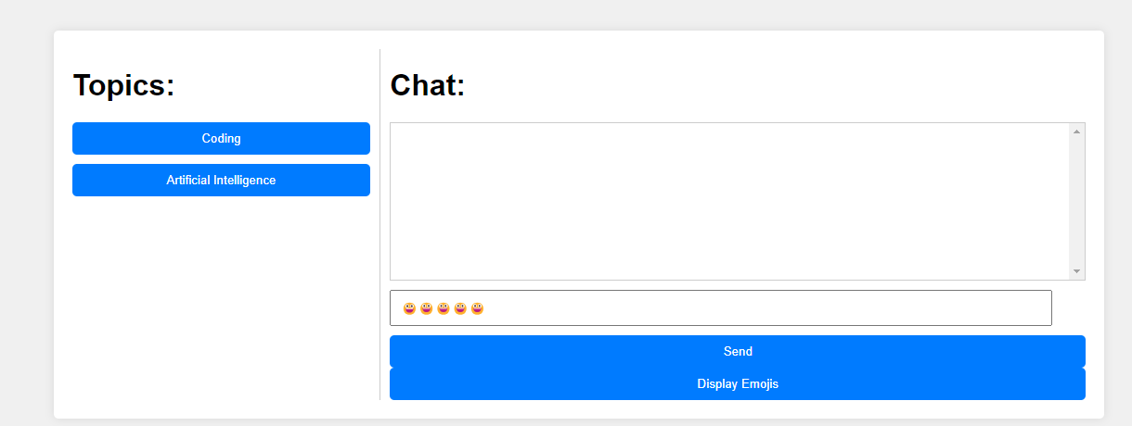Option to switch to dark mode for better viewing in low light conditions.

3. **Add topic (create new room)**

* 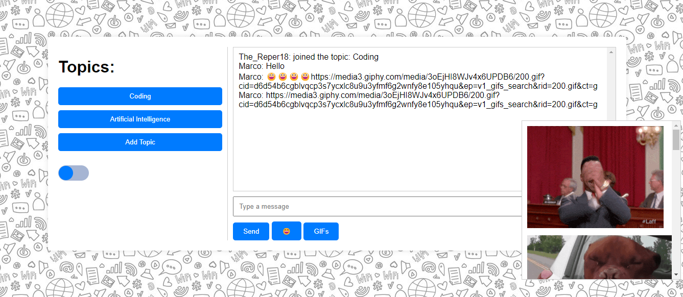Users can create the rooms that they want to find users with the same interest

**HTML CODE:**

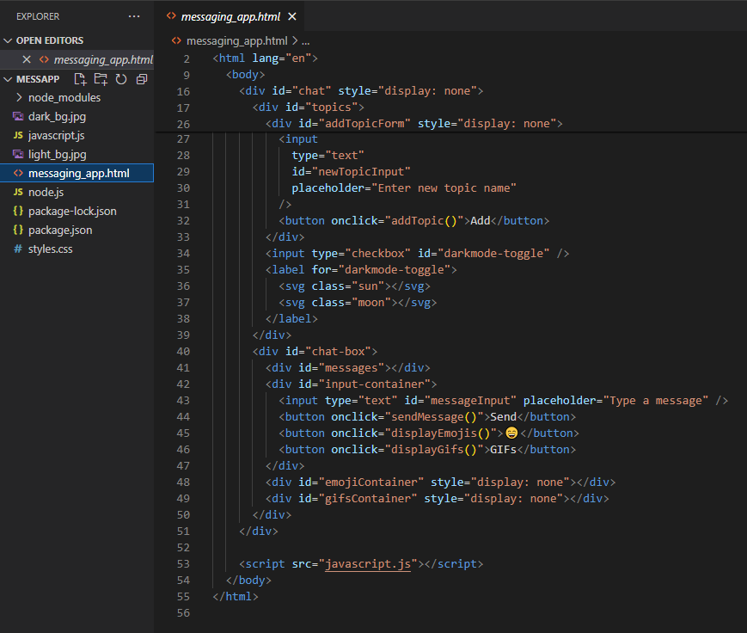

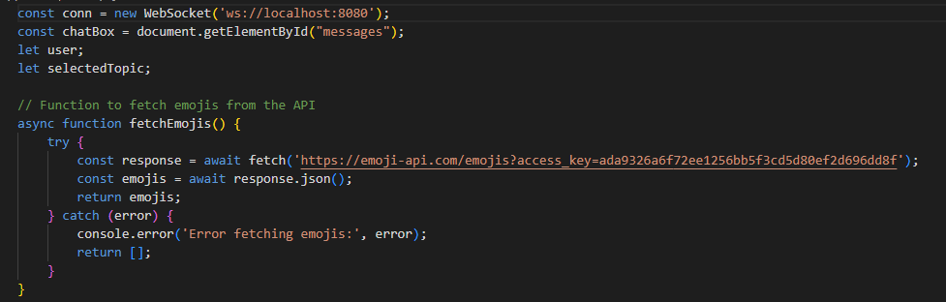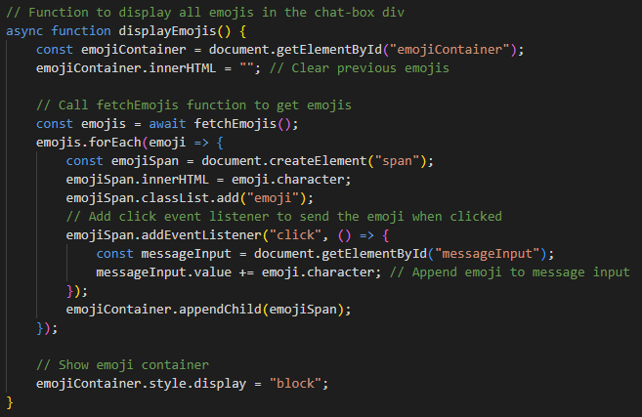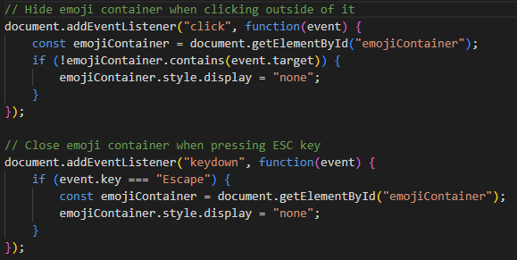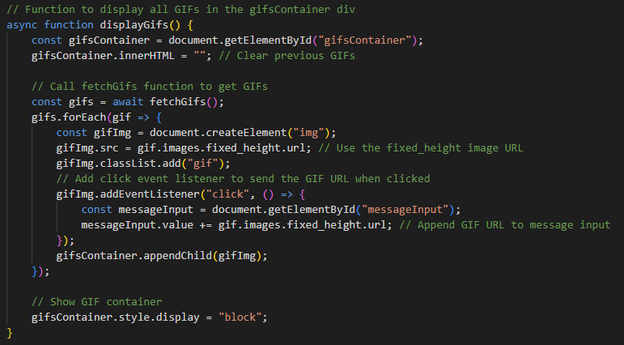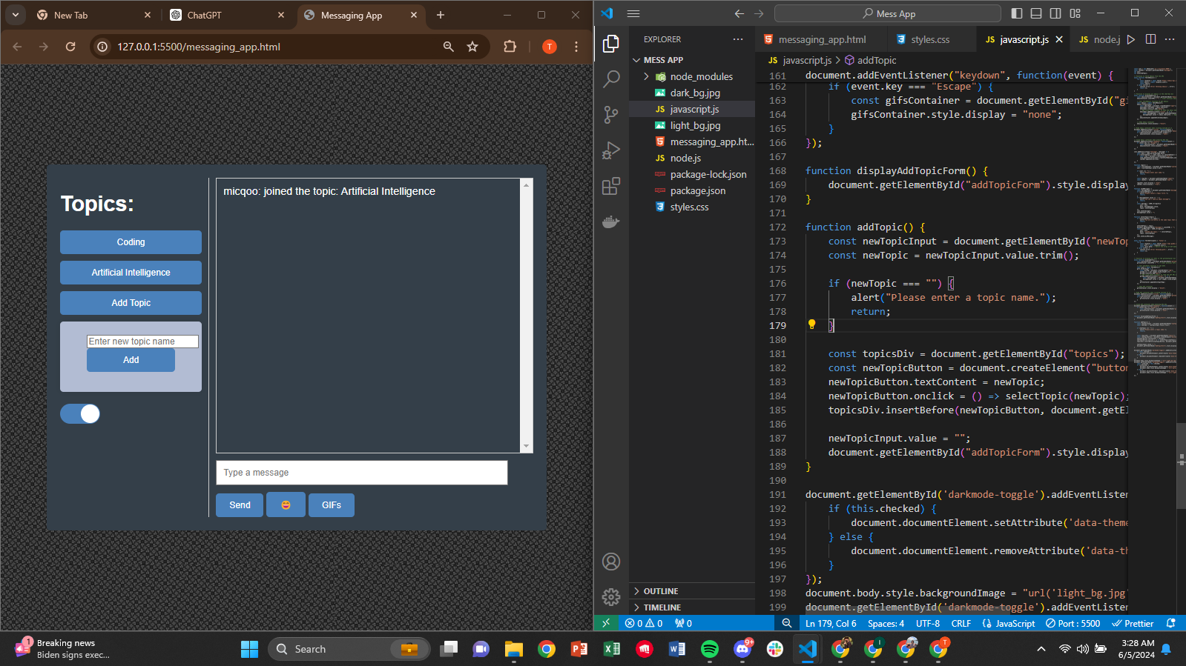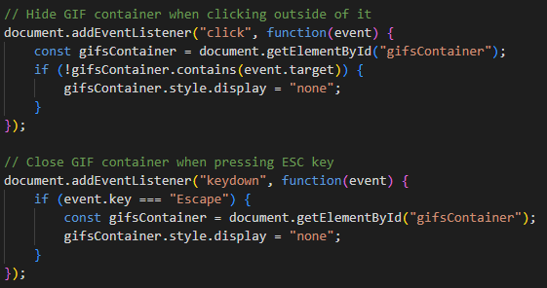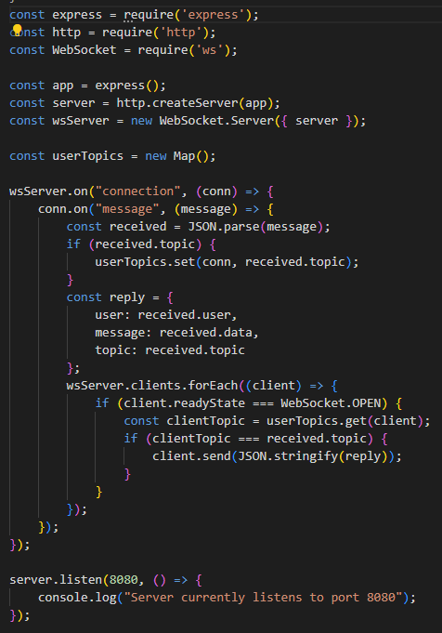

**JAVASCRIPT CODE:**

**SERVER CODE:**