VIETNAM GENERAL CONFEDERATION OF LABOUR

**TON DUC THANG UNIVERSITY**

**FACULTY OF INFORMATION TECHNOLOGY**



**REPORT OF THESIS RESEARCH 1**

**PROBABILISTIC WEIGHTED**

**FREQUENT ITEMSET MINING OVER UNCERTAIN DATA STREAMS**

*Advised by*: **Dr Nguyễn Chí Thiện**

*Authors*:  **Nguyễn Đình Quý – 520H0675**

**Nguyễn Nhất Thống – 52000808**

**HO CHI MINH CITY, 2024**

VIETNAM GENERAL CONFEDERATION OF LABOUR

**TON DUC THANG UNIVERSITY**

**FACULTY OF INFORMATION TECHNOLOGY**



**REPORT OF THESIS RESEARCH 1**

**PROBABILISTIC WEIGHTED**

**FREQUENT ITEMSET MINING OVER UNCERTAIN DATA STREAMS**

*Advised by*: **Dr Nguyễn Chí Thiện**

*Authors*:  **Nguyễn Đình Quý – 520H0675**

**Nguyễn Nhất Thống – 52000808**

**HO CHI MINH CITY, 2024**

**ACKNOWLEDGMENT**

We sincerely thank the Faculty of Information Technology for providing us with the opportunity to access and complete the report. We would like to express our heartfelt gratitude to Dr Nguyen Chi Thien for guiding us in completing the report.

During the process of preparing the report, due to limited knowledge and experience, there may be some shortcomings. We greatly appreciate any feedback from you so that we can learn more skills and experiences, and improve further.

We sincerely thank you!

*Ho Chi Minh City, day month year 2024*

*Author*

*(Signature and full name)*

**THE REPORT WAS COMPLETED**

**AT TON DUC THANG UNIVERSITY**

I hereby declare that this is our own research work, conducted under the scientific supervision of Dr. Nguyen Chi Thien. The research contents and results in this topic are truthful and have not been previously published in any form. The data presented in tables and figures, serving for analysis, comments, and evaluations, are collected by the author from various sources, clearly referenced in the reference section.

Furthermore, the project also incorporates some comments, evaluations, as well as data from other authors, and different organizations, all of which are appropriately cited and referenced.

**If any misconduct is discovered, I take full responsibility for the content of my project.** Ton Duc Thang University is not liable for any copyright infringements or violations caused by me during the implementation process (if any).

*Ho Chi Minh City, day month year 2024*

*Author*

*(Signature and full name)*

**ABSTRACT**

Mining frequent itemsets from uncertain data streams is a critical task in data analysis, yet it poses unique challenges due to the inherent uncertainty and dynamic nature of streaming data. This report presents a novel approach, focusing on probabilistic weighted frequent itemset mining over uncertain data streams.

Our method, PFIT, leverages an efficient in-memory index to manage data synopsis, facilitating real-time output of probabilistic frequent itemsets within sliding windows. We introduce PFIMoS, a dynamic depth-first algorithm, to construct and update PFIT, optimizing runtime and memory usage by estimating probabilistic support ranges. Additionally, we tackle the computational overhead associated with low minimum support thresholds and dense data through PFIMoS**+**, an error-parameter-guided heuristic algorithm.

Our methods are developed based on the algorithmic proposals found in the study by *Li, H., Zhang, N., Zhu, J., Wang, Y., & Cao, H. (2018) on Probabilistic Frequent Itemset Mining over Uncertain Data Streams*. Furthermore, to enhance flexibility in usage, improve the quality of outcomes, and increase efficiency in processing large datasets, we have incorporated a probability weighting approach based on the research by *Li, Z., Chen, F., Wu, J., Liu, Z., & Liu, W. (2020) in Efficient Weighted Probabilistic Frequent Itemset Mining in Uncertain Databases*. This integration aims to refine our methodology by considering the importance and uncertainty associated with each data item, thereby enriching our analysis and enabling more nuanced interpretations of complex data environments.

Through empirical evaluation, we demonstrate the effectiveness and efficiency of our approach, offering insights into scalable probabilistic frequent itemset mining in uncertain data stream environments.

**CONTENTS**

LIST OF FIGURES 5

LIST OF TABLE, DIAGRAM 6

ABBREVIATIONS 7

CHAPTER 1. INTRODUCTION AND OVERVIEW TOPIC 8

1.1 Introduction 8

1.2 Challenges and our contributions 8

1.3 Report organization 10

1.4 Related work: 10

CHAPTER 2. THEORETICAL BASIS 12

2.1 Preliminaries 12

2.2 UML Class Diagram 17

2.3 PFIT with weight: 18

2.4 PFMIoS with weight 19

2.4.1 ADDTRANS function 19

2.4.2 DELTRANS function 21

2.5 PFIMoS+ with weight 23

CHAPTER 3. EXPERIMENTS 24

3.1 Running environment and datasets 24

3.2 Experiment Results and Discussion 24

3.2.1 Experiment Results 24

3.2.2 Discussion 25

CHAPTER 4. CONCLUSION 27

REFERENCES 29

# LIST OF FIGURES

Figure 2.1 UML Class Diagram 17

Figure 2.2 Diagram describe the example's result of Buildtree Function 19

Figure 2.3 Diagram describe the example's result of ADDTRANS Function 21

Figure 2.4 Diagram describe the example's result of DELTRANS Function 23

Figure 3.1 Effect of Number of Line Data(runtime cost) 25

Figure 3.2 Effect of Number of Minimum Support(runtime cost) 25

# LIST OF TABLE, DIAGRAM

Table 2.1 Example of a Uncertain Database 13

Table 2.2 Table describe the result of calculating weight of each item 16

Table 2.3 Pseudcode Buildtree function in PFIT with weight 18

Table 2.4 Pseudocode ADDTRANS function in PFMIoS with weight 20

Table 2.5 Pseudocode DELTRANS function in PFMIoS with weight 22

Table 3.1 Details about the datasets used for experiment 24

# ABBREVIATIONS

|  |  |
| --- | --- |
| λ | Minimum support |
|  | Minimum probability |
| i | Distinct item |
| I | Uncertain item |
| **I** | Uncertain itemset |
| **UT** | Uncertain Transaction |
| *UD* | Uncertain Database |
|  | Sliding window |
| p(X) | Occurrence probability of itemset |
|  | Support of itemset |
|  | Expected Support of itemset |
|  | Weight of itemset |
|  | Probability support |
|  | Probability support in itemset but greater than minimum probability |
|  | Lower bound |
|  | Upper bound |
|  | Probability support with weight |

# INTRODUCTION AND OVERVIEW TOPIC

## Introduction

In the field of data mining, uncovering frequent itemsets within streams of data is crucial for extracting meaningful insights. The exploration of probabilistic frequent itemsets in uncertain data streams, as presented by ***Li et al. (2018)*** in "Probabilistic frequent itemset mining over uncertain data streams" in Expert Systems With Applications, marks a significant advancement in this domain. Their work introduces the PFIMoS and PFIMoS+ algorithms, which efficiently mine such itemsets by employing an innovative in-memory index, PFIT, and by estimating the range of probabilistic support to reduce computational demands.

Building upon the foundation laid by ***Li et al. (2018)***, this project seeks to extend the existing methodology by introducing weights to the frequent probability itemsets. This modification aims to enhance the granularity of the analysis by accounting for the varying significance of item occurrences within itemsets, thereby offering a more refined understanding of data stream patterns. The weighted approach promises to improve the algorithms' applicability across different contexts, enabling a prioritized analysis of itemsets based on their relevance or importance to specific applications.

This report aims to detail the theoretical underpinnings of this modification, its implementation, and the potential impacts it holds for the field of data mining. Through a meticulous examination of the proposed approach and its comparison with the foundational work of ***Li et al. (2018)***, this report endeavors to highlight the innovation and added value brought about by incorporating weights into the mining of probabilistic frequent itemsets.m mining research.

## Challenges and our contributions

* **Sliding Window Model and PFIT**:
* **Approach**: Using a sliding window model to analyze data streams.
* **Data Structure**: Introducing PFIT (Probabilistic Frequent Item-set Tree), an in-memory data structure designed to store data synopsis of probabilistic frequent item-sets in a bottom-up manner.
* **Objective**: Efficiently reducing the search space during the analysis of uncertain data streams.
* **PFIMoS Algorithm**:
* **Algorithm Name**: PFIMoS (Probabilistic Frequent Itemset Mining over Streams).
* **Objective**: Incrementally discovering and maintaining probabilistic frequent itemsets.
* **Innovation**: Utilizing a probabilistic support estimating method that computes upper and lower bounds of probabilistic support at a significantly lower cost.
* **Performance Improvement**: The method, when used in conjunction with PFIT, is claimed to yield better overall performance.
* **PFIMoS+ Algorithm**:
* **Algorithm Name**: PFIMoS+ (an improved version of PFIMoS).
* **Enhancement**: Introducing a heuristic rule to reduce the count of probabilistic support computing that is not pruned by the bounds.
* **Effectiveness**: The heuristic rule is claimed to be particularly effective when mining over streams, significantly reducing runtime costs, especially in scenarios with low minimum support or dense data.
* **Weighted PFIT, Weighted PFIMoS, Weighted PFIMoS+:**
* **Algorithm Name:** Weighted PFIT, Weighted PFIMoS, Weighted PFIMoS+
* **Objective**: Enhance both the performance and accuracy compared to the algorithm's original version before the integration of weights
* **Evaluation of Algorithms**:
* **Datasets**: Evaluation conducted on 2 synthetic datasets and 4 real-life datasets.
* **Outcome**: The proposed algorithms are reported to be effective and efficient

## Report organization

**Chapter 1 Introduction and Overview:** This initial chapter sets the stage by introducing the topic of probabilistic weighted frequent itemset mining. It outlines the challenges associated with uncertain data streams and enumerates our contributions to addressing these challenges. The chapter concludes with an outline of related work, establishing the context and relevance of our research.

**Chapter 2 Theoretical Basis:** The second chapter delves into the theoretical underpinnings of our study. It begins with the preliminaries and problem definition, laying the groundwork for understanding the algorithms and methods employed. Subsequent sections detail the various components of our approach, including the computation of probabilistic support bounds, the construction of a probabilistic frequent itemset tree, and the description of the PFIMoS algorithm. We also discuss algorithms for adding and deleting uncertain transactions and introduce an enhanced version of PFIMoS.

**Chapter 3 Experiments:** In this chapter, we present the empirical evaluation of our proposed methods. We describe the experimental setup, including the computing environment and datasets used. The results of our experiments are then thoroughly discussed

**Chapter 4 Conclusion:** The final chapter concludes the report, summarizing the key findings and contributions of our research.

**References:** At the end of the report, a comprehensive list of references is provided, documenting the scholarly works and sources cited throughout the report.

## Related work:

To explore deeply into this topic. Two new definitions must be clearly. Firstly, ***Expected Frequent Item-set (Chui,Kao & Hung, 2007)***. For expected frequent itemset,this definition focuses on calculating the expected support of itemsets. The expected support can be computed with O(n) time complexity and O(1) space complexity. Several algorithms have been devised to discover expected frequent itemsets, mainly based on a priori rules and traditional data structures like ***FP-tree (Cuzzocrea & Leung, 2016; Leung & MacKinnon, 2014)*** and ***H-struct (Aggarwal, Li, Wang & Wang, 2009)***.

However, expected support cannot show the total of probabilistic characteristic of data. Therefore, ***Probabilistic Frequent item-set (Bernecker, Kriegel, Renz, Verhein, & Zuefle, 2009)*** was invented.Mining probabilistic frequent itemsets can better discover probabilistic features. Algorithms like ***ProApriori (Bernecker et al., 2009)*** and ***ProFPGrowth (Bernecker, Kriegel, Renz, Verhein, & Züfle, 2012)*** have been proposed to discover probabilistic frequent itemsets, utilizing a priori rules and the ***ProFP-tree (Sun et al., 2010)*** data structure to maintain itemsets.

In the realm of uncertain data mining over data streams, algorithms such as ***FEMP (Akbarinia & Masseglia, 2013)*** and ***PFIMUDS (Akbarinia & Masseglia, 2013)*** have been proposed to discover probabilistic frequent itemsets in data streams. These methods focus on computing probabilistic support and employ techniques like a priori rules to reduce computational costs.

Further advancing this domain, **Li et al. (2018)** developed **PFIMoS** and **PFIMoS+** algorithms to efficiently mine probabilistic frequent itemsets in uncertain data streams, using an in-memory index (**PFIT**) and probabilistic support ranges to significantly cut down on computational time and memory use, surpassing previous methods like **TODIS-Stream** and **FEMP**. This breakthrough enhances uncertain data stream mining for practical use. In a subsequent study by **Li, Chen, Wu, Liu, and Liu (2020)**, a new algorithm for mining weighted probabilistic frequent itemsets **(w-PFIs)** in uncertain databases was introduced, employing a novel probability model and three pruning techniques to efficiently reduce the search space. This research advances weighted uncertain data mining by combining weights and probabilistic assessments, providing a thorough analysis of itemset mining's significance and uncertainty.

# THEORETICAL BASIS

## Preliminaries

* **Definition 1**: Distinct Item (*i*)
* **Concept:** The list of different items in uncertain database
* **Formula:** Where n is the number of distinct items. Available on all data

|  |  |  |
| --- | --- | --- |
|  |  | (2.1) |

* **Explanation and Example:** This is 5 different items in uncertain database

|  |  |  |
| --- | --- | --- |
|  |  |  |

* **Definition 2:** Uncertain Item
* **Concept:** It is a random variable. Corresponding to each item, there will be a different occurrence probability
* **Formula:**

|  |  |  |
| --- | --- | --- |
|  |  | (2.2) |

* **Explanation and Example:** This presents the item ‘A’ and the occurrence probability ‘0.3’

|  |  |  |
| --- | --- | --- |
|  |  |  |

* **Definition 3:** Uncertain itemset
* **Concept:** It is Mutitional random variables
* **Formula:** Where n is the number of random variables.

|  |  |  |
| --- | --- | --- |
|  |  | (2.3) |

* **Explanation and Example:** This example shows the Uncertain itemset with 3 pairs of uncertain items and the probabilities are (A, 0.3), (B, 0.6), (D, 0.8)

|  |  |  |
| --- | --- | --- |
|  |  |  |

* **Definition 4:** Uncertain Transaction
* **Concept:** Uncertain Transaction is a list of multidimensional random variables. Corresponding to a multi-dimensional random variable, there will be a symbolic ID.
* **Formula:** Where n is the number of uncertain transactions

|  |  |  |
| --- | --- | --- |
|  |  | (2.4) |

* **Explanation and Example:** This example shows 1 Uncertain transaction consists of a list of multidimensional random variables including (A, 0.3), (B, 0.6), (D, 0.8) and symbolic ID

|  |  |  |
| --- | --- | --- |
|  |  |  |

* **Definition 5:** Uncertain Database
* **Concept:** Uncertain Database is a collection of uncertain transactions.
* **Formula:** where n is the number of uncertain transactions

|  |  |  |
| --- | --- | --- |
|  |  | (2.5) |

* **Explanation and Example:** This example shows an uncertain database as a table where each of its rows is an uncertain transaction

|  |  |
| --- | --- |
| ID1 | {(A,0.3), (B, 0.6), (D, 0.8)} |
| ID2 | {(C, 0.4), (E, 0.7)} |
| ID3 | {(B, 0.9)} |
| ID4 | {(D, 0.6), (E, 0.7)} |
| ID5 | {(A,0.5), (B, 0.4),(C, 0.6),(D, 0.8), (E, 0.8)} |

Table 2.1 Example of a Uncertain Database

* **Definition 6**: Support
* **Concept:** Support is the frequency of an itemset appearing in the entire uncertain database.
* **Formula:**

|  |  |  |
| --- | --- | --- |
|  |  | (2.6) |

* **Explanation and Example:** It compute the sum of items occur in uncertain database. Similarly, according to **Table 2.1,** itemset A occurs in the first Uncertain transaction 1 time so increase to 1, Otherwise, in Uncertain transaction 2, 3, 4 don’t have so increase to 0. Finally, in the last uncertain transaction also own ‘A’ so we continue rising to 1. At the end of computing support, collecting support is 2
* **Definition 7:** Expected Frequent Itemset:
* **Concept:** An itemset is considered a frequent itemset when expected support > minimum support. Below is the formula to calculate expected support. (Expected support is a form of support but is often used in uncertain data streams)
* **Formula:**

|  |  |  |
| --- | --- | --- |
|  |  | (2.7) |

* **Explanation and Example**: Calculate expected frequent itemset based on the sum of each item's probability on each transaction
* **Definition 8:** Probabilistic Frequent Item-set
* **Concept:** An itemset is considered frequent when probabilistic support > minimum support. Below is the calculation formula
* **Formula:**

|  |  |  |
| --- | --- | --- |
|  |  | (2.8) |
| Where: |  | (2.9) |

* **Explanation and Example:** For itemset ‘A’ we see that with minimum probability is 0.2 so first transaction and five transaction have probability greater than minimum probability so we have probability support equals to 2.
* **Definition 9:** Probability Support weight
* **Concept**: Is a variation of probability support. But we will calculate more with weighted to block the conditions in ADDTRANS and DELTRANS functions
* **Formula**:

|  |  |  |
| --- | --- | --- |
|  |  | (2.10) |
| Where: |  | (2.11) |

* **Explanation and Example**:Similar to probability support but we will multiply each Probability support with weight of itemset
* **Definition 10**: Lower bound
* **Concept**: The smallest value that a random variable, a set of numbers, or a quantity can take or not exceed towards the bottom. In the context of an algorithm or a probability distribution, the lower bound has can indicate the minimum value below which the probability of finding a value of the variable is very low or non-existent.
* **Formula**:

|  |  |  |
| --- | --- | --- |
|  |  | (2.12) |
| Where: |  | (2.13) |

* **Explanation and Example**: Base on Expected support and minimum probability we compute the lower bound and check the condition if it smaller than 0 we mark it 0
* **Definition 11**: Upper bound
* **Concept**: The maximum value that a random variable, a set of numbers, or a quantity can reach or not exceed. In an algorithm or model, an upper limit can be used to indicates the value above which the probability of finding the value of the variable is very low or non-existent.
* **Formula**:

|  |  |  |
| --- | --- | --- |
|  |  | (2.14) |
| Where: |  | (2.15) |

* **Explanation and Example**: Base on Expected support and Support we compute the lower bound and check the condition if it smaller than 0 we mark it support
* **Definition 12:** Weighted
* **Concept:** Is in the number of each itemset
* **Formula:**

|  |  |  |
| --- | --- | --- |
|  |  | (2.16) |

* **Explanation and Example**: We will compute the weight in each itemset base on the average weight of each item.

|  |  |  |  |  |
| --- | --- | --- | --- | --- |
| A | B | C | D | E |
| 0.2 | 0.4 | 0.1 | 0.9 | 0.7 |

Table 2.2 Table describe the result of calculating weight of each item

## UML Class Diagram

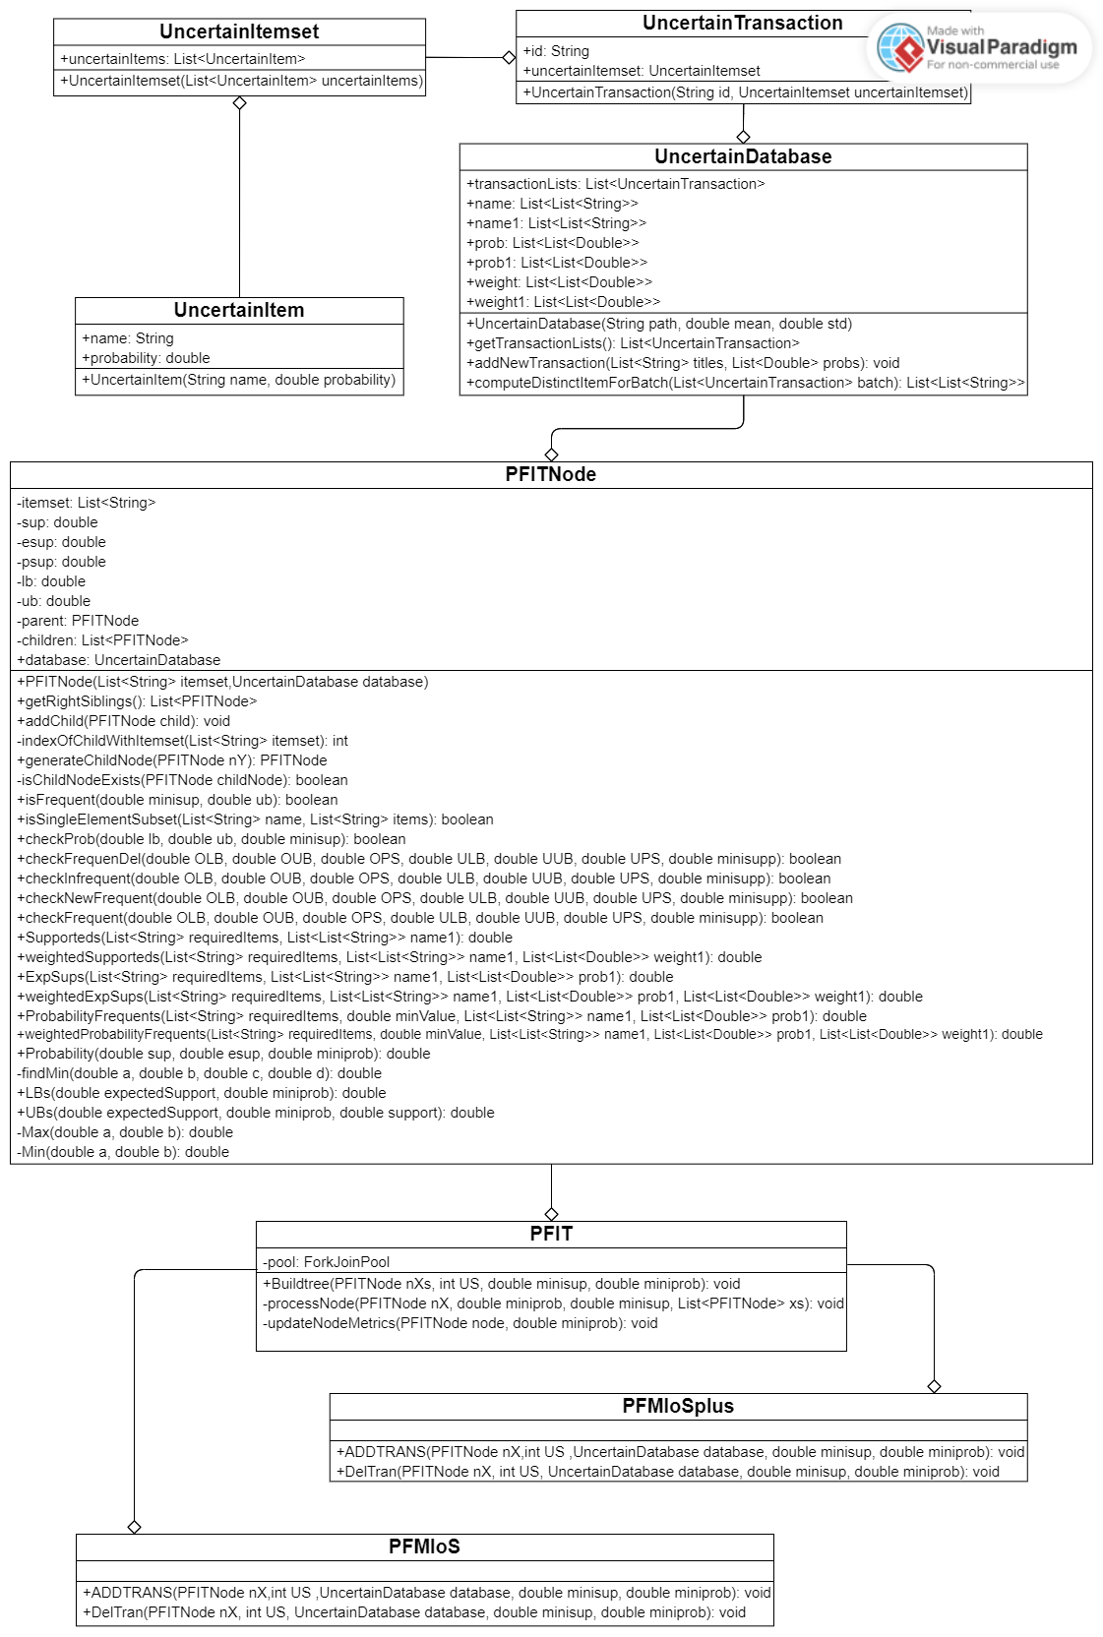

Figure 2.1 UML Class Diagram

## PFIT with weight:

|  |  |
| --- | --- |
| **Function:** Buildtree | |
| **Require:** nXs: PFITNode, US: int, minisup: double, miniprob: double | |
| 1: | **Initialize** a **new** RecursiveAction |
| 2: | **Define** compute() method |
| 3: | **Initialize** an empty list xs **of** PFITNode |
| 4: | **For** **each** child nX **of** nXs **in** parallel **do** |
| 5: | **Set** nX's support, expected support, LB, UB |
| 6: | **If** nX is not frequent **then** |
| 7: | **Continue** **to** the **next** child |
| 8: | **Set** the probability **of** nX |
| 9: | **For** **each** right sibling node of nX in parallel **do** |
| 10: | **If** the sibling node is frequent **then** |
| 11: | **Generate** a child node |
| 12: | **Set** child's support, expected support, LB, UB |
| 13: | **If** the child node's LB <= minisup and UB >= minisup **then** |
| 14: | **Set** the probability of the child |
| 15: | **Synchronize** access to xs |
| 16: | **Add** the child node to xs |
| 17: | **Add** all nodes in xs to the children of nXs |

Table 2.3 Pseudcode Buildtree function in PFIT with weight

**Explanation and Example: List itemset includes ‘A’, ‘B’, ‘C’, ‘D’,’E’ in Table 2.1can see that, with minimum support (lamda) is 2, minimum probability (t) is 0.6. itemset ‘A’ has support 2 and it is greater than or equal minimum support so it define frequent. If itemset is not frequent, it will continue to check the right parents. The righr parent is frequent so continuing generate children with the itemset not frequent. The condition lowerbound and upper bound keep computing probability support less consume running time cost. In this probability we multiply probability support with weight of itemset (dựa trên bài báo gì đó). Finally, we add all childnode to root.**

**Output:** This output is the calculation result between ***Table 2.1 Example of a Uncertain Database***

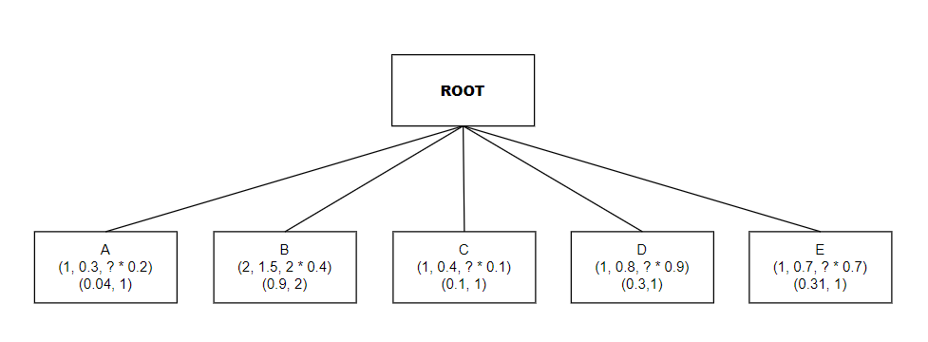

Figure 2.2 Diagram describe the example's result of Buildtree Function

## PFMIoS with weight

### ADDTRANS function

|  |  |
| --- | --- |
| **Function:** ADDTRANS | |
| **Require:** nX: PFITNode, US: int, database: UncertainDatabase, minisup: double, miniprob: double | |
| 1: | **Retrieve** the last value, probability, and weight **from** the database |
| 2: | **Initialize** three lists: childrenCopy, newfre, and frequent |
| 3: | **If** nX has no children **then** |
| 4: | **Return** |
| 5: | **For each** child nY **of** nX **do** |
| 6: | **Store** nY's original lower bound, upper bound, and probability |
| 7: | **If** nY is a subset of the transaction (value) **then** |
| 8: | **Update** nY's support, expected support, lower bound, upper bound, and reset probability |
| 9: | **If** nY's updated bounds indicate it's potentially frequent **then** |
| 10: | **Update** nY's probability |
| 11: | **If** nY transitions to a frequent state **then** |
| 12: | **Add** nY to newfre list |
| 13: | **Generate** new child nodes for all right siblings of nY |
| 14: | **Update** support and expected support for each child |
| 15: | **Add** each child to childrenCopy and as a child of nY |
| 16: | **If** nY remains frequent and is a subset of the transaction **then** |
| 17: | **Add** nY to frequent list |
| 18: | **For each** node in frequent **then** |
| 19: | **For each** right sibling that is newly frequent **then** |
| 20: | **Generate** and update a new child node  **Add** this new child to childrenCopy and as a child of the current node |
| 21: | **Add** all nodes in childrenCopy to the children of nX |

Table 2.4 Pseudocode ADDTRANS function in PFMIoS with weight

**Explanation and Example**: When owning a tree include a list of itemset frequent or not frequent, we continue to addtran to check conditions in uncertain data stream. When new uncertain transaction add, store a original upper bound, lower bound and probability support (with weight). Iteration between each childnode and check if itemsets are on list or not. The condition become true so moving to update again support, expected support, lower bound, upper bound and probability support. When done, check itemset are new frequent or not (i - f). if new frequent, Build again Tree, If itemsets keep frequent (f - f) after updating number, we loop all right parents and check if parents are new frequent, integrating itemset with parents. At the end, add all childNode to root children.

**Output:** This output is the calculation result between ***Table 2.1 Example of a Uncertain Database*** and the output of the **Buildtree function** in ***Figure 2.2***

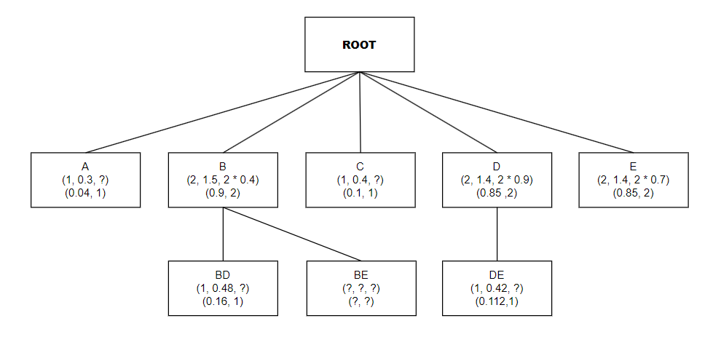

Figure 2.3 Diagram describe the example's result of ADDTRANS Function

### DELTRANS function

|  |  |
| --- | --- |
| **Function:** DELTRANS | |
| **Require:** nX: PFITNode, US: int, database: UncertainDatabase, minisup: double, miniprob: double | |
| 1: | **Retrieve** the first set of names, probabilities, and weights **from** the database |
| 2: | **Initialize** an infre list to track infrequent nodes |
| 3: | **If** nX has no children **then** |
| 4: | **Return** |
| 5: | **Copy** nX's children for iteration |
| 6: | **Remove** the first set of names, probabilities, and weights **from** the database |
| 7: | **For each** node nY in the copied list of children **do** |
| 8: | **Store** nY's original lower bound, upper bound, and probability |
| 9: | **If** nY's items are a subset of the transaction (list) **then** |
| 10: | **Update** nY's support, expected support, lower bound, and upper bound without database access |
| 11: | **Update** nY's probability based on the new bounds |
| 12: | **Set** nY's probability to 0 if it is not in the frequent bounds anymore |
| 13: | **For each** child nZ of nY **do** |
| 14: | **If** nZ becomes infrequent after the transaction removal **then** |
| 15: | **Remove** nZ **from** nX's children |
| 16: | **Add** nZ **to** the infre list |
| 17: | **If** nZ remains frequent but needs updates due to the transaction removal **then** |
| 18: | **Remove** all children of nZ **from** nX's children if they are related to the transaction |

Table 2.5 Pseudocode DELTRANS function in PFMIoS with weight

**Explanation and Example:** When updating complete we need delete the old uncertain transaction, especially, first row. We take first uncertain transaction and check item sets include in first transaction. If it occur, we remove all unnecessary value. When done, check after removing value we move to identify itemset become infrequent (f - i). if it infrequent, remove all childnode of this node. And if itemset keep frequent, we will remove childnode of this.

**Output:** This output is the calculation result between ***Table 2.1 Example of a Uncertain Database,*** the output of the **Buildtree function** in ***Figure 2.2*** and the output of the **ADDTRANS function** in ***Figure 2.3***

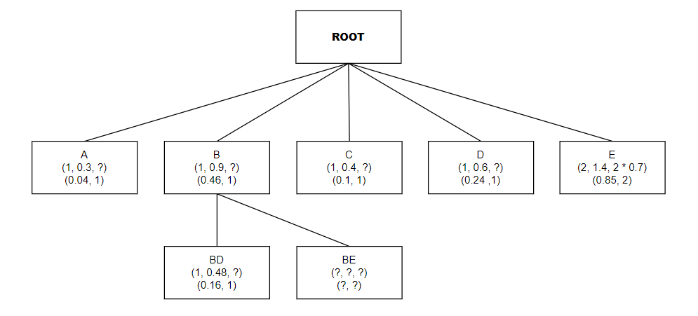

Figure 2.4 Diagram describe the example's result of DELTRANS Function

## PFIMoS+ with weight

**Explanation and Example: Similar to PFMIoS but we compute again Probability support which base on ***Herutical rules*** in document *Li et al. (2018)*. The new thing we change in this is about add itemset’s weight in each probability support to make time consuming in the condition ADDTRANS and DELTRANS more efficient than the older. However, it reduce quite small compared to the older without weight. Here is the formula, we use for this function:**

|  |  |  |
| --- | --- | --- |
|  |  | (2.17) |

# EXPERIMENTS

## Running environment and datasets

* **Programming language**: Java
* **Compile environment**: java 21.0.2 2024-01-16 LTS, Java(TM) SE Runtime Environment (build 21.0.2+13-LTS-58), Java HotSpot(TM) 64-Bit Server VM (build 21.0.2+13-LTS-58, mixed mode, sharing)
* **IDE used for compilation**: Visual Studio Code
* **Device**: Laptop LENOVO AMD Ryzen 5 4600H with Radeon Graphics 3.00 GHz and 8.00 GB of main memory
* **Datasets**:

|  |  |  |  |
| --- | --- | --- | --- |
| Datasets | Transactions count | Mean | Variance |
| T40I10D100K | 100 000 | 0.79 | 0.61 |
| CONNECT4 | 67 557 | 0.78 | 0.65 |
| GAZELLE | 59 602 | 0.94 | 0.08 |

Table 3.1 Details about the datasets used for experiment

* **Processing data**: To address the lack of item probabilities and weights in the dataset, we used a **Gaussian distribution** to aggregate the probabilities, applying a **sigmoid function** to prevent overflow, following ***Li et al. (2018)*** and assign random weights between 0 and 1 according to ***Li et al. (2020)***.

## Experiment Results and Discussion

### Experiment Results

|  |  |  |
| --- | --- | --- |
|  |  |  |

Figure 3.1 Effect of Number of Line Data(runtime cost)

|  |  |  |
| --- | --- | --- |
|  |  |  |

Figure 3.2 Effect of Number of Minimum Support(runtime cost)

### Discussion

* **According to *Figure 3.1:***
* There is a clear upward trend in running time cost as the number of line data increases for both algorithms, which is a typical behavior as more data generally requires more processing time.
* wPFIMoS+ shows an advantage over wPFIMoS in handling larger datasets, particularly evident in the T40I10D100K dataset at 50 thousand lines of data.
* The incremental running time cost with increasing data volume appears to be more linear for wPFIMoS+, while wPFIMoS exhibits a steeper increase, especially in the T40I10D100K dataset. This indicates better scalability of wPFIMoS+ under heavier data loads.
* **According to *Figure 3.2***:
* Across all datasets, wPFIMoS+ consistently performs better (i.e., lower running time) than wPFIMoS. This suggests that the enhancements made in the wPFIMoS+ algorithm effectively reduce computation time compared to its predecessor.
* The running time cost tends to decrease for both algorithms as the minimum support increases from 0.01 to 1. This is an expected behavior because a higher minimum support threshold usually results in fewer itemsets being considered frequent, thus reducing the computational workload.
* The T40I10D100K dataset appears to be more computationally demanding than the CONNECT4 and GAZELLE datasets, as indicated by the overall higher running times for both algorithms on this dataset.
* The relative difference in performance between wPFIMoS and wPFIMoS+ is most pronounced at the lower minimum support level (0.01), particularly in the T40I10D100K dataset. This suggests that the improvements in wPFIMoS+ are especially beneficial when dealing with denser datasets and more stringent (lower) minimum support thresholds.
* While all datasets show improved running times at higher minimum support levels, the T40I10D100K dataset demonstrates a less pronounced improvement compared to the other datasets. This could indicate scalability issues with larger or more complex datasets and might be an area for further optimization.

Overall, these diagrams suggest that the wPFIMoS+ algorithm is more efficient than wPFIMoS, particularly when dealing with larger datasets and when the minimum support threshold is high. Additionally, the diagrams also indicate that algorithm performance can vary significantly depending on the characteristics of the dataset being processed.

# CONCLUSION

Our research into Probabilistic Weighted Frequent Itemset Mining over Uncertain Data Streams has presented a approach that integrates the concepts of weight and probability in the analysis of uncertain data streams. This integration is pivotal in addressing the dynamic and inherently uncertain nature of streaming data, which poses significant challenges in the field of data mining.

The introduction of the PFIT, PFIMoS, and PFIMoS+ algorithms represents a significant leap forward in our ability to efficiently and effectively mine weighted frequent itemsets from such streams. The 'weighted' aspect of these algorithms is particularly noteworthy, as it allows for a more nuanced understanding of the data by considering not only the occurrence frequency of itemsets but also their respective weights. This approach acknowledges that not all itemsets contribute equally to the insights derived from the data, hence offering a more sophisticated analysis tool that aligns more closely with real-world complexities.

Through our experimental evaluations, we have demonstrated that the incorporation of weights into the probabilistic mining process significantly enhances the performance and accuracy of the mining task. The weighted approach enables the algorithms to prioritize the analysis of itemsets based on their relevance or importance, which is crucial for applications where the significance of the data varies.

Moreover, our experiments using synthetic and real-life datasets have unequivocally shown the superior efficacy of our proposed methods in terms of runtime and memory usage. This not only validates our approach but also emphasizes the practical utility of weighted itemset mining in uncertain data streams, offering potential applications in a wide array of domains such as market basket analysis, real-time monitoring systems, and beyond.

In conclusion, the weighted dimension introduced in our probabilistic frequent itemset mining methodology has opened up new avenues for more refined and relevant data analysis in the face of uncertainty. The success of this approach underscores the importance of continuing to explore and optimize weighted mining techniques, with future work aimed at further enhancing the efficiency and applicability of these algorithms in other complex data environments. Our research thus provides a substantial contribution to the ongoing development of data mining technologies, offering a robust, efficient, and adaptable solution for uncovering the intricate patterns hidden within uncertain data streams.

# REFERENCES

1. [Aggarwal, C. C., Li, Y., Wang, J., & Wang, J. (2009). Frequent pattern mining with uncertain data. In Proceedings of the 15th acm sigkdd international conference on knowledge discovery and data mining (pp. 29–38). ACM](https://dl.acm.org/doi/10.1145/1557019.1557030)
2. [Akbarinia, R., & Masseglia, F. (2013). Fast and exact mining of probabilistic data streams. In Machine learning and knowledge discovery in databases (pp. 493–508).Springer.]("https://link.springer.com/chapter/10.1007/978-3-642-40988-2_32)
3. [Bernecker, T., Kriegel, H.-P., Renz, M., Verhein, F., & Zuefle, A. (2009). Probabilistic frequent itemset mining in uncertain databases. In Proceedings of the 15th acm sigkdd international conference on knowledge discovery and data mining (pp. 119–128). ACM.](https://dl.acm.org/doi/10.1145/1557019.1557039)
4. [Bernecker, T., Kriegel, H.-P., Renz, M., Verhein, F., & Züfle, A. (2012). Probabilistic frequent pattern growth for itemset mining in uncertain databases. In Scientific and statistical database management (pp. 38–55). Springer](https://link.springer.com/chapter/10.1007/978-3-642-31235-9_3)
5. [Chui, C.-K., Kao, B., & Hung, E. (2007). Mining frequent itemsets from uncertain data. In Advances in knowledge discovery and data mining (pp. 47–58). Springer.](https://link.springer.com/chapter/10.1007/978-3-540-71701-0_8)
6. [Cuzzocrea, A., & Leung, C. K. (2016). Computing theoretically-sound upper bounds to expected support for frequent pattern mining problems over uncertain big data. In International conference on information processing and management of uncertainty in knowledge-based systems (pp. 379–392). Springer.](https://link.springer.com/chapter/10.1007/978-3-319-40581-0_31)
7. [Leung, C. K.-S., & MacKinnon, R. K. (2014). Blimp: A compact tree structure for uncertain frequent pattern mining. In Data warehousing and knowledge discovery (pp. 115–123). Springer.](https://link.springer.com/chapter/10.1007/978-3-319-10160-6_11)
8. [Li, H., Zhang, N., Zhu, J., Wang, Y., & Cao, H. (2018). Probabilistic Frequent Itemset Mining over Uncertain Data Streams. Proceedings of the 2018 International Conference on Database Systems for Advanced Applications, 11382, 646–661.](https://www.sciencedirect.com/science/article/abs/pii/S0957417418303890)
9. [Li, Z., Chen, F., Wu, J., Liu, Z., & Liu, W. (2020). Efficient weighted probabilistic frequent itemset mining in uncertain databases. Expert Systems, e12551. https://doi.org/10.1111/exsy.12551](https://onlinelibrary.wiley.com/doi/abs/10.1111/exsy.12551)
10. [Sun, L., Cheng, R., Cheung, D. W., & Cheng, J. (2010). Mining uncertain data withprobabilistic guarantees. In Proceedings of the 16th acm sigkdd international conference on knowledge discovery and data mining (pp. 273–282). ACM.](https://dl.acm.org/doi/10.1145/1835804.1835841)
11. [Mike Novey, Tülay Adali, Anindya Roy.(2010). A Complex Generalized Gaussian Distribution— Characterization, Generation, and Estimation. In IEEE Transactions on Signal Processing ( Volume: 58, Issue: 3). 10.1109/TSP.2009.2036049](https://ieeexplore.ieee.org/document/5313943)
12. [Jun Han, Claudio Moraga. (2005). The influence of the sigmoid function parameters on the speed of backpropagation learning. In Computational Models of Neurons and Neural Nets. https://doi.org/10.1007/3-540-59497-3_175](https://link.springer.com/chapter/10.1007/3-540-59497-3_175" \l "editor-information)
13. [Seok-Ho Chang, Pamela C. Cosman, Laurence B. Milstein. (2011) . Chernoff-Type Bounds for the Gaussian Error Function. In IEEE Transactions on Communications. 10.1109/TCOMM.2011.072011.100049](https://ieeexplore.ieee.org/abstract/document/5963622/authors" \l "authors)
14. [Lin, J.CW., Gan, W., Fournier-Viger, P. et al. Weighted frequent itemset mining over uncertain databases. Appl Intell 44, 232–250 (2016). https://doi.org/10.1007/s10489-015-0703-9](https://link.springer.com/article/10.1007/s10489-015-0703-9" \l "rightslink)
15. [Toon Calders, Calin Garboni, Bart Goethals. (2010). Approximation of Frequentness Probability of Itemsets in Uncertain Data. In 2010 IEEE International Conference on Data Mining. 10.1109/ICDM.2010.42.](https://ieeexplore.ieee.org/abstract/document/5694033)
16. [Chengjie Luo, Clement Yu, and Jorge Lobo, Gaoming Wang, Tracy Pham, Clement Yu. (1996). Computation of Best Bounds of Probabilities from Uncertain Data. https://doi.org/10.1111/j.1467-8640.1996.tb00276.x](https://onlinelibrary.wiley.com/doi/abs/10.1111/j.1467-8640.1996.tb00276.x)
17. [Razieh Davashi. (2021). UP-tree & UP-Mine: A fast method based on upper bound for frequent pattern mining from uncertain data. https://doi.org/10.1016/j.engappai.2021.104477](https://www.sciencedirect.com/science/article/abs/pii/S0952197621003250" \l "preview-section-references)
18. [Carson Kai-Sang Leung, Boyu Hao. (2009). Mining of Frequent Itemsets from Streams of Uncertain Data. In 2009 IEEE 25th International Conference on Data Engineering. 10.1109/ICDE.2009.157](https://ieeexplore.ieee.org/abstract/document/4812590/references" \l "references)
19. [Islam, M.S., Kar, P.C., Samiullah, M. et al. Discovering probabilistically weighted sequential patterns in uncertain databases. Appl Intell 53, 6525–6553 (2023). https://doi.org/10.1007/s10489-022-03699-7](https://link.springer.com/article/10.1007/s10489-022-03699-7)
20. [Gan, W., Lin, J.CW., Fournier-Viger, P., Chao, HC. (2016). Mining Recent High Expected Weighted Itemsets from Uncertain Databases. In: Li, F., Shim, K., Zheng, K., Liu, G. (eds) Web Technologies and Applications. APWeb 2016. Lecture Notes in Computer Science(), vol 9931. Springer, Cham. https://doi.org/10.1007/978-3-319-45814-4_47](https://link.springer.com/chapter/10.1007/978-3-319-45814-4_47" \l "editor-information)