1. Non-functional : Start the app, Exit the app, Show the list after buying

Functional : Qrcode, Purchase, Clear

Domain requirement: No requirement.

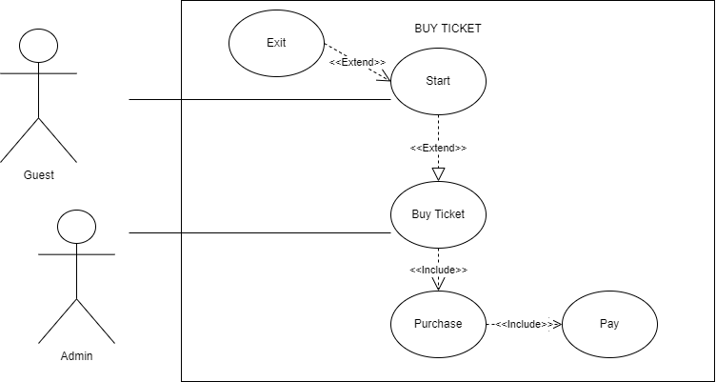

1. Activity Diagram

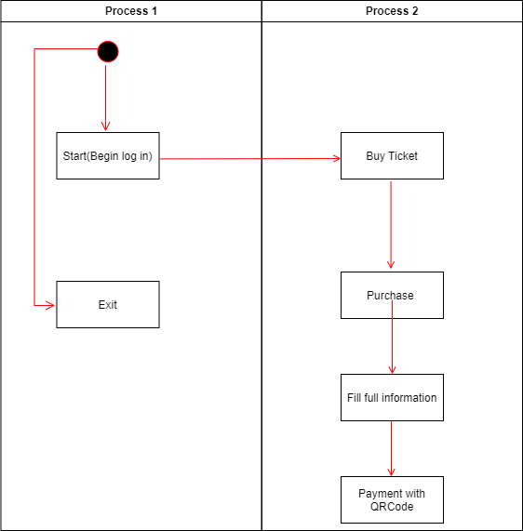

1. Sequence Diagram

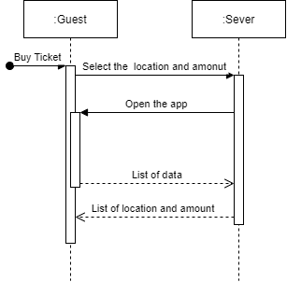

State Diagram

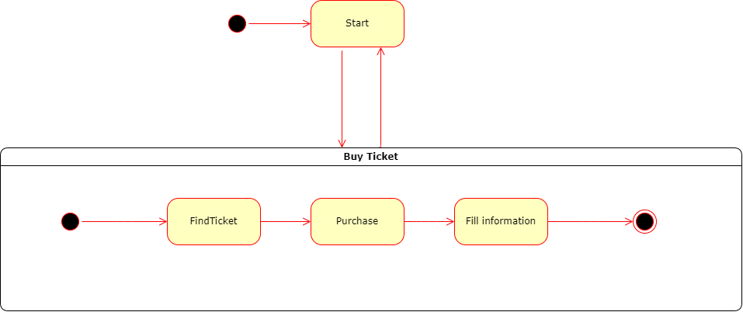

<https://github.com/Rom1009/Software-Engineering>