Лекция 16

ПСКП

ПОИТ-3

**Node.js: Express**

1. **Express:**

<https://www.npmjs.com/package/express>

<http://expressjs.com/>

<https://metanit.com/web/nodejs/4.1.php>

1. **Express:** require(express), listen, middleware, next, send

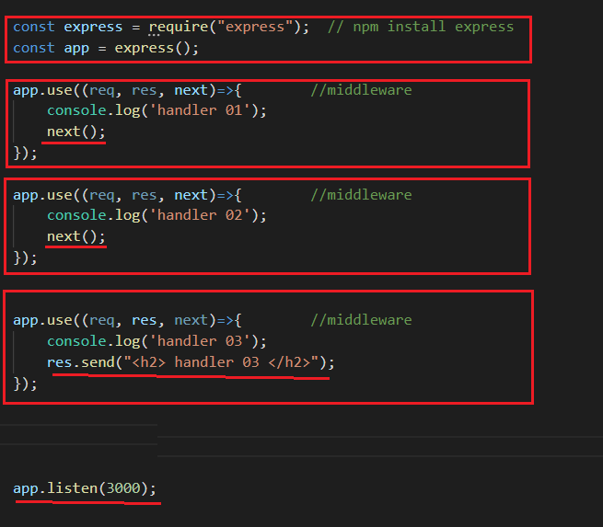

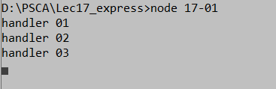



1. **Express:** POST, PUT, DELETE

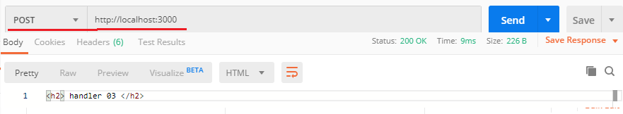

1. **Express:** server**.**close

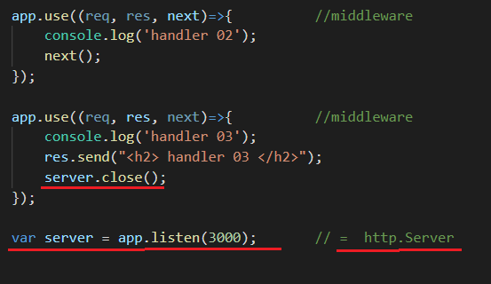

1. **Express:** routing, get/post/put/delete-response

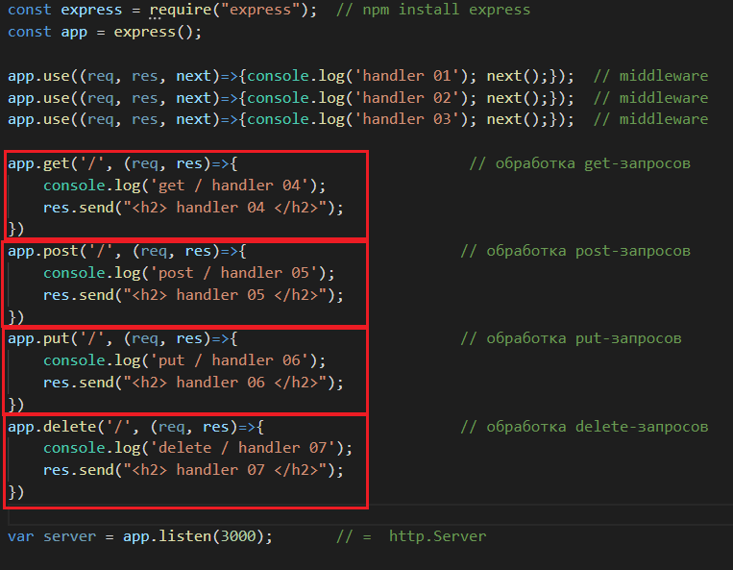

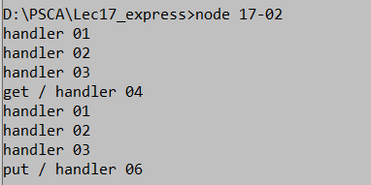

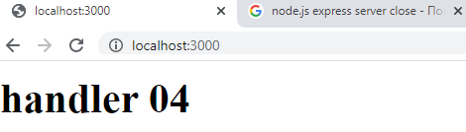

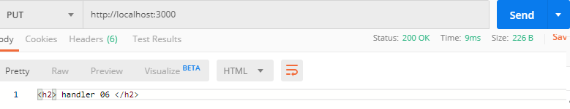

1. **Express:** routing/middleware, get/post/put/delete-response

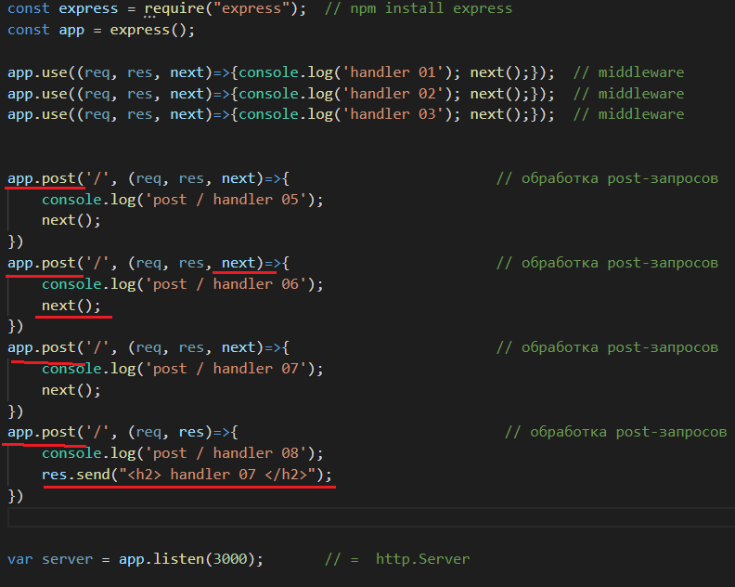

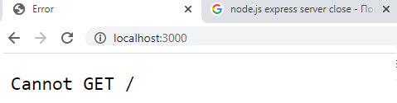

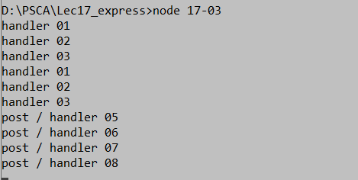

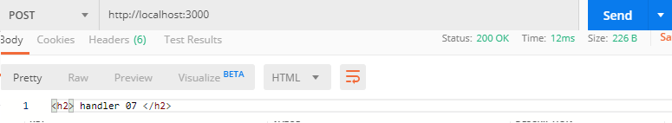

1. **Express:** объект request, свойства объекта request

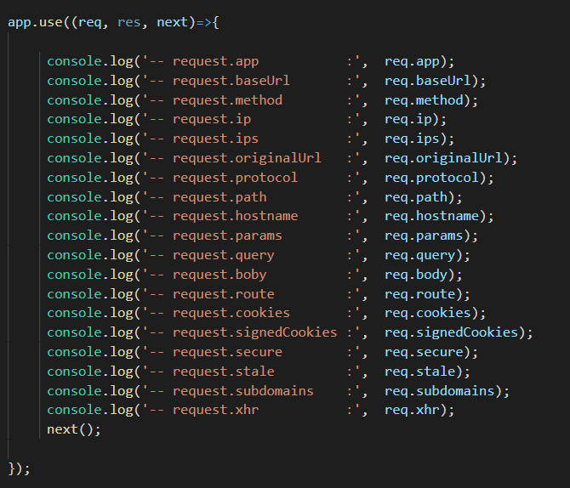

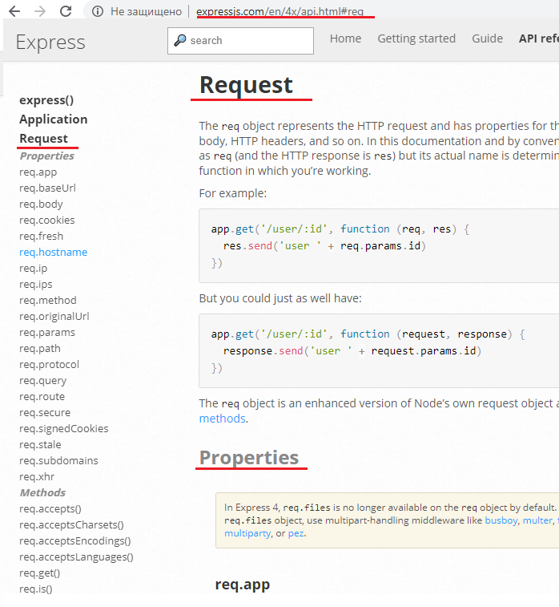

1. **Express:** объект request, методы объекта request

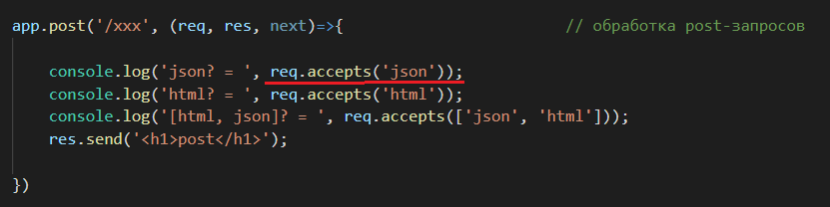

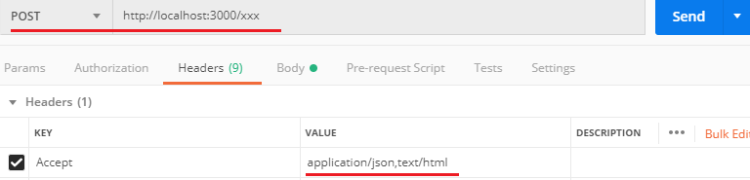

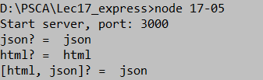

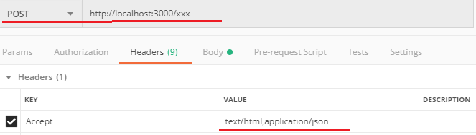

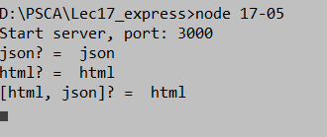

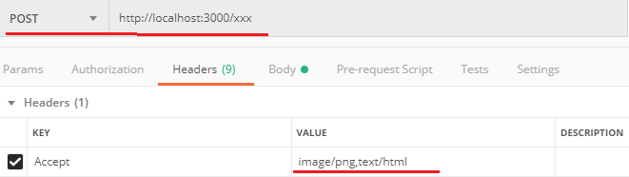

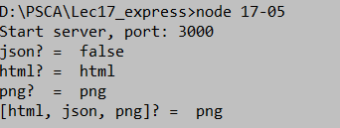

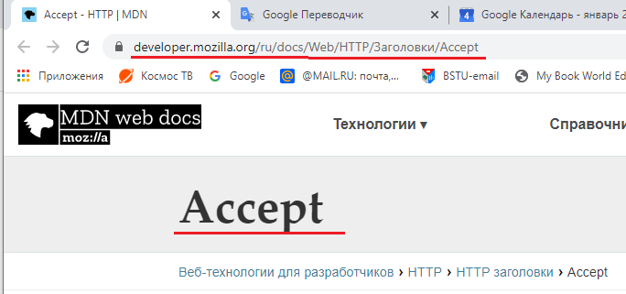

1. **Express:**
2. **Express:**
3. **Express:**
4. **Express:**
5. **Express:**
6. **Express:**
7. **Express:**
8. **Express:**
9. **Express:**
10. **Express:**
11. **Express:**
12. **Express:**
13. **Express:**
14. **Express:**
15. **Express:**
16. **Express:**
17. **Express:**
18. **Express:**